**Request to Use Microsoft Forms to Populate Form DS-3072**

CA/OCS/ACS is seeking permission to use Microsoft (MS) Forms to populate the OMB approved form DS-3072. This is a non-substantive change request. The questions from the DS-3072 are directly duplicated into the MS Form to make it electronically available to applicants. There are no new or additional questions added into the MS Form.

The MS form will be utilized by loan applicants to more efficiently submit their information for a repatriation or EMDA loan application to U.S. posts abroad. Posts will utilize the MS Forms tool to auto populate the form DS-3072 to prepare the form prior to the applicant’s arrival at the U.S. Consulate or Embassy, thereby streamlining the application review and approval process.

**Process Map**

**Repatriation / Emergency Medical and Dietary Assistance Loan Application**

1. Applicant completes MS Form

 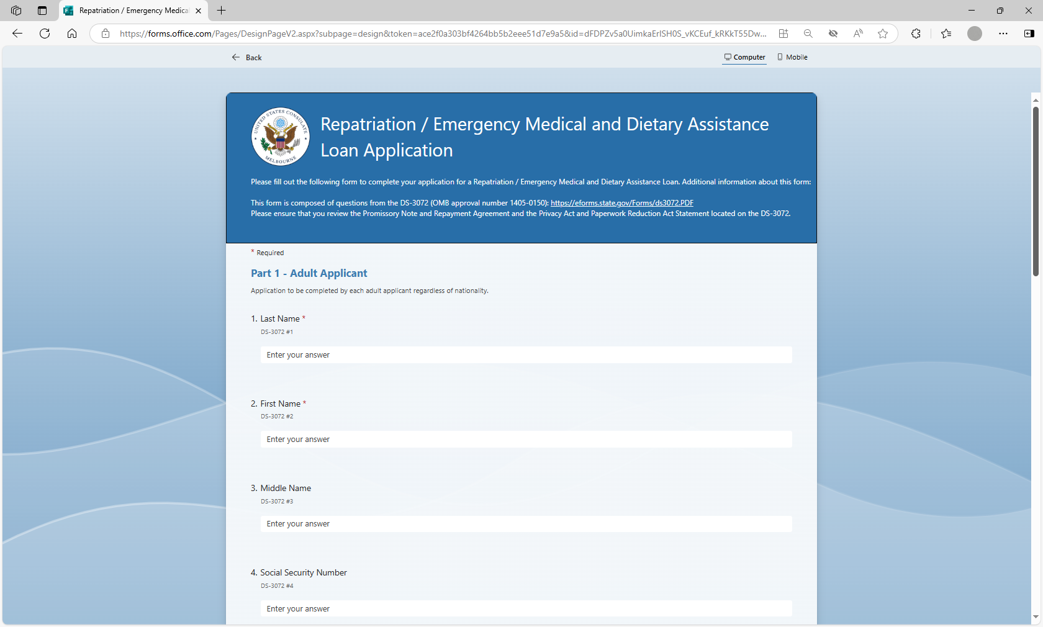

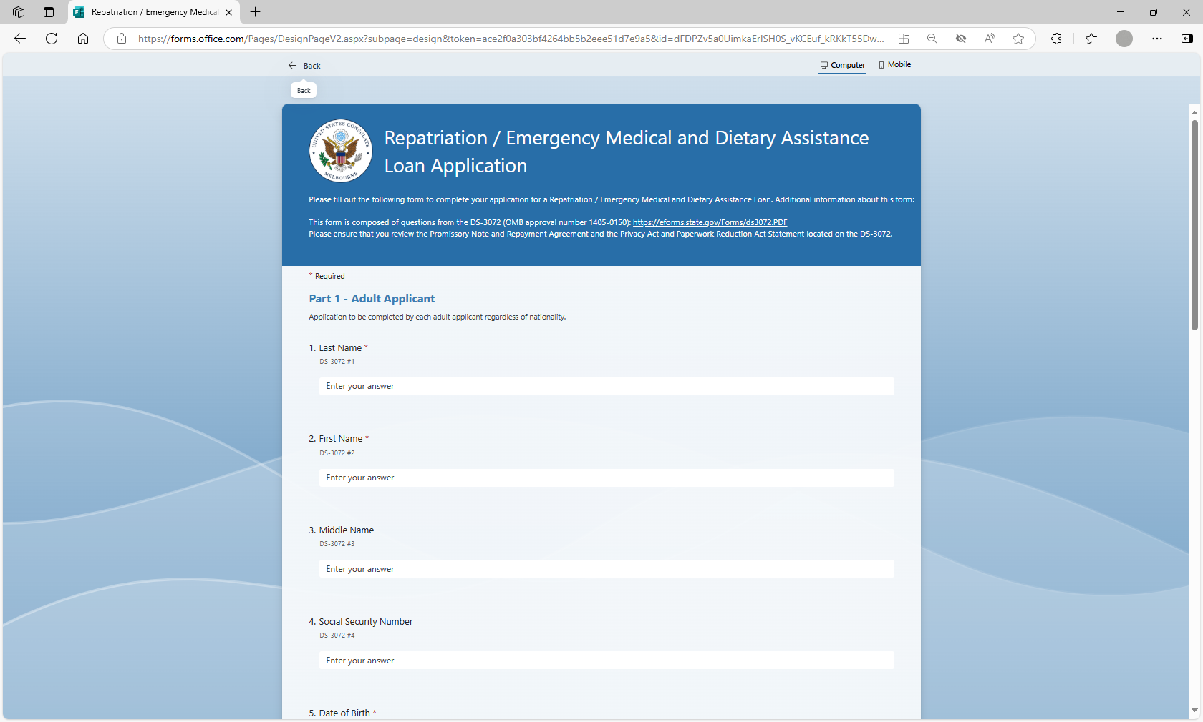

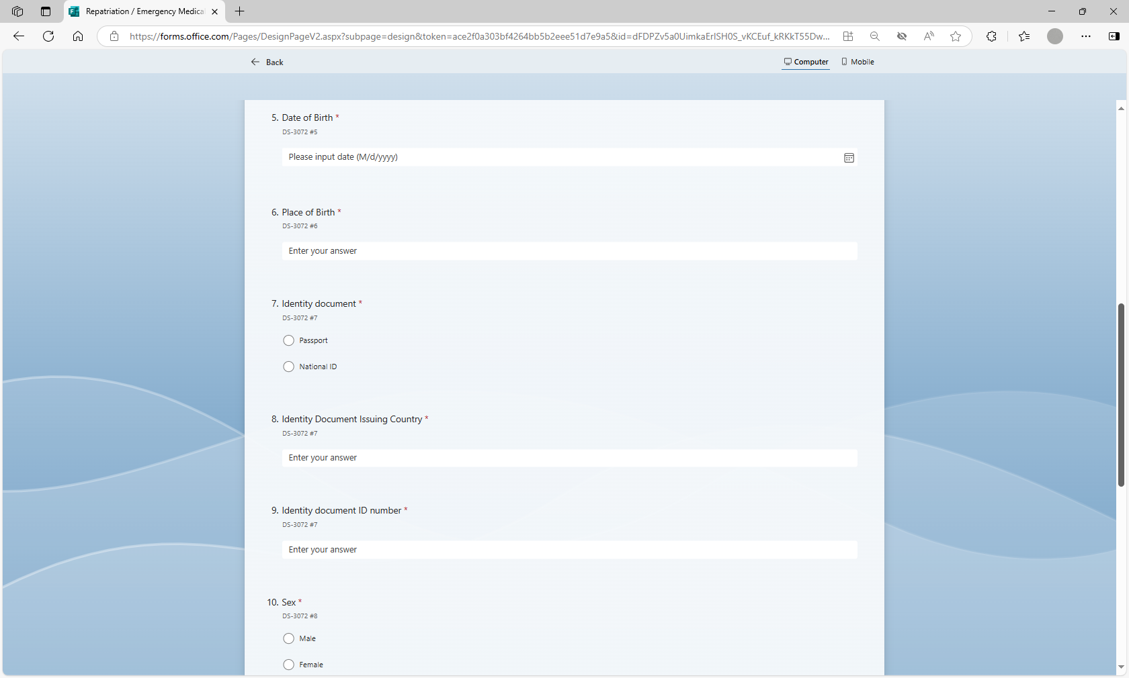

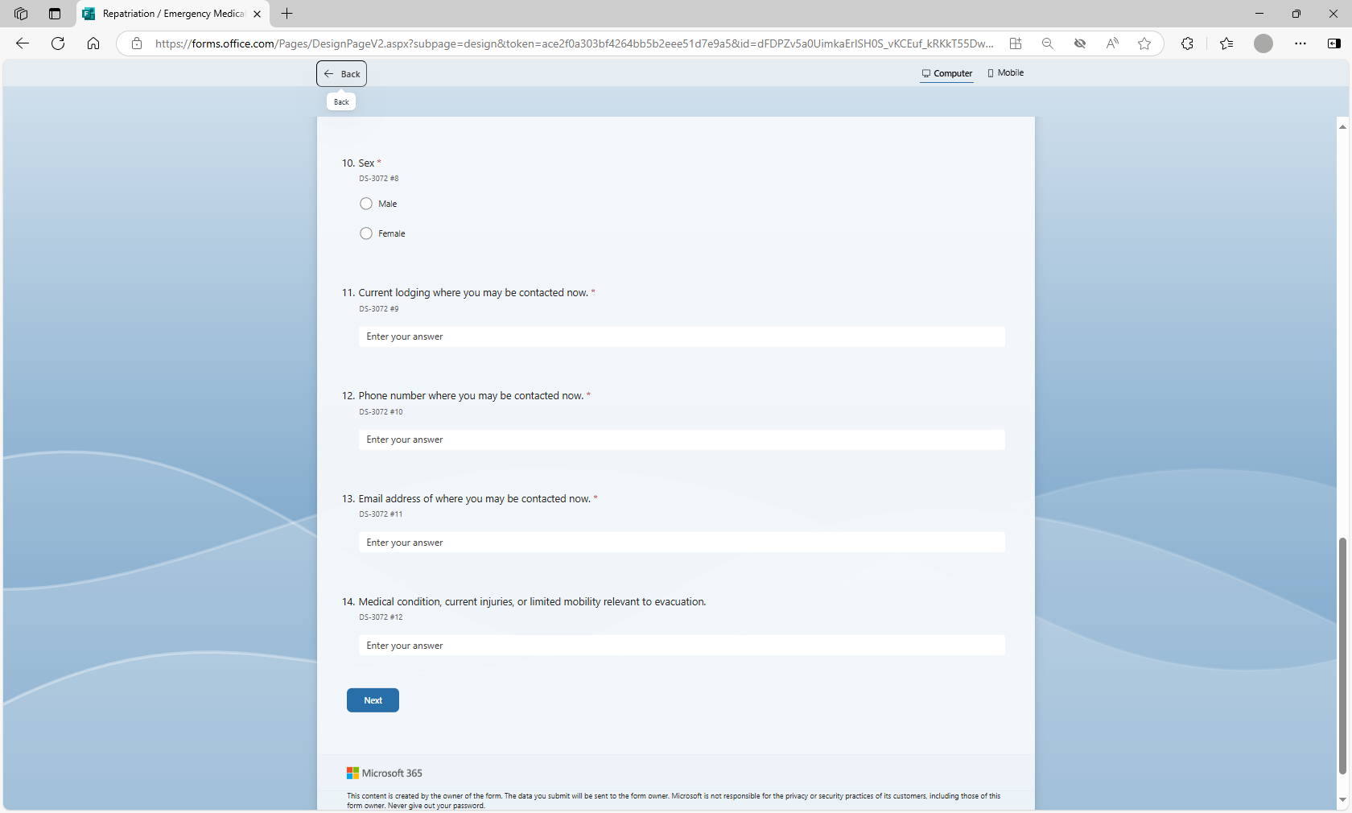

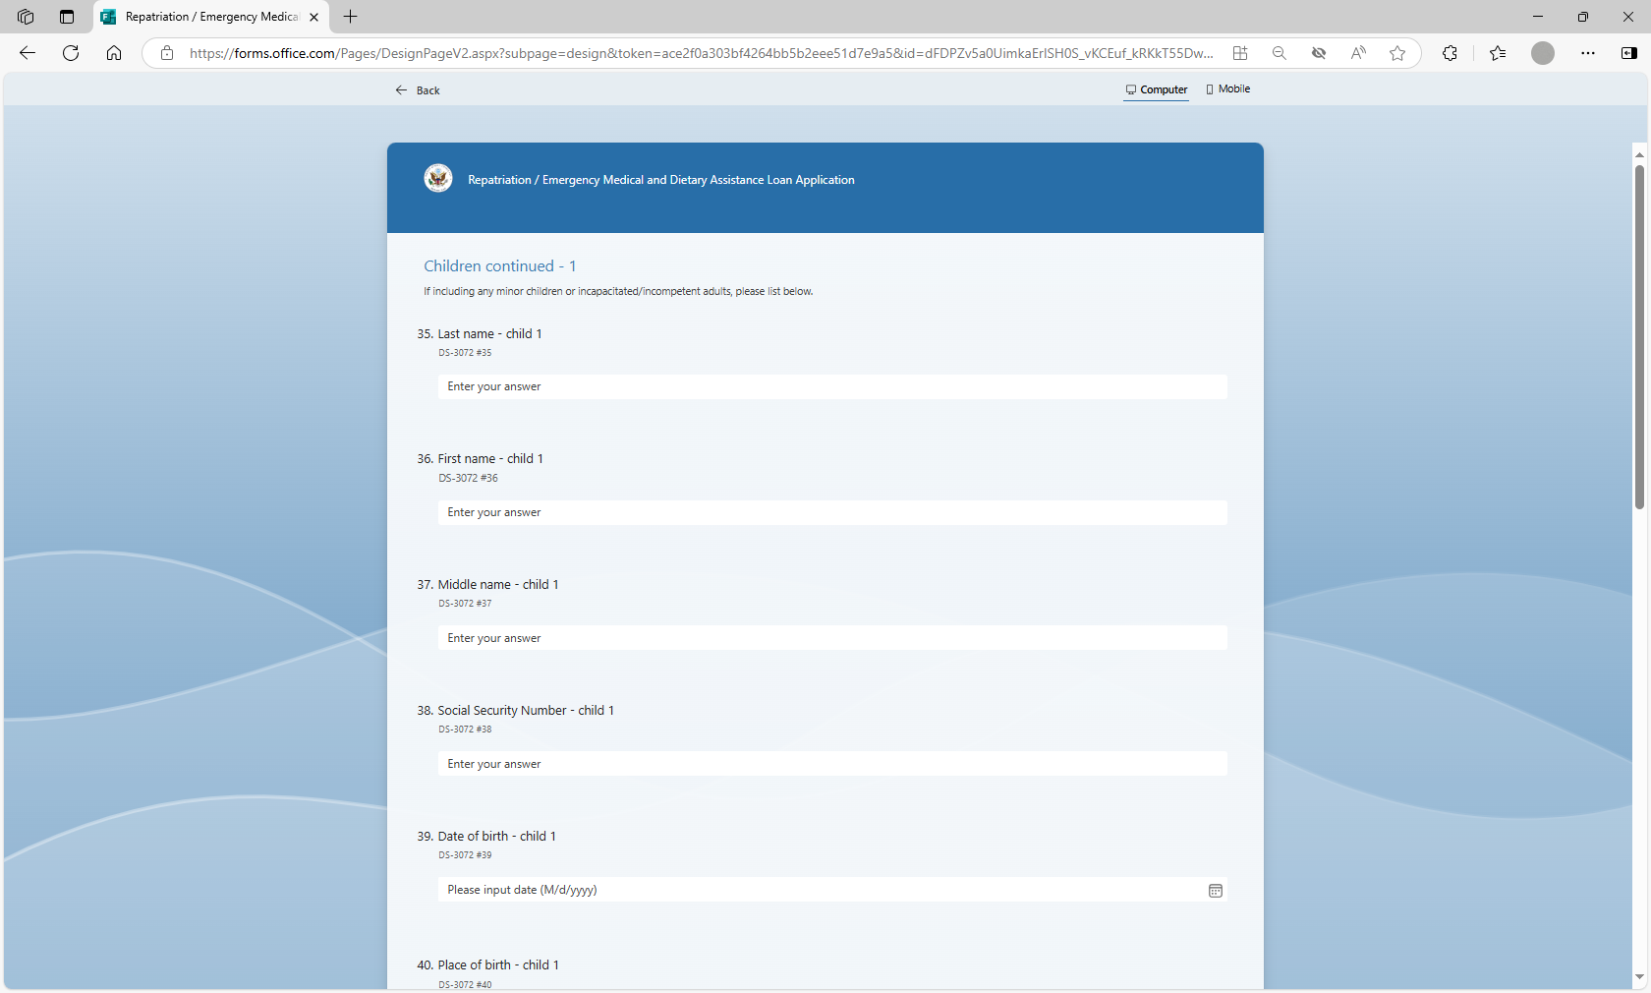

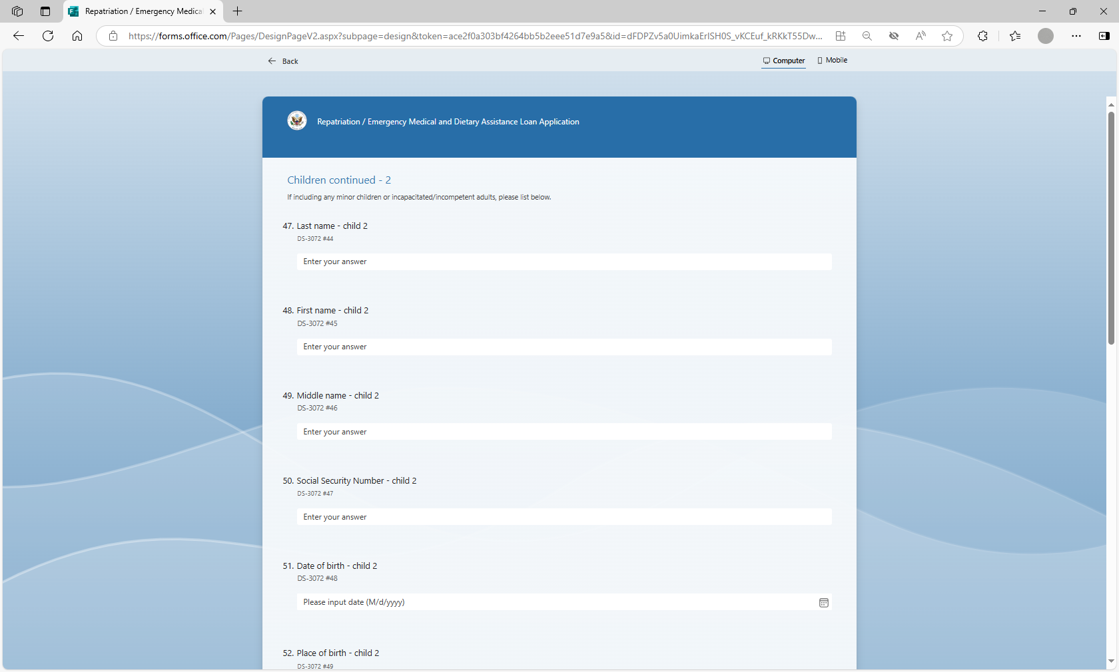

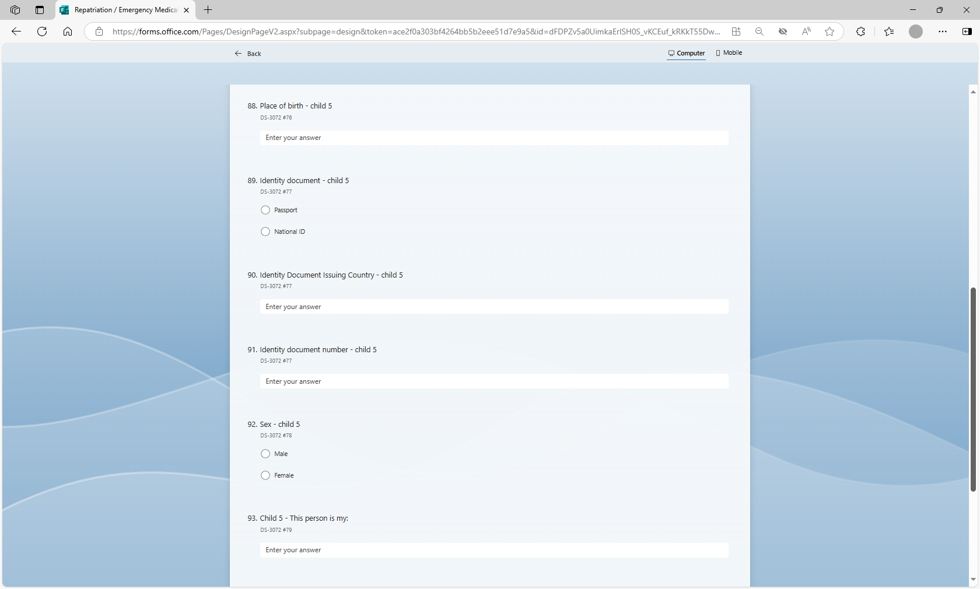

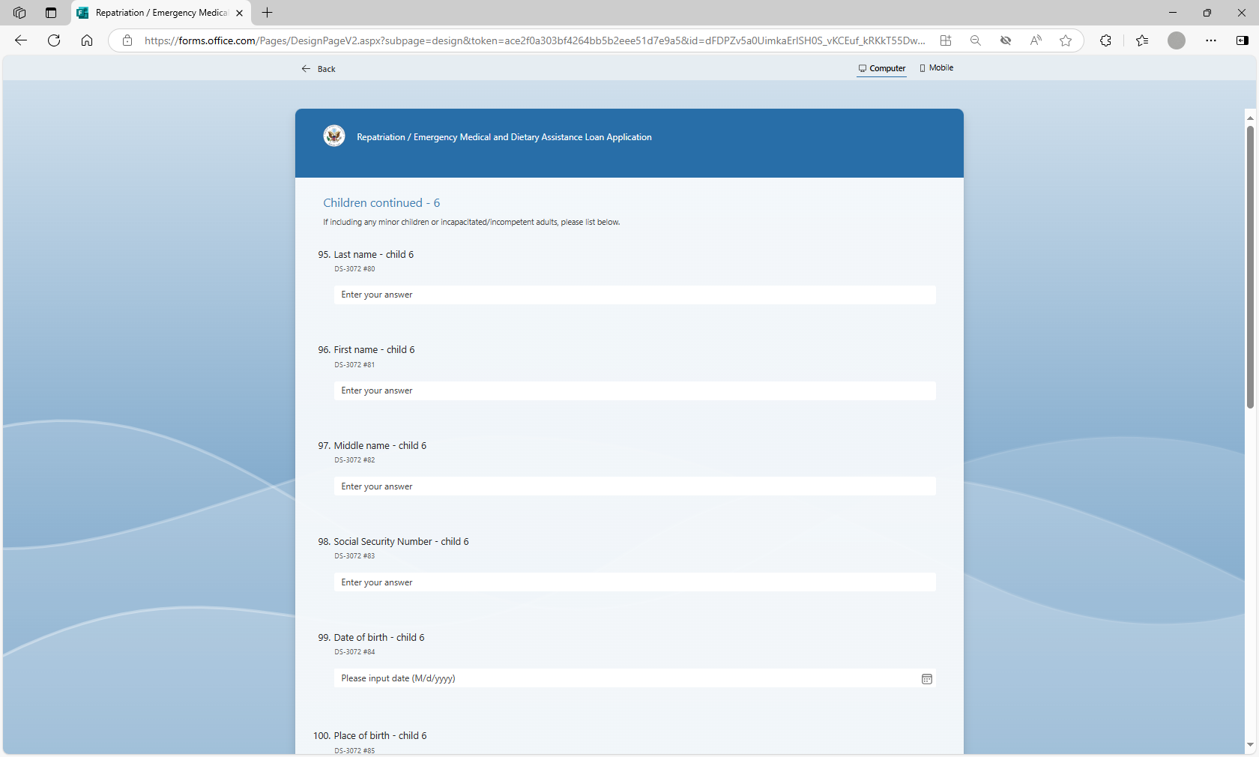

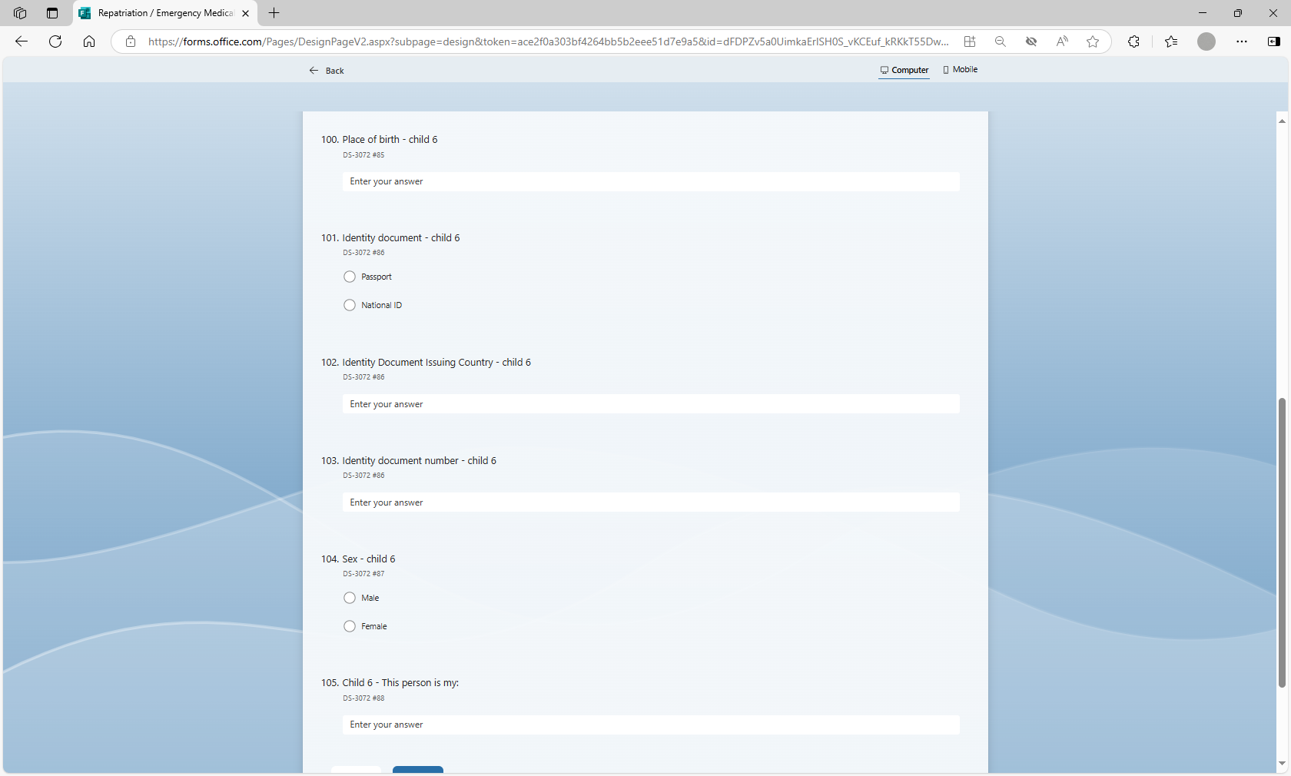

1. Power Automate pulls data from MS Form to MS Excel

1. MS Mail Merge pulls data from MS Excel to Repat package

