NATIONAL CENTER FOR EDUCATION STATISTICS NATIONAL ASSESSMENT OF EDUCATIONAL PROGRESS

National Assessment of Educational Progress (NAEP) 2026

Appendix J1
2026 Student Questionnaires

OMB# 1850-0928 v.37



July 2025

Important changes in how we collect demographic information are reflected in the 2026 instruments that are ready for publication and review. In March 2024, the Office of Management and Budget (OMB) announced revisions to Statistical Policy Directive No. 15: Standards for Maintaining, Collecting, and Presenting Federal Data on Race and Ethnicity (SPD 15) and published the revised SPD15 standard in the Federal Register (89 FR 22182). See Part A.7 of this package to see how NCES plans to incorporate these revisions into NAEP 2026.
Additionally, materials in this Amendment are in compliance with the White House’s Executive Orders “Defending Women from Gender Ideology Extremism and Restoring Biological Truth to the Federal Government,” (January 20, 2025) and “Ending Radical and Wasteful Government DEI Programs and Preferencing,” (January 20, 2025).
Appendix J1 provides the student survey questionnaires that will be administered in 2026. Summary tables reflect any changes to the items from the 2024 administration. Please note, some of the numbers of the items may be missing or out of order in these printed versions. This will be corrected in the platform view.
Table of Contents
Student Questionnaires
Student Login Screen 4
Appendix J1-1: Summary of Changes Operational Grade 4 (Core) 5
Appendix J1-2: Operational Grade 4 (Core) 10
Appendix J1-3: Summary of Changes Operational Grade 8 (Core) 12
Appendix J1-4: Operational Grade 8 (Core) 18
Appendix J1-5: Summary of Changes Operational Grade 4 (Mathematics) 23
Appendix J1-6: Operational Grade 4 (Mathematics) 25
Appendix J1-7: Summary of Changes Operational Grade 8 (Mathematics) 28
Appendix J1-8: Operational Grade 8 (Mathematics) 32
Appendix J1-9: Summary of Changes Operational Grade 4 (Reading) 37
Appendix J1-10: Operational Grade 4 (Reading) 40
Appendix J1-11: Summary of Changes Operational Grade 8 (Reading) 44
Appendix J1-12: Operational Grade 8 (Reading) 48
Appendix J1-13: Operational Grade 8 (Civics) 53
Appendix J1-14: Operational Grade 8 (U.S. History) 58
Appendix J1-15: Summary of Changes Operational Grade 4 (Debrief) 62
Appendix J1-16: Operational Grade 4 (Debrief) 63
Appendix J1-17: Summary of Changes Operational Grade 8 (Debrief) 64
Appendix J1-18: Operational Grade 8 (Debrief) 65
Appendix J1-19: Pilot Grade 4 (Core) 66
Appendix J1-20: Pilot Grade 8 (Core) 68
Appendix J1-21: Pilot Grade 12 – Sequence 1 (Core) 73
Appendix J1-22: Pilot Grade 12 – Sequence 2 (Core) 80
Appendix J1-23: Pilot Grade 4 (Mathematics) 86
Appendix J1-24: Pilot Grade 8 (Mathematics) 89
Appendix J1-25: Pilot Grade 12 – Sequence 1 (Mathematics) 94
Appendix J1-26: Pilot Grade 12 – Sequence 2 (Mathematics) 100
Appendix J1-27: Pilot Grade 4 (Reading) 109
Appendix J1-28: Pilot Grade 8 (Reading) 113
Appendix J1-29: Pilot Grade 12 – Sequence 1 (Reading) 118
Appendix J1-30: Pilot Grade 12 – Sequence 2 (Reading) 124
Appendix J1-31: Pilot Grade 4 (Debrief) 132
Appendix J1-32: Pilot Grade 8 (Debrief) 133
Appendix J1-33: Pilot Grade 12 (Debrief) 134

Student Login Screen
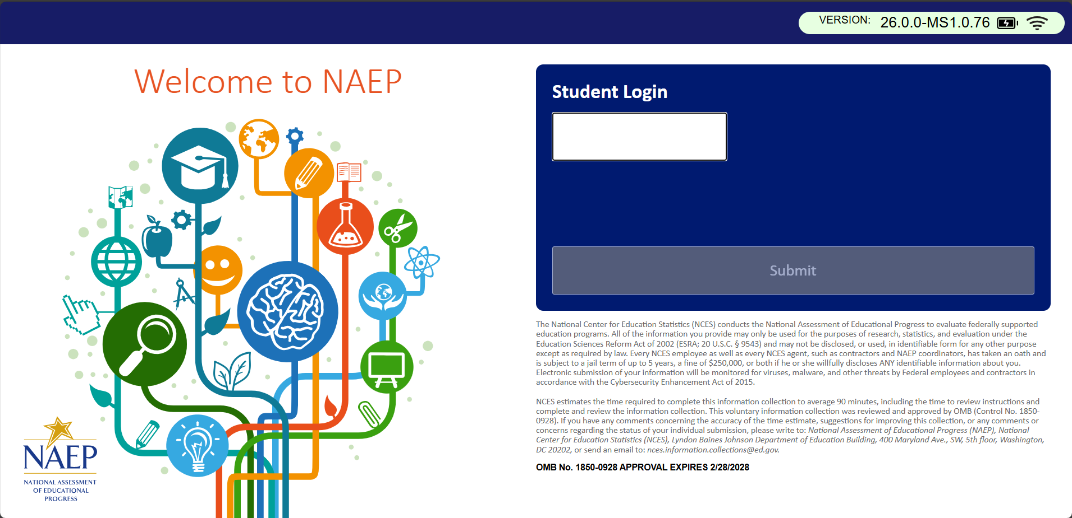

Appendix J1-1: Summary of Changes Operational Grade 4 (Core)
2026 Operational Grade 4 Core Student
Previous Item | 2026 Item | D/A/R+ | Rationale
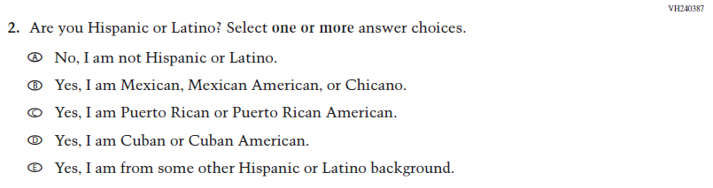  (2024) | N/A | D | This Item was dropped and replaced with an updated Item (VR858698) that adheres to OMB updated Statistical Policy Directive No. 15.
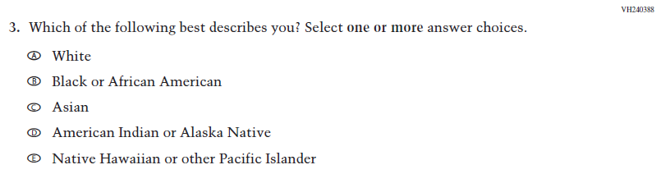  (2024) | 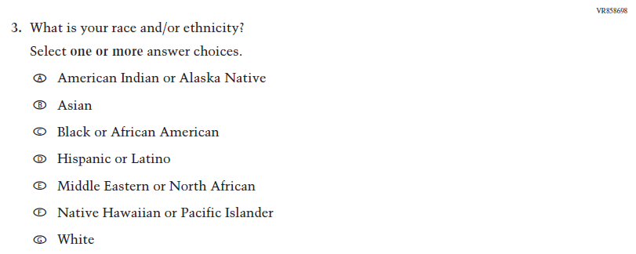  Issue: Student Background | R | VH240387 and this Item were replaced with this updated Item that adheres to OMB updated Statistical Policy Directive No. 15.

2026 Operational Grade 4 Core Student
Previous Item | 2026 Item | D/A/R+ | Rationale
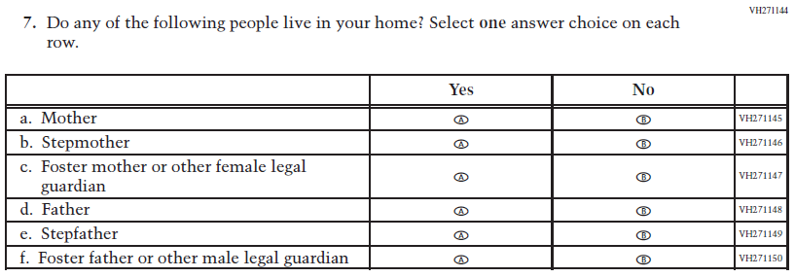  (2024) | 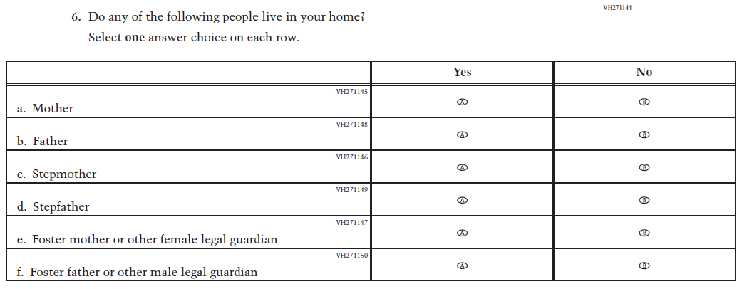  Issue: Socioeconomic Status | R | The SubItems in this Item were re-sequenced for clarity.
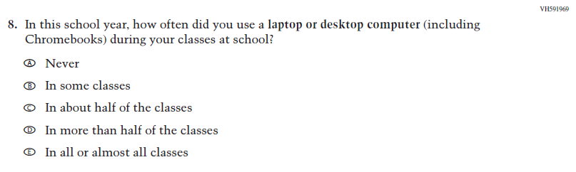  (2024) | N/A | D | This Item was dropped to make space for new Student Items in the 2026 NAEP Assessment.
N/A  (2024) | 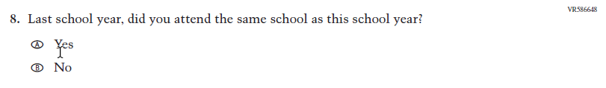  Issue: School Climate | A | This Item was added to gather information on student mobility.

2026 Operational Grade 4 Core Student
Previous Item | 2026 Item | D/A/R+ | Rationale
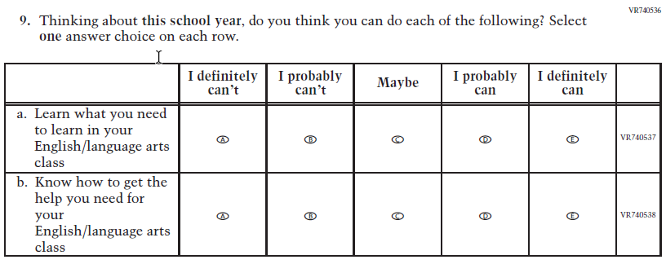  (2024) | N/A | D | Learning Recovery Items were dropped from the 2026 NAEP Assessment.
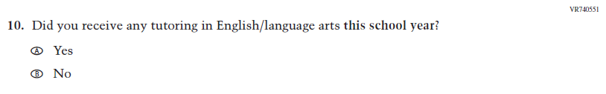  (2024) | N/A | D | Learning Recovery Items were dropped from the 2026 NAEP Assessment.
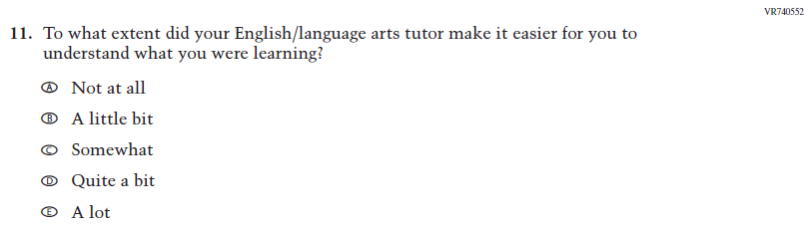  (2024) | N/A | D | Learning Recovery Items were dropped from the 2026 NAEP Assessment.
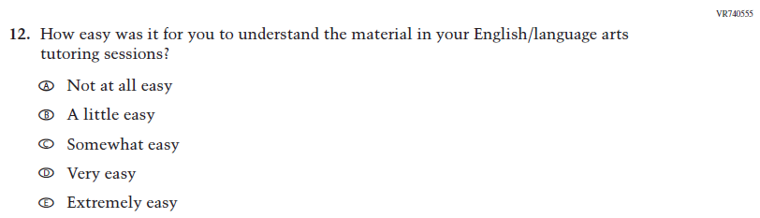  (2024) | N/A | D | Learning Recovery Items were dropped from the 2026 NAEP Assessment.

2026 Operational Grade 4 Core Student
Previous Item | 2026 Item | D/A/R+ | Rationale
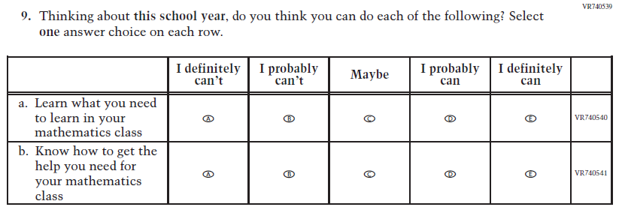  (2024) | N/A | D | Learning Recovery Items were dropped from the 2026 NAEP Assessment.
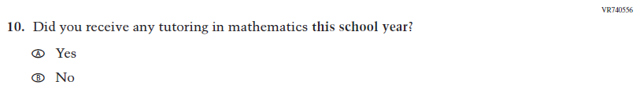  (2024) | N/A | D | Learning Recovery Items were dropped from the 2026 NAEP Assessment.
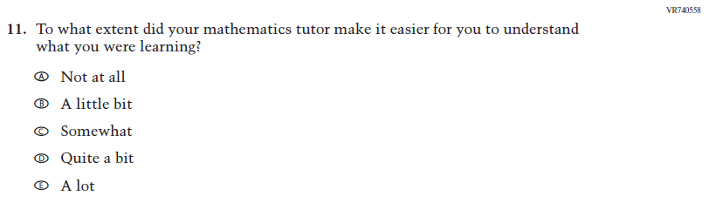  (2024) | N/A | D | Learning Recovery Items were dropped from the 2026 NAEP Assessment.
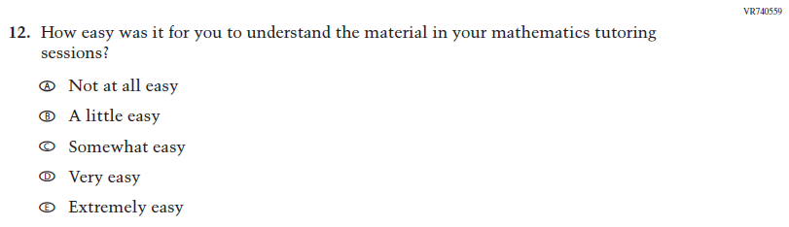  (2024) | N/A | D | Learning Recovery Items were dropped from the 2026 NAEP Assessment.

2026 Operational Grade 4 Core Student
Previous Item | 2026 Item | D/A/R+ | Rationale
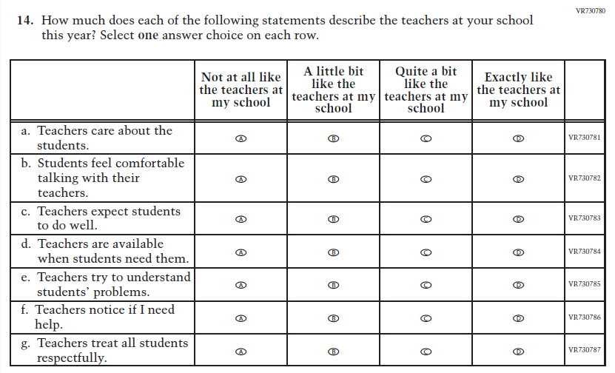  (2024) | 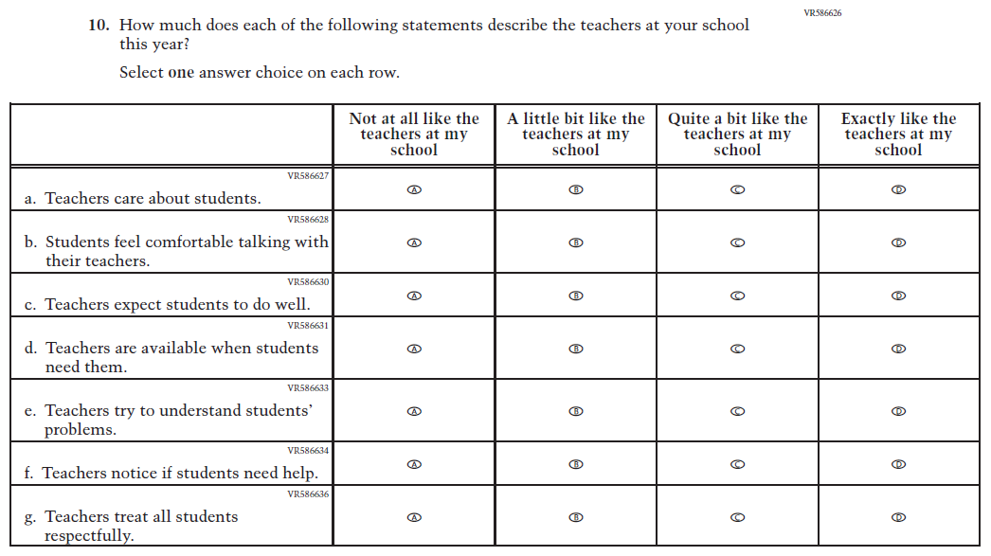  Issue: Learning Environment | R | SubItems a. and f. were revised for clarity and consistency.

Appendix J1-2: Operational Grade 4 (Core)
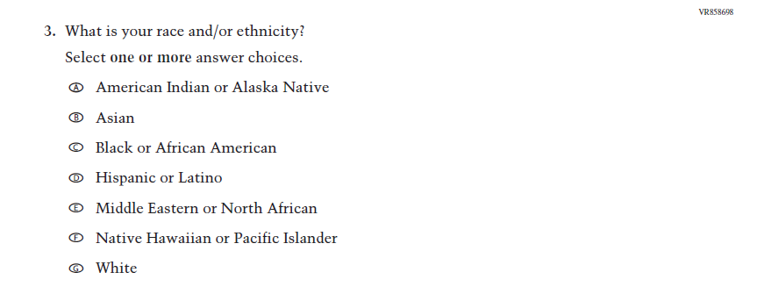
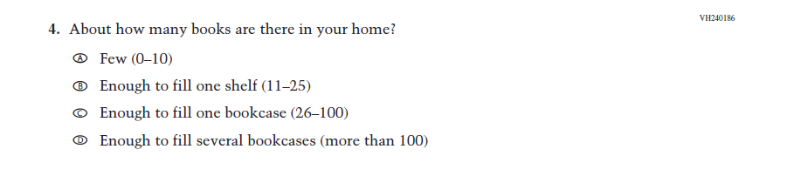
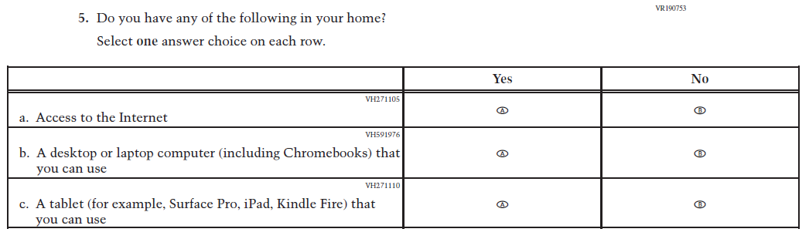
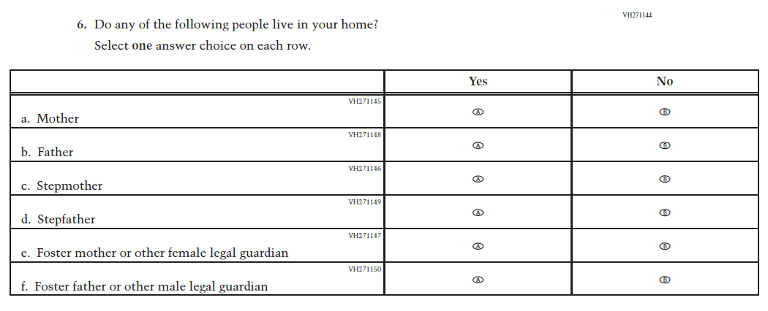
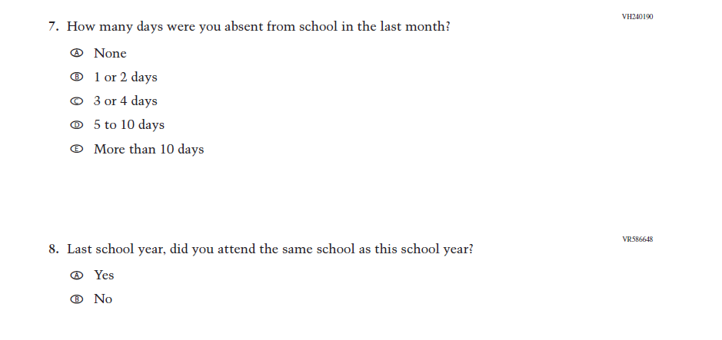
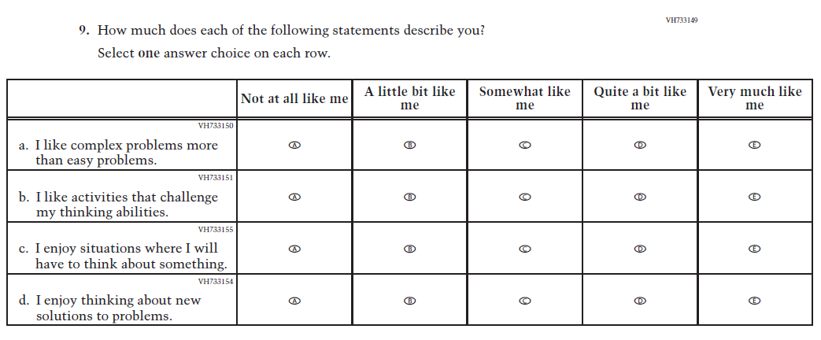
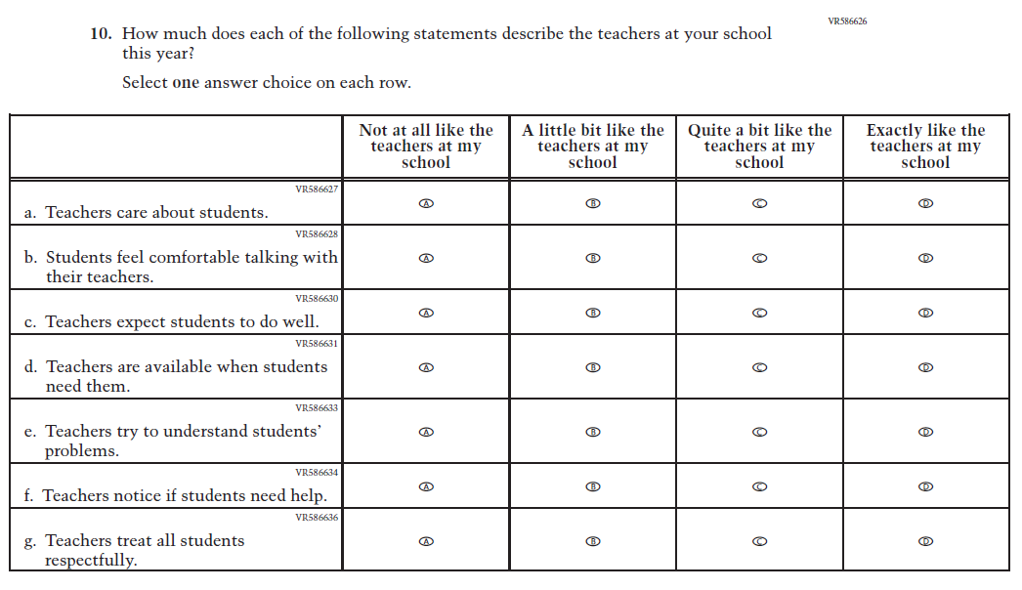

Appendix J1-3: Summary of Changes Operational Grade 8 (Core)
2026 Operational Grade 8 Core Student
Previous Item | 2026 Item | D/A/R+ | Rationale
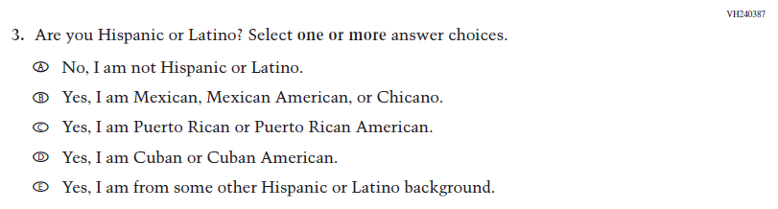  (2024) | N/A | D | This Item was dropped and replaced with an updated Item (VR858698) that adheres to OMB updated Statistical Policy Directive No. 15.
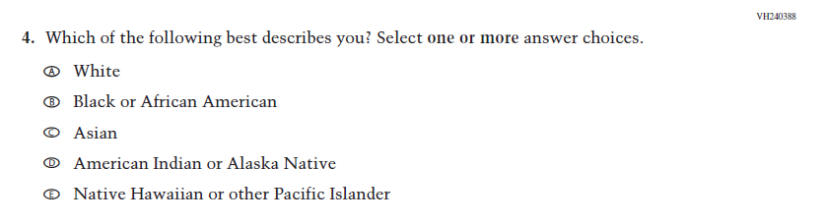  (2024) | 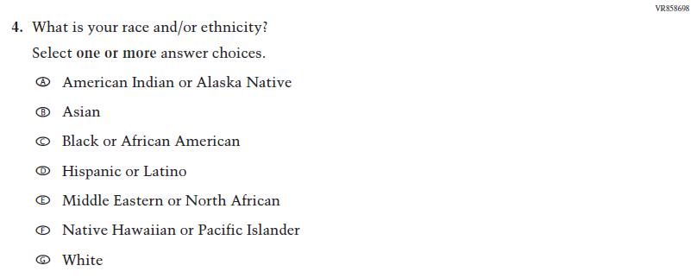  Issue: Student Background | R | VH240387 and this Item were replaced with this updated Item that adheres to OMB updated Statistical Policy Directive No. 15.
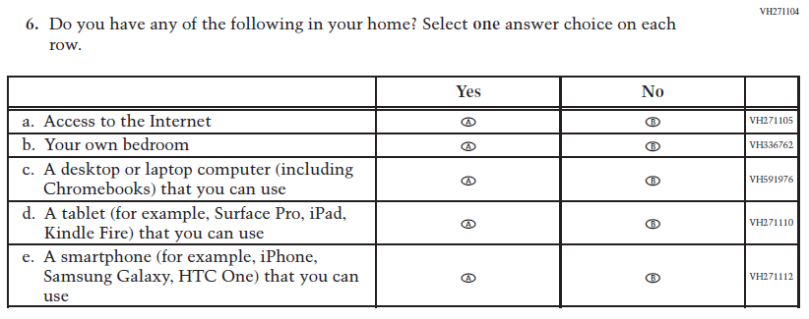  (2024) | 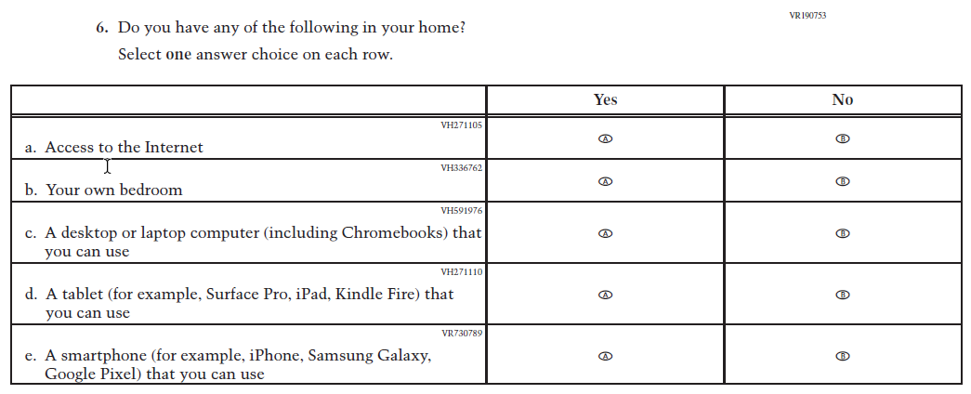  Issue: Socioeconomic Status | R | SubItem e. was revised to provide a more current example.
2026 Operational Grade 8 Core Student
Previous Item | 2026 Item | D/A/R+ | Rationale
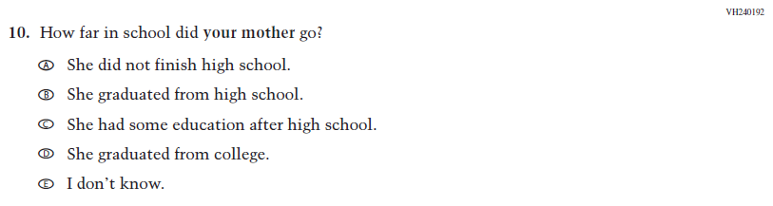  (2024) | 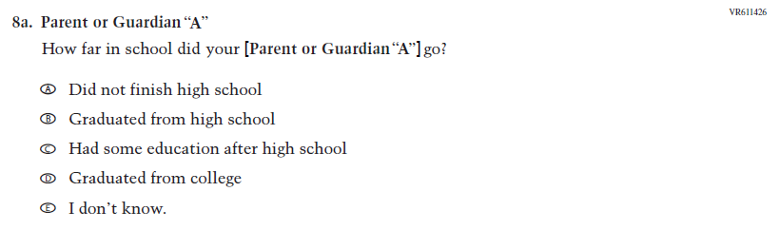  Issue: Socioeconomic Status | R | Dated Parent/  Guardian Education Item was replaced with an updated format.
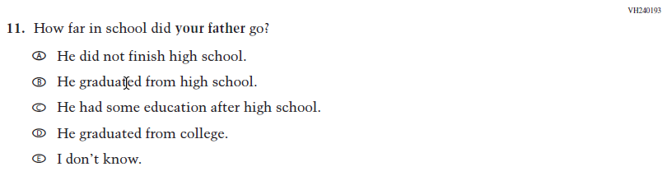  (2024) | 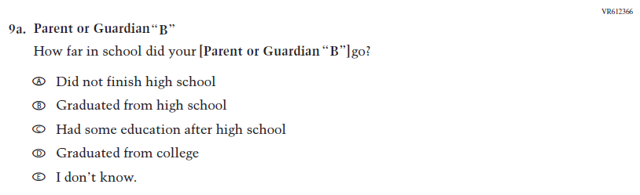  Issue: Socioeconomic Status | R | Dated Parent/  Guardian Education Item was replaced with an updated format.
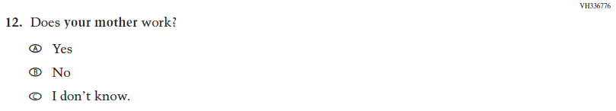  (2024) | 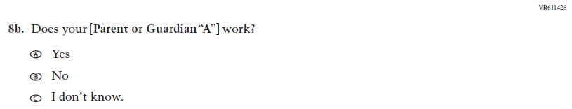  Issue: Socioeconomic Status | R | Dated Parent/  Guardian Employment Item was replaced with an updated format.
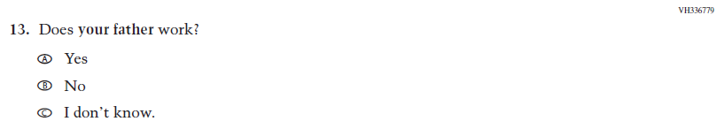  (2024) | 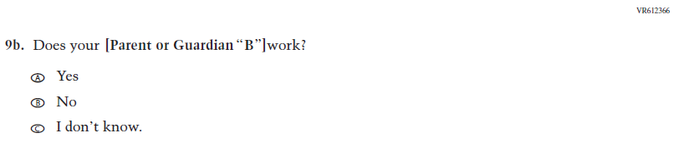  Issue: Socioeconomic Status | R | Dated Parent/  Guardian Employment Item was replaced with an updated format.

2026 Operational Grade 8 Core Student
Previous Item | 2026 Item | D/A/R+ | Rationale
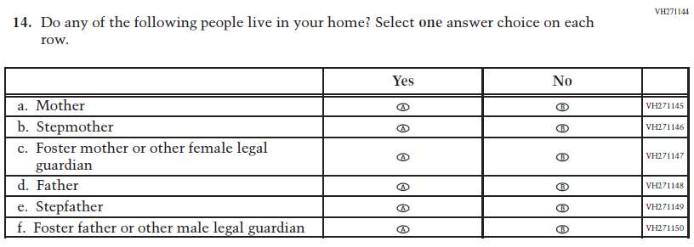  (2024) | 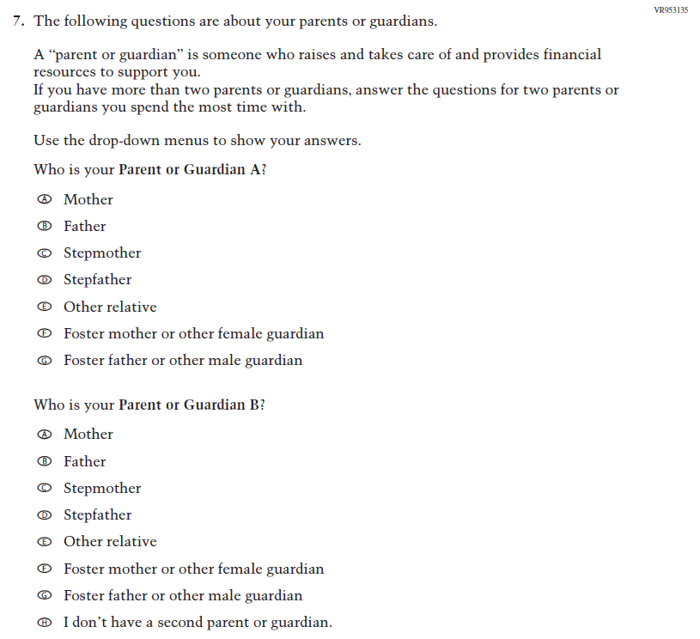  Issue: Socioeconomic Status | R | VH27144 was dropped and replaced with Item VR935135 as an updated format for collecting information on parent/ guardian education and employment.
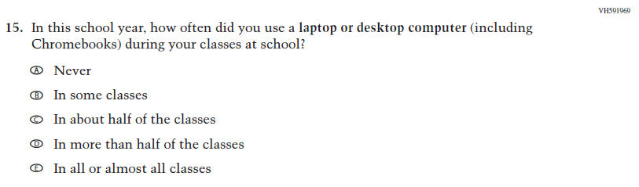  (2024) | N/A | D | This Item was dropped to make space for new Student Items in the 2026 NAEP Assessment.

2026 Operational Grade 8 Core Student
Previous Item | 2026 Item | D/A/R+ | Rationale
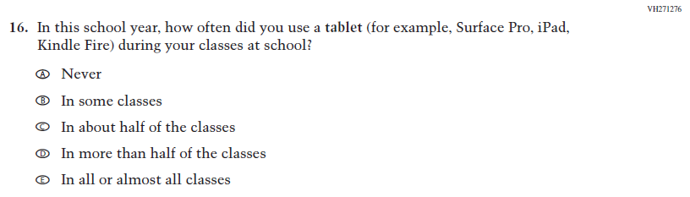  (2024) | N/A | D | This Item was dropped to make space for new Student Items in the 2026 NAEP Assessment.
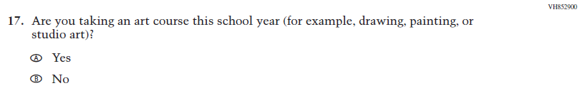  (2024) | N/A | D | This Item was dropped to make space for new Student Items in the 2026 NAEP Assessment.
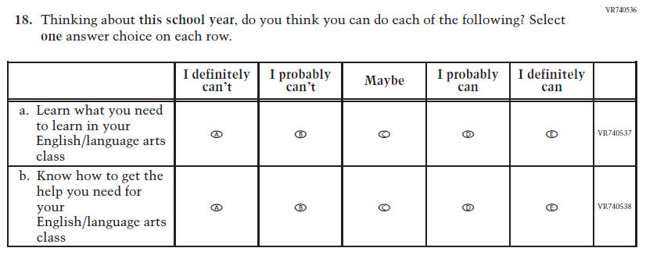  (2024) | N/A | D | Learning Recovery Items were dropped from the 2026 NAEP Assessment.
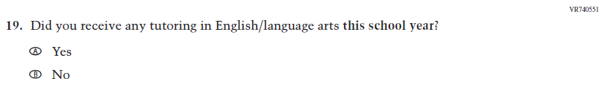  (2024) | N/A | D | Learning Recovery Items were dropped from the 2026 NAEP Assessment.

2026 Operational Grade 8 Core Student
Previous Item | 2026 Item | D/A/R+ | Rationale
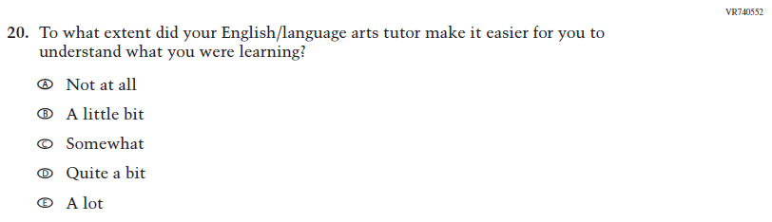  (2024) | N/A | D | Learning Recovery Items were dropped from the 2026 NAEP Assessment.
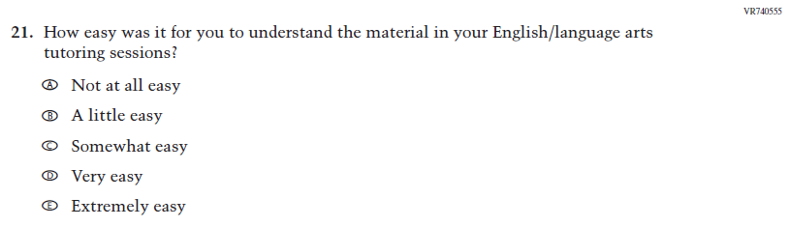  (2024) | N/A | D | Learning Recovery Items were dropped from the 2026 NAEP Assessment.
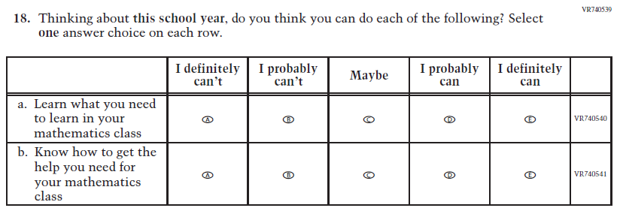  (2024) | N/A | D | Learning Recovery Items were dropped from the 2026 NAEP Assessment.
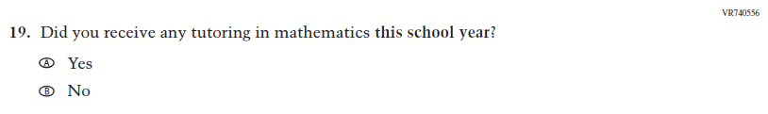  (2024) | N/A | D | Learning Recovery Items were dropped from the 2026 NAEP Assessment.

2026 Operational Grade 8 Core Student
Previous Item | 2026 Item | D/A/R+ | Rationale
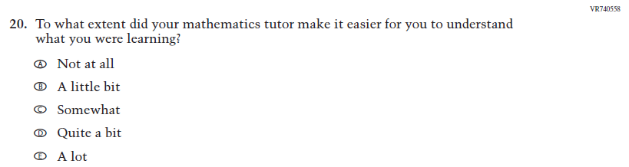  (2024) | N/A | D | Learning Recovery Items were dropped from the 2026 NAEP Assessment.
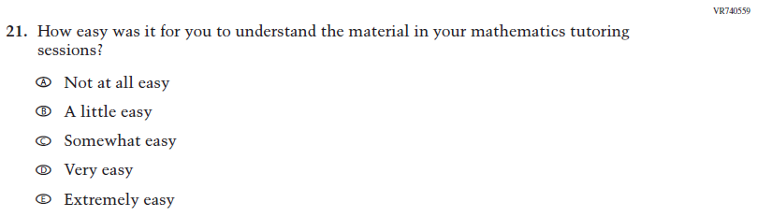  (2024) | N/A | D | Learning Recovery Items were dropped from the 2026 NAEP Assessment.
N/A  (2024) | 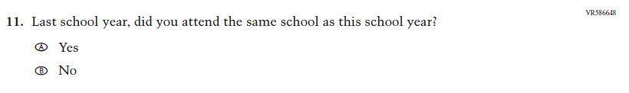  Issue: School Climate | A | This Item was added to gather information on student mobility.

2026 Operational Grade 8 Core Student
Previous Item | 2026 Item | D/A/R+ | Rationale
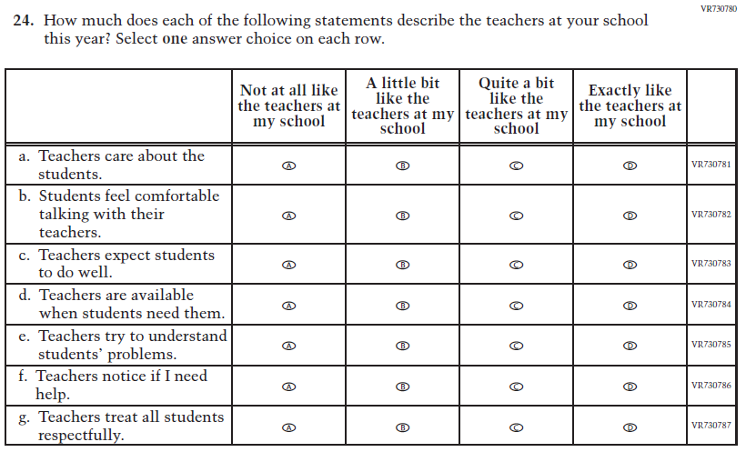  (2024) | 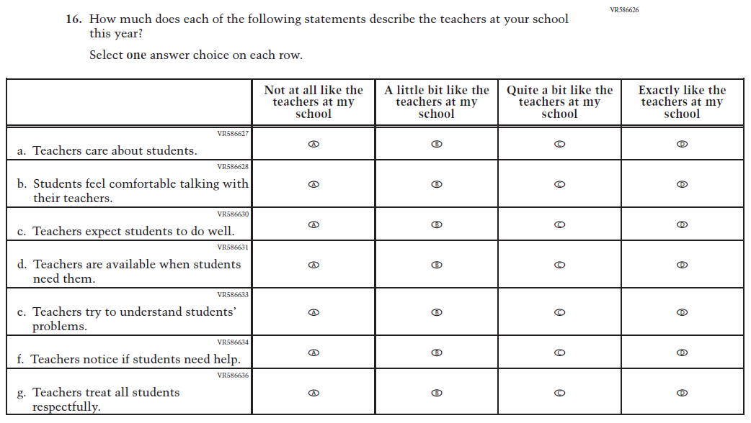  Issue: Learning Environment | R | SubItems a. and f. were revised for clarity and consistency.

Appendix J1-4: Operational Grade 8 (Core)
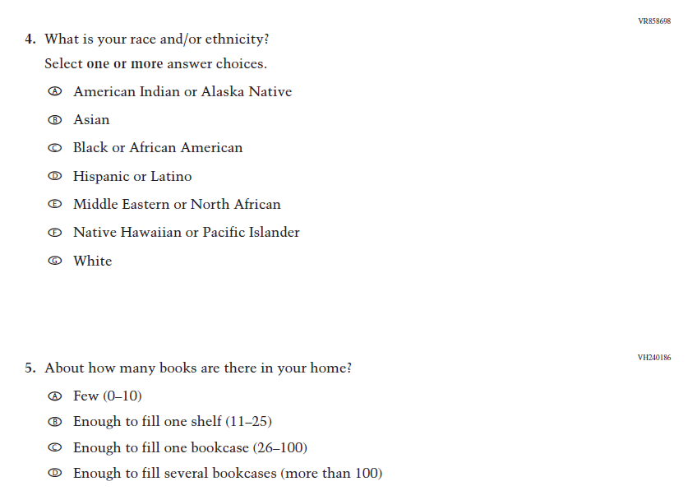
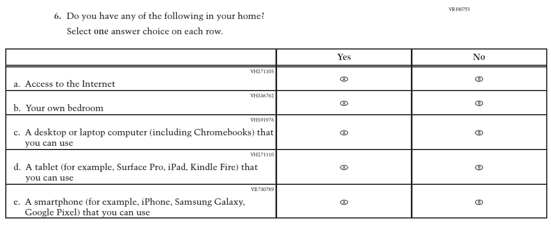
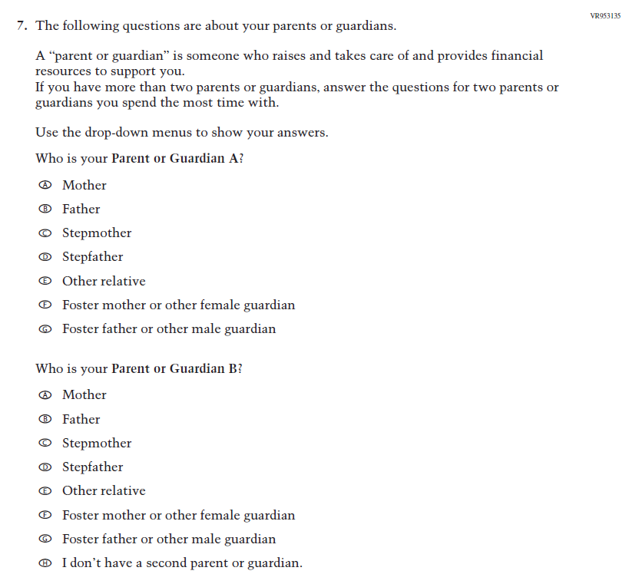
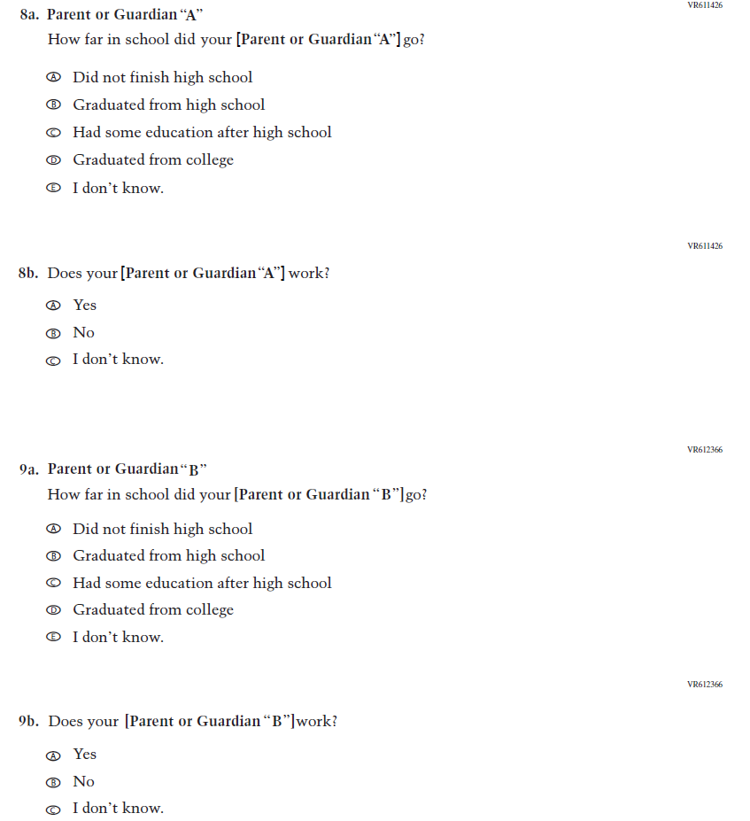
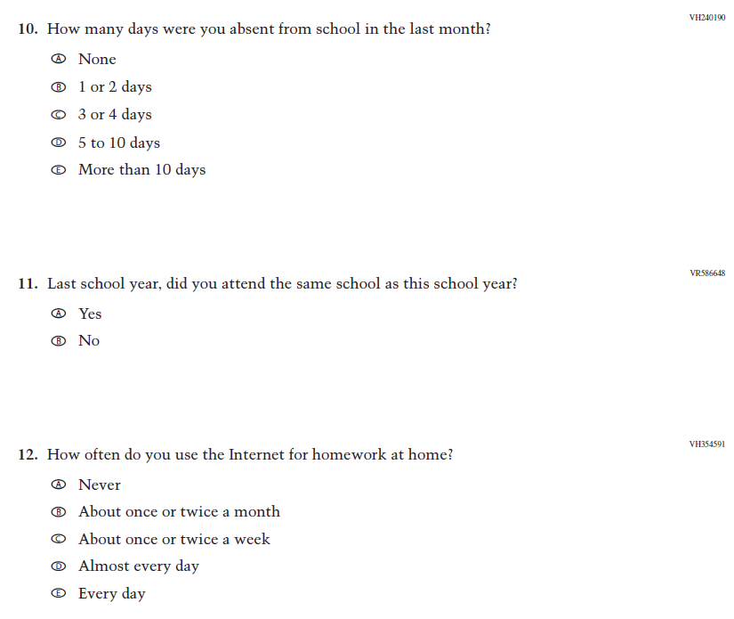
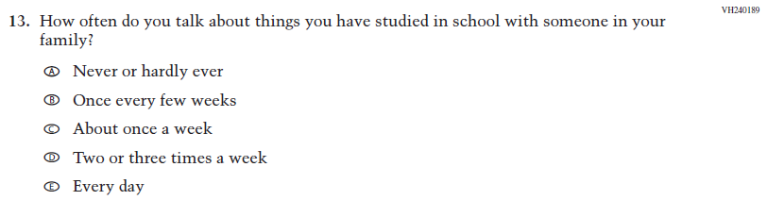
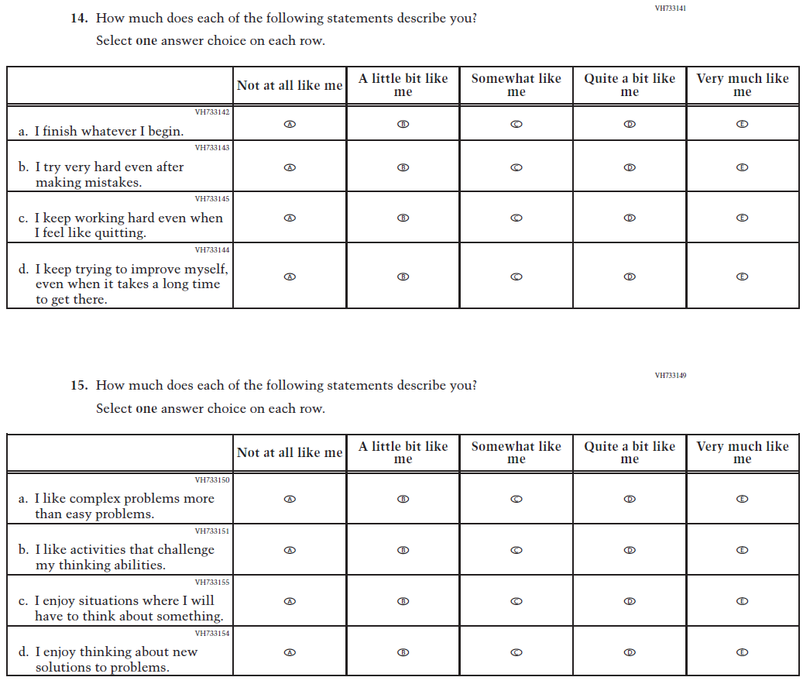
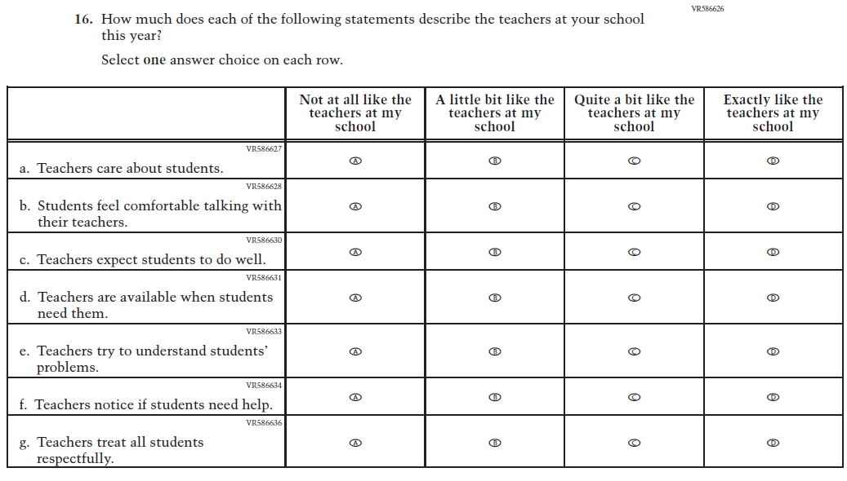

Appendix J1-5: Summary of Changes Operational Grade 4 (Mathematics)
2026 Operational Grade 4 Mathematics Student
Previous Item | 2026 Item | D/A/R+ | Rationale
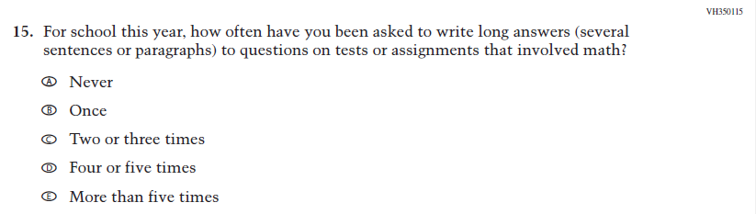  (2024) | N/A | D | This item was dropped in favor of a new item.
N/A  (2024) | 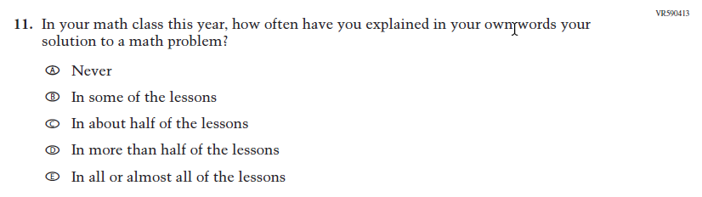  Issue: Student Mathematical Identity | A | This item was developed to measure content aligned with the new Mathematics framework.
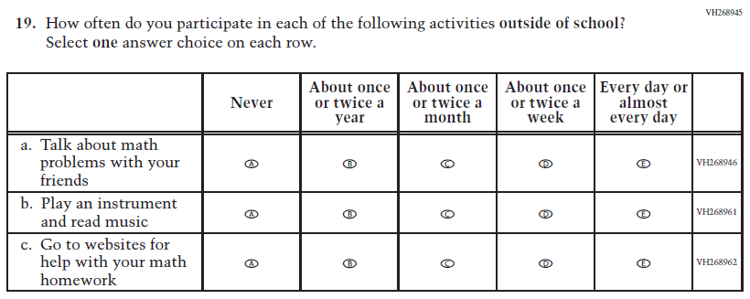  (2024) | N/A | D | This item was dropped to reduce questionnaire length.

2026 Operational Grade 4 Mathematics Student
Previous Item | 2026 Item | D/A/R+ | Rationale
N/A  (2024) | 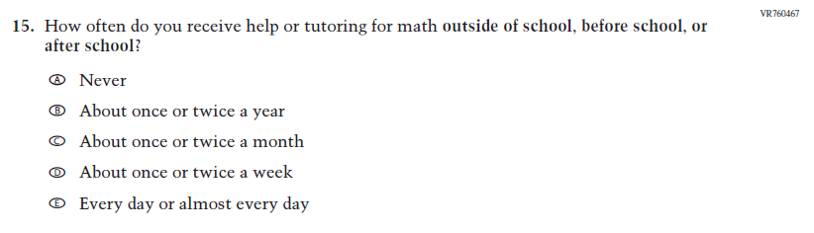  Issue: N/A | A | This item captures the important aspect of help or tutoring received by students.
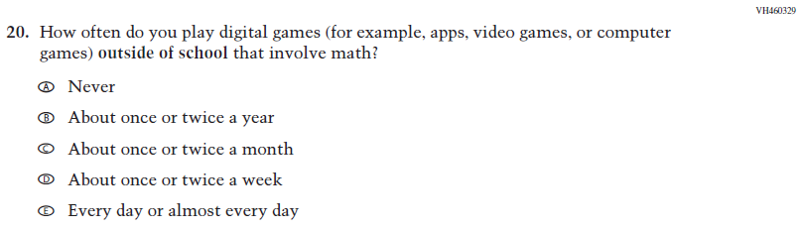  (2024) | N/A | D | This item was dropped to reduce questionnaire length.
N/A  (2024) | 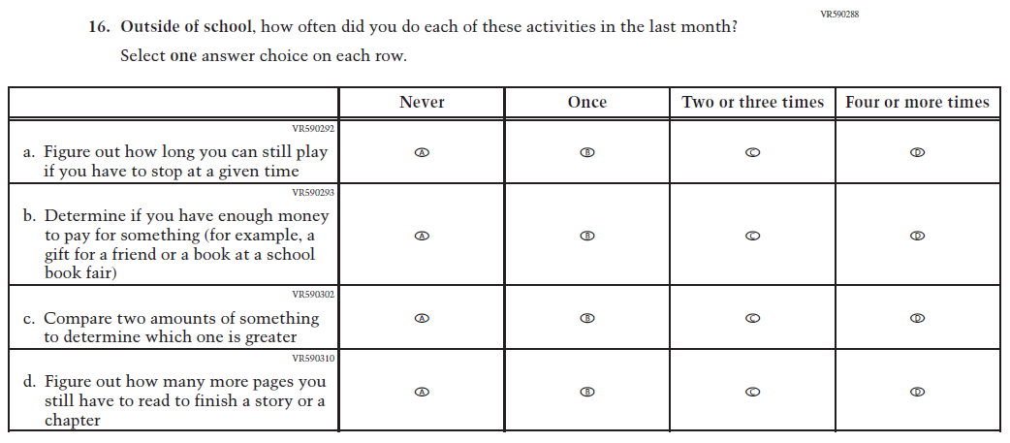  Issue: Mathematical Content and Practices | A | This item was developed to measure content aligned with the new Mathematics framework.

2026 Operational Grade 4 Mathematics Student
Previous Item | 2026 Item | D/A/R+ | Rationale
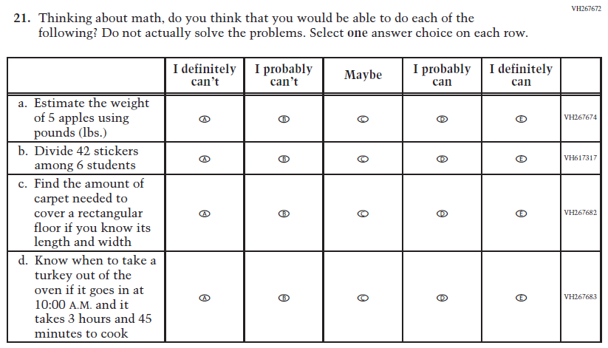  (2024) | 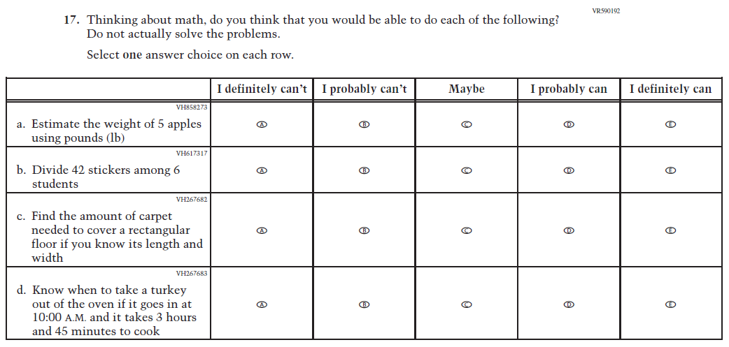  Issue: Student Mathematical Identity | R | Subitem a was revised for clarity.

Appendix J1-6: Operational Grade 4 (Mathematics)
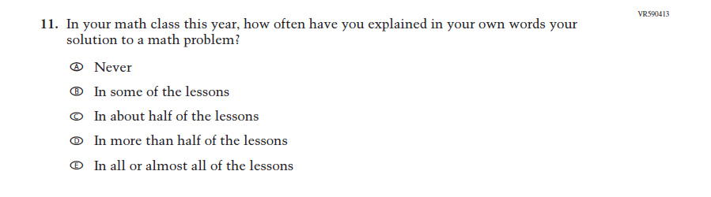
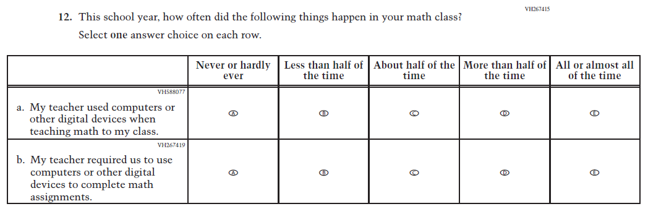
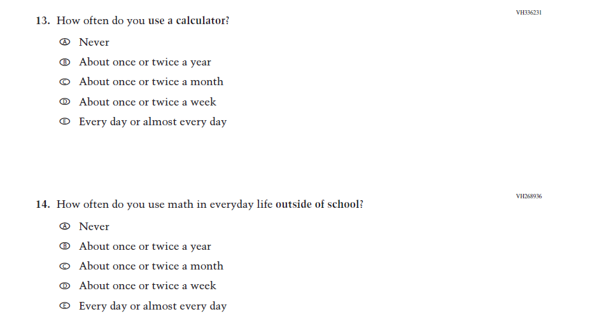
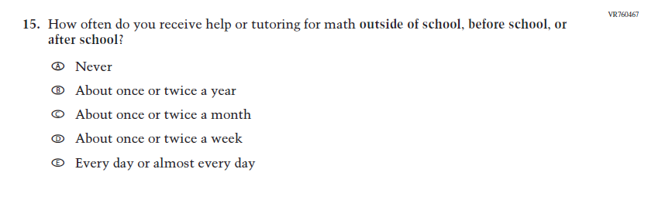
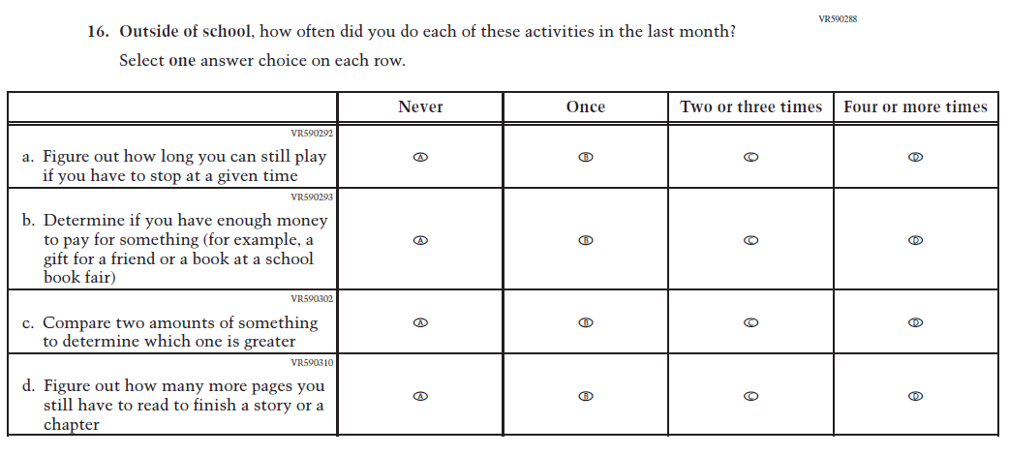
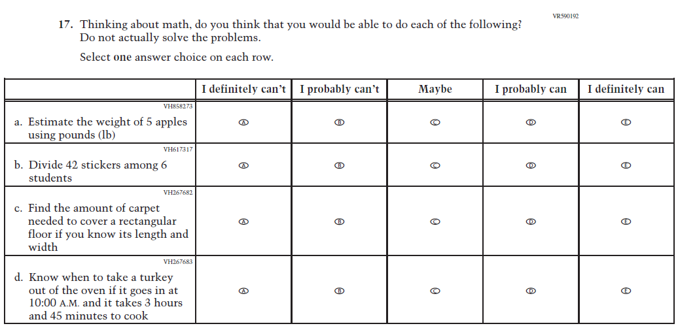
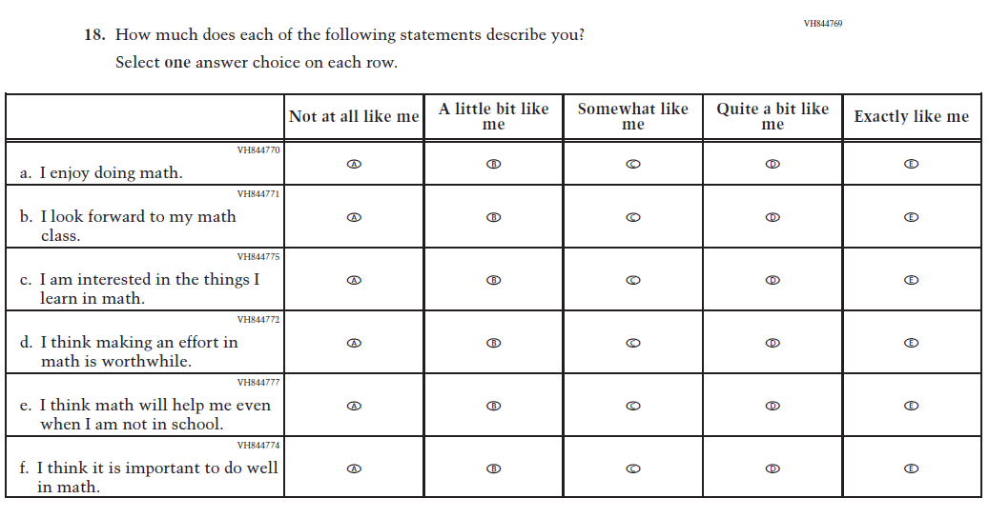
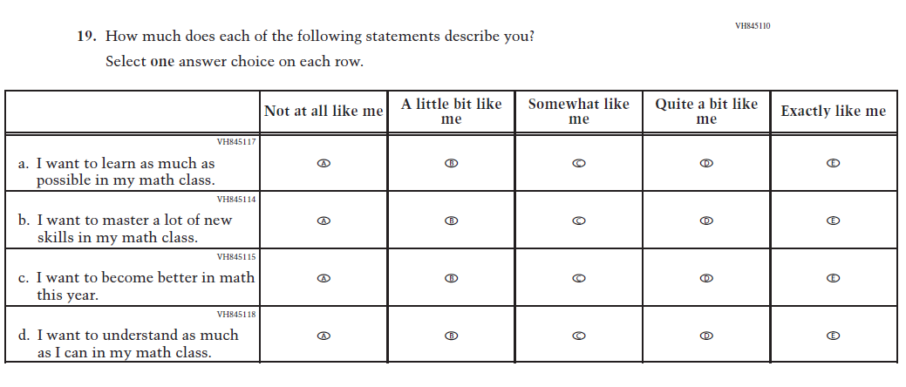

Appendix J1-7: Summary of Changes Operational Grade 8 (Mathematics)

2026 Operational Grade 8 Mathematics Student
Previous Item | 2026 Item | D/A/R+ | Rationale
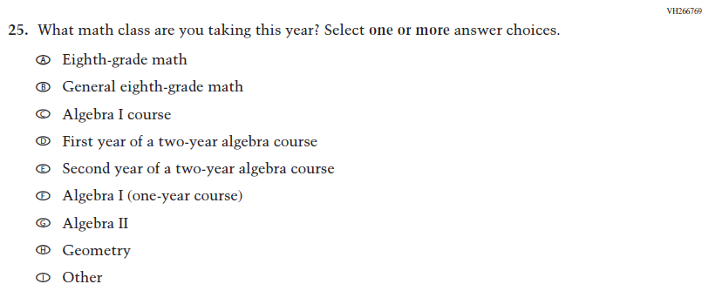  (2024) | 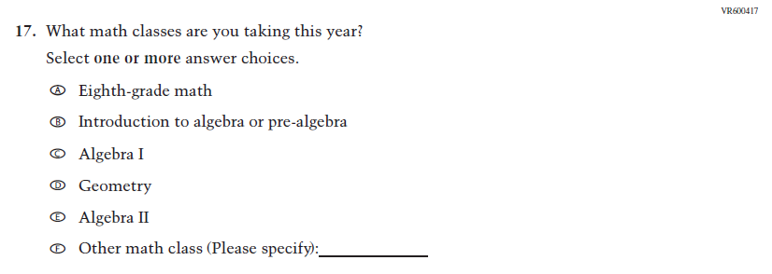  Issue: Mathematical Content and Practices | R | The revised item includes streamlined response options.
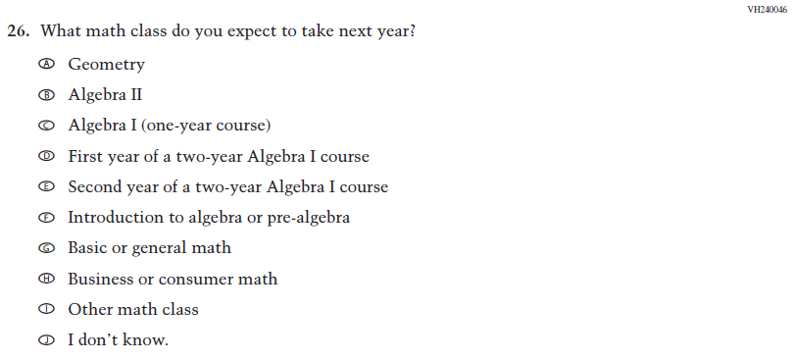  (2024) | 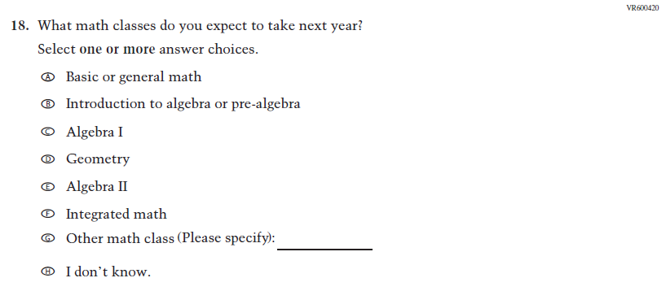  Issue: Mathematical Content and Practices | R | The revised item includes streamlined response options.
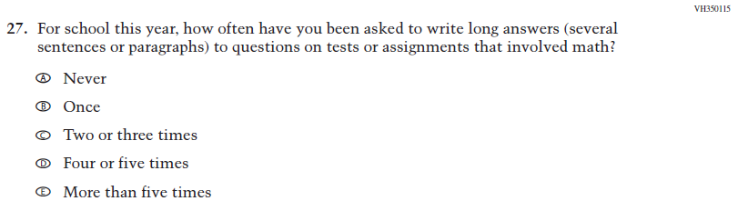  (2024) | N/A | D | This item was dropped in favor of a new item.
2026 Operational Grade 8 Mathematics Student
Previous Item | 2026 Item | D/A/R+ | Rationale
N/A  (2024) | 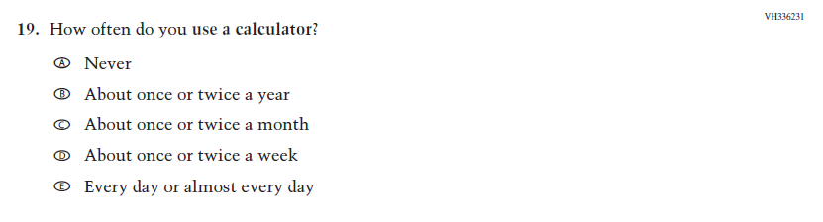  Issue: Instructional Organization and Strategies | A | This item was added for consistency with the questionnaire at grade 4.
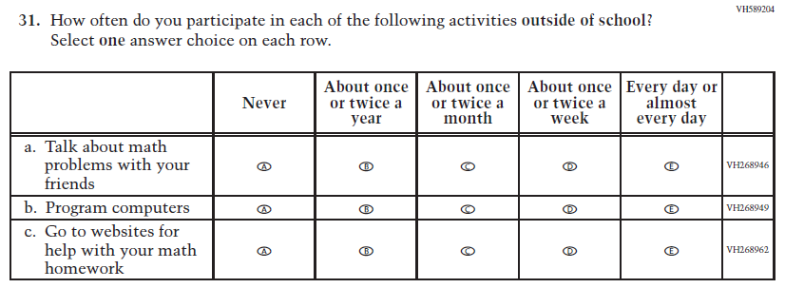  (2024) | N/A | D | This item was dropped to reduce questionnaire length.
N/A  (2024) | 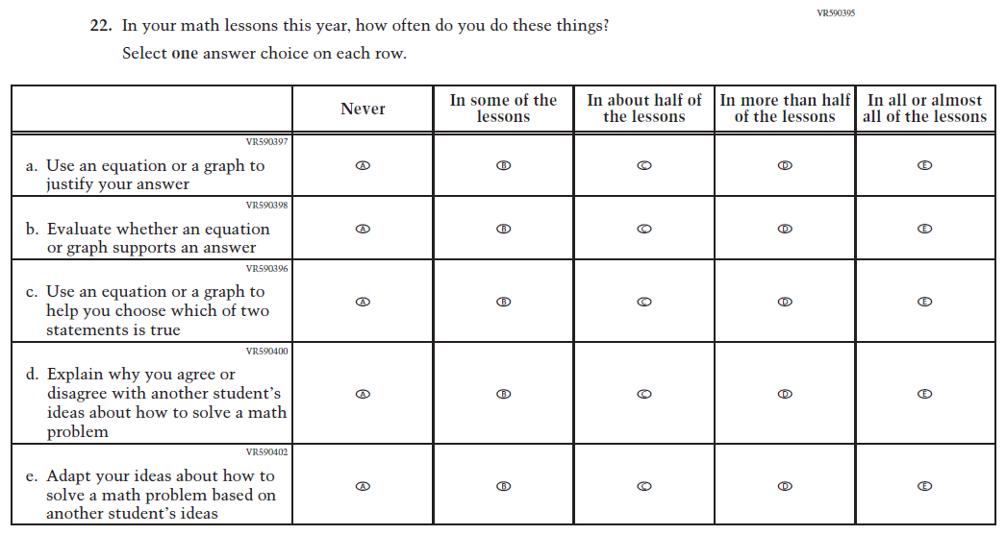  Issue: Mathematical Content and Practices | A | This item was developed to measure content aligned with the new Mathematics framework.

2026 Operational Grade 8 Mathematics Student
Previous Item | 2026 Item | D/A/R+ | Rationale
N/A  (2024) | 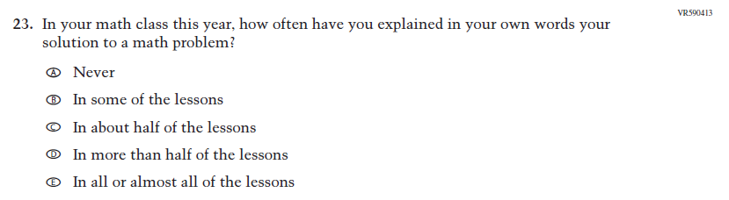  Issue: Student Mathematical Identity | A | This item was developed to measure content aligned with the new Mathematics framework.
N/A  (2024) | 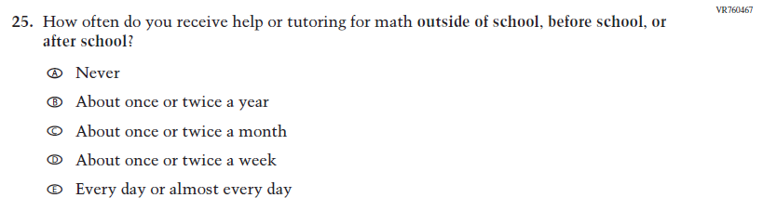  Issue: N/A | A | This item captures the important aspect of help or tutoring received by students.
N/A  (2024) | 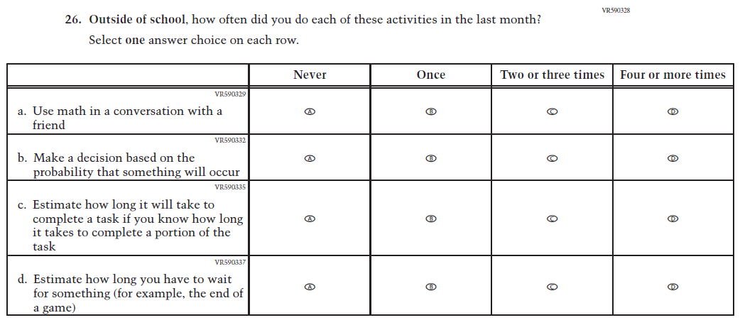  Issue: Mathematical Content and Practices | A | This item was developed to measure content aligned with the new Mathematics framework.

2026 Operational Grade 8 Mathematics Student
Previous Item | 2026 Item | D/A/R+ | Rationale
N/A  (2024) | 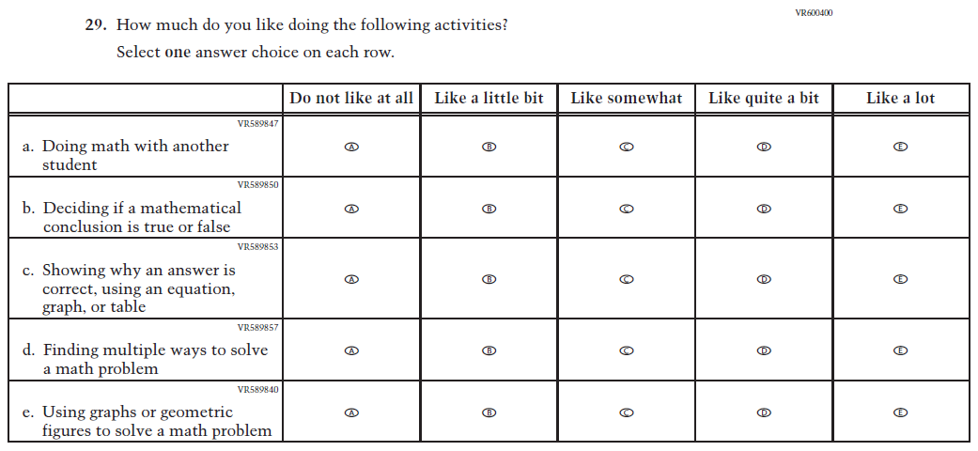  Issue: Student Mathematical Identity | A | This item was developed to measure content aligned with the new Mathematics framework.
N/A  (2024) | 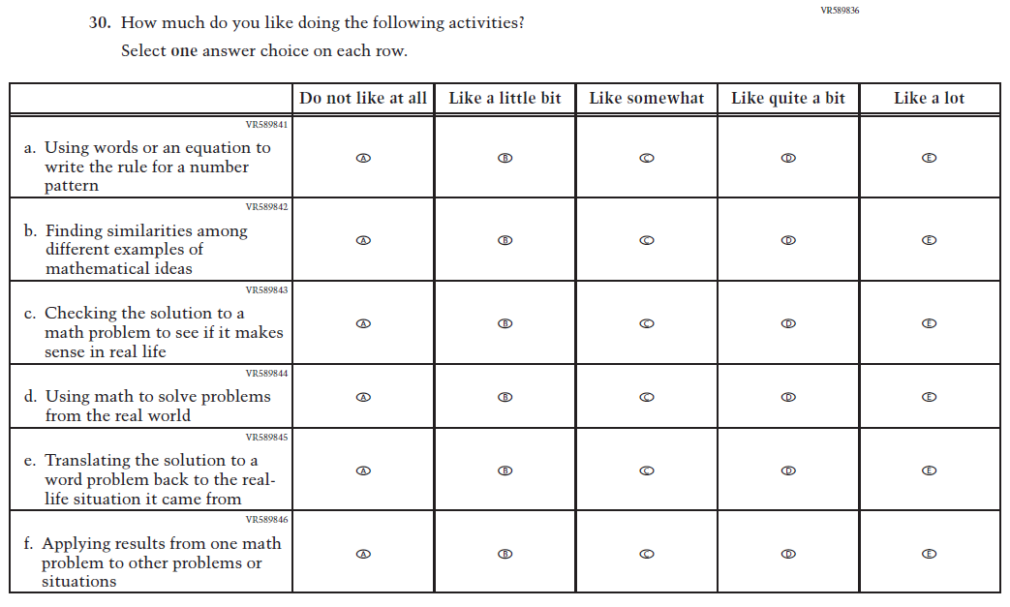  Issue: Student Mathematical Identity | A | This item was developed to measure content aligned with the new Mathematics framework.

2026 Operational Grade 8 Mathematics Student
Previous Item | 2026 Item | D/A/R+ | Rationale
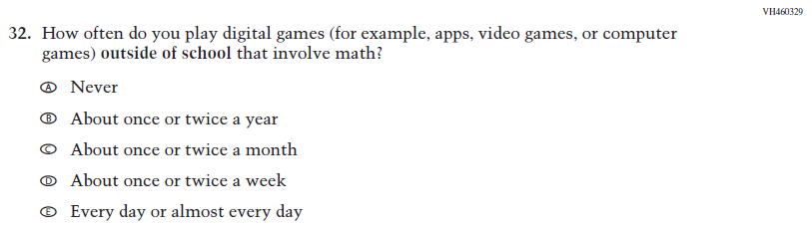  (2024) | N/A | D | This item was dropped to reduce questionnaire length.
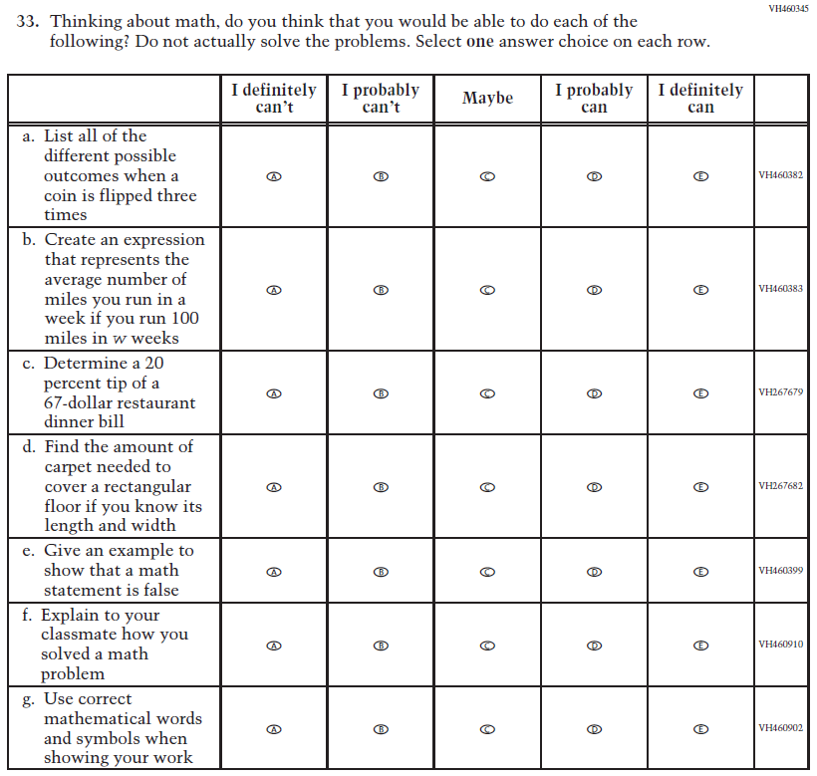  (2024) | 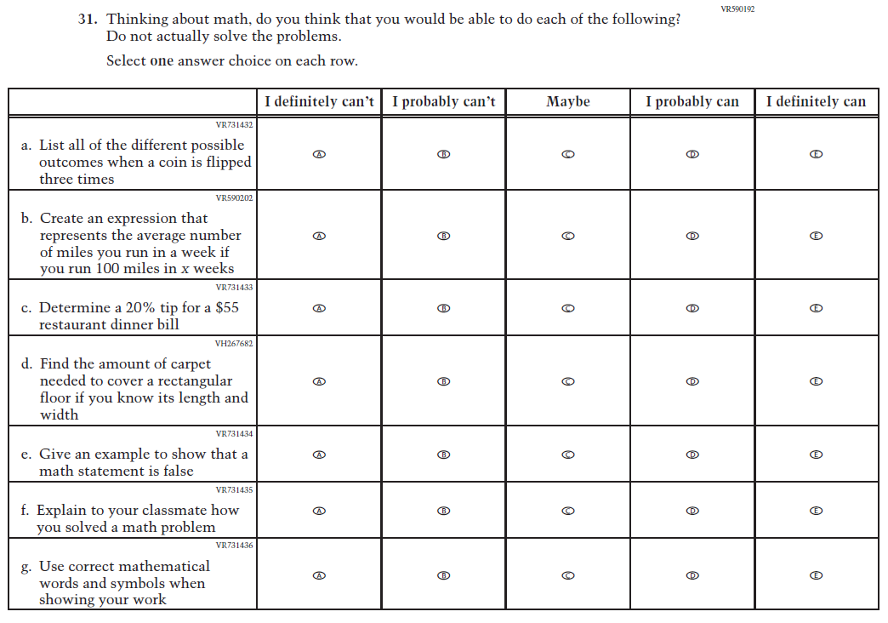  Issue: Student Mathematical Identity | R | Subitems b and c were revised for clarity.

Appendix J1-8: Operational Grade 8 (Mathematics)
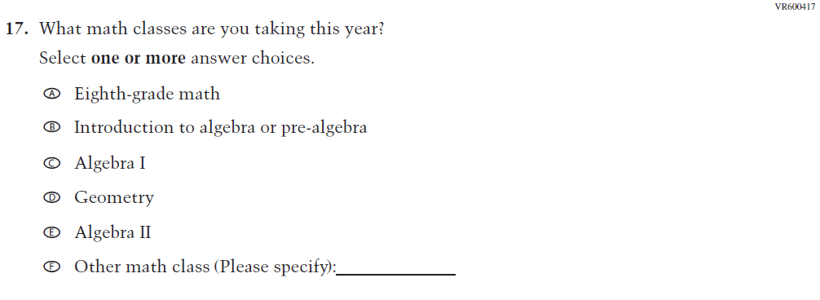
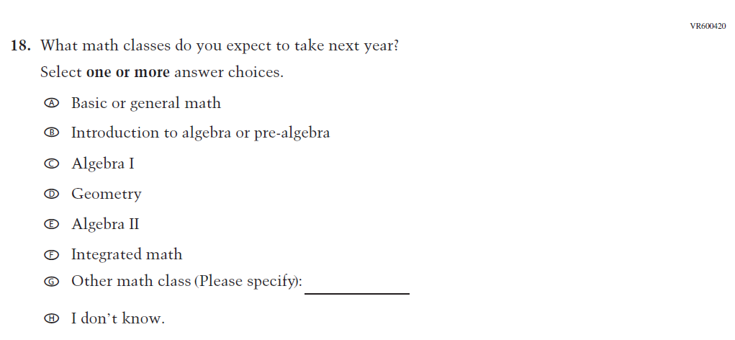
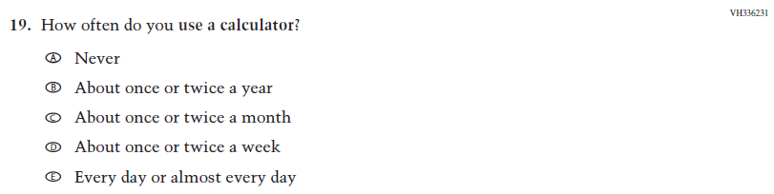
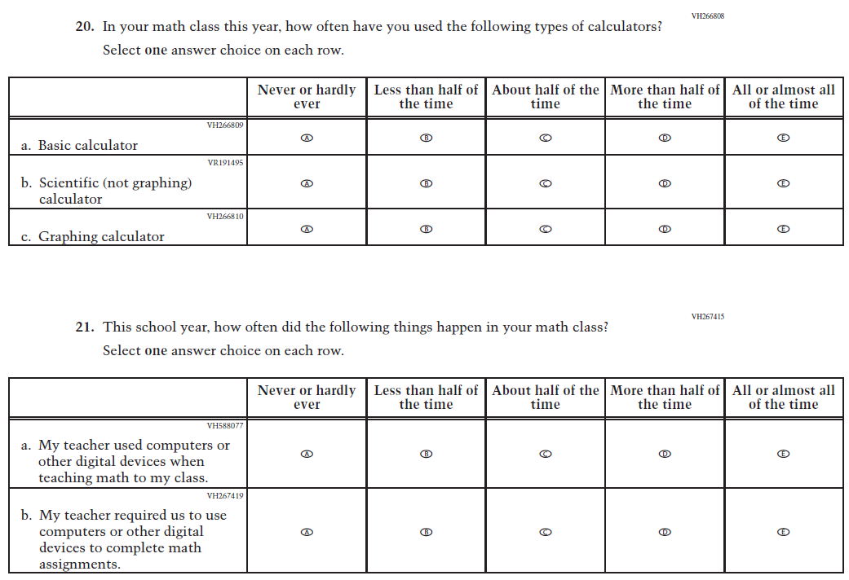
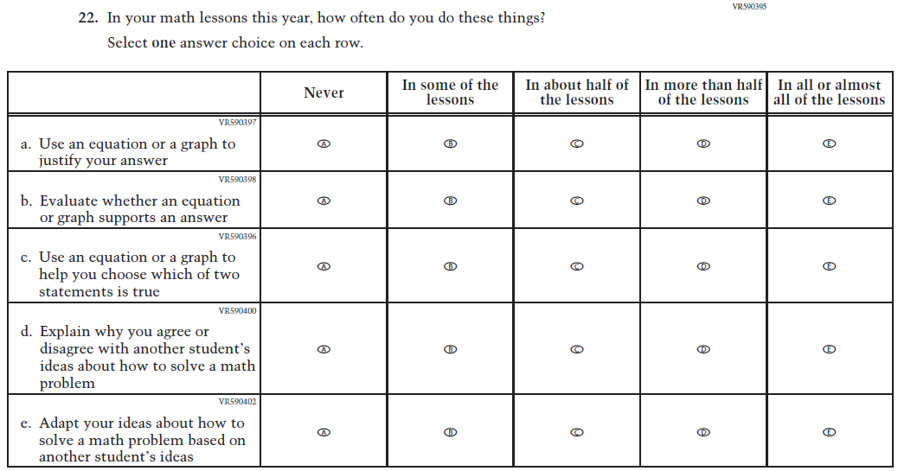
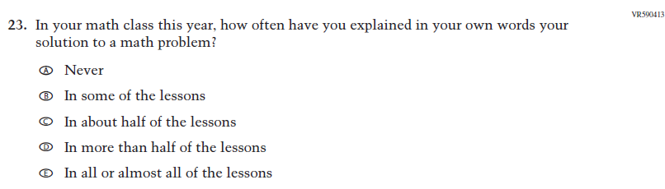
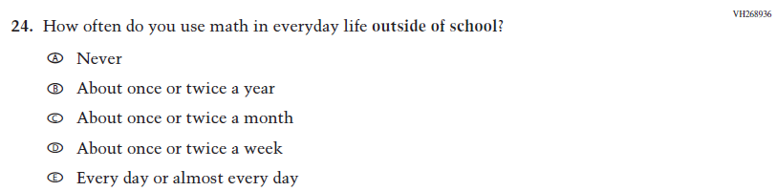
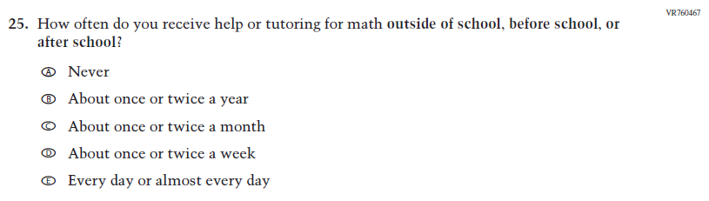
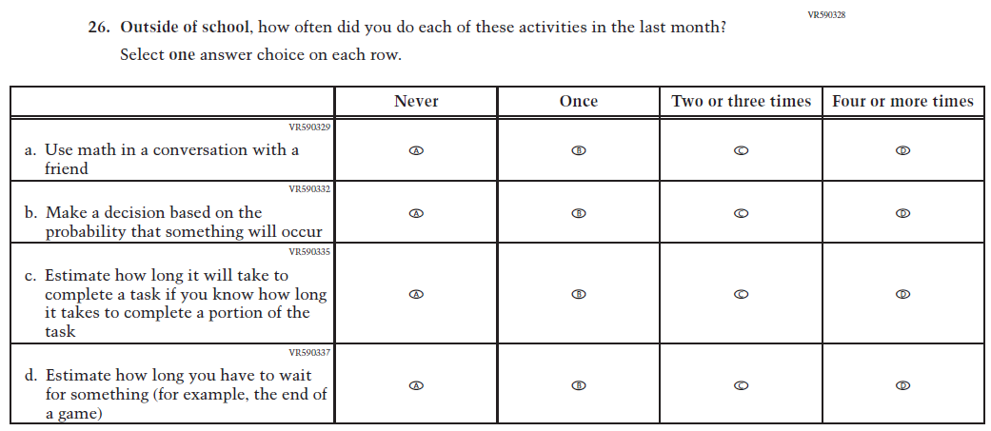
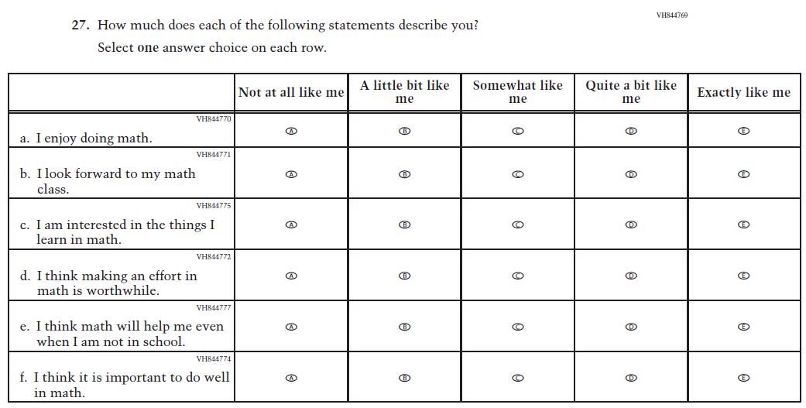
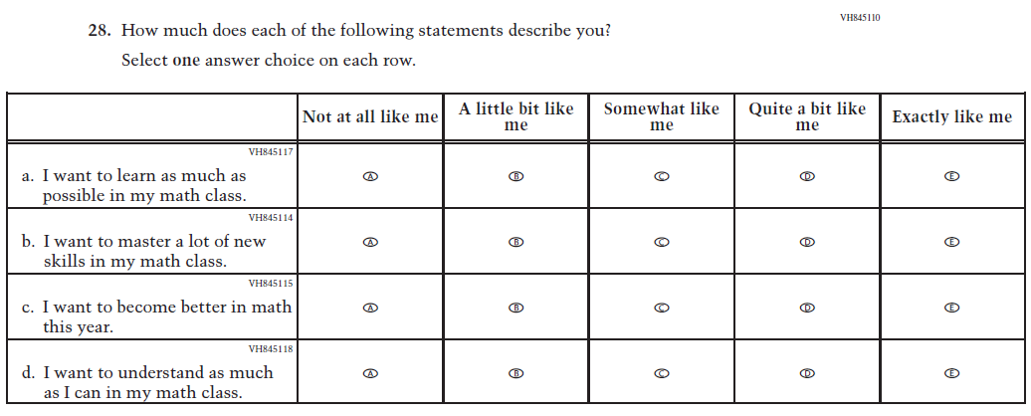
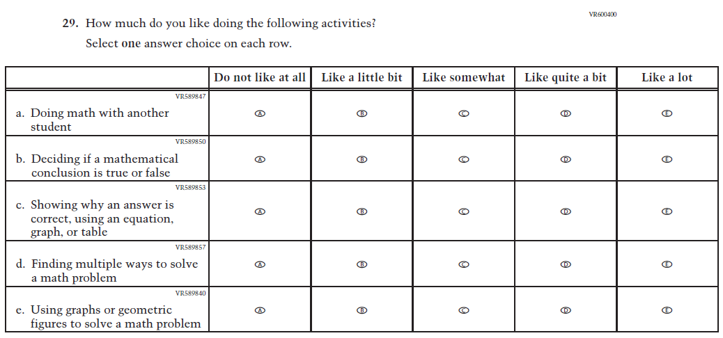
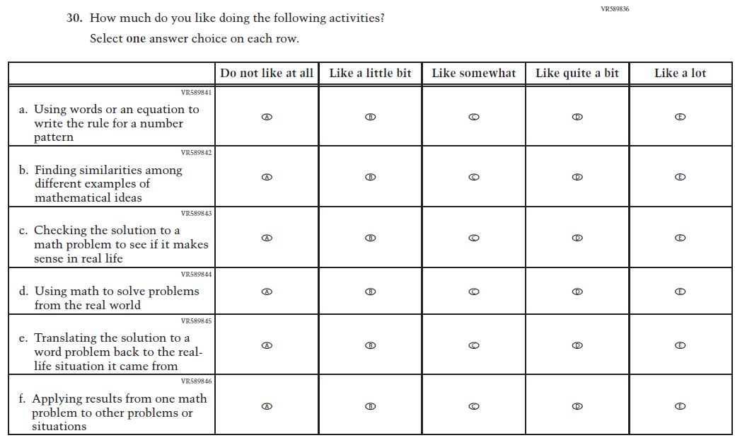
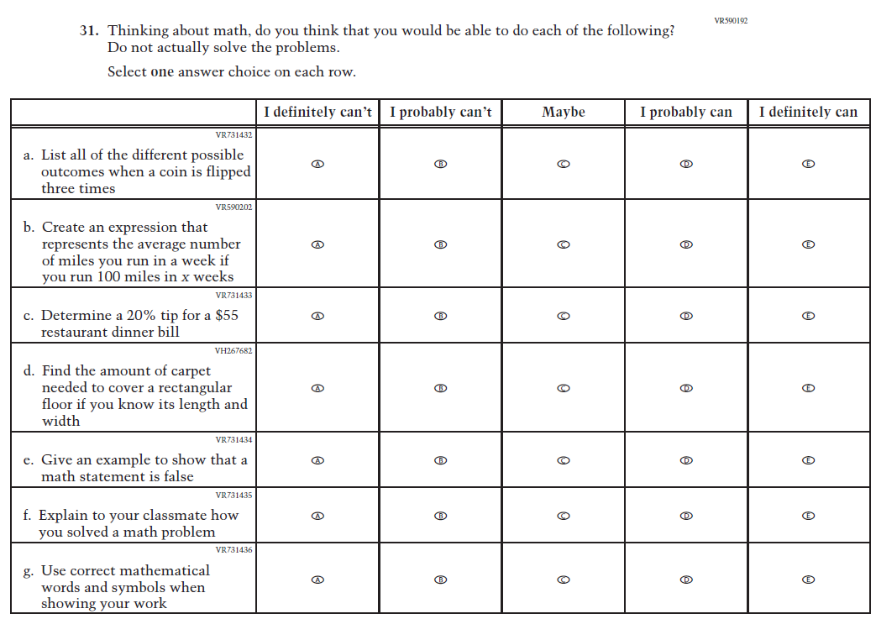

Appendix J1-9: Summary of Changes Operational Grade 4 (Reading)
2026 Operational Grade 4 Reading Student
Previous Item | 2026 Item | D/A/R+ | Rationale
N/A  (2024) | 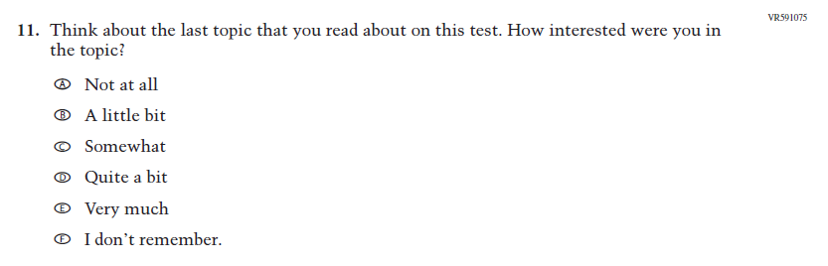  Issue: Engagement and Motivation | A | This item was developed to measure content aligned with the new Reading framework.
N/A  (2024) | 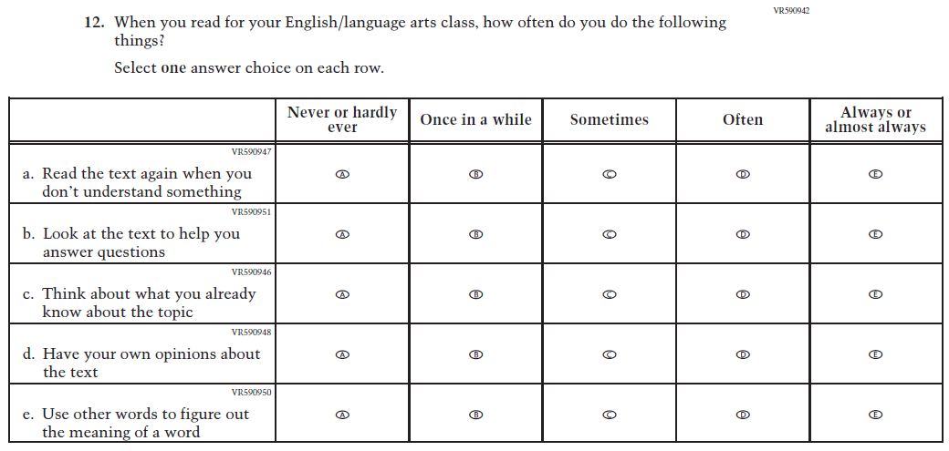  Issue: Cognition and Metacognition | A | This item was developed to measure content aligned with the new Reading framework.
N/A  (2024) | 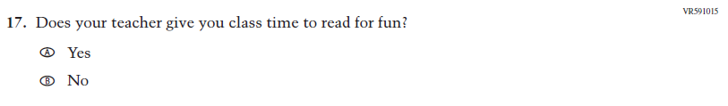  Issue: Teacher, Instructional, and Classroom Supports | A | This item was developed to measure content aligned with the new Reading framework.

2026 Operational Grade 4 Reading Student
Previous Item | 2026 Item | D/A/R+ | Rationale
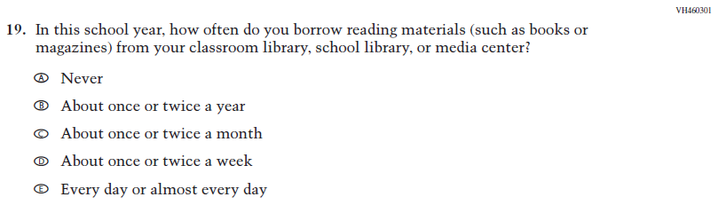  (2024) | 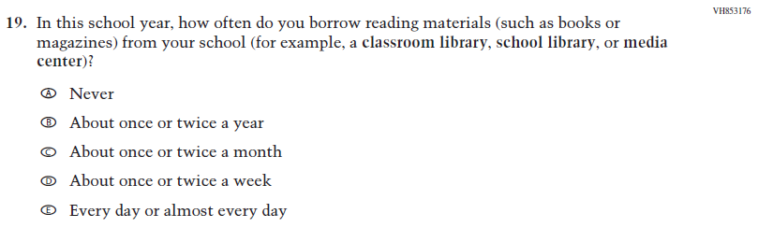  Issue: Engagement and Motivation | R | This item was revised for clarity.
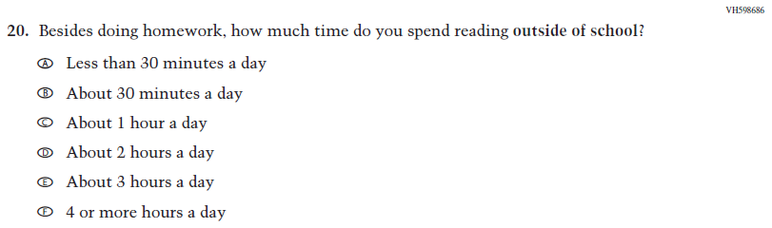  (2024) | 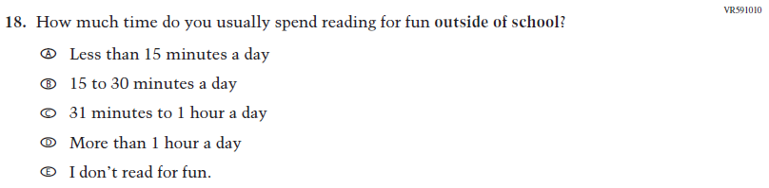  Issue: Engagement and Motivation | R | This Item was revised to put the emphasis on “reading for fun.”
N/A  (2024) | 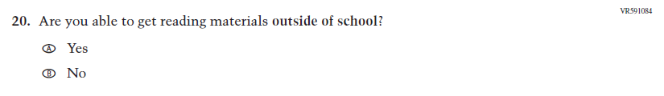  Issue: School and Community Resources | A | This item was developed to measure content aligned with the new Reading framework.

2026 Operational Grade 4 Reading Student
Previous Item | 2026 Item | D/A/R+ | Rationale
N/A  (2024) | 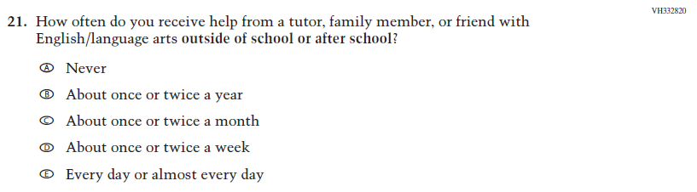  Issue: School and Community Resources | A | This trend item was added to measure content aligned with the new Reading framework.
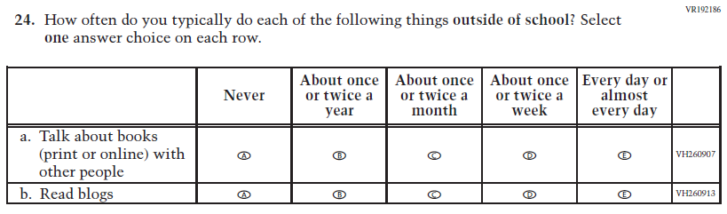  (2024) | N/A | D | This Item was dropped to reduce questionnaire length.

Appendix J1-10: Operational Grade 4 (Reading)
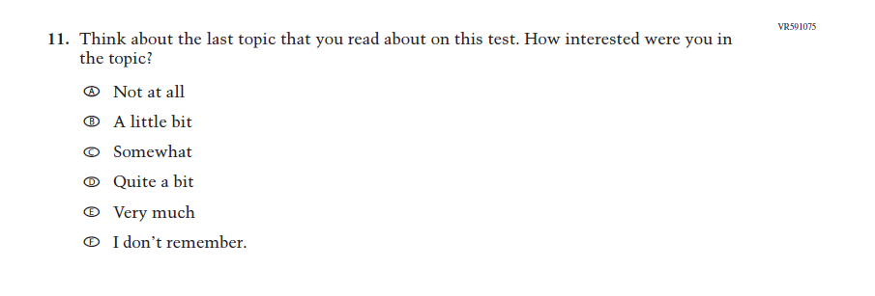
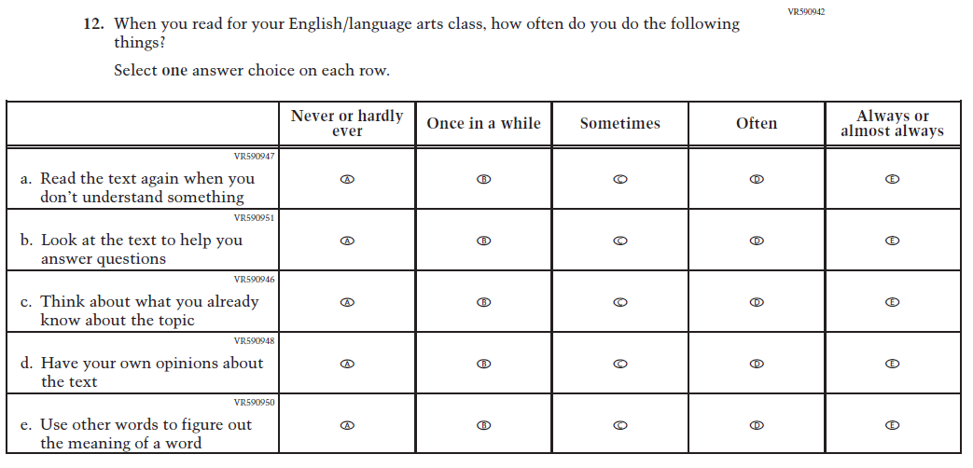
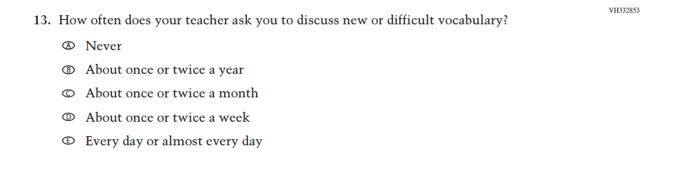
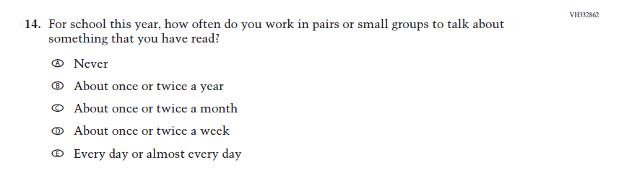
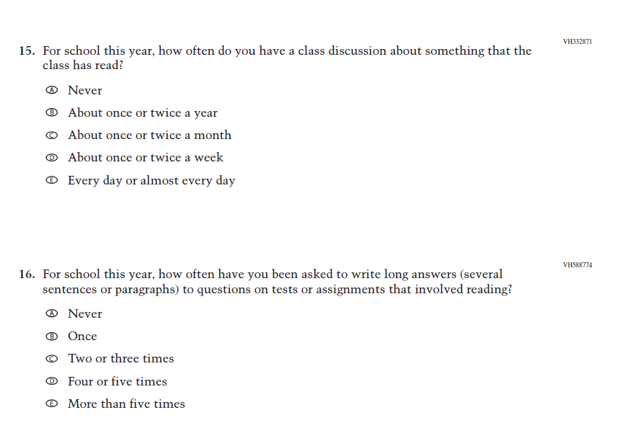
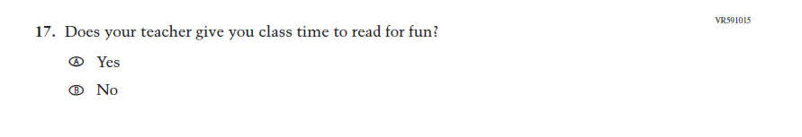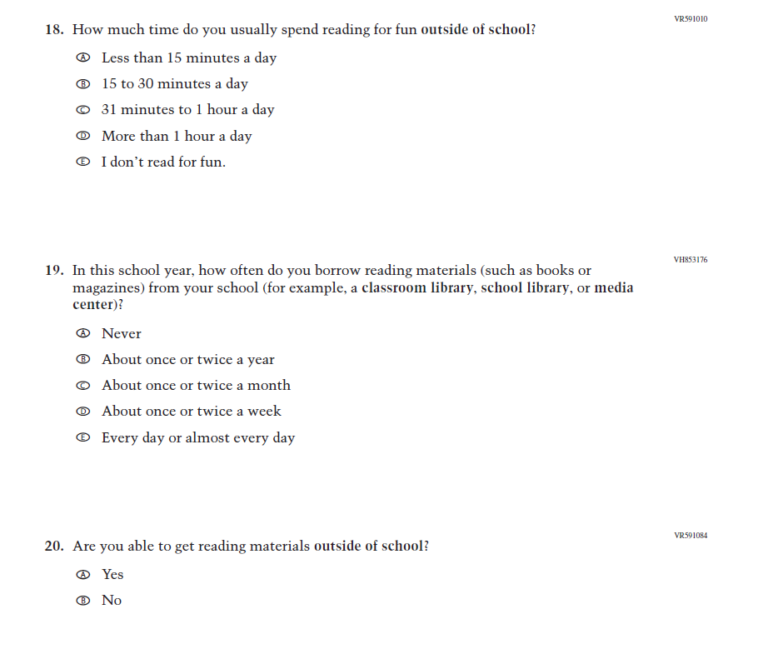
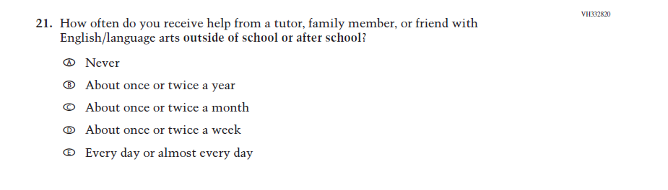
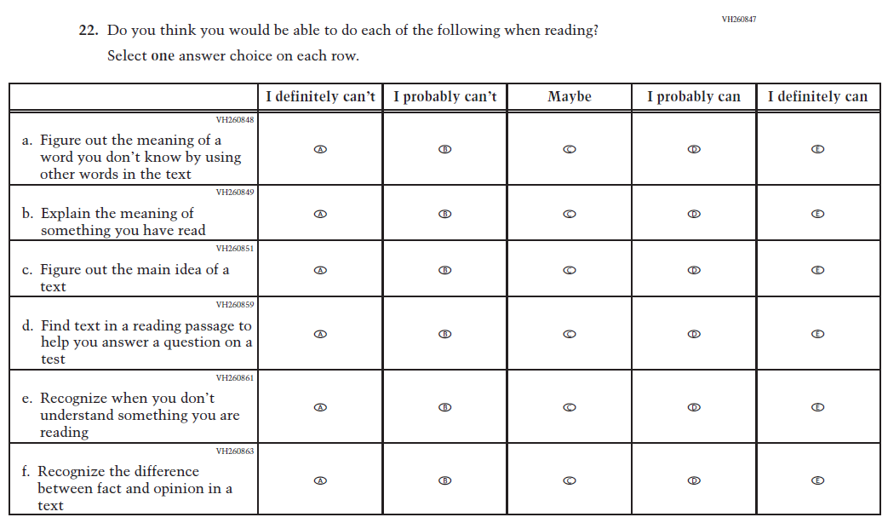
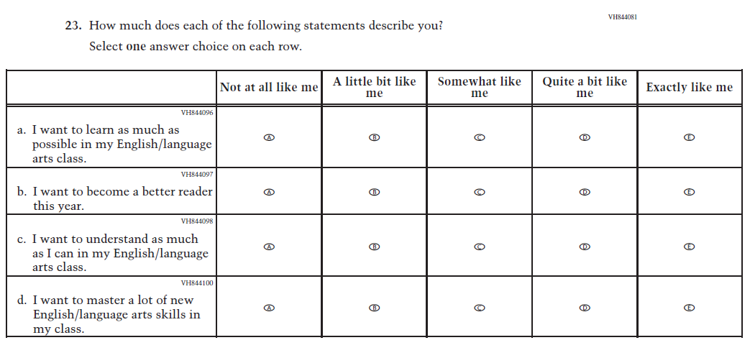
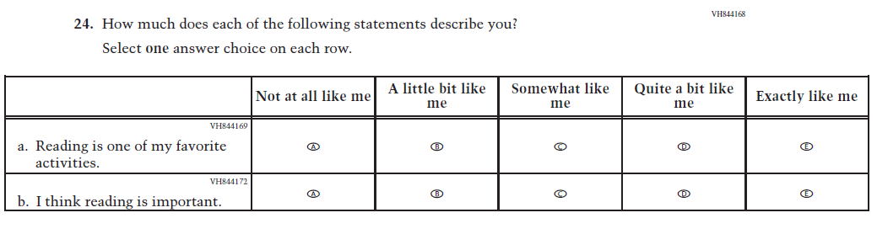

Appendix J1-11: Summary of Changes Operational Grade 8 (Reading)
2026 Operational Grade 8 Reading Student
Previous Item | 2026 Item | D/A/R+ | Rationale
N/A  (2024) | 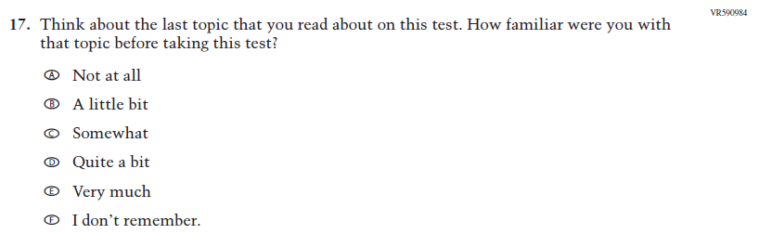  Issue: Cognition and Metacognition | A | This item was developed to measure content aligned with the new Reading framework.
N/A  (2024) | 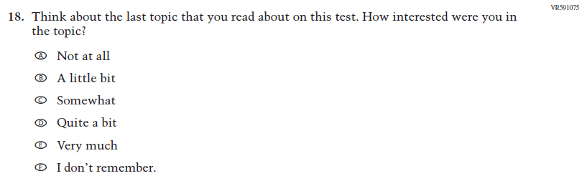  Issue: Engagement and Motivation | A | This item was developed to measure content aligned with the new Reading framework.
N/A  (2024) | 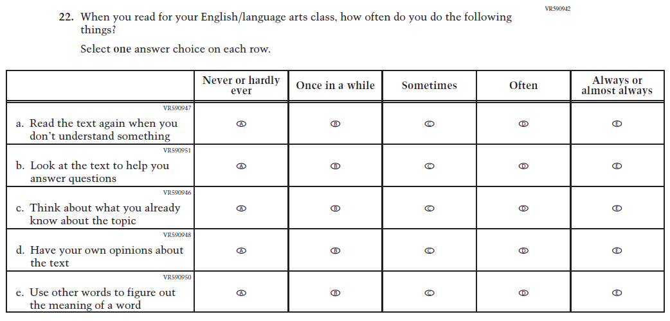  Issue: Cognition and Metacognition | A | This item was developed to measure content aligned with the new Reading framework.

2026 Operational Grade 8 Reading Student
Previous Item | 2026 Item | D/A/R+ | Rationale
N/A  (2024) | 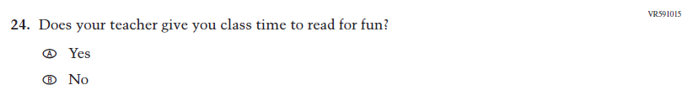  Issue: Engagement and Motivation | A | This item was developed to measure content aligned with the new Reading framework.
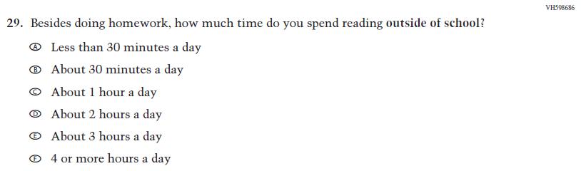  (2024) | 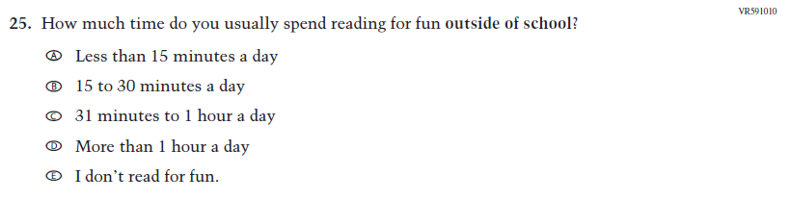  Issue: Engagement and Motivation | R | This Item was revised to put the emphasis on “reading for fun.”
N/A  (2024) | 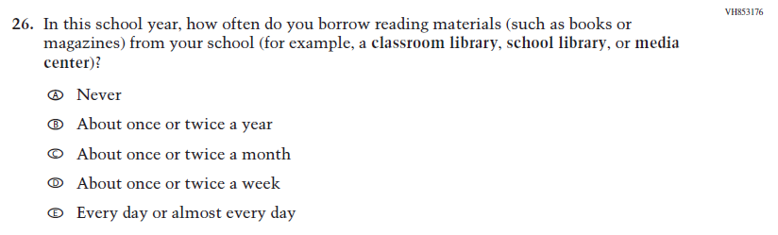  Issue: Engagement and Motivation | A | This item was developed to measure content aligned with the new Reading framework.
N/A  (2024) | 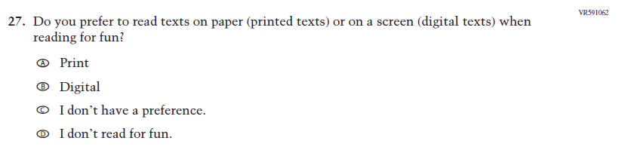  Issue: Engagement and Motivation | A | This item was developed to measure content aligned with the new Reading framework.

2026 Operational Grade 8 Reading Student
Previous Item | 2026 Item | D/A/R+ | Rationale
N/A  (2024) | 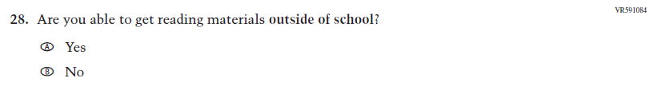  Issue: School and Community Resources | A | This item was developed to measure content aligned with the new Reading framework.
N/A  (2024) | 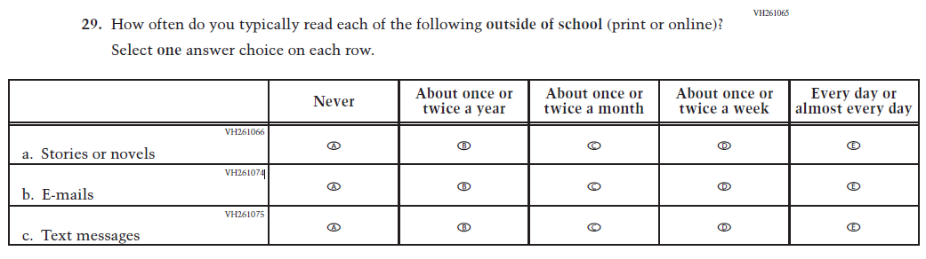  Issue: School and Community Resources | A | This trend item was added to measure content aligned with the new Reading framework.
N/A  (2024) | 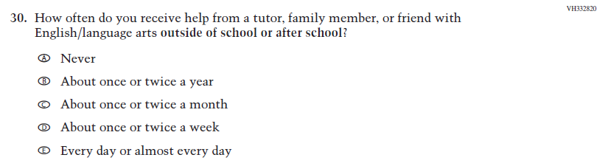  Issue: School and Community Resources | A | This trend item was added to measure content aligned with the new Reading framework.

2026 Operational Grade 8 Reading Student
Previous Item | 2026 Item | D/A/R+ | Rationale
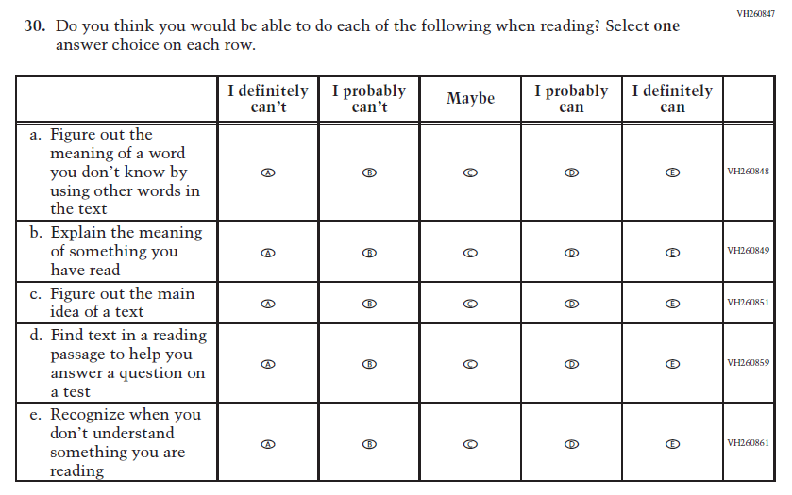  (2024) | 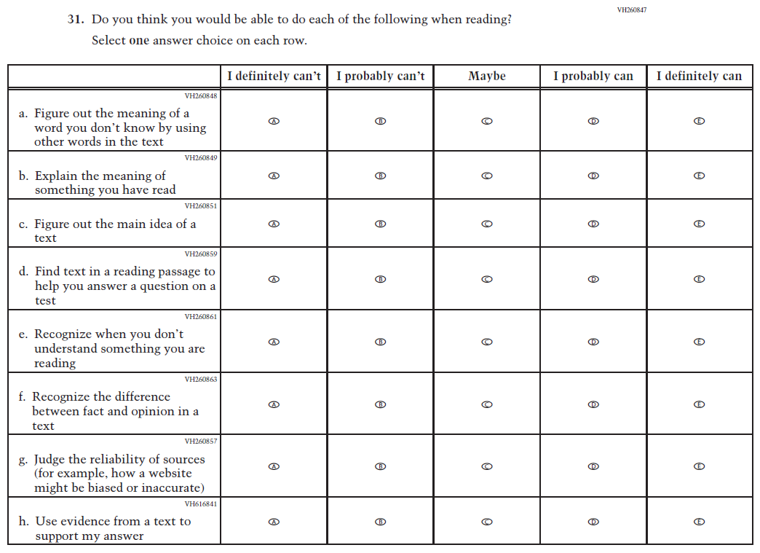  Issue: Engagement and Motivation | R | Two matrix items were combined into VH260847 for 2026.
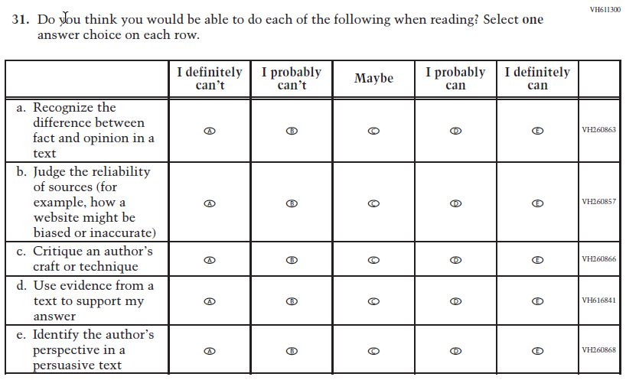  (2024) | N/A | D | This Item was dropped and some subitems were included in new matrix item VH260847 for 2026.

2026 Operational Grade 8 Reading Student
Previous Item | 2026 Item | D/A/R+ | Rationale
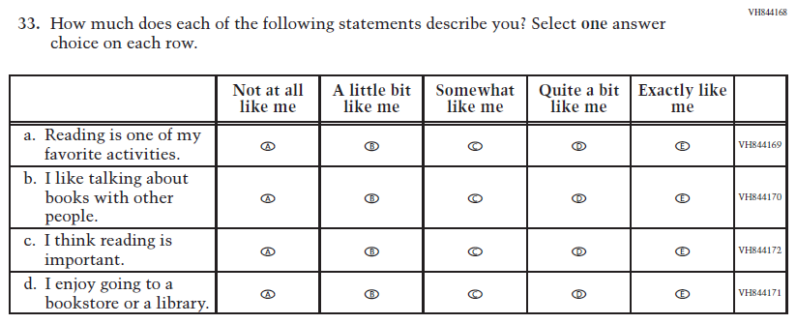  (2024) | 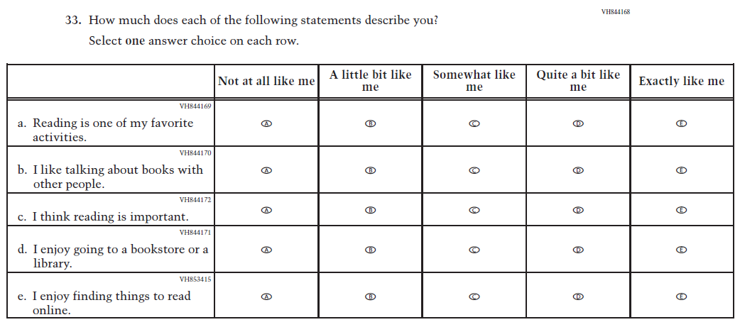  Issue: Engagement and Motivation | R | This item was revised to add subitem VH844168.

Appendix J1-12: Operational Grade 8 (Reading)
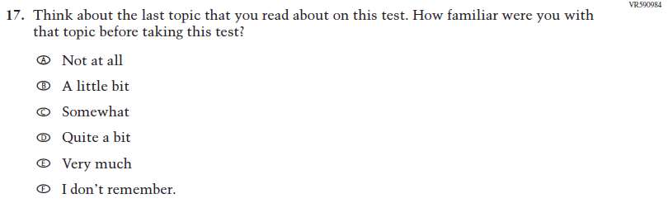
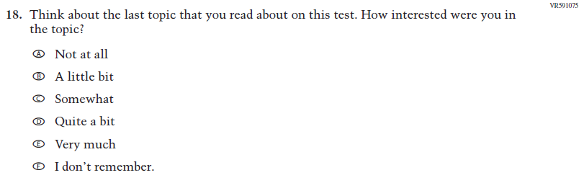
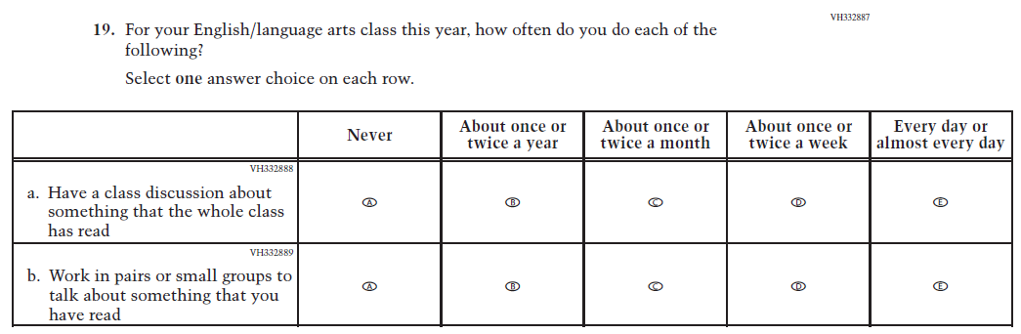
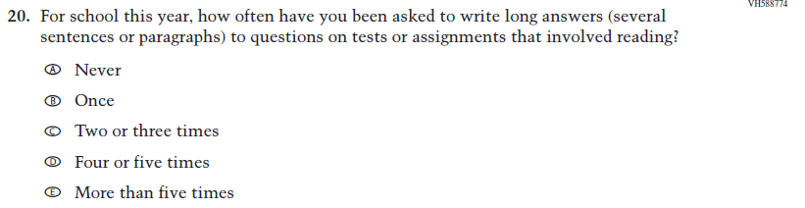
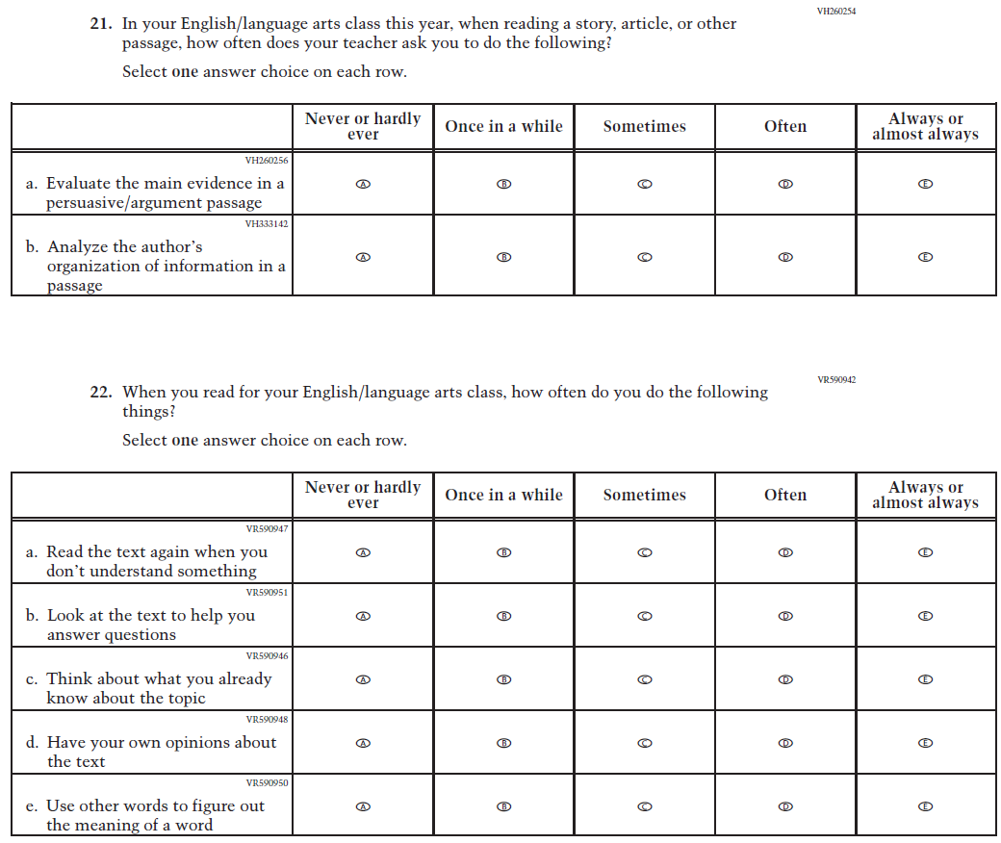
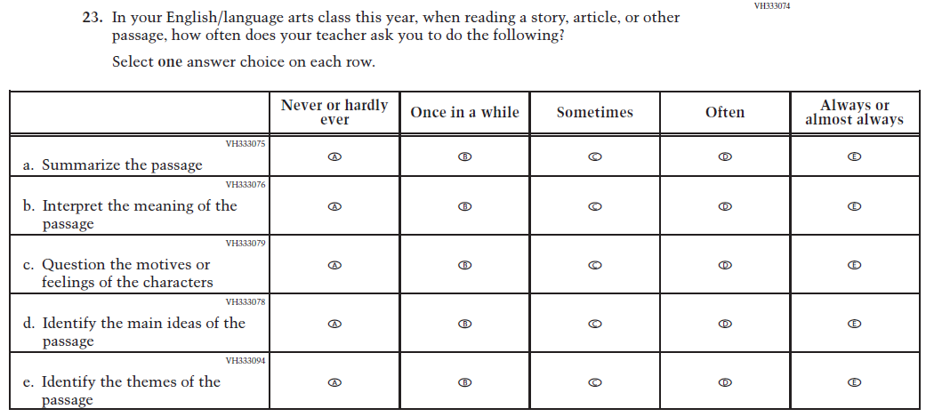
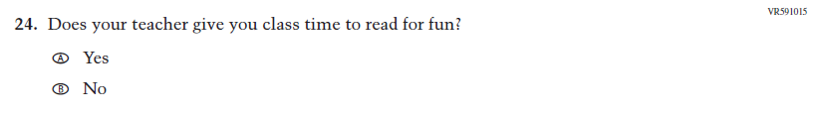
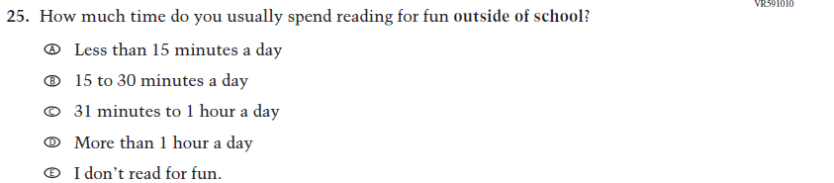
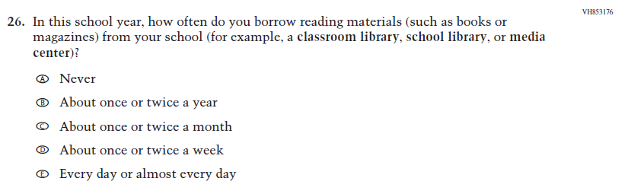
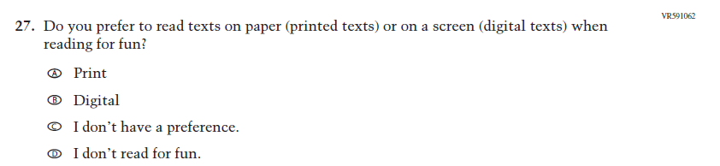
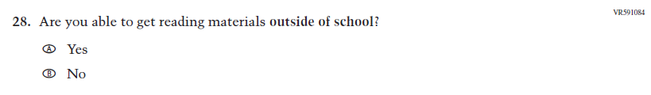
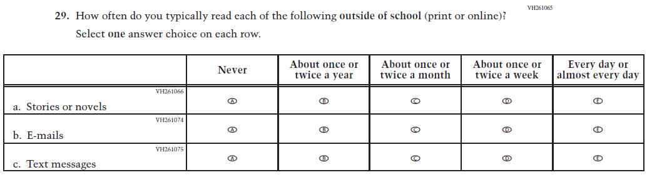
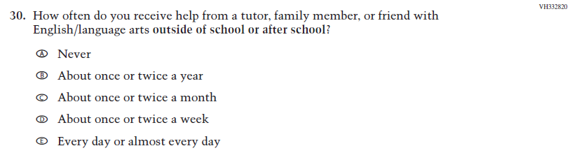
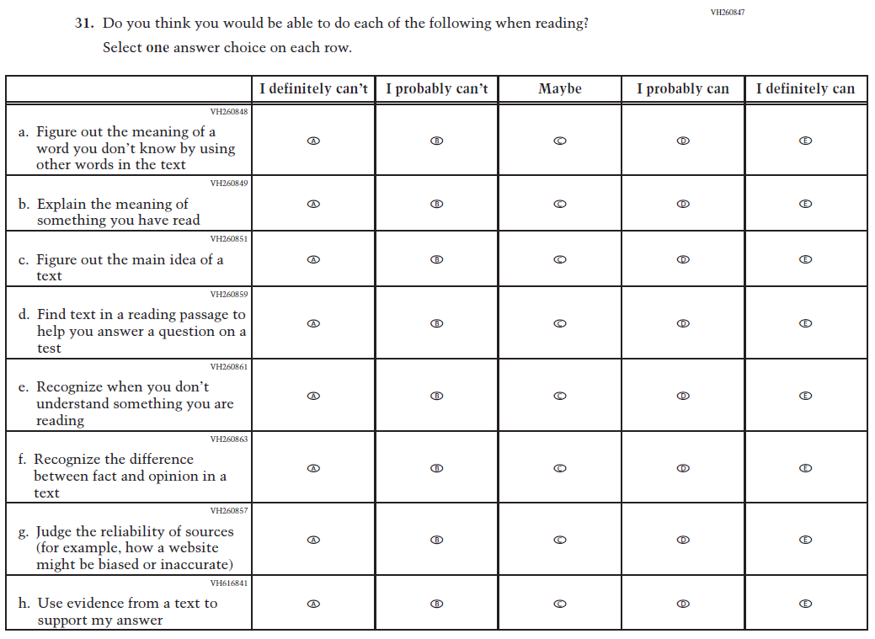
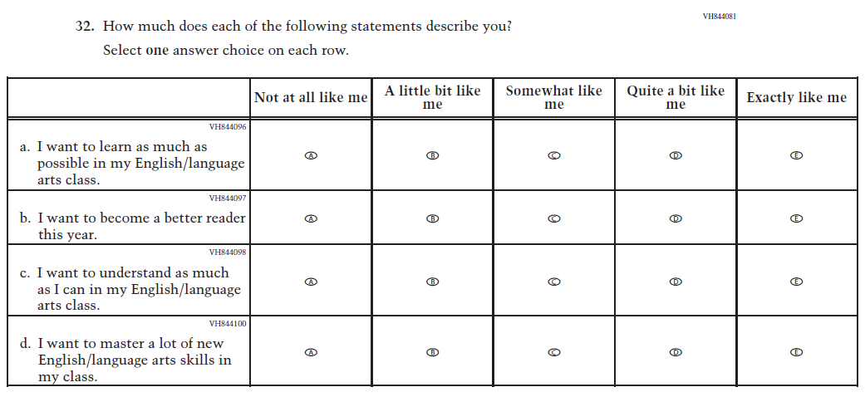
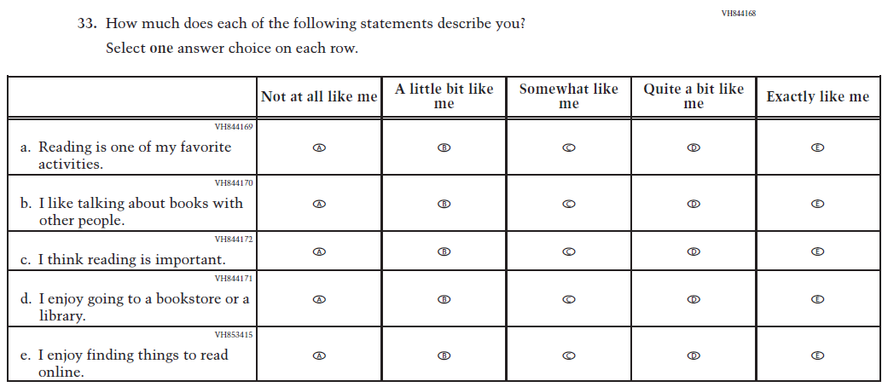

Appendix J1-13: Operational Grade 8 (Civics)

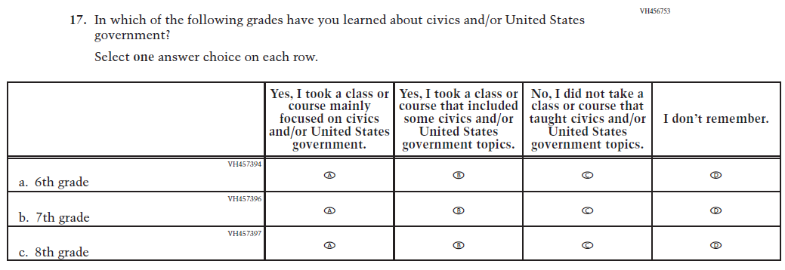
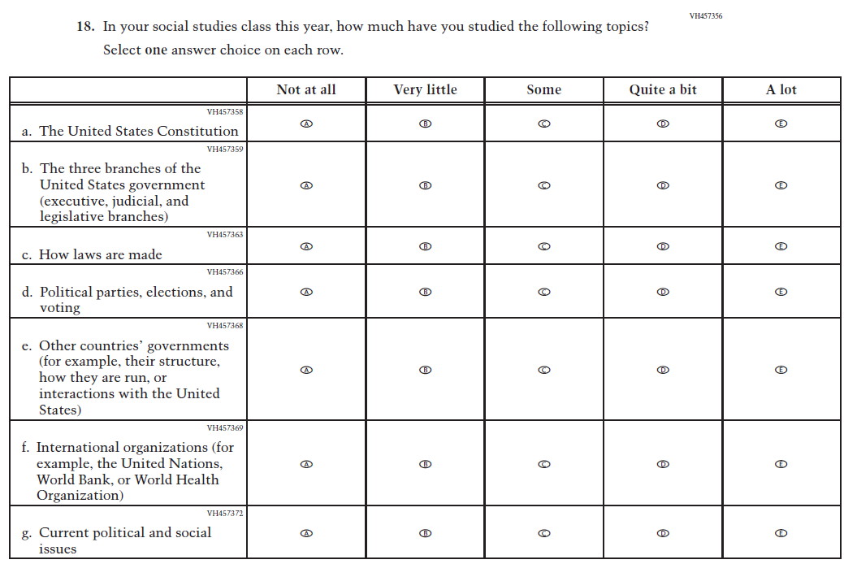
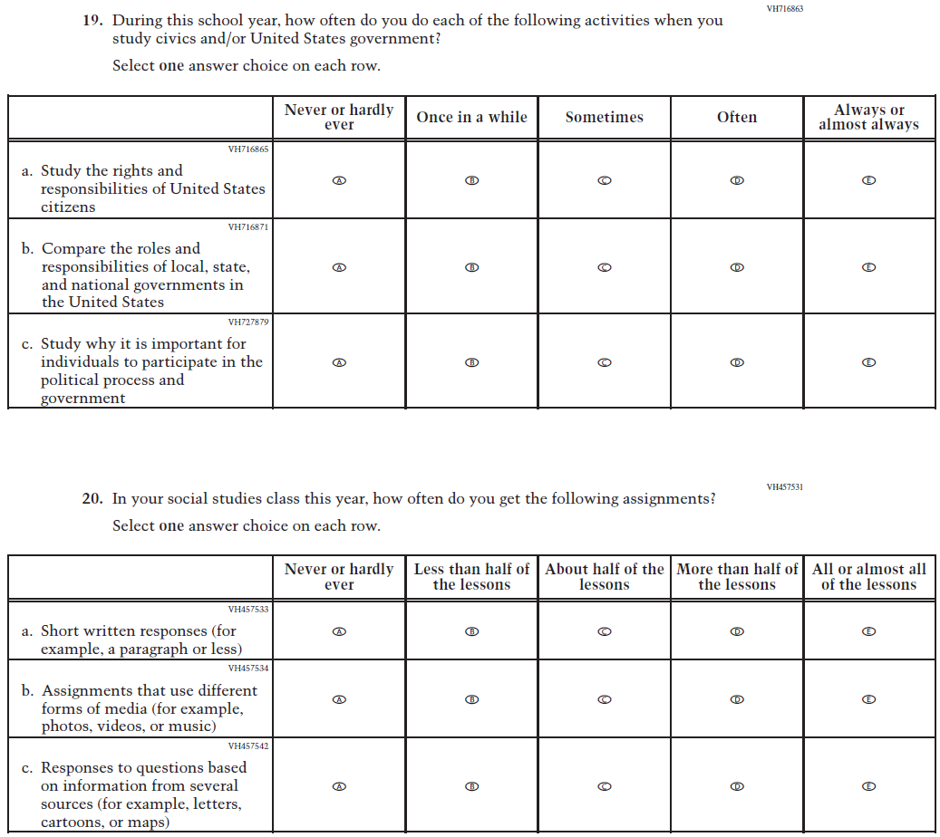
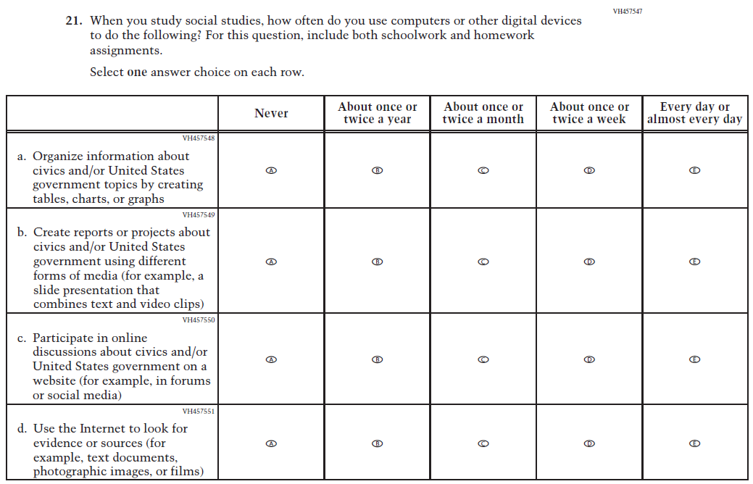
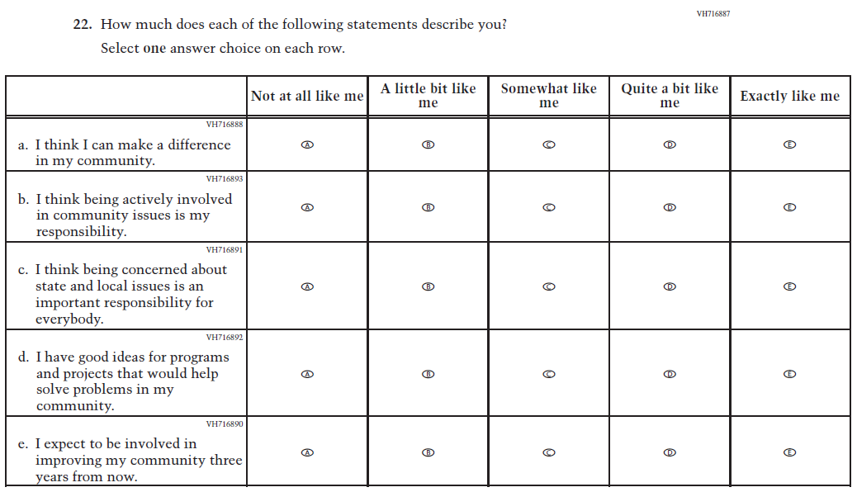
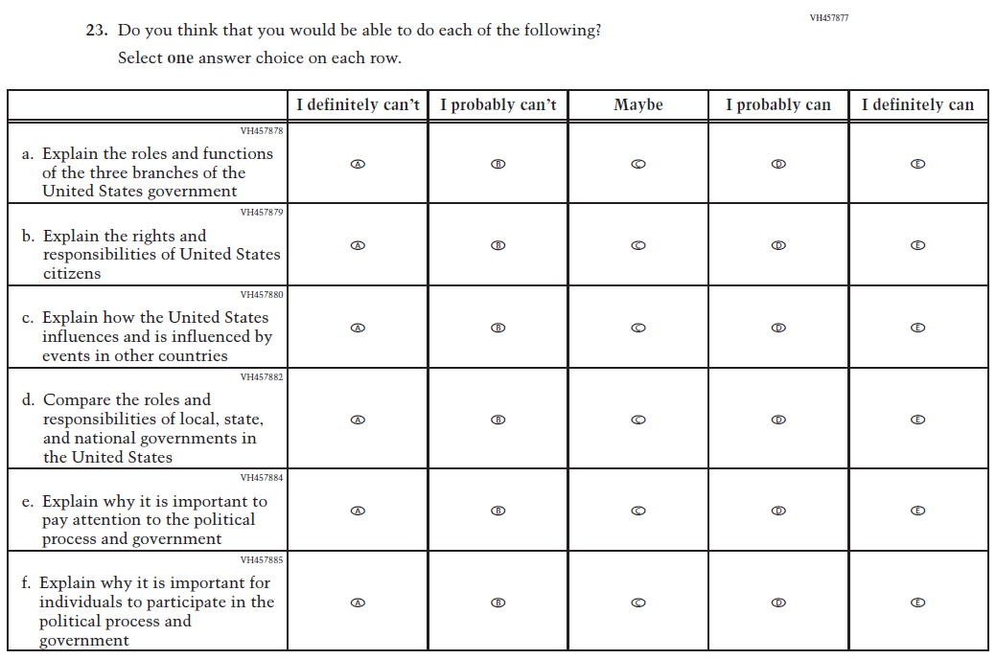
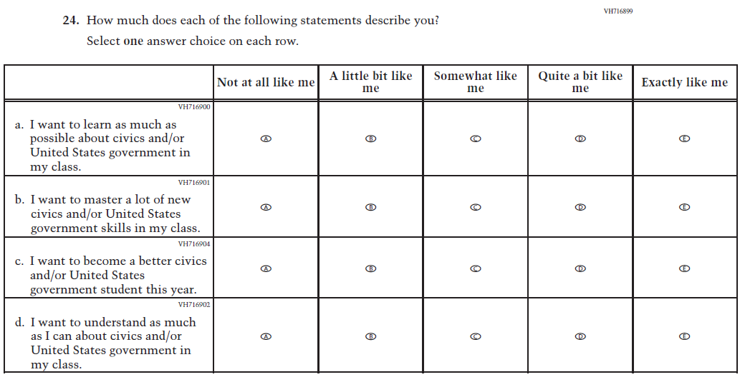
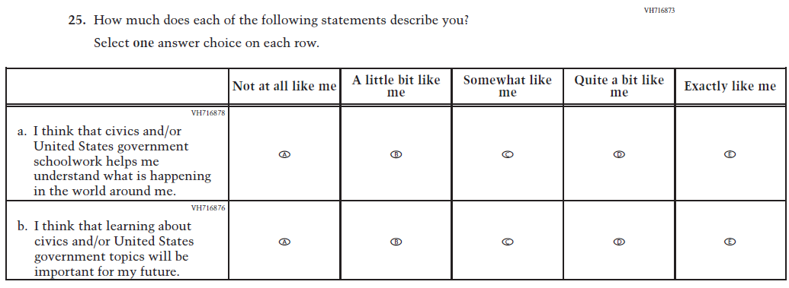
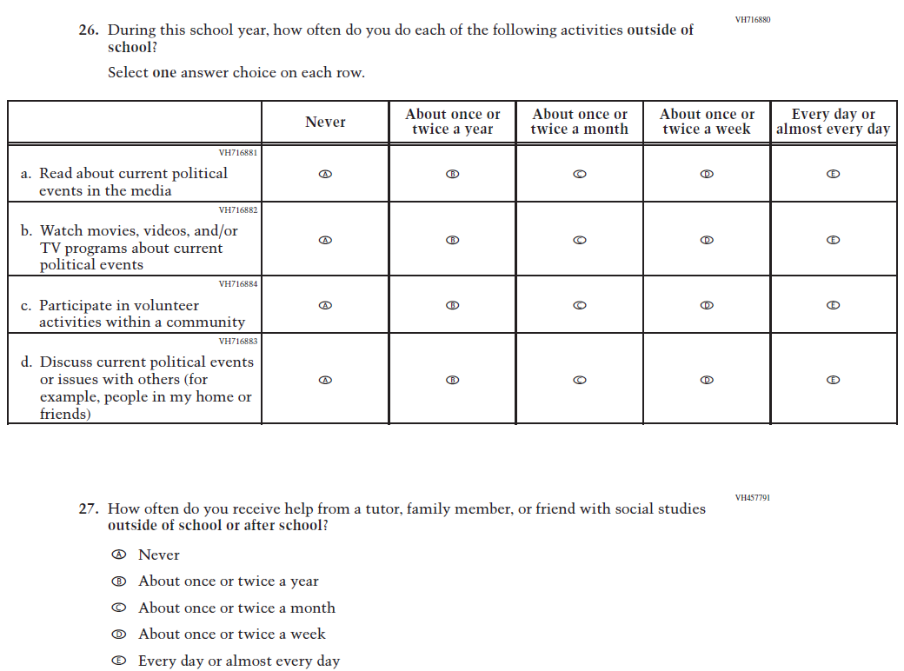

Appendix J1-14: Operational Grade 8 (U.S. History)
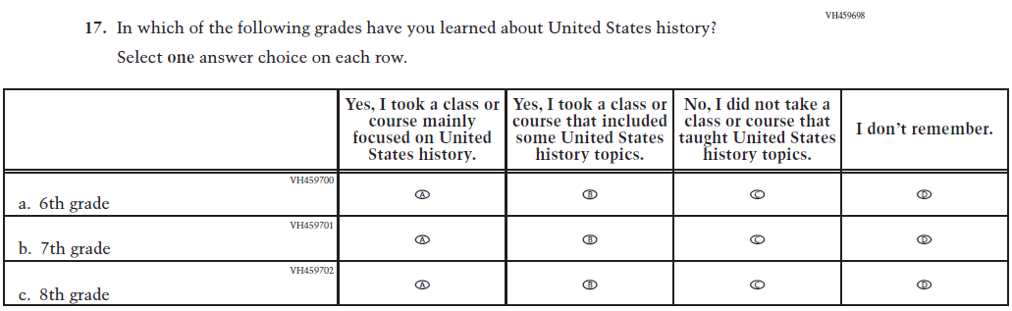
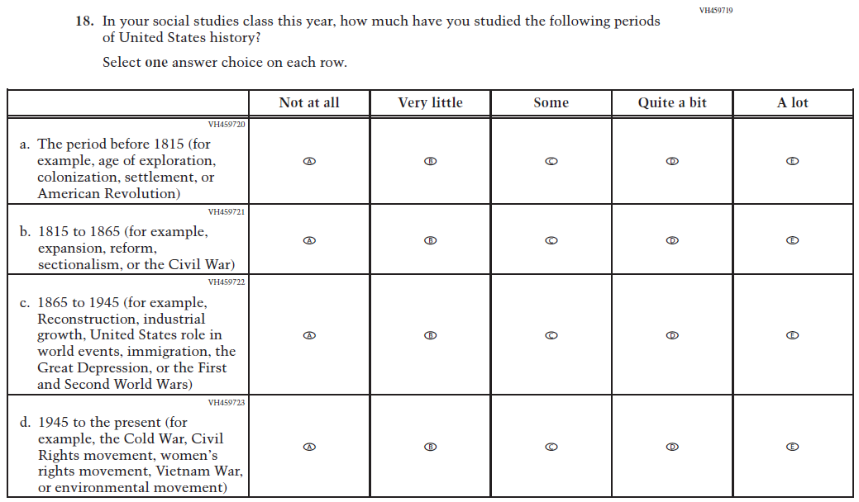
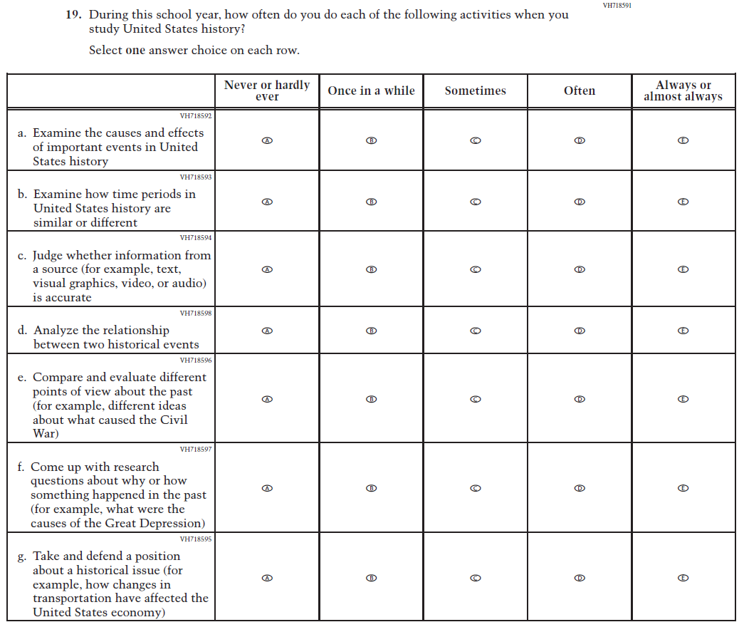
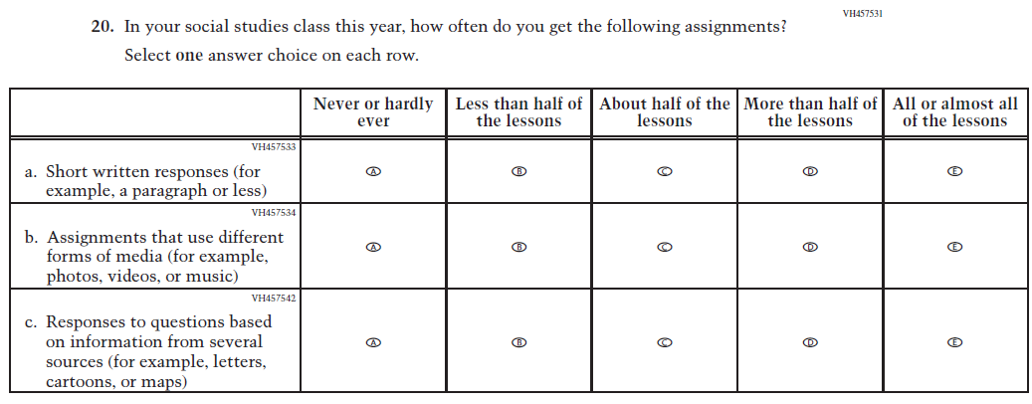
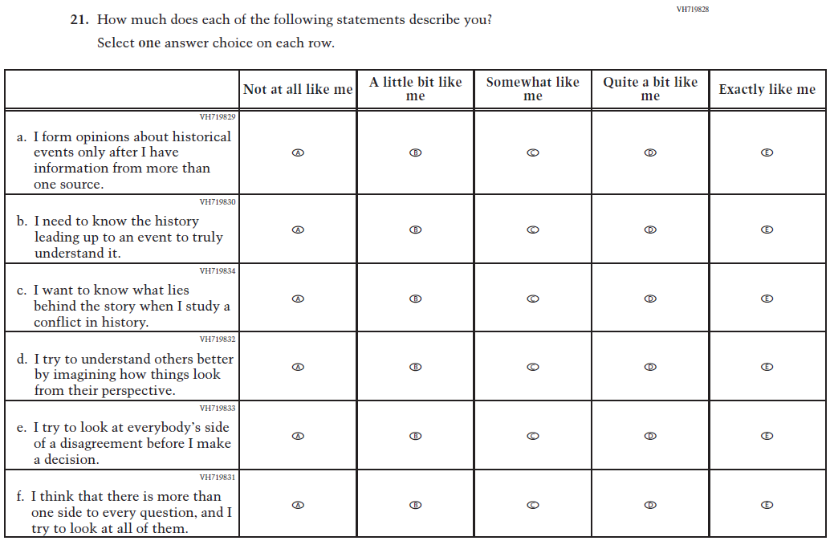
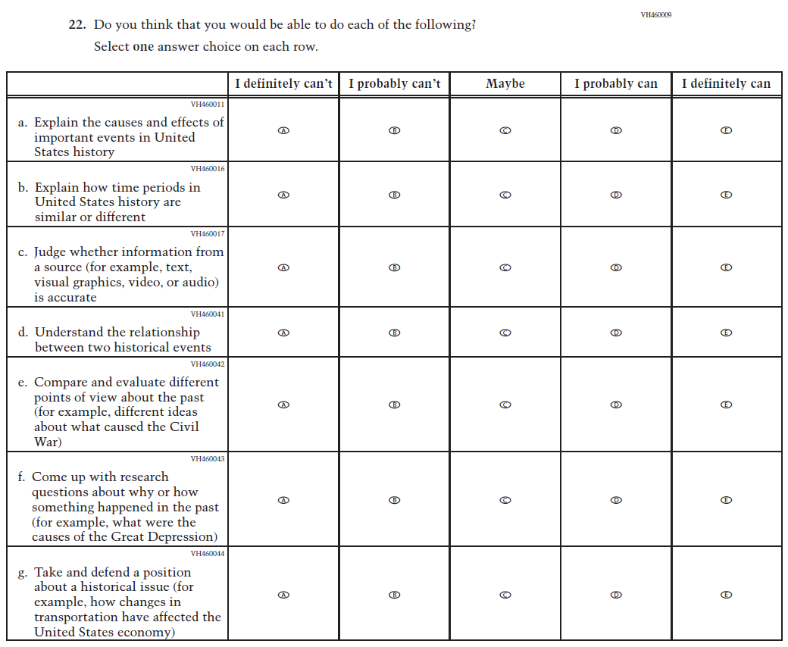
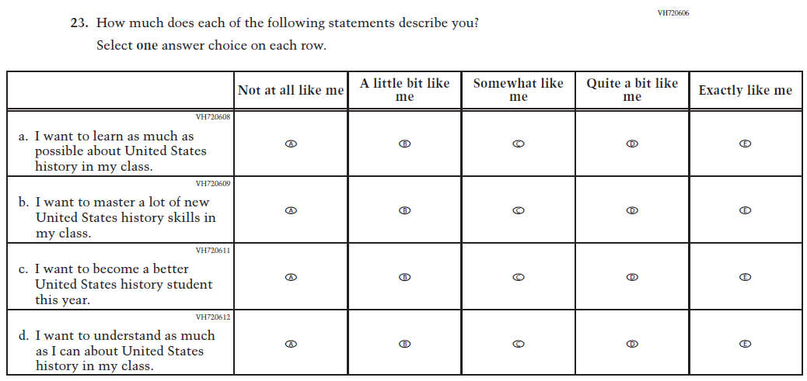
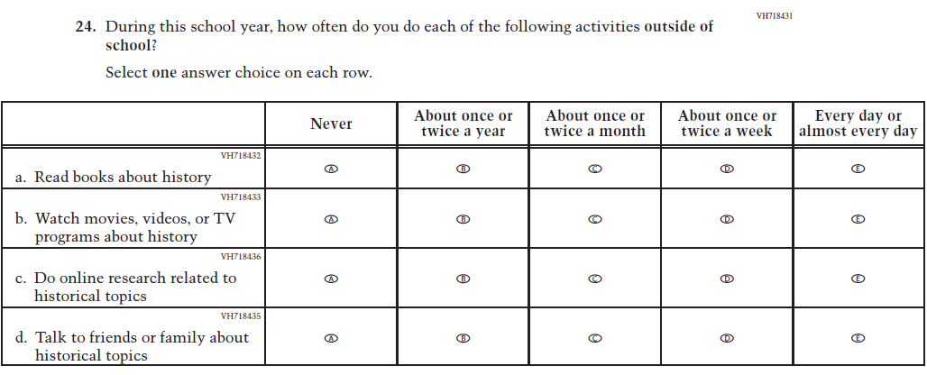
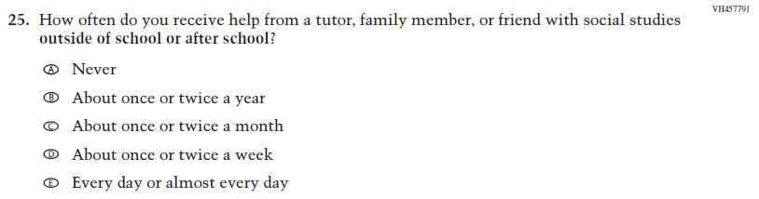

Appendix J1-15: Summary of Changes Operational Grade 4 (Debrief)
2026 Operational Grade 4 Debrief Student
Previous Item | 2026 Item | D/A/R+ | Rationale
N/A  (2024) | 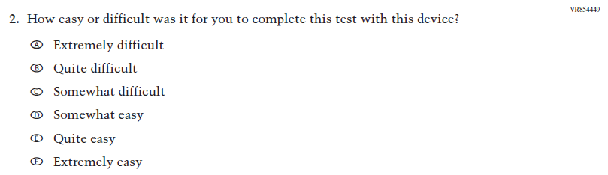  Issue: Debrief | A | This Item was added to understand students’ experiences with using their devices to take the assessment.

Appendix J1-16: Operational Grade 4 (Debrief)
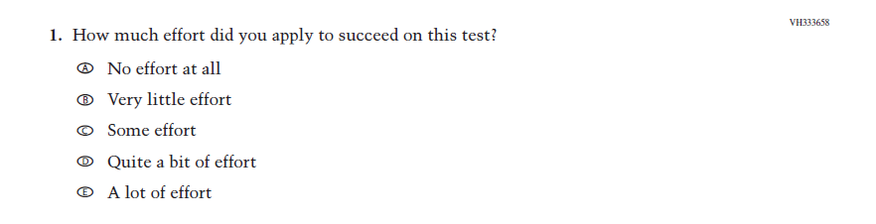
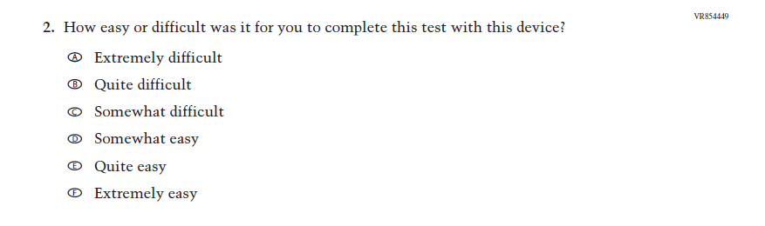

Appendix J1-17: Summary of Changes Operational Grade 8 (Debrief)
2026 Operational Grade 8 Debrief Student
Previous Item | 2026 Item | D/A/R+ | Rationale
N/A  (2024) | Issue: Debrief | A | This Item was added to understand students’ experiences with using their devices to take the assessment.

Appendix J1-18: Operational Grade 8 (Debrief)
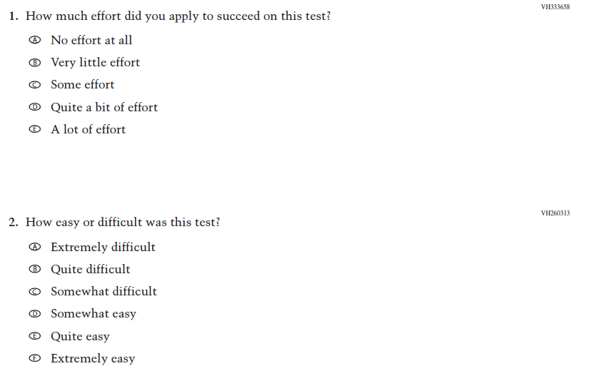
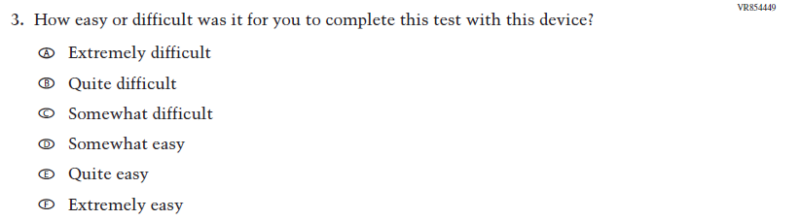

Appendix J1-19: Pilot Grade 4 (Core)

Appendix J1-20: Pilot Grade 8 (Core)

Appendix J1-21: Pilot Grade 12 – Sequence 1 (Core)
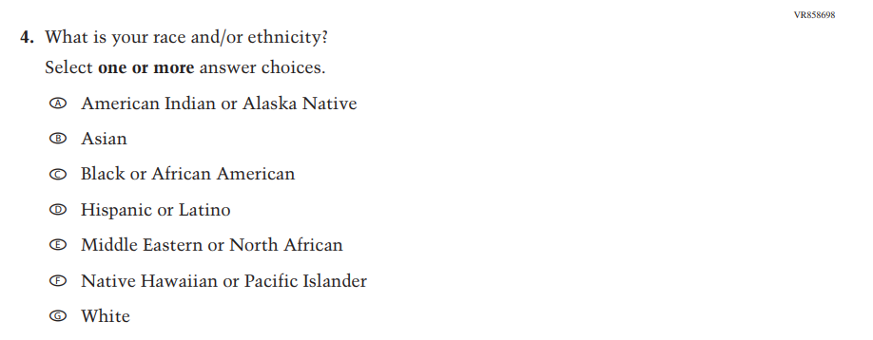

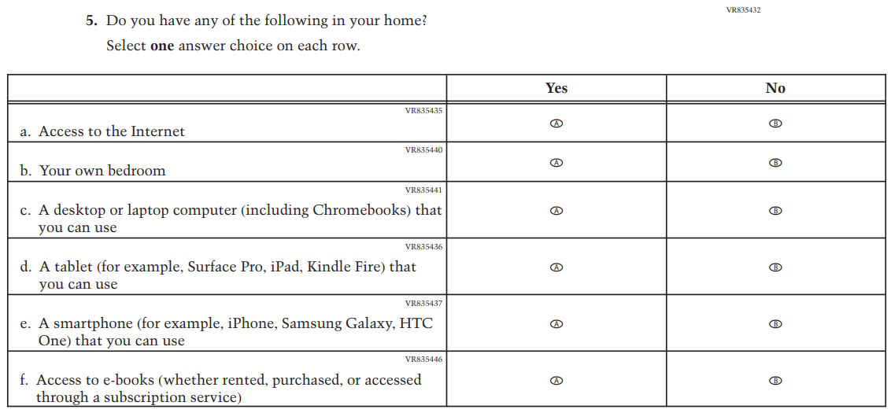
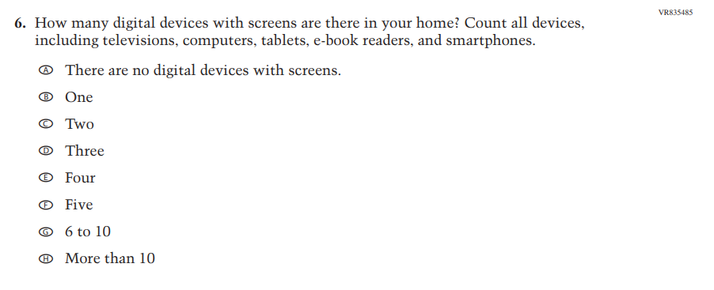
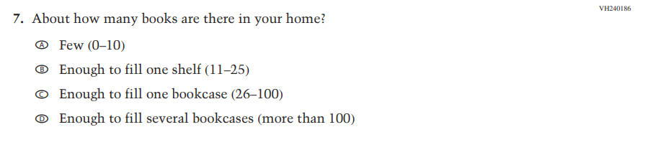

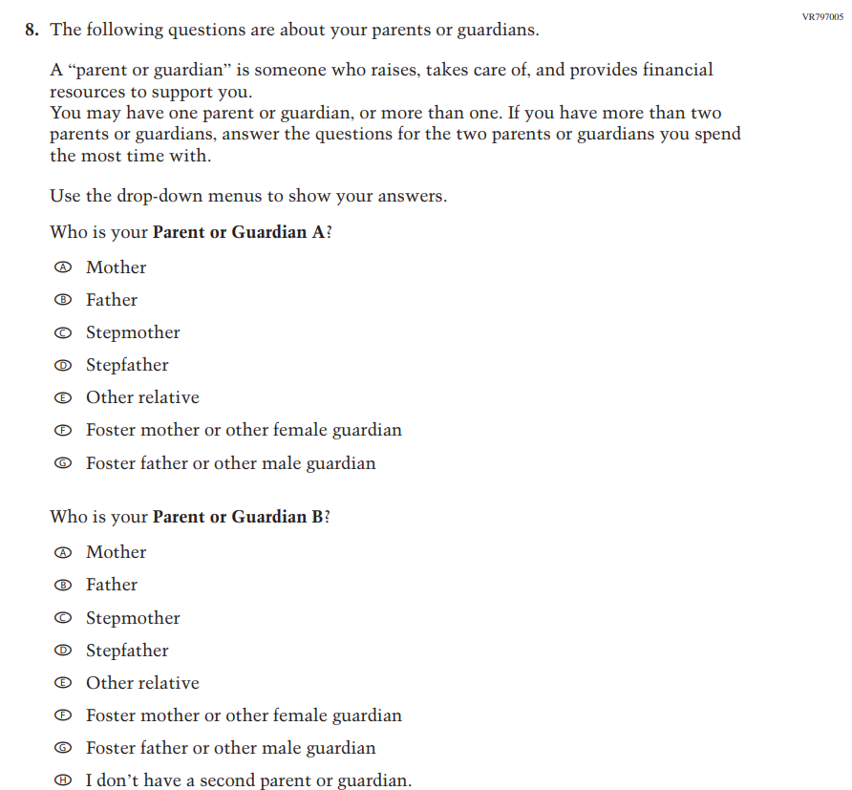

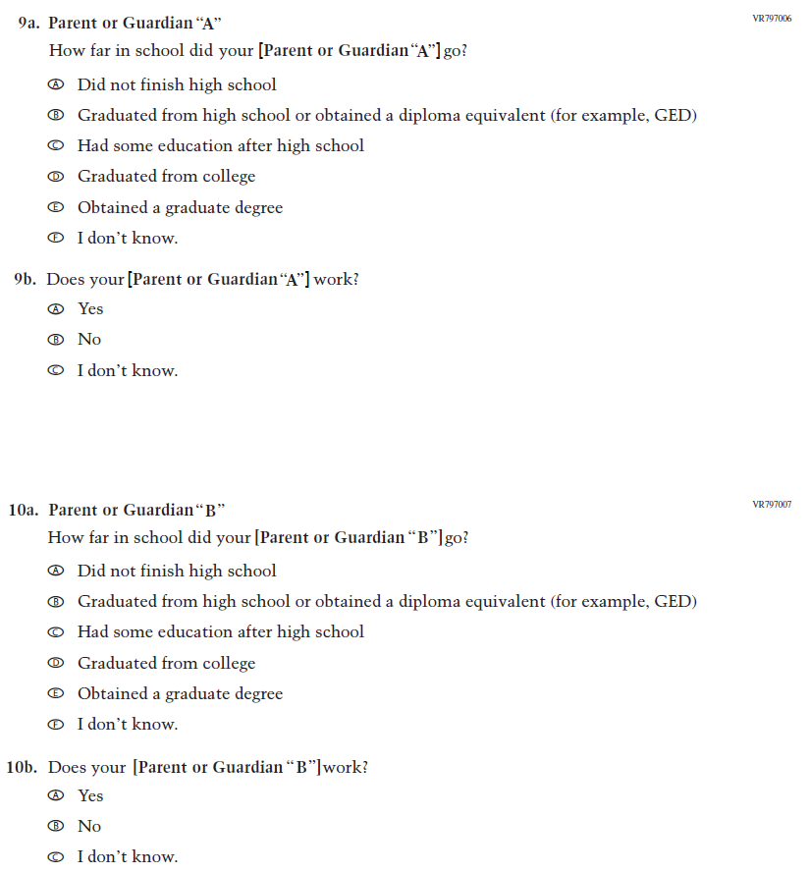

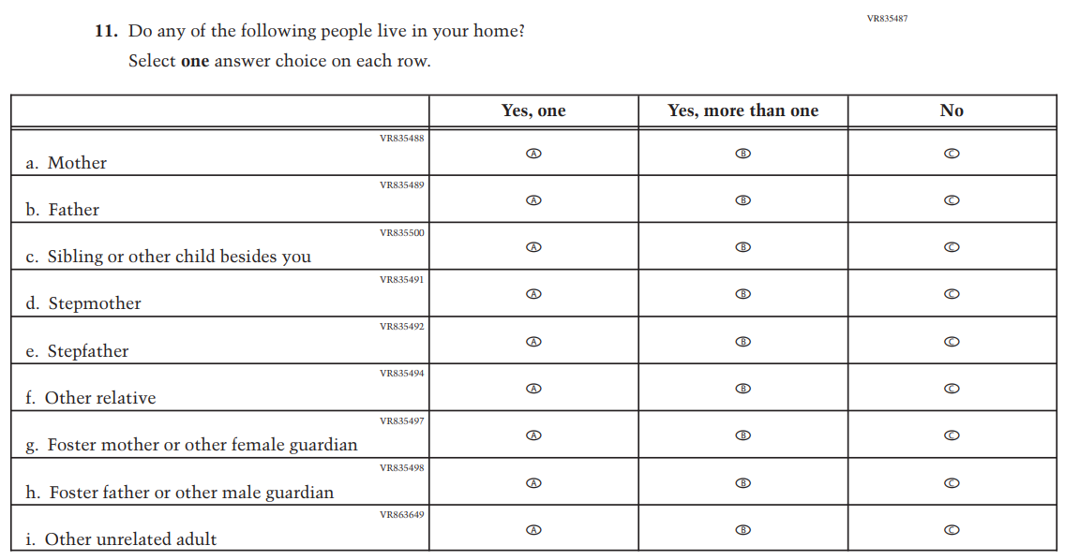
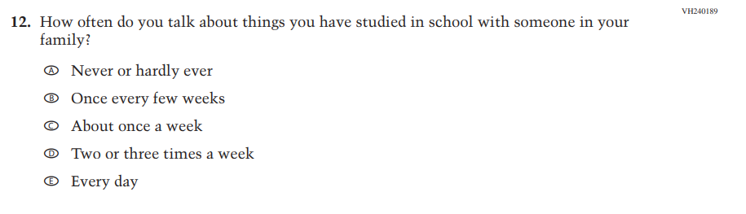
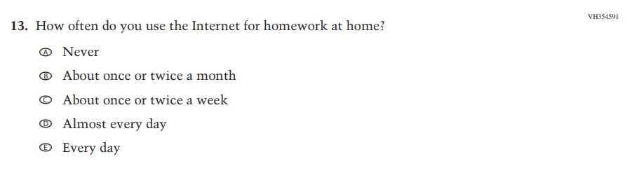

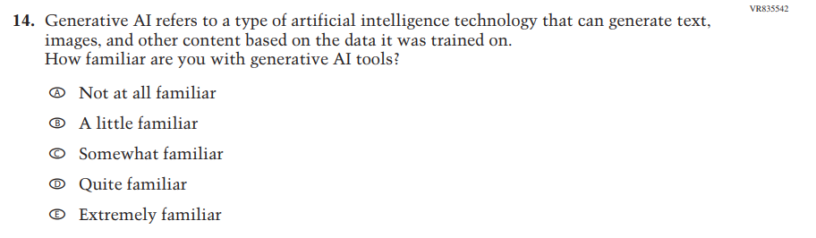
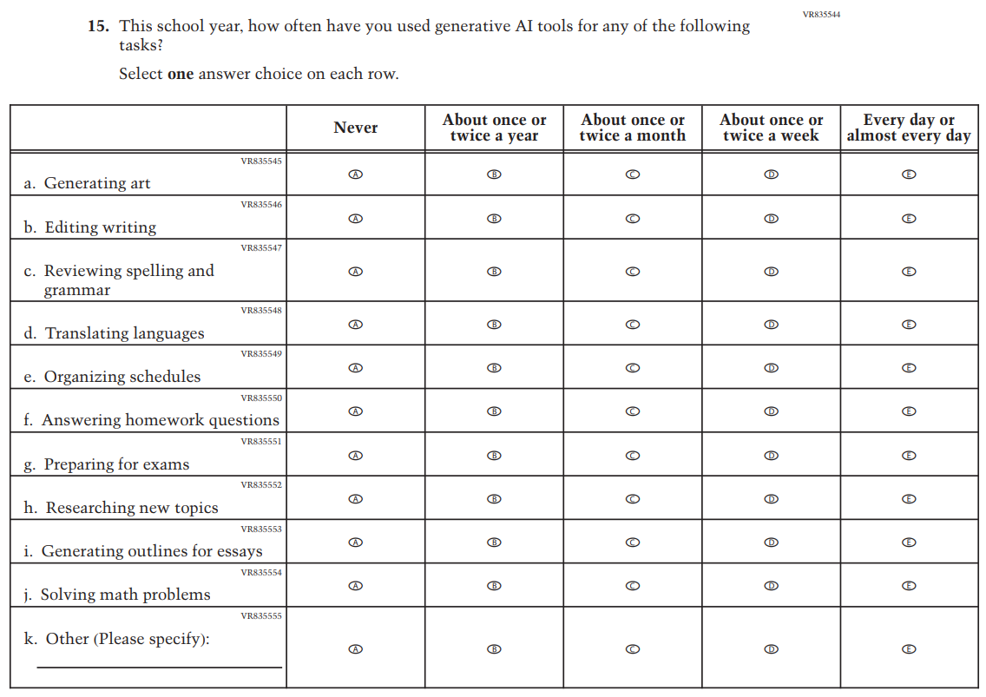

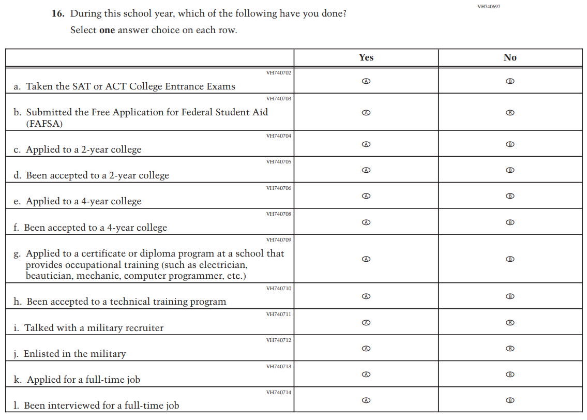
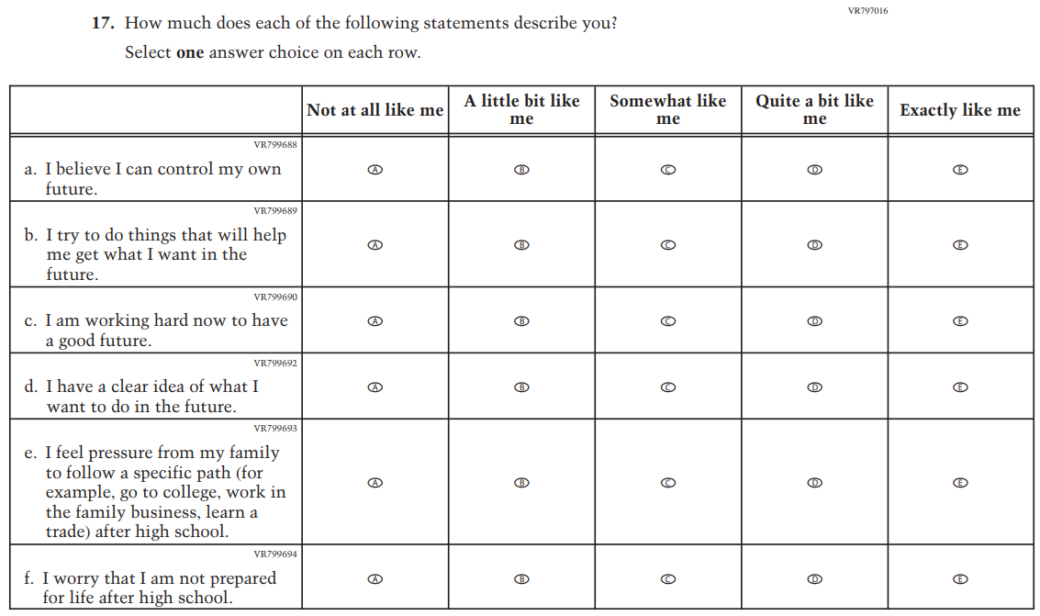
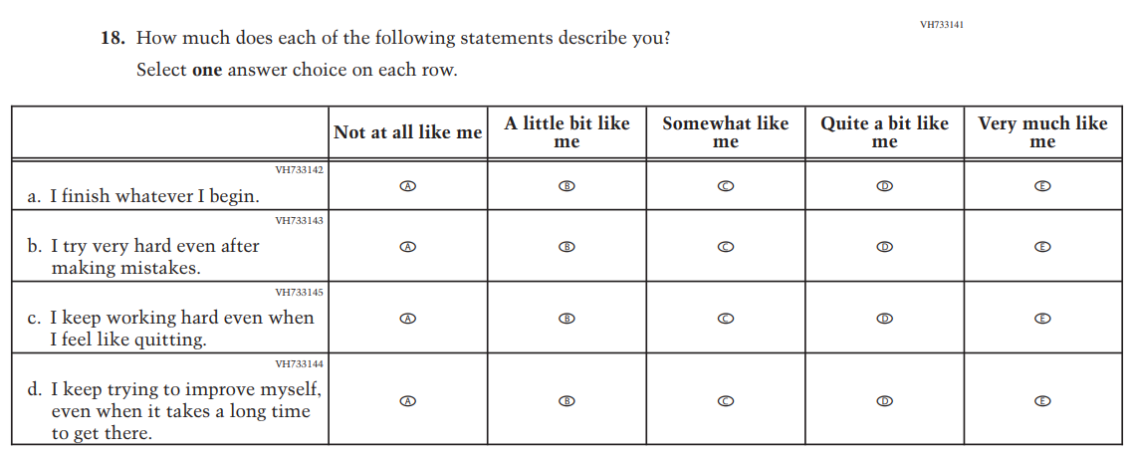

Appendix J1-22: Pilot Grade 12 – Sequence 2 (Core)

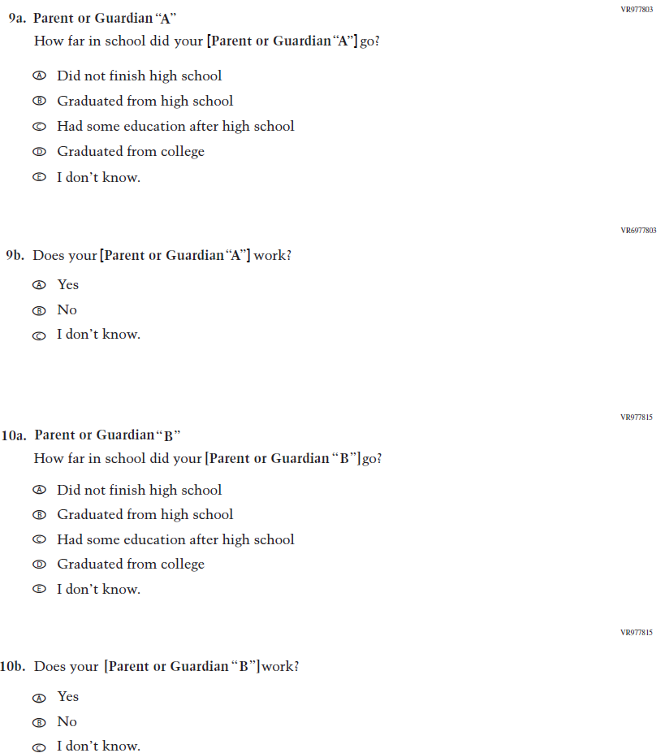
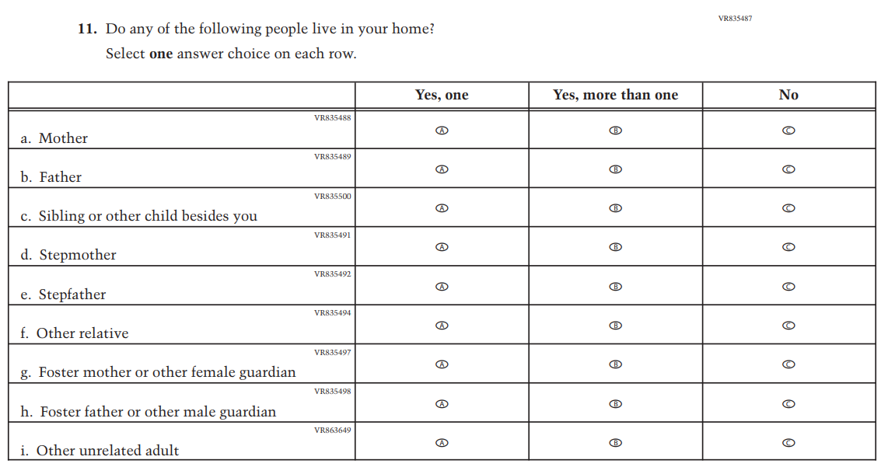
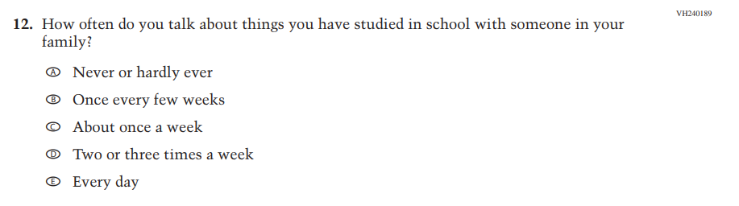
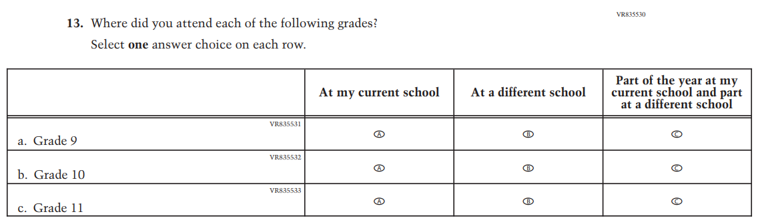

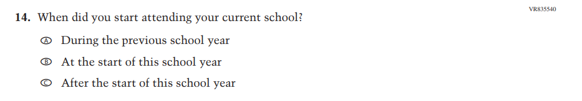
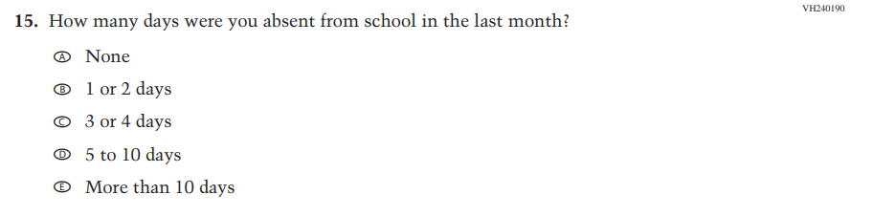
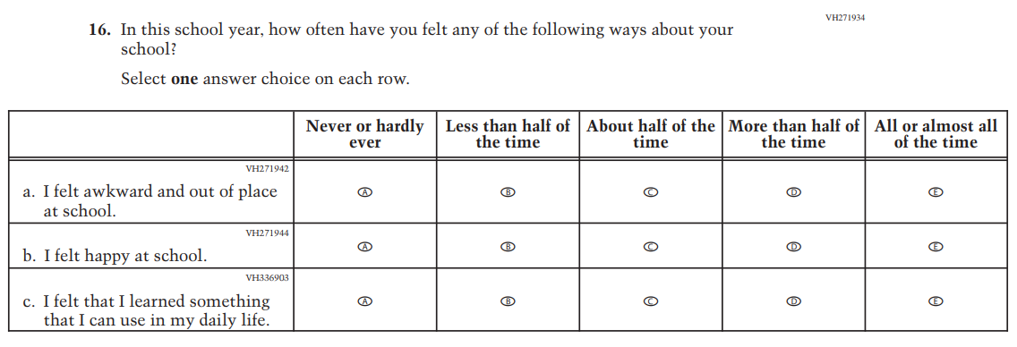
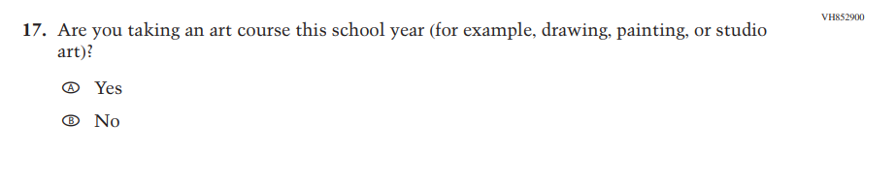

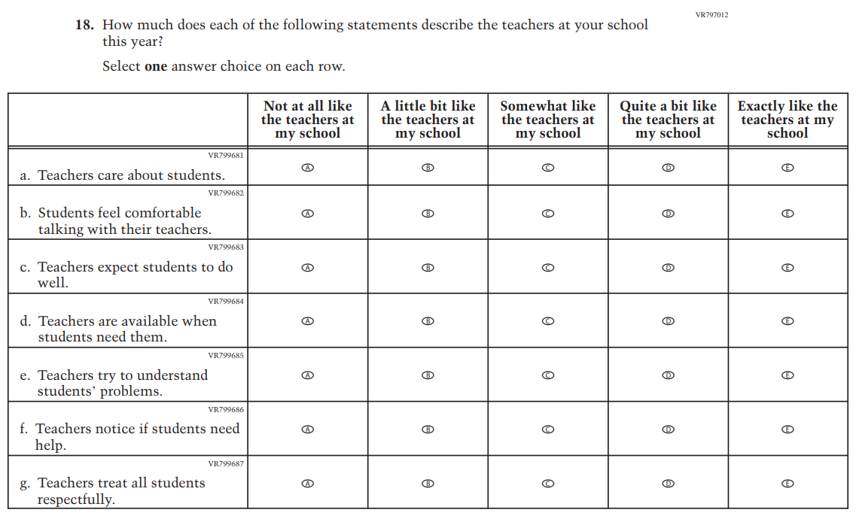
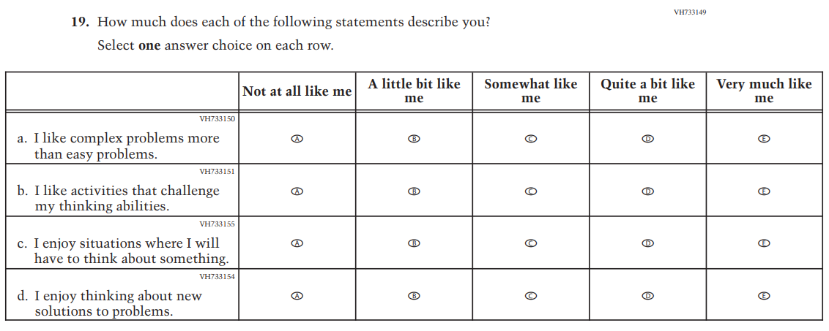

Appendix J1-23: Pilot Grade 4 (Mathematics)
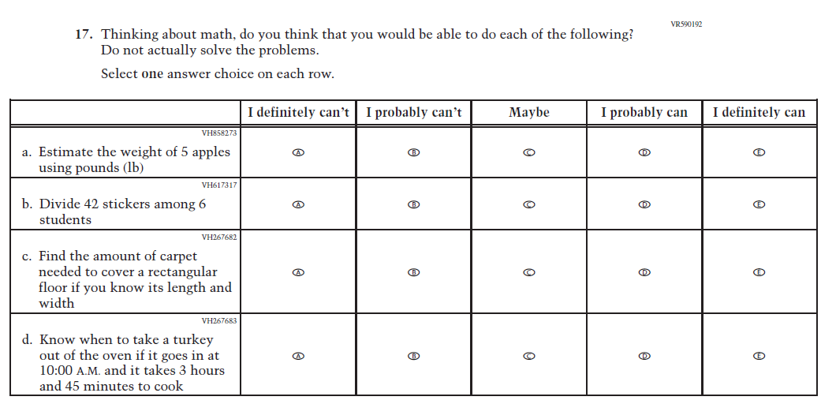

Appendix J1-24: Pilot Grade 8 (Mathematics)
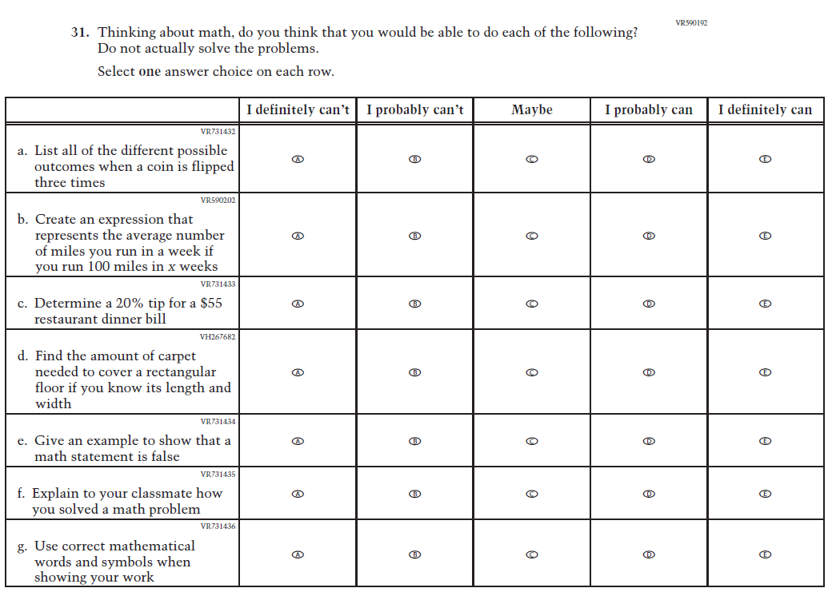

Appendix J1-25: Pilot Grade 12 – Sequence 1 (Mathematics)
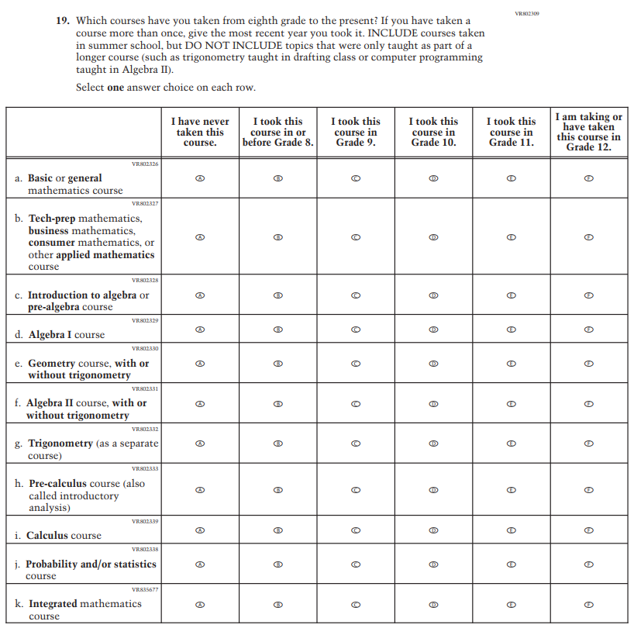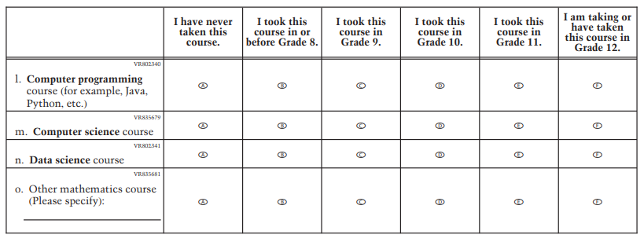
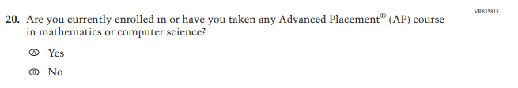
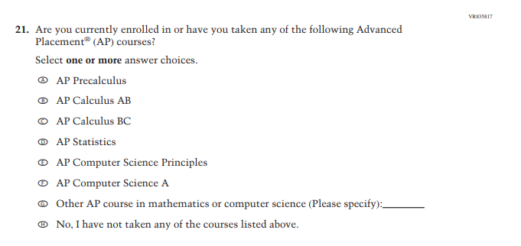
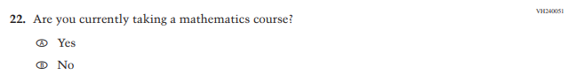
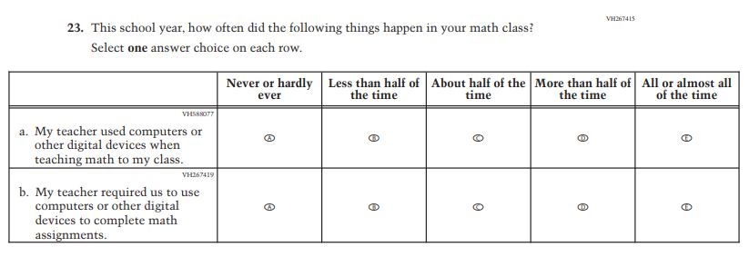
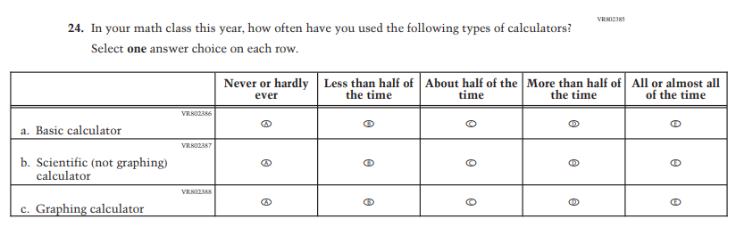
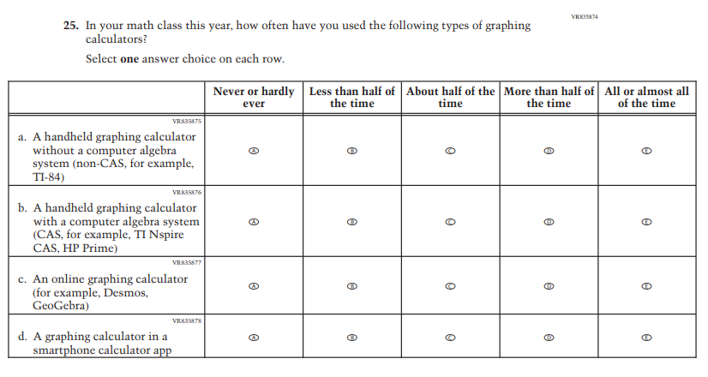
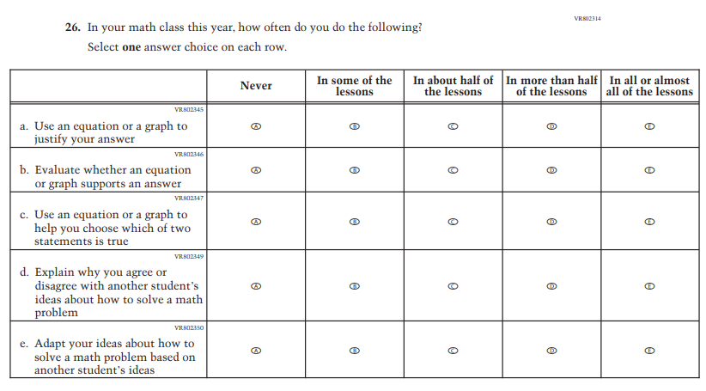
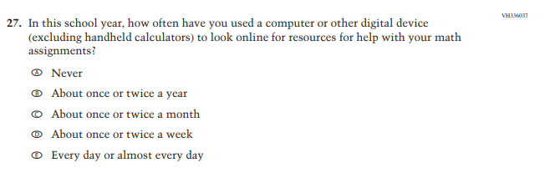
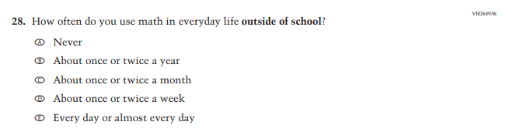
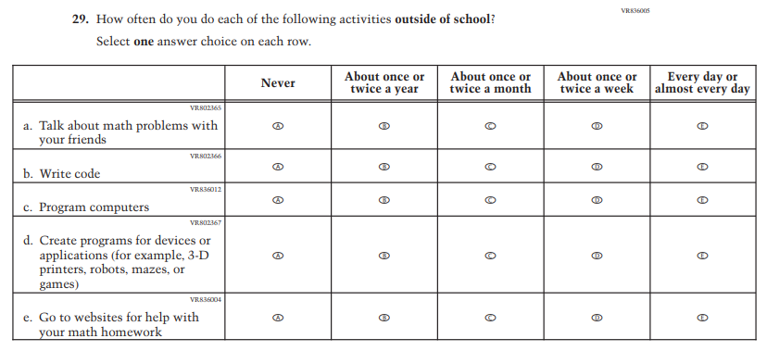

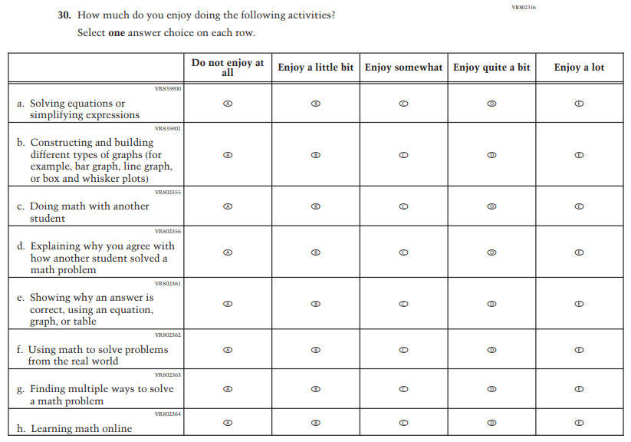
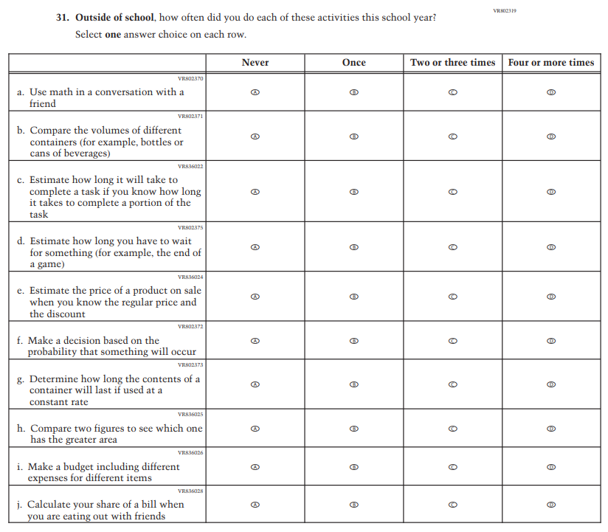

Appendix J1-26: Pilot Grade 12 – Sequence 2 (Mathematics)
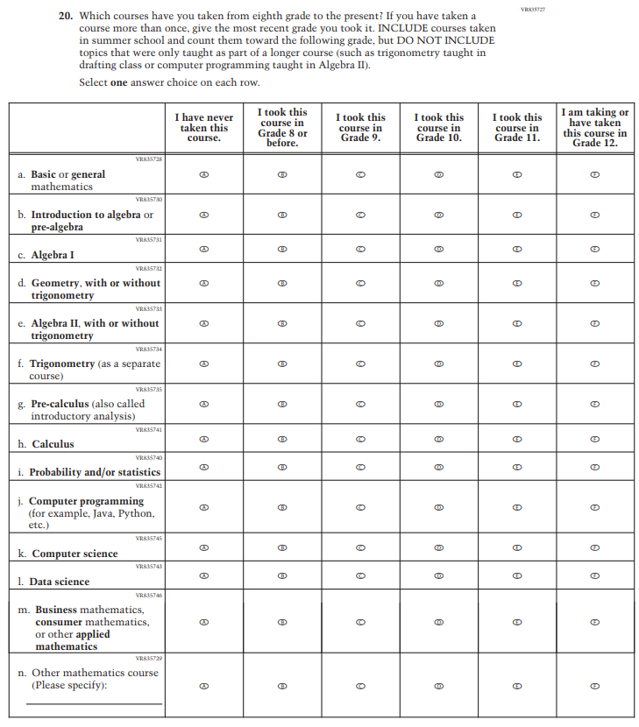

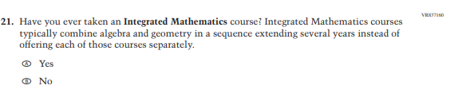
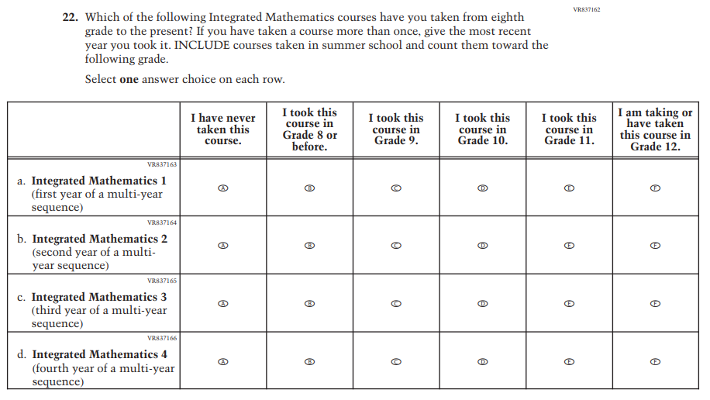
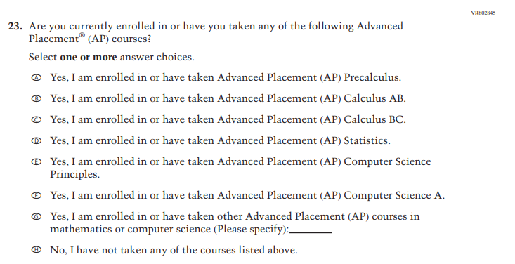

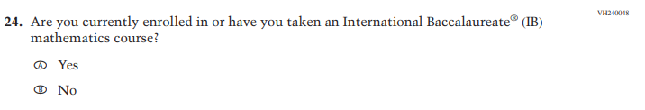

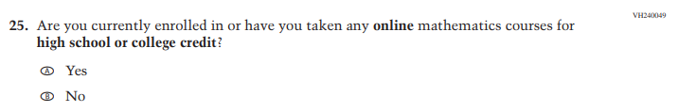

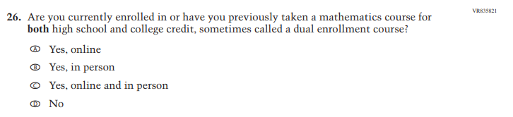

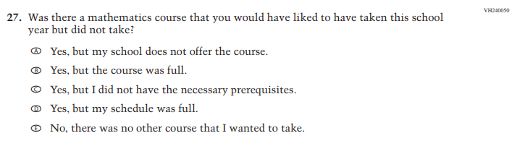

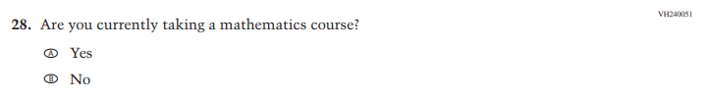

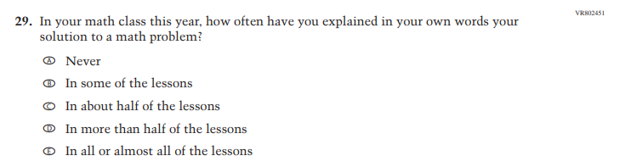

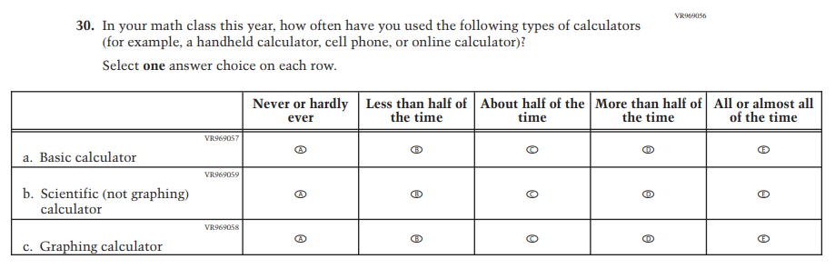

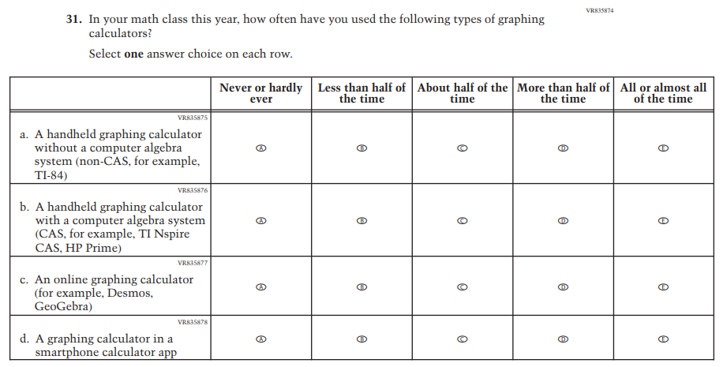

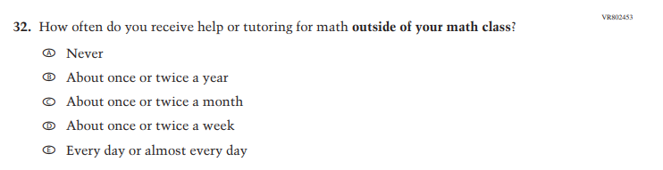

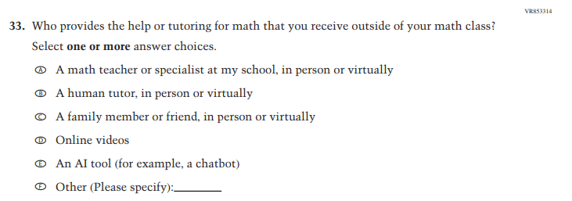

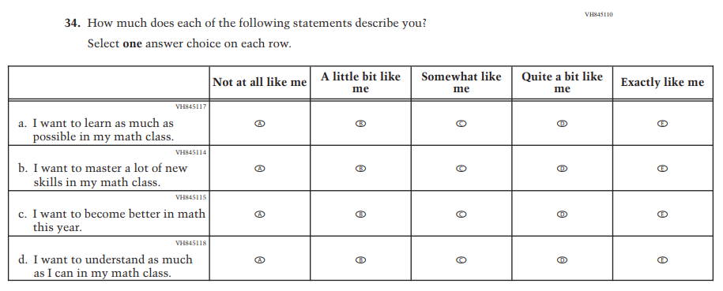

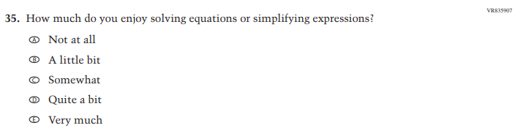

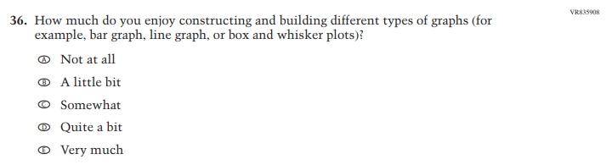

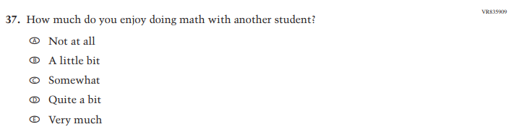

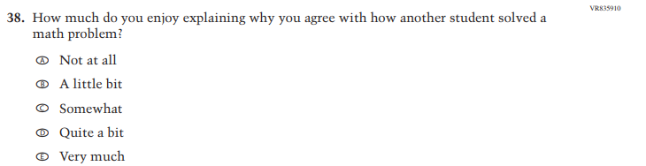

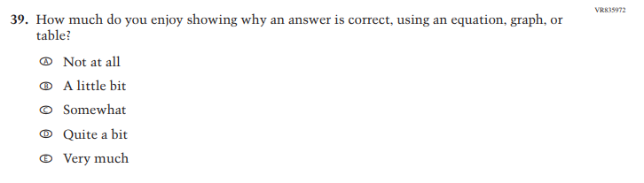

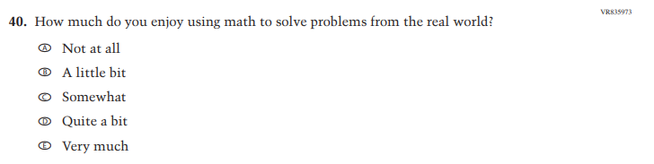

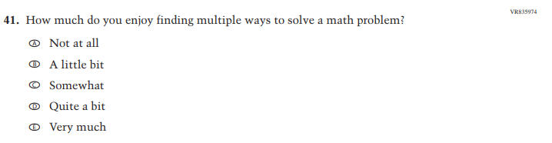

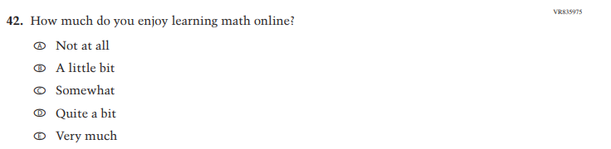

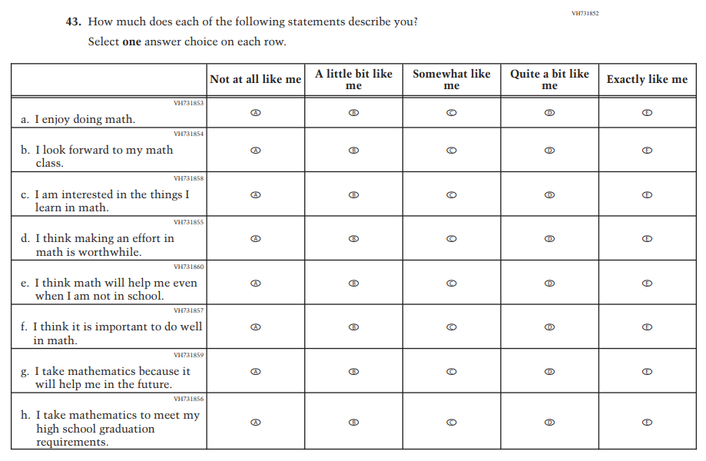

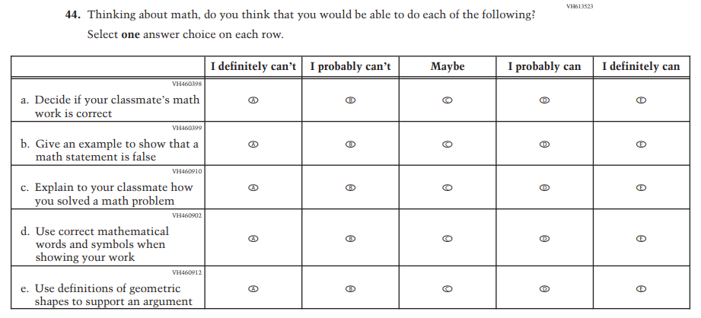

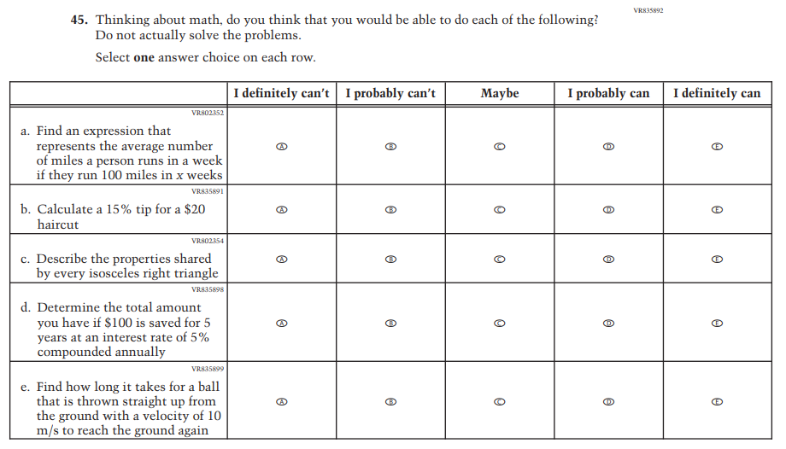

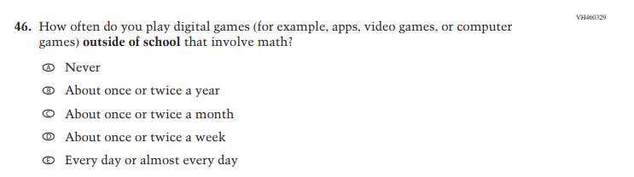

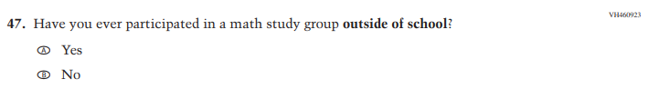

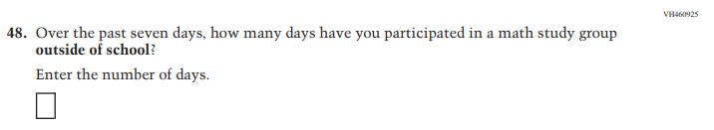

Appendix J1-27: Pilot Grade 4 (Reading)

Appendix J1-28: Pilot Grade 8 (Reading)

Appendix J1-29: Pilot Grade 12 – Sequence 1 (Reading)
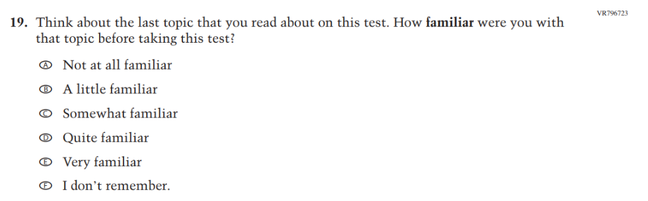

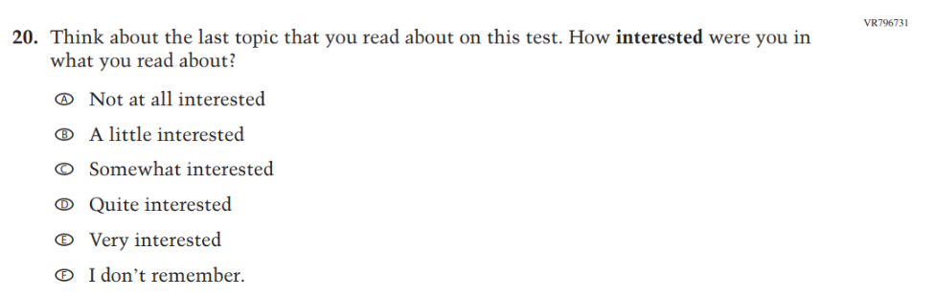

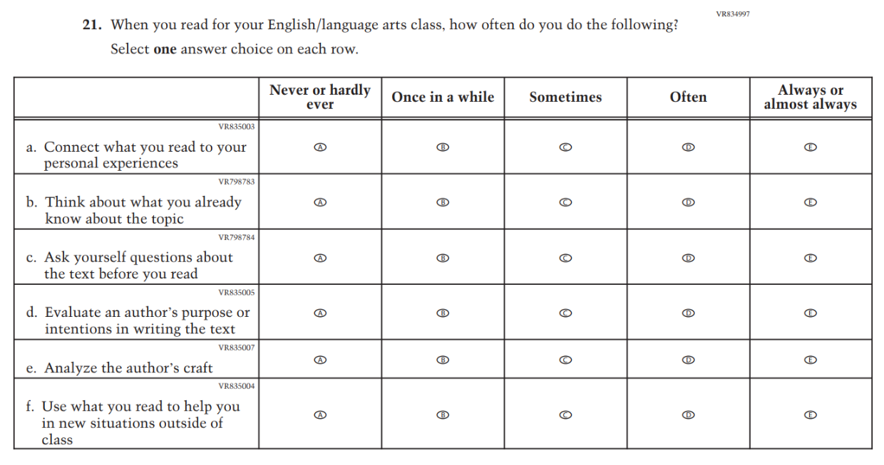

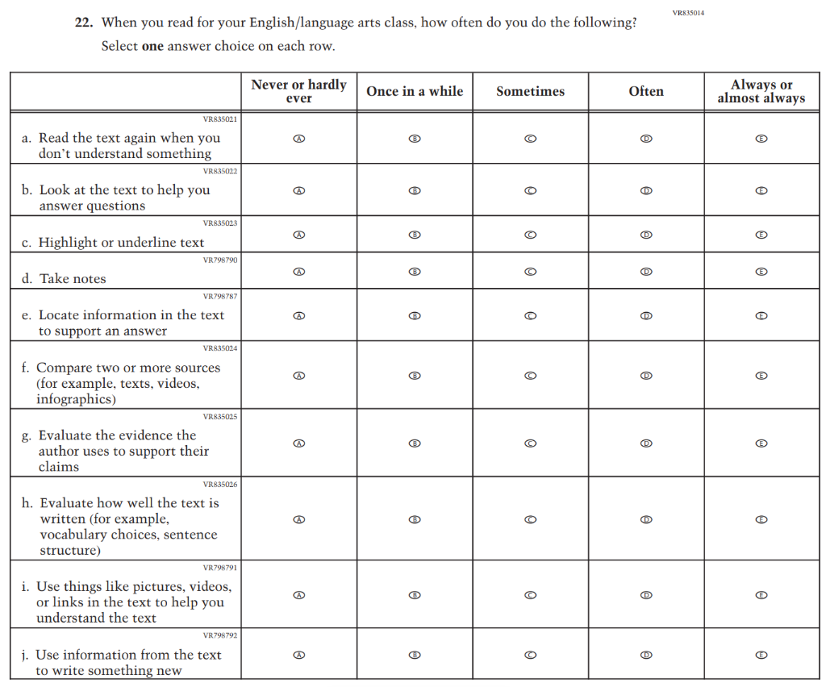

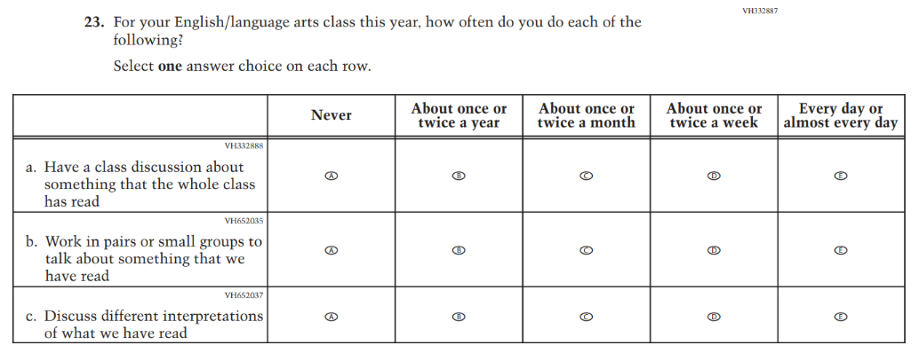

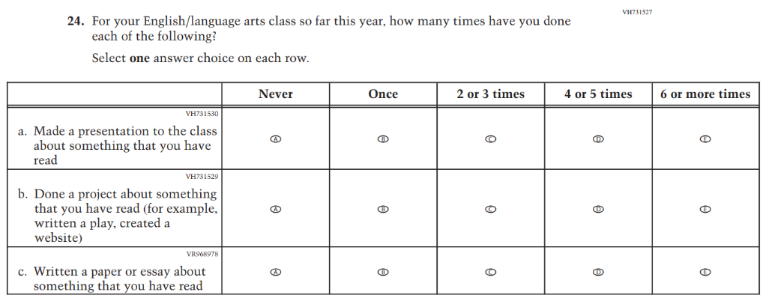

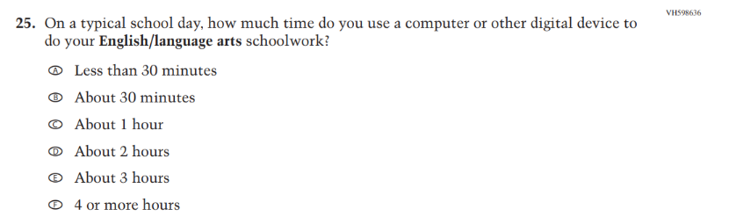

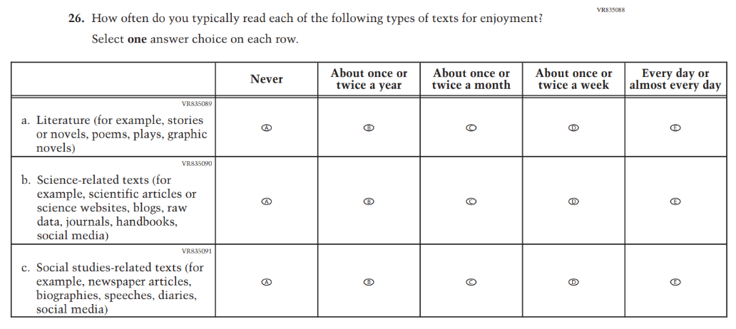

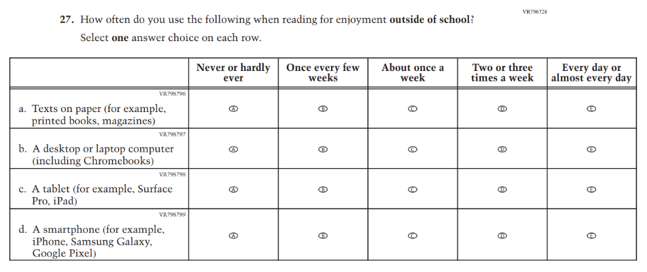

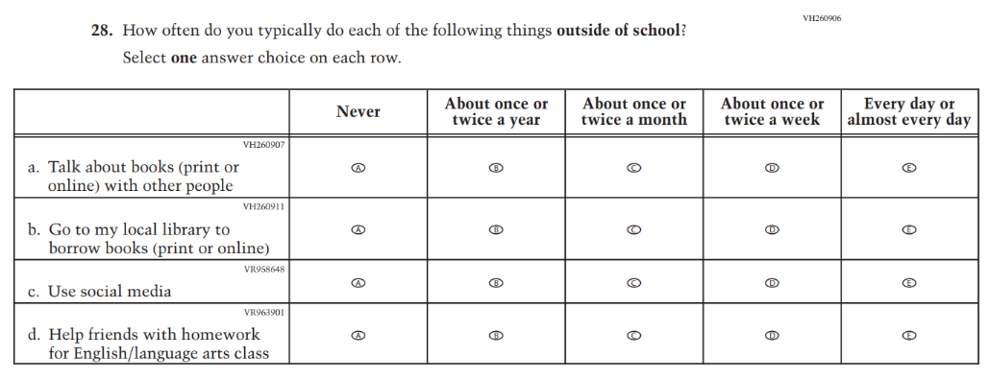

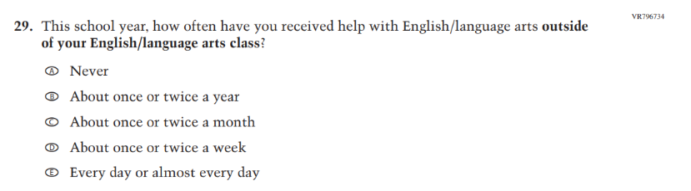

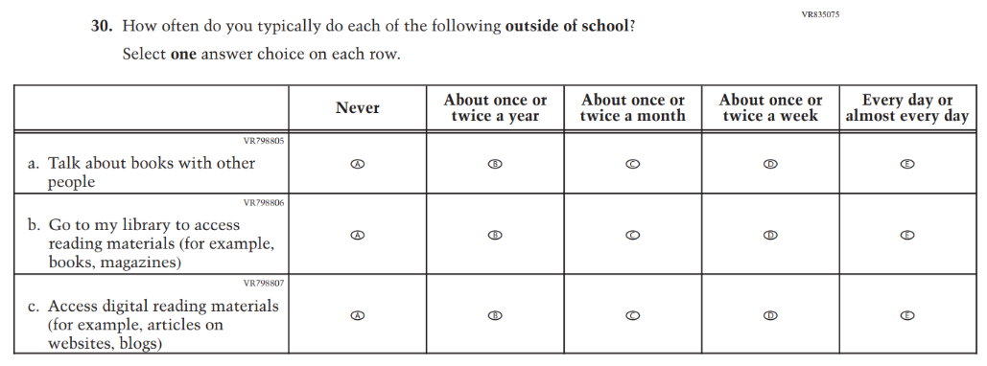

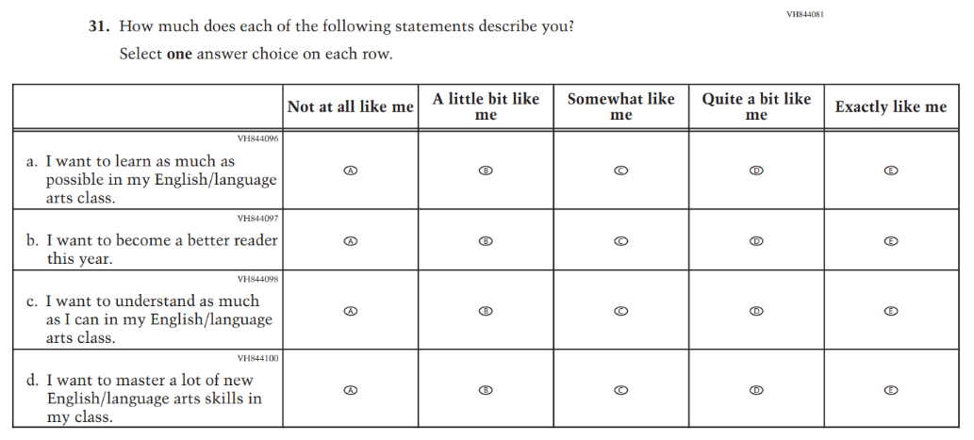

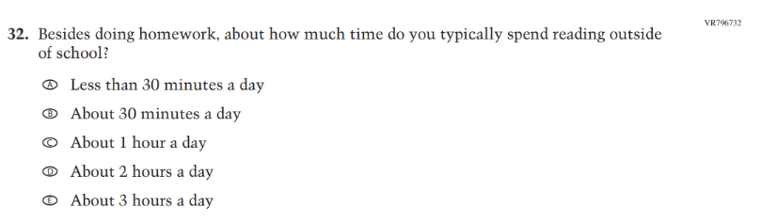

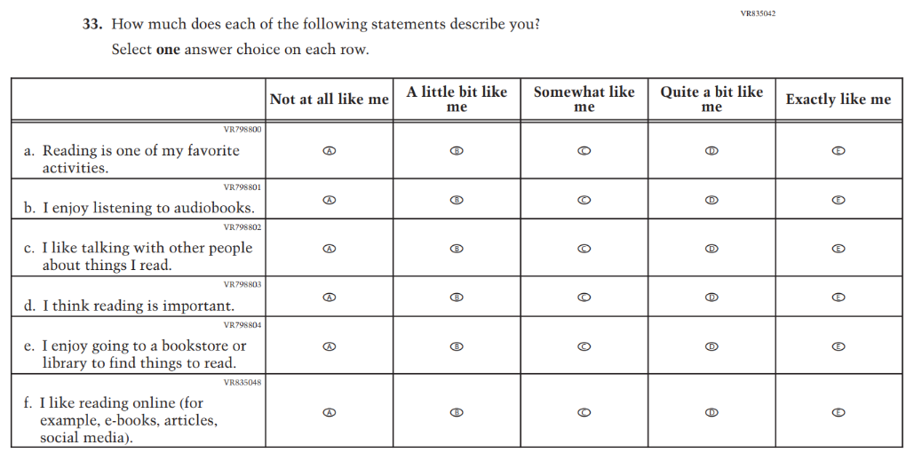

Appendix J1-30: Pilot Grade 12 – Sequence 2 (Reading)
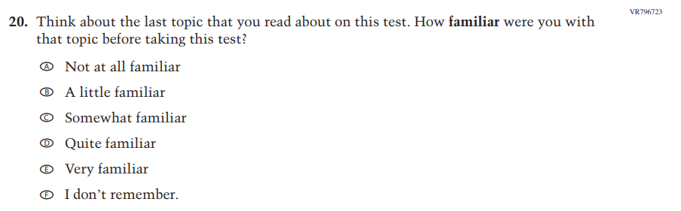

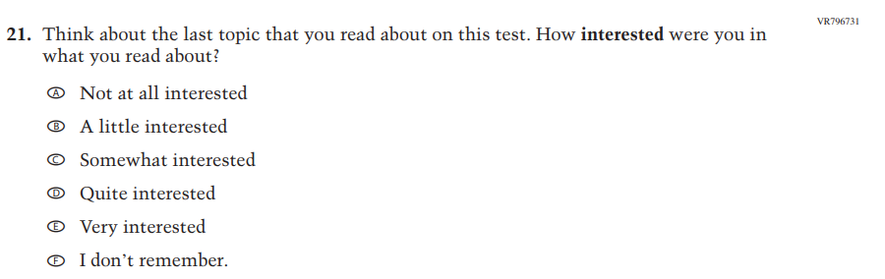

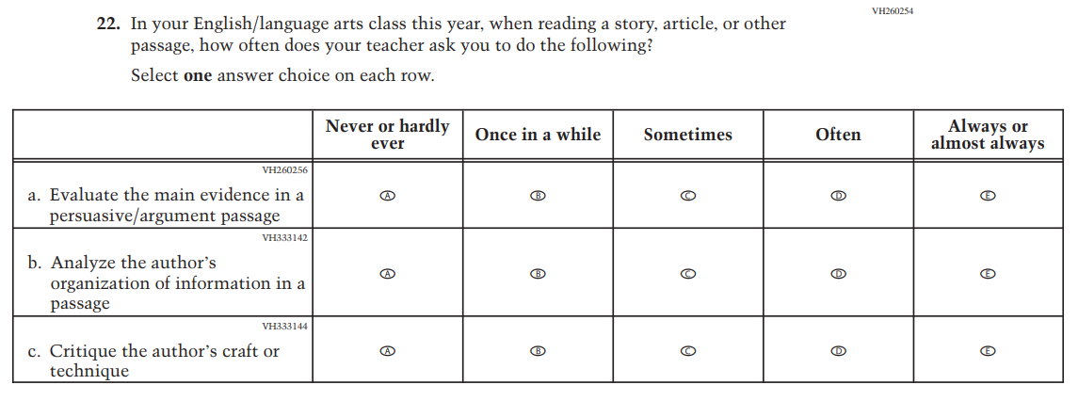

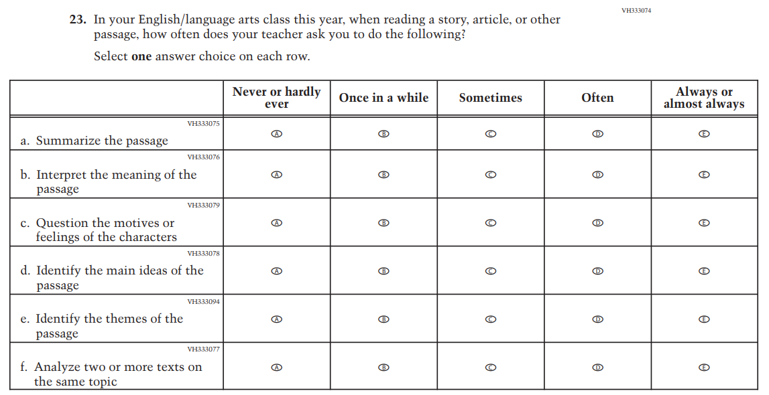

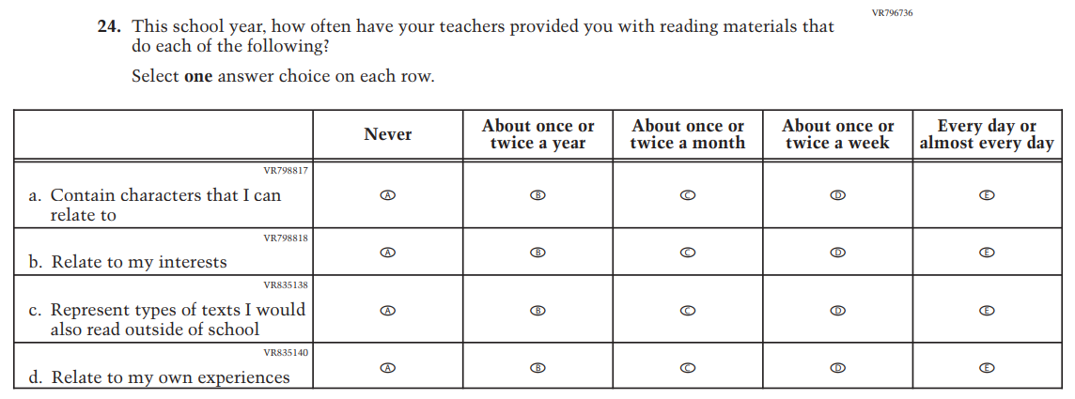

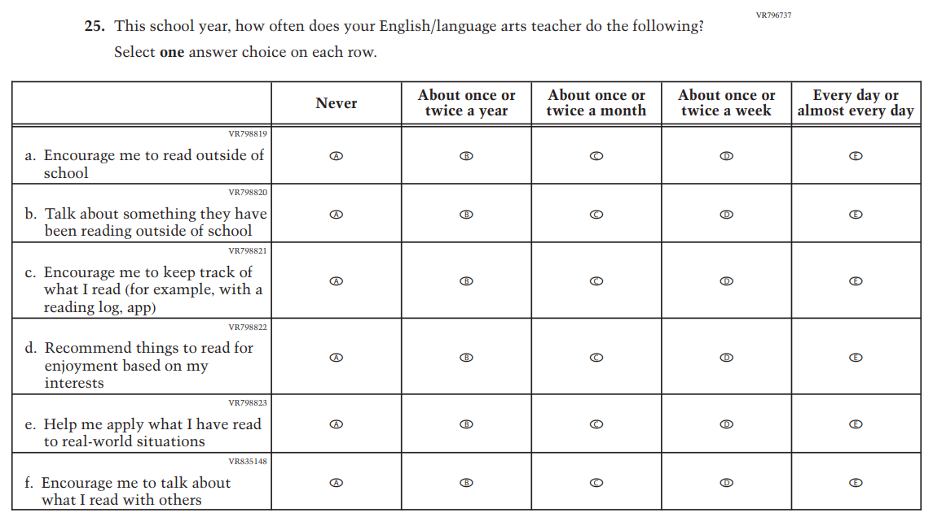

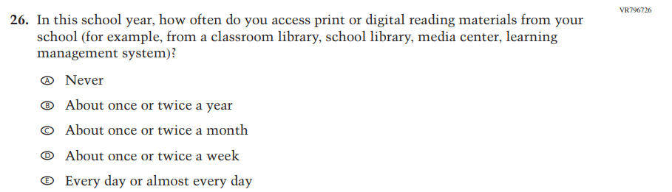

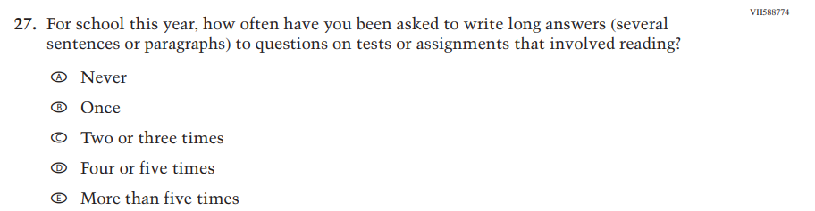

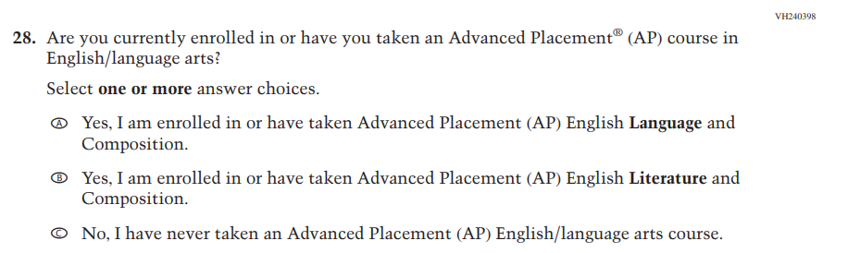

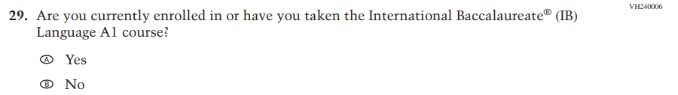

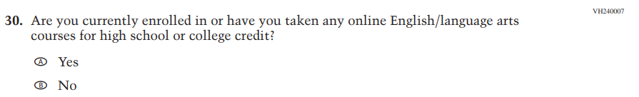

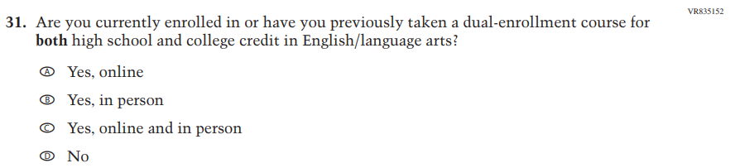

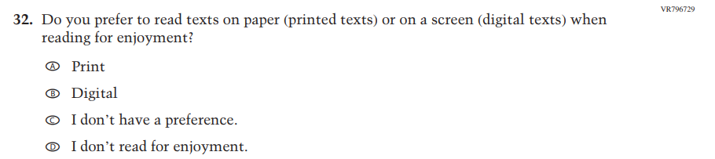
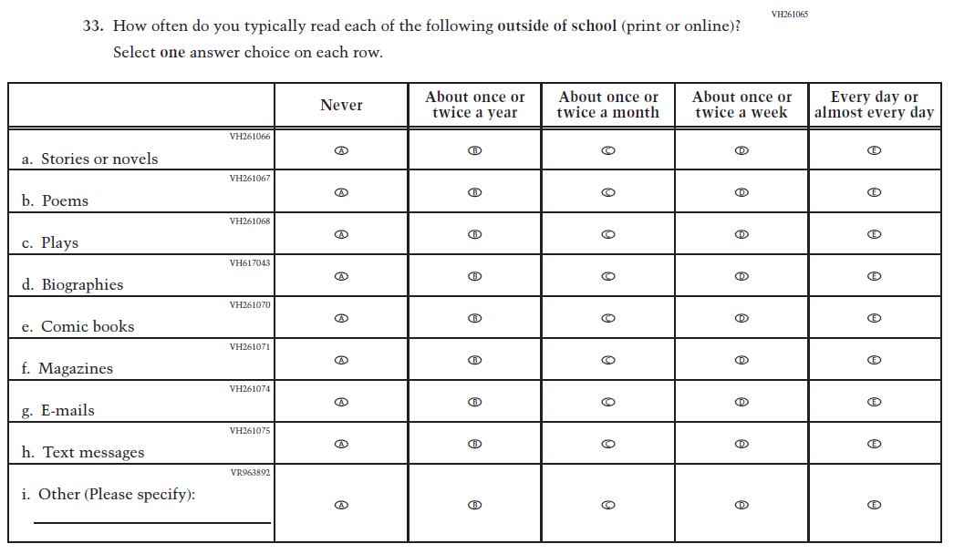

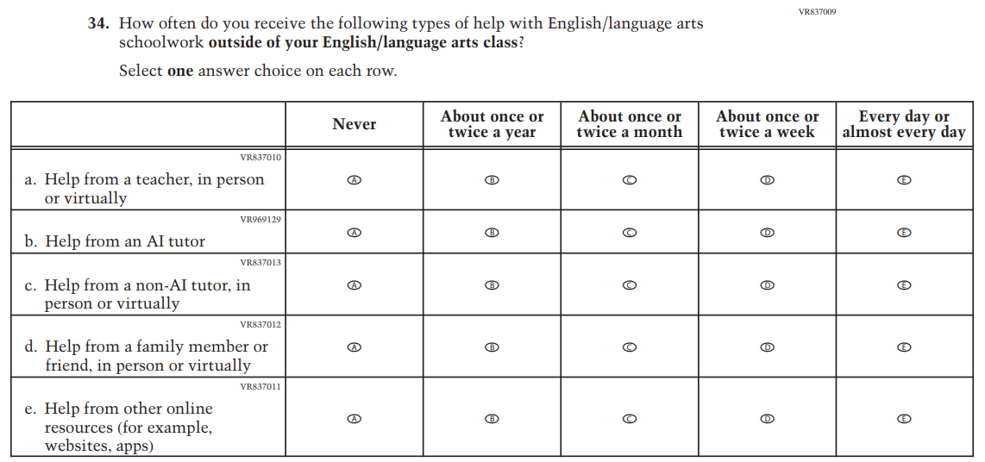

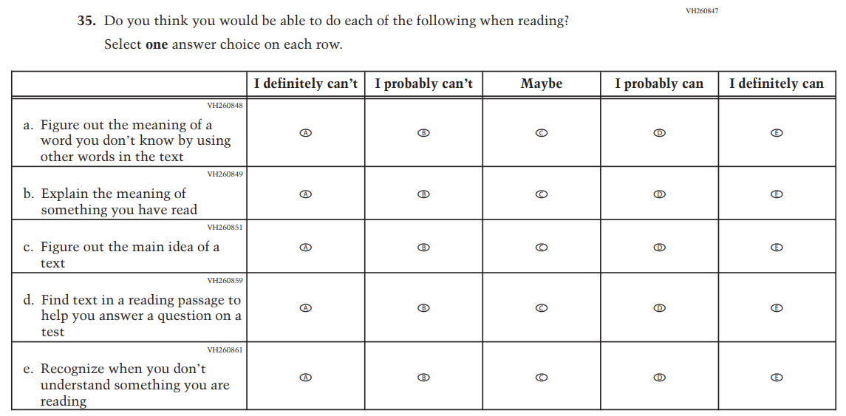

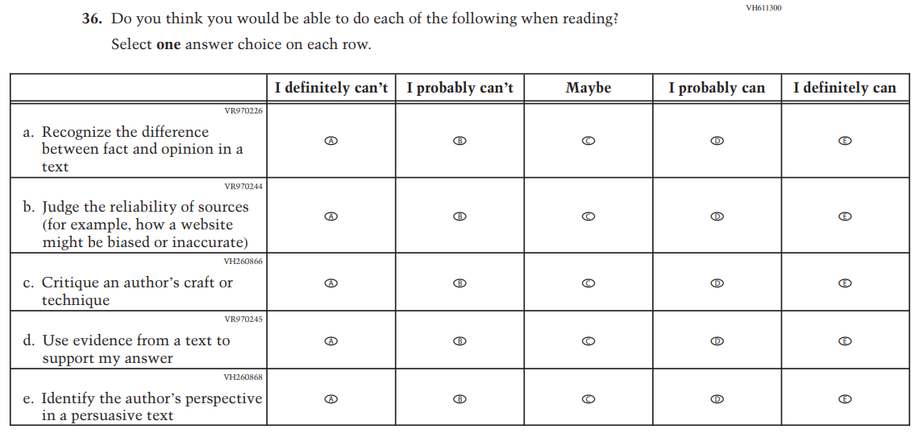

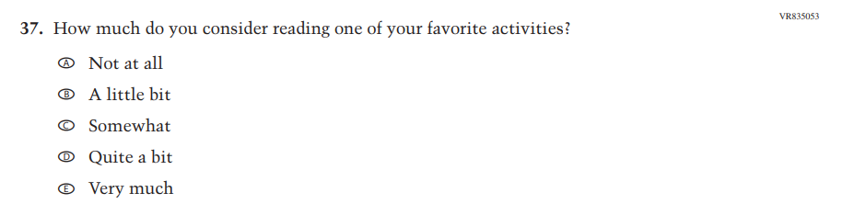
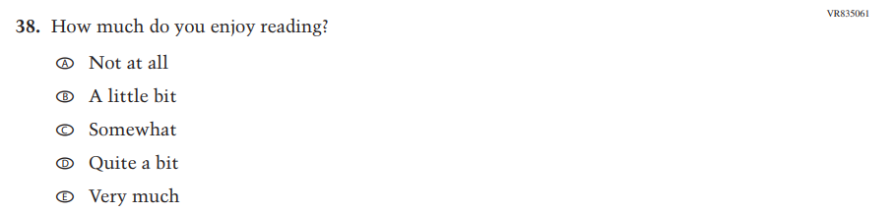

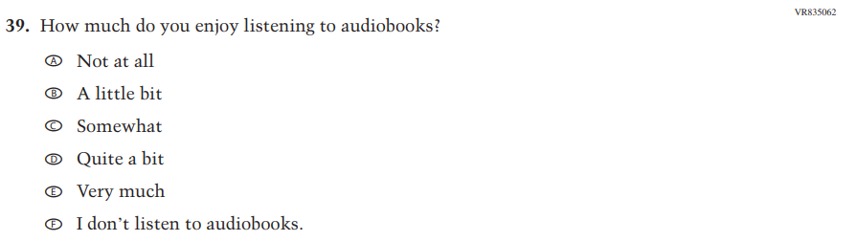

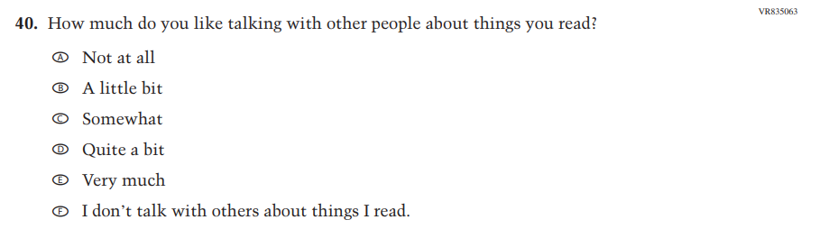

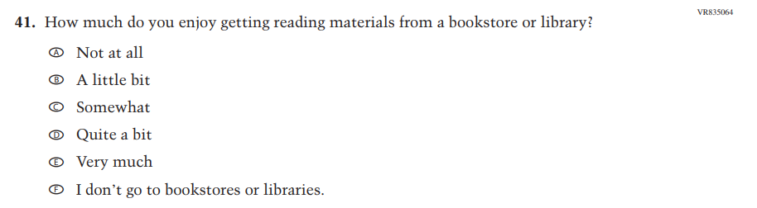

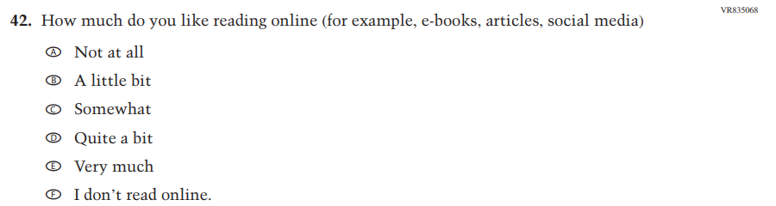

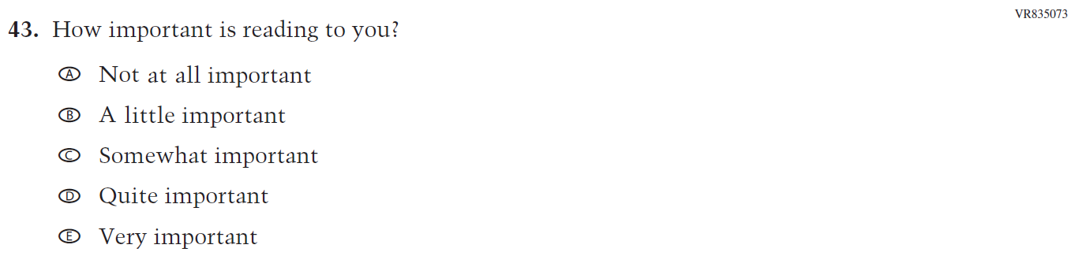

Appendix J1-31: Pilot Grade 4 (Debrief)

Appendix J1-32: Pilot Grade 8 (Debrief)

Appendix J1-33: Pilot Grade 12 (Debrief)
