NATIONAL CENTER FOR EDUCATION STATISTICS NATIONAL ASSESSMENT OF EDUCATIONAL PROGRESS

National Assessment of Educational Progress (NAEP) 2026

Appendix J2
2026 Teacher Questionnaires

OMB# 1850-0928 v.37



July 2025

Important changes in how we collect demographic information are reflected in the 2026 instruments that are ready for publication and review. In March 2024, the Office of Management and Budget (OMB) announced revisions to Statistical Policy Directive No. 15: Standards for Maintaining, Collecting, and Presenting Federal Data on Race and Ethnicity (SPD 15) and published the revised SPD15 standard in the Federal Register (89 FR 22182). See Part A.7 of this package to see how NCES plans to incorporate these revisions into NAEP 2026.
Additionally, materials in this Amendment are in compliance with the White House’s Executive Orders “Defending Women from Gender Ideology Extremism and Restoring Biological Truth to the Federal Government,” (January 20, 2025) and “Ending Radical and Wasteful Government DEI Programs and Preferencing,” (January 20, 2025).
Appendix J2 provides the teacher survey questionnaires that will be administered in 2026, and any changes to the items from the 2024 administration are reflected in summary tables. Please note, some of the numbers of the items may be missing or out of order in these printed versions. This will be corrected in the platform view.
Table of Contents
Teacher Questionnaires
Sample Teacher Questionnaire Login Screens 3
Appendix J2-1: Summary of Changes Operational Grade 4 (Core) 4
Appendix J2-2: Operational Grade 4 (Core) 16
Appendix J2-3: Summary of Changes Operational Grade 8 (Core) 25
Appendix J2-4: Operational Grade 8 (Core) 41
Appendix J2-5: Summary of Changes Operational Grade 4 (Mathematics) 51
Appendix J2-6: Operational Grade 4 (Mathematics) 58
Appendix J2-7: Summary of Changes Operational Grade 8 (Mathematics) 65
Appendix J2-8: Operational Grade 8 (Mathematics) 73
Appendix J2-9: Summary of Changes Operational Grade 4 (Reading) 83
Appendix J2-10: Operational Grade 4 (Reading) 93
Appendix J2-11: Summary of Changes Operational Grade 8 (Reading) 100
Appendix J2-12: Operational Grade 8 (Reading) 110
Appendix J2-13: Summary of Changes Operational Grade 8 (Social Studies) 119
Appendix J2-14: Operational Grade 8 (Social Studies) 126
Appendix J2-15: Pilot Grade 4 (Core) 135
Appendix J2-16: Pilot Grade 4 (Mathematics) 144
Appendix J2-17: Pilot Grade 4 (Reading) 152

Sample Teacher Questionnaire Login Screens
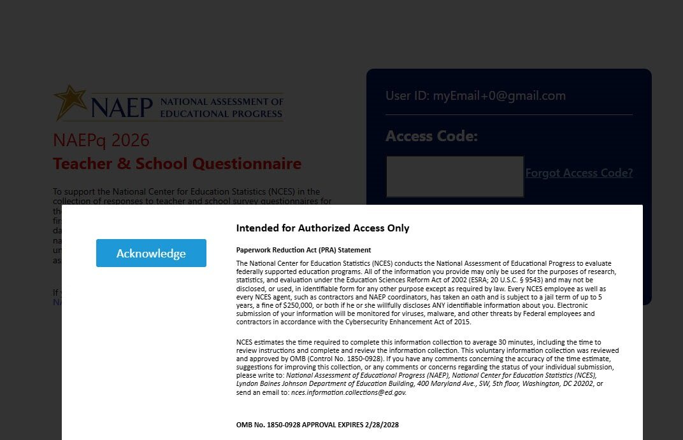

Appendix J2-1: Summary of Changes Operational Grade 4 (Core)
2026 Operational Grade 4 Core Teacher
Previous Item | 2026 Item | D/A/R+ | Rationale
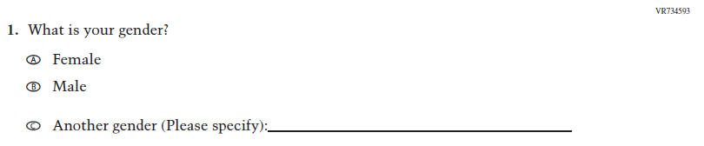  (2024) | N/A | D | This Item was dropped to adhere to the January 2025 Executive Order on gender ideology and identity.
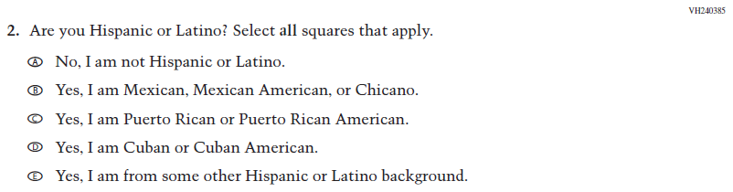  (2024) | N/A | D | This Item was dropped and folded into the following suite of updated Race/ Ethnicity Items.

2026 Operational Grade 4 Core Teacher
Previous Item | 2026 Item | D/A/R+ | Rationale
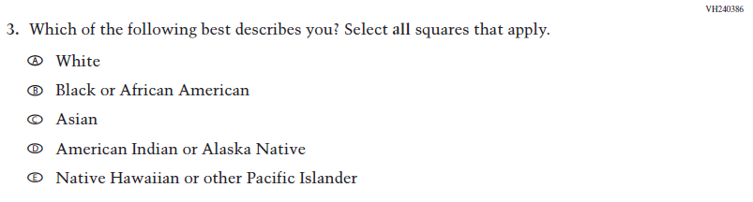  (2024) | 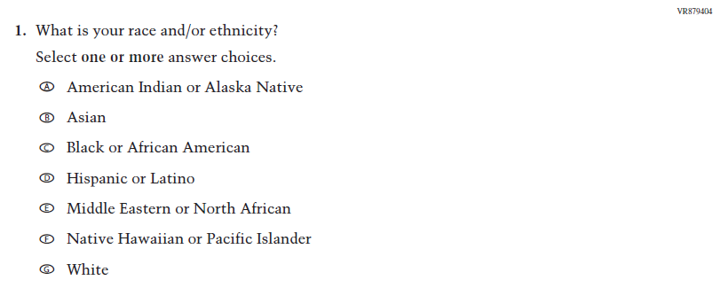  Issue: Race/Ethnicity | R | For 2026, we have aligned Inline Directions in Teacher and School Items with the Directions currently used in Student Items. The Race/ Ethnicity Items have been updated to adhere to OMB updated Statistical Policy Directive No. 15.
N/A  (2024) | 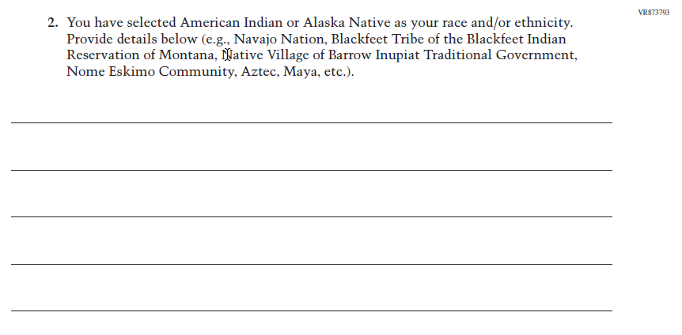  Issue: Race/Ethnicity | A | The Race/ Ethnicity Items have been updated.

2026 Operational Grade 4 Core Teacher
Previous Item | 2026 Item | D/A/R+ | Rationale
N/A  (2024) | 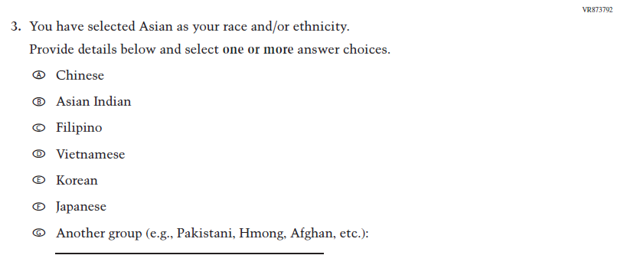  Issue: Race/Ethnicity | A | The Race/ Ethnicity Items have been updated.
N/A  (2024) | 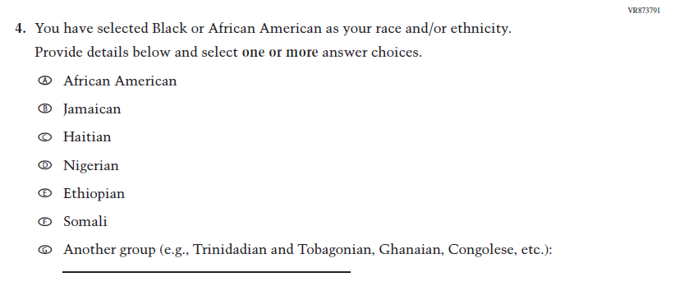  Issue: Race/Ethnicity | A | The Race/ Ethnicity Items have been updated.
N/A  (2024) | 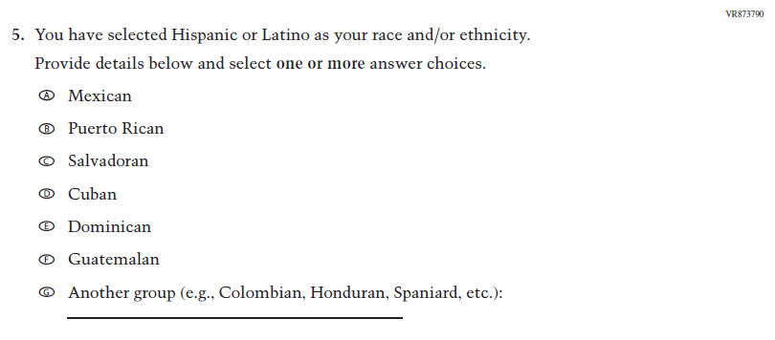  Issue: Race/Ethnicity | A | The Race/ Ethnicity Items have been updated.
2026 Operational Grade 4 Core Teacher
Previous Item | 2026 Item | D/A/R+ | Rationale
N/A  (2024) | 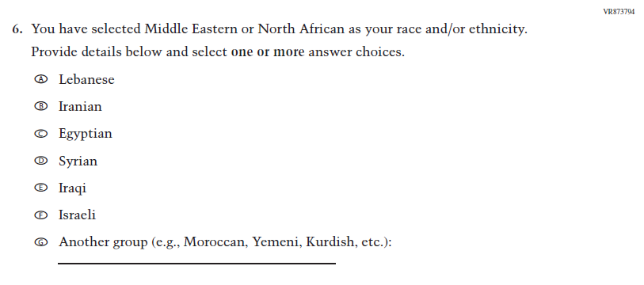  Issue: Race/Ethnicity | A | The Race/ Ethnicity Items have been updated.
N/A  (2024) | 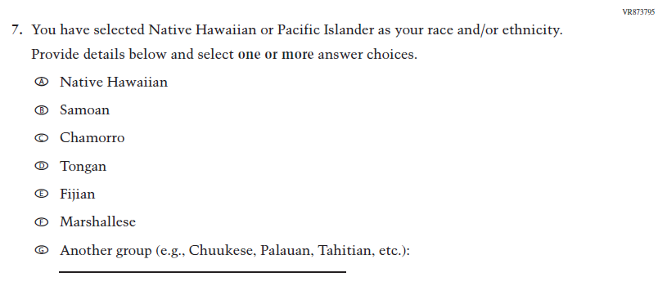  Issue: Race/Ethnicity | A | The Race/ Ethnicity Items have been updated.
N/A  (2024) | 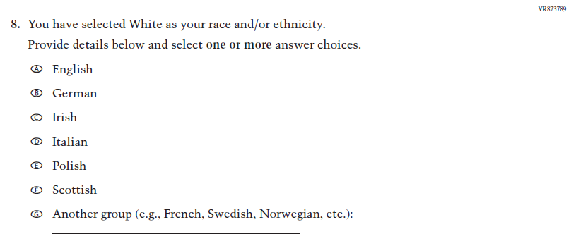  Issue: Race/Ethnicity | A | The Race/ Ethnicity Items have been updated.

2026 Operational Grade 4 Core Teacher
Previous Item | 2026 Item | D/A/R+ | Rationale
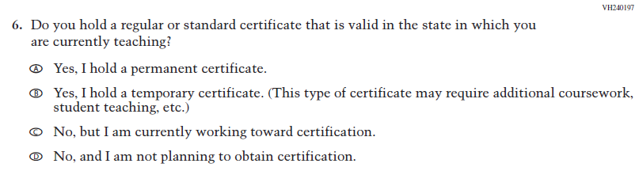  (2024) | 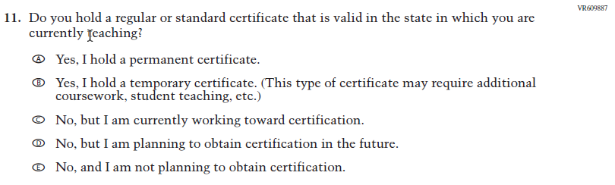  Issue: Teacher Preparation | R | Response Option D was added.
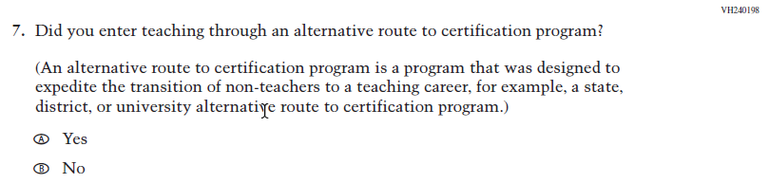  (2024) | 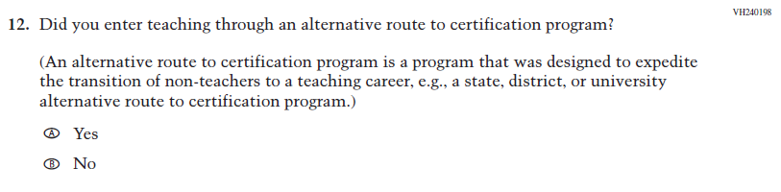  Issue: Teacher Preparation | R | We revised “for example” to “e.g.” to be consistent with the phrasing used elsewhere in Teacher and School Items.

2026 Operational Grade 4 Core Teacher
Previous Item | 2026 Item | D/A/R+ | Rationale
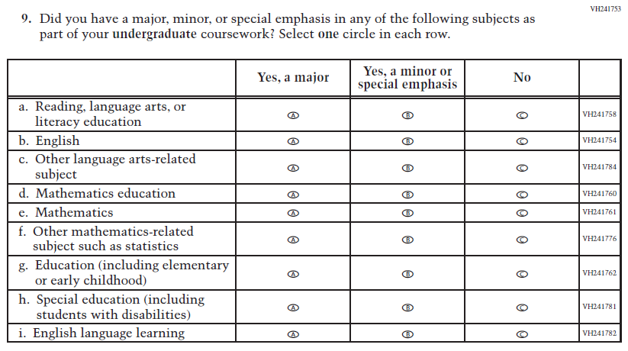  (2024) | 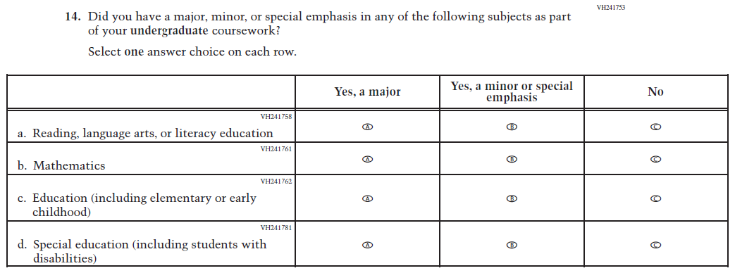  Issue: Teacher Preparation | R | For 2026, we have aligned Inline Directions in Teacher and School Items with the Directions currently used in Student Items. SubItems b, c, d, f, and i were dropped due to high percentages of “No” responses (over 80%).
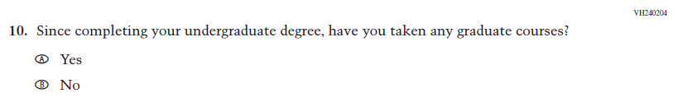  (2024) | N/A | D | This Item was dropped to reduce burden and streamline content.

2026 Operational Grade 4 Core Teacher
Previous Item | 2026 Item | D/A/R+ | Rationale
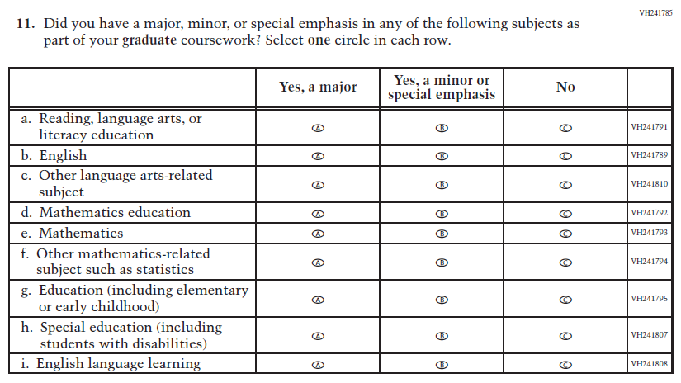  (2024) | 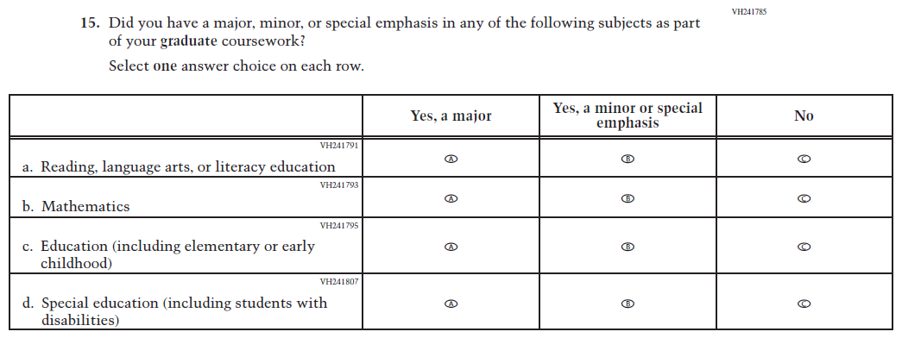  Issue: Teacher Preparation | R | For 2026, we have aligned Inline Directions in Teacher and School Items with the Directions currently used in Student Items. SubItems b, c, d, f, and i were dropped due to high percentages of “No” responses (over 80%).
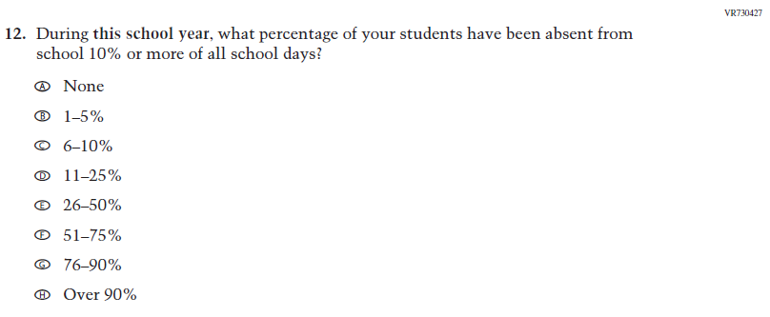  (2024) | N/A | D | Learning Recovery Items were dropped from the 2026 NAEP Assessment.

2026 Operational Grade 4 Core Teacher
Previous Item | 2026 Item | D/A/R+ | Rationale
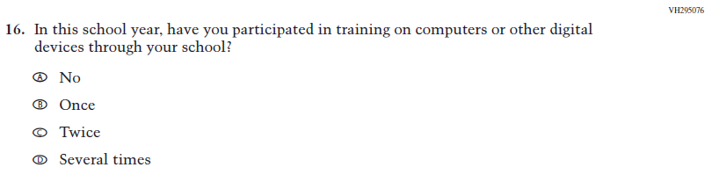  (2024) | N/A | D | This Item was dropped to prioritize newer, updated Teacher items on Technology Use.
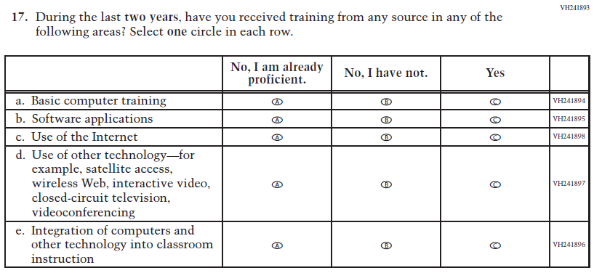  (2024) | 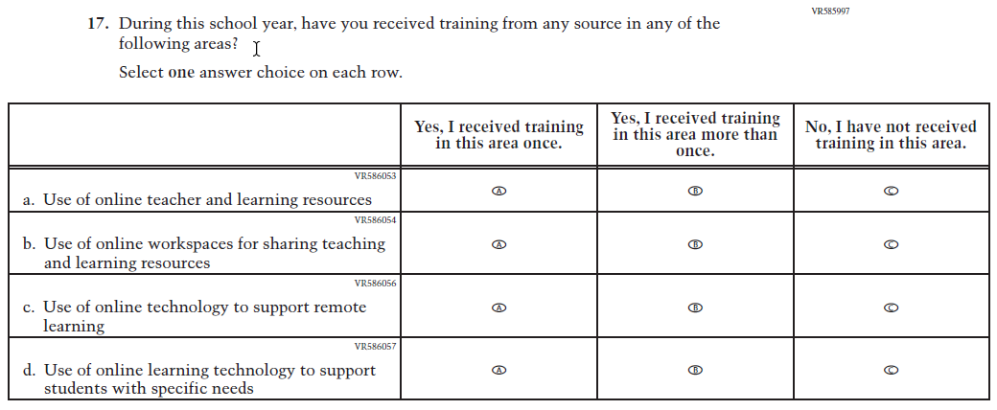  Issue: Technology Use | R | For 2026, we have aligned Inline Directions in Teacher and School Items with the Directions currently used in Student Items. The Item has been revised to focus on training in Technology Use.
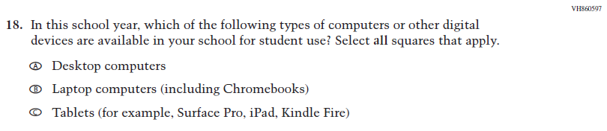  (2024) | N/A | D | This and the related Items were dropped in favor of a more current and concise format for questions on Technology Use.
2026 Operational Grade 4 Core Teacher
Previous Item | 2026 Item | D/A/R+ | Rationale
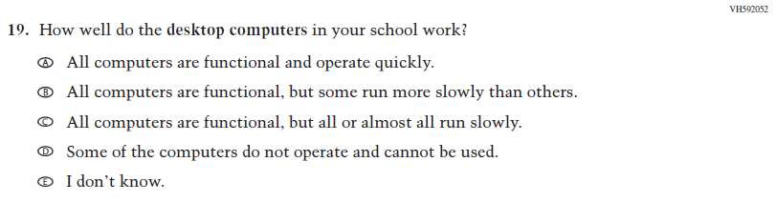  (2024) | N/A | D | This and the related Items were dropped in favor of a more current and concise format for questions on Technology Use.
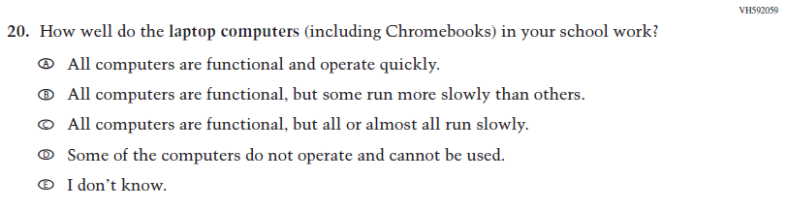  (2024) | N/A | D | This and the related Items were dropped in favor of a more current and concise format for questions on Technology Use.
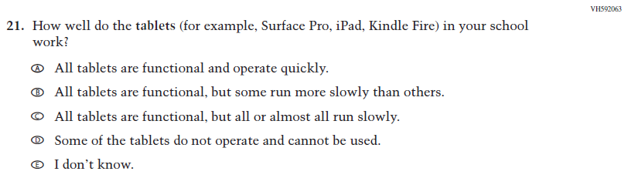  (2024) | N/A | D | This and the related Items were dropped in favor of a more current and concise format for questions on Technology Use.

2026 Operational Grade 4 Core Teacher
Previous Item | 2026 Item | D/A/R+ | Rationale
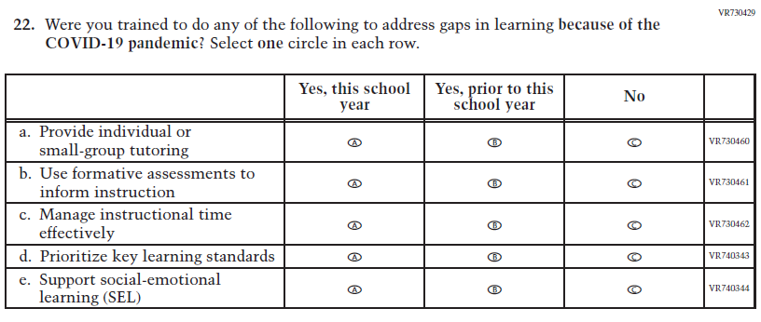  (2024) | N/A | D | Learning Recovery Items were dropped from the 2026 NAEP Assessment.
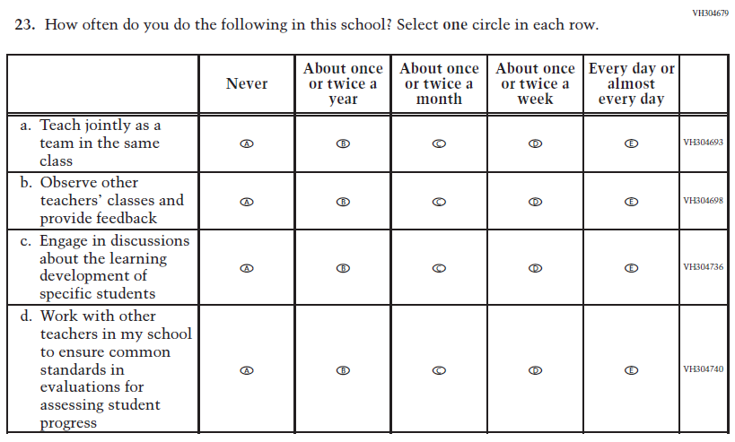  (2024) | N/A | D | This Item was dropped to make space for new Teacher Items in the 2026 NAEP Assessment.

2026 Operational Grade 4 Core Teacher
Previous Item | 2026 Item | D/A/R+ | Rationale
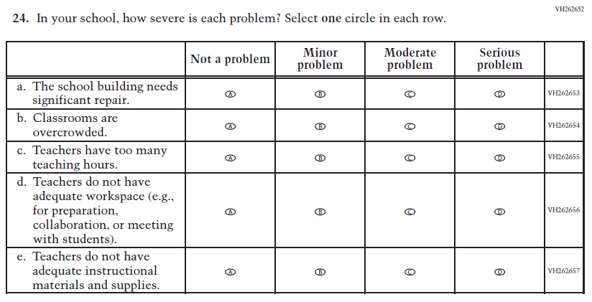  (2024) | 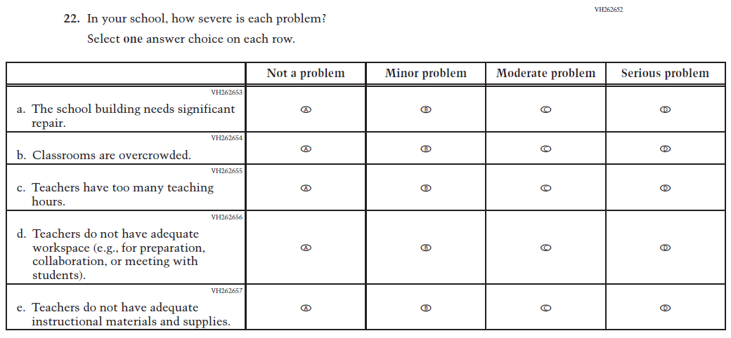  Issue: School Climate | R | For 2026, we have aligned Inline Directions in Teacher and School Items with the Directions currently used in Student Items.
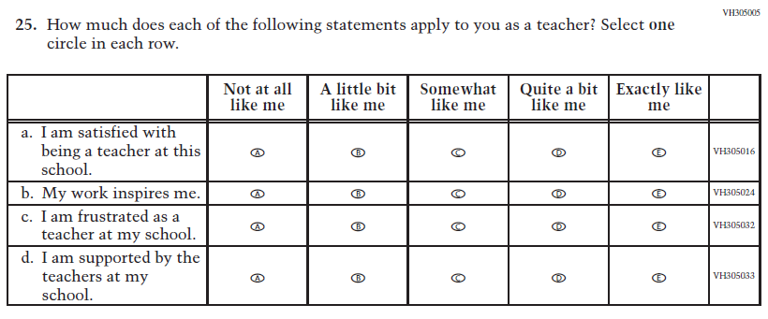  (2024) | 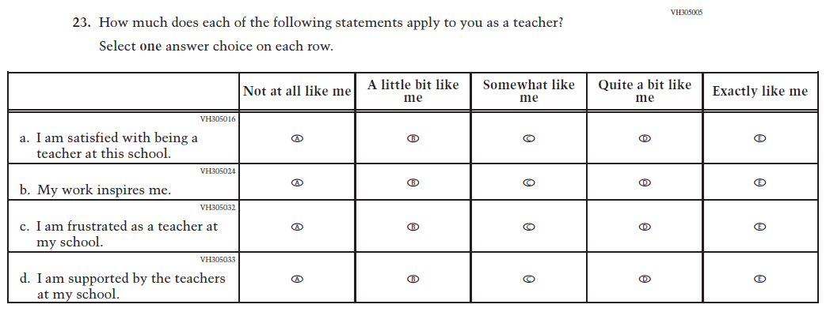  Issue: School Climate | R | For 2026, we have aligned Inline Directions in Teacher and School Items with the Directions currently used in Student Items.

2026 Operational Grade 4 Core Teacher
Previous Item | 2026 Item | D/A/R+ | Rationale
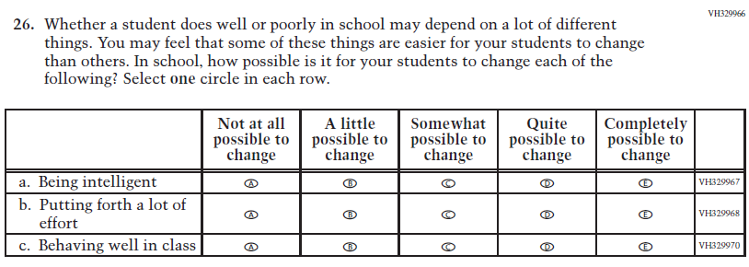  (2024) | 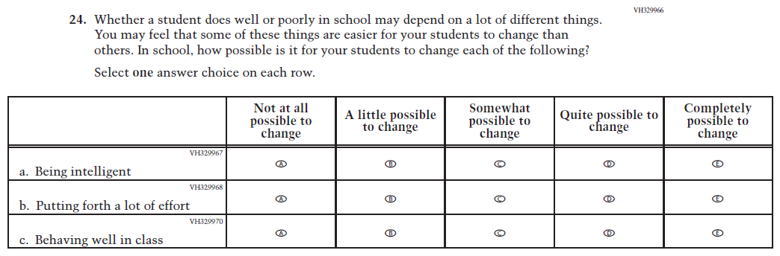  Issue: Desire for Learning | R | For 2026, we have aligned Inline Directions in Teacher and School Items with the Directions currently used in Student Items.
N/A  (2024) | 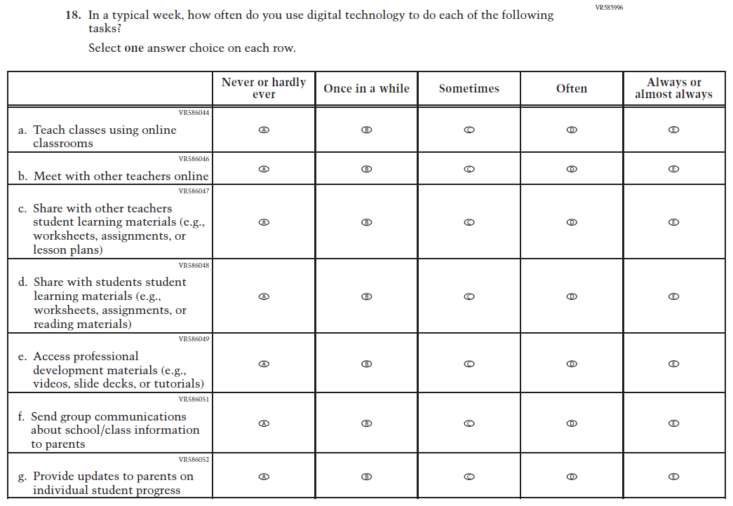  Issue: Technology Use | A | This Item was added to measure technology use among teachers.

2026 Operational Grade 4 Core Teacher
Previous Item | 2026 Item | D/A/R+ | Rationale
N/A  (2024) | 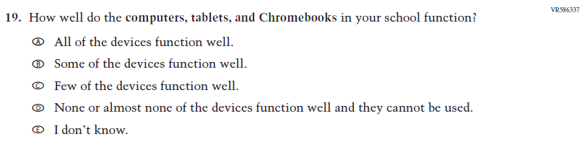  Issue: Technology Use | A | This Item was developed to measure technology use and quality of digital technology in schools.
N/A  (2024) | 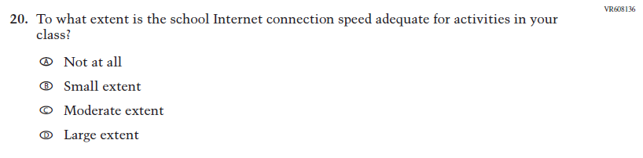  Issue: Technology Use | A | This Item was developed to measure technology use and quality of digital technology in schools.
N/A  (2024) | 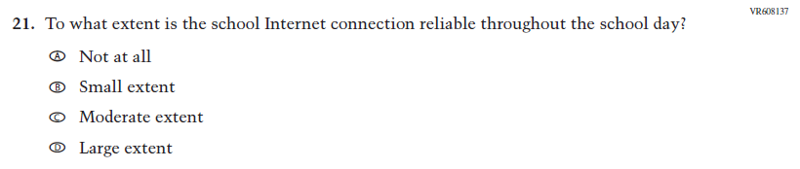  Issue: Technology Use | A | This Item was developed to measure technology use and quality of digital technology in schools.

2026 Operational Grade 4 Core Teacher
Previous Item | 2026 Item | D/A/R+ | Rationale
N/A  (2024) | 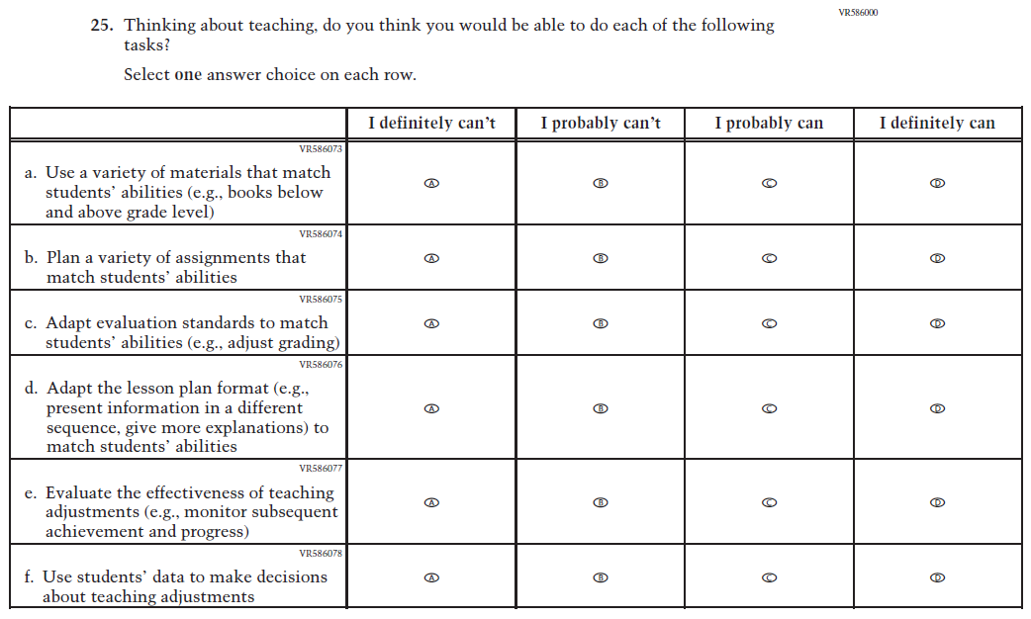  Issue: Teacher Factors | A | This Item was developed to measure teaching self-efficacy.
N/A  (2024) | 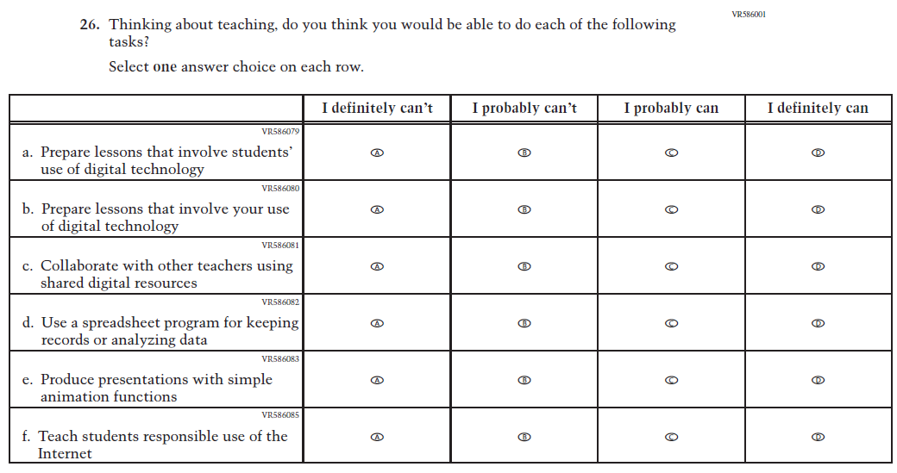  Issue: Teacher Factors | A | This Item was developed to measure teacher technology self-efficacy.

Appendix J2-2: Operational Grade 4 (Core)
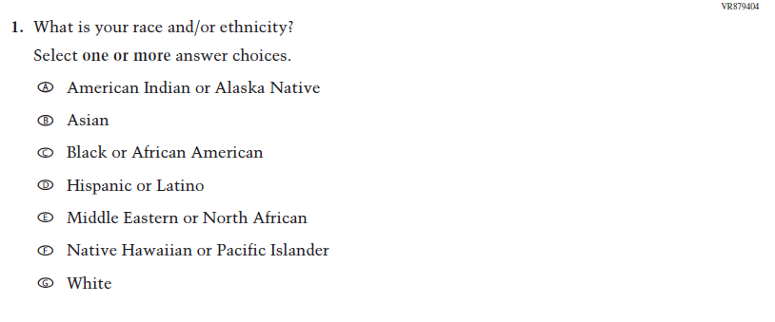
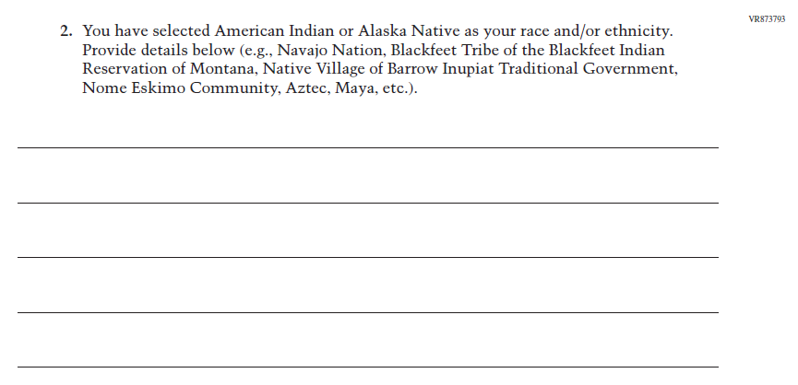
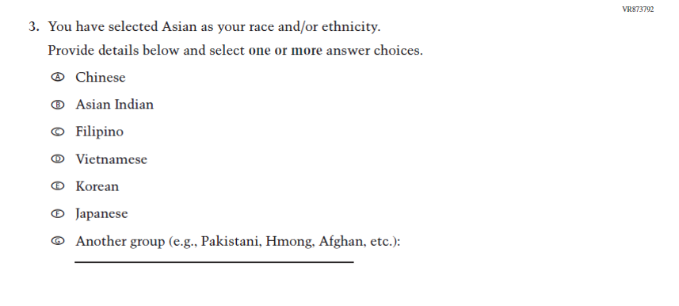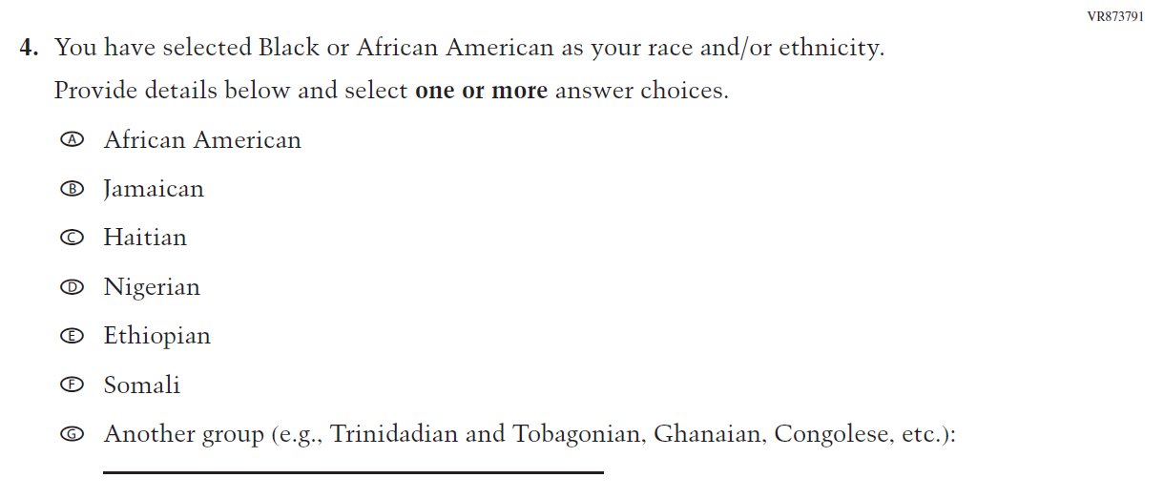
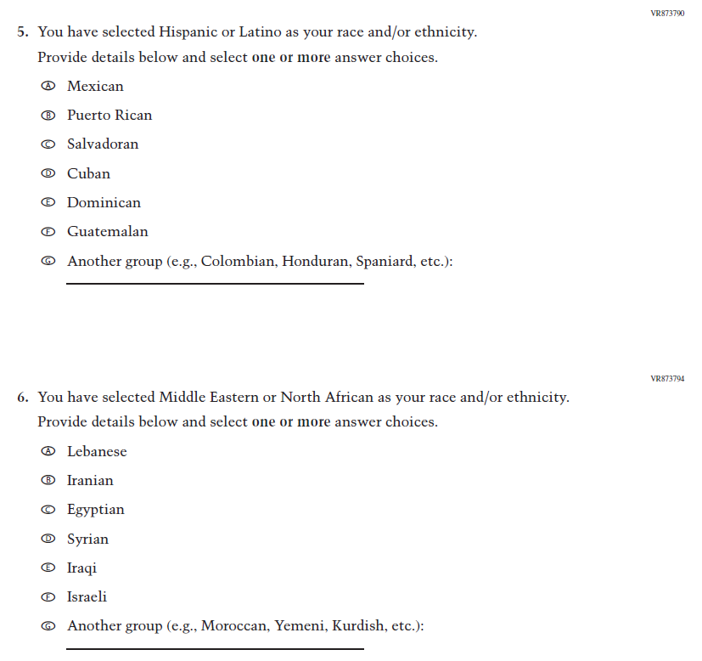
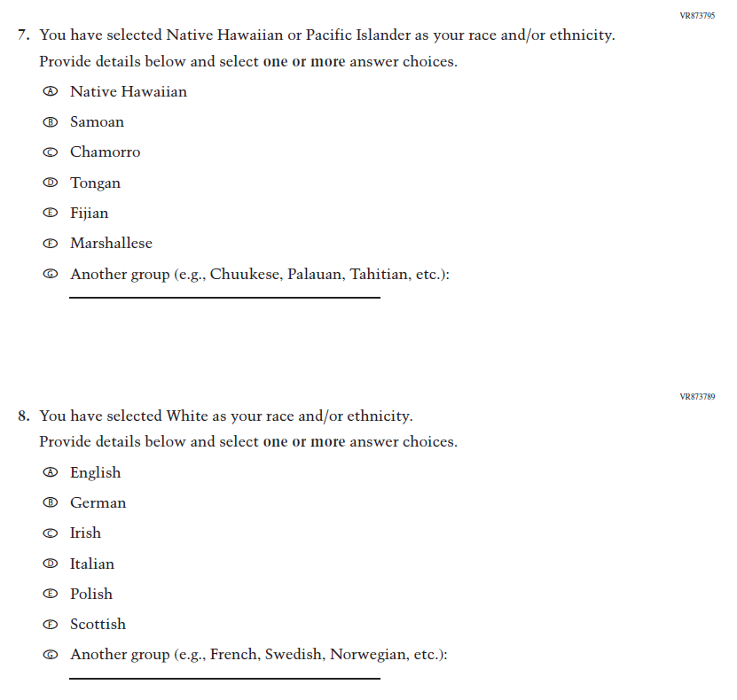
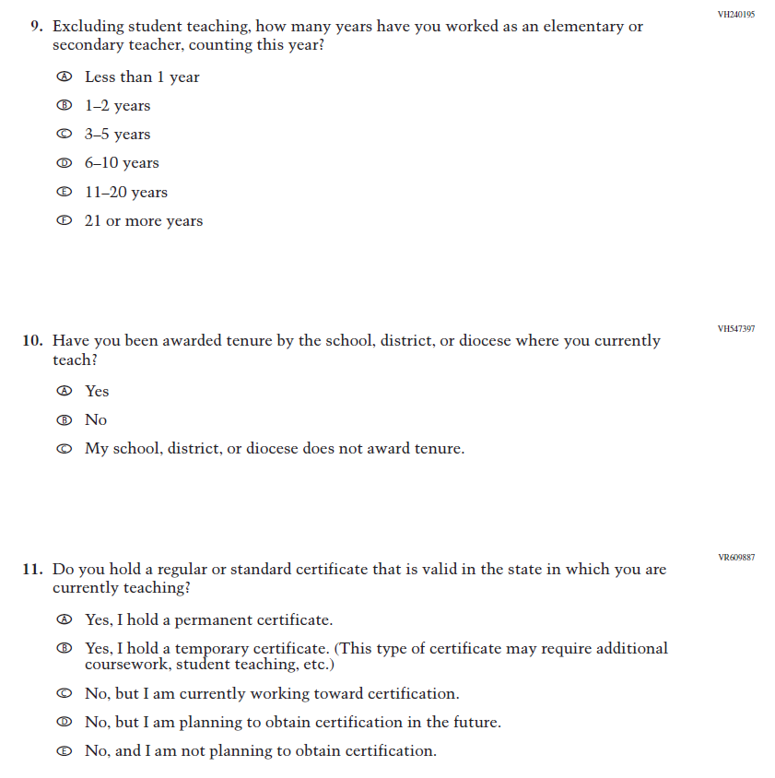
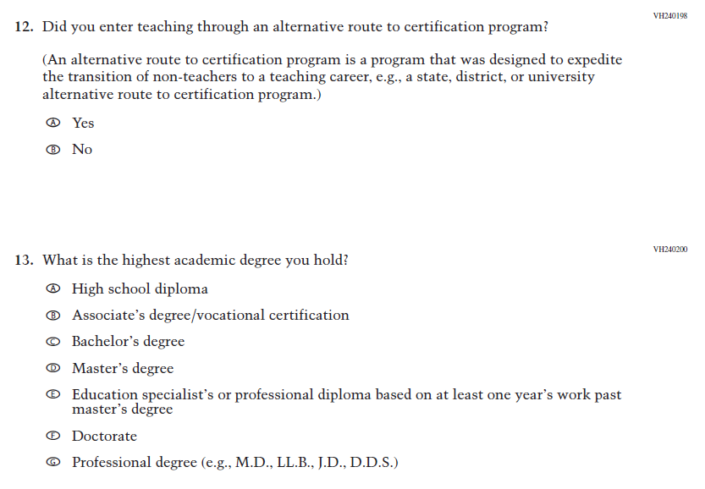
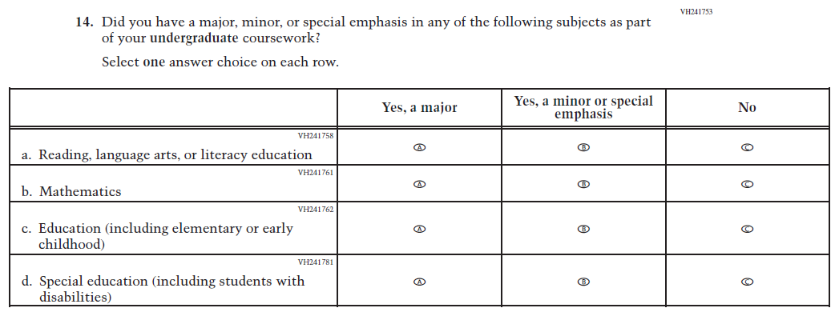
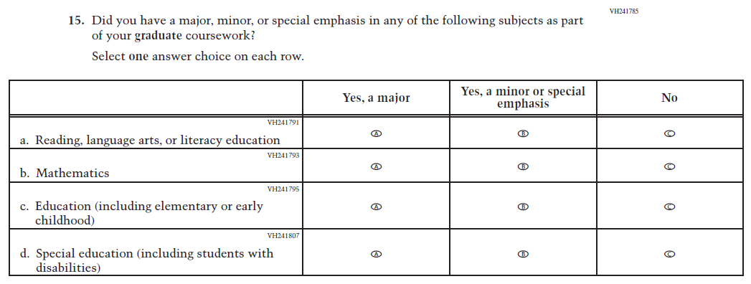
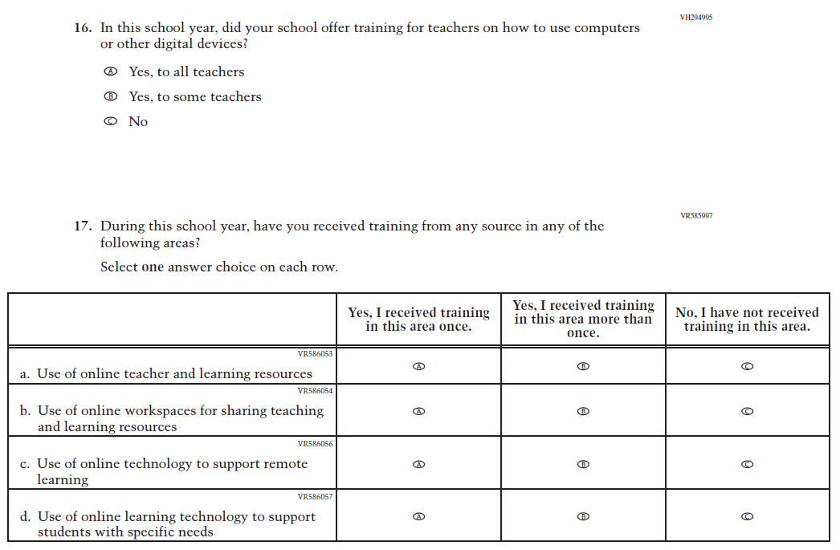
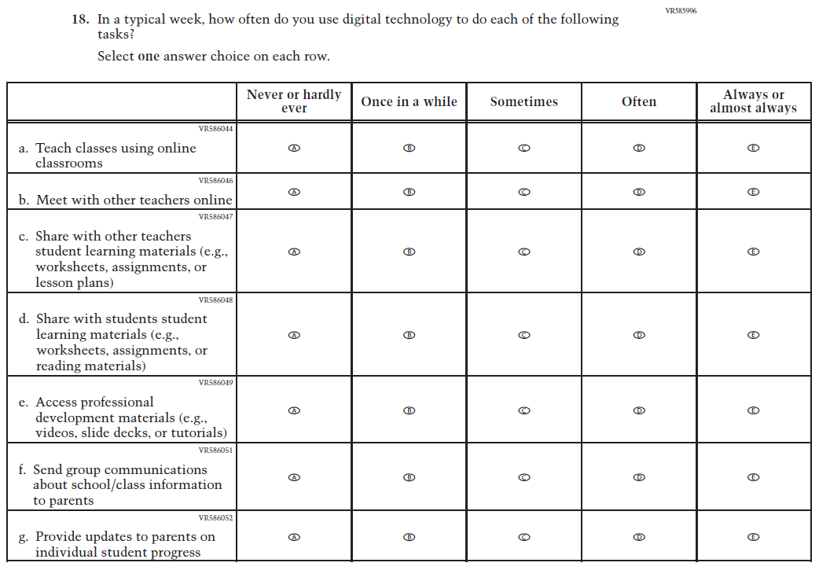
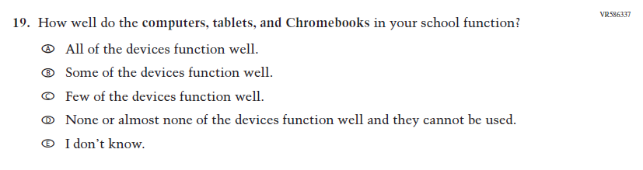
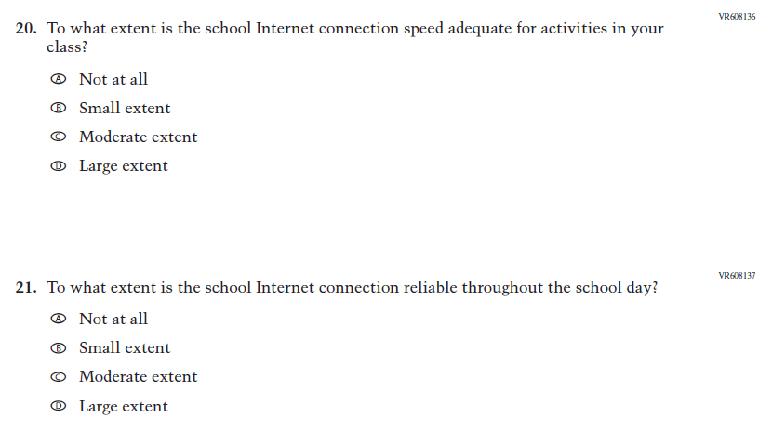
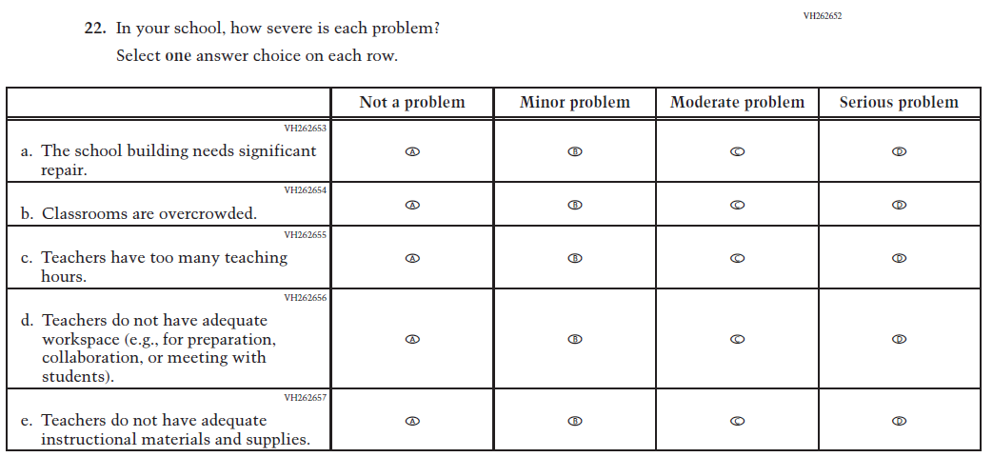
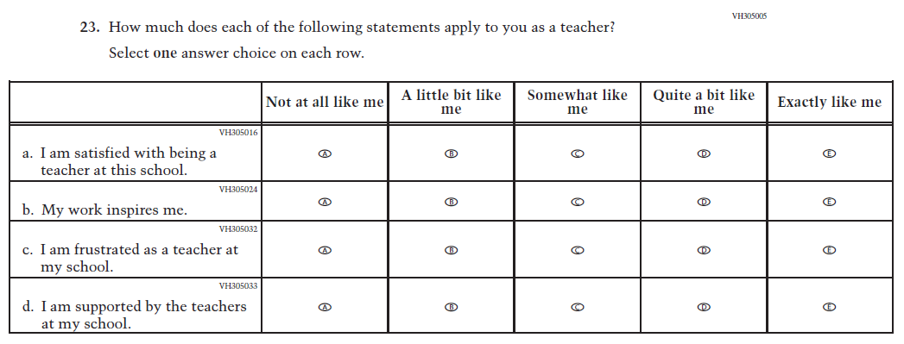
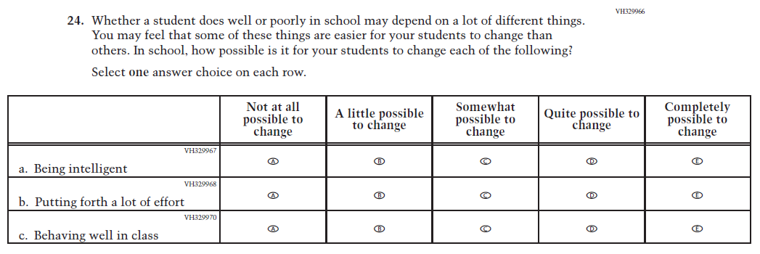
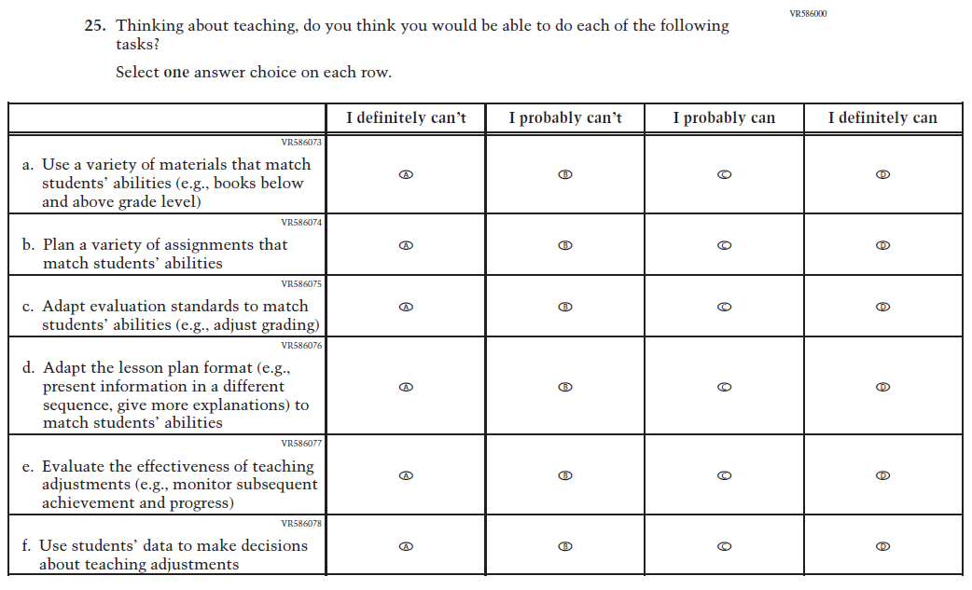
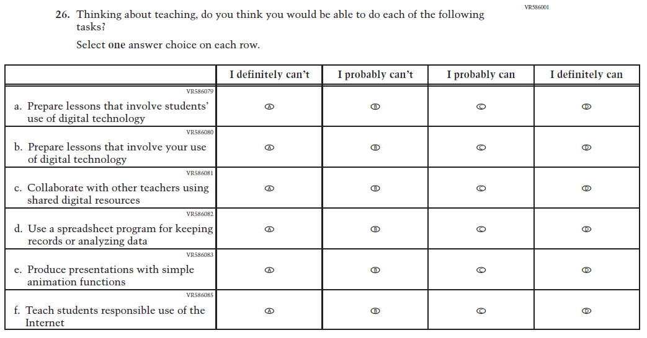

Appendix J2-3: Summary of Changes Operational Grade 8 (Core)
2026 Operational Grade 8 Core Teacher
Previous Item | 2026 Item | D/A/R+ | Rationale
(2024) | N/A | D | This Item was dropped to adhere to the January 2025 Executive Order on gender ideology and identity.
(2024) | N/A | D | This Item was dropped and folded into the following suite of updated Race/ Ethnicity Items.

2026 Operational Grade 8 Core Teacher
Previous Item | 2026 Item | D/A/R+ | Rationale
(2024) | Issue: Race/Ethnicity | R | For 2026, we have aligned Inline Directions in Teacher and School Items with the Directions currently used in Student Items. The Race/ Ethnicity Items have been updated.
N/A  (2024) | Issue: Race/Ethnicity | A | The Race/ Ethnicity Items have been updated.

2026 Operational Grade 8 Core Teacher
Previous Item | 2026 Item | D/A/R+ | Rationale
N/A  (2024) | Issue: Race/Ethnicity | A | The Race/ Ethnicity Items have been updated.
N/A  (2024) | 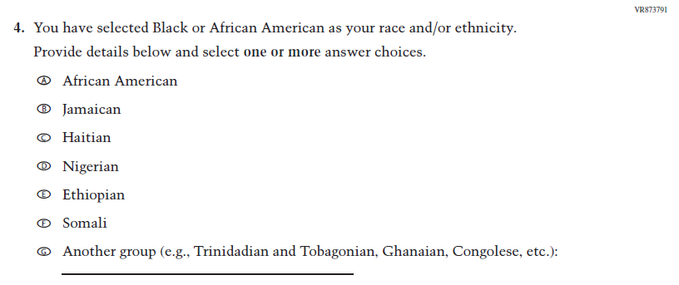  Issue: Race/Ethnicity | A | The Race/ Ethnicity Items have been updated.
N/A  (2024) | Issue: Race/Ethnicity | A | The Race/ Ethnicity Items have been updated.

2026 Operational Grade 8 Core Teacher
Previous Item | 2026 Item | D/A/R+ | Rationale
N/A  (2024) | Issue: Race/Ethnicity | A | The Race/ Ethnicity Items have been updated.
N/A  (2024) | Issue: Race/Ethnicity | A | The Race/ Ethnicity Items have been updated.
N/A  (2024) | Issue: Race/Ethnicity | A | The Race/ Ethnicity Items have been updated.
2026 Operational Grade 8 Core Teacher
Previous Item | 2026 Item | D/A/R+ | Rationale
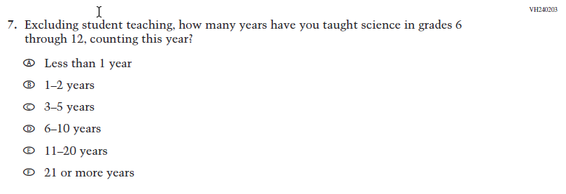  (2024) | N/A | D | This Item was dropped because Science is not part of the NAEP Assessment in 2026.
N/A  (2024) | 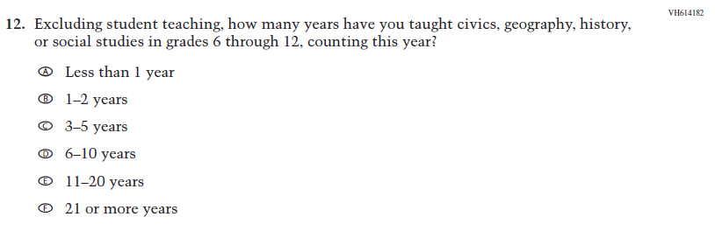  Issue: Teacher Preparation | A | This Item was added because Social Studies is part of the NAEP Assessment in 2026.
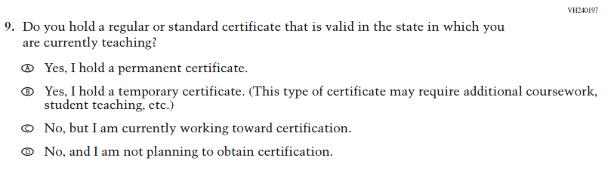  (2024) | 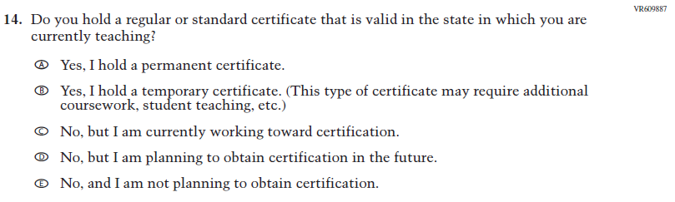  Issue: Teacher Preparation | R | Response Option D was added.

2026 Operational Grade 8 Core Teacher
Previous Item | 2026 Item | D/A/R+ | Rationale
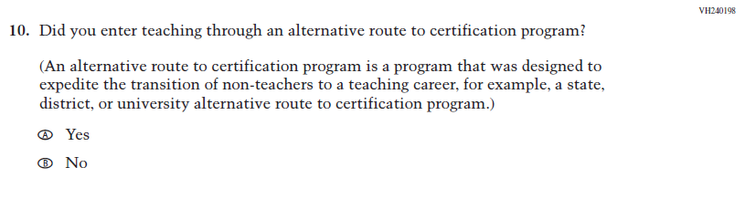  (2024) | 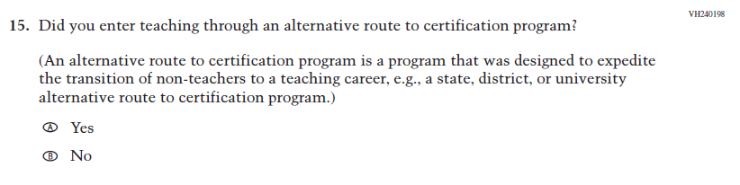  Issue: Teacher Preparation | R | We revised “for example” to “e.g.” to be consistent with the phrasing used elsewhere in Teacher and School Items.

2026 Operational Grade 8 Core Teacher
Previous Item | 2026 Item | D/A/R+ | Rationale
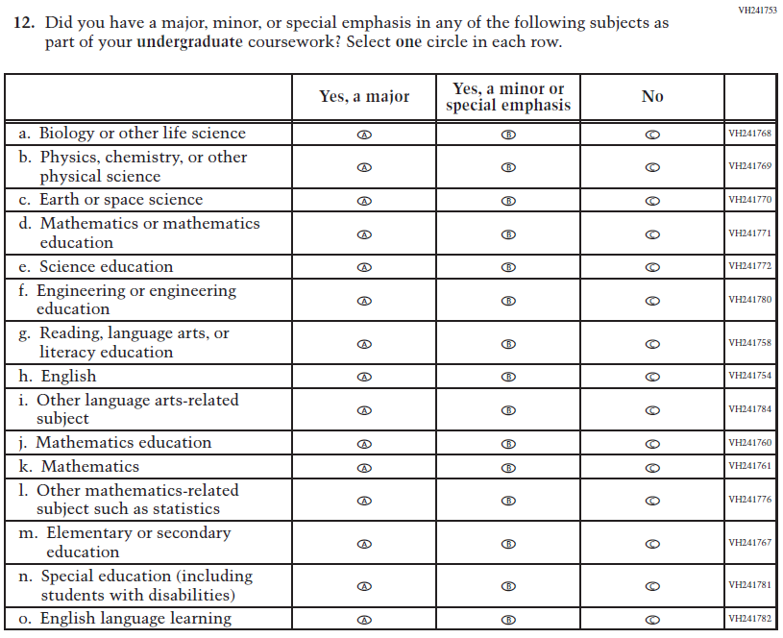  (2024) | 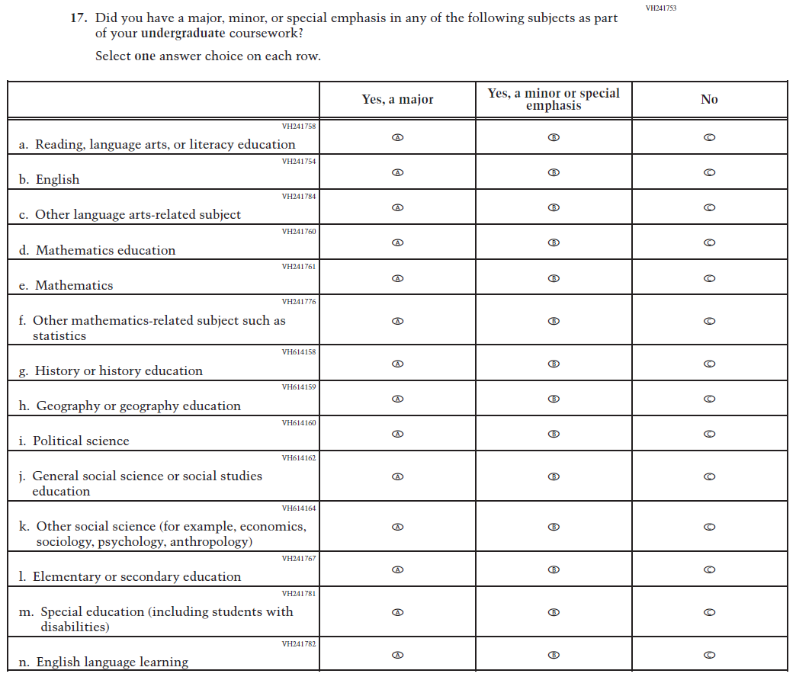  Issue: Teacher Preparation | R | For 2026, we have aligned Inline Directions in Teacher and School Items with the Directions currently used in Student Items. This Item was revised to remove Science-related SubItems a through f and add Social Studies-related SubItems, since Science is not being administered in 2026, and Social Studies is.
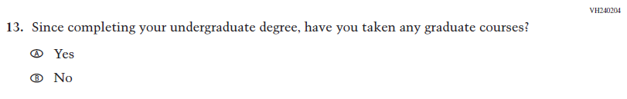  (2024) | N/A | D | This Item was dropped to reduce burden and streamline content.

2026 Operational Grade 8 Core Teacher
Previous Item | 2026 Item | D/A/R+ | Rationale
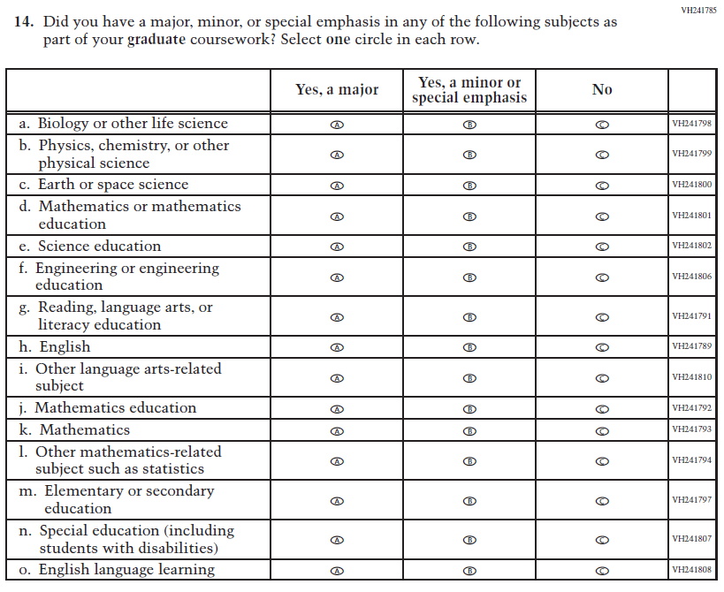  (2024) | 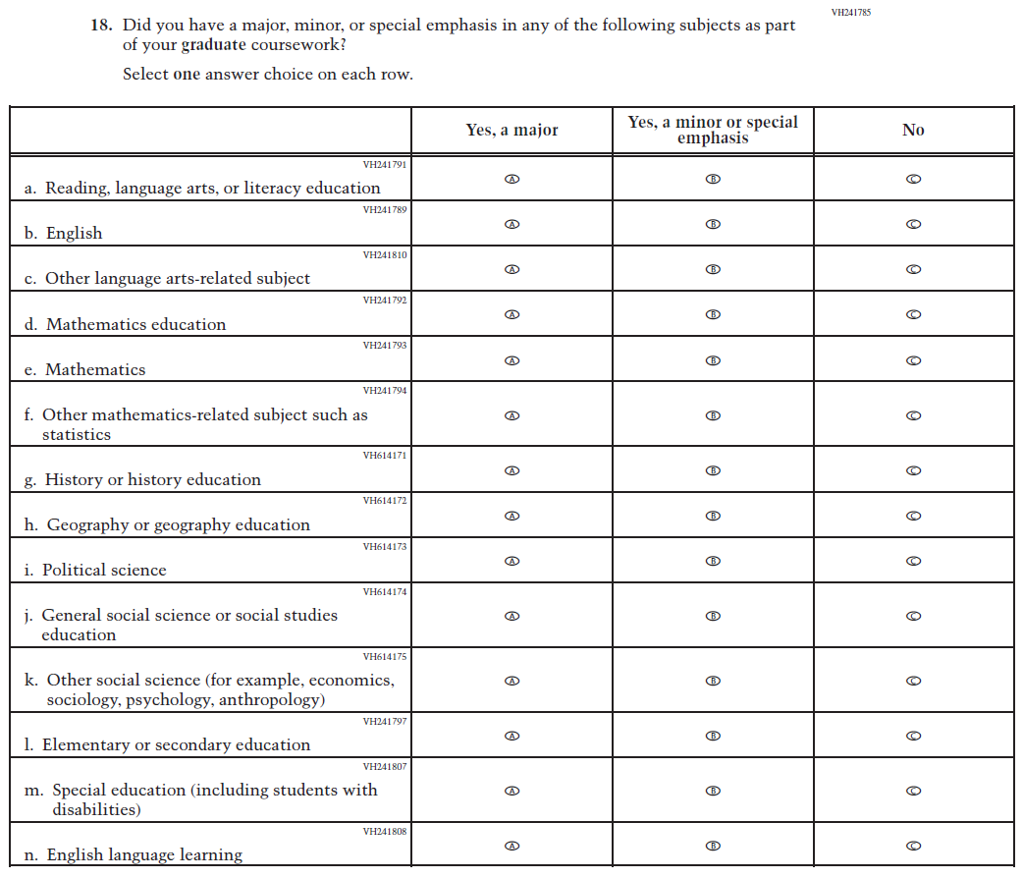  Issue: Teacher Preparation | R | For 2026, we have aligned Inline Directions in Teacher and School Items with the Directions currently used in Student Items. This Item was revised to remove Science-related SubItems a through f and add Social Studies-related SubItems, since Science is not being administered in 2026, and Social Studies is.

2026 Operational Grade 8 Core Teacher
Previous Item | 2026 Item | D/A/R+ | Rationale
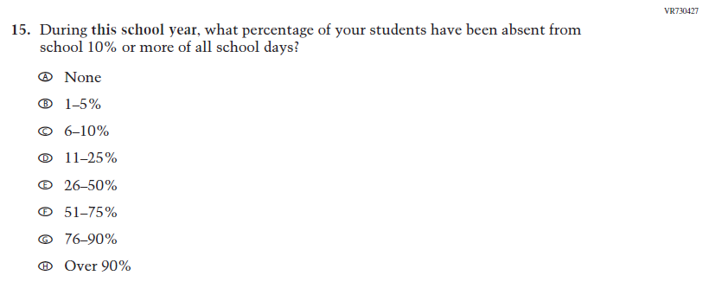  (2024) | N/A | D | Learning Recovery Items were dropped from the 2026 NAEP Assessment.
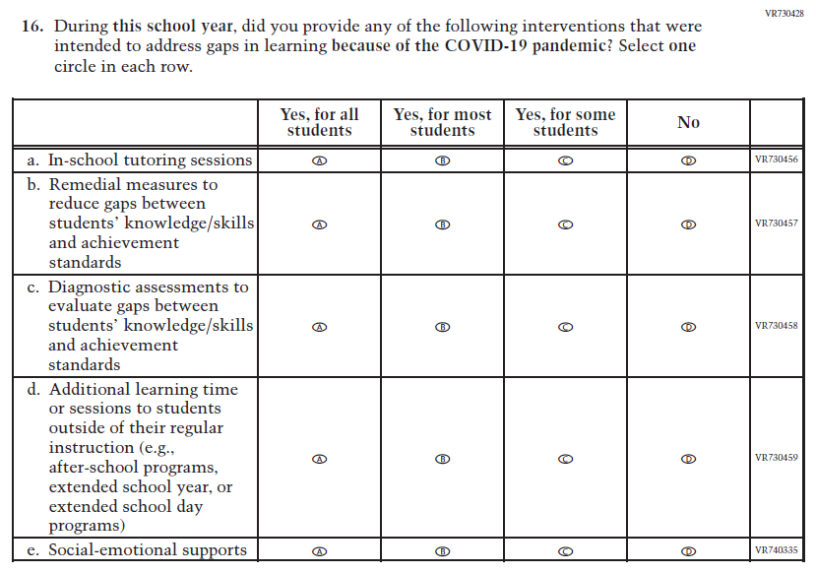  (2024) | N/A | D | Learning Recovery Items were dropped from the 2026 NAEP Assessment.

2026 Operational Grade 8 Core Teacher
Previous Item | 2026 Item | D/A/R+ | Rationale
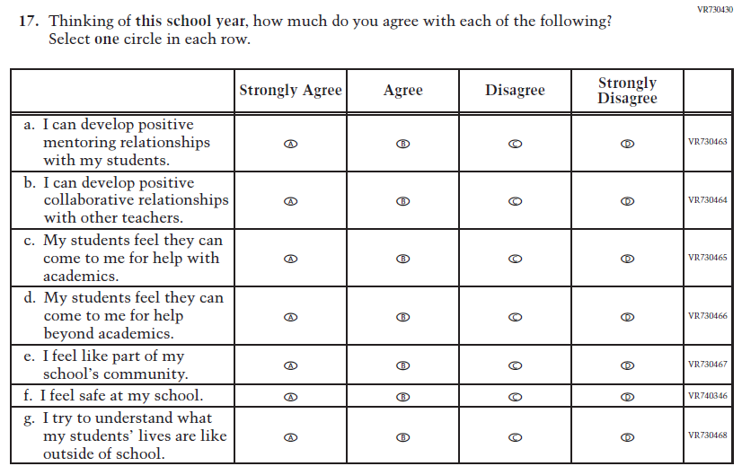  (2024) | N/A | D | Learning Recovery Items were dropped from the 2026 NAEP Assessment.
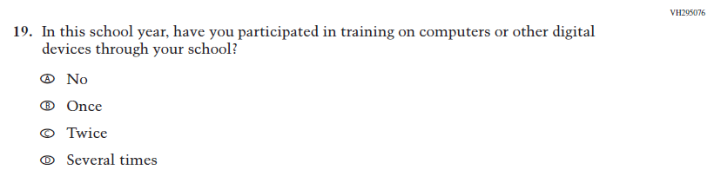  (2024) | N/A | D | This Item was dropped to prioritize newer, updated Teacher items on Technology Use.

2026 Operational Grade 8 Core Teacher
Previous Item | 2026 Item | D/A/R+ | Rationale
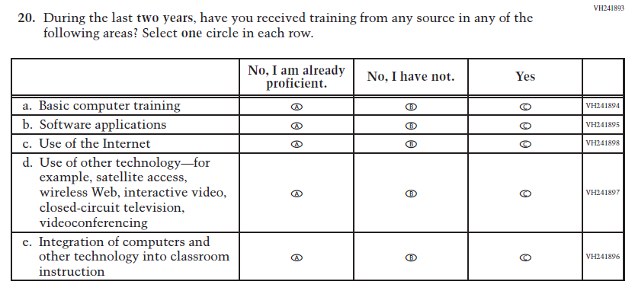  (2024) | 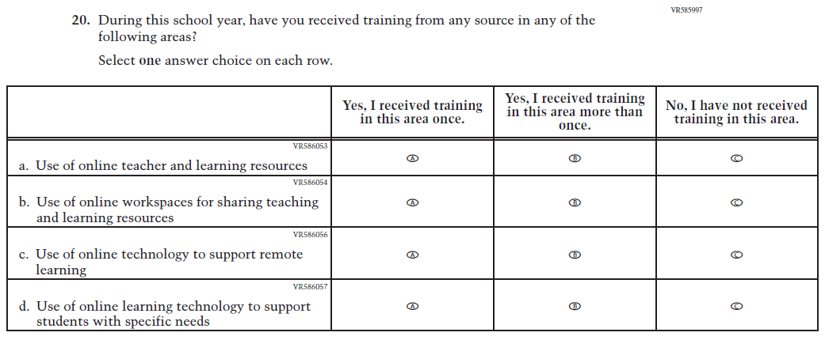  Issue: Technology Use | R | For 2026, we have aligned Inline Directions in Teacher and School Items with the Directions currently used in Student Items. The Item has been revised to focus on training in Technology Use.
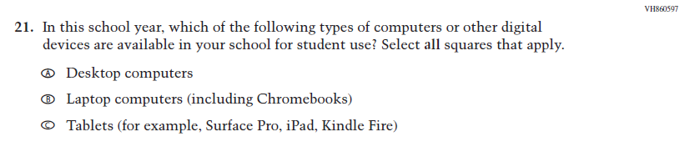  (2024) | N/A | D | This and the related Items were dropped in favor of a more current and concise format for questions on Technology Use.

2026 Operational Grade 8 Core Teacher
Previous Item | 2026 Item | D/A/R+ | Rationale
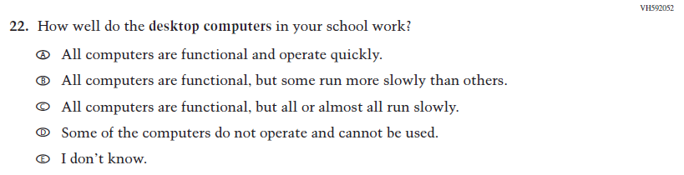  (2024) | N/A | D | This and the related Items were dropped in favor of a more current and concise format for questions on Technology Use.
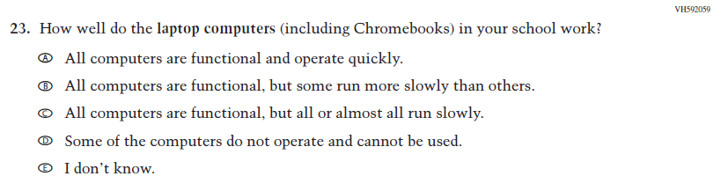  (2024) | N/A | D | This and the related Items were dropped in favor of a more current and concise format for questions on Technology Use.
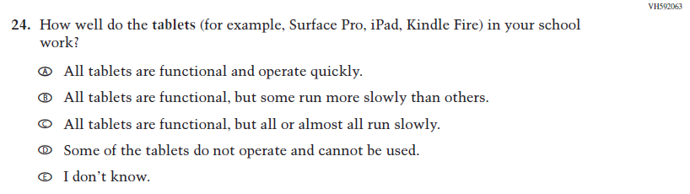  (2024) | N/A | D | This and the related Items were dropped in favor of a more current and concise format for questions on Technology Use.

2026 Operational Grade 8 Core Teacher
Previous Item | 2026 Item | D/A/R+ | Rationale
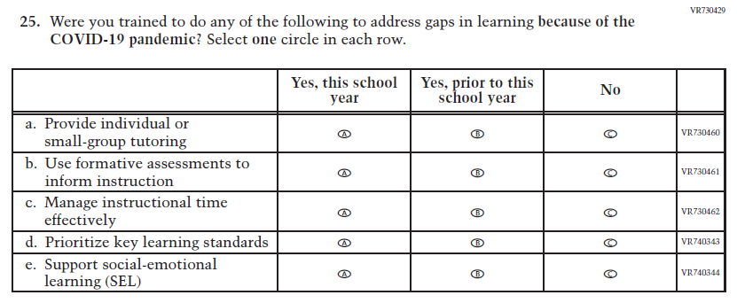  (2024) | N/A | D | Learning Recovery Items were dropped from the 2026 NAEP Assessment.
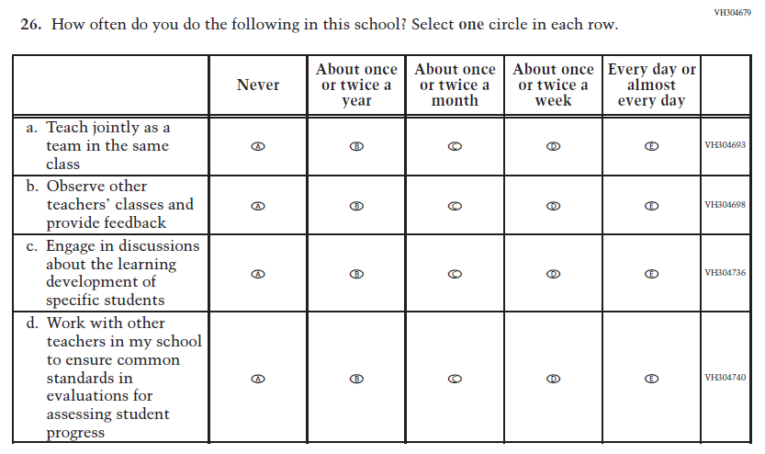  (2024) | N/A | D | This Item was dropped to make space for new Teacher Items in the 2026 NAEP Assessment.

2026 Operational Grade 8 Core Teacher
Previous Item | 2026 Item | D/A/R+ | Rationale
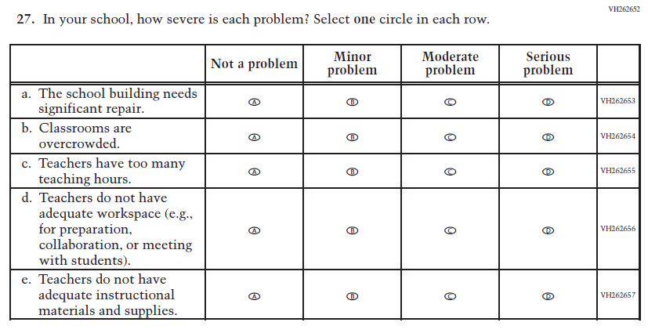  (2024) | 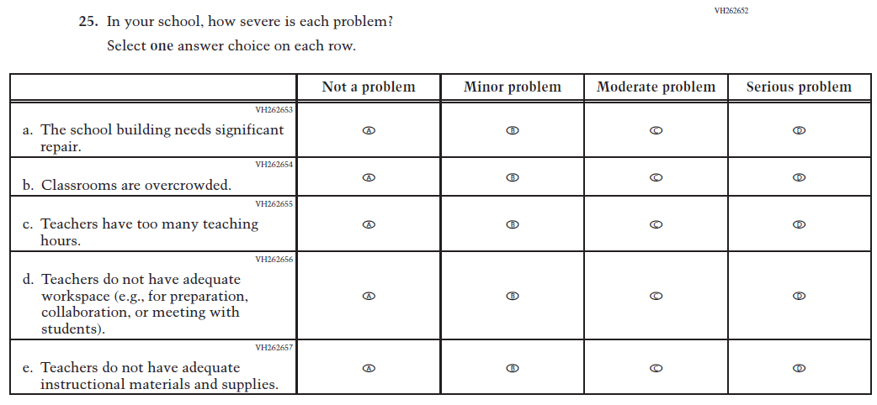  Issue: School Climate | R | For 2026, we have aligned Inline Directions in Teacher and School Items with the Directions currently used in Student Items.
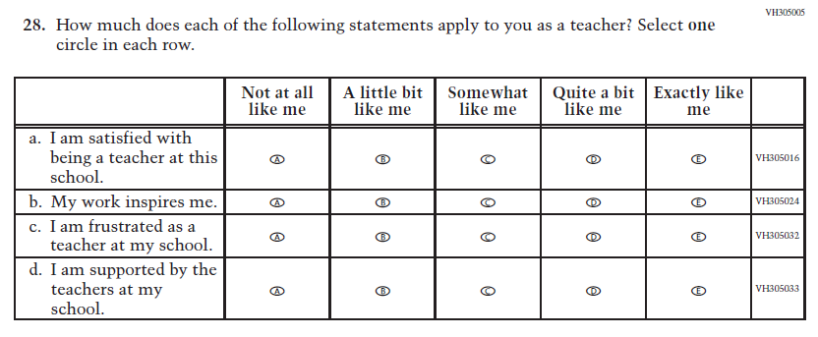  (2024) | 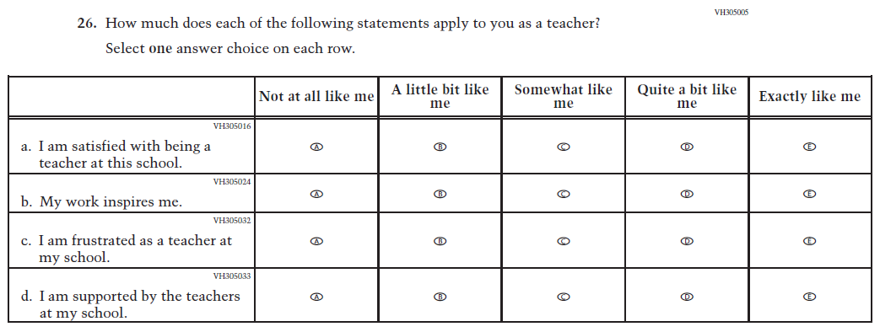  Issue: School Climate | R | For 2026, we have aligned Inline Directions in Teacher and School Items with the Directions currently used in Student Items.

2026 Operational Grade 8 Core Teacher
Previous Item | 2026 Item | D/A/R+ | Rationale
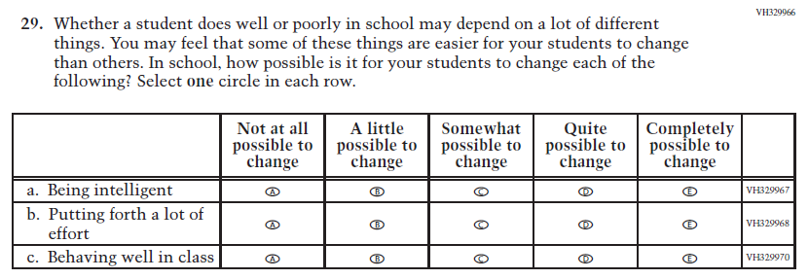  (2024) | 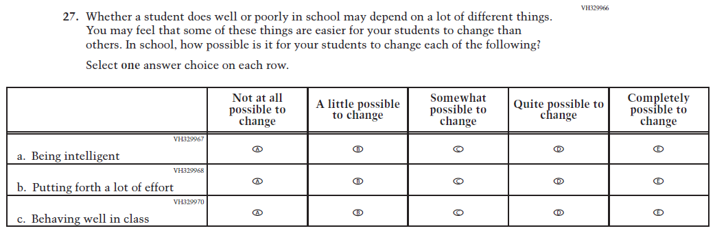  Issue: Desire for Learning | R | For 2026, we have aligned Inline Directions in Teacher and School Items with the Directions currently used in Student Items.
N/A  (2024) | 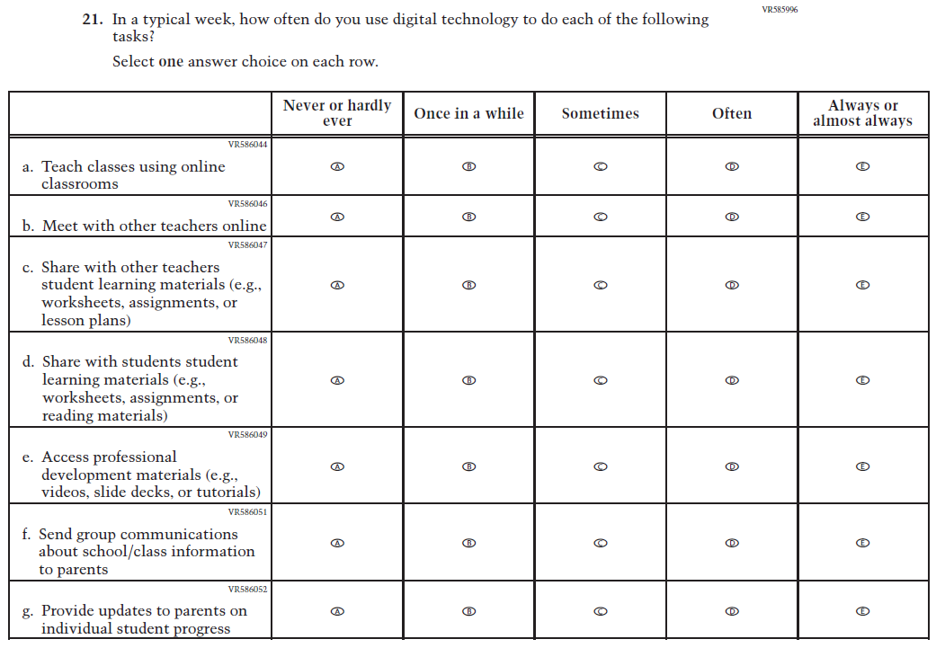  Issue: Technology Use | A | This Item was added to measure technology use among teachers.

2026 Operational Grade 8 Core Teacher
Previous Item | 2026 Item | D/A/R+ | Rationale
N/A  (2024) | 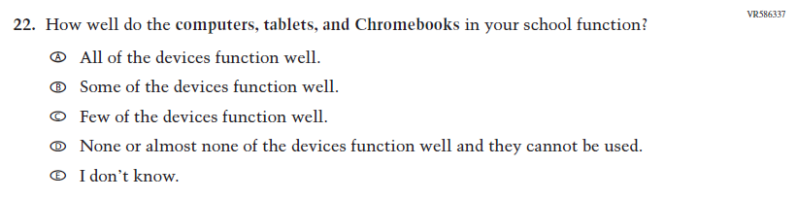  Issue: Technology Use | A | This Item was developed to measure technology use and quality of digital technology in schools.
N/A  (2024) | 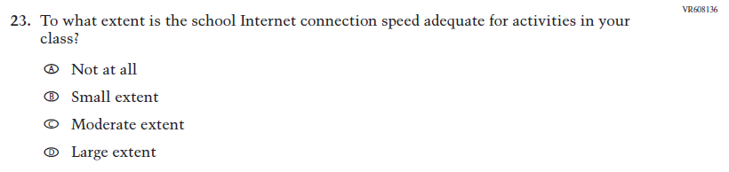  Issue: Technology Use | A | This Item was developed to measure technology use and quality of digital technology in schools.
N/A  (2024) | 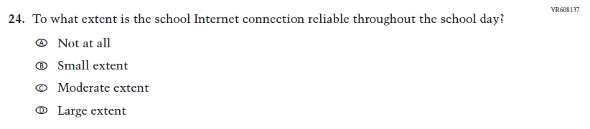  Issue: Technology Use | A | This Item was developed to measure technology use and quality of digital technology in schools.

2026 Operational Grade 8 Core Teacher
Previous Item | 2026 Item | D/A/R+ | Rationale
N/A  (2024) | 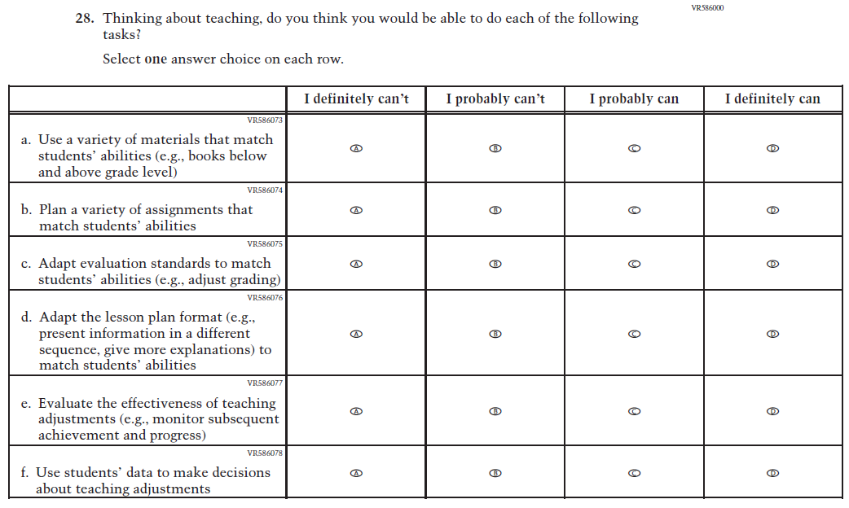  Issue: Teacher Factors | A | This Item was developed to measure teaching self-efficacy.
N/A  (2024) | 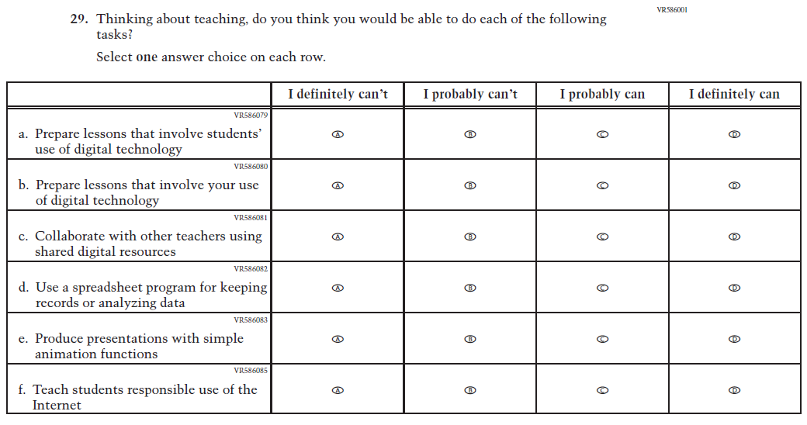  Issue: Teacher Factors | A | This Item was developed to measure teacher technology self-efficacy.

Appendix J2-4: Operational Grade 8 (Core)
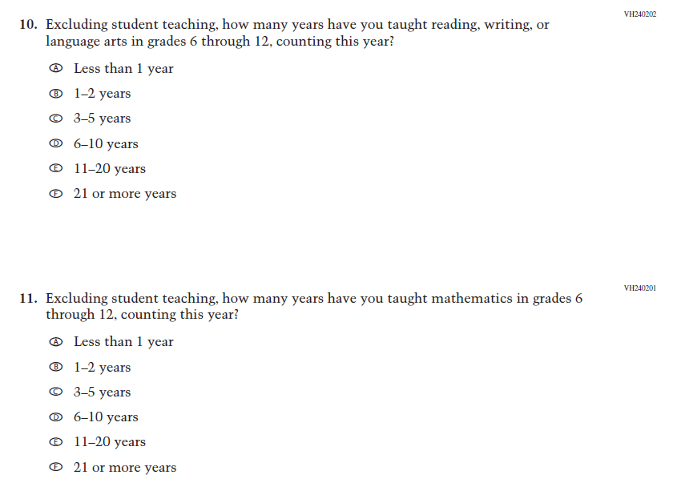
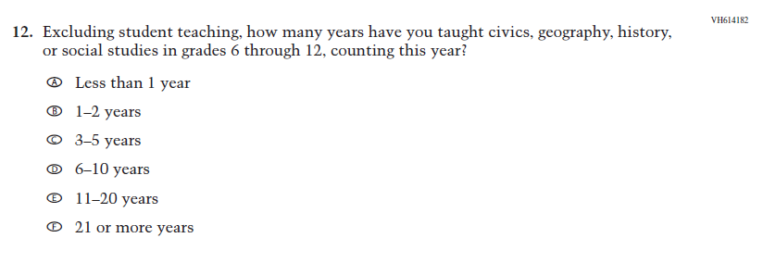
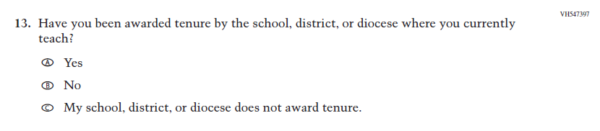
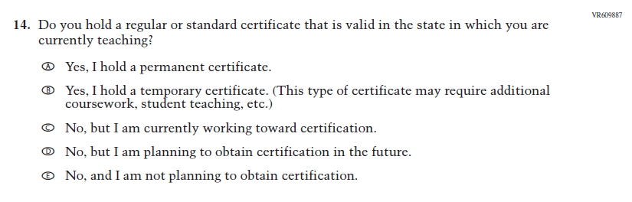
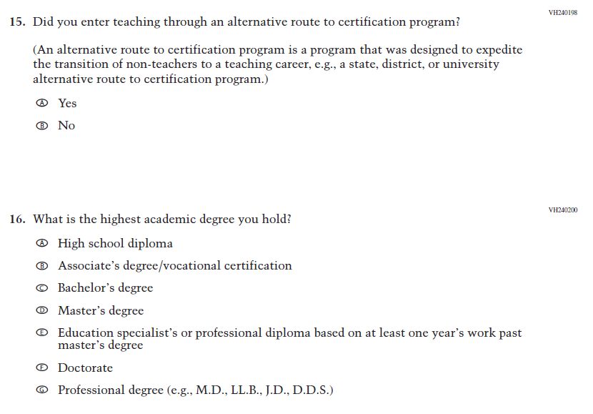
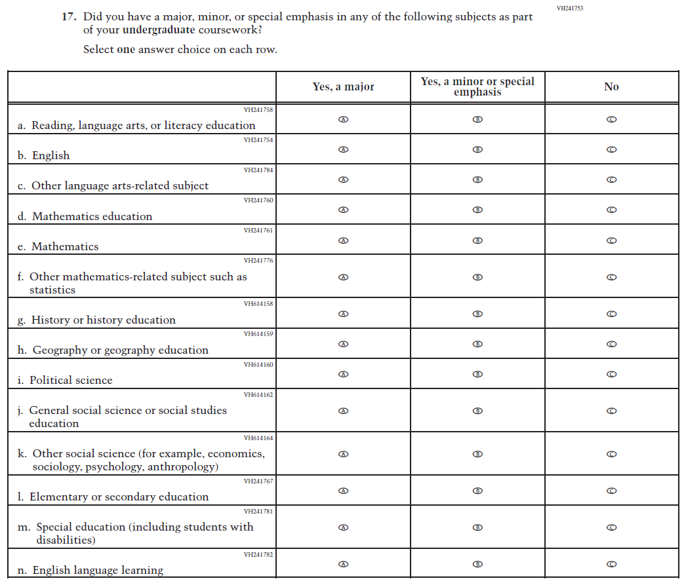
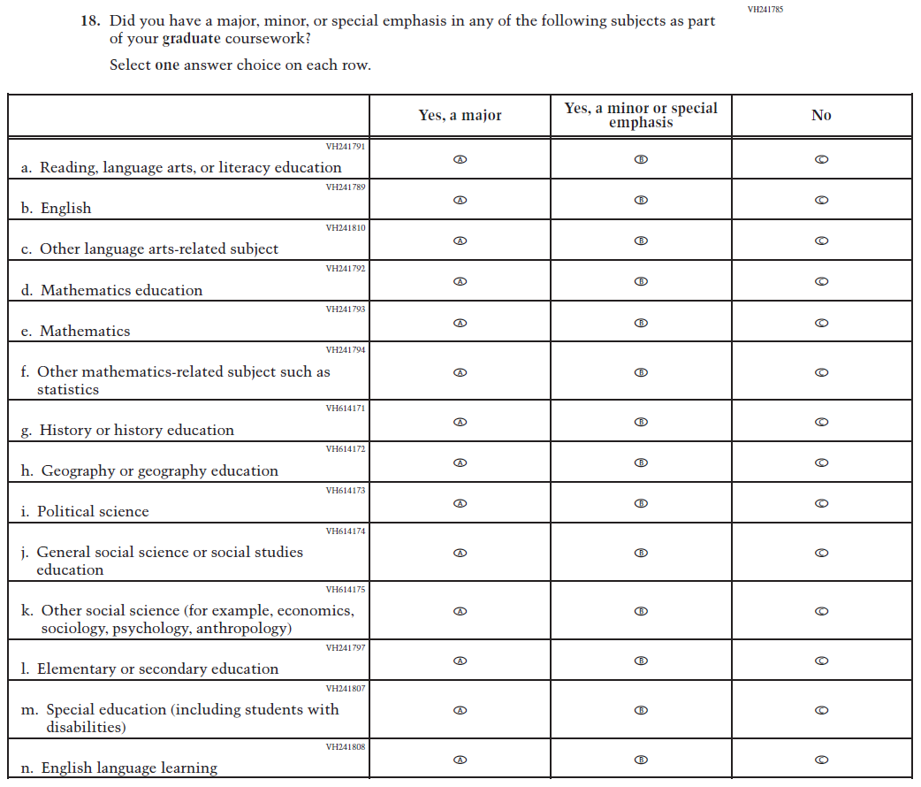
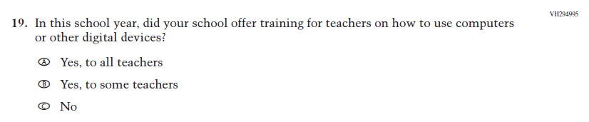
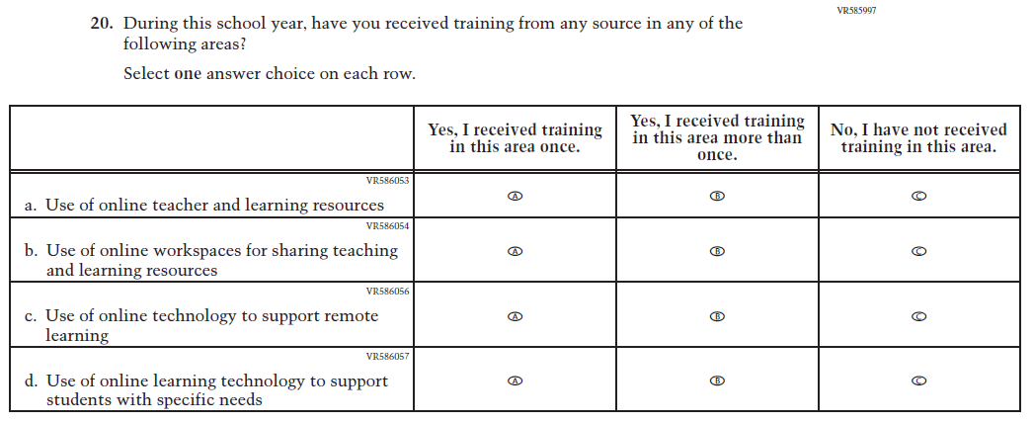
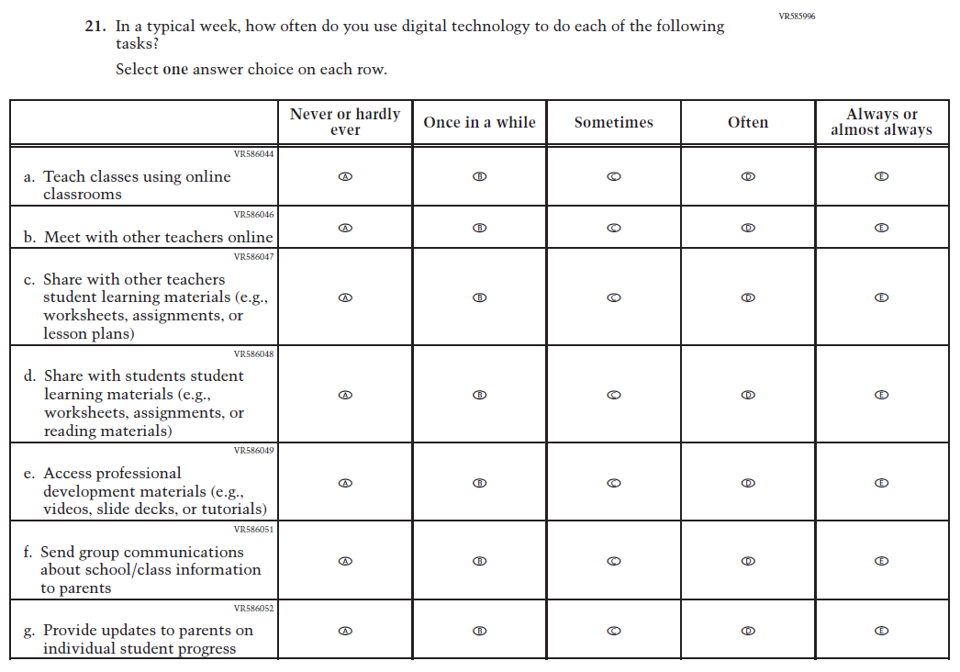
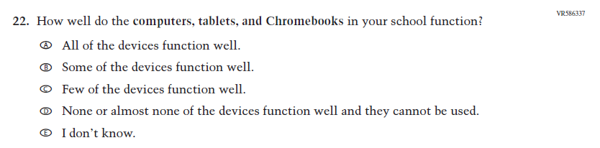
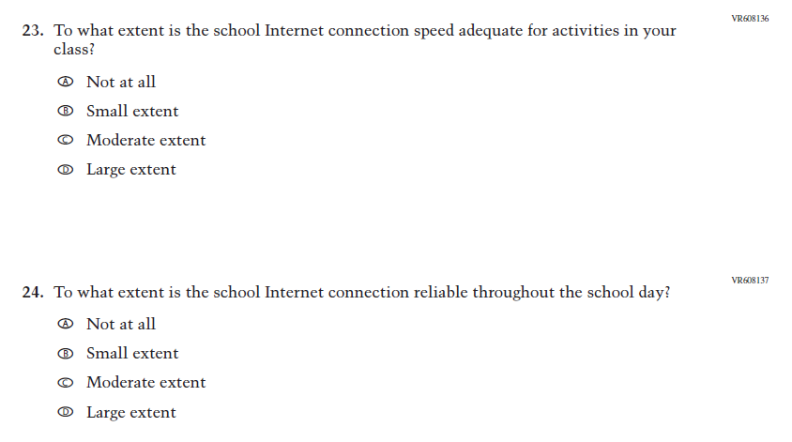
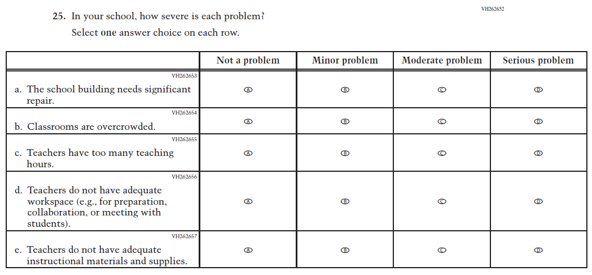
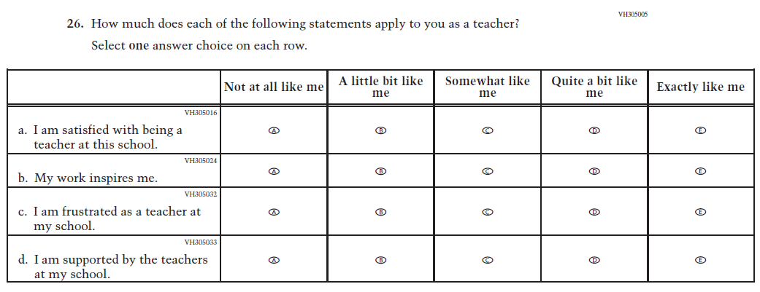
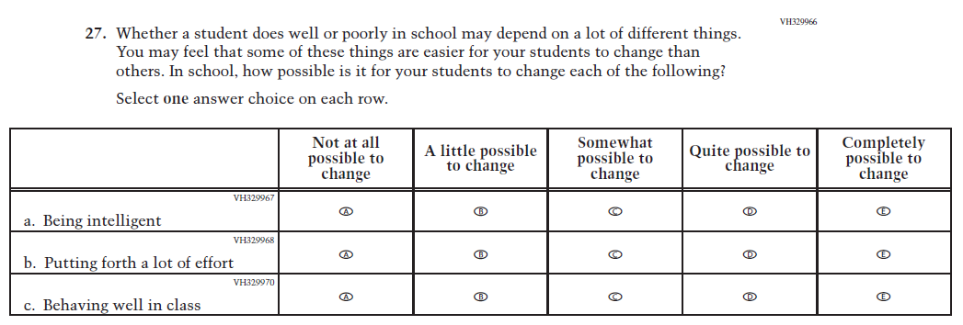
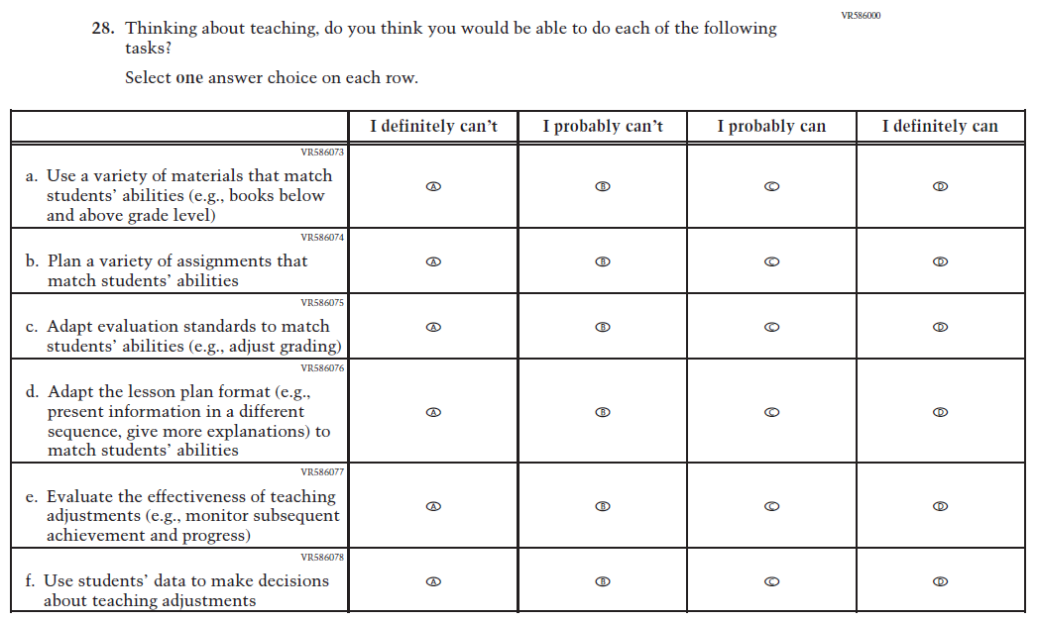
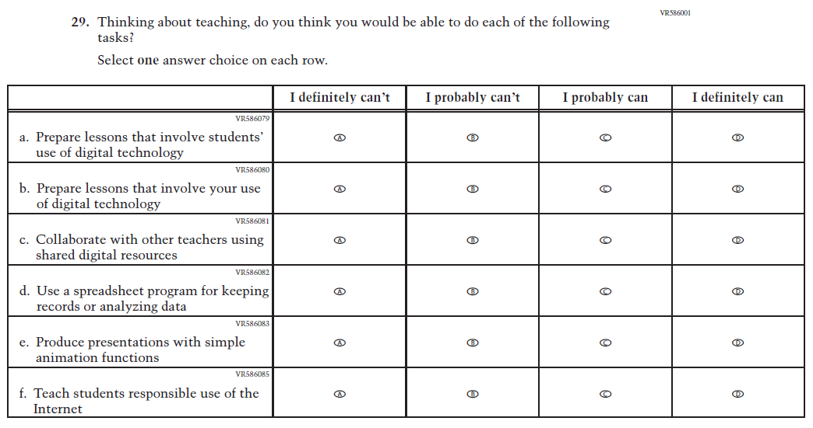

Appendix J2-5: Summary of Changes Operational Grade 4 (Mathematics)
2026 Operational Grade 4 Mathematics Teacher
Previous Item | 2026 Item | D/A/R+ | Rationale
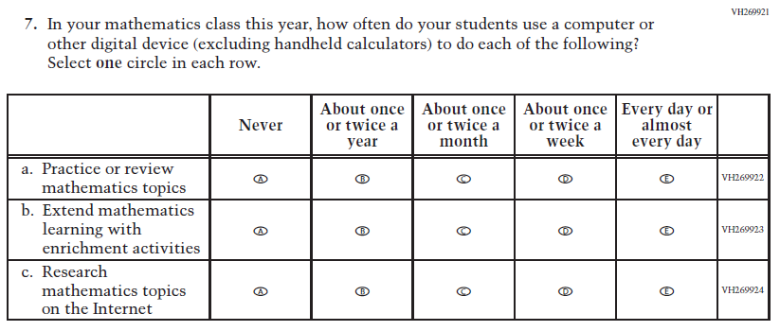  (2024) | 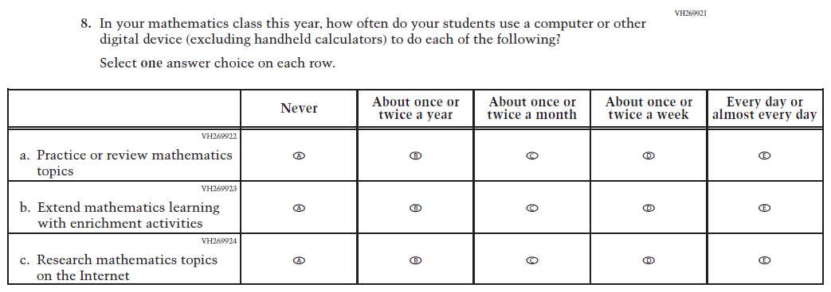  Issue: Instructional Organization and Strategies | R | For 2026, we have aligned Inline Directions in Teacher and School Items with the Directions currently used in Student Items.

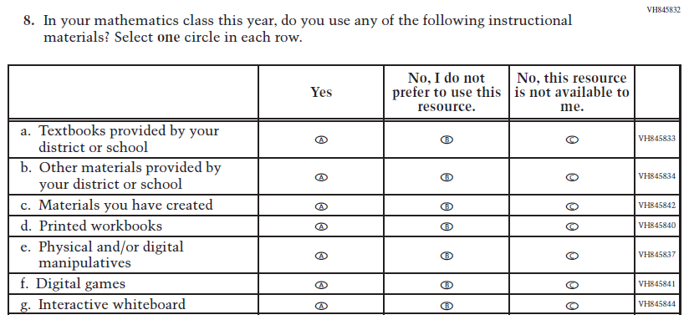  (2024) | 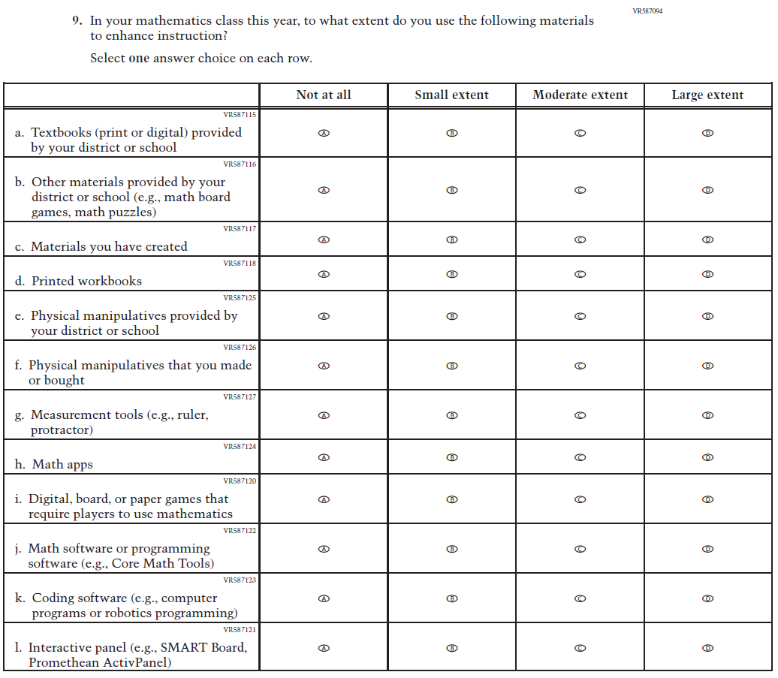  Issue: Instructional Resources | R | For 2026, we have aligned Inline Directions in Teacher and School Items with the Directions currently used in Student Items. The Item stem and subitems a, b, e, f, and g were revised for clarity and new subitems were developed to measure content aligned with the new Mathematics framework.

2026 Operational Grade 4 Mathematics Teacher
Previous Item | 2026 Item | D/A/R+ | Rationale
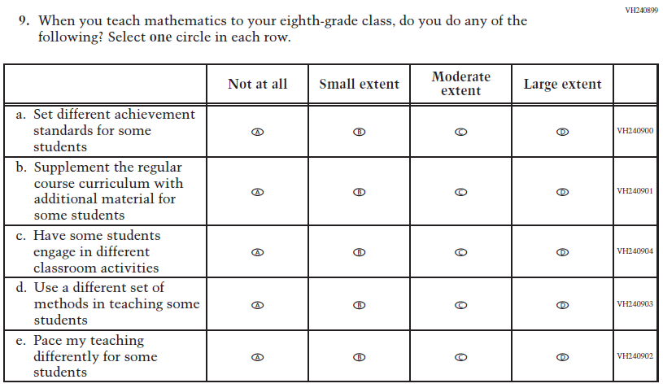  (2024) | 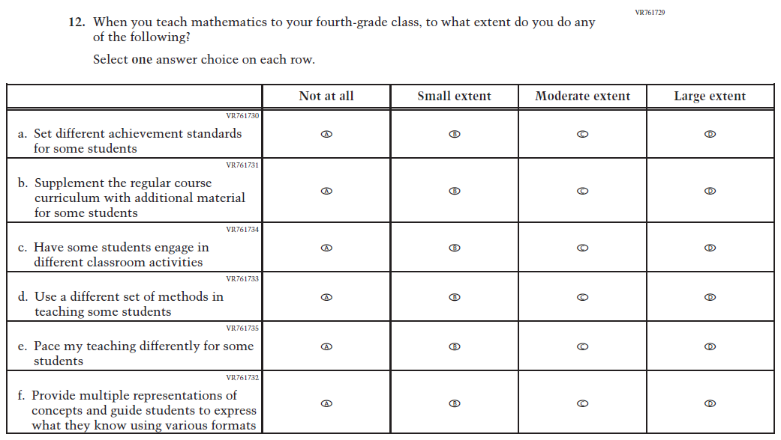  Issue: Instructional Organization and Strategies | R | For 2026, we have aligned Inline Directions in Teacher and School Items with the Directions currently used in Student Items. The Item stem was revised and subItem f was developed to measure content aligned with the new Mathematics framework.

2026 Operational Grade 4 Mathematics Teacher
Previous Item | 2026 Item | D/A/R+ | Rationale
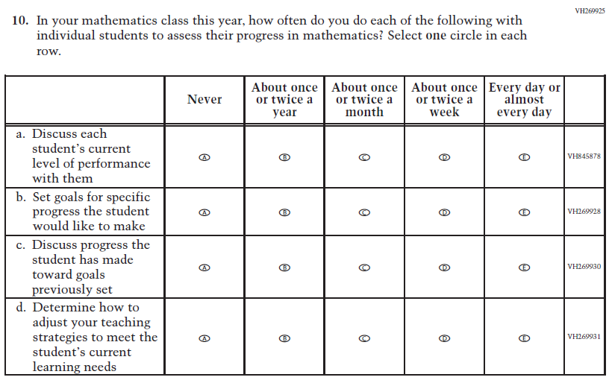  (2024) | 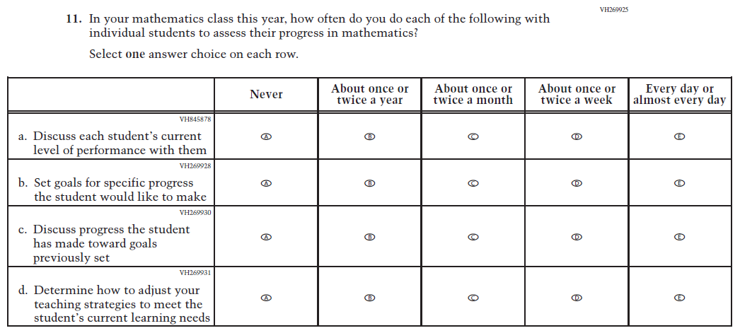  Issue: Instructional Organization and Strategies | R | For 2026, we have aligned Inline Directions in Teacher and School Items with the Directions currently used in Student Items.

2026 Operational Grade 4 Mathematics Teacher
Previous Item | 2026 Item | D/A/R+ | Rationale
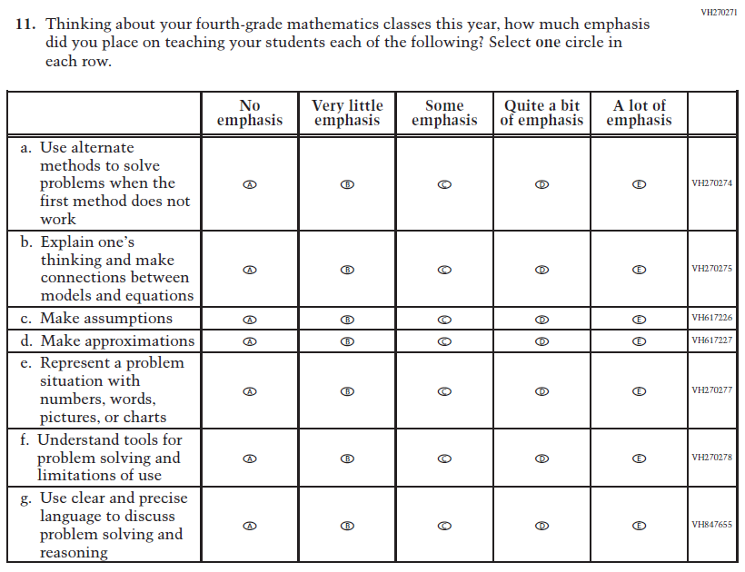  (2024) | 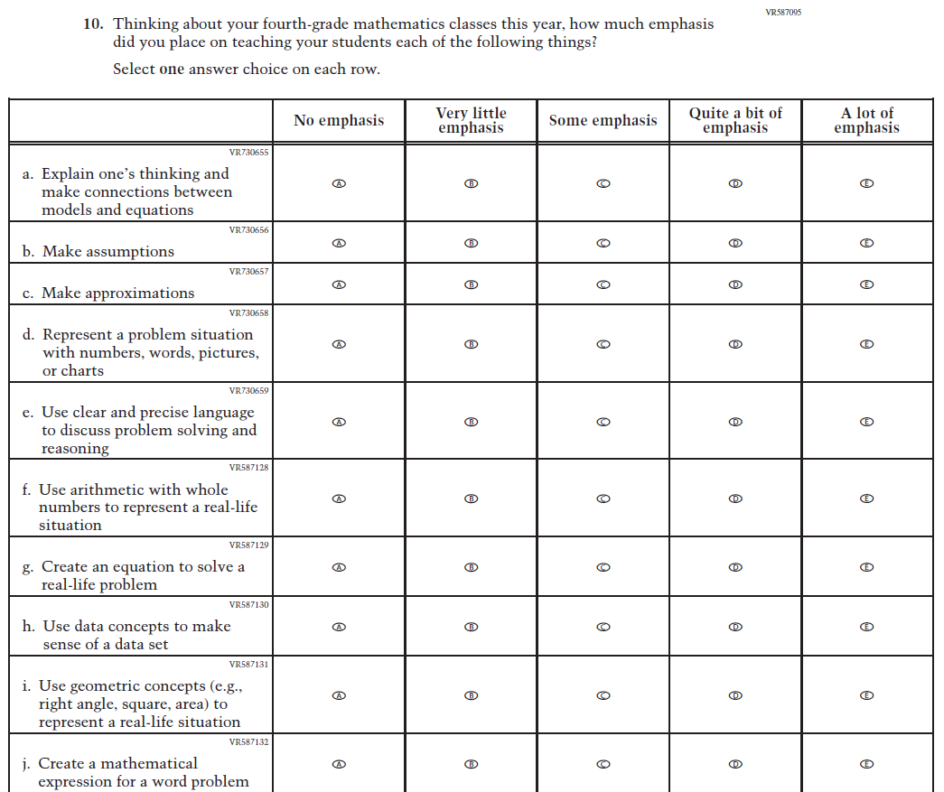  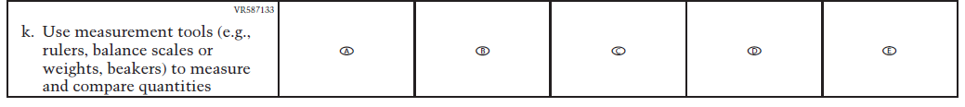  Issue: N/A | R | For 2026, we have aligned Inline Directions in Teacher and School Items with the Directions currently used in Student Items. The Item stem was revised for clarity, six subitems were kept, and new subitems were developed to measure content aligned with the new Mathematics framework.
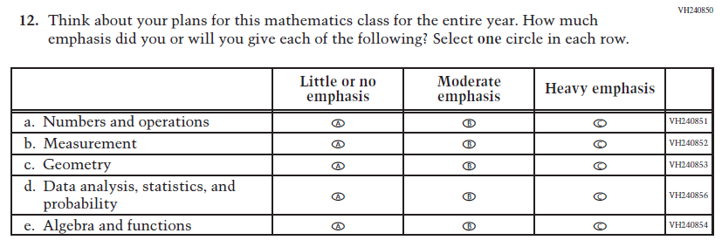  (2024) | N/A | D | This Item was dropped to reduce questionnaire length.
2026 Operational Grade 4 Mathematics Teacher
Previous Item | 2026 Item | D/A/R+ | Rationale
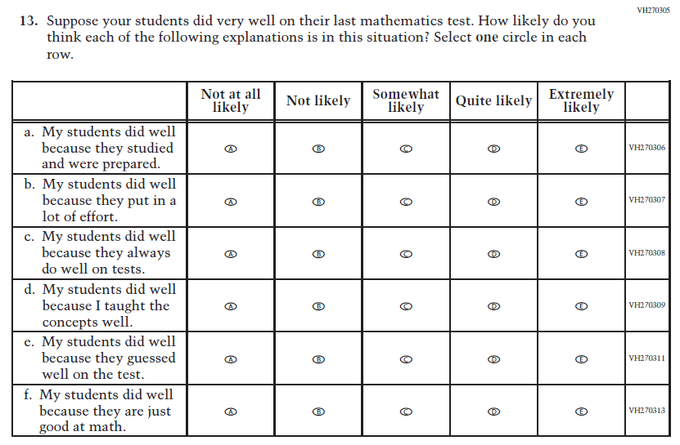  (2024) | N/A | D | This Item was dropped to reduce questionnaire length.
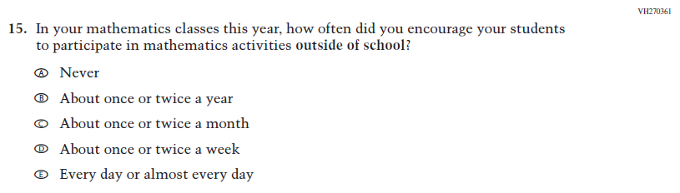  (2024) | N/A | D | This item was dropped to reduce questionnaire length.
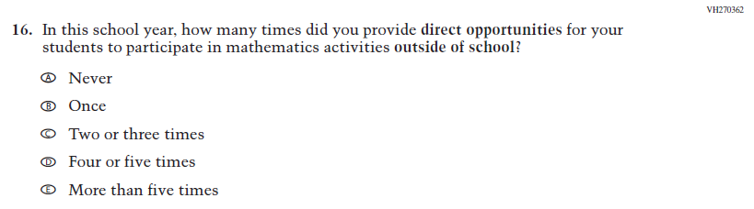  (2024) | N/A | D | This item was dropped to reduce questionnaire length.

2026 Operational Grade 4 Mathematics Teacher
Previous Item | 2026 Item | D/A/R+ | Rationale
N/A  (2024) | 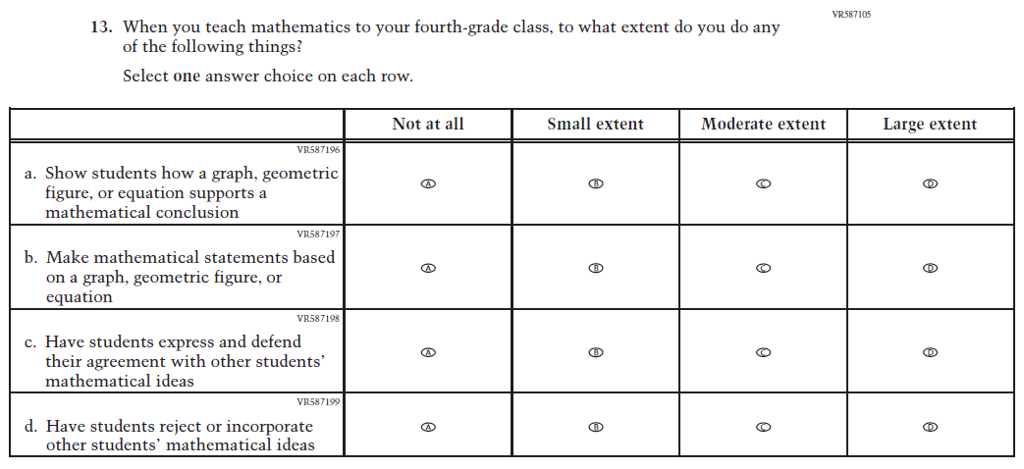  Issue: Instructional Organization and Strategies | A | This item was developed to measure content aligned with the new Mathematics framework.
N/A  (2024) | 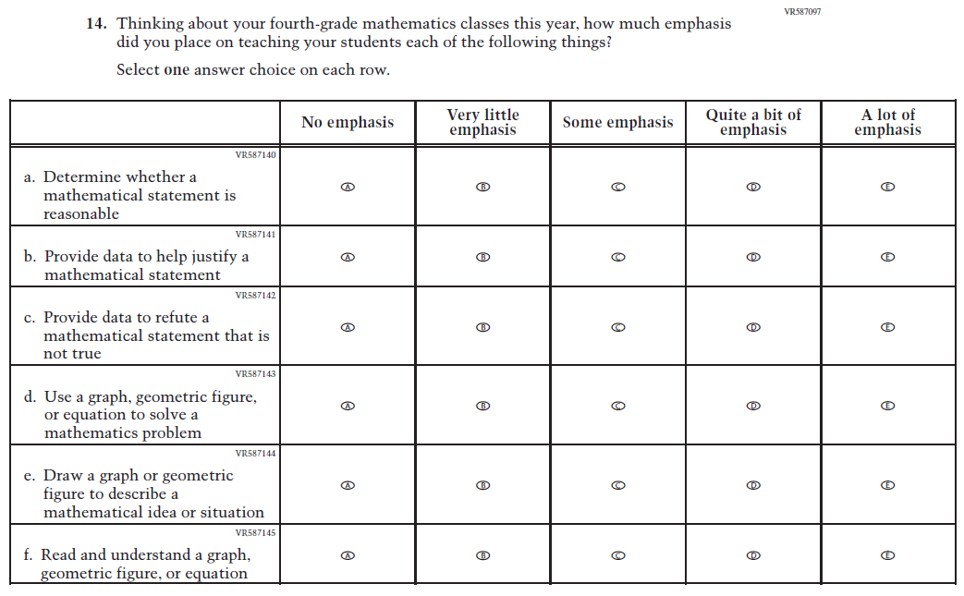  Issue: Mathematical Content and Practices | A | This item was developed to measure content aligned with the new Mathematics framework.

2026 Operational Grade 4 Mathematics Teacher
Previous Item | 2026 Item | D/A/R+ | Rationale
N/A  (2024) | 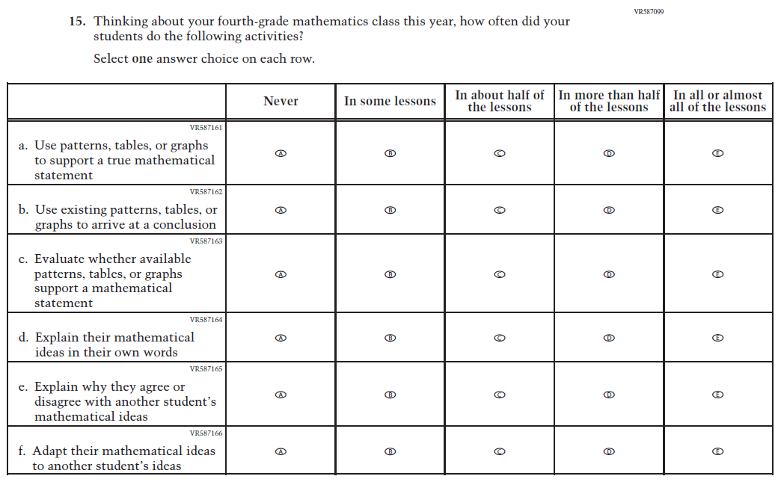  Issue: Mathematical Content and Practices | A | This Item was developed to measure content aligned with the new Mathematics framework.
N/A  (2024) | 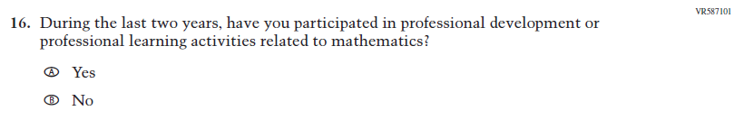  Issue: Teacher Factors | A | This item was developed to measure content aligned with the new Mathematics framework.

2026 Operational Grade 4 Mathematics Teacher
Previous Item | 2026 Item | D/A/R+ | Rationale
N/A  (2024) | 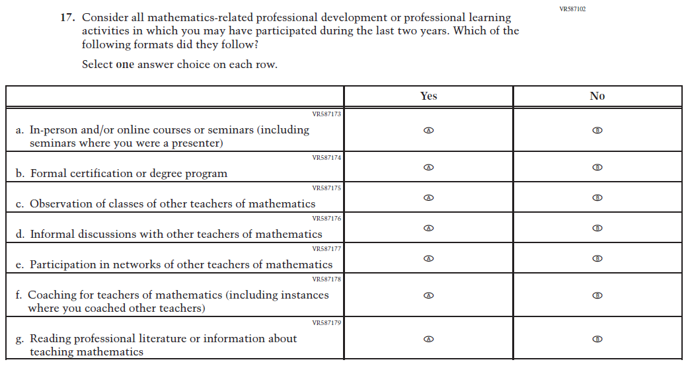  Issue: Teacher Factors | A | This item was developed to measure content aligned with the new Mathematics framework.
N/A  (2024) | 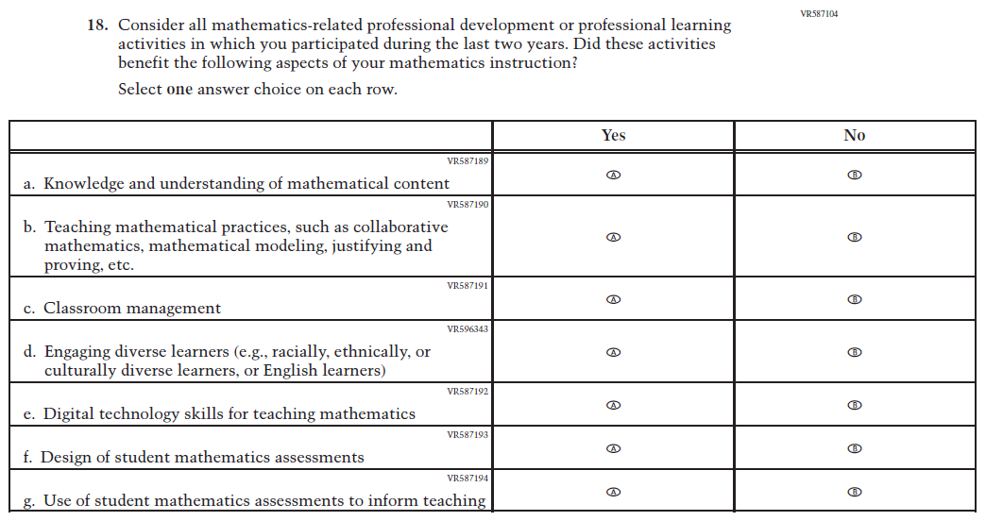  Issue: Teacher Factors | A | This item was developed to measure content aligned with the new Mathematics framework.

Appendix J2-6: Operational Grade 4 (Mathematics)

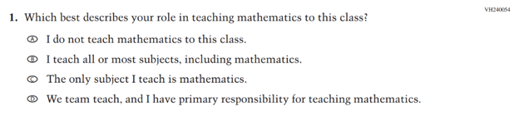
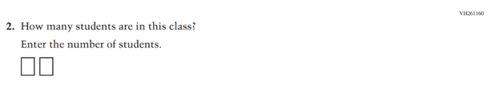
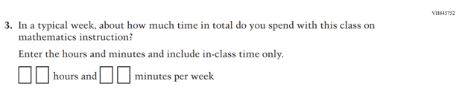
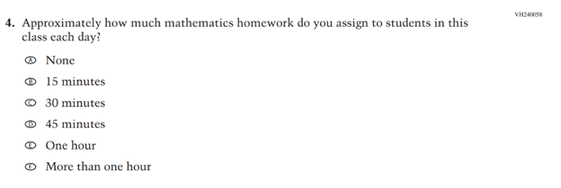

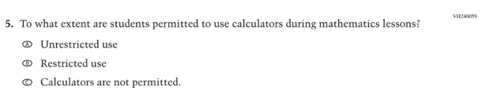
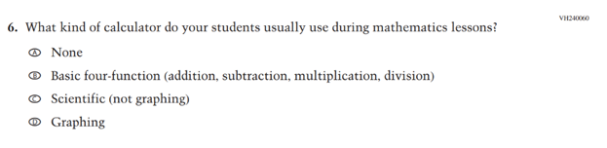
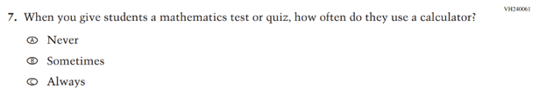
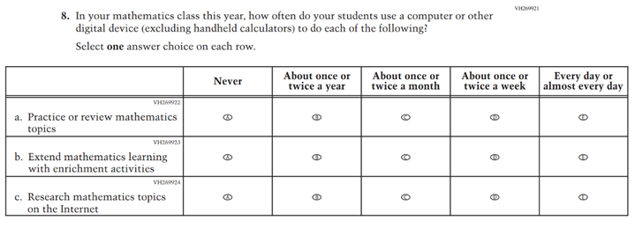

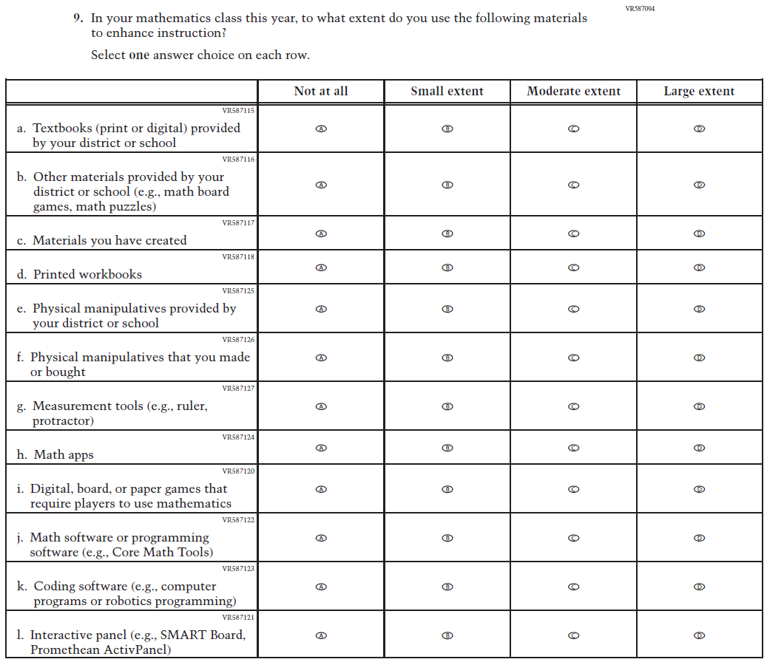

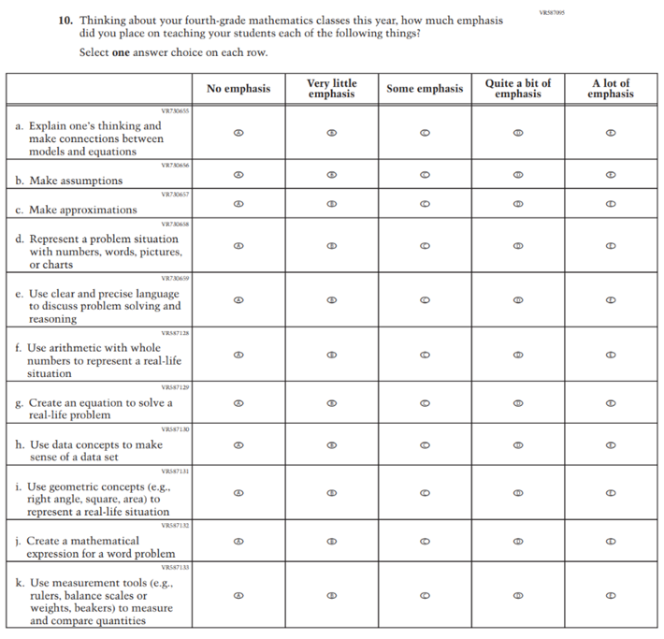

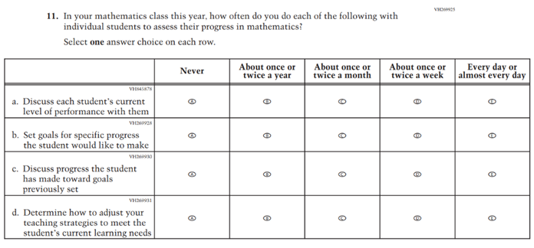

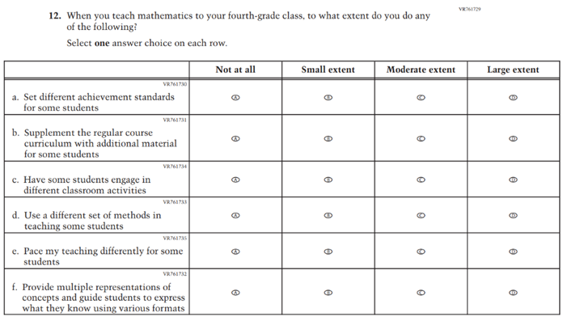

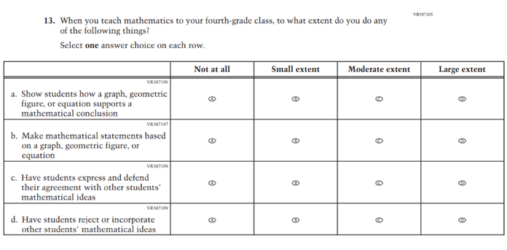

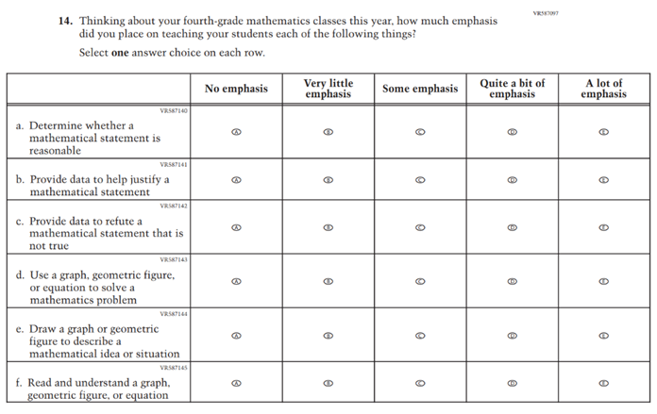

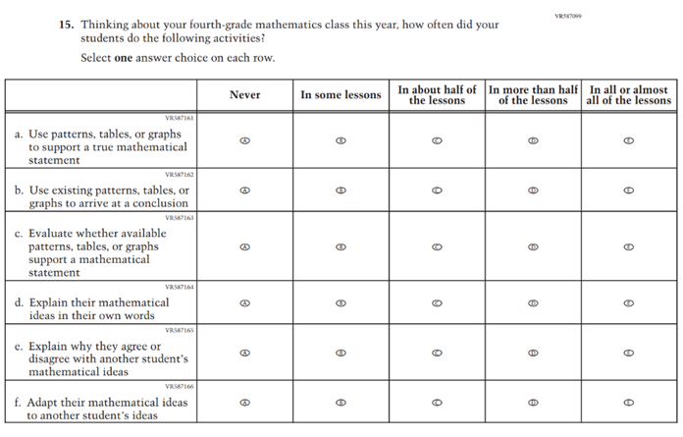
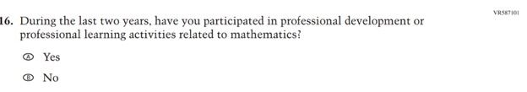
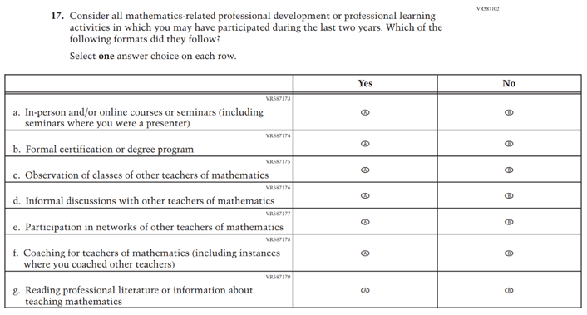

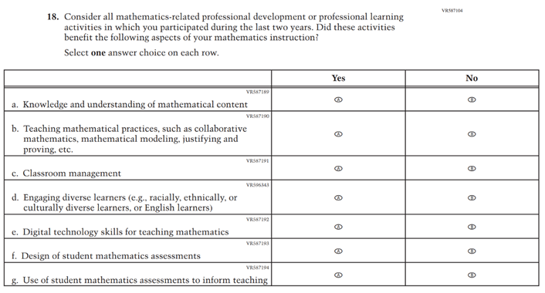

Appendix J2-7: Summary of Changes Operational Grade 8 (Mathematics)
2026 Operational Grade 8 Mathematics Teacher
Previous Item | 2026 Item | D/A/R+ | Rationale
(2024) | Issue: Instructional Organization and Strategies | R | For 2026, we have aligned Inline Directions in Teacher and School Items with the Directions currently used in Student Items.

2026 Operational Grade 8 Mathematics Teacher
Previous Item | 2026 Item | D/A/R+ | Rationale
(2024) | Issue: Instructional Resources | R | For 2026, we have aligned Inline Directions in Teacher and School Items with the Directions currently used in Student Items. The Item stem and subitems a, b, e, f, and g were revised for clarity, and new subitems i-l were developed to measure content aligned with the new Mathematics framework.

2026 Operational Grade 8 Mathematics Teacher
Previous Item | 2026 Item | D/A/R+ | Rationale
(2024) | 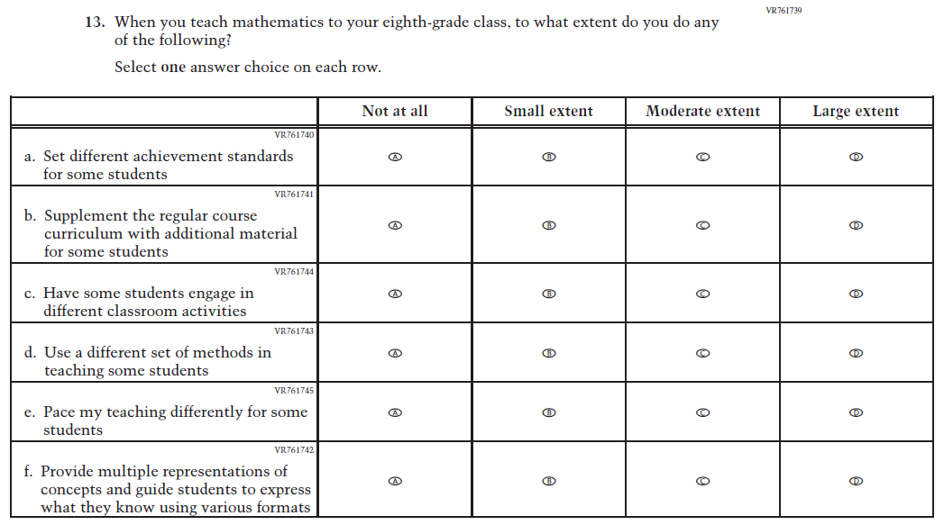  Issue: Instructional Organization and Strategies | R | For 2026, we have aligned Inline Directions in Teacher and School Items with the Directions currently used in Student Items. The Item stem was revised for clarity and subItem f was developed to measure content aligned with the new Mathematics framework.

2026 Operational Grade 8 Mathematics Teacher
Previous Item | 2026 Item | D/A/R+ | Rationale
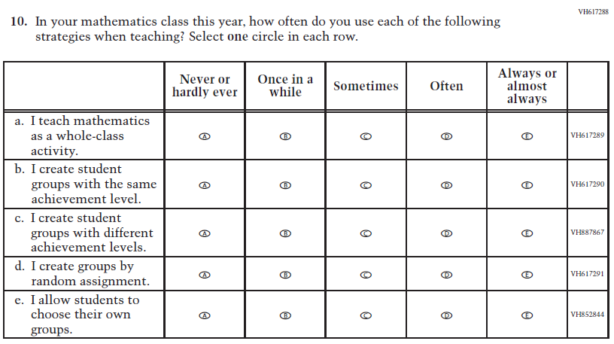  (2024) | 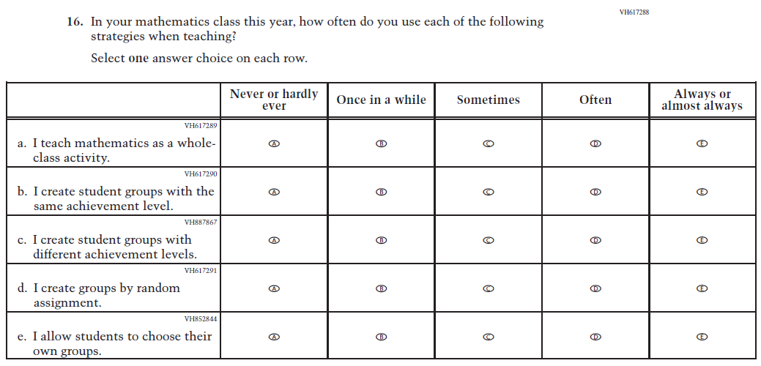  Issue: Instructional Organization and Strategies | R | For 2026, we have aligned Inline Directions in Teacher and School Items with the Directions currently used in Student Items.
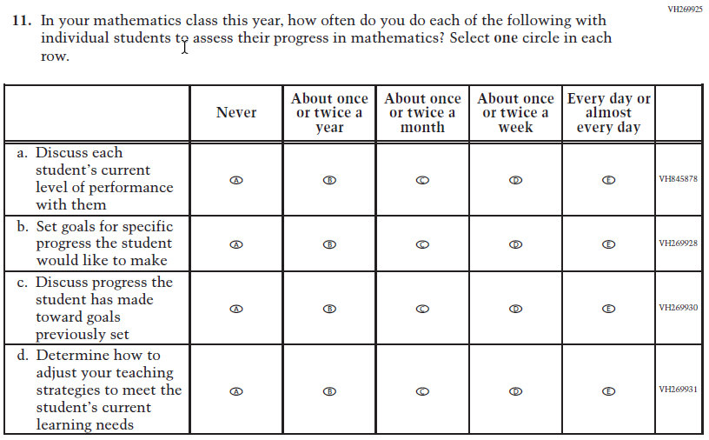  (2024) | 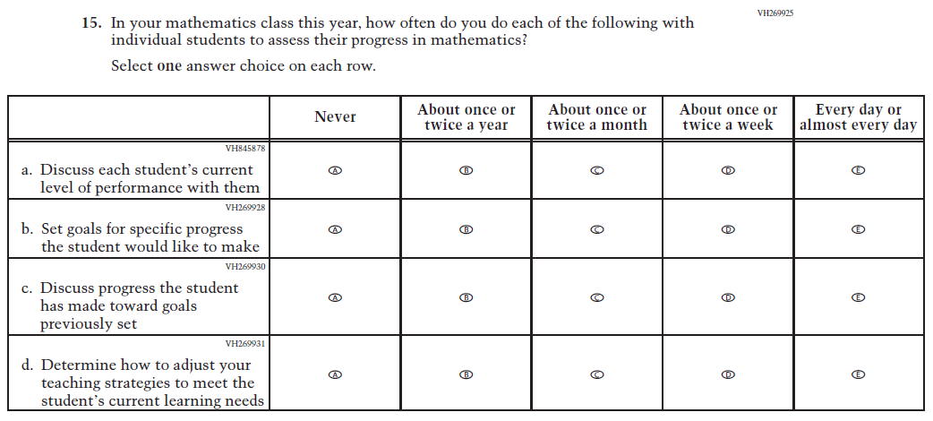  Issue: Instructional Organization and Strategies | R | For 2026, we have aligned Inline Directions in Teacher and School Items with the Directions currently used in Student Items.

2026 Operational Grade 8 Mathematics Teacher
Previous Item | 2026 Item | D/A/R+ | Rationale
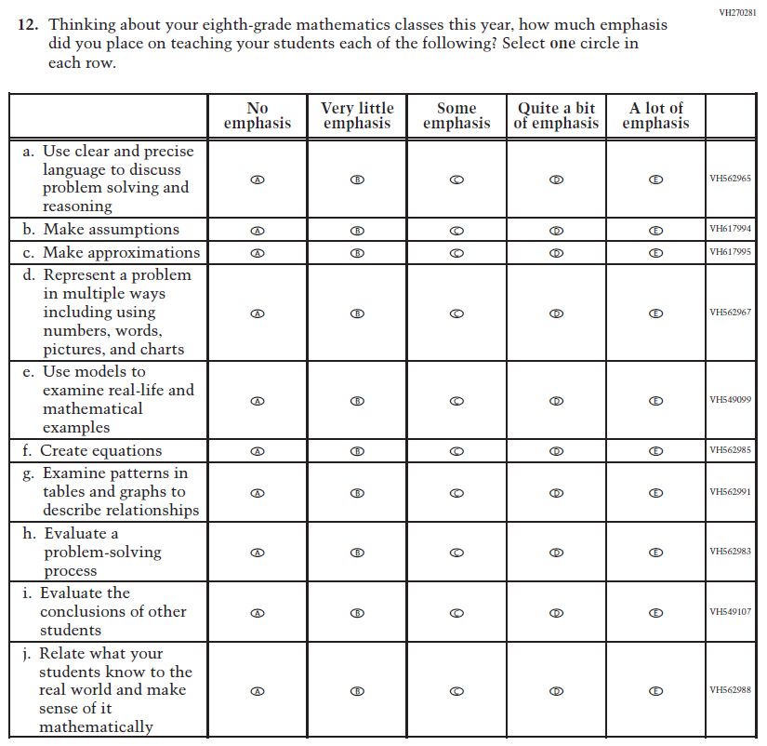  (2024) | 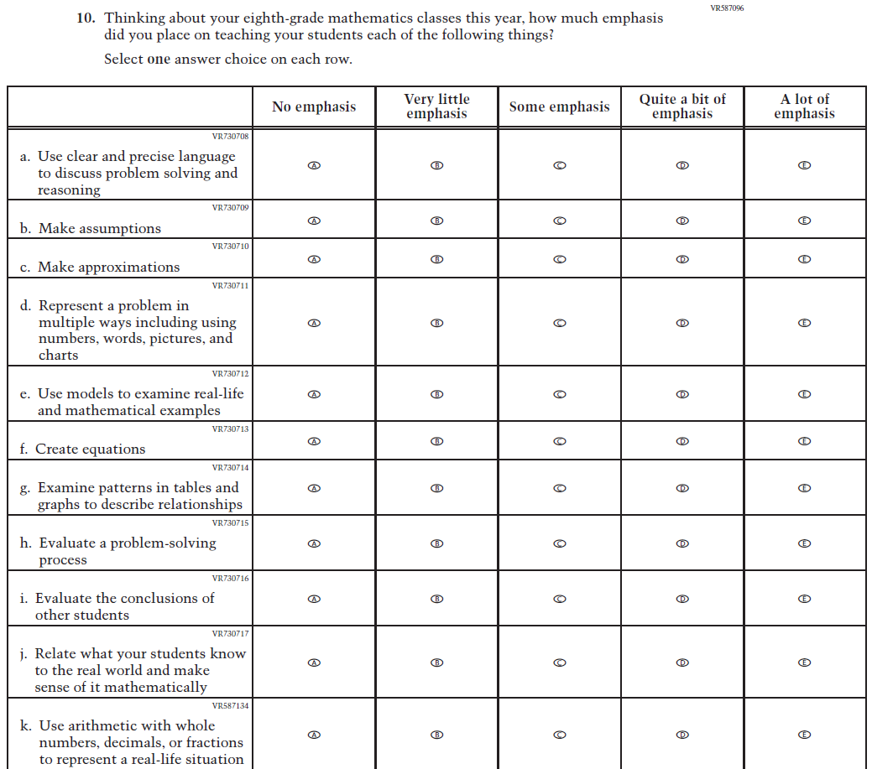  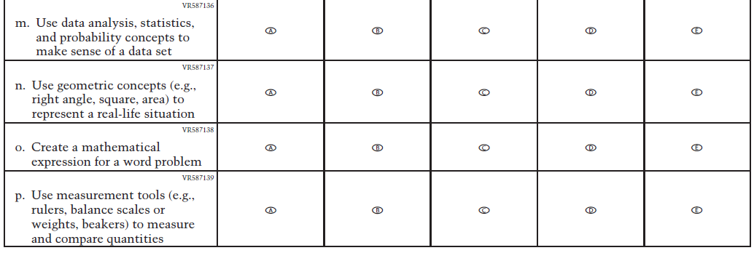  Issue: Mathematical Content and Practices | R | For 2026, we have aligned Inline Directions in Teacher and School Items with the Directions currently used in Student Items. The Item stem was revised for clarity and subitems k-p were developed to measure content aligned with the new Mathematics framework.

2026 Operational Grade 8 Mathematics Teacher
Previous Item | 2026 Item | D/A/R+ | Rationale
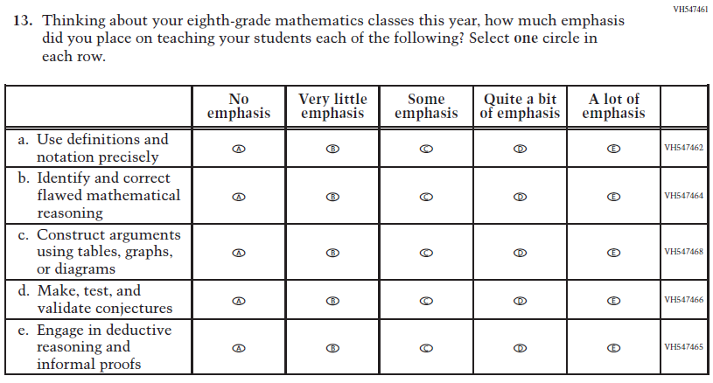  (2024) | 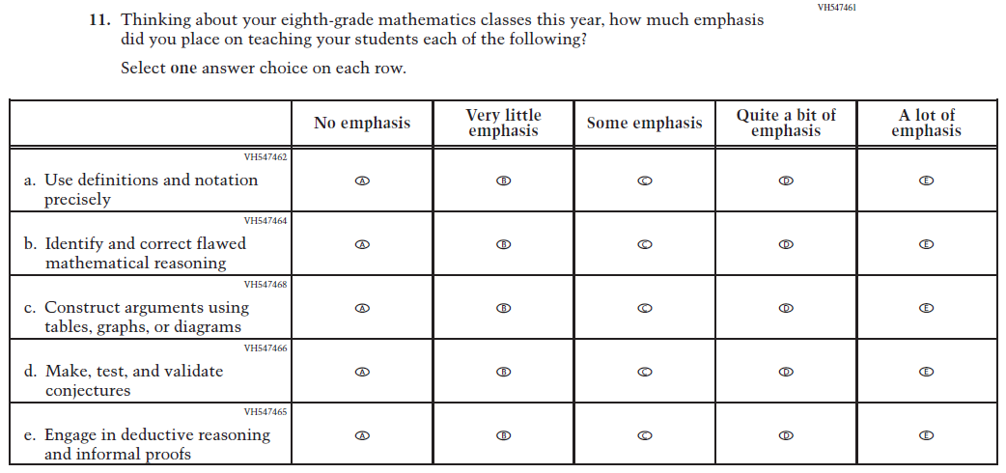  Issue: Mathematical Content and Practices | R | For 2026, we have aligned Inline Directions in Teacher and School Items with the Directions currently used in Student Items.
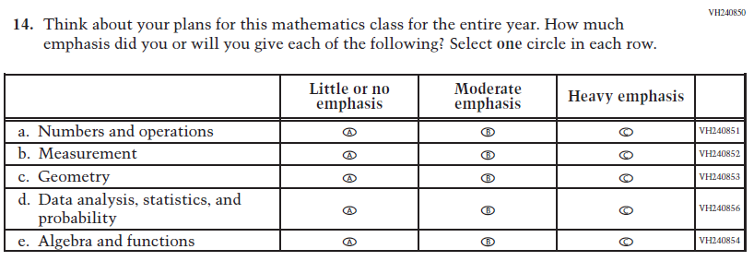  (2024) | N/A | D | This Item was dropped to reduce questionnaire length.

2026 Operational Grade 8 Mathematics Teacher
Previous Item | 2026 Item | D/A/R+ | Rationale
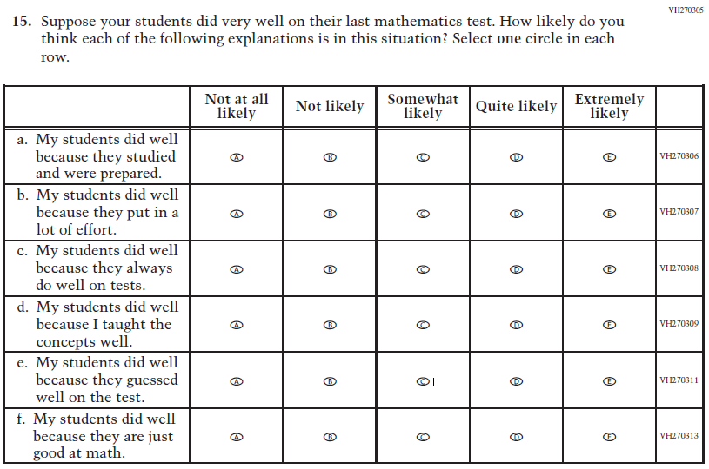  (2024) | N/A | D | This Item was dropped to reduce questionnaire length.
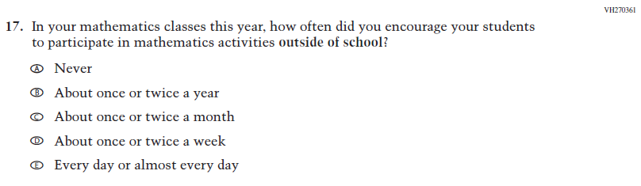  (2024) | N/A | D | This Item was dropped to reduce questionnaire length.
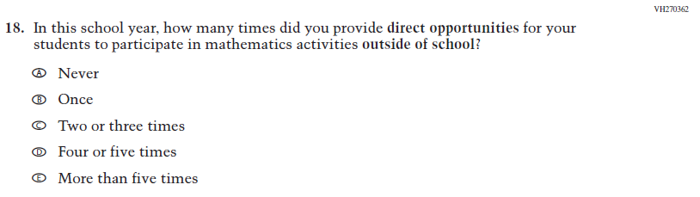  (2024) | N/A | D | This Item was dropped to reduce questionnaire length.

2026 Operational Grade 8 Mathematics Teacher
Previous Item | 2026 Item | D/A/R+ | Rationale
N/A  (2024) | 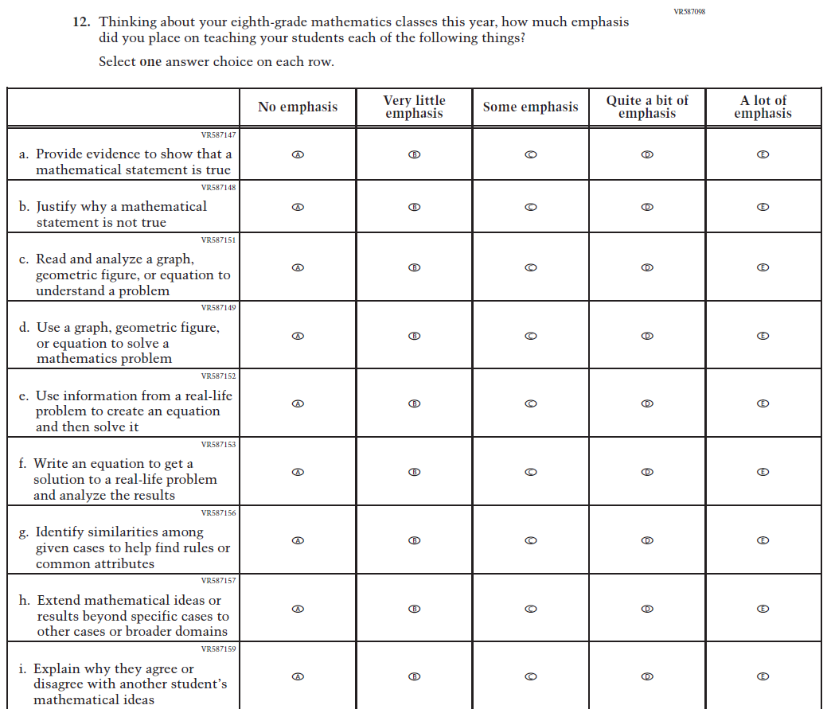  Issue: Mathematical Content and Practices | A | This Item was developed to measure content aligned with the new Mathematics framework.
N/A  (2024) | 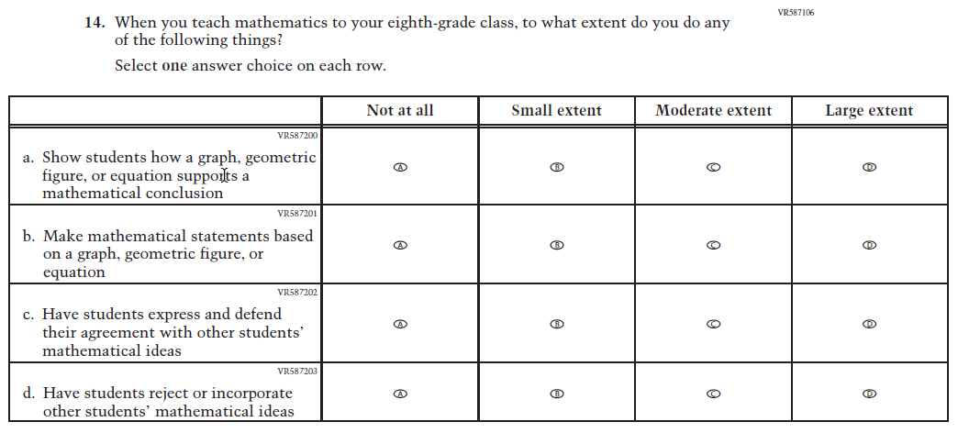  Issue: Instructional Organization and Strategies | A | This Item was developed to measure content aligned with the new Mathematics framework.

2026 Operational Grade 8 Mathematics Teacher
Previous Item | 2026 Item | D/A/R+ | Rationale
N/A  (2024) | 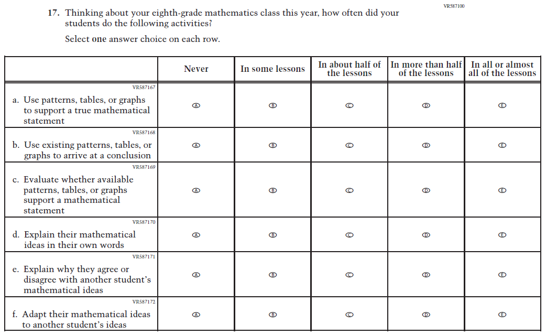  Issue: Mathematical Content and Practices | A | This Item was developed to measure content aligned with the new Mathematics framework.
N/A  (2024) | 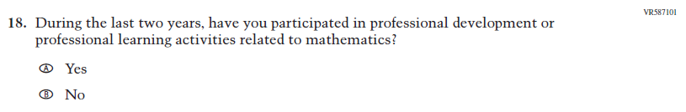  Issue: Teacher Factors | A | This Item was developed to measure content aligned with the new Mathematics framework.

2026 Operational Grade 8 Mathematics Teacher
Previous Item | 2026 Item | D/A/R+ | Rationale
N/A  (2024) | 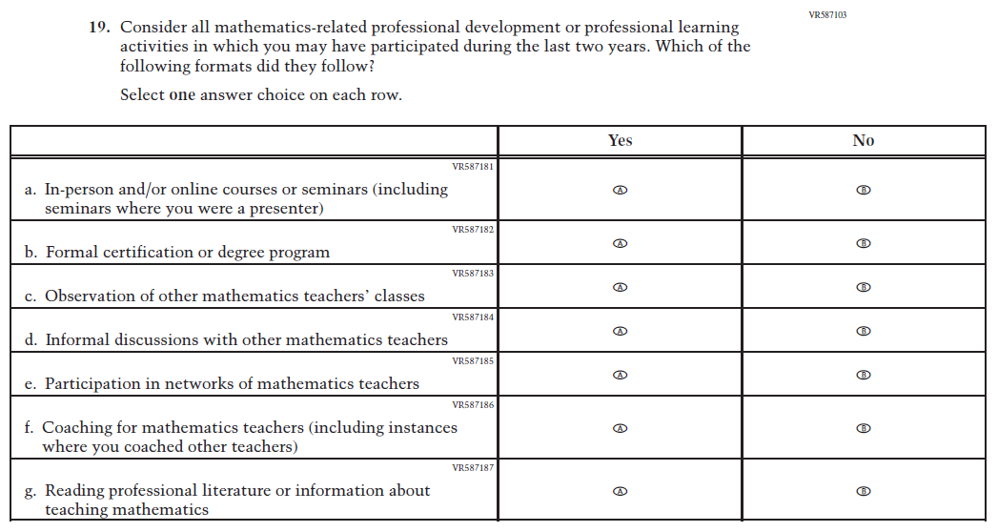  Issue: Teacher Factors | A | This Item was developed to measure content aligned with the new Mathematics framework.
N/A  (2024) | 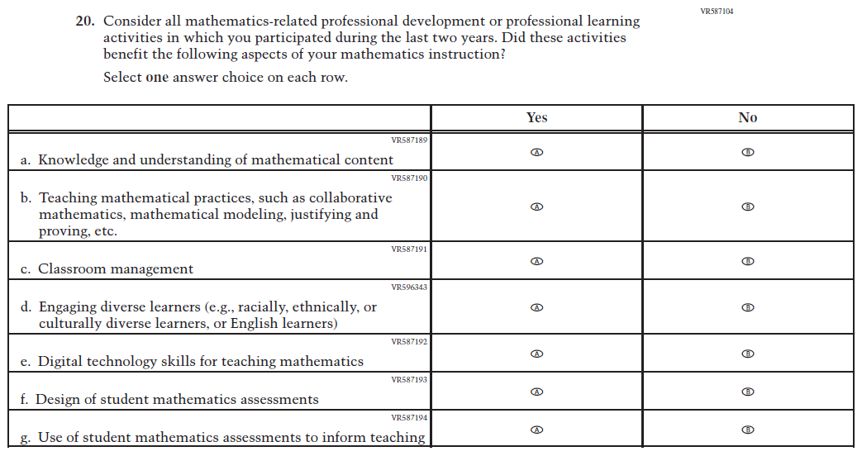  Issue: Teacher Factors | A | This Item was developed to measure content aligned with the new Mathematics framework.

Appendix J2-8: Operational Grade 8 (Mathematics)

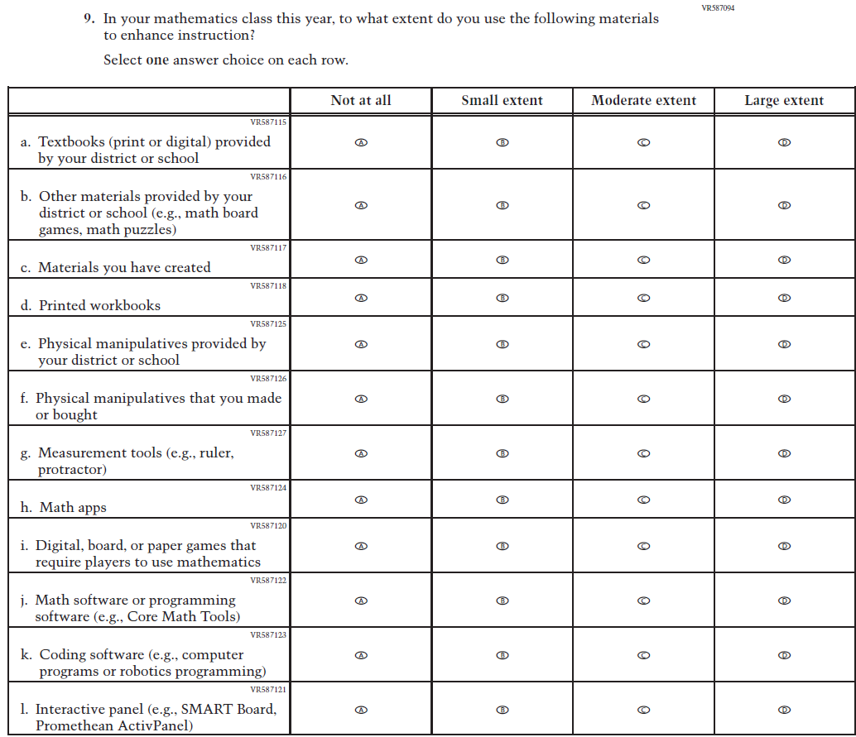

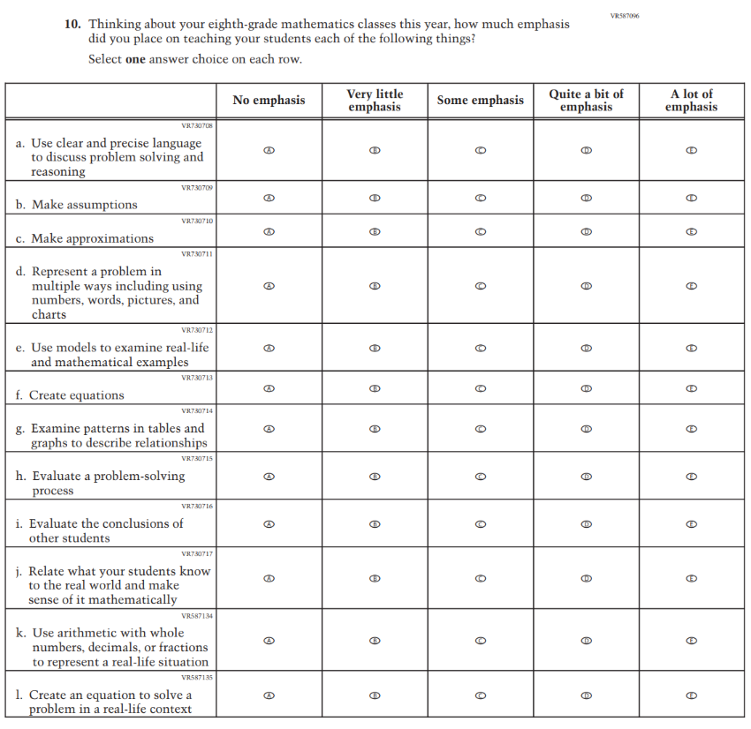
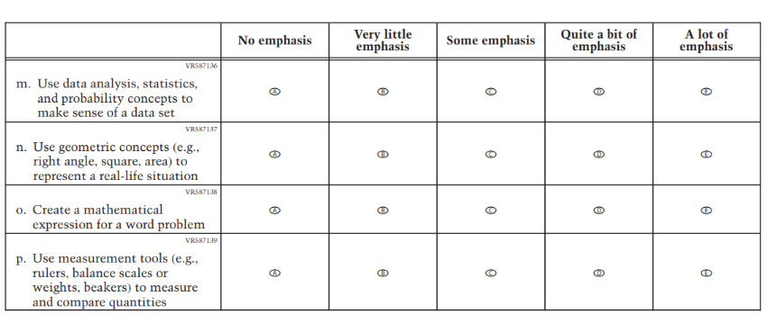

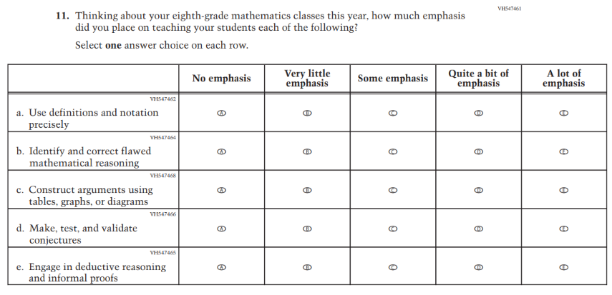
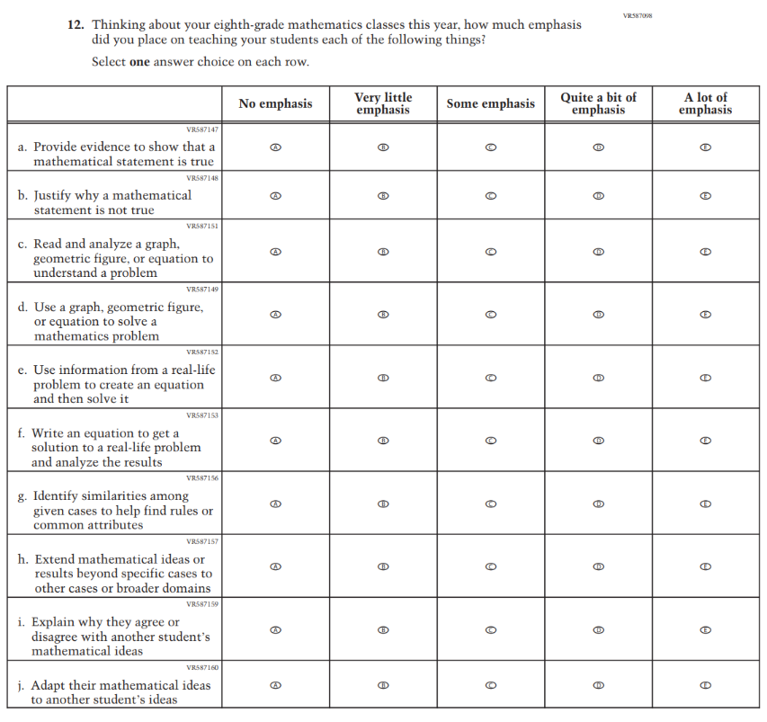

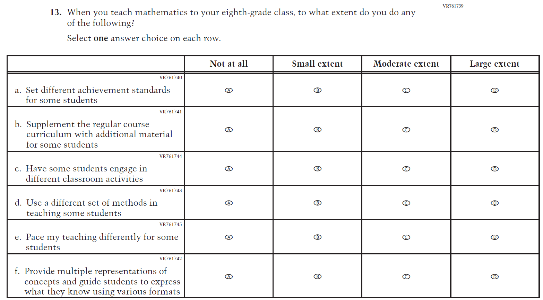

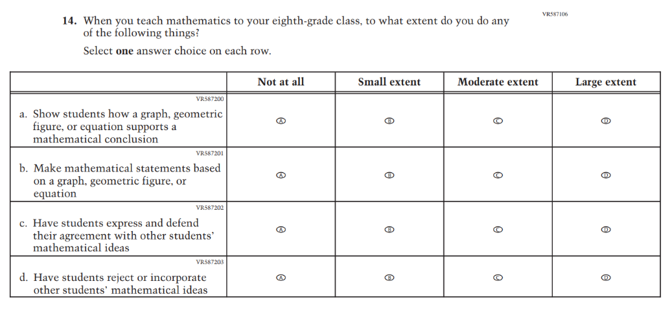

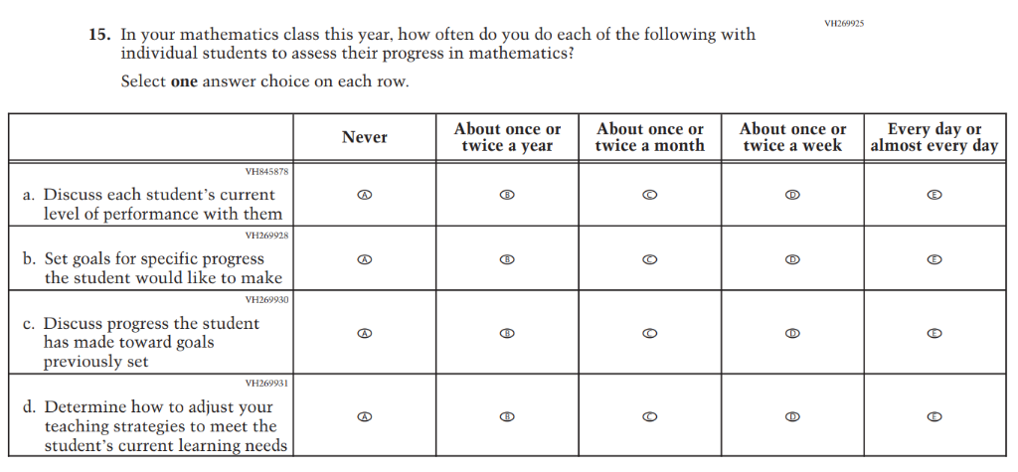

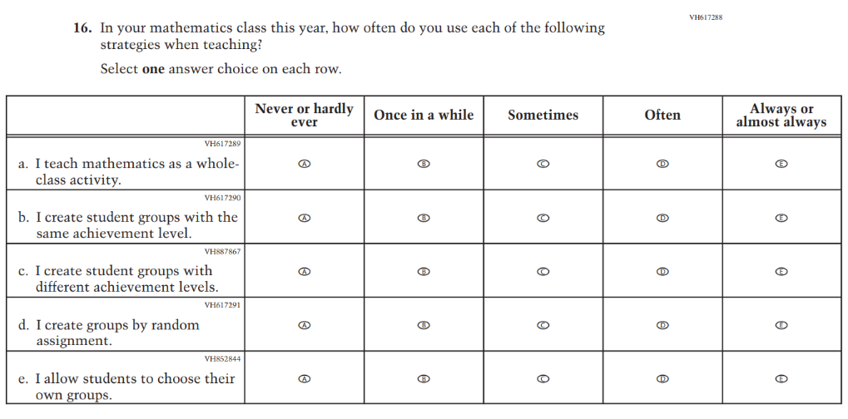
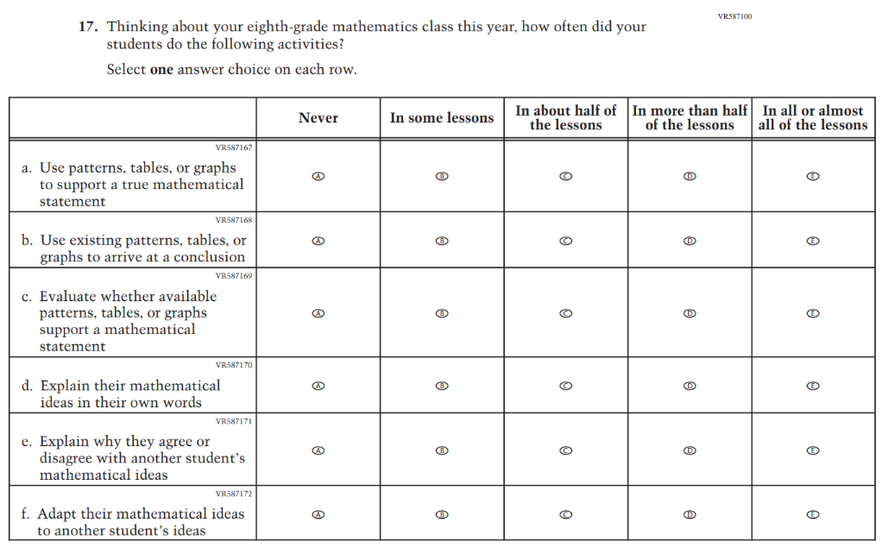

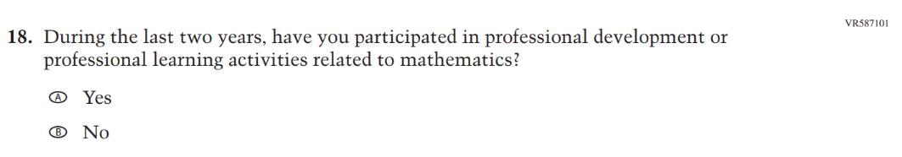

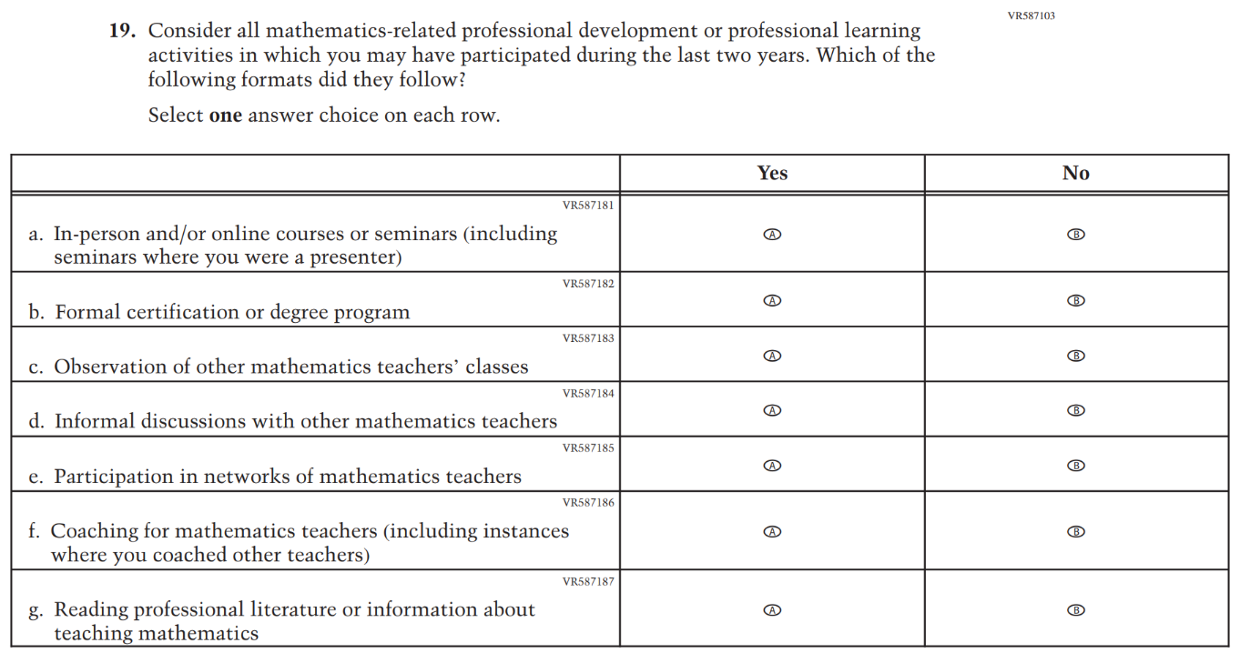

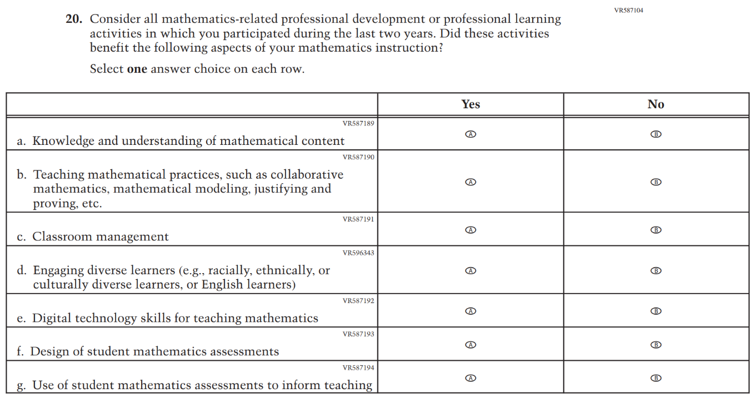

Appendix J2-9: Summary of Changes Operational Grade 4 (Reading)
2026 Operational Grade 4 Reading Teacher
Previous Item | 2026 Item | D/A/R+ | Rationale
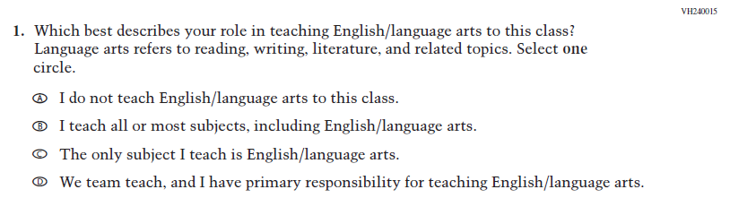  (2024) | 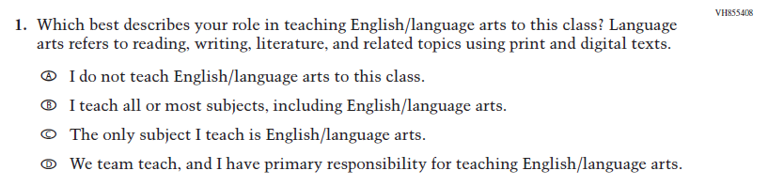  Issue: Teacher, Instructional, and Classroom Supports | R | This Item was revised for clarity and Inline Directions inconsistent with other items were removed.
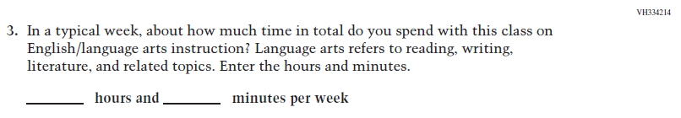  (2024) | 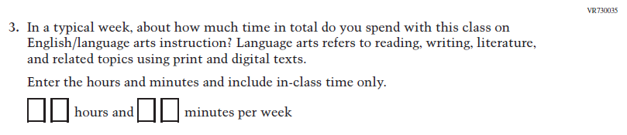  Issue: Teacher, Instructional, and Classroom Supports | R | This Item and Inline Directions were revised for clarity.

2026 Operational Grade 4 Reading Teacher
Previous Item | 2026 Item | D/A/R+ | Rationale
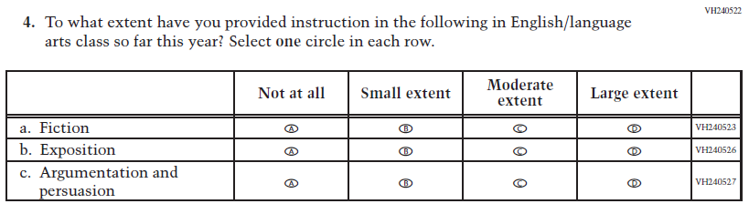  (2024) | 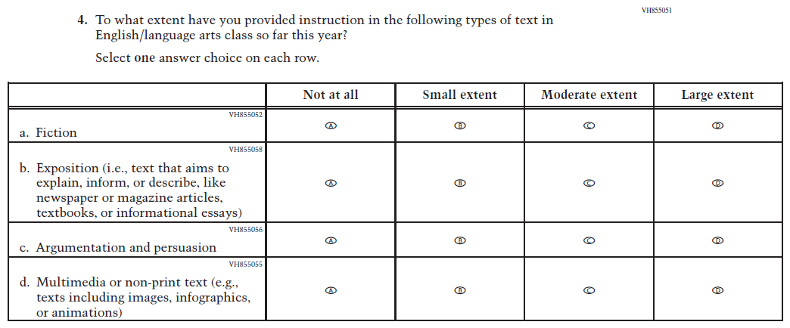  Issue: Teacher, Instructional, and Classroom Supports | R | For 2026, we have aligned Inline Directions in Teacher and School Items with the Directions currently used in Student Items. The Item stem and subitem b were revised for clarity and subitem d was developed to measure content aligned with the new Reading framework.

2026 Operational Grade 4 Reading Teacher
Previous Item | 2026 Item | D/A/R+ | Rationale
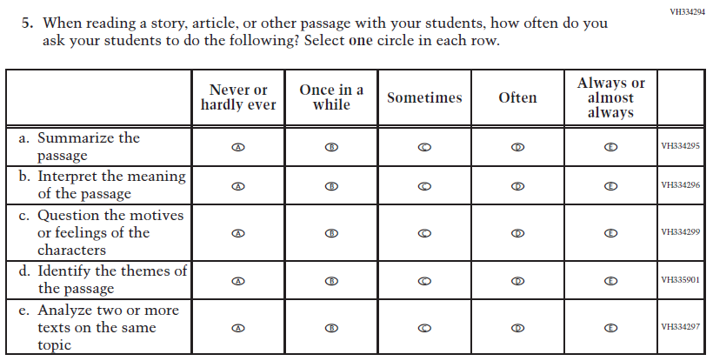  (2024) | 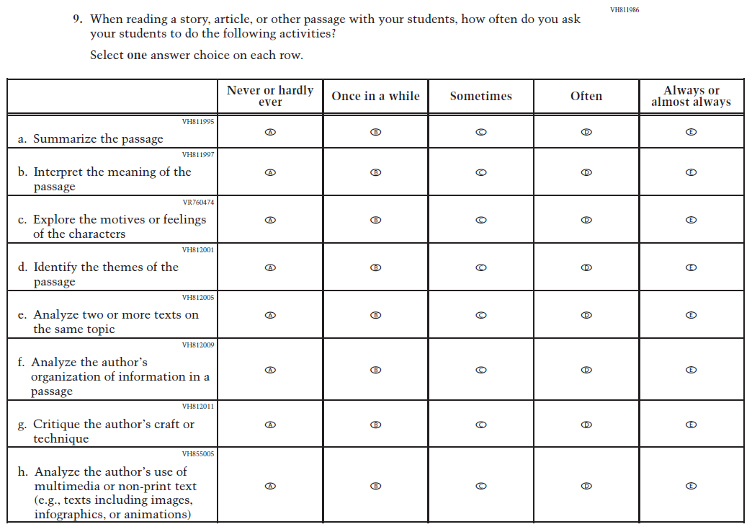  Issue: Cognition and Metacognition | R | For 2026, we have aligned Inline Directions in Teacher and School Items with the Directions currently used in Student Items. The Item stem and subitem c were revised for clarity, and subitems f, g, and h were developed to measure content aligned with the new Reading framework.

2026 Operational Grade 4 Reading Teacher
Previous Item | 2026 Item | D/A/R+ | Rationale
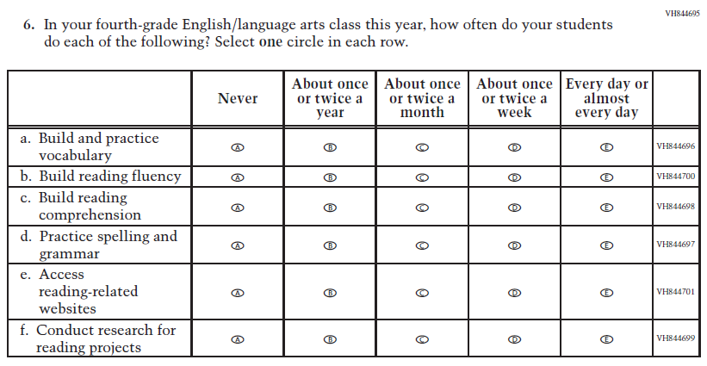  (2024) | 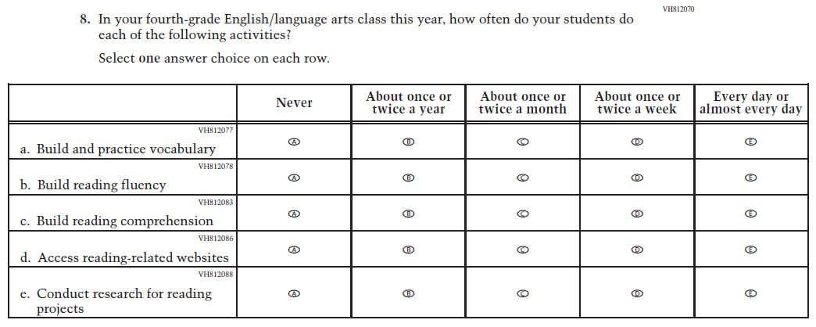  Issue: Teacher, Instructional, and Classroom Supports | R | For 2026, we have aligned Inline Directions in Teacher and School Items with the Directions currently used in Student Items. The Item stem was revised for clarity and subItem d was dropped to reduce questionnaire length.

2026 Operational Grade 4 Reading Teacher
Previous Item | 2026 Item | D/A/R+ | Rationale
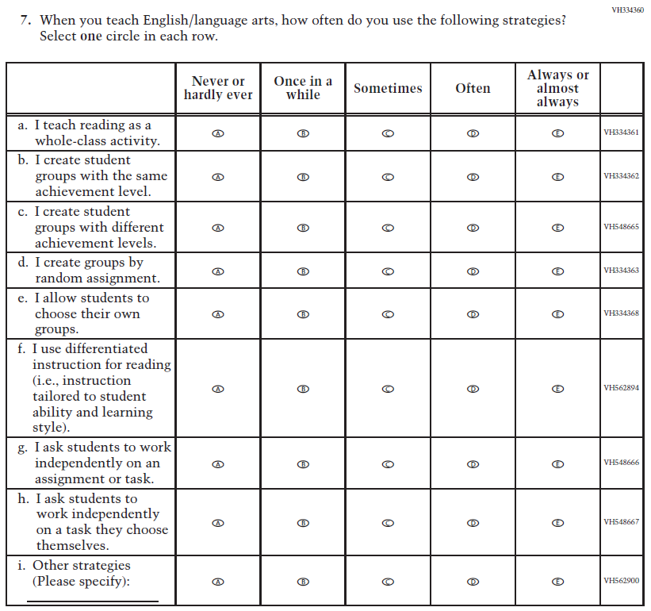  (2024) | 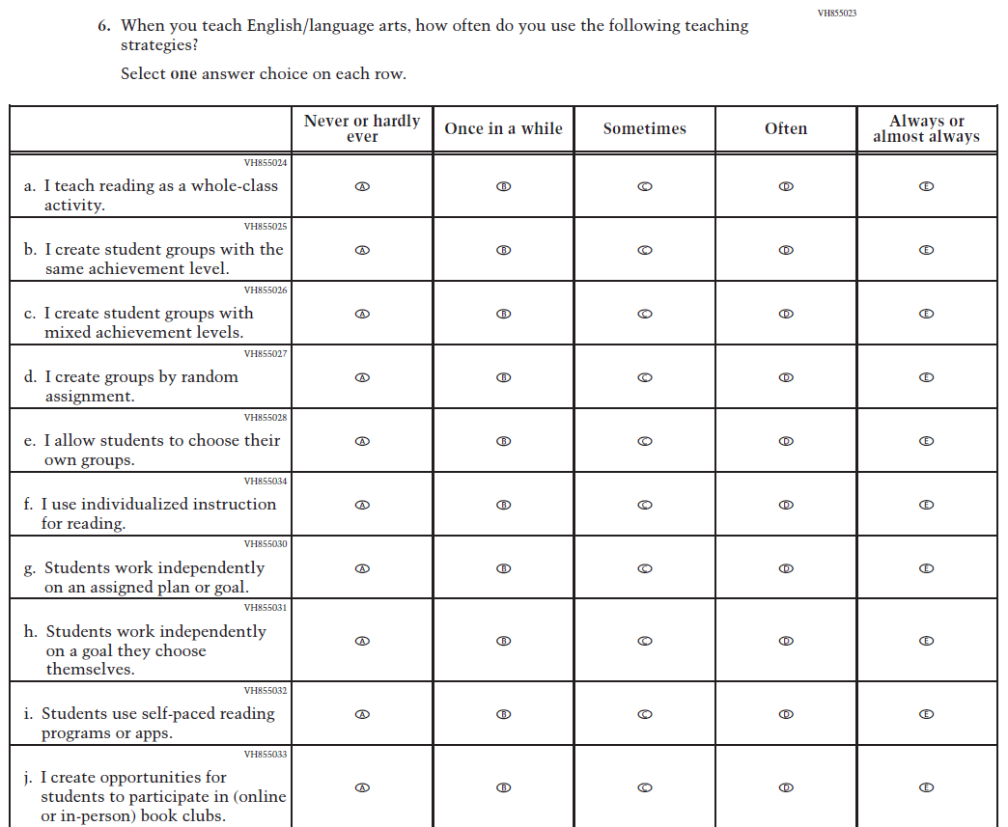  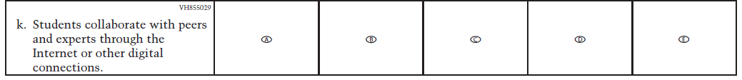  Issue: Teacher, Instructional, and Classroom Supports | R | For 2026, we have aligned Inline Directions in Teacher and School Items with the Directions currently used in Student Items. The Item stem and subitems c, f, g, and h were revised for clarity, and subitems i, j, and k were developed to measure content aligned with the new Reading framework.

2026 Operational Grade 4 Reading Teacher
Previous Item | 2026 Item | D/A/R+ | Rationale
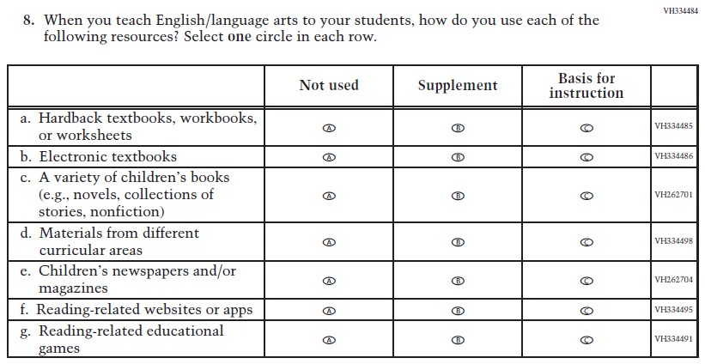  (2024) | 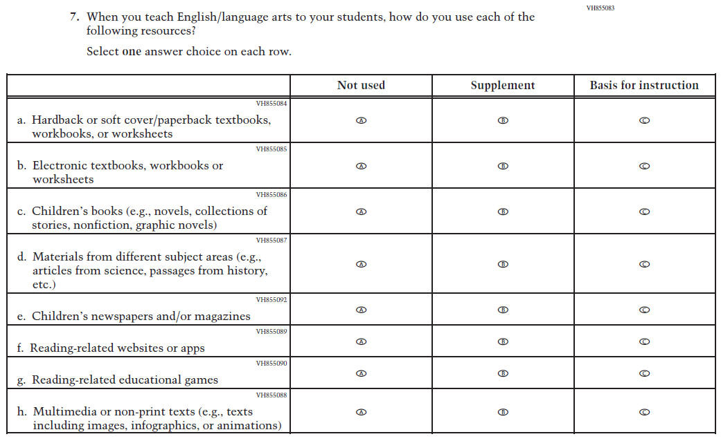  Issue: Teacher, Instructional, and Classroom Supports | R | For 2026, we have aligned Inline Directions in Teacher and School Items with the Directions currently used in Student Items. Subitems a, b, c, and d were revised for clarity and subitem h was developed to measure content aligned with the new Reading framework.

N/A  (2024) | 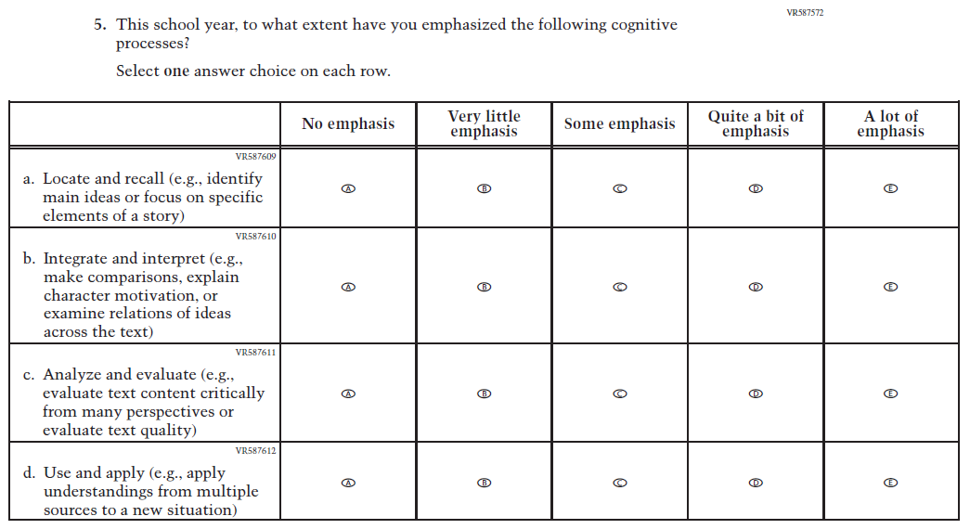  Issue: Teacher, Instructional, and Classroom Supports | A | This Item was developed to measure content aligned with the new Reading framework.

2026 Operational Grade 4 Reading Teacher
Previous Item | 2026 Item | D/A/R+ | Rationale
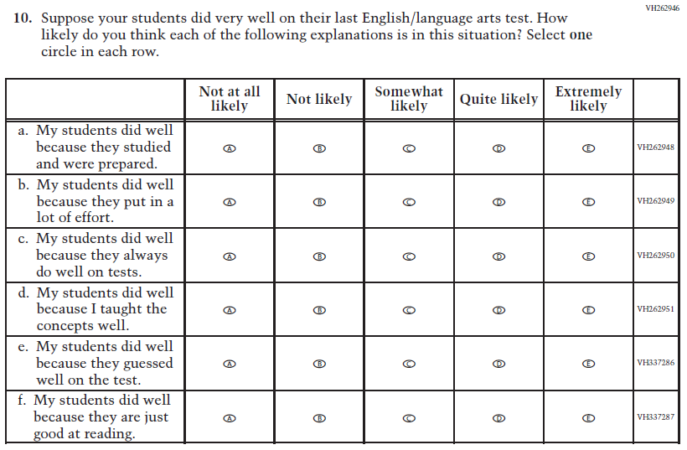  (2024) | N/A | D | This Item was dropped to reduce questionnaire length.
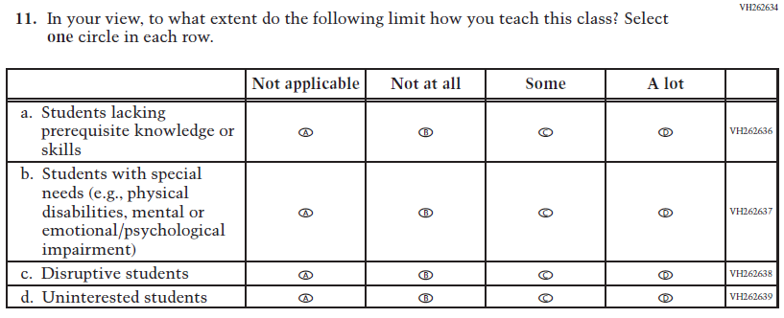  (2024) | N/A | D | This matrix Item was dropped to reduce questionnaire length.

2026 Operational Grade 4 Reading Teacher
Previous Item | 2026 Item | D/A/R+ | Rationale
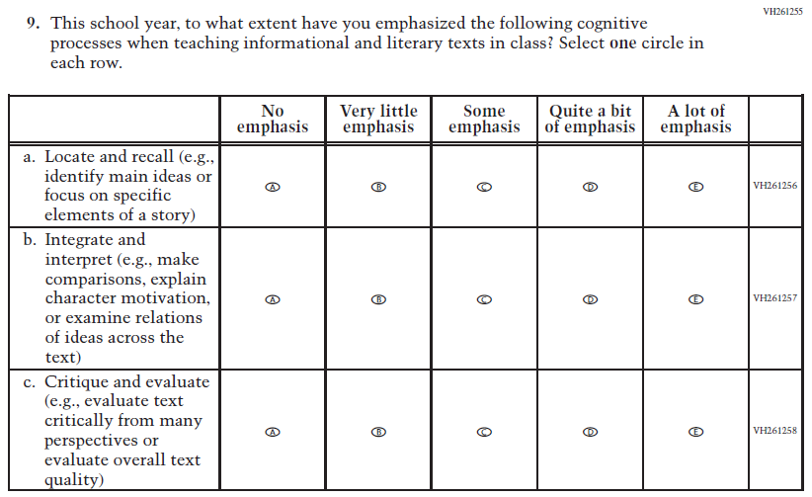  (2024) | 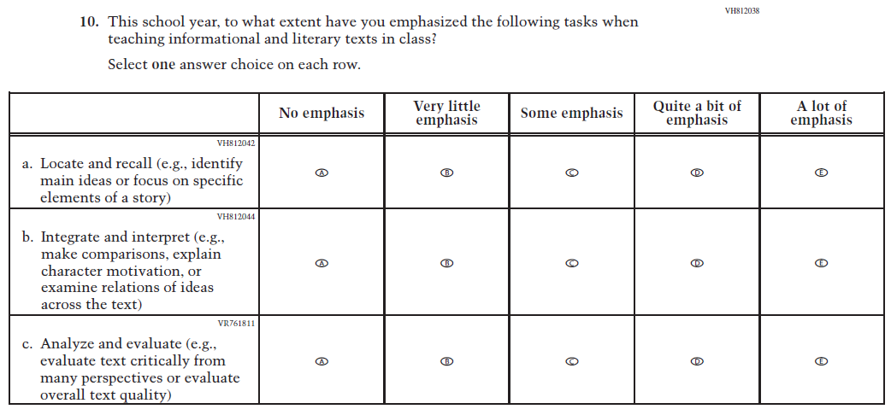  Issue: Cognition and Metacognition | R | For 2026, we have aligned Inline Directions in Teacher and School Items with the Directions currently used in Student Items. The Item stem and subitem c were revised for clarity.

2026 Operational Grade 4 Reading Teacher
Previous Item | 2026 Item | D/A/R+ | Rationale
N/A  (2024) | 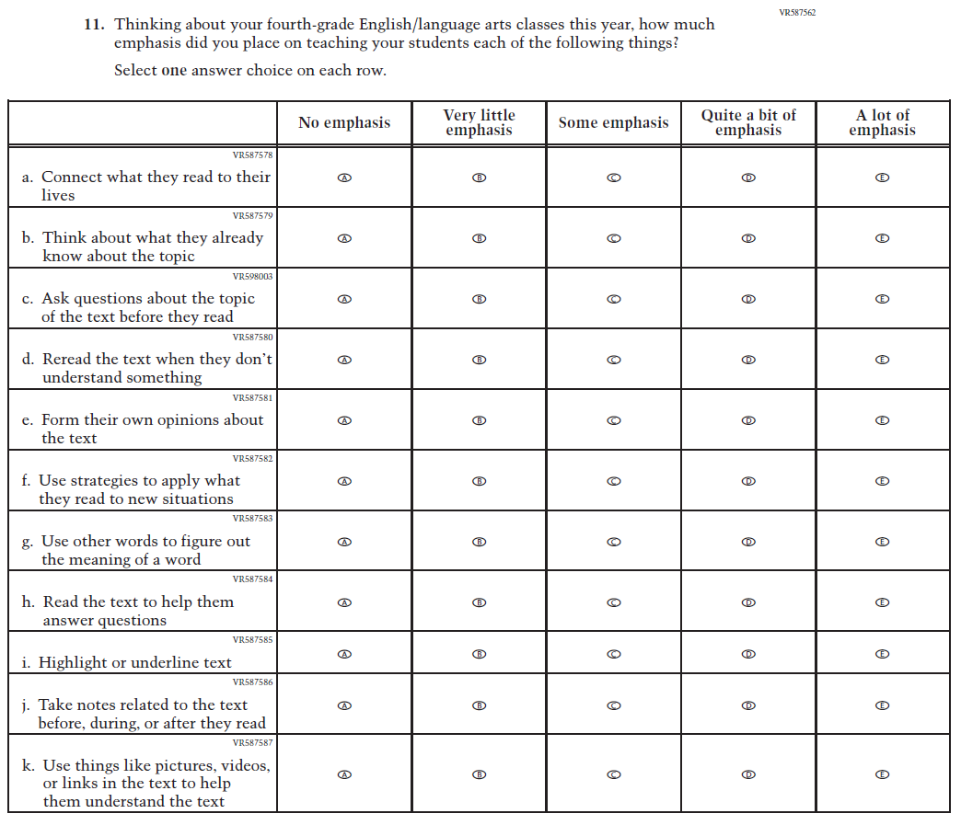  Issue: Cognition and Metacognition | A | This Item was developed to measure content aligned with the new Reading framework.
N/A  (2024) | 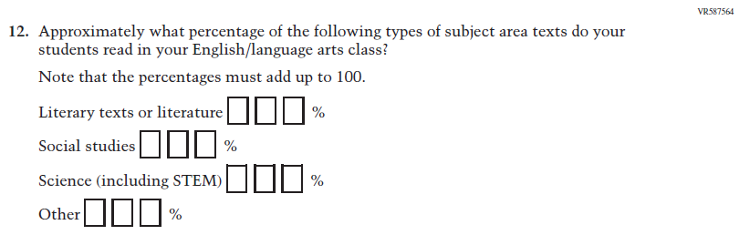  Issue: Cognition and Metacognition | A | This Item was developed to measure content aligned with the new Reading framework.

2026 Operational Grade 4 Reading Teacher
Previous Item | 2026 Item | D/A/R+ | Rationale
N/A  (2024) | 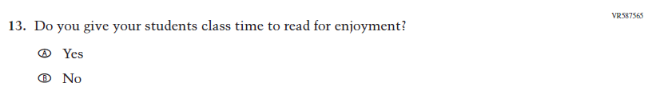  Issue: Engagement and Motivation | A | This Item was developed to measure content aligned with the new Reading framework.
N/A  (2024) | 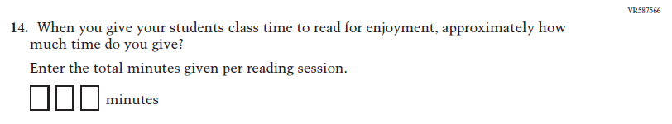  Issue: Engagement and Motivation | A | This Item was developed to measure content aligned with the new Reading framework.
N/A  (2024) | 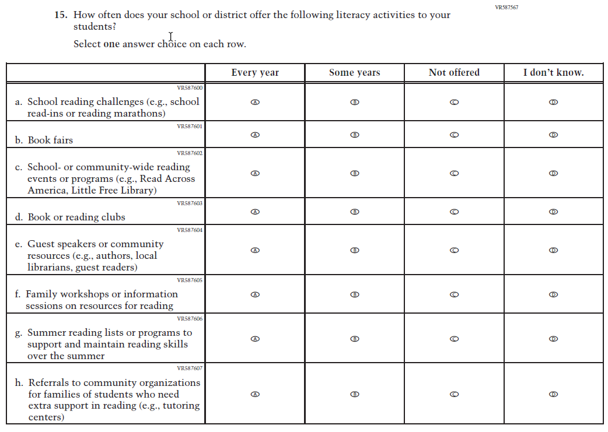  Issue: School and Community Resources | A | This Item was developed to measure content aligned with the new Reading framework.

2026 Operational Grade 4 Reading Teacher
Previous Item | 2026 Item | D/A/R+ | Rationale
N/A  (2024) | 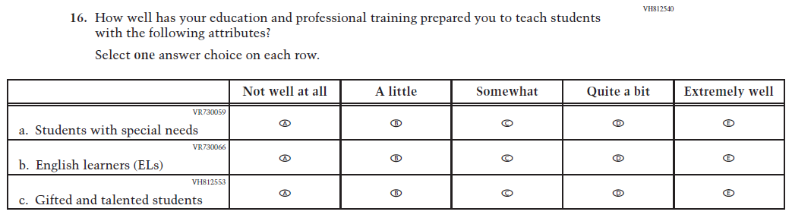  Issue: N/A | A | This Item was added to measure the important aspect of teacher preparation for teaching a variety of students.

Appendix J2-10: Operational Grade 4 (Reading)

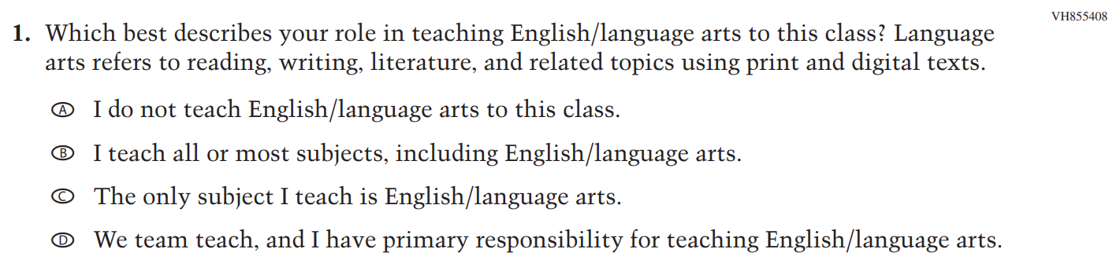

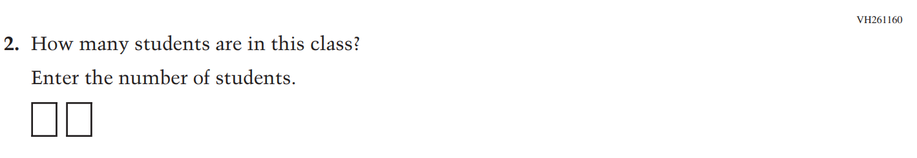
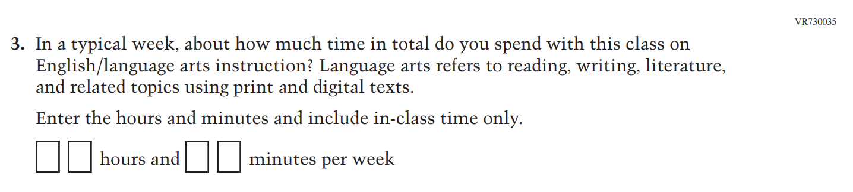

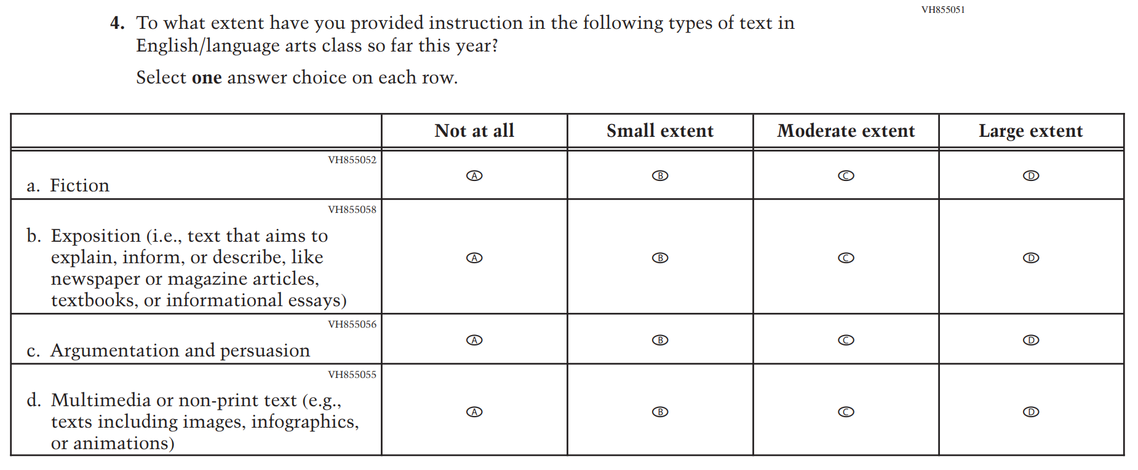

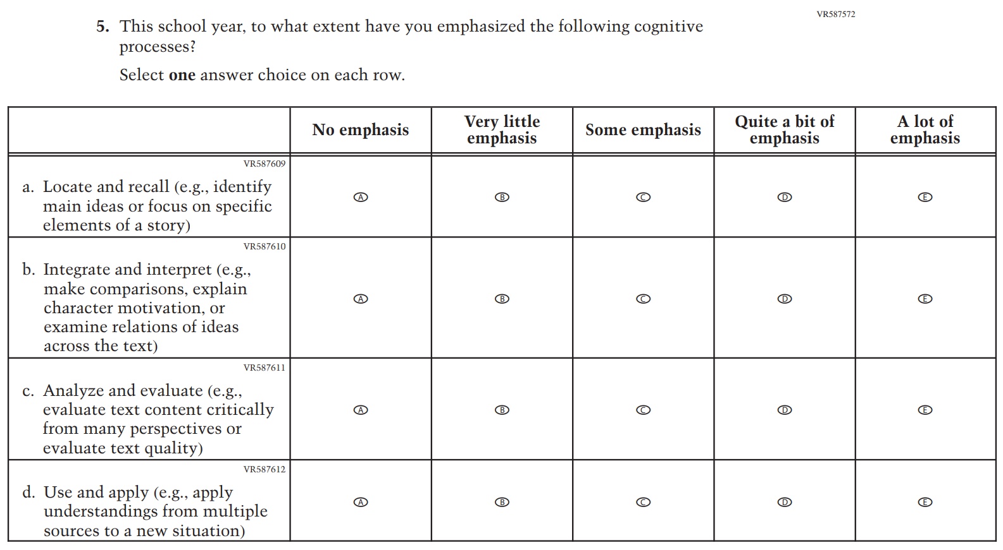

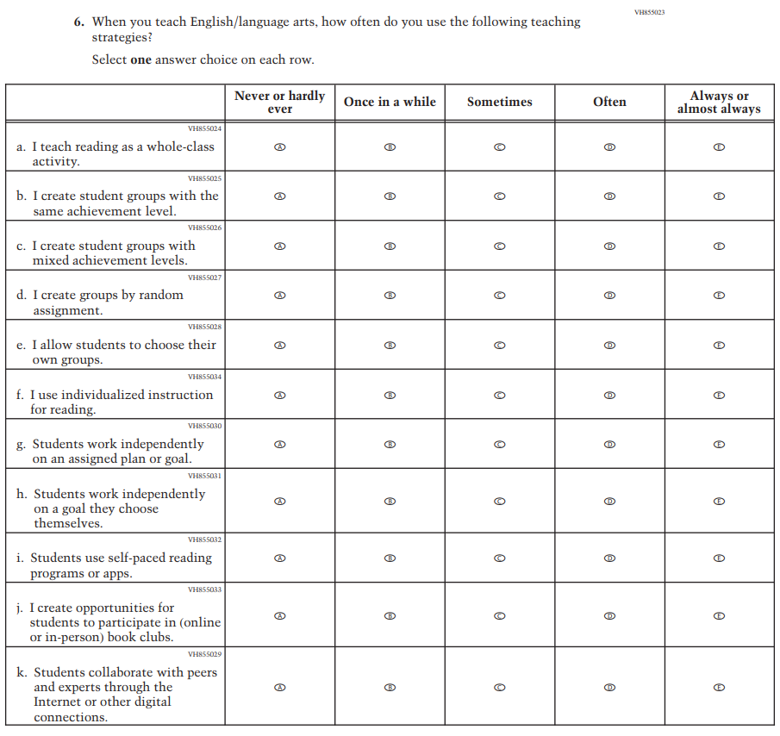
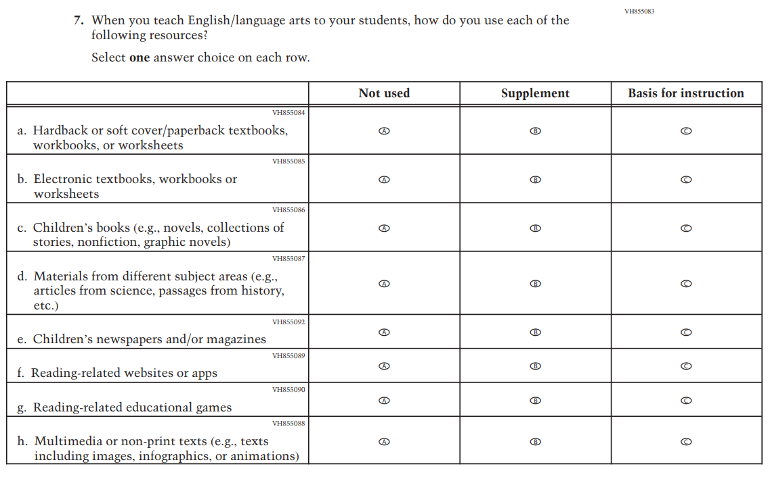
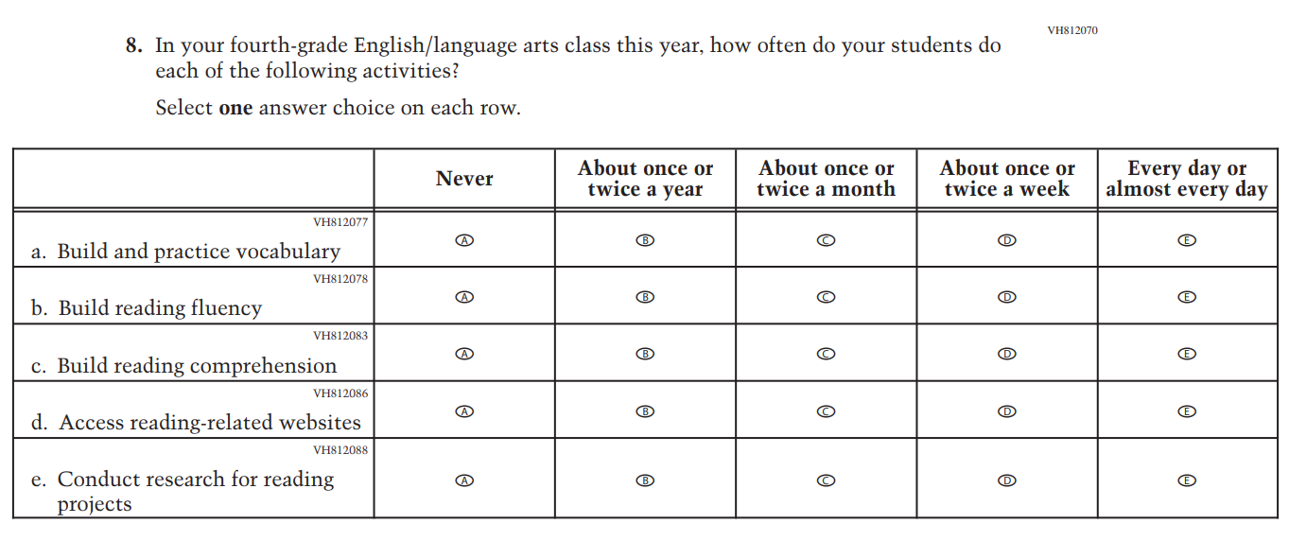

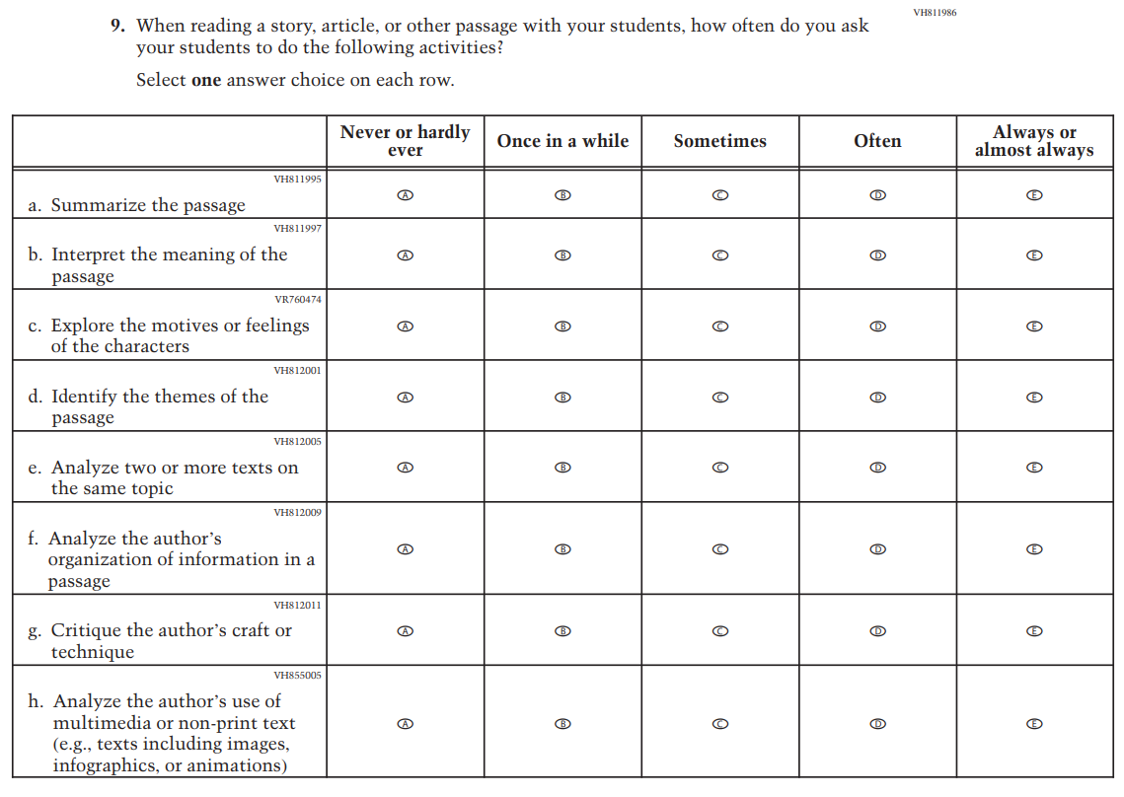
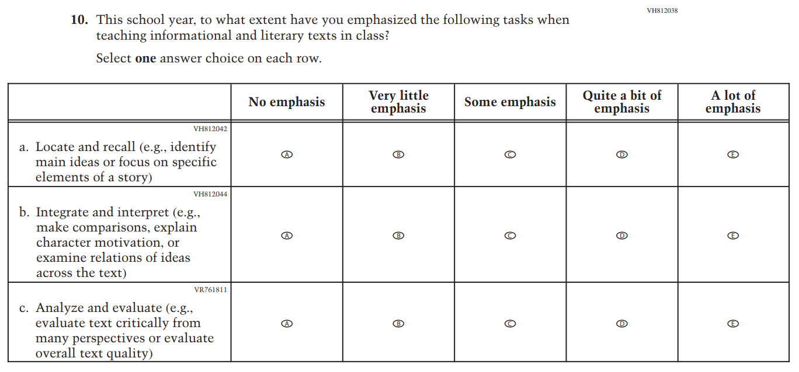
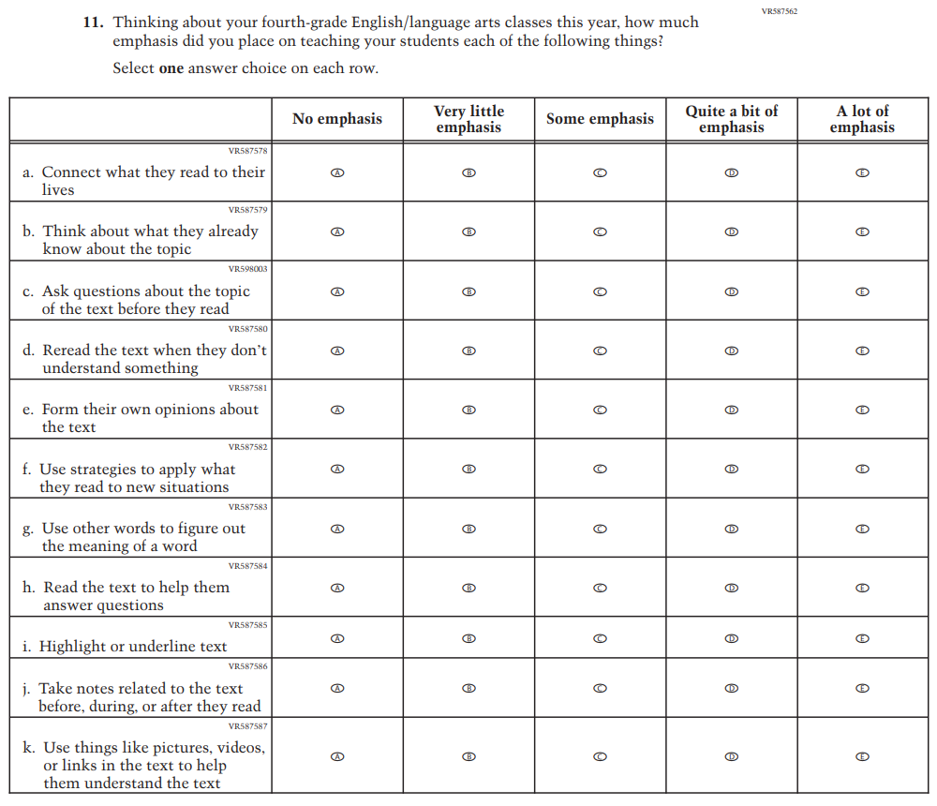

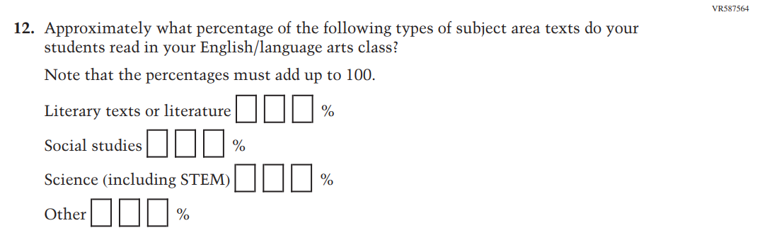
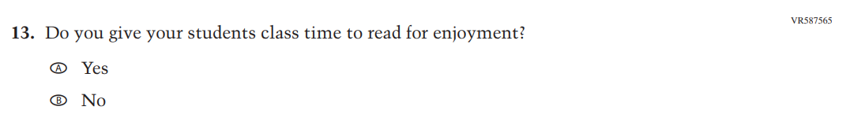

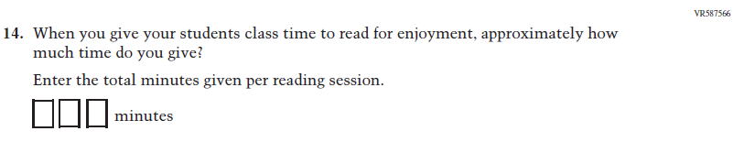

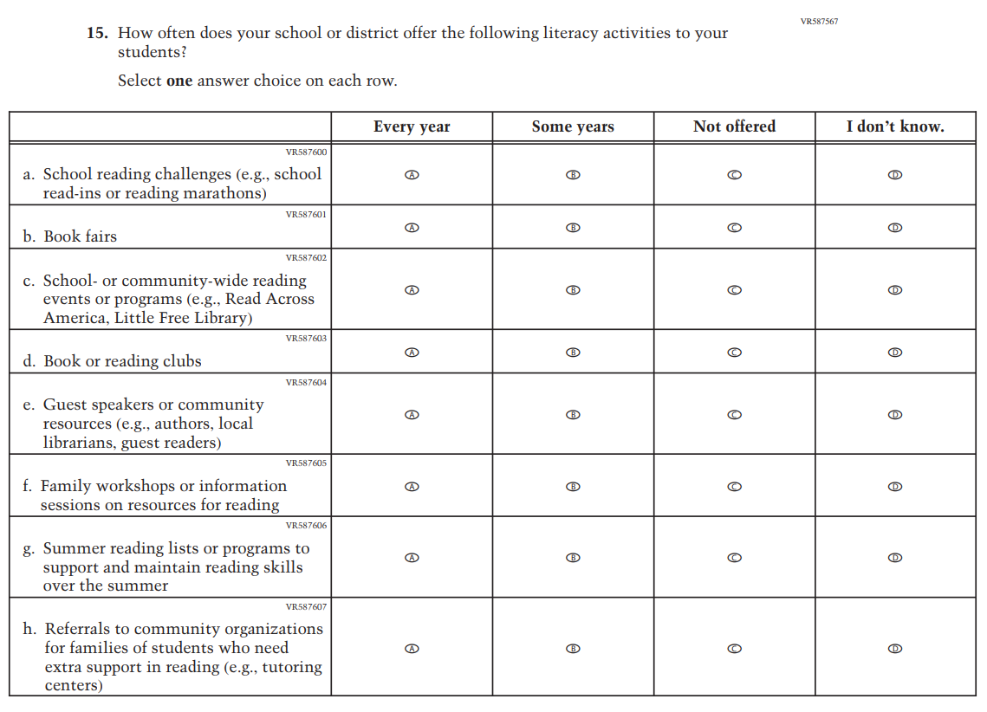

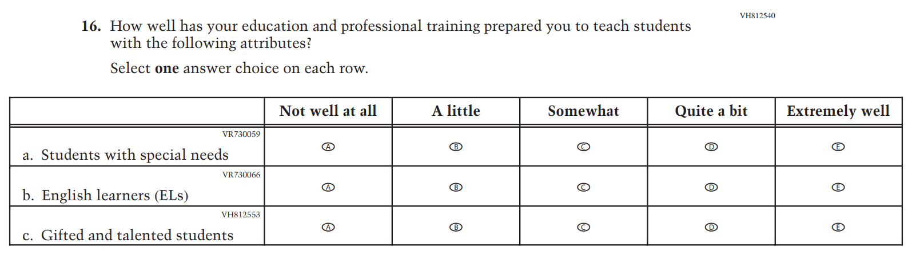

Appendix J2-11: Summary of Changes Operational Grade 8 (Reading)
2026 Operational Grade 8 Reading Teacher
Previous Item | 2026 Item | D/A/R+ | Rationale
(2024) | Issue: Teacher, Instructional, and Classroom Supports | R | The Item Stem was revised for clarity and Inline Directions inconsistent with other items were removed.
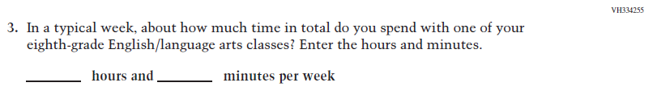  (2024) | 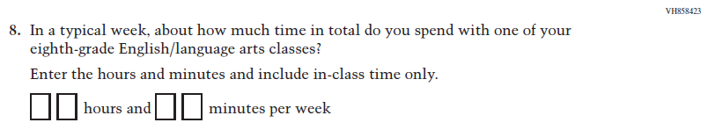  Issue: Teacher, Instructional, and Classroom Supports | R | This Item was revised for clarity.
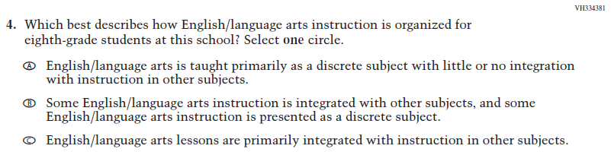  (2024) | 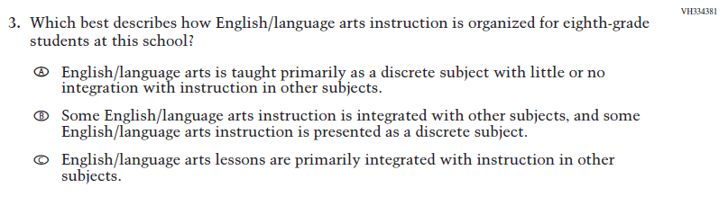  Issue: Teacher, Instructional, and Classroom Supports | R | Inline Directions inconsistent with other items were removed.

2026 Operational Grade 8 Reading Teacher
Previous Item | 2026 Item | D/A/R+ | Rationale
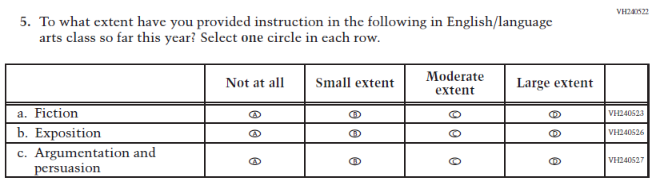  (2024) | 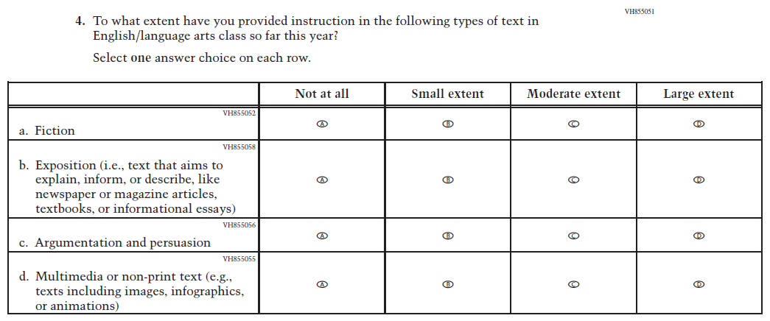  Issue: Teacher, Instructional, and Classroom Supports | R | For 2026, we have aligned Inline Directions in Teacher and School Items with the Directions currently used in Student Items. The Item stem and subitem b were revised for clarity, and subitem d was developed to measure content aligned with the new Reading framework.

2026 Operational Grade 8 Reading Teacher
Previous Item | 2026 Item | D/A/R+ | Rationale
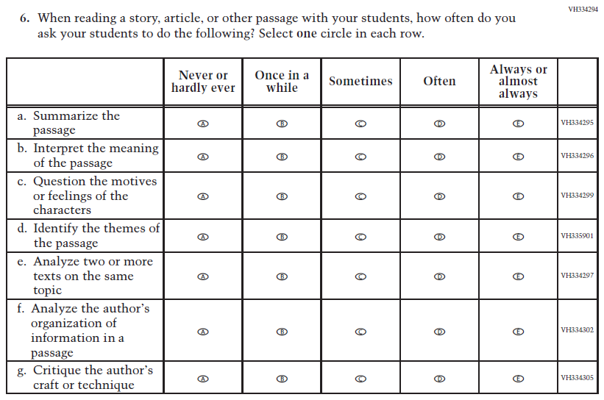  (2024) | 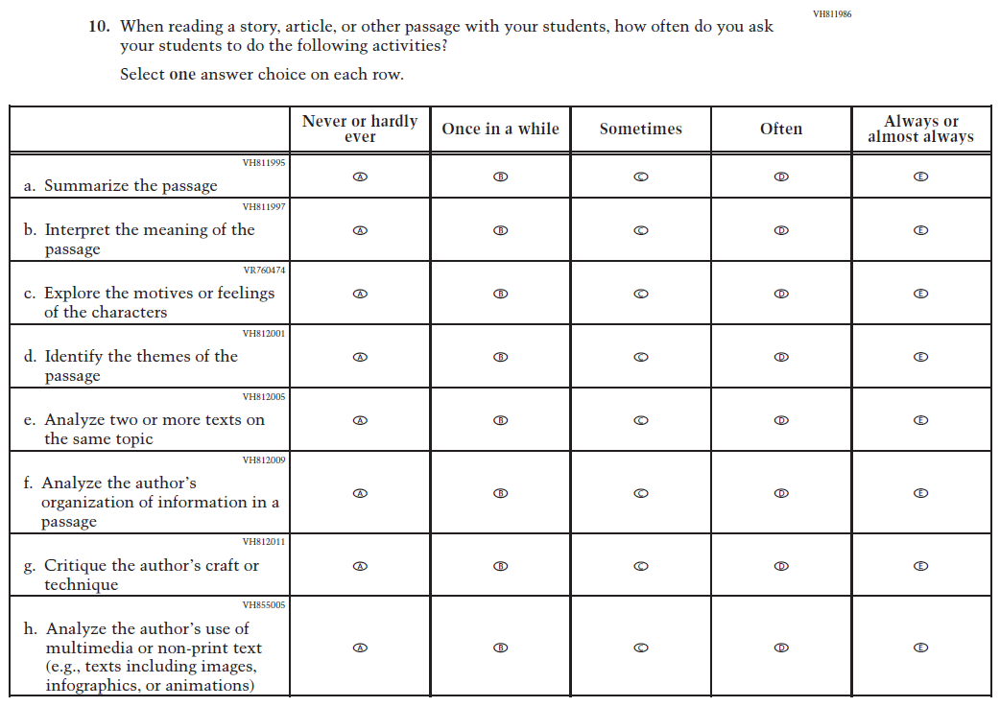  Issue: Cognition and Metacognition | R | For 2026, we have aligned Inline Directions in Teacher and School Items with the Directions currently used in Student Items. The Item stem and subitem c were revised for clarity and subitem h was developed to measure content aligned with the new Reading framework.

2026 Operational Grade 8 Reading Teacher
Previous Item | 2026 Item | D/A/R+ | Rationale
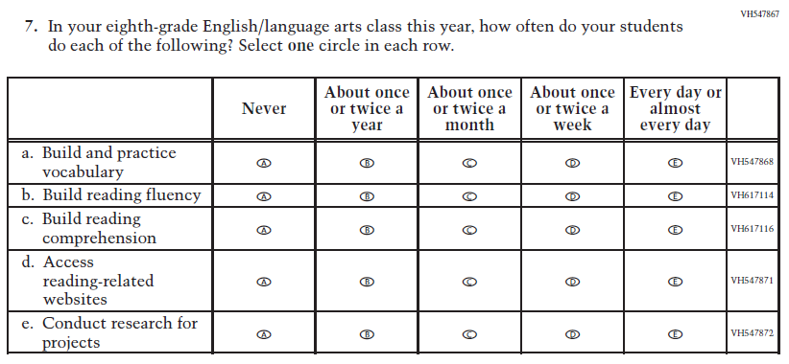  (2024) | 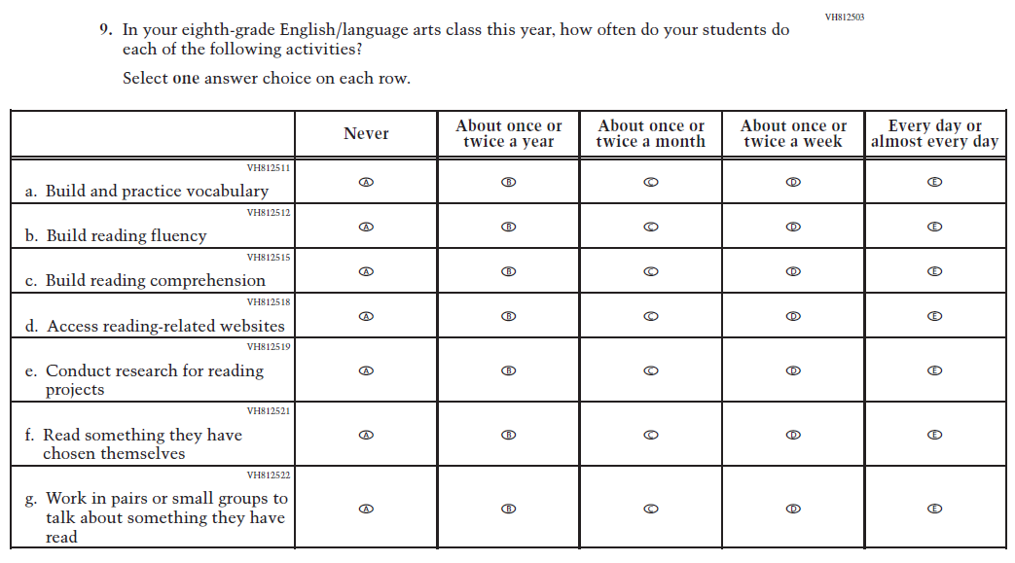  Issue: Teacher, Instructional, and Classroom Supports | R | For 2026, we have aligned Inline Directions in Teacher and School Items with the Directions currently used in Student Items. The Item stem and subitem e were revised for clarity, and subitems f and g were developed to measure content aligned with the new Reading framework.

2026 Operational Grade 8 Reading Teacher
Previous Item | 2026 Item | D/A/R+ | Rationale
N/A  (2024) | 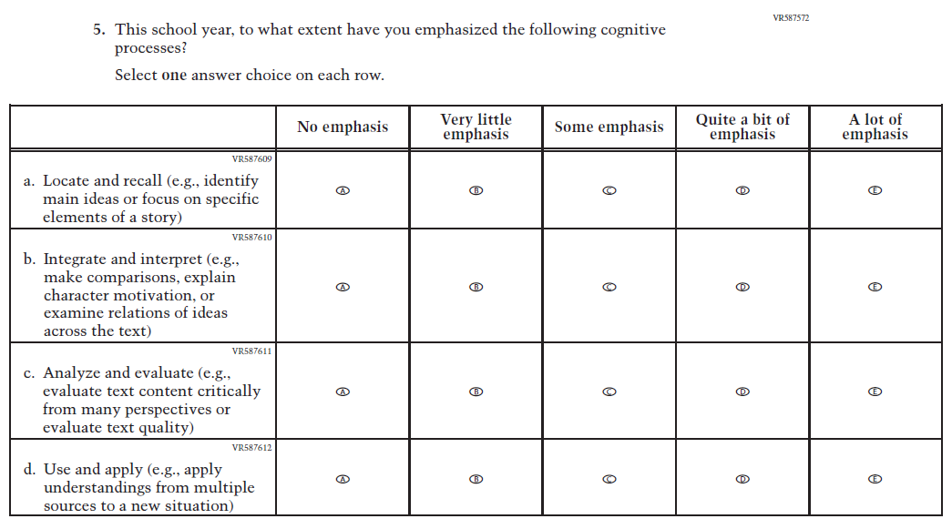  Issue: Teacher, Instructional, and Classroom Supports | A | This Item was developed to measure content aligned with the new Reading framework.

2026 Operational Grade 8 Reading Teacher
Previous Item | 2026 Item | D/A/R+ | Rationale
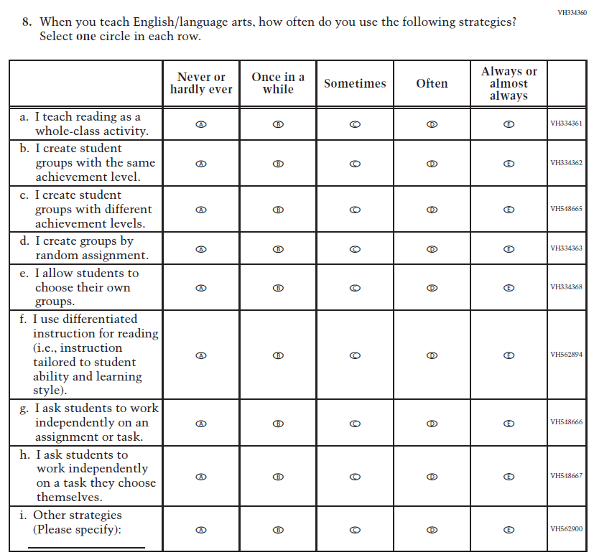  (2024) | 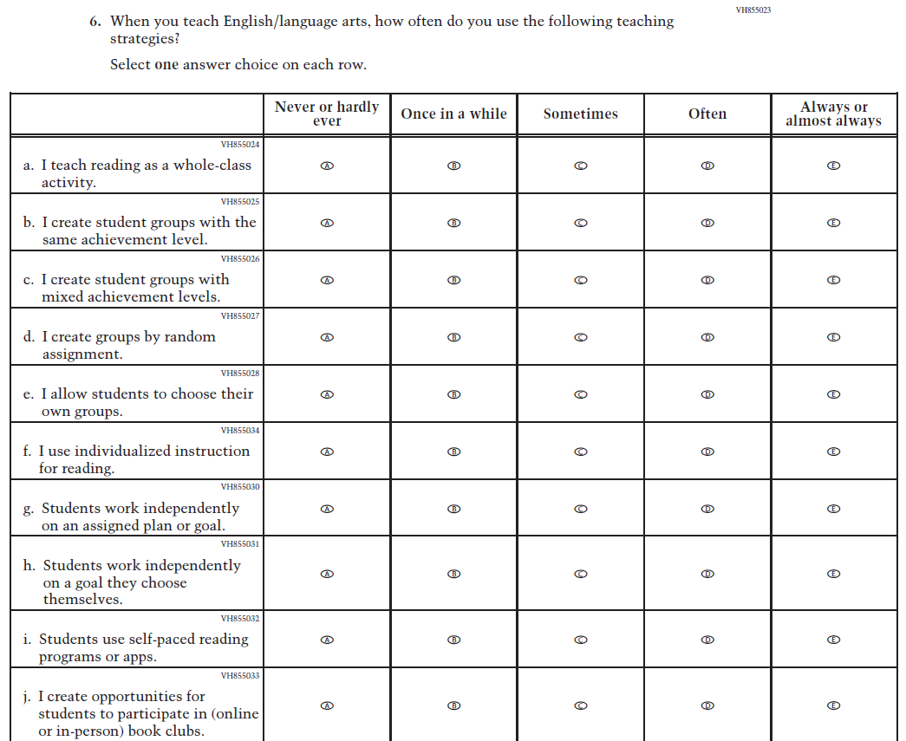  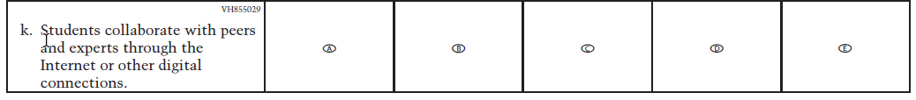  Issue: Teacher, Instructional, and Classroom Supports | R | For 2026, we have aligned Inline Directions in Teacher and School Items with the Directions currently used in Student Items. Subitems c, f, g, and h were revised for clarity, and subitems i, j, and k were developed to measure content aligned with the new Reading framework.

2026 Operational Grade 8 Reading Teacher
Previous Item | 2026 Item | D/A/R+ | Rationale
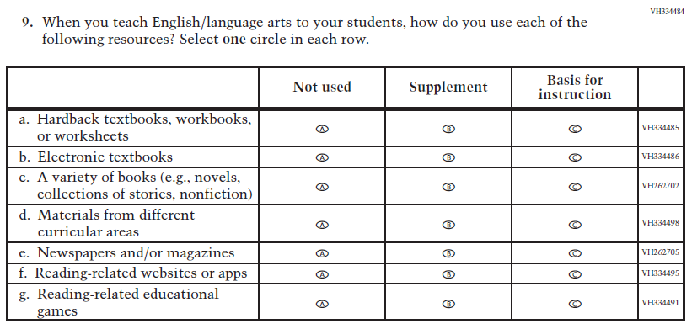  (2024) | 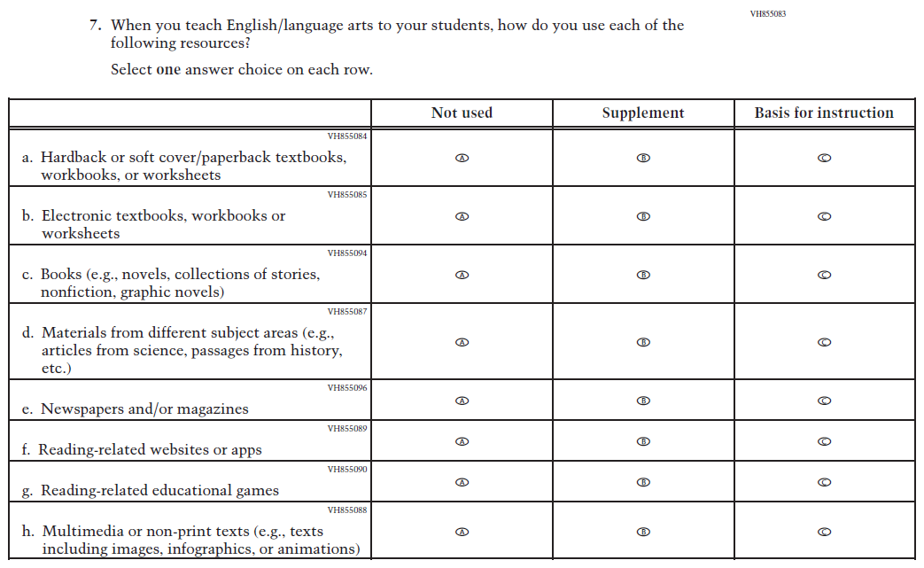  Issue: Teacher, Instructional, and Classroom Supports | R | For 2026, we have aligned Inline Directions in Teacher and School Items with the Directions currently used in Student Items. Subitems a, b, c, and d were revised for clarity and subitem h was developed to measure content aligned with the new Reading framework.

2026 Operational Grade 8 Reading Teacher
Previous Item | 2026 Item | D/A/R+ | Rationale
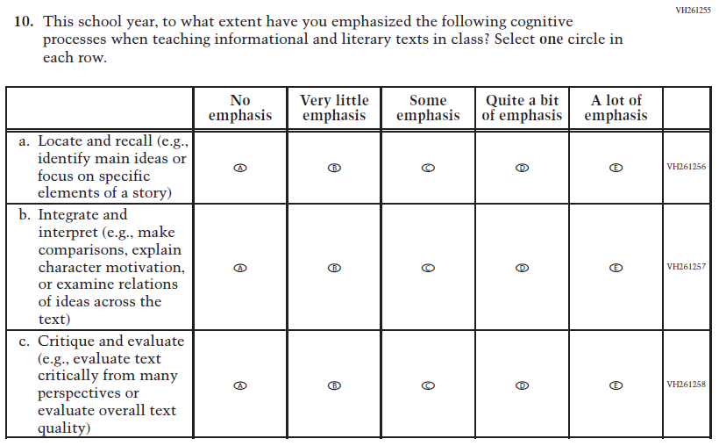  (2024) | 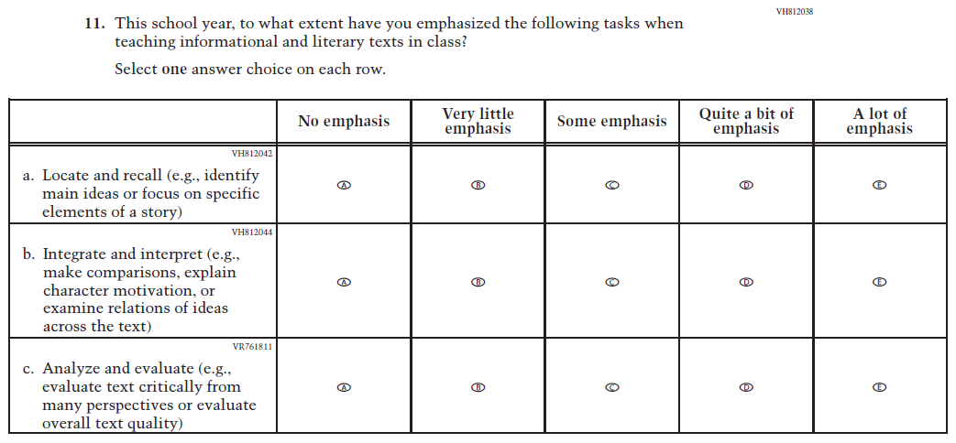  Issue: Cognition and Metacognition | R | For 2026, we have aligned Inline Directions in Teacher and School Items with the Directions currently used in Student Items. The Item stem and subitem c were revised for clarity.
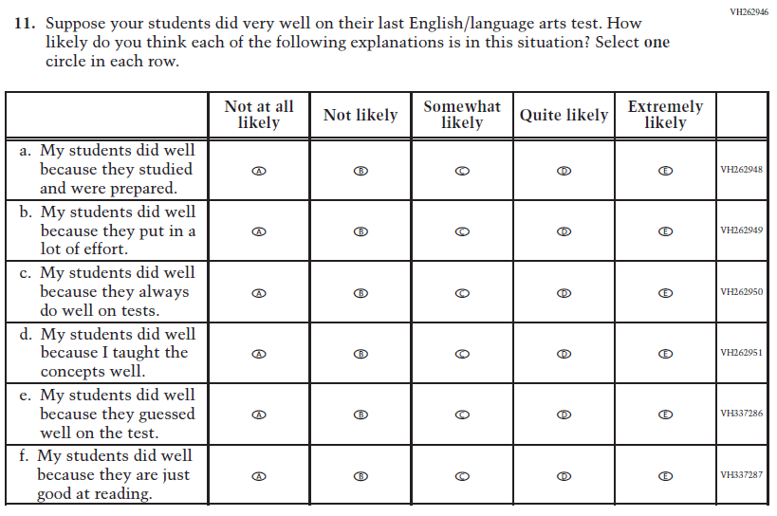  (2024) | N/A | D | This Item was dropped to reduce questionnaire length.

2026 Operational Grade 8 Reading Teacher
Previous Item | 2026 Item | D/A/R+ | Rationale
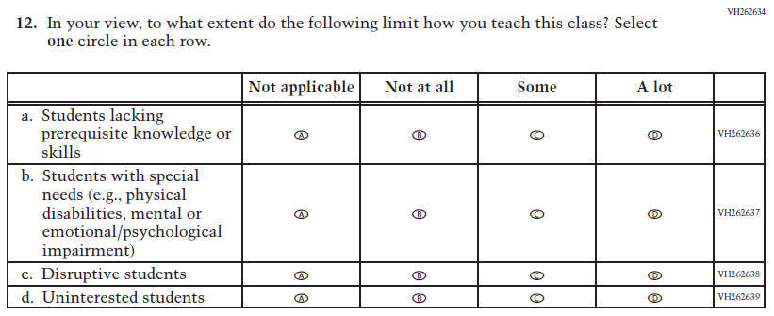  (2024) | N/A | D | This Item was dropped to reduce questionnaire length.
N/A  (2024) | 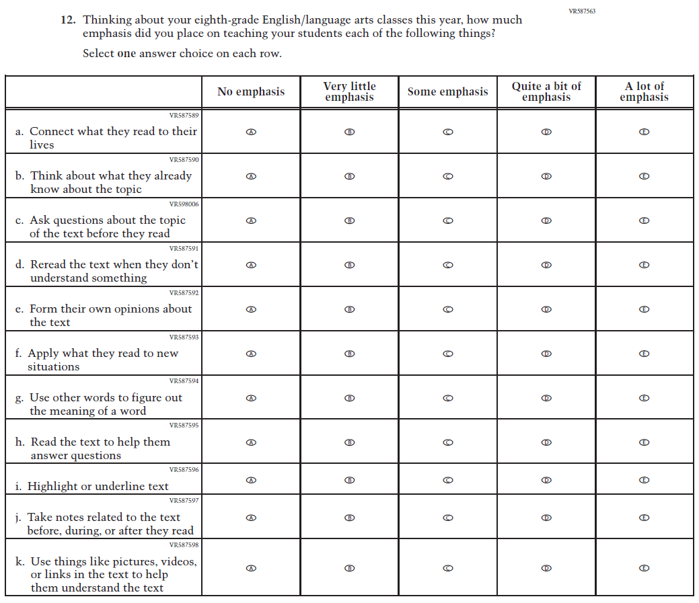  Issue: Cognition and Metacognition | A | This item was developed to measure content aligned with the new Reading framework.

2026 Operational Grade 8 Reading Teacher
Previous Item | 2026 Item | D/A/R+ | Rationale
N/A  (2024) | 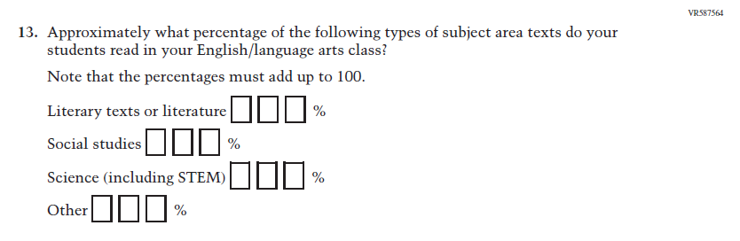  Issue: Cognition and Metacognition | A | This item was developed to measure content aligned with the new Reading framework.
N/A  (2024) | 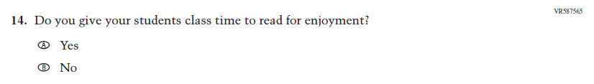  Issue: Engagement and Motivation | A | This Item was developed to measure content aligned with the new Reading framework.
N/A  (2024) | 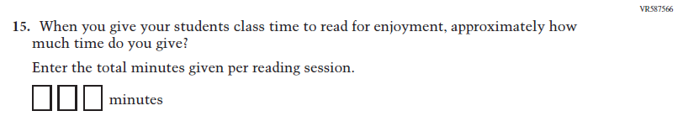  Issue: Engagement and Motivation | A | This Item was developed to measure content aligned with the new Reading framework.

2026 Operational Grade 8 Reading Teacher
Previous Item | 2026 Item | D/A/R+ | Rationale
N/A  (2024) | 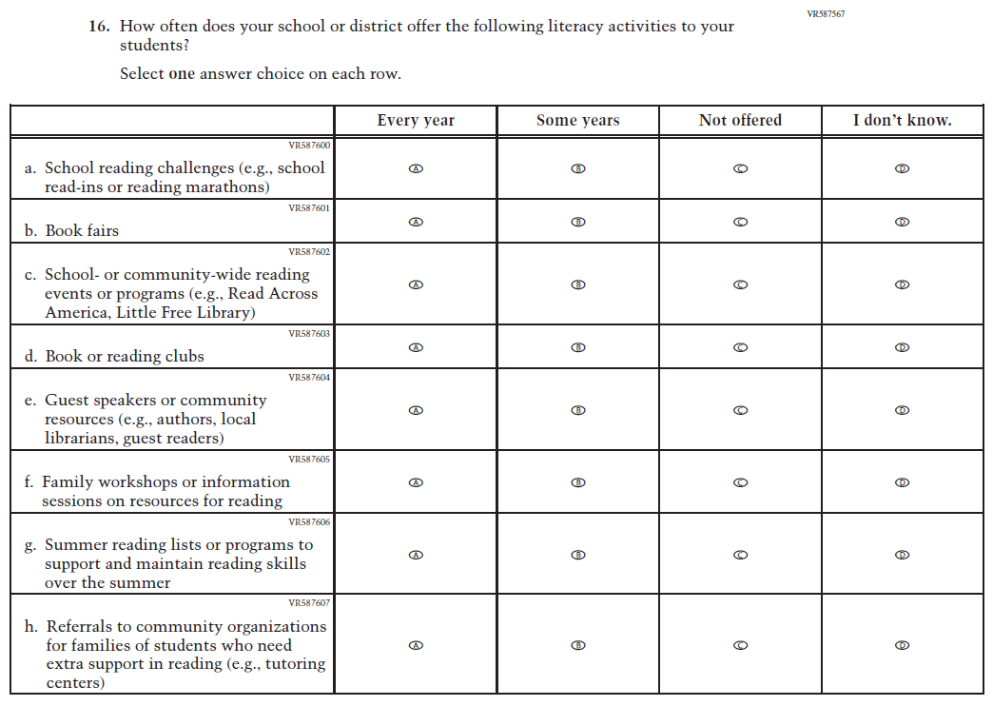  Issue: School and Community Resources | A | This item was developed to measure content aligned with the new Reading framework.
N/A  (2024) | 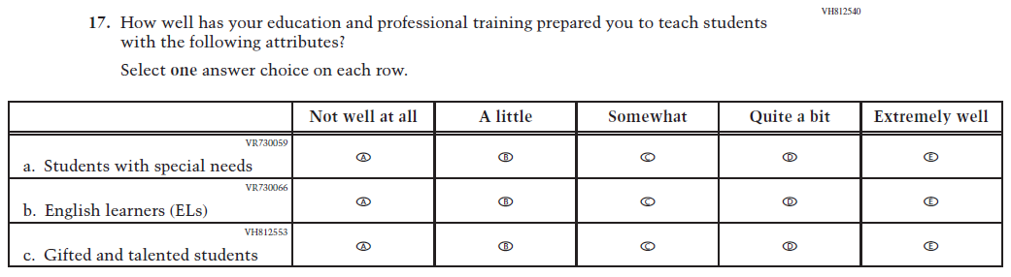  Issue: N/A | A | This Item was added to measure the important aspect of teacher preparation for teaching a variety of students.

Appendix J2-12: Operational Grade 8 (Reading)

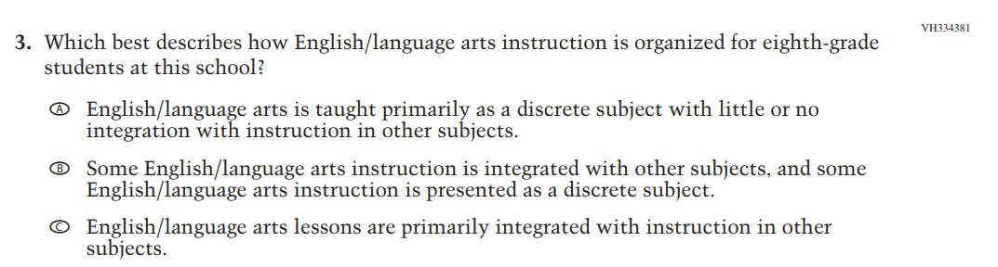

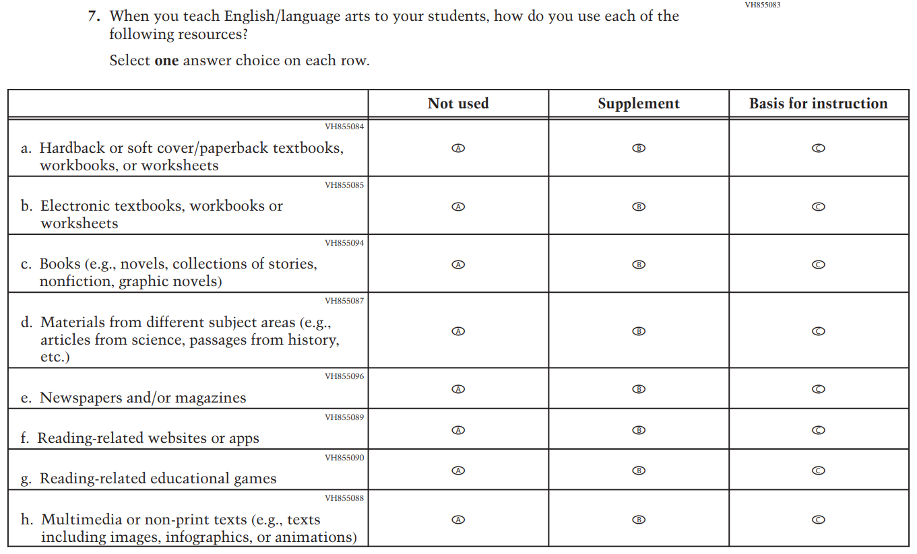

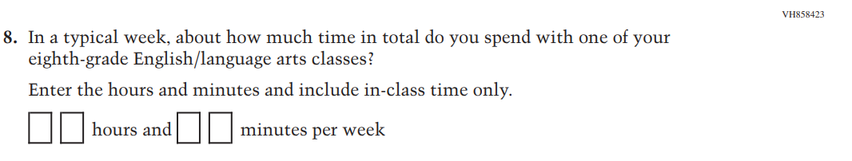

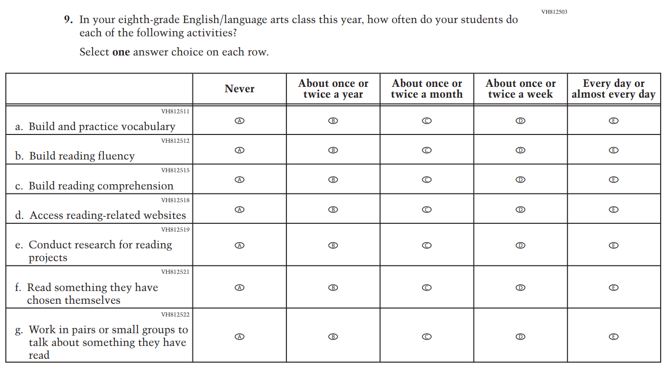

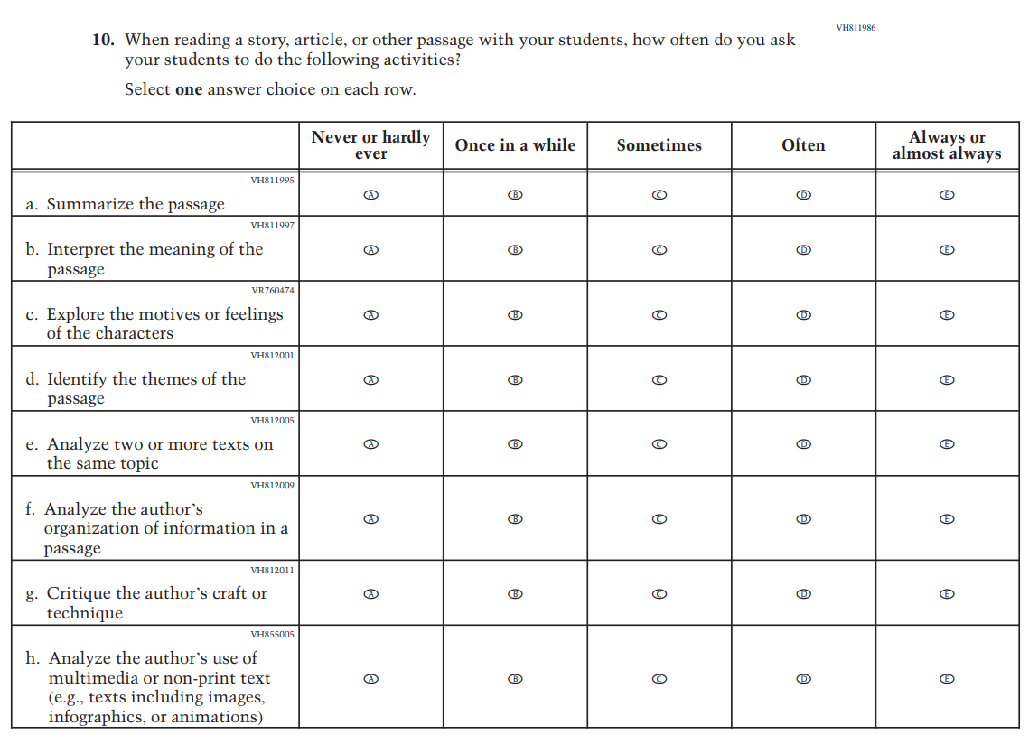

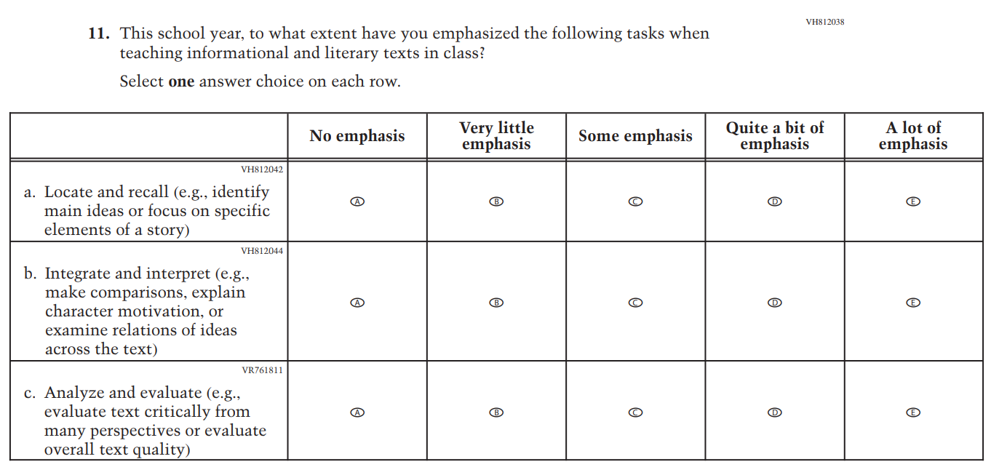

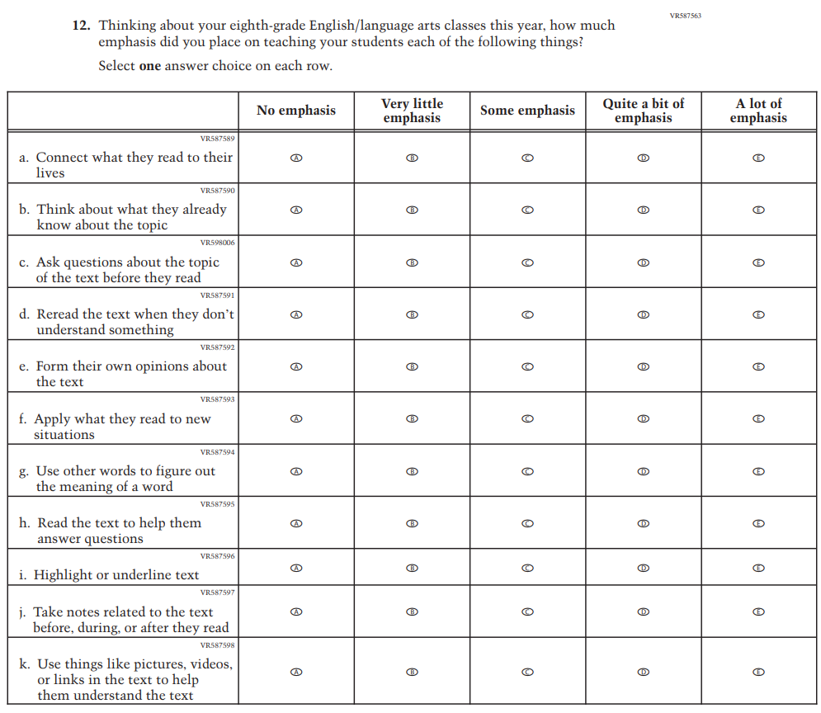

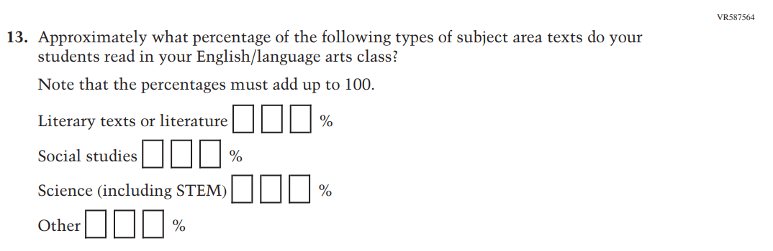

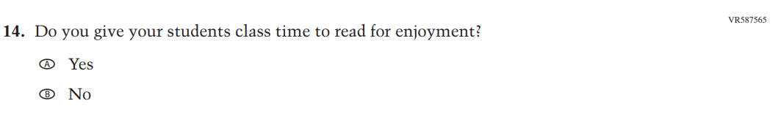
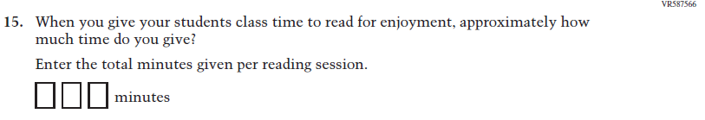

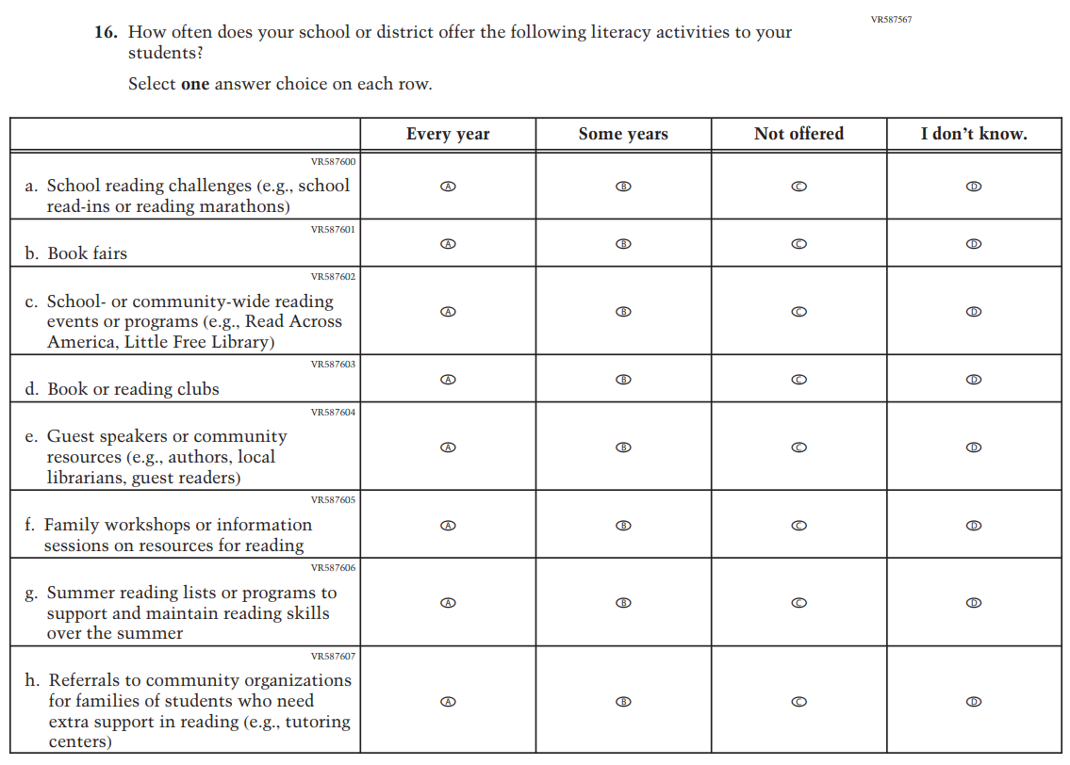

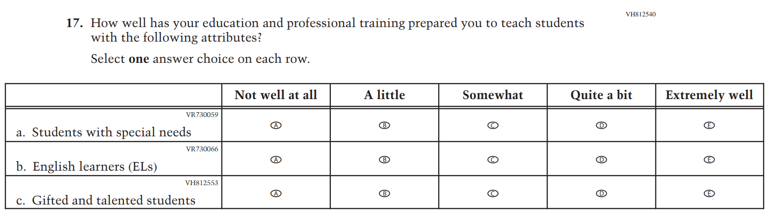

Appendix J2-13: Summary of Changes Operational Grade 8 (Social Studies)
2026 Operational Grade 8 Social Studies Teacher
Previous Item | 2026 Item | D/A/R+ | Rationale
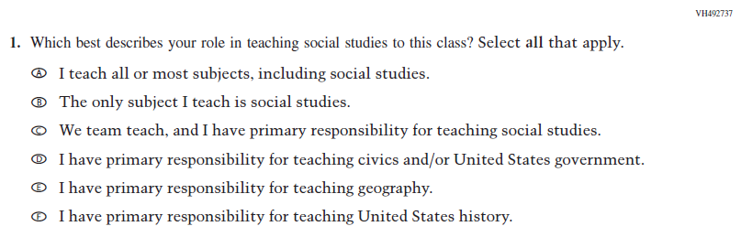  (2022) | 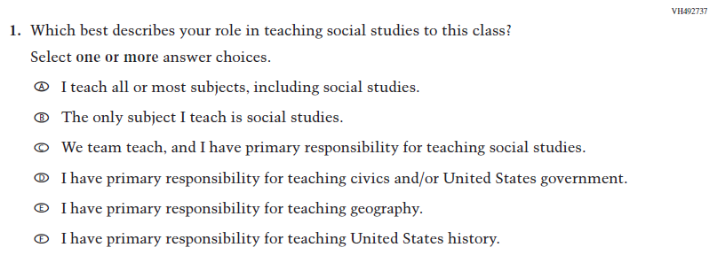  Issue: Resources for Learning and Instruction | R | For 2026, we have aligned Inline Directions in Teacher and School Items with the Directions currently used in Student Items.
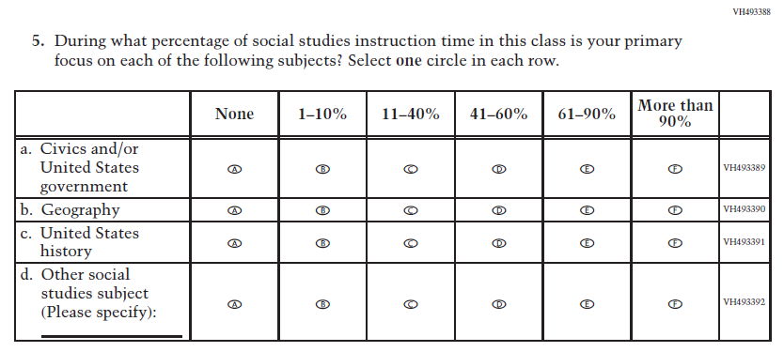  (2022) | 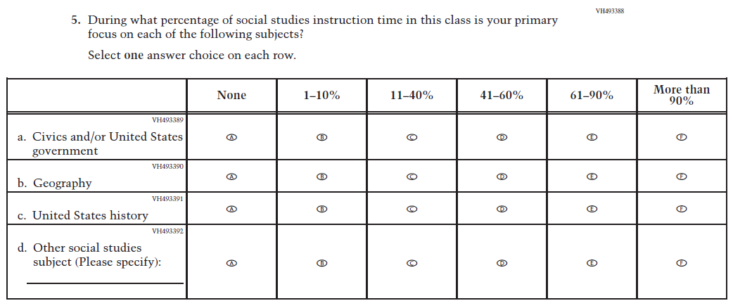  Issue: Resources for Learning and Instruction | R | For 2026, we have aligned Inline Directions in Teacher and School Items with the Directions currently used in Student Items.

2026 Operational Grade 8 Social Studies Teacher
Previous Item | 2026 Item | D/A/R+ | Rationale
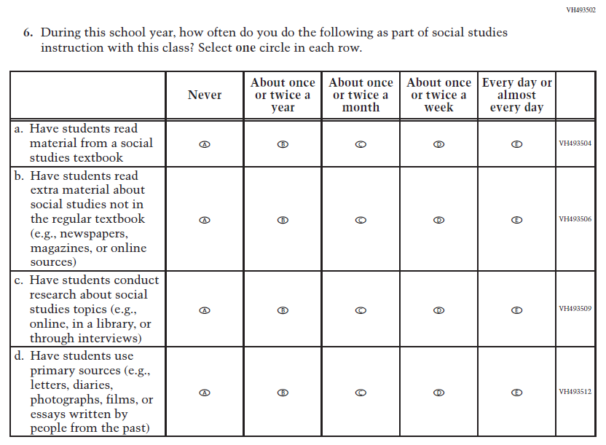  (2022) | 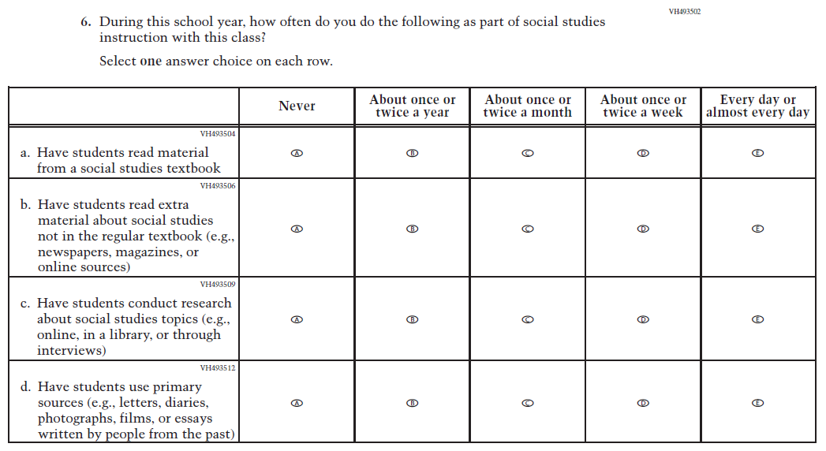  Issue: Organization of Instruction | R | For 2026, we have aligned Inline Directions in Teacher and School Items with the Directions currently used in Student Items.
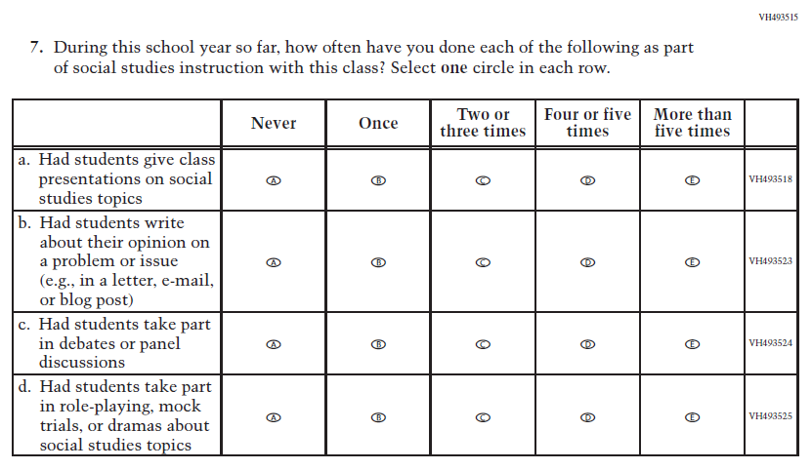  (2022) | 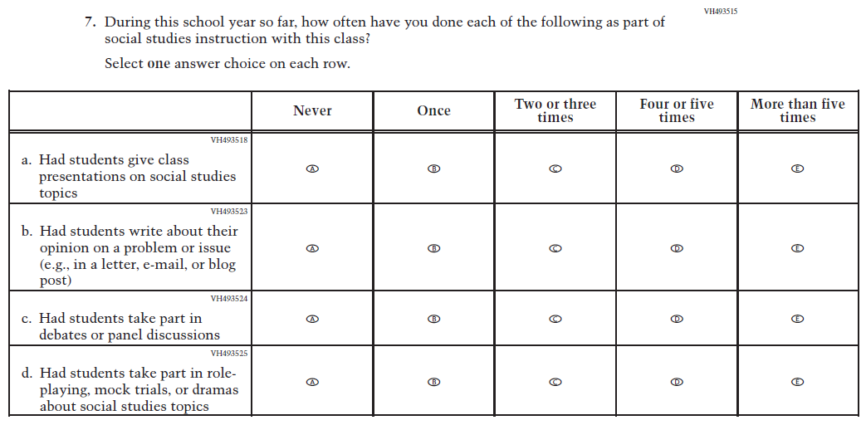  Issue: Organization of Instruction | R | For 2026, we have aligned Inline Directions in Teacher and School Items with the Directions currently used in Student Items.

2026 Operational Grade 8 Social Studies Teacher
Previous Item | 2026 Item | D/A/R+ | Rationale
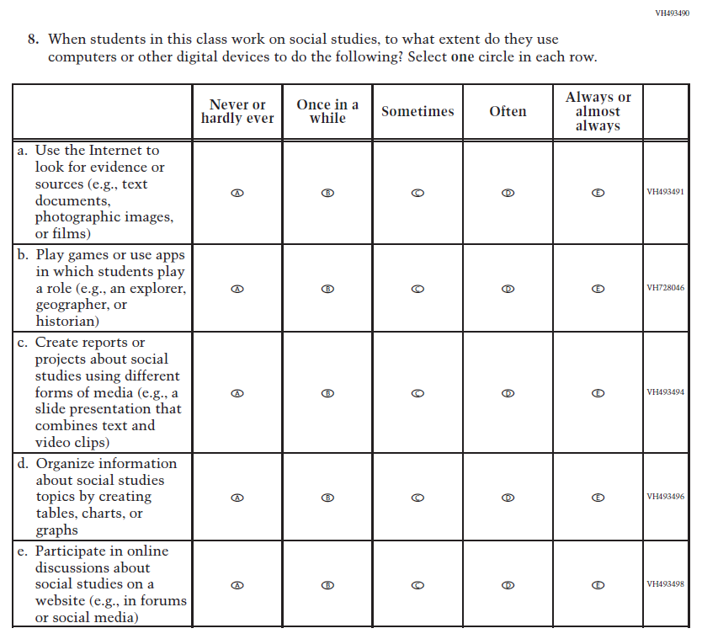  (2022) | 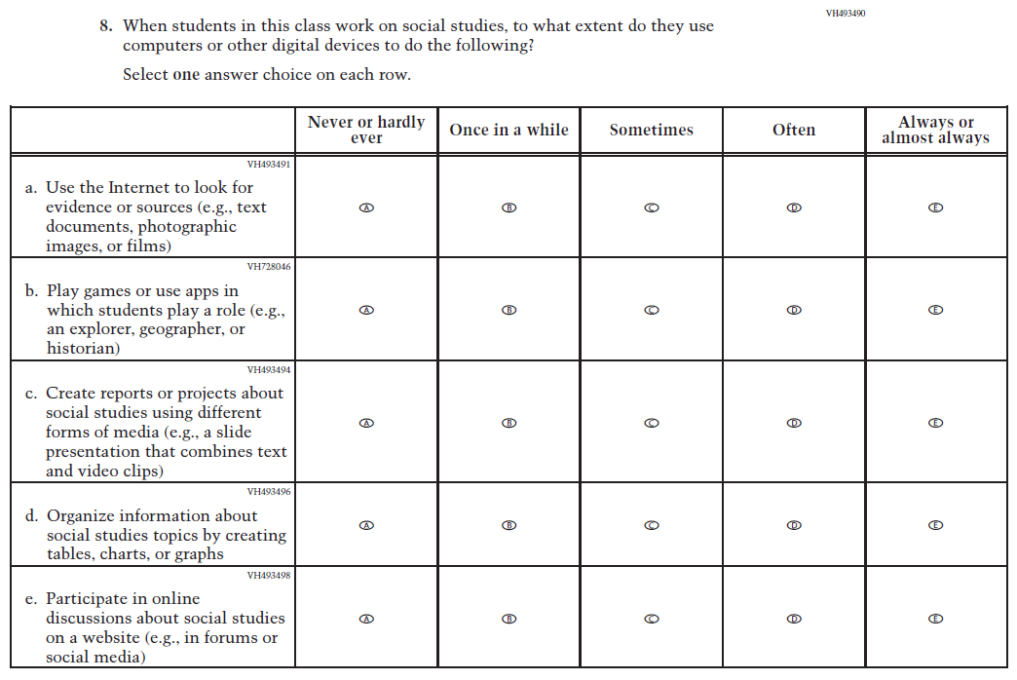  Issue: Organization of Instruction | R | For 2026, we have aligned Inline Directions in Teacher and School Items with the Directions currently used in Student Items.

2026 Operational Grade 8 Social Studies Teacher
Previous Item | 2026 Item | D/A/R+ | Rationale
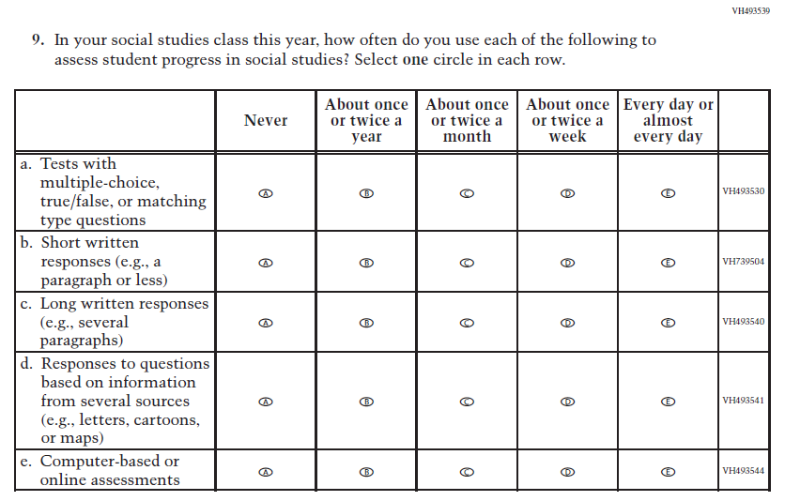  (2022) | 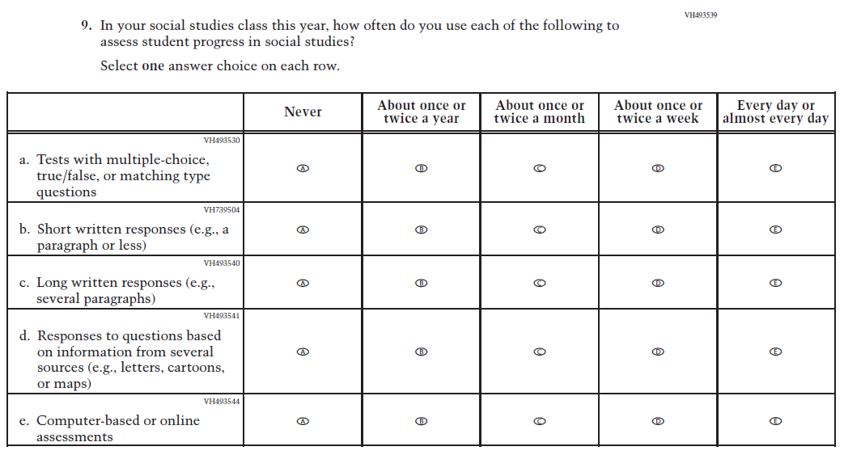  Issue: Organization of Instruction | R | For 2026, we have aligned Inline Directions in Teacher and School Items with the Directions currently used in Student Items.
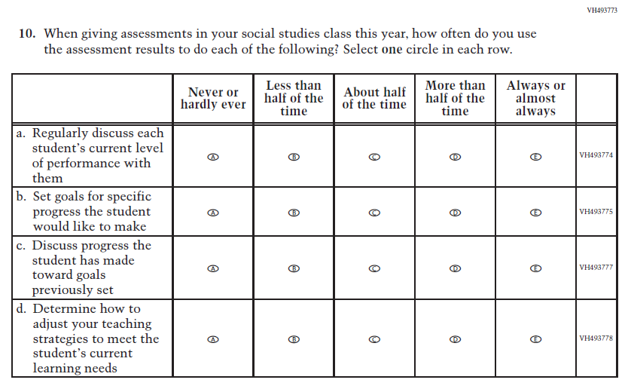  (2022) | 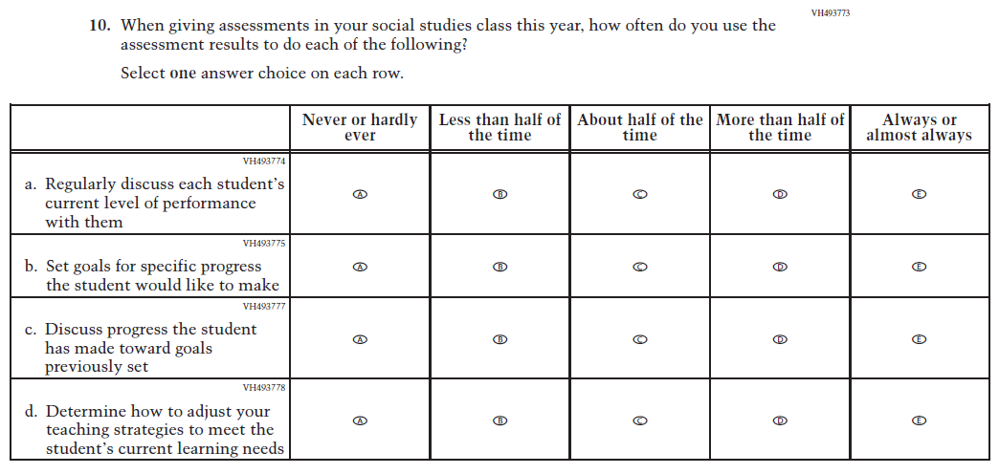  Issue: Organization of Instruction | R | For 2026, we have aligned Inline Directions in Teacher and School Items with the Directions currently used in Student Items.

2026 Operational Grade 8 Social Studies Teacher
Previous Item | 2026 Item | D/A/R+ | Rationale
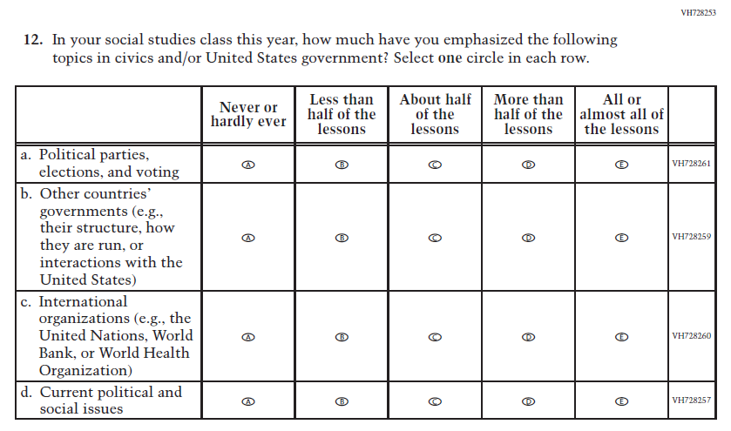  (2022) | 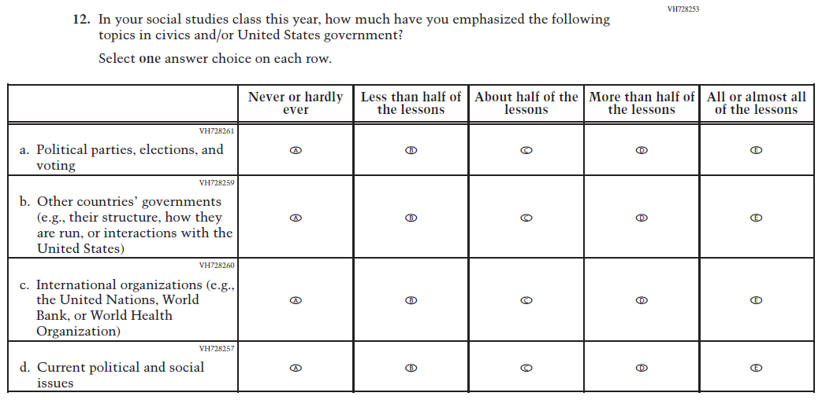  Issue: Organization of Instruction | R | For 2026, we have aligned Inline Directions in Teacher and School Items with the Directions currently used in Student Items.

2026 Operational Grade 8 Social Studies Teacher
Previous Item | 2026 Item | D/A/R+ | Rationale
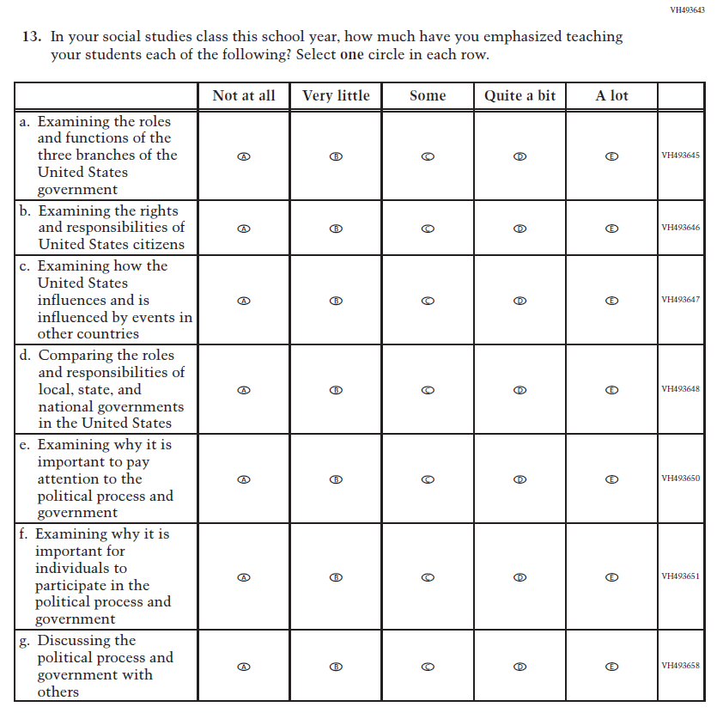  (2022) | 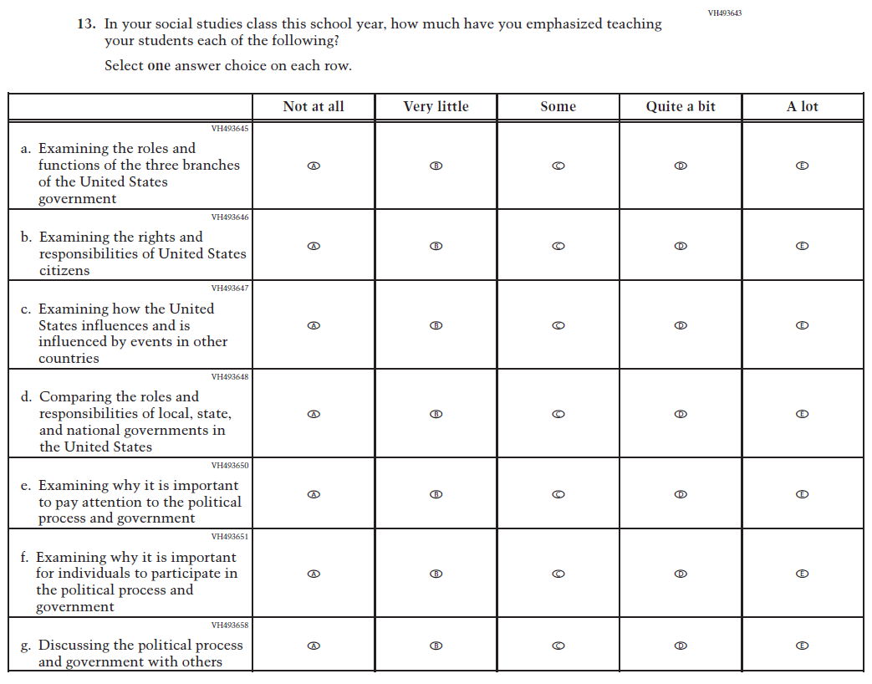  Issue: Organization of Instruction | R | For 2026, we have aligned Inline Directions in Teacher and School Items with the Directions currently used in Student Items.
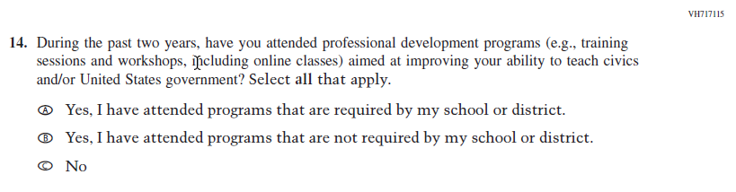  (2022) | 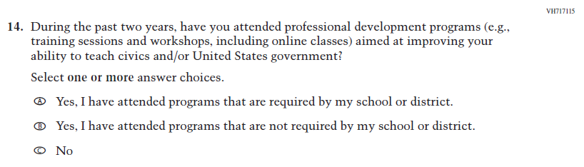  Issue: Teacher Preparation | R | For 2026, we have aligned Inline Directions in Teacher and School Items with the Directions currently used in Student Items.

2026 Operational Grade 8 Social Studies Teacher
Previous Item | 2026 Item | D/A/R+ | Rationale
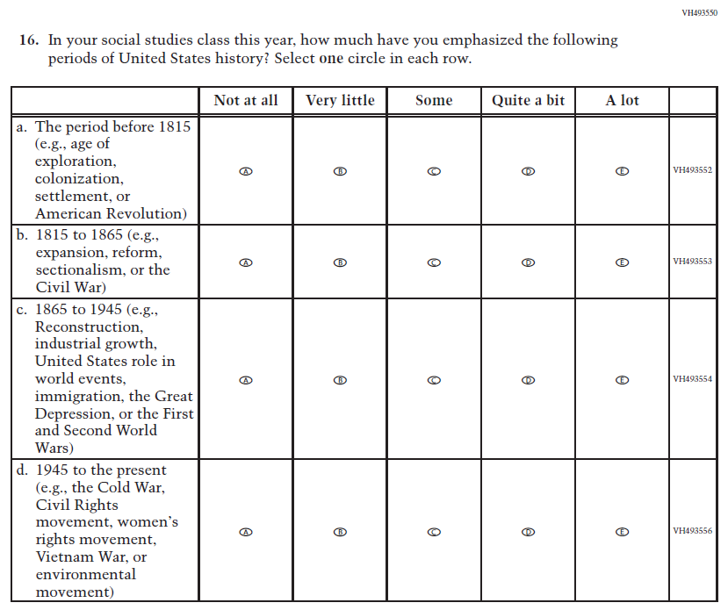  (2022) | 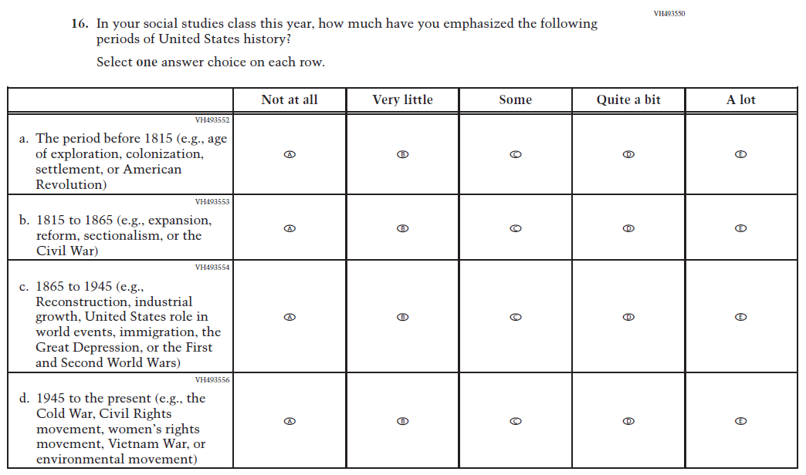  Issue: Organization of Instruction | R | For 2026, we have aligned Inline Directions in Teacher and School Items with the Directions currently used in Student Items.

2026 Operational Grade 8 Social Studies Teacher
Previous Item | 2026 Item | D/A/R+ | Rationale
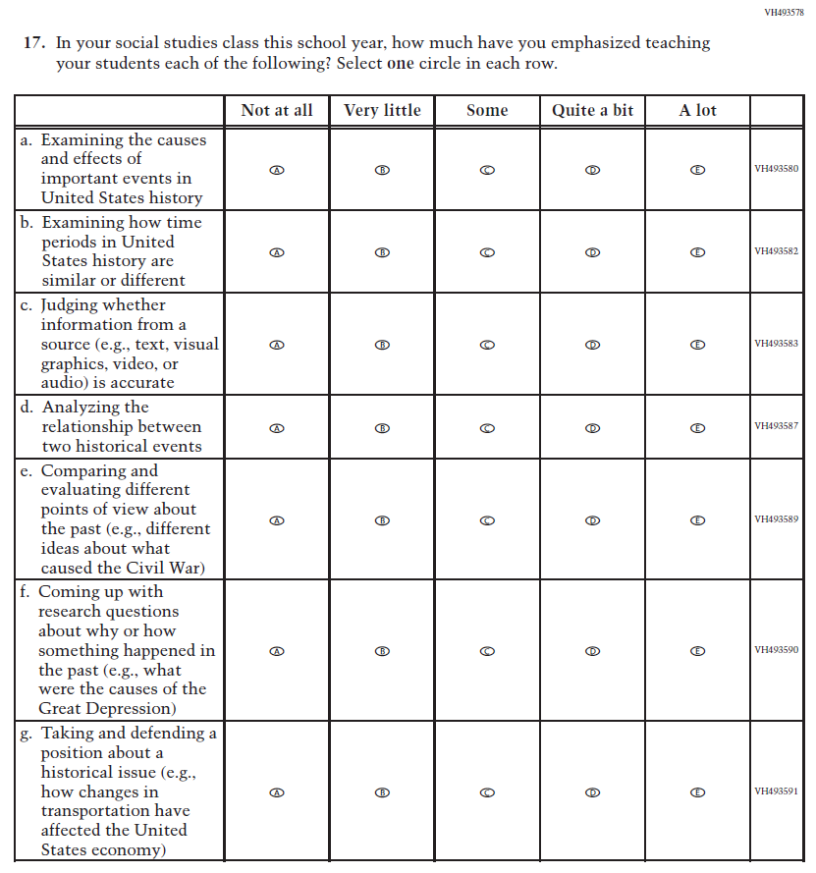  (2022) | 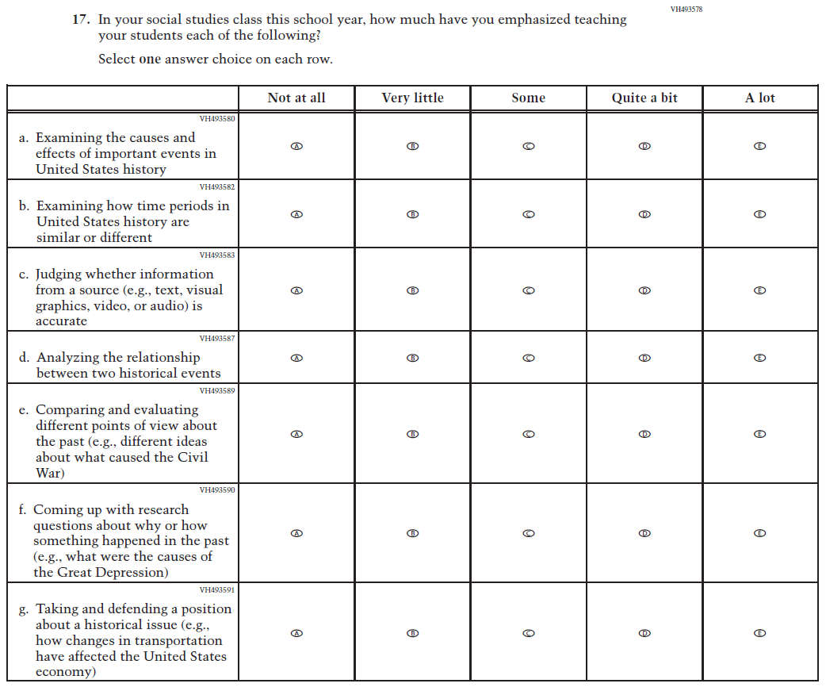  Issue: Organization of Instruction | R | For 2026, we have aligned Inline Directions in Teacher and School Items with the Directions currently used in Student Items.

2026 Operational Grade 8 Social Studies Teacher
Previous Item | 2026 Item | D/A/R+ | Rationale
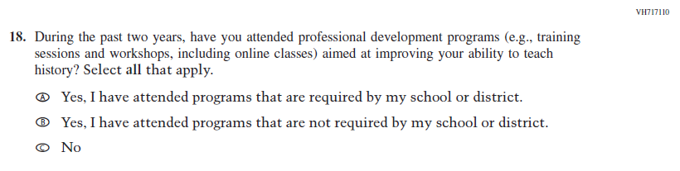  (2022) | 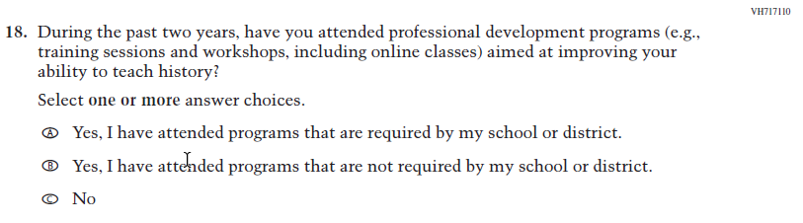  Issue: Teacher Preparation | R | For 2026, we have aligned Inline Directions in Teacher and School Items with the Directions currently used in Student Items.
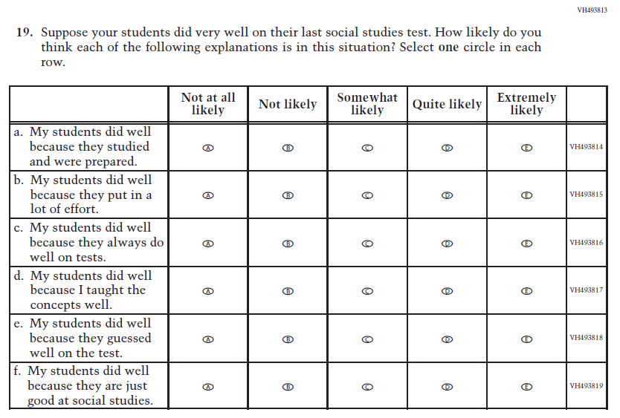  (2022) | 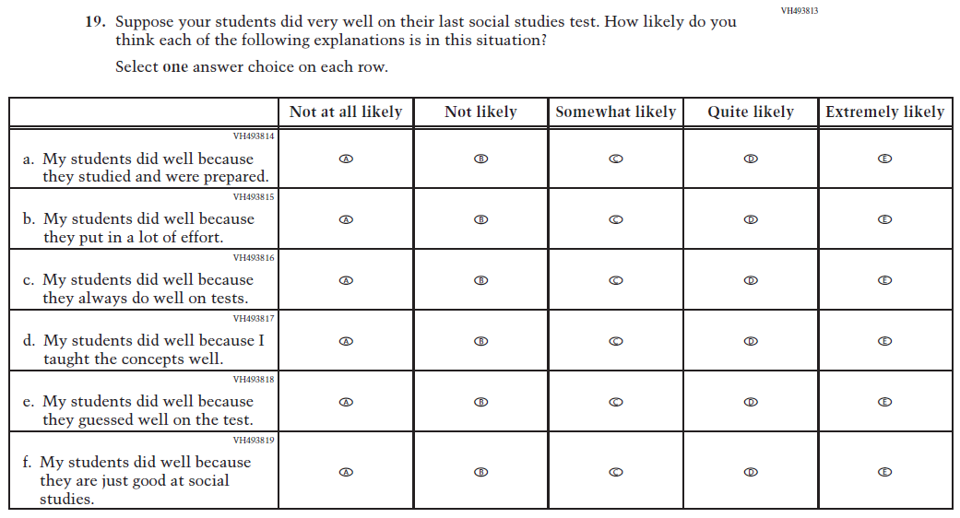  Issue: Teacher Preparation | R | For 2026, we have aligned Inline Directions in Teacher and School Items with the Directions currently used in Student Items.

Appendix J2-14: Operational Grade 8 (Social Studies)
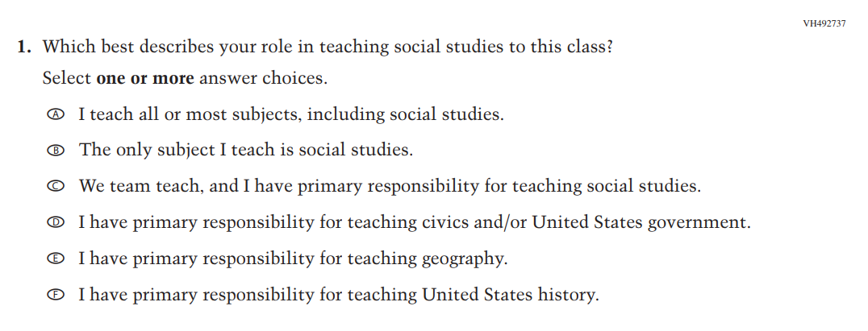

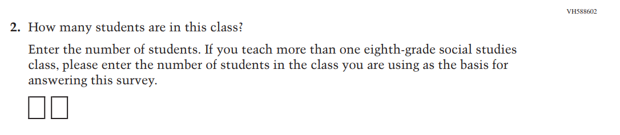

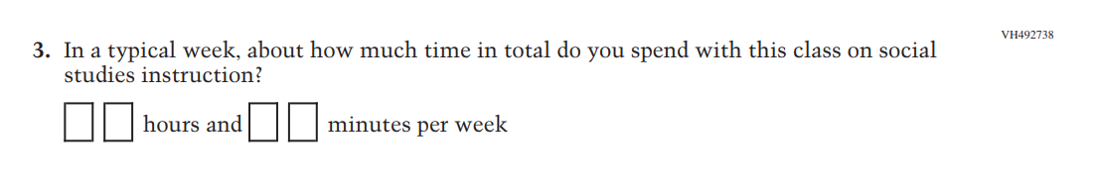
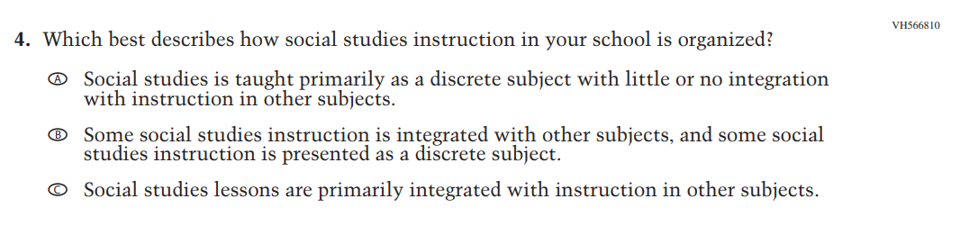
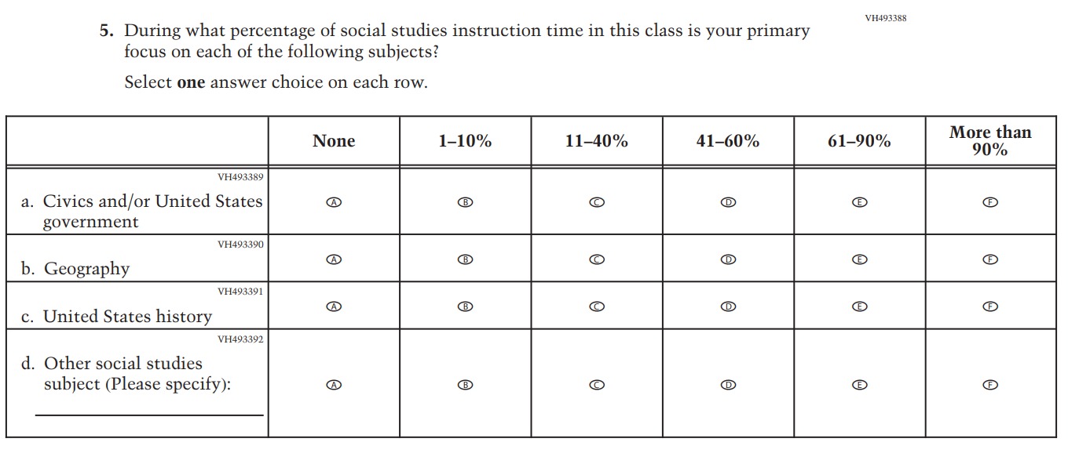

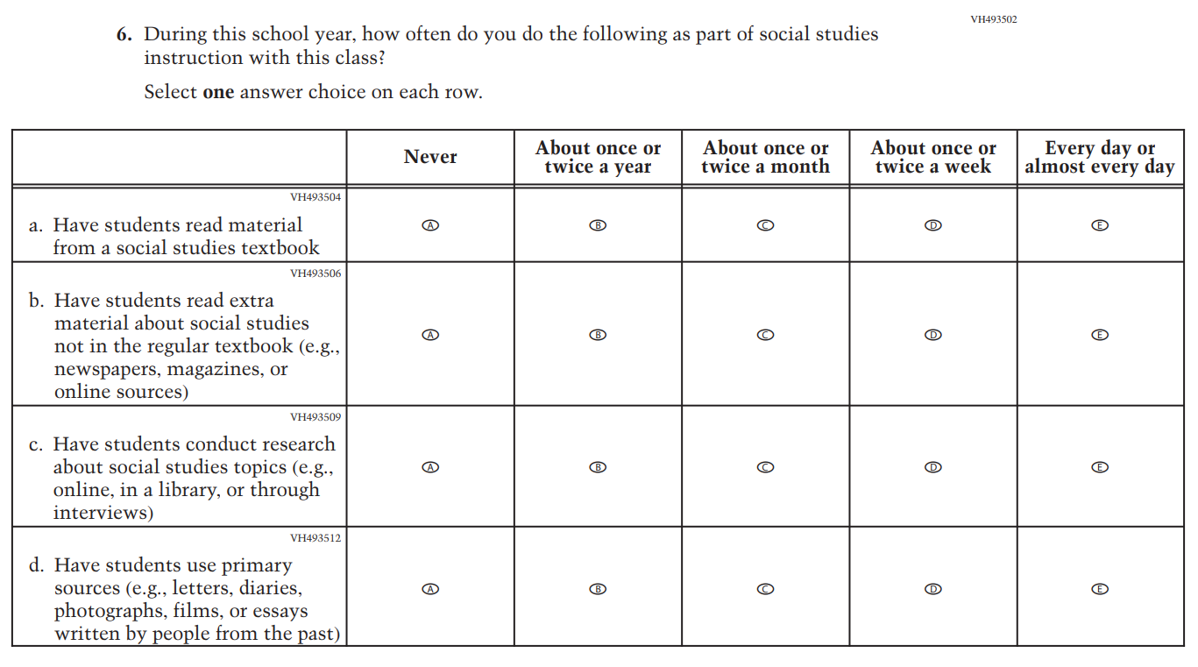

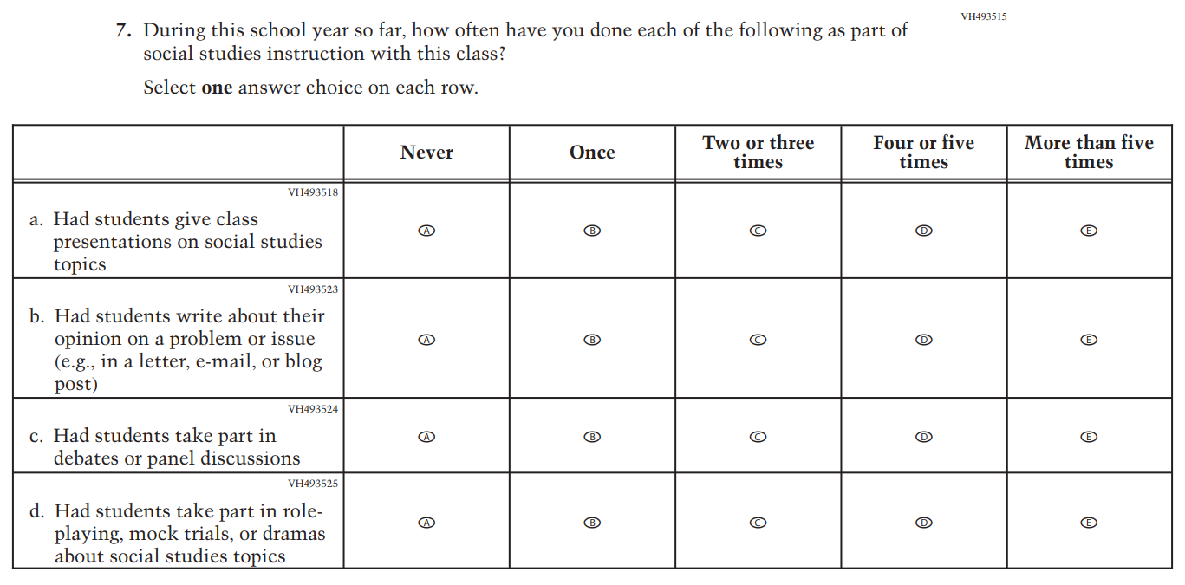
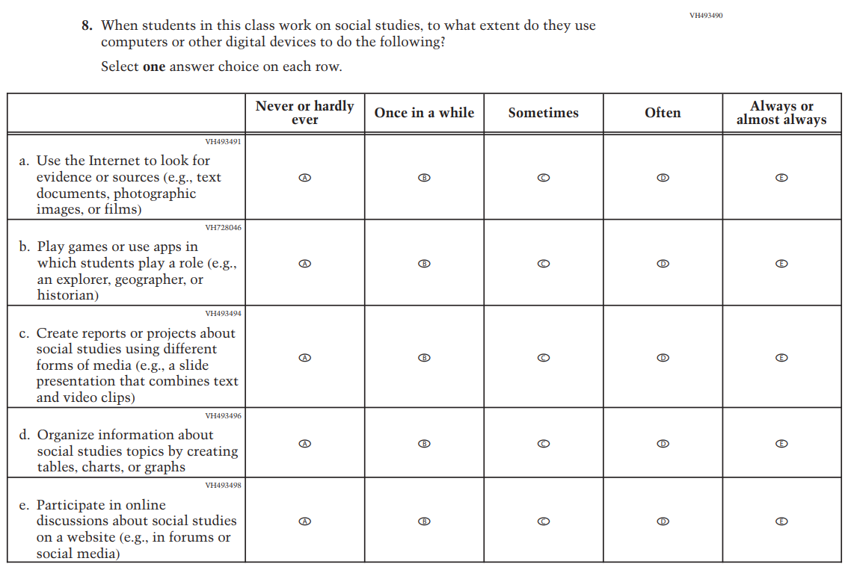
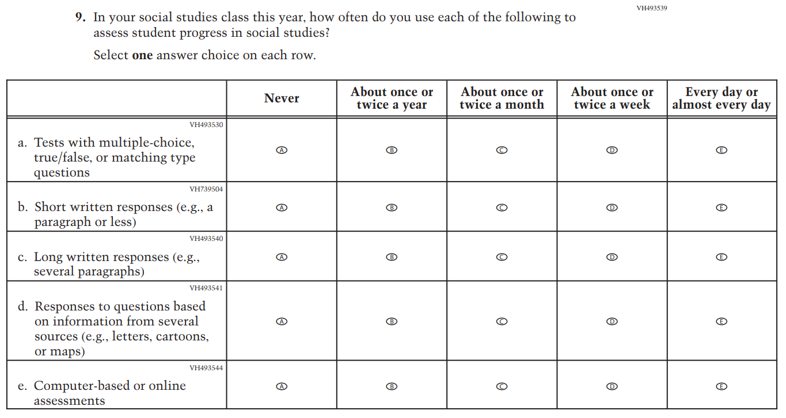

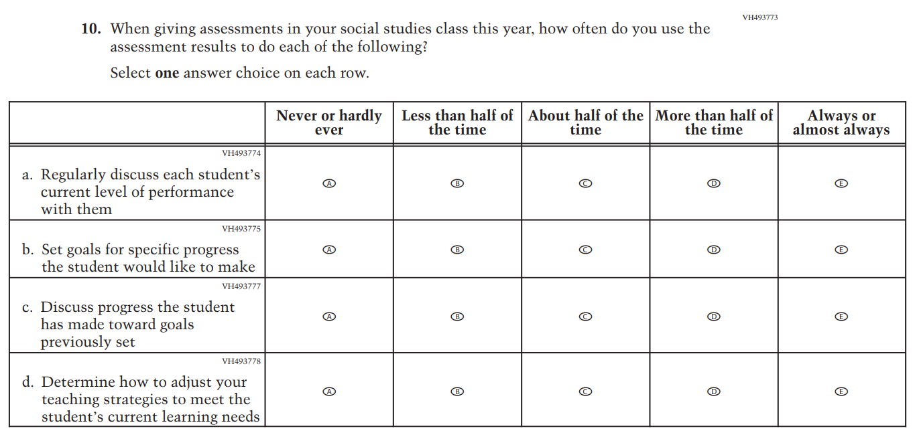

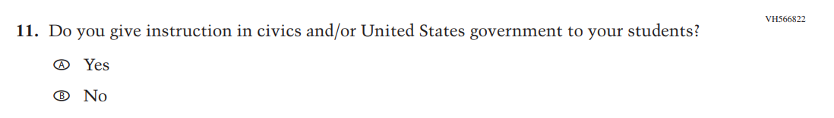

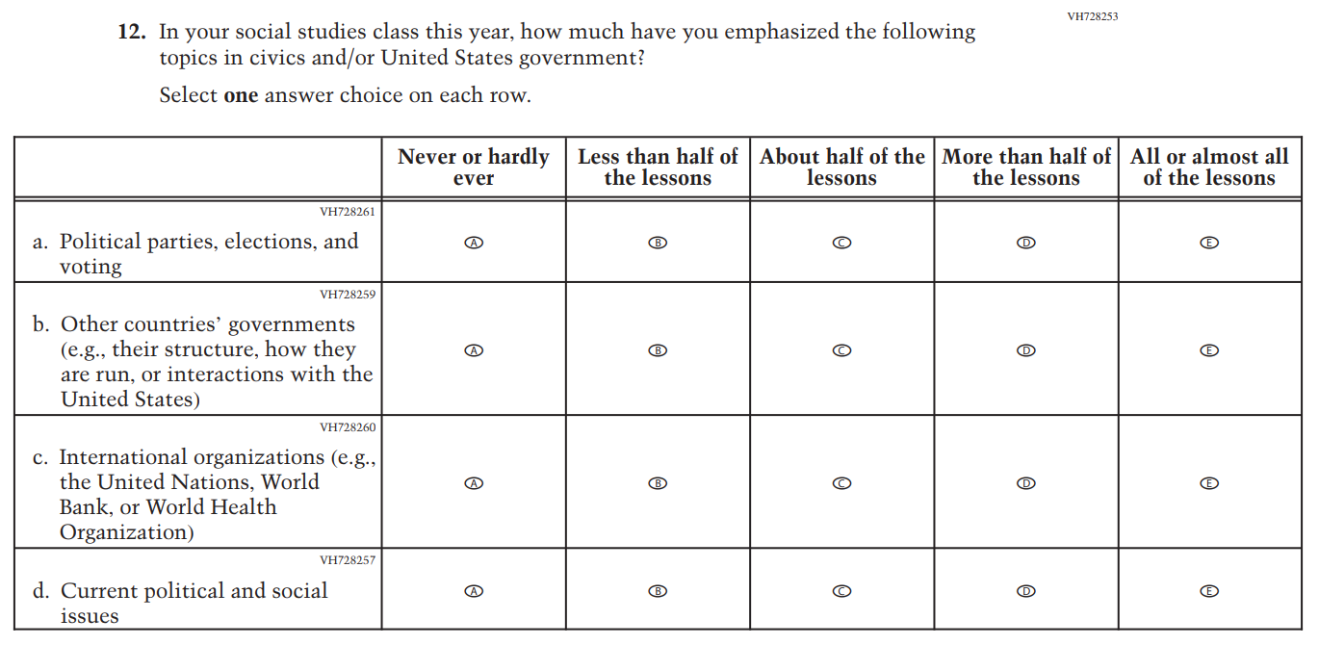

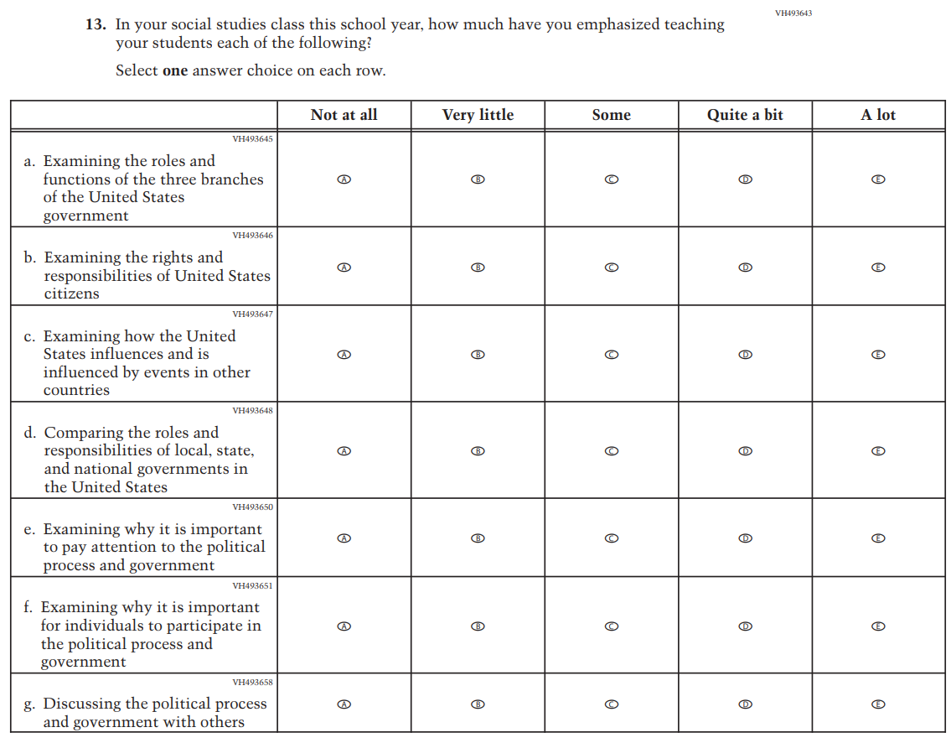

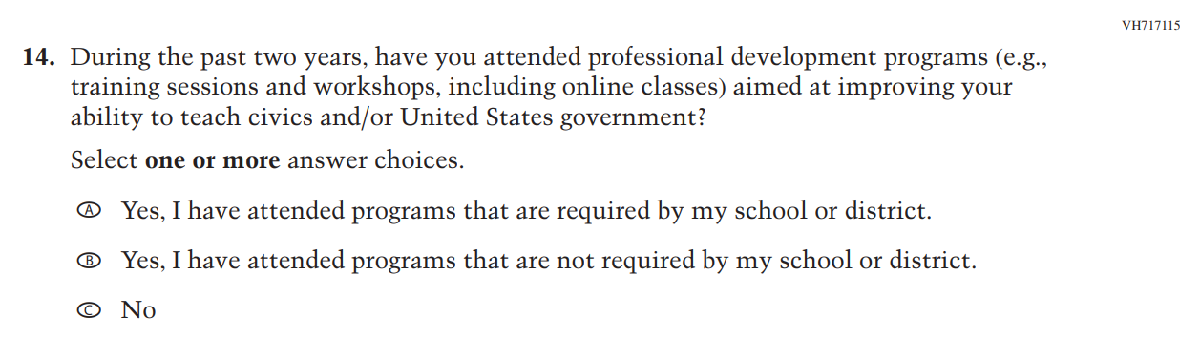

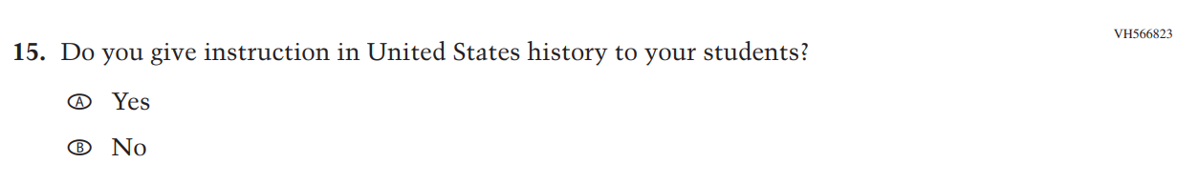

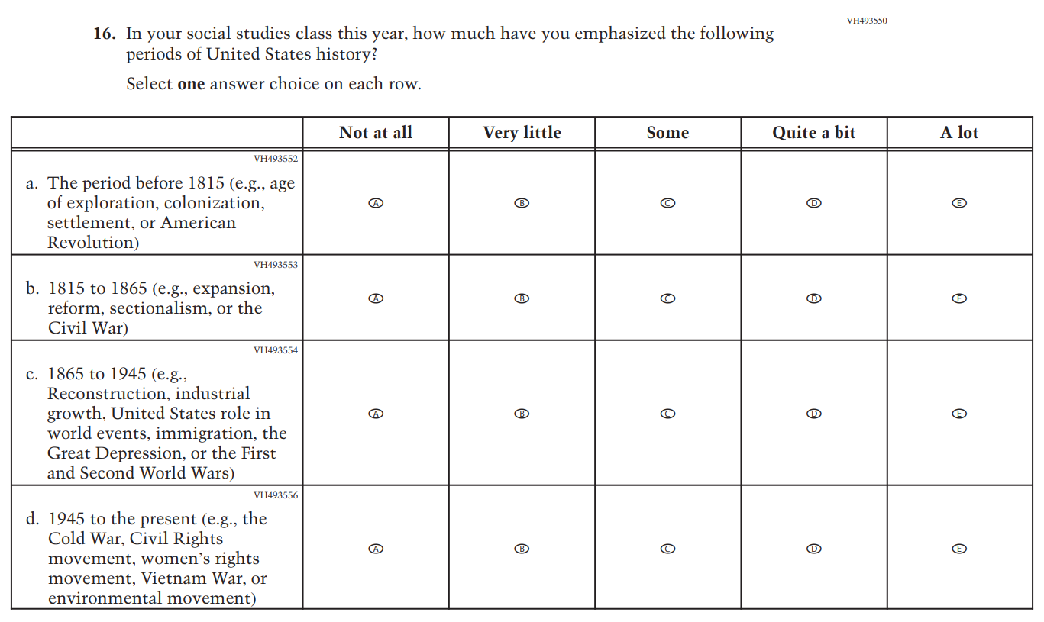

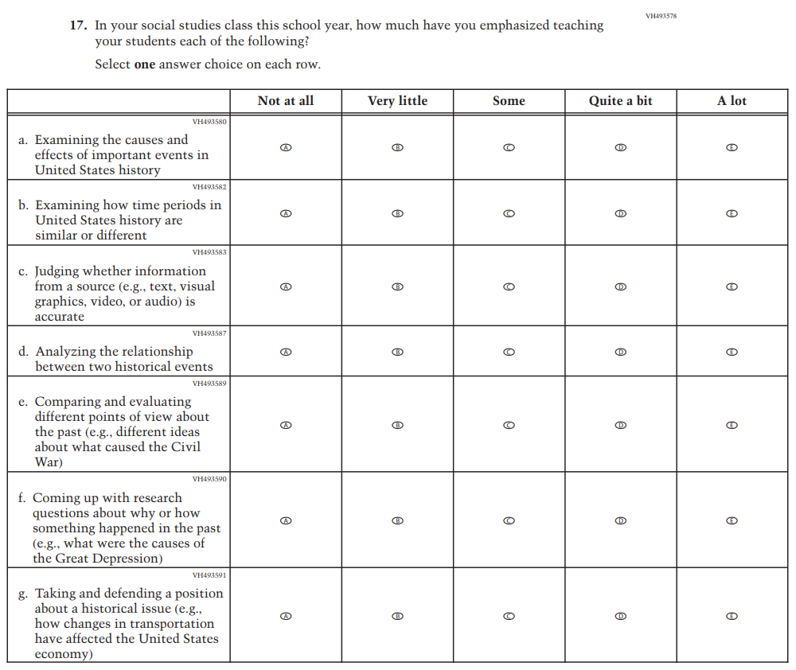

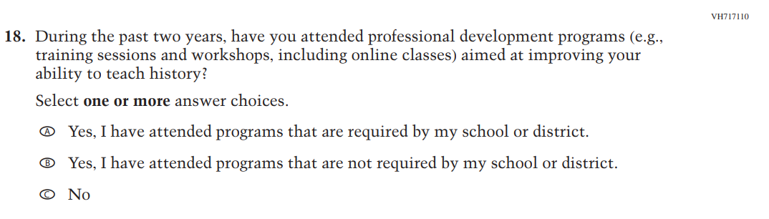

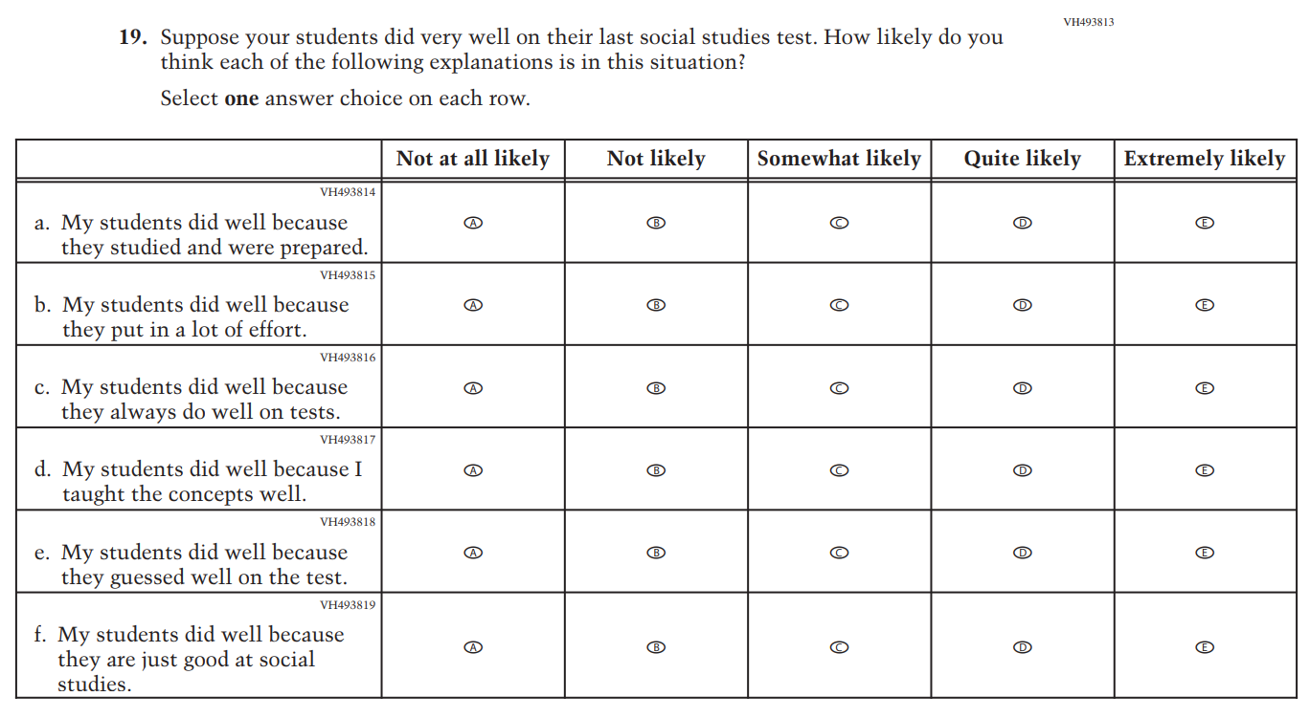

Appendix J2-15: Pilot Grade 4 (Core)

Appendix J2-16: Pilot Grade 4 (Mathematics)

Appendix J2-17: Pilot Grade 4 (Reading)
