Log into CARES
https://cares-uat.faa.gov/
Log in with Username (email and Password)
Agree to Terms and Conditions
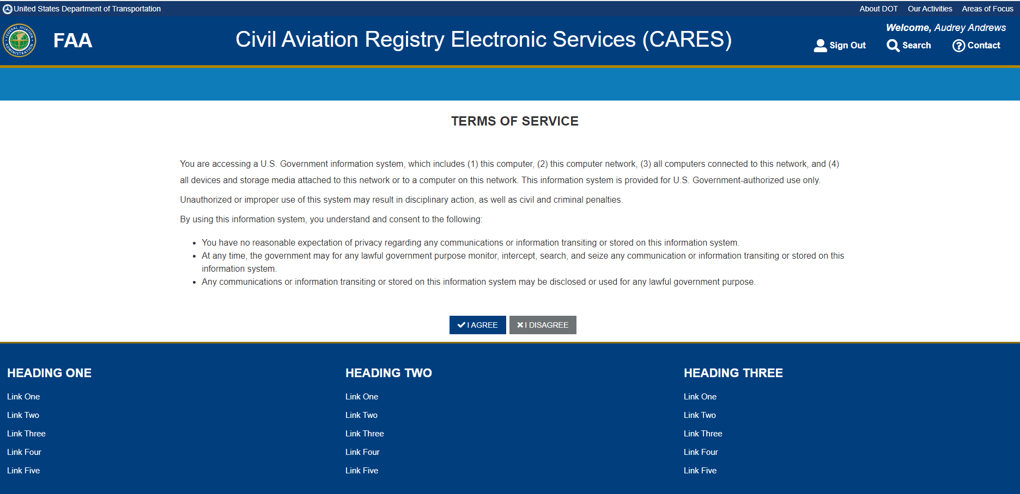
Get Started
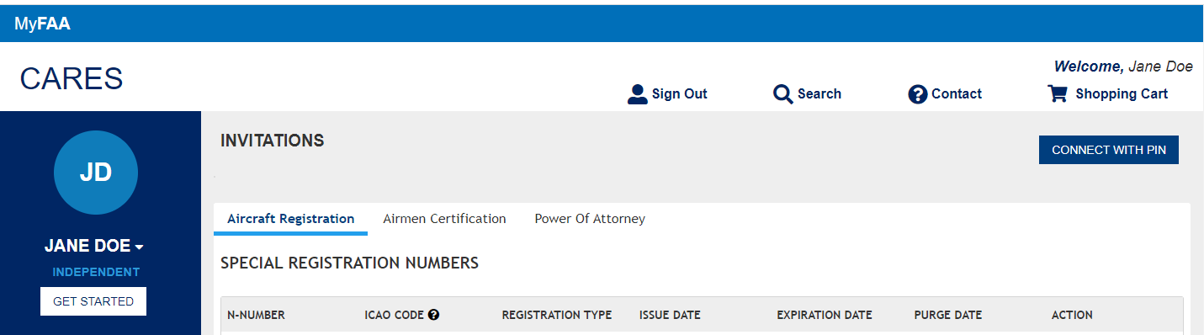
Select Account Management

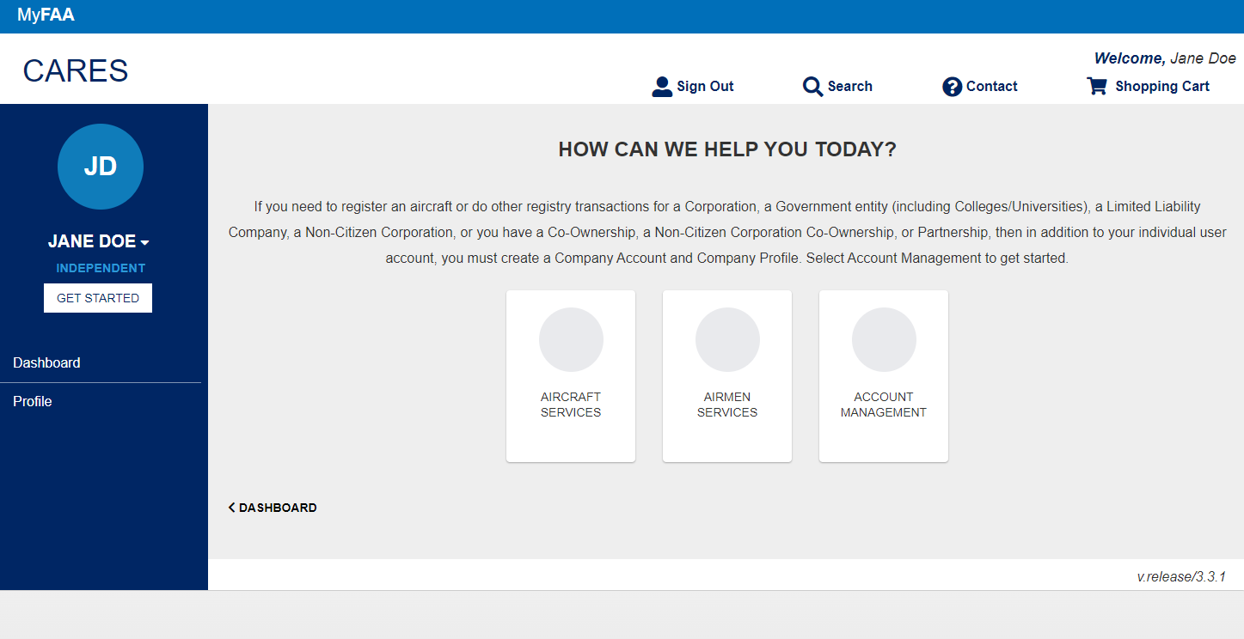
Select Apply for a Dealer Certificate
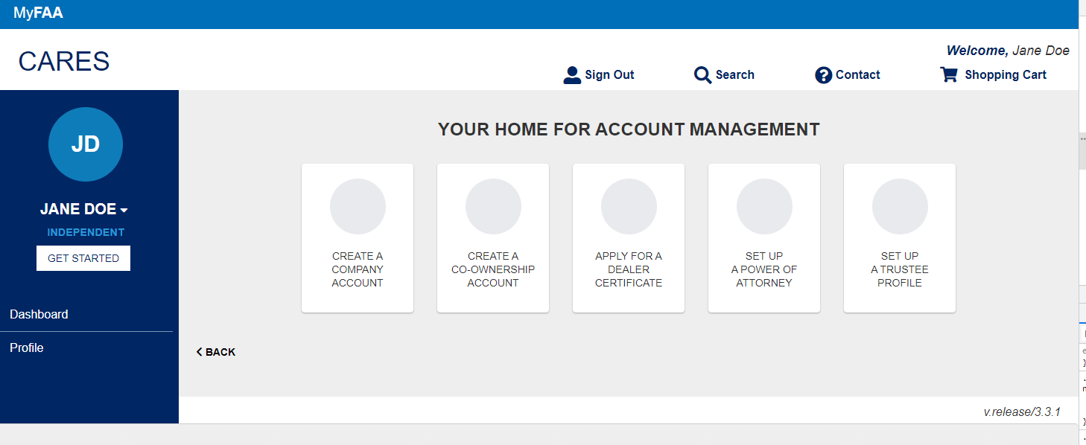
Select Owner for Registration and fill out Dealer Name and Fill out Addresses as well as contact information page
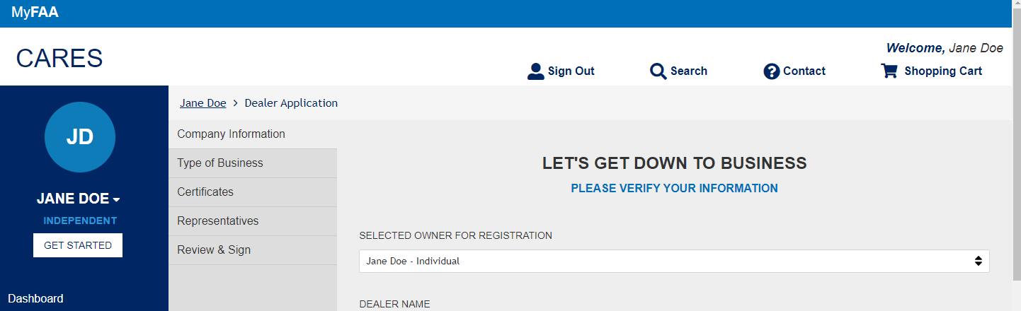
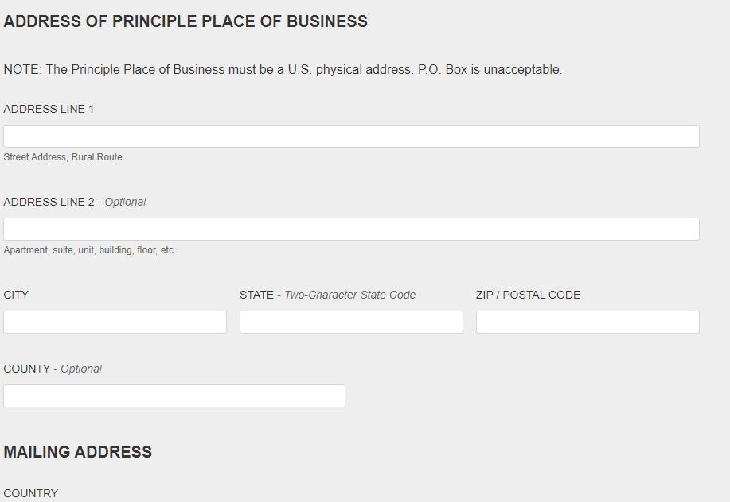

SELECT CONTINUE
CHOOSE ONE OF THE FOLLOWING OPTIONS THAT YOU ARE ENGAGED IN and CONTINUE

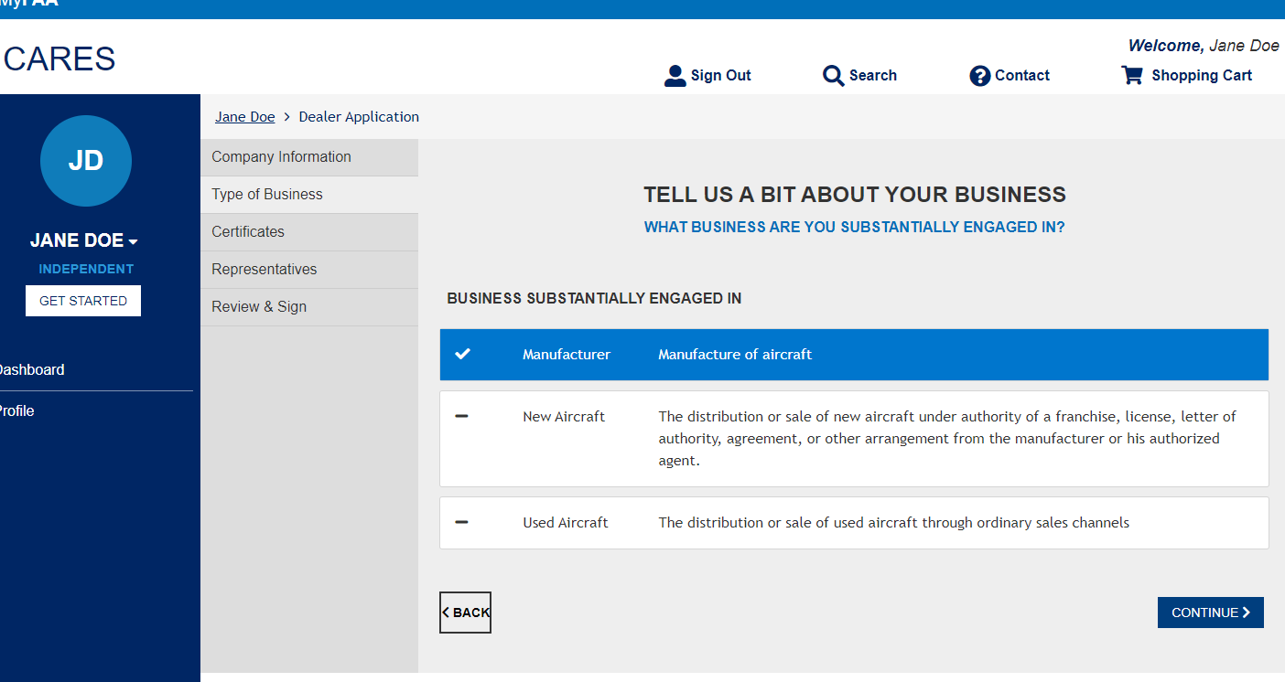
SELECT NUMBER OF CERTIFICATES and CONTINUE
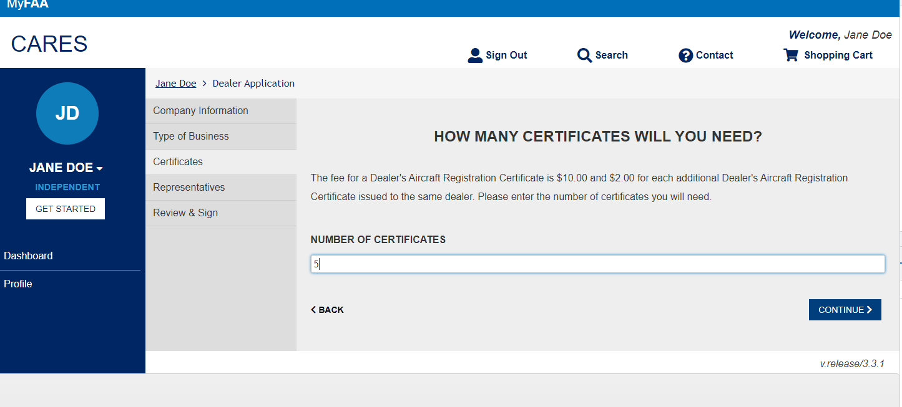
REPRESENTATIVES AND CERTIFICATION PAGES ARE DISPLAYED
SELECT OPTION AND CONTINUE
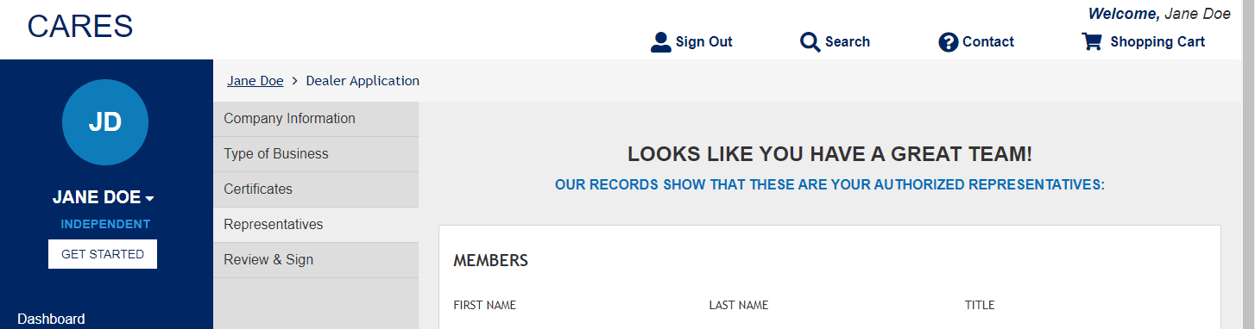
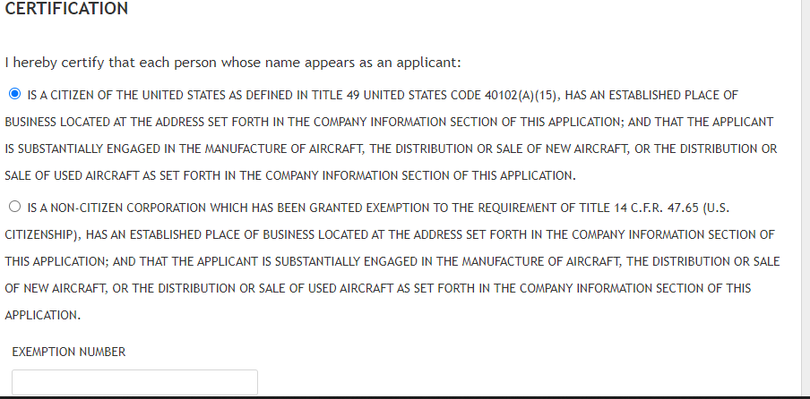

REVIEW & SIGN DOCUMENT IS PRESENTED to include Principle Place of Business, Mailing Address, Members and number of certificates requested with total amount
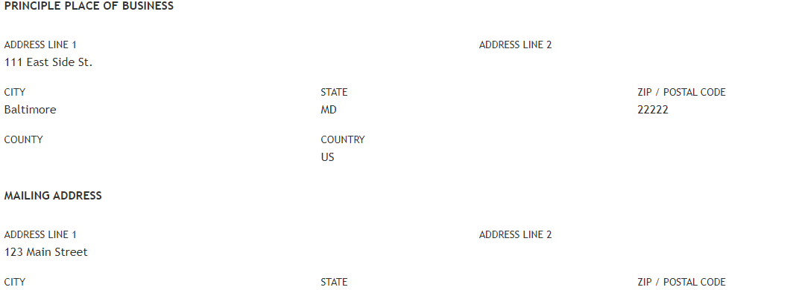
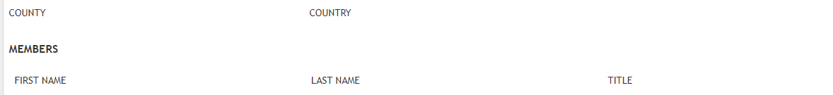
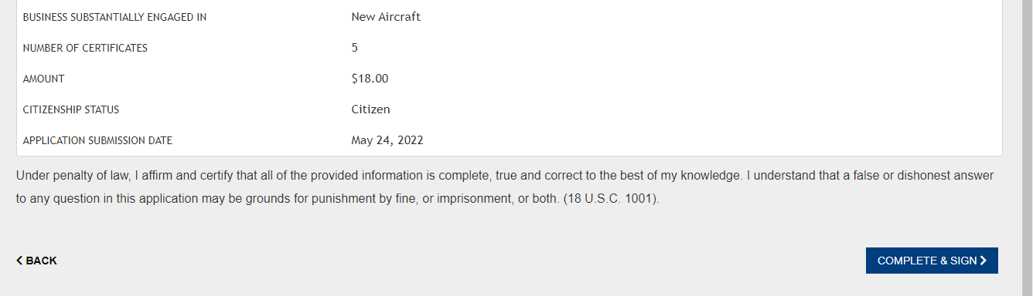
COMPLETE AND SIGN

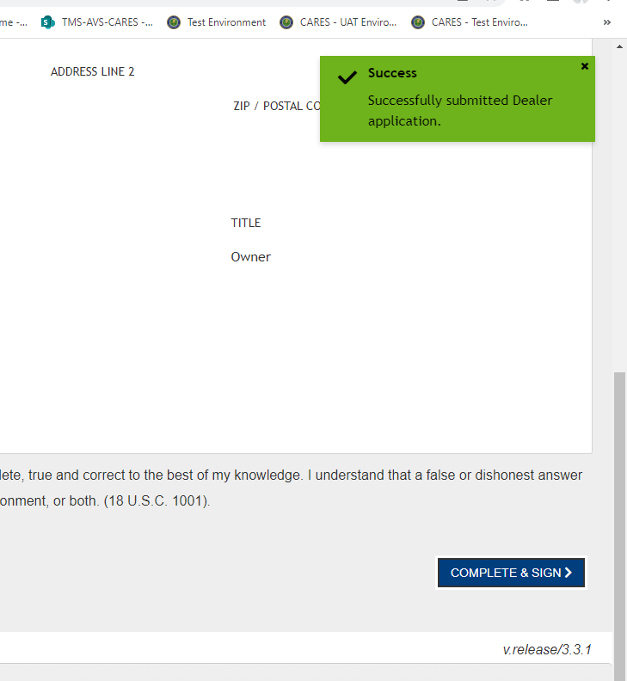
A green Success button show up and you are presented with the 8050-5 Form to review. Agree to the disclosure and CONTINUE

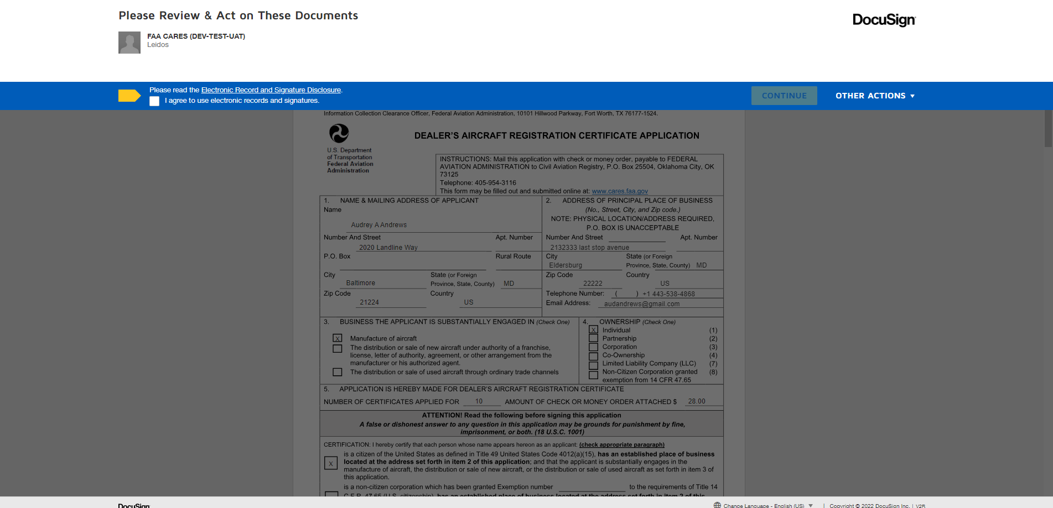

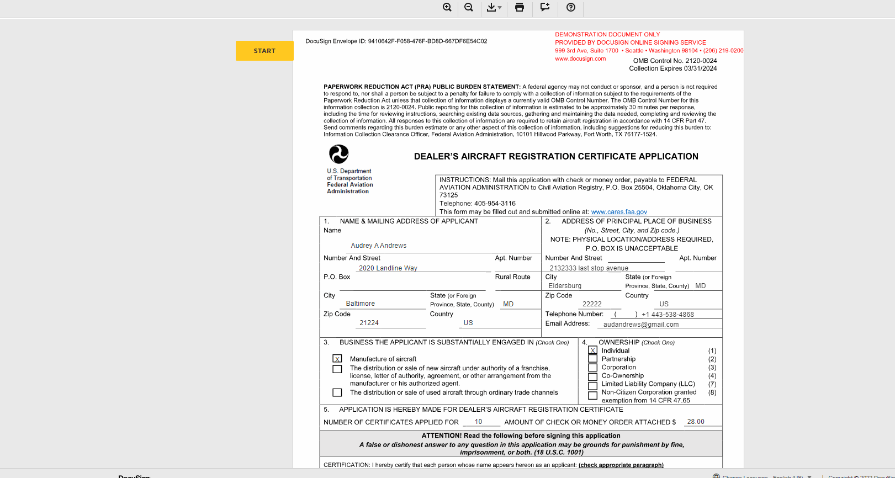
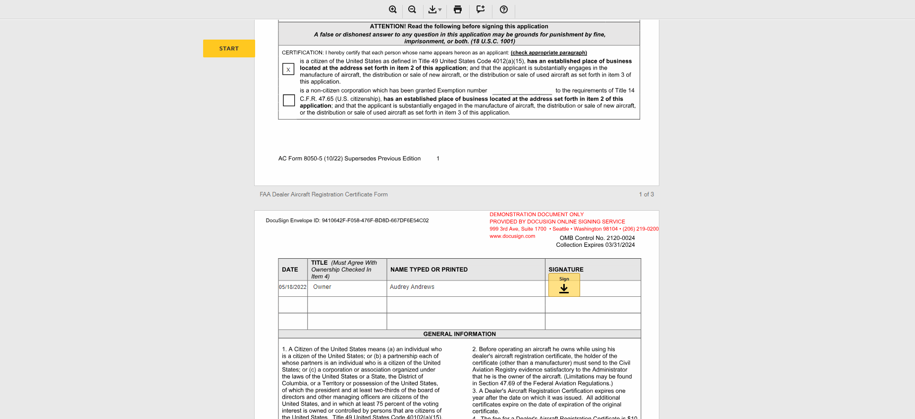
SIGNATURE PAGE AND FINISH
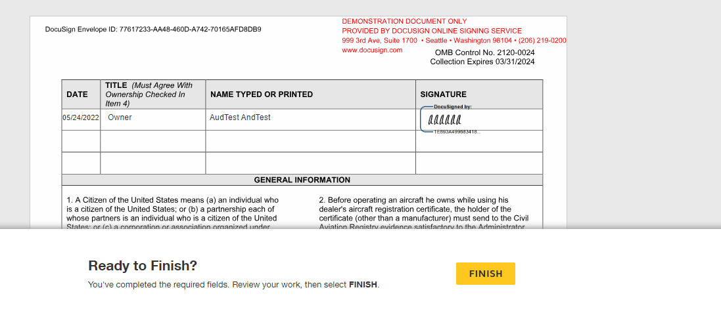


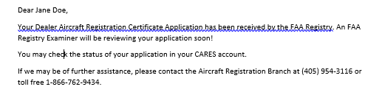

Shopping Cart is Presented to Pay with PAY.GOV
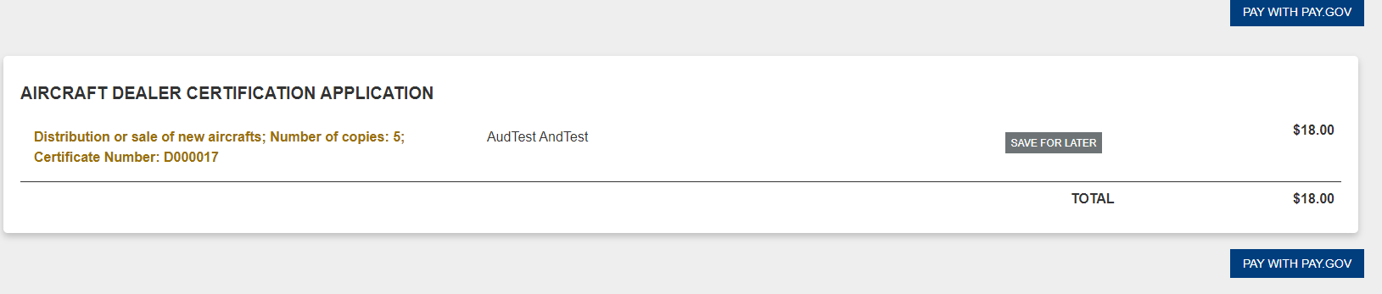

Select payment information and continue
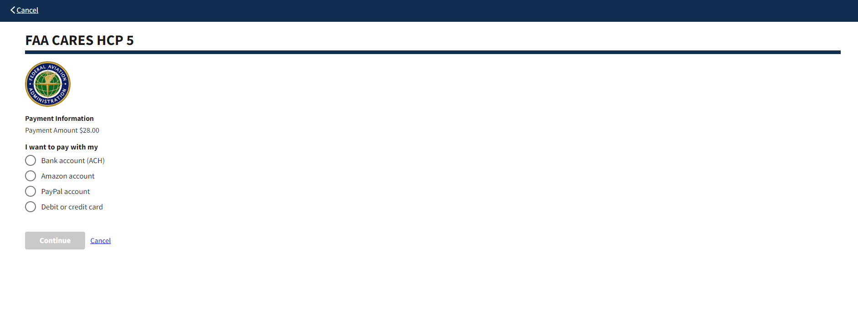
Fill in all Fields and Continue
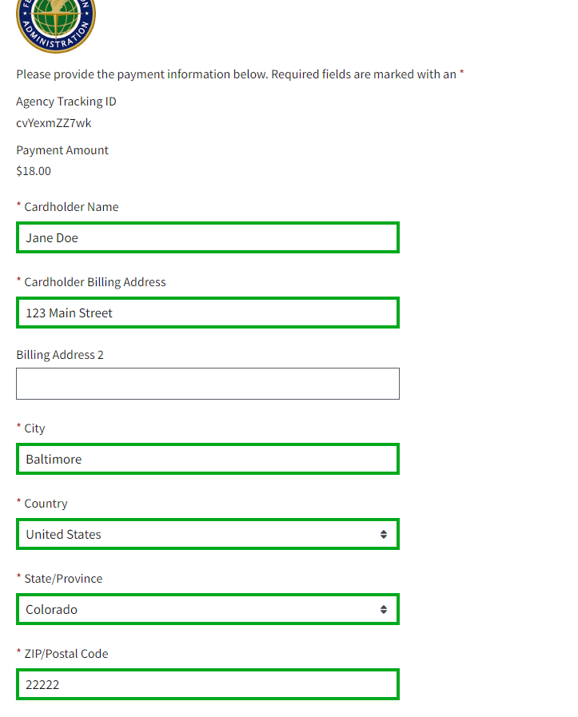
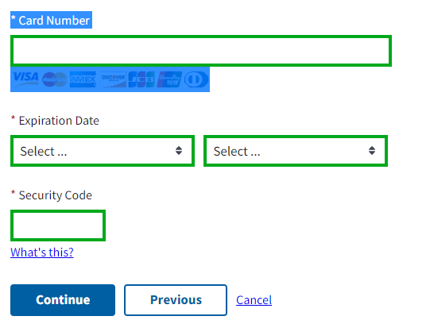
Confirmation Page to authorize Payment and Continue
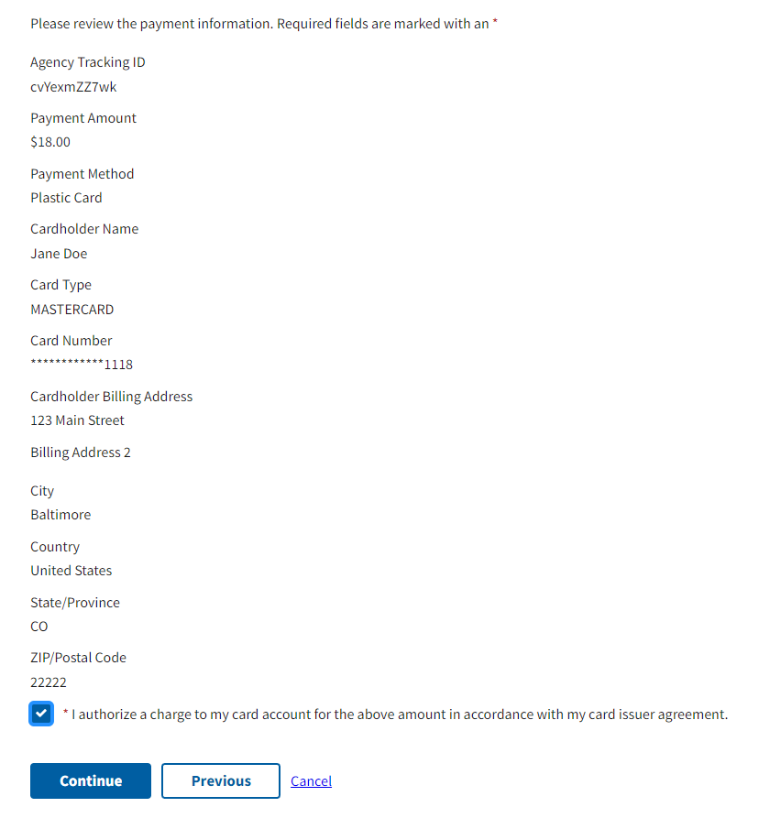
Shopping Cart is empty and an email notification for payment is received in email inbox


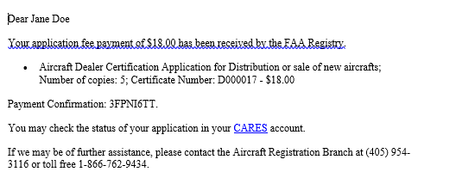
Go back to the Dashboard:
On the Pending Agency Review Section will see the Application for review
Once Application is approved by Examiner it will appear as a tab on the dashboard with the dealer number.
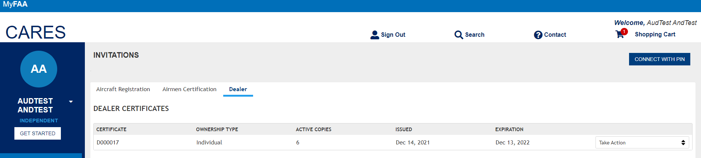
Option to print Certificates
