

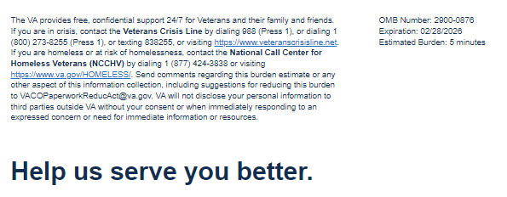

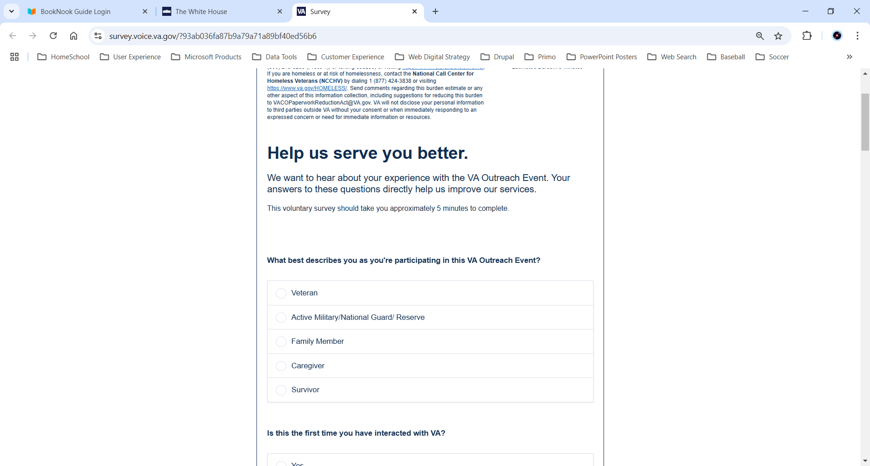

­ 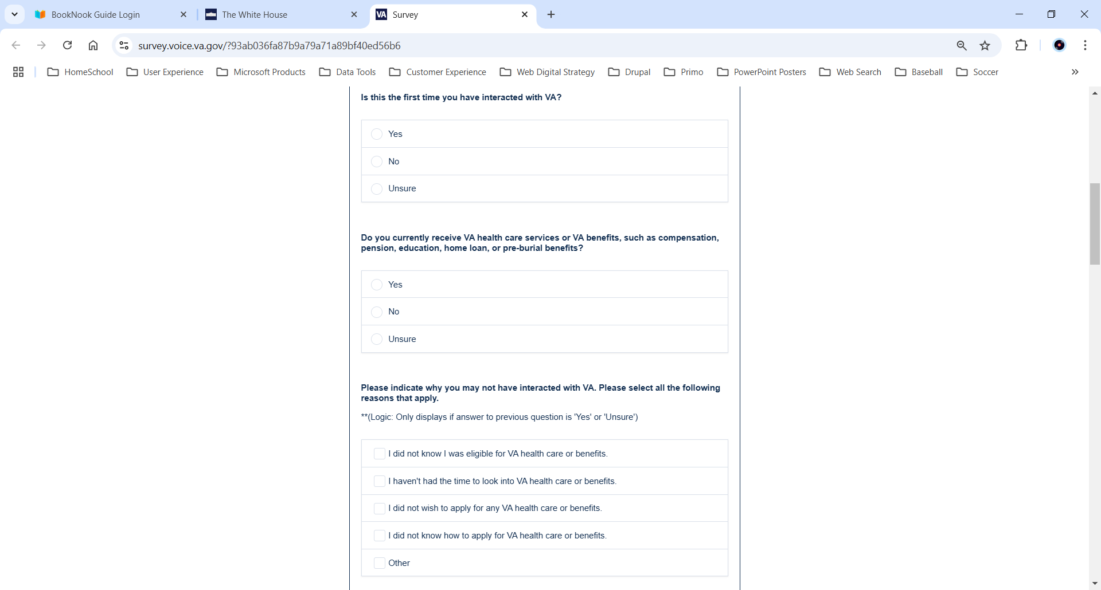

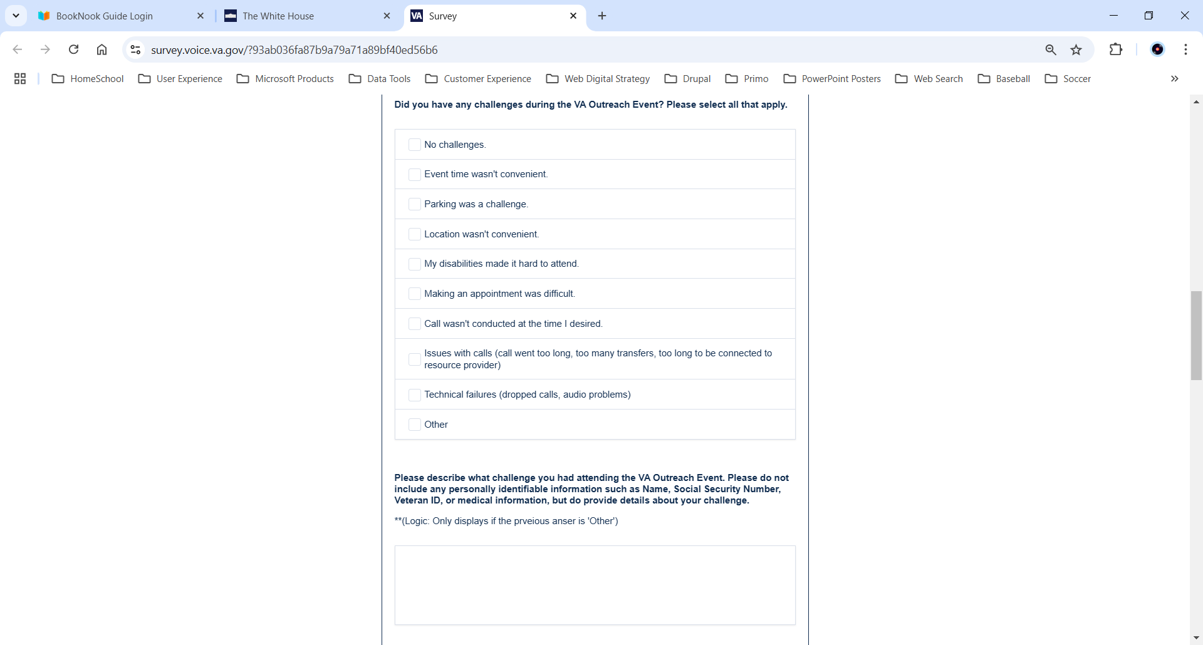

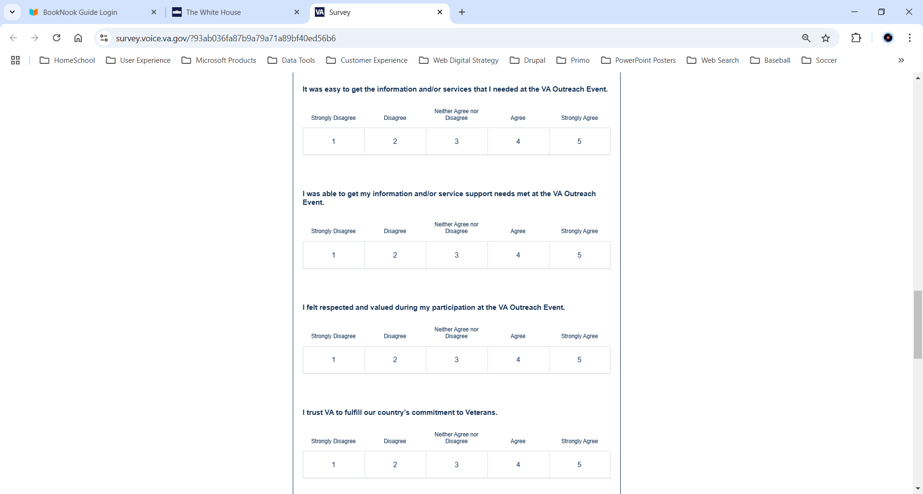 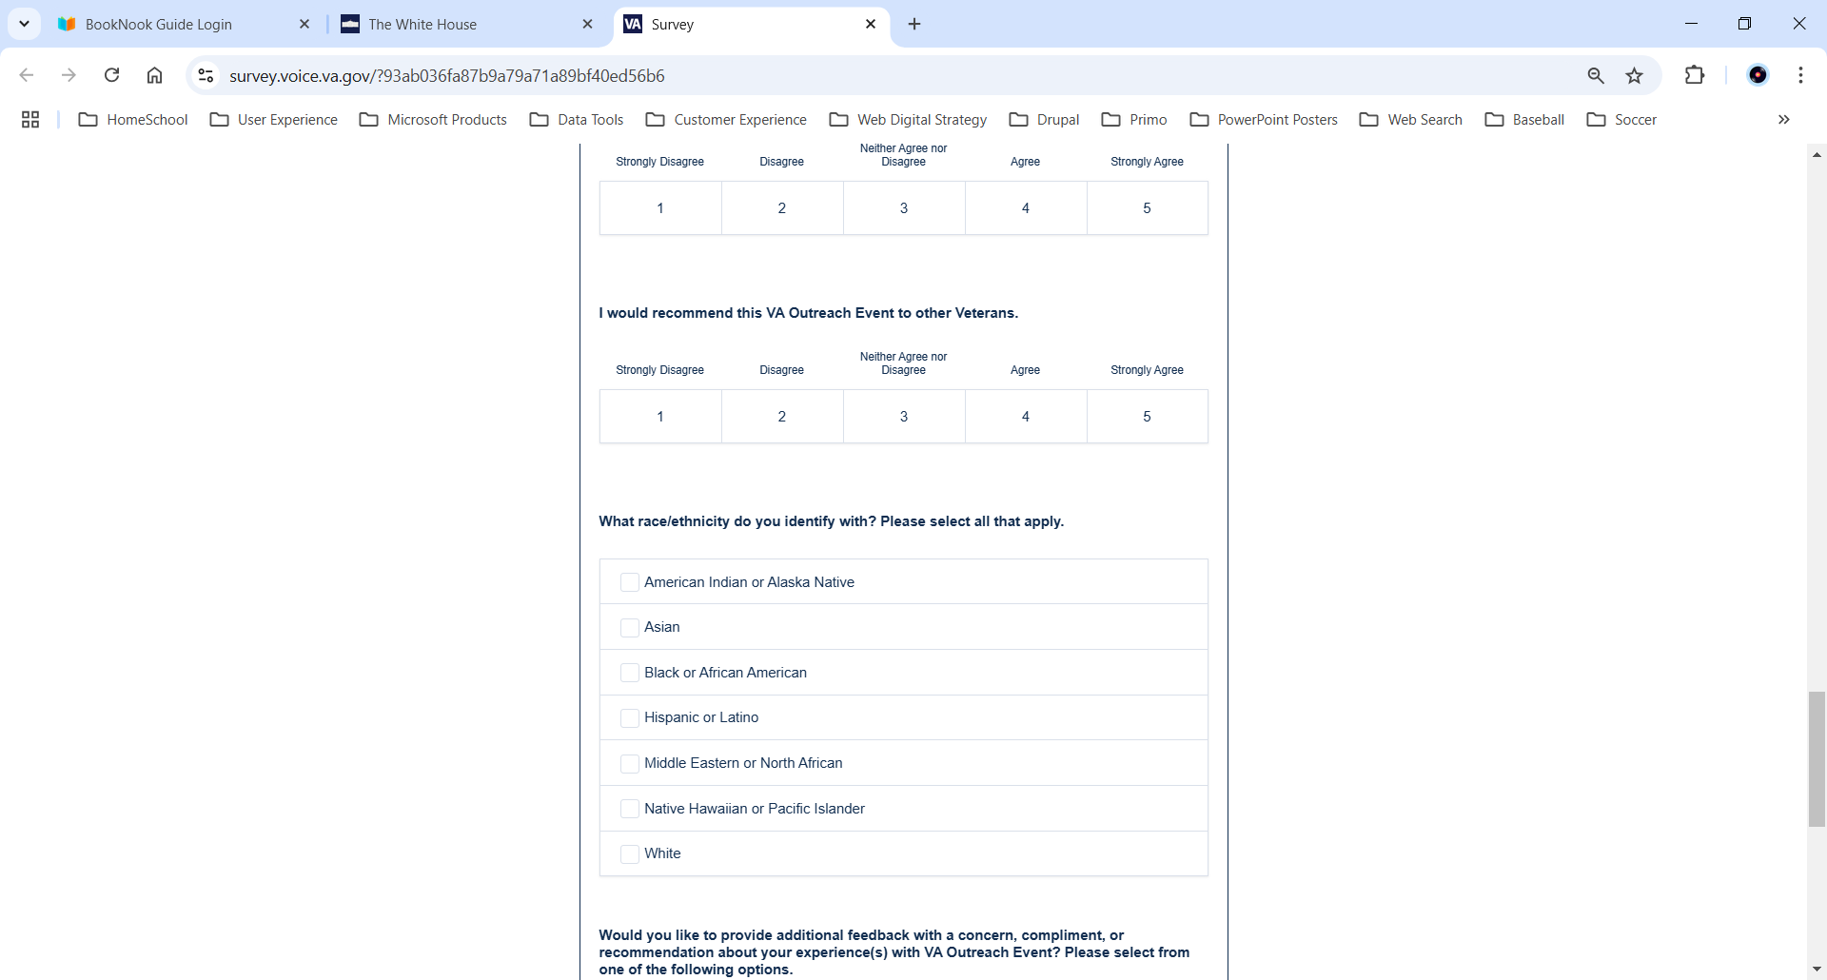 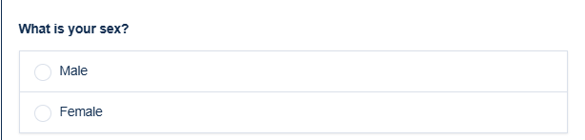

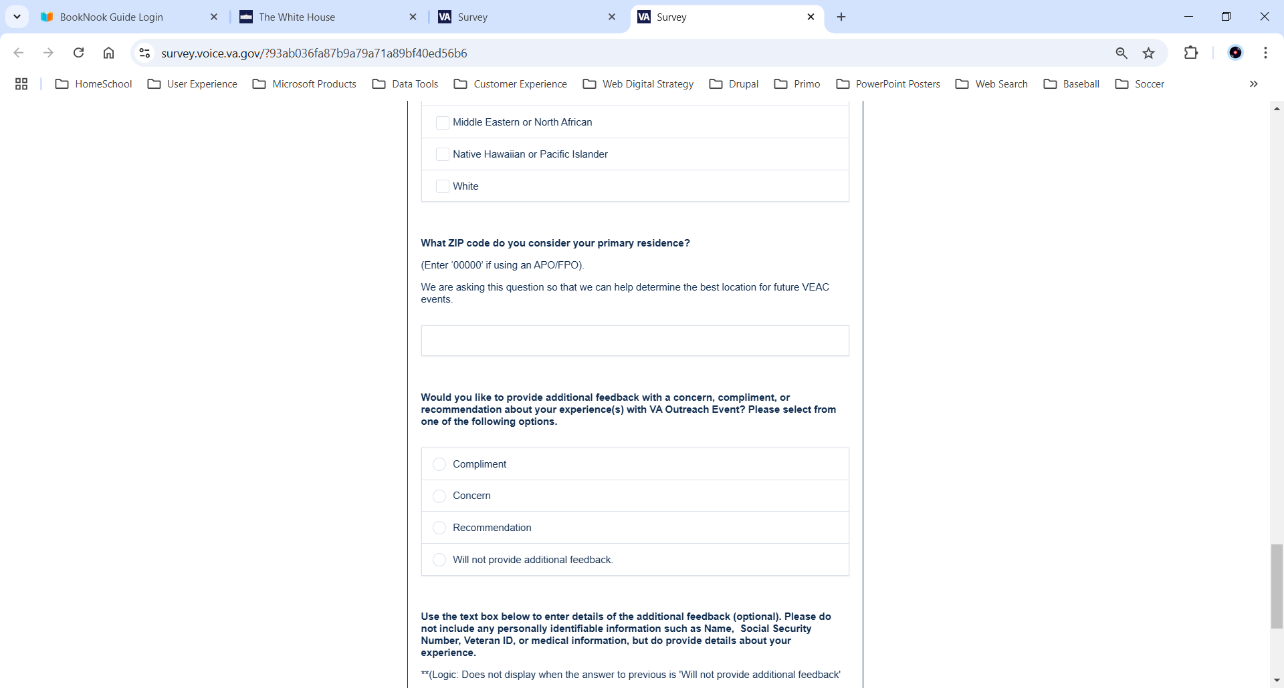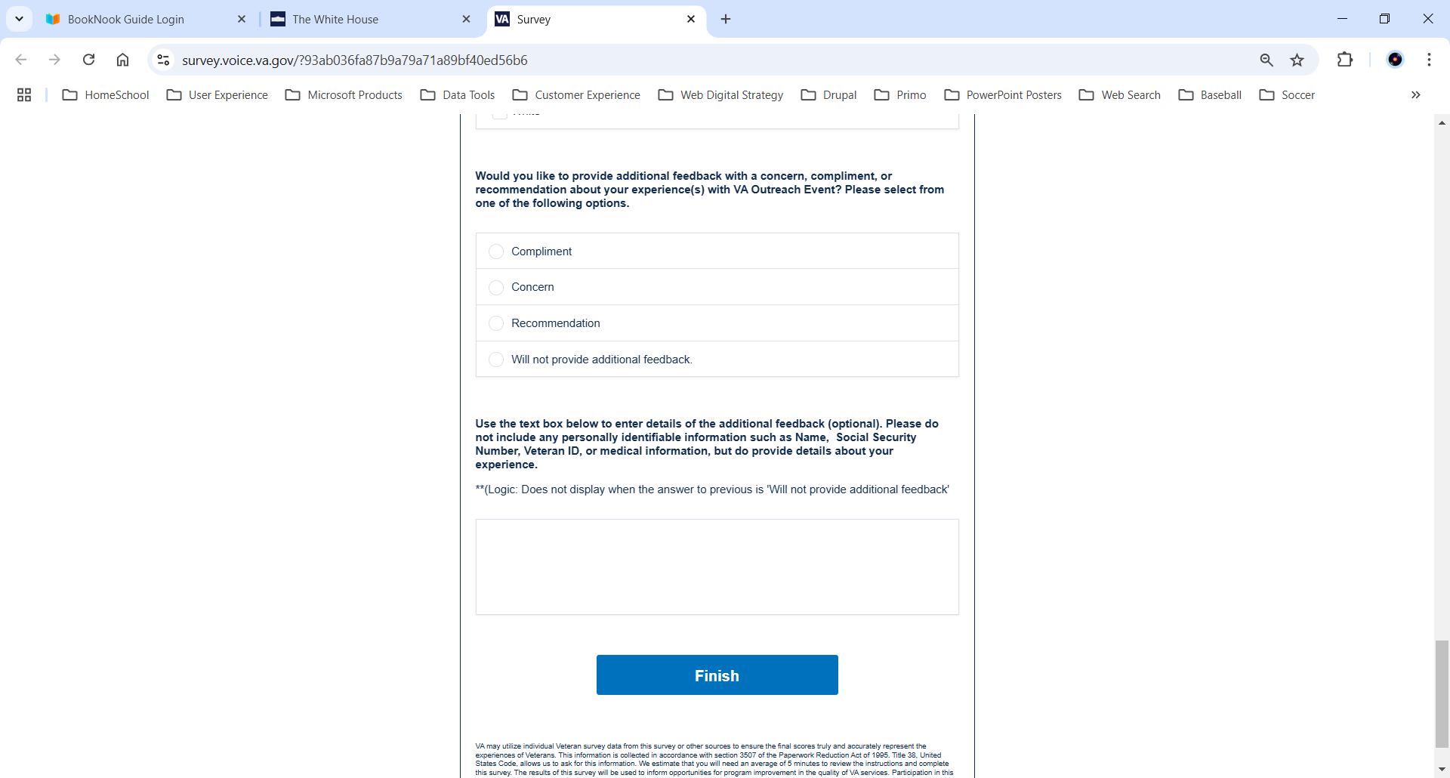

VA Burden Statement: An agency may not conduct or sponsor, and a person is not required to respond to, a collection of information unless it displays a currently valid OMB control number. The OMB control number for this project is 2900-0912, and it expires 09/30/2025. Public reporting burden for this collection of information is estimated to average 5 minutes per respondent, per year, including the time for reviewing instructions, searching existing data sources, gathering, and maintaining the data needed, and completing and reviewing the collection of information. Send comments regarding this burden estimate and any other aspect of this collection of information, including suggestions for reducing the burden, to VA Reports Clearance Officer at [VACOPaperworkReduAct@va.gov](mailto:VACOPaperworkReduAct@va.gov). Please refer to OMB Control No. 2900-0912 in any correspondence. Do not send your completed VA Form to this email address.