Form COA-1 Screens, Descriptions, and Notes
The proposed Form COA-1, Change of Address (Internet), will be used by railroad annuitants, beneficiaries, or claimants to initiate a change to their mailing address on RRB.gov (myRRB), after they have completed the Login.gov identity verification process.

The Form COA-1 screens contain sample data and no real PII.

Screens 1 – 5 contains examples of accessing and completing the myRRB login process.

Screen 6 is the myRRB Landing Page to Access Form COA-1.

Screen 7 contains an example of a user’s account information.

Screens 8 – 9 contains examples of Change of Address using Form COA-1 and USPS address validation as well as the Paperwork Reduction Act and Privacy Act Notices.

Screens 10 – 12 contain examples of the confirmation for the change of address, processing, and update notifications.

Screen 13 contains examples of Update Address data entry integrity rules when completing Screens 8 and 9.

RRB Home Page (www.rrb.gov) to Access myRRB | Screen 1
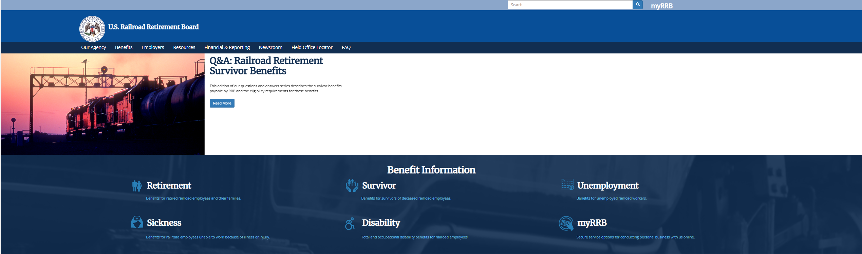
myRRB – Landing Page for User to Access RUIA and Retirement Services | Screen 2
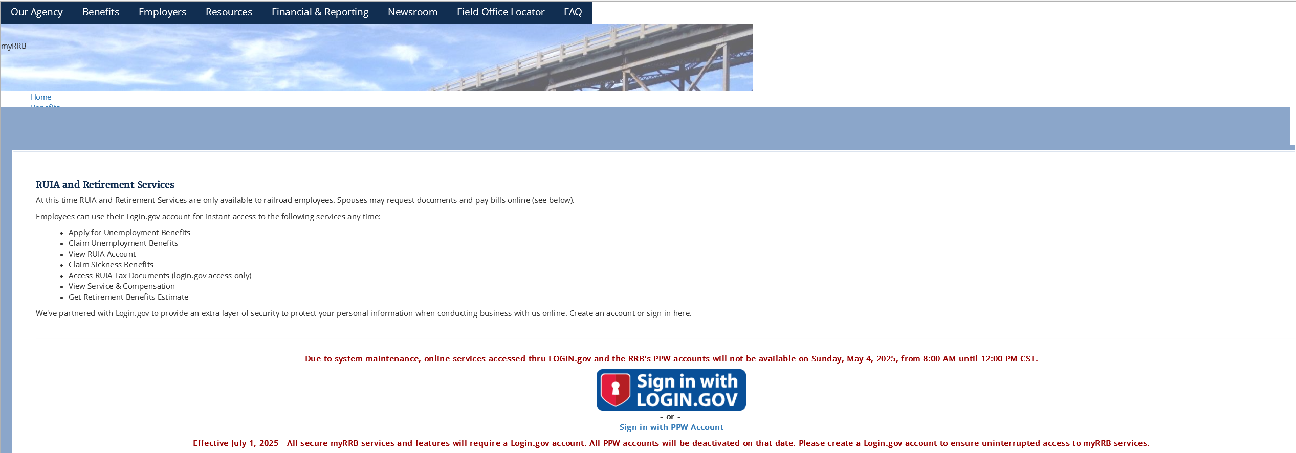
myRRB – Login.gov  Users can create or use an existing username and password to login and complete the validation process to access Form COA-1. A user creating a new account encounters the examples in screen 4. | Screen 3
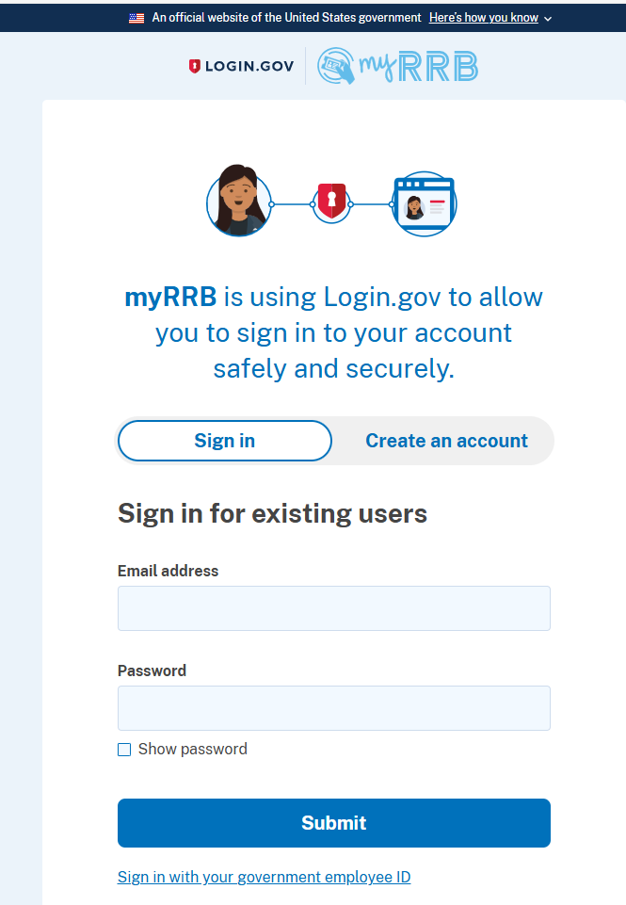

myRRB – Login.gov – Creating a New Account |  | Screen 4
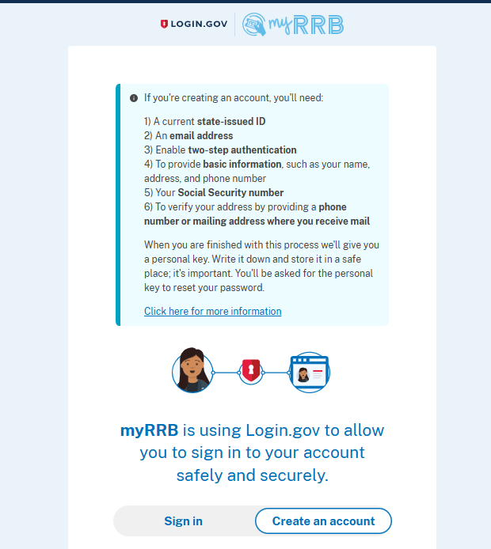 | 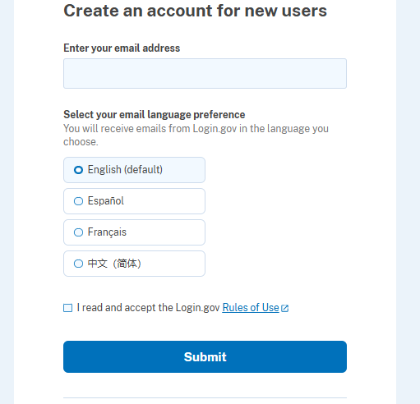

Login.gov User Experience |  | Screen 5
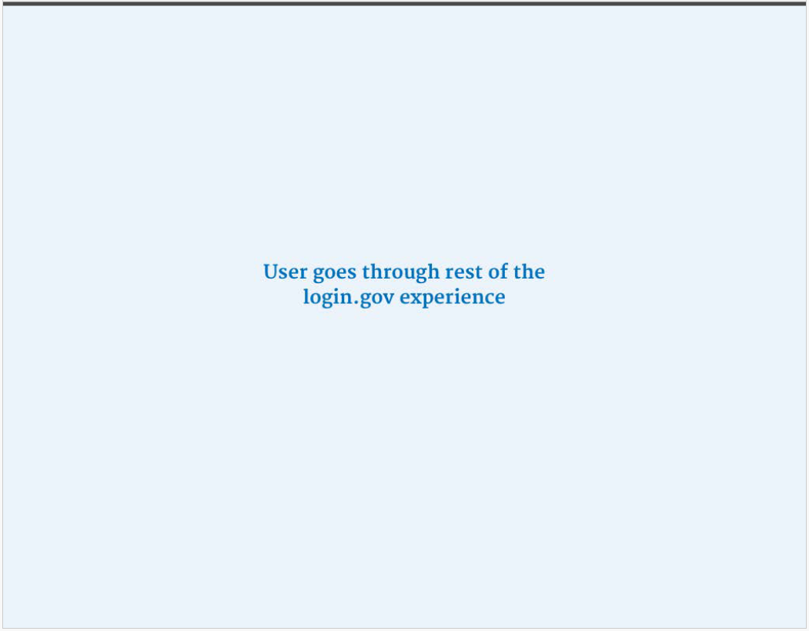

myRRB – Landing Page | Screen 6
User clicks “MANAGE Your Information” to access Form COA-1.

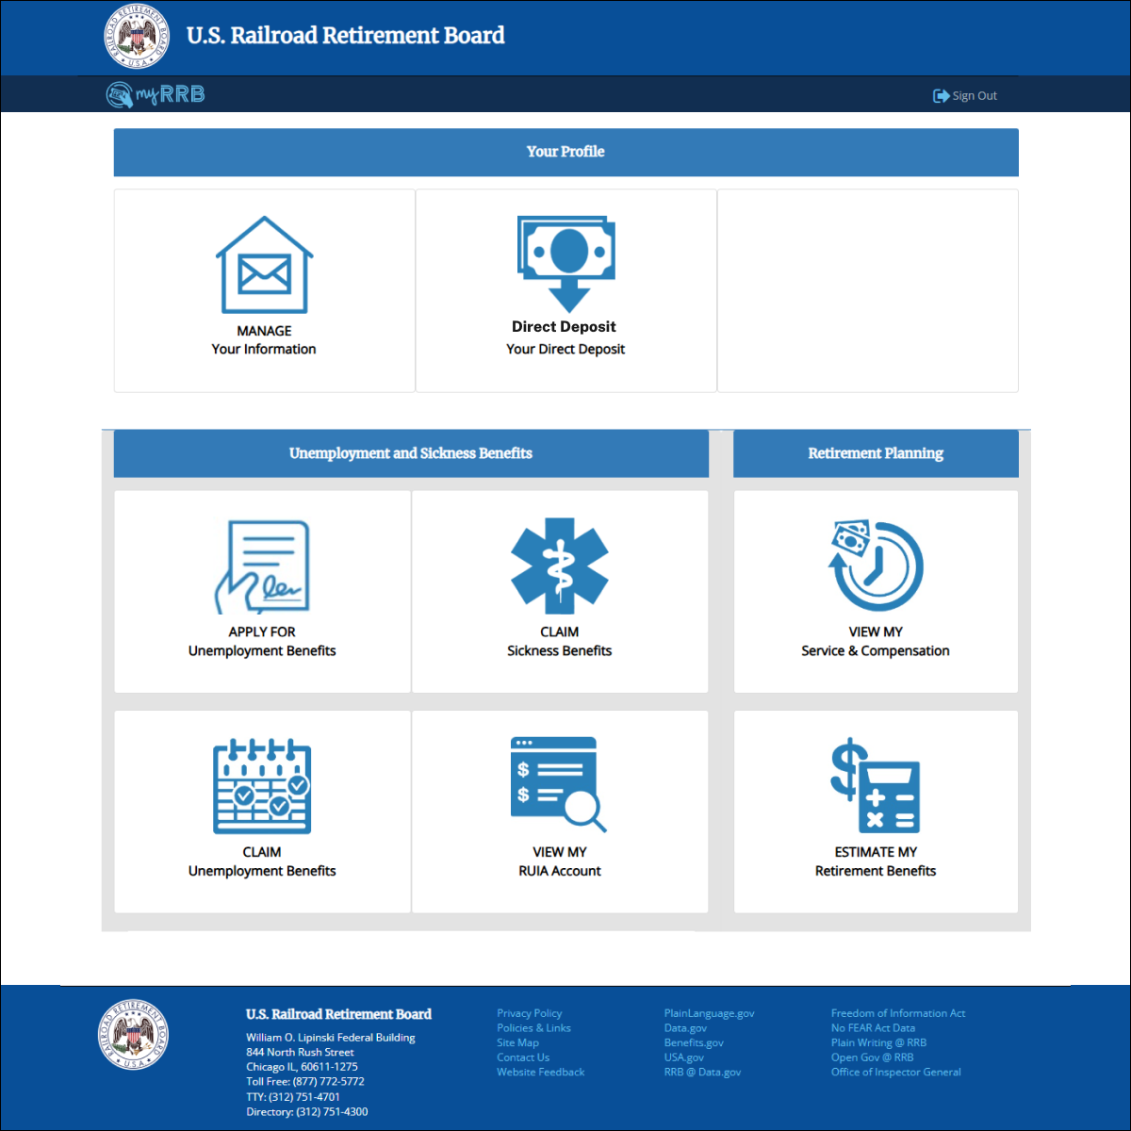

myRRB – Primary Mailing Address in User Account Profile  User clicks “Update address” button to initiate a change to their mailing address. | Screen 7
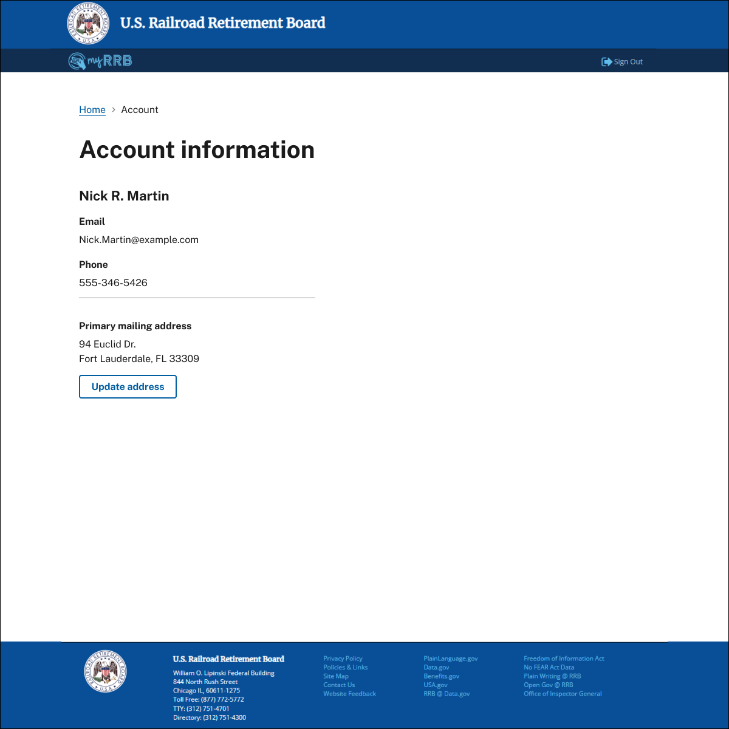

myRRB – Access Form COA-1 to Update Address  The user is required to complete all fields with a red (*) and make valid entries to ensure completeness and consistency of user-submitted data. Error messages and invalid entries (see Screen 13) indicated in red text will guide the user to make valid entries for data integrity.  Note: Form COA-1 entries will be matched to the USPS address validation to ensure correct address. |  |  | Screen 8
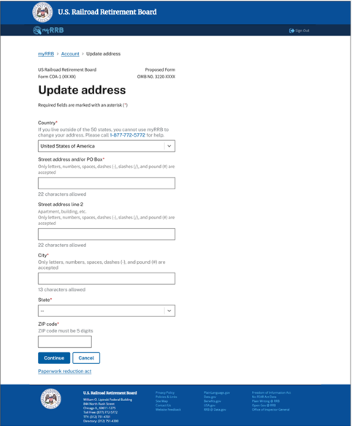  16 Spring Street  Beaverton  Illinois  97005 | 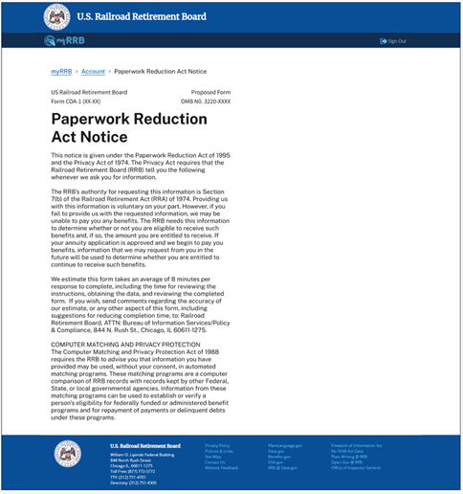
myRRB – Access to USPS Address Validation Occurs During Address Update  Note: Address entries will be matched to the USPS address validation. |  | Screen 9
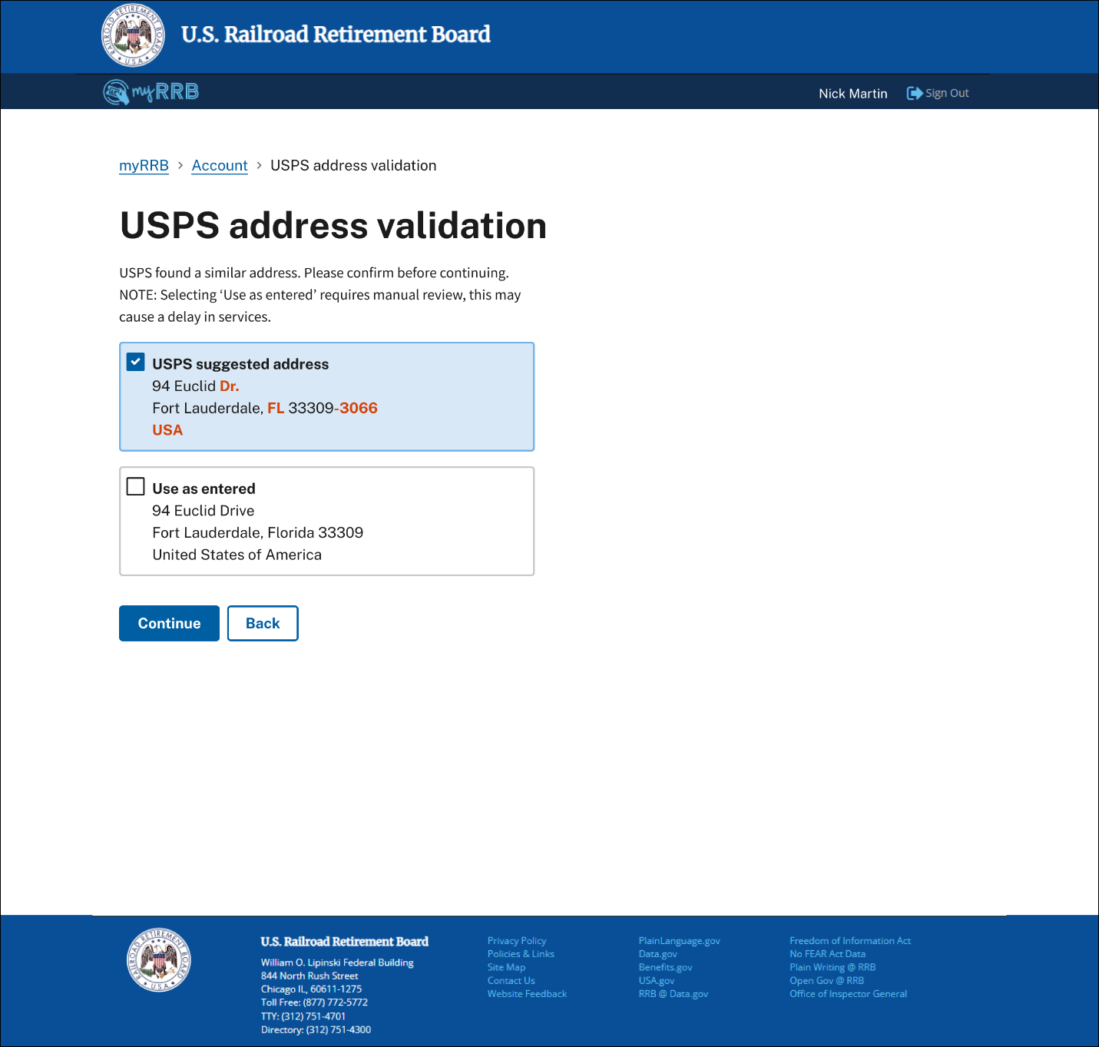
16 Spring Street
Beaverton, Illinois 97005
United States of America

16 Spring St.
Beaverton, IL 97005-1112
USA

myRRB – Confirm Change of Address  The user can now verify and submit their change of address request. | Screen 10
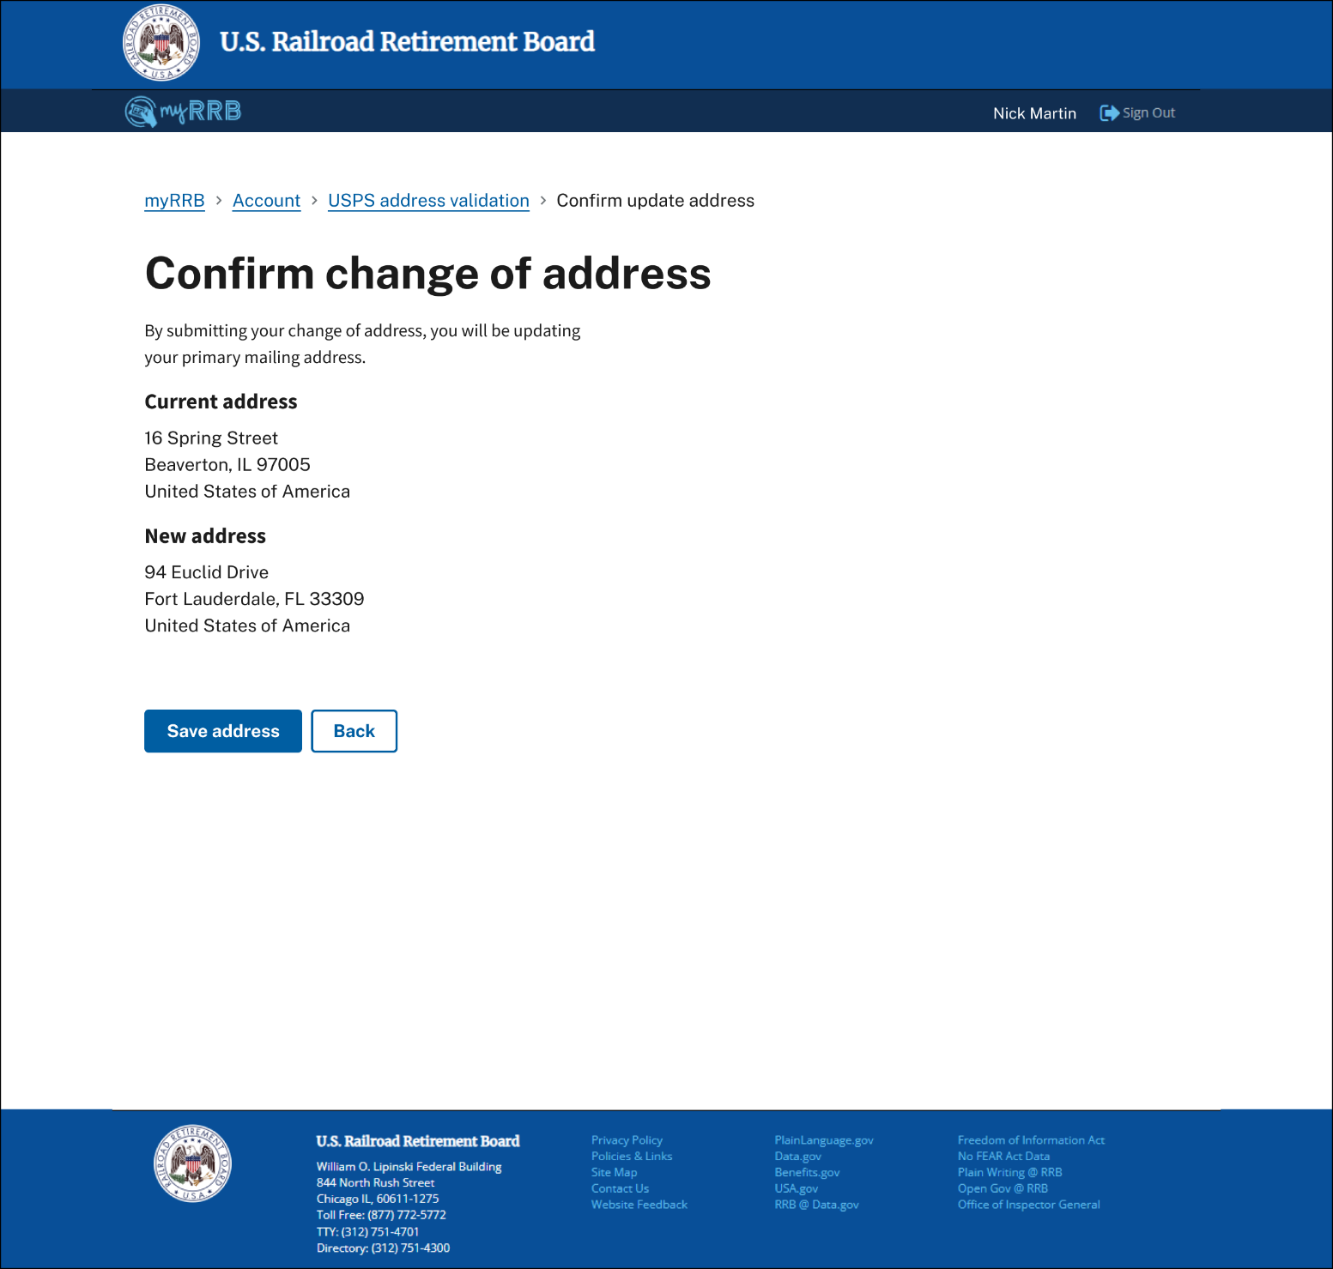
16 Spring Street
Beaverton, IL97005
United States of America
94 Euclid Drive
Fort Lauderdale, FL 33309
United States of America

myRRB – Address Change Processing Update Status  Provide information to the user on the status of their request, timeline expectation, and who to contact if they need assistance. | Screen 11
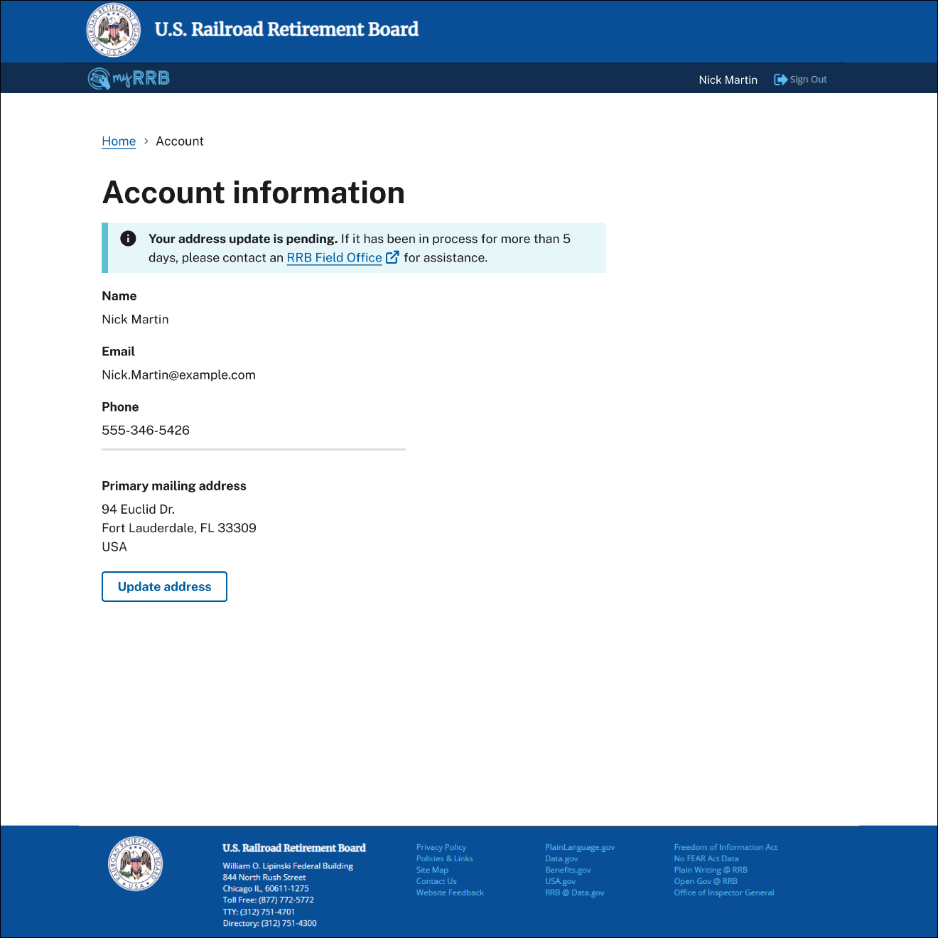

myRRB Account Information – Address Update Notification  Note: See the banner above Your Profile. | Screen 12
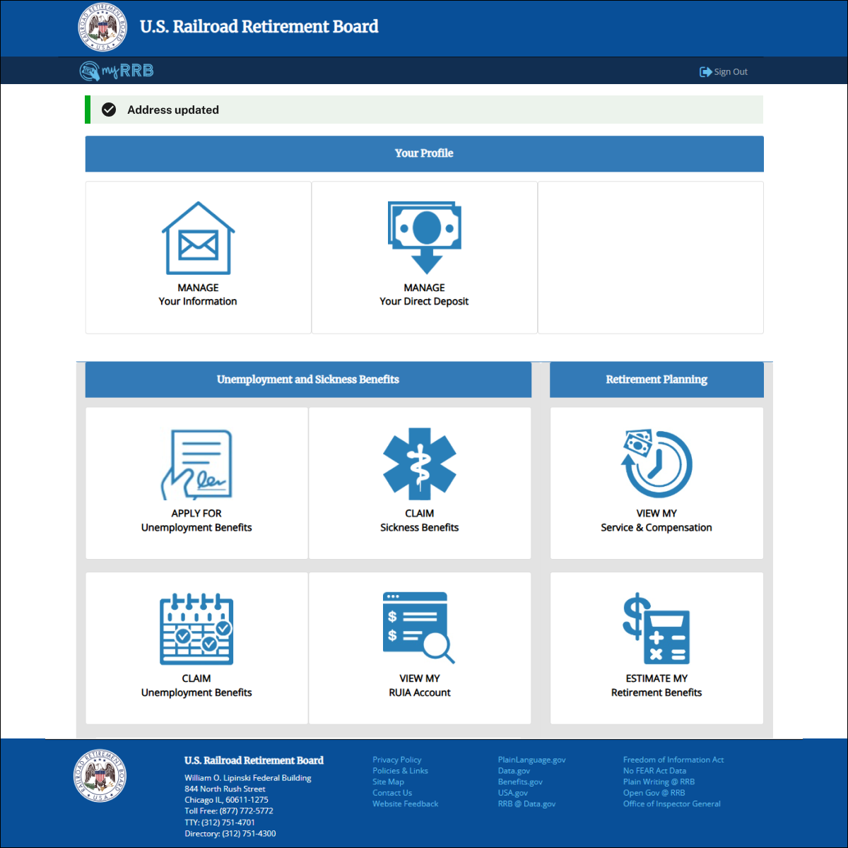

myRRB – Examples of Form COA-1 Update address and Data Entry Verification/Integrity Rules  Note: Error messages and invalid entries are displayed below in red text and provide guidance to the user to make valid entries for data integrity. |  | Screen 13
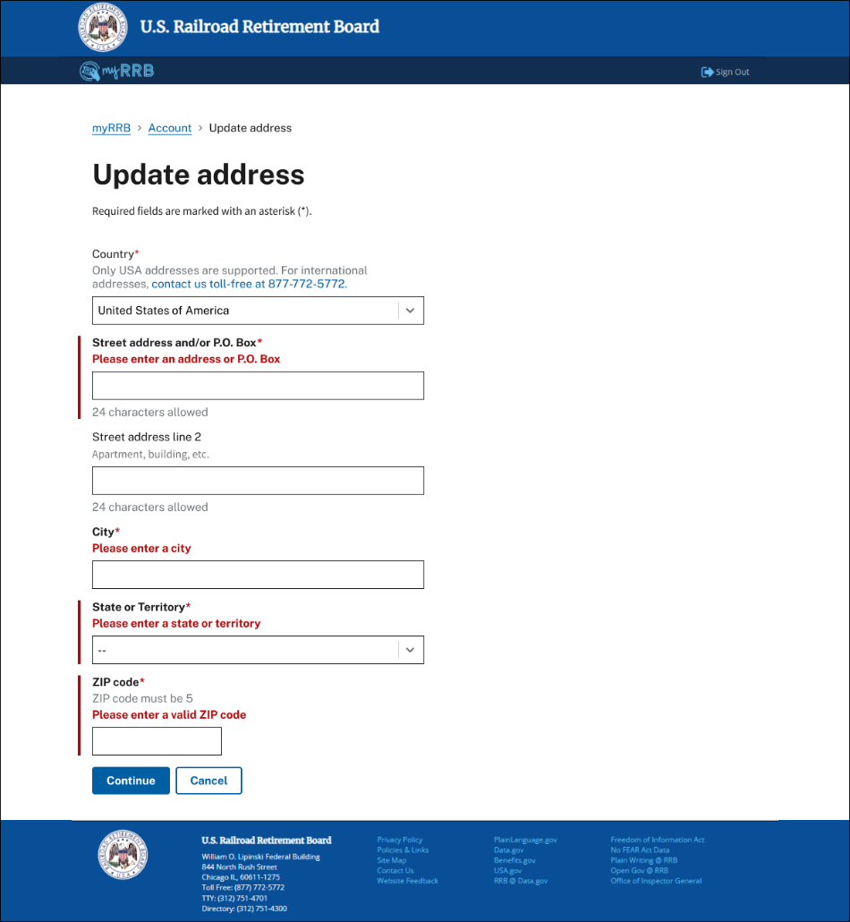 | 