Form DDC-1 Screens, Descriptions and Notes

The proposed Form DDC-1, Direct Deposit Change (Internet), will be used by railroad annuitants, beneficiaries, or claimants to update their bank routing and account number after they have completed the Login.gov identity verification process.

The Form DDC-1 screens contain sample data and no real PII.

Screens 1 – 5 contains examples of accessing and completing the myRRB login process.

Screen 6 is the myRRB Landing Page to Access Form DDC-1.

Screens 7 – 9 contains examples of myRRB notifications to an annuitant if a Direct Deposit account exists and system errors.

Screen 10 contains an example of Form DDC-1 screen when annuitant clicks “Add account” or “Add different account” button in screens 7 and 8 as well as the Paperwork Reduction Act and Privacy Act Notices.

Screens 11 – 13 contains examples of Form DDC-1 screen when an annuitant creates a new Direct Deposit or receives an error message during the process.

Screen 14 contains an example of Direct Deposit request confirmations when a user selects “Continue” in screens 12 and 13.

Screen 15 contains an example of Direct Deposit Processing Notification.

Screen 16 contains an example of Direct Deposit Process Complete Notification.

Screen 17 contains an example of Direct Deposit Cancel Request.

Screen 18 contains examples of New Direct Deposit Data Entry Verification/Data Integrity.

RRB Home Page (www.rrb.gov) to Access myRRB | Screen 1
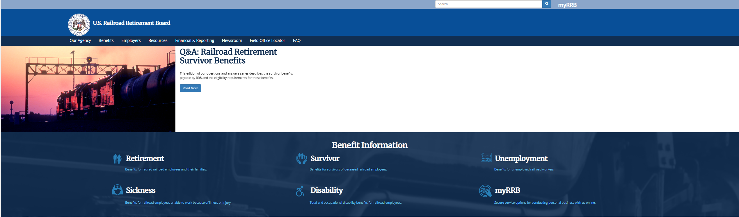
myRRB – Landing Page to Access RUIA and Retirement Services | Screen 2
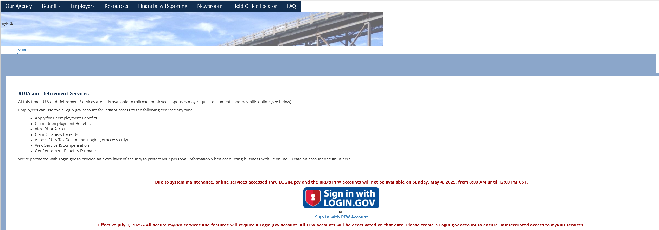
myRRB – Login.gov  Users can create or use an existing username and password to login and complete the validation process to access Form DDC-1. A user creating a new account encounters the examples in screen 4. | Screen 3
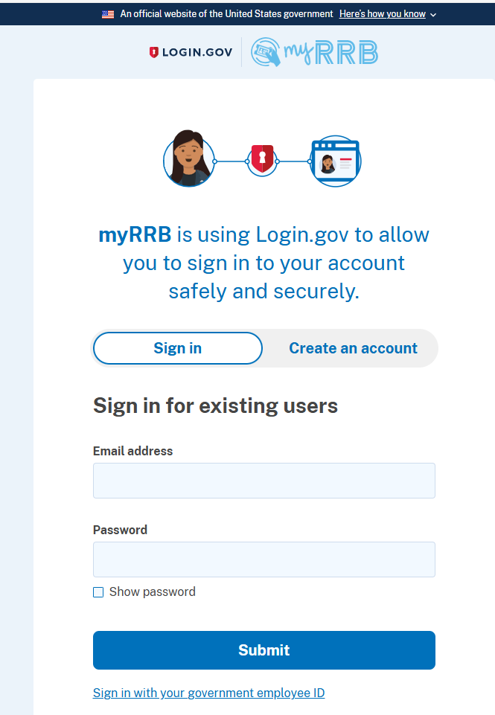

myRRB – Login.gov – Creating a New Account |  | Screen 4
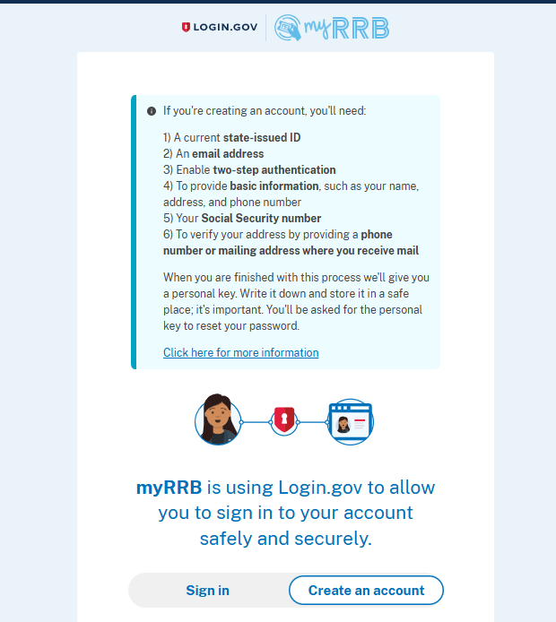 | 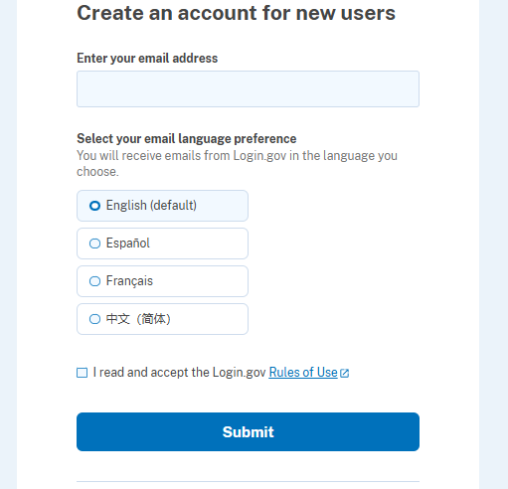

Login.gov User Experience |  | Screen 5
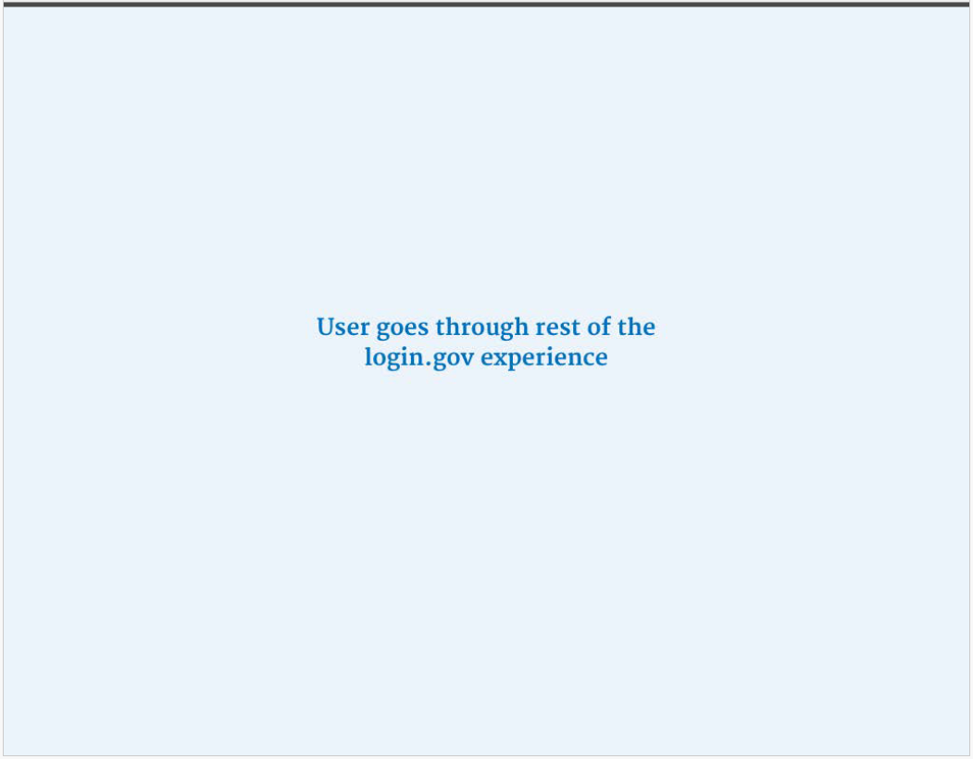

myRRB – Landing Page | Screen 6
User clicks “Direct Deposit” to access Form DDC-1.

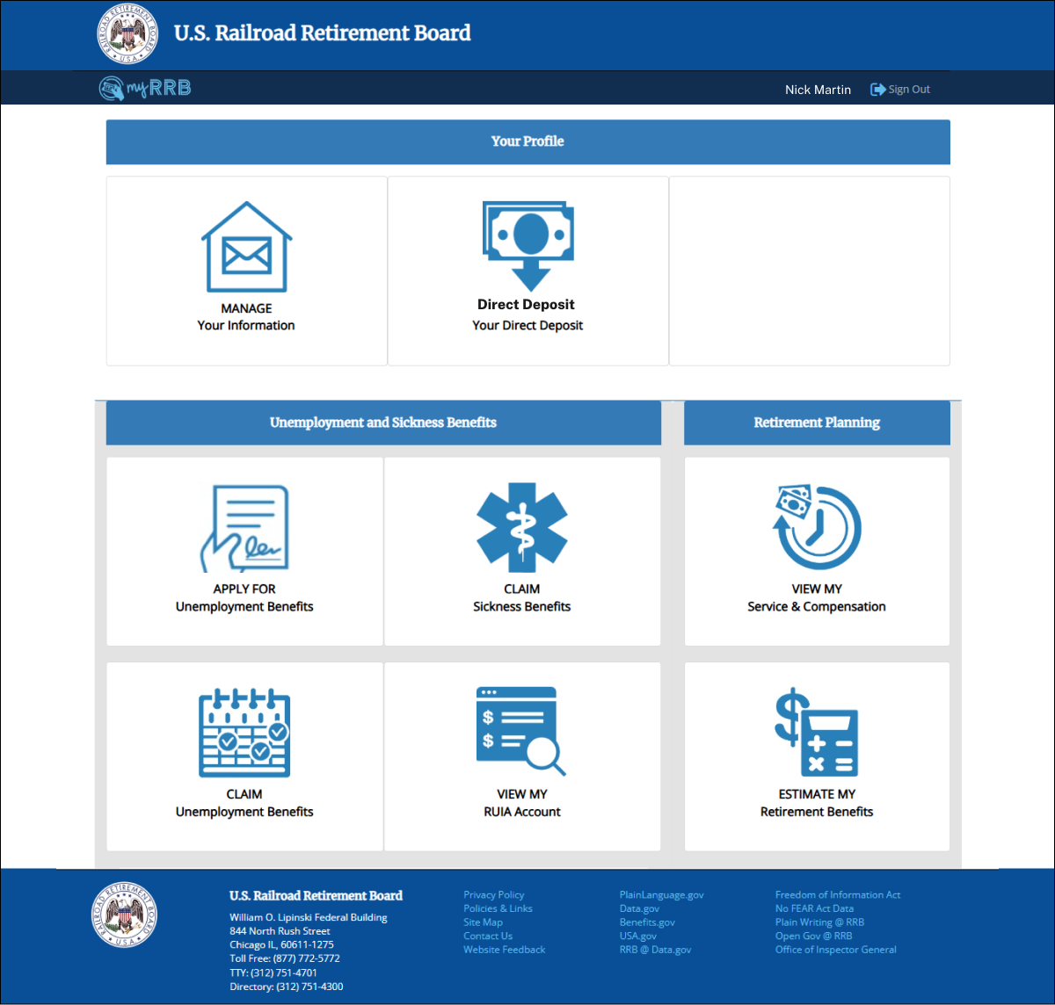

myRRB – Notification to User of No Direct Deposit Information on File  User clicks the “Add account” to access Form DDC-1 to add banking account information to create a direct deposit. | Screen 7
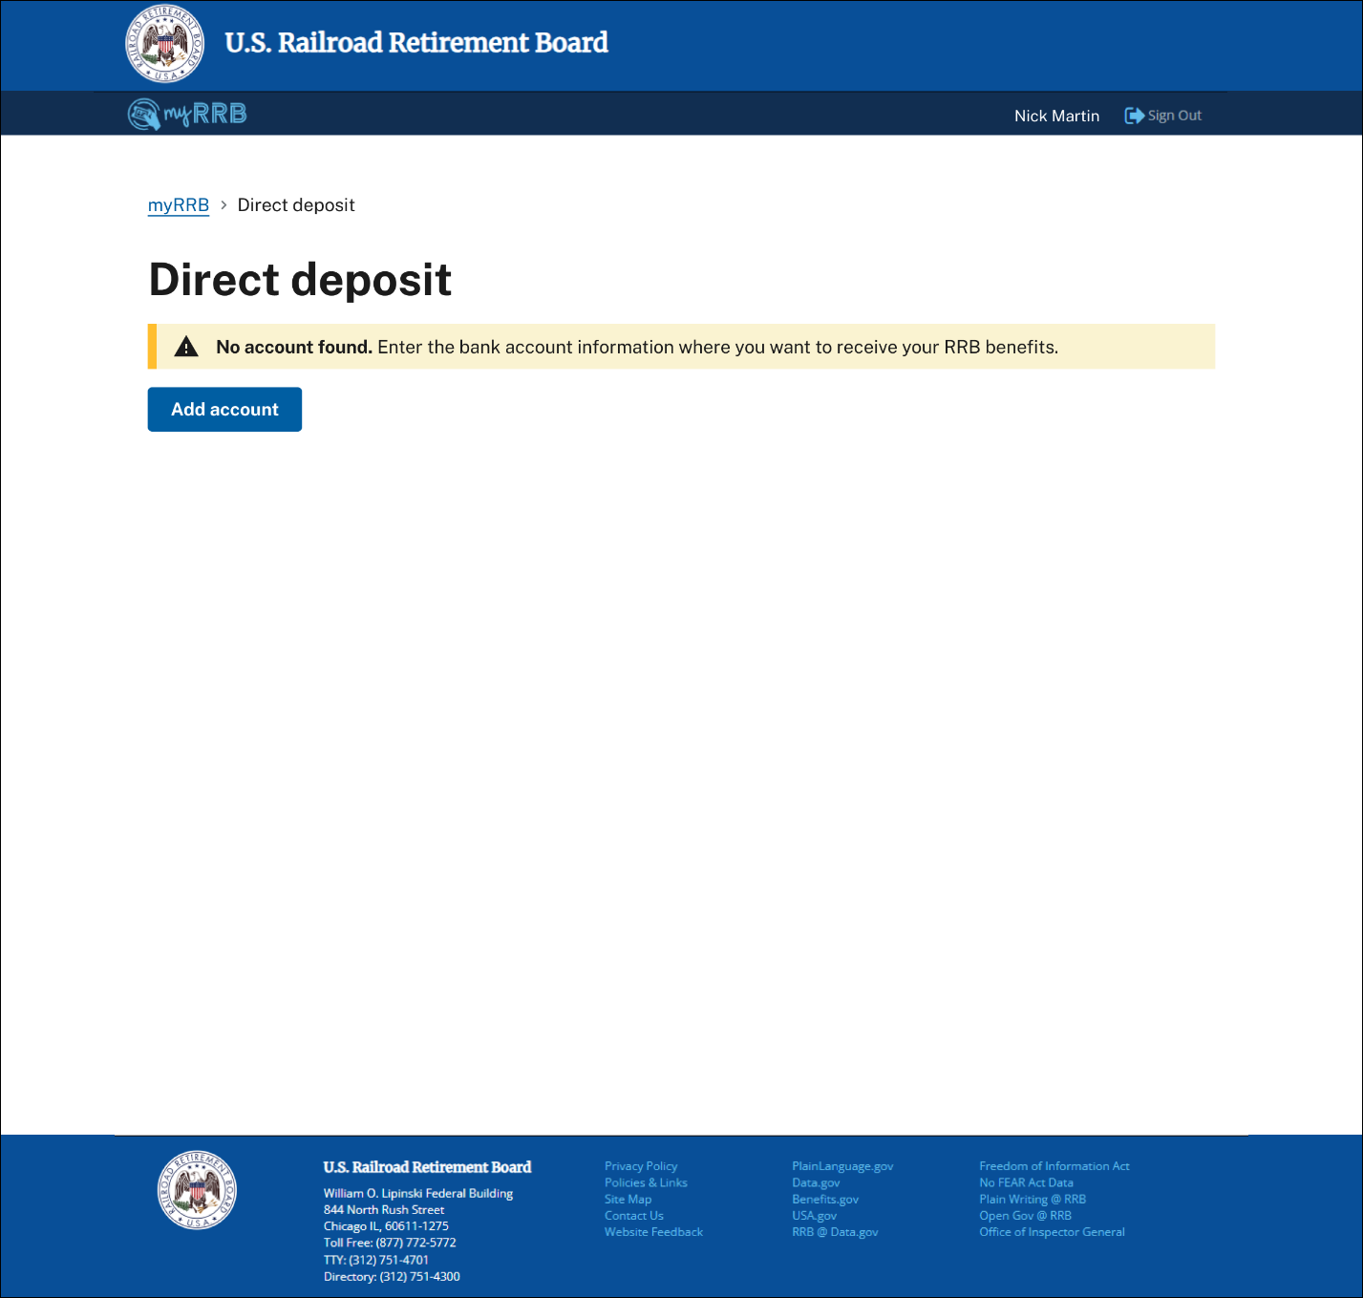
myRRB – Notification to User of Direct Deposit Information on File  User clicks the “Add different account” to access Form DDC-1 to update an account.  Note: The production version of Form DDC-1 will mask the user’s account number except for the last 4 digits on this screen. | Screen 8
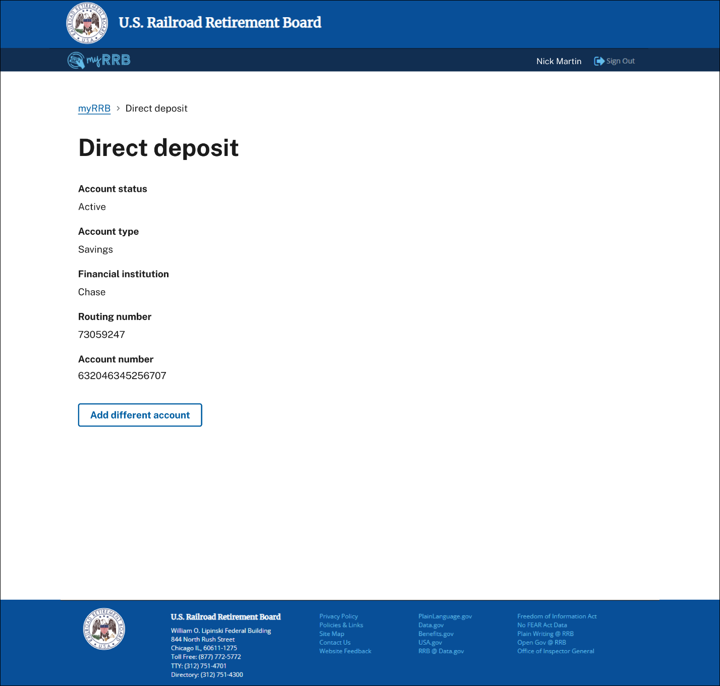
myRRB – Notification to User of Direct Deposit Processing Error  Users are instructed to refresh their screen if myRRB is unable to process the request and provides guidance on how to contact the RRB for assistance. | Screen 9
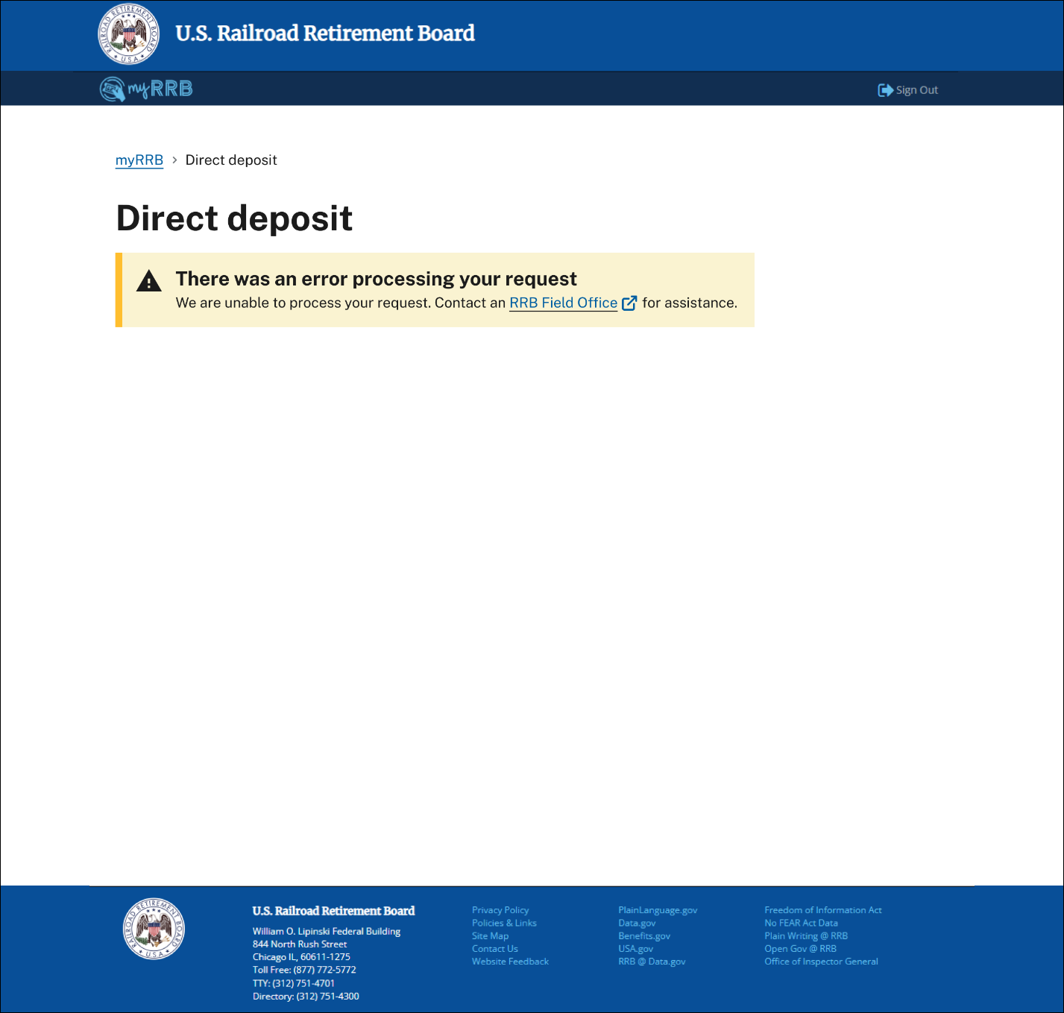
myRRB – Form DDC-1 screen that appears when the user clicks on “Add account” or “Add different account” button in screens 6 and 7.  User selects the appropriate account type and adds their bank routing and account number. |  | Screen 10
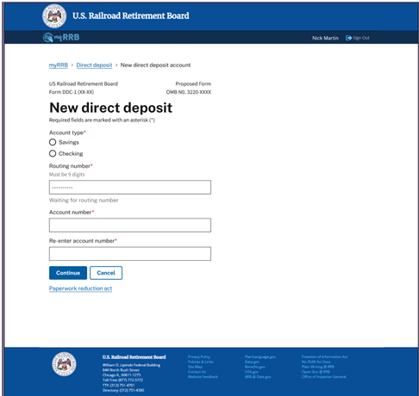 | 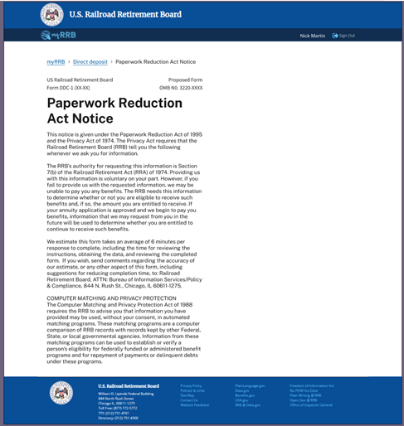

myRRB – Example of Form DDC-1 New Direct Deposit Request  The user is required to complete all fields with a red (*) and make valid entries to ensure completeness and consistency of user-submitted data. Error messages and invalid entries (see Screen 18) indicated in red text will guide the user to make valid entries for data integrity.  Note: The production version of Form DDC-1 will mask the user’s account number except for the last four digits on this screen. | Screen 11
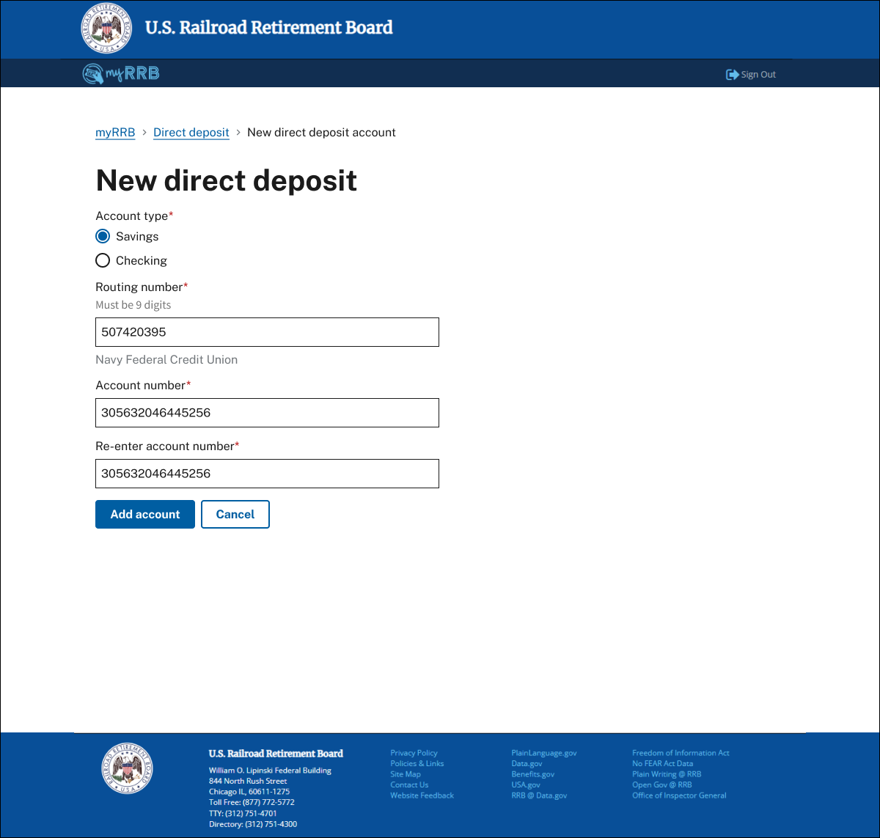

myRRB – New Direct Deposit Processing Error Notification to User  Note: The production version of Form DDC-1 will mask the user’s account number except for the last four digits on screens 12 – 16. | Screen 12
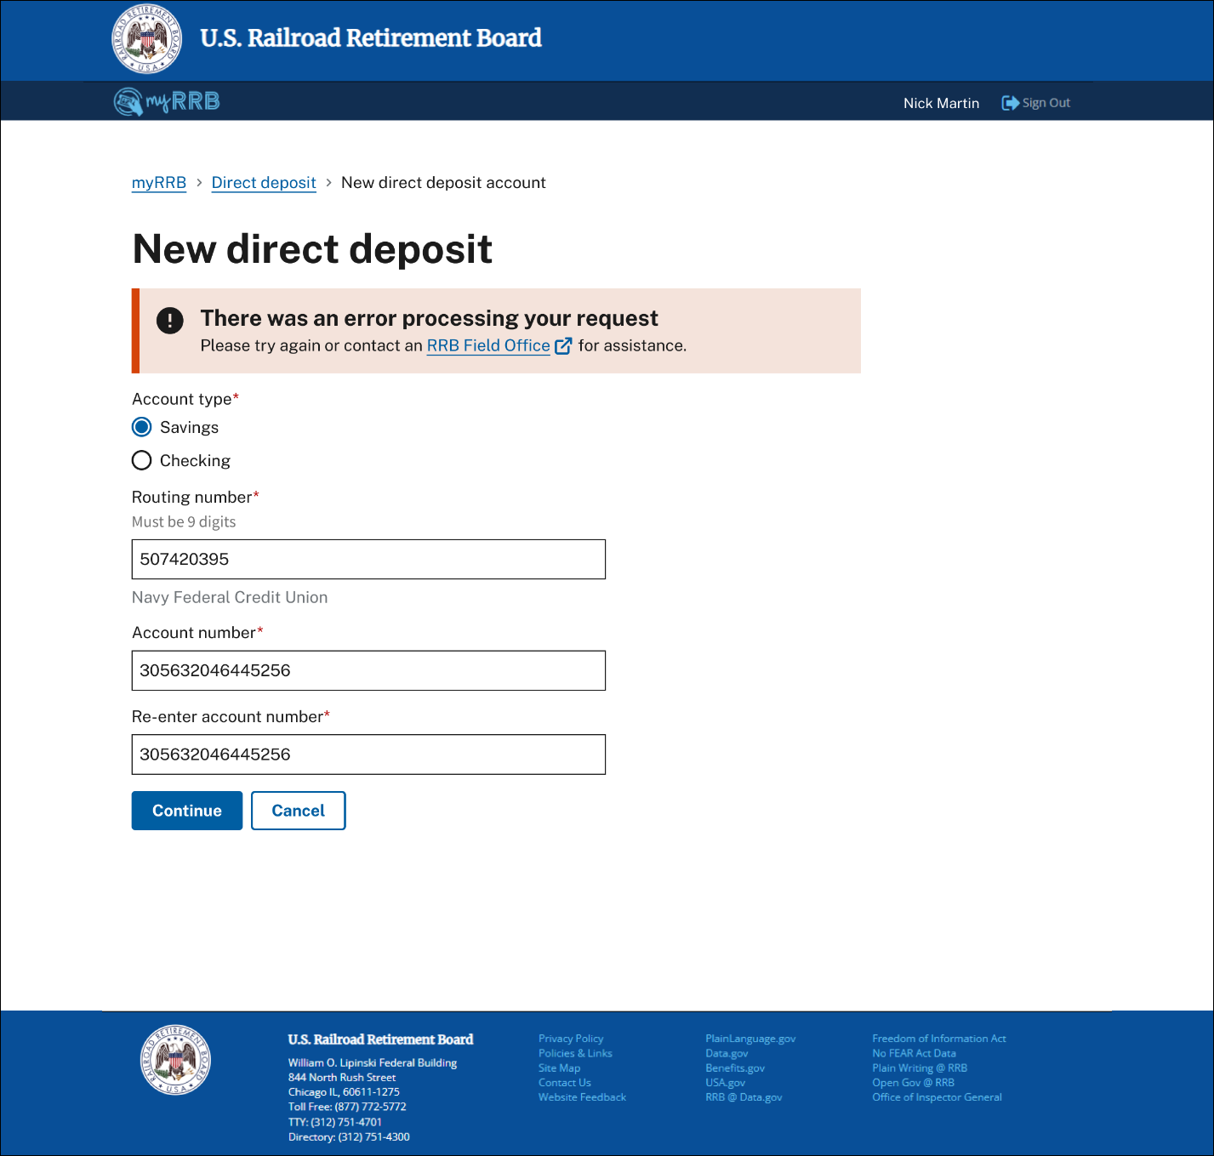

myRRB – New Direct Deposit Session Timeout Notification | Screen 13
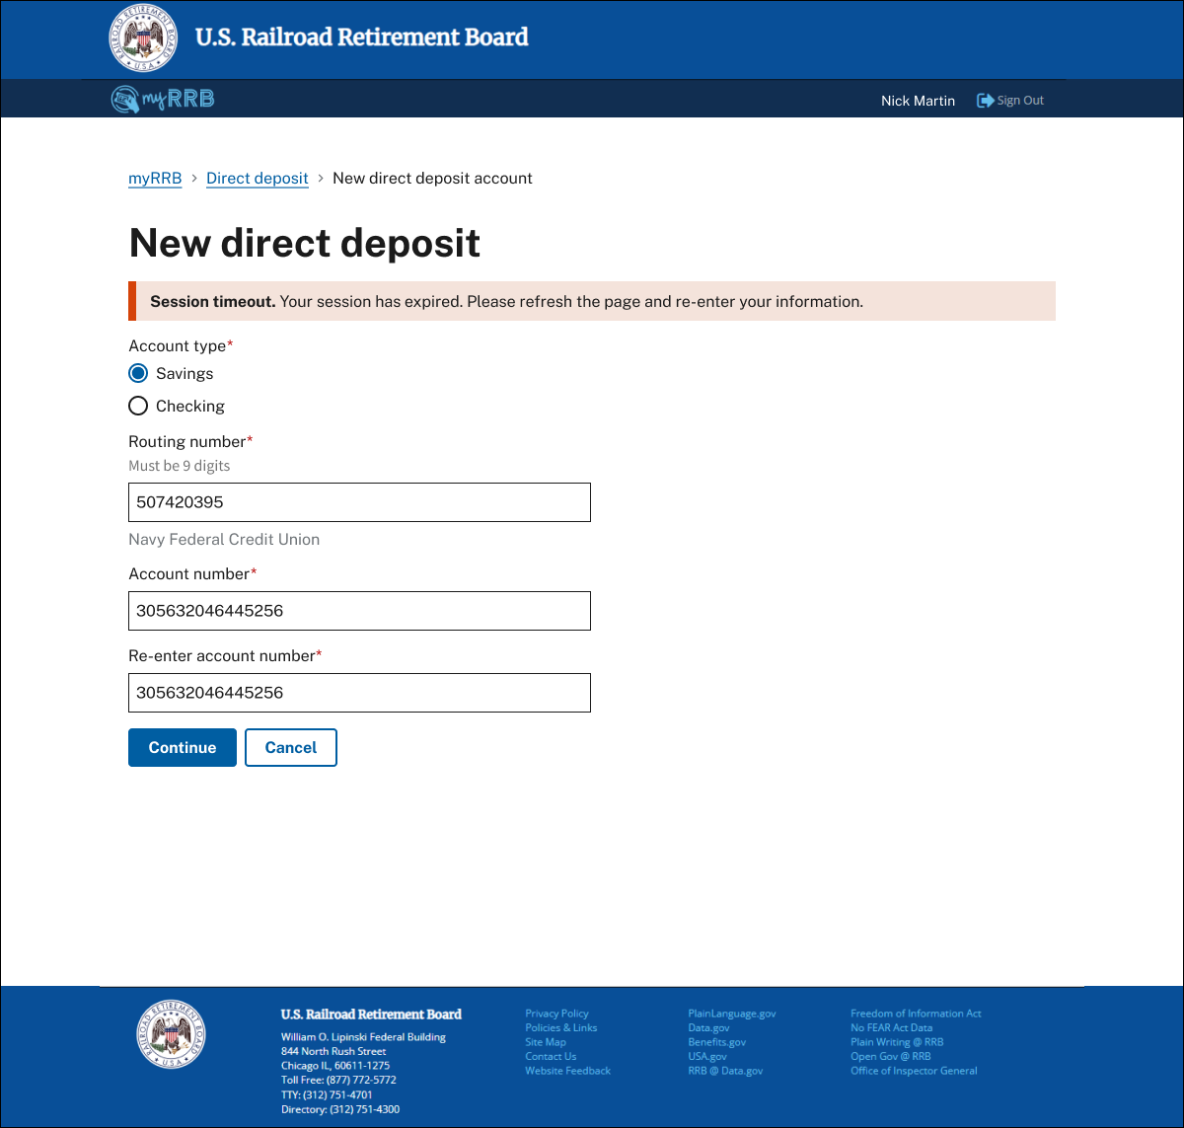

myRRB – Confirmation Options of Direct Deposit Request  When a user selects “Continue” in screens 11 or 12, they will be redirected to one of the two confirmation screens below.  A user has the option to click the “Back” button to correct any errors.  When a user selects “Save account”, they are redirected to the Direct deposit screen and the appropriate myRRB banner/status will appear. |  | Screen 14
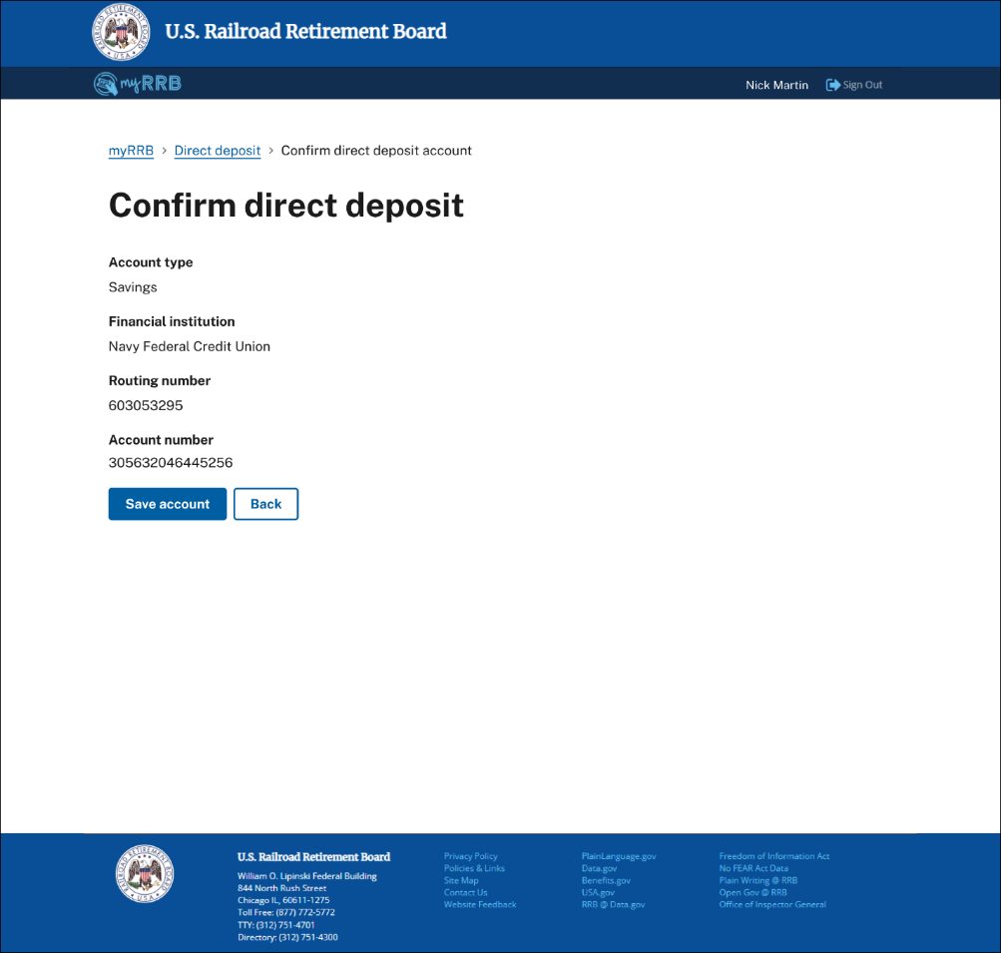 | 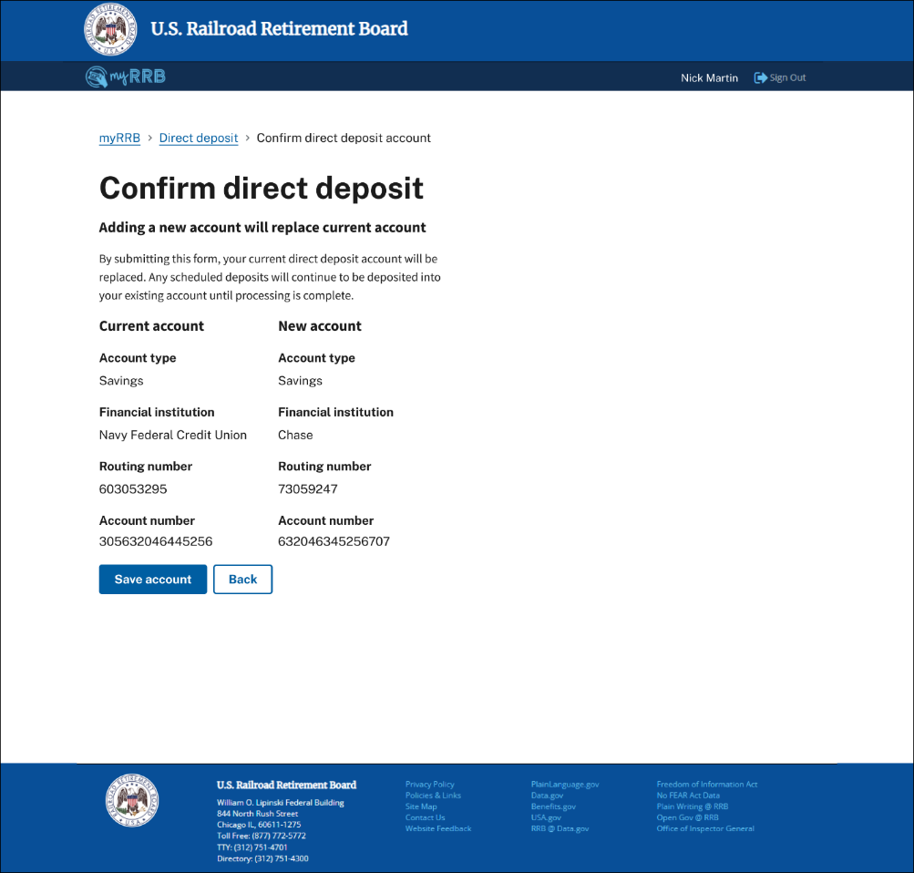
myRRB – Direct Deposit Processing Notification  When a user selects “Save account” on one of the confirmation notification screens above, they are ending the update process.  The user will be redirected to a screen that provide information on the status of their request, timeline expectation, and who to contact if they need assistance. |  | Screen 15
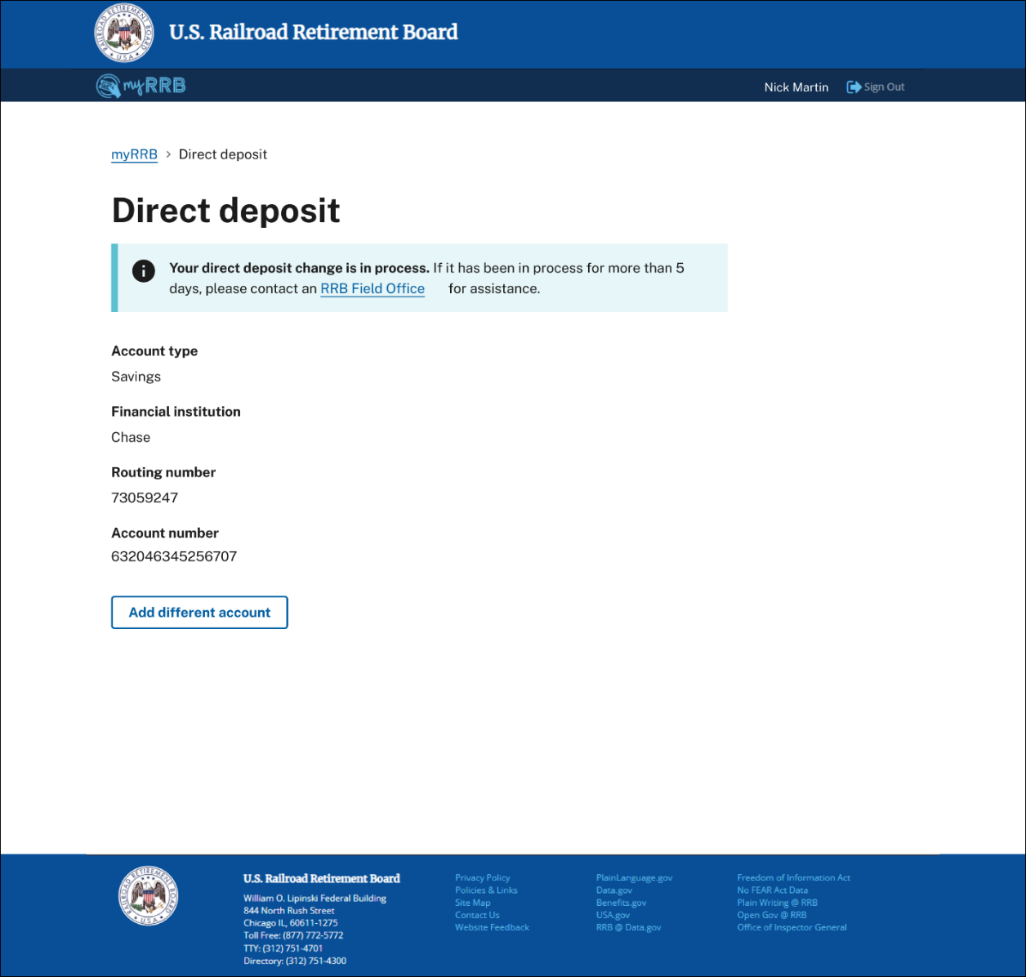
myRRB – Direct Deposit Process Complete Notification  Once “Account save” processing is complete, the Account status in the banner will change to “Active”. | Screen 16
myRRB – Direct Deposit Cancel Request  If a user decides to stop a new addition or update to their direct deposit, the user can click the “Cancel” button.  Example of myRRB popup message for the user to “Exit without adding” or “Continue adding” is displayed below. | Screen 17
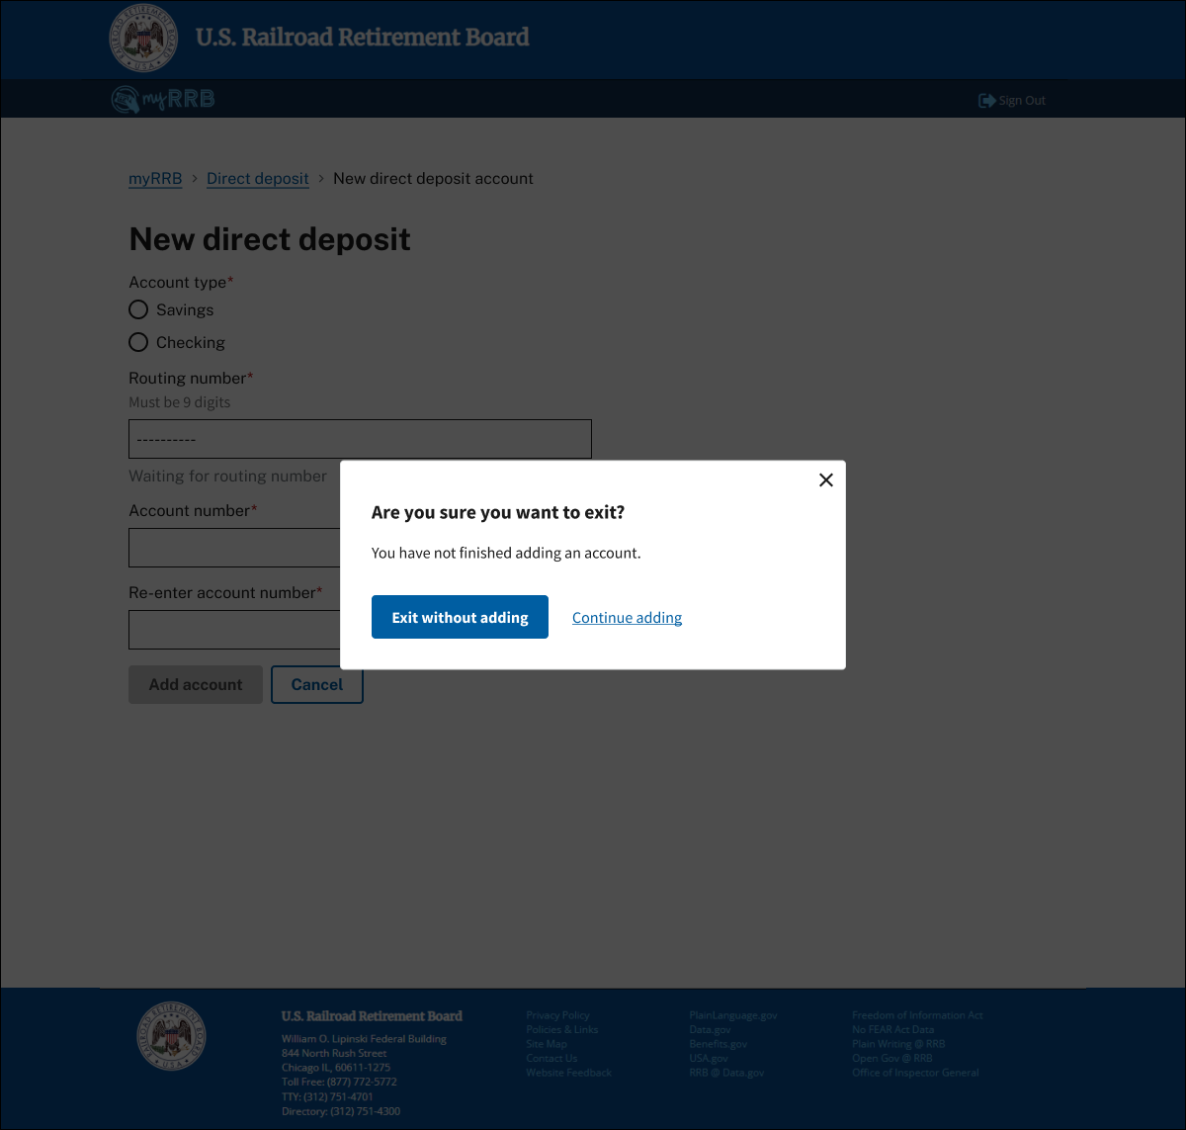

myRRB – Examples of New Direct Deposit Data Entry Verification and Data Integrity  Note for screens 11 – 13: Error messages and invalid entries are indicated in the red text and provide guidance to users to make valid entries for data integrity. |  | Screen 18
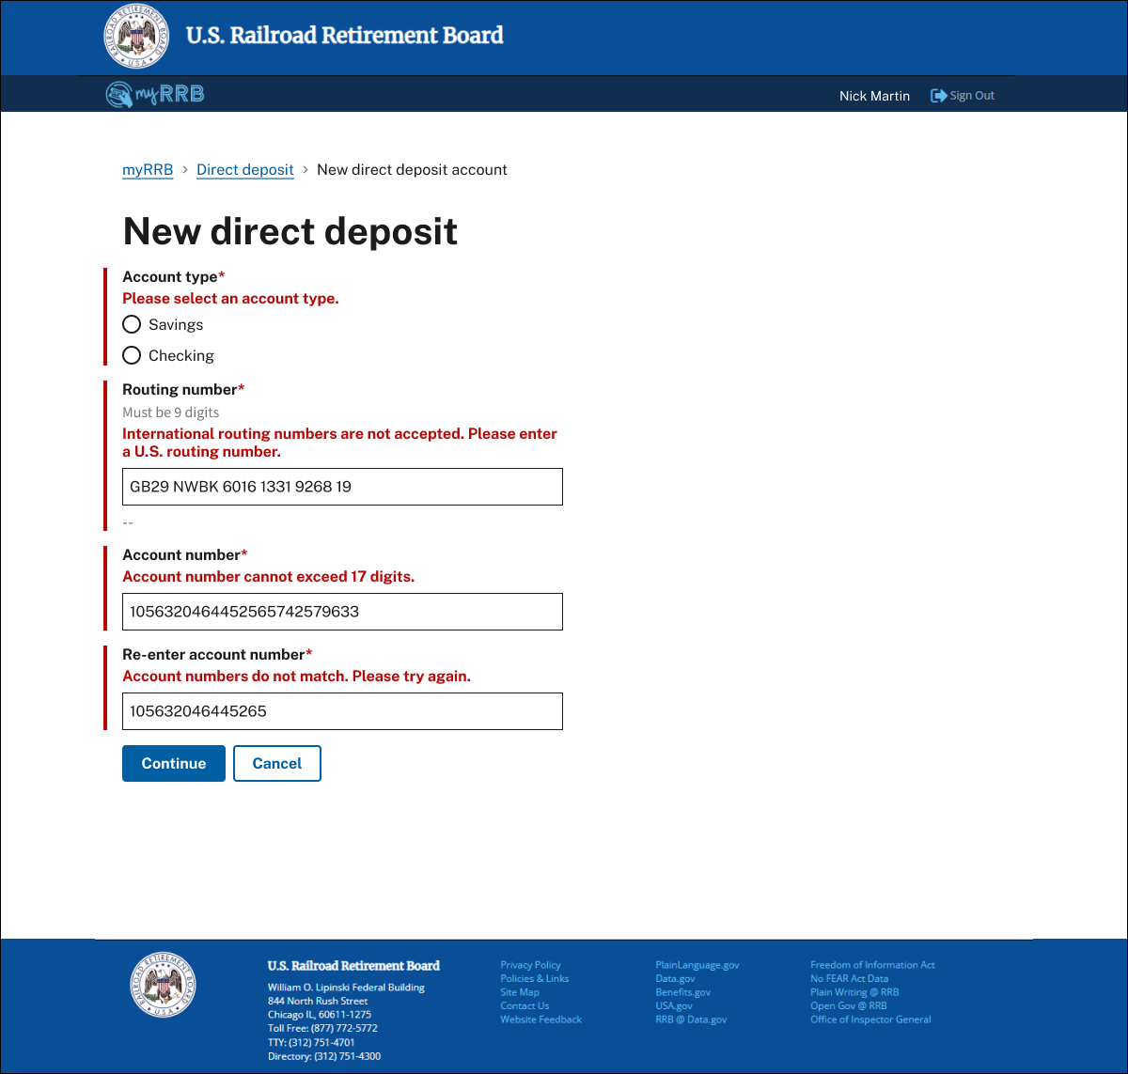 | 