**National Telecommunications and Information Administration (NTIA) Internet Use Survey Cognitive Interviews**

**Attachment D: Communication Materials, Screener**

OMB# **0607-0725**

CBSM

February 2023

Contents

Recruitment advertisement text for cognitive interviews 3

Screeners (by phone) 4

Screeners (by web) 8

Consent Form 11

Teams Attachment 13

Incentive Note (this will be a note embedded in the USPS Priority mail envelope) 17

# Recruitment advertisement text for cognitive interviews

*Internal Census Bureau Email Announcement*

**Subject:** Participants needed for testing survey

***From the Desk of Paul Beatty, Chief, Center for Behavioral Science Methods…***

The U.S. Census Bureau is looking for participants (age 18 and older) to answer survey questions on a national survey about computer and internet use.

We are interested in participants who meet **any** of the following criteria:

* Live in a household with other unrelated people (e.g., roommate or housemate)
* Live in a household with distantly related people (e.g., grandparent or grandchild, cousins, aunt or uncle, etc.)

Interviews will be 65 minutes and will take place in March and April 2023 on your computer using Microsoft Teams. **Participants will receive $40.** Federal employees are not eligible to receive the $40, but family and friends are.

If you know anyone who may be interested, please let them know about this research opportunity. Please have interested participants complete a short questionnaire [QUALTRICS SCREENER LINK] or contact [NAME] at [PHONE NUMBER] or [EMAIL] for further information. Please mention the code **COMPUTER** when you call or email.

*Flyer/Craig’s List advertisement*

**People Needed for Testing Survey – Receive $40 (ONLINE)**

The U.S. Census Bureau is looking for people (age 18 and older) to participate in a research project. You will answer survey questions on a national survey about computer and internet use.

We are interested in people who meet **any** of the following criteria:

* Live in a household with other unrelated people (e.g., roommate or housemate)
* Live in a household with distantly related people (e.g., grandparent or grandchild, cousins, aunt or uncle, etc.)

Interviews will last up to 65 minutes and will be conducted via Microsoft Teams. **You will receive $40 to thank you for your time.**

To learn more, please (1) click on this link [QUALTRICS SCREENER LINK] or (2) call [NAME] at xxx-xxx-xxxx or (3) email [NAME] at [xxxx@census.gov](mailto:xxxx@census.gov). If you email or call, **please be sure to mention the code** **“COMPUTER.”**

# Screeners (by phone)

Hello, I’m _____________ from the Census Bureau. Thank you for contacting us about participating in one of our studies. I just need to get a little bit of background information to start.

1. What is your name?

First name:_____________________

Last name:_____________________

1. Before we begin, I’m required to give you some information about how we protect your information. Would you like me to send the information in an email or read it to you now?

* Statement emailed (privacy statement is emailed below and participant must review before proceeding with #3)
* Statement read aloud (privacy act statement is read to participant below)

**Privacy Act Statement**

The U.S. Census Bureau is conducting this voluntary study under the authority of 13 U.S.C. Section(s) Sections 8(b), 141, and 182; and Title 29, United States Code, Section 2 authorize the collection of most of the information we request in this survey. The purpose of collecting this information is to improve and inform future surveys.

Your privacy is protected by the Privacy Act of 1974 (5 U.S.C. Section 552a). The Privacy Act permits sharing of the information provided to us for work-related purposes as identified in the Privacy Act System of Records Notices COMMERCE/Census-3, Demographic Survey Collection (Census Bureau Sampling Frame).

[If Title 13 collection: The confidentiality of your data is protected by 13 U.S.C. Section 9. The Census Bureau can use your responses only to produce statistics, and is not permitted to publicly release your responses in a way that could identify you, your business, organization, or institution].

We estimate that completing these screening questions will take 15 minutes on average. This information collection has been approved by the Office of Management and Budget (OMB). You can validate that this survey is a legitimate federally-approved information collection using the Office of Management and Budget's approval number 0607-0725, which expires December 31, 2025. We are required to tell you this number to conduct this survey. Send comments regarding this estimate or any other aspect of this survey, including suggestions for reducing the time it takes to complete this survey to adrm.pra@census.gov.

1. What is your email address?
2. What is the best number to reach you during the day?

Mobile ([ ]) [ ] – [ ]

Home (if not mobile) ([ ]) [ ] – [ ]

Work (if any) ([ ]) [ ] – [ ] EXT.[ ]

4a. IF PROVIDED MOBILE NUMBER: If you qualify to participate in a study, we may send you a text message to remind you of your appointment. Do we have permission to send you text message reminders?

* Yes, you have my permission to send me text message reminders
* No, I prefer not to receive them

1. In what city, state, and ZIP code do you currently live?

City:_____________________

State:_____________________

Zip code:__________________

1. How many people age 15 or older currently live in your household, INCLUDING yourself?
2. How many people younger than 15 currently live in your household?
3. [ASK IF HOUSEHOLD HAS > 1 PERSON AND NO PEOPLE YOUNGER THAN 15 IN HOUSEHOLD]

Who lives with you? Please select all that apply.

[ ] Parent(s)

[ ] Grandparent(s)

[ ] Husband/wife/spouse

[ ] Unmarried partner

[ ] Children

[ ] Grandchildren

[ ] Other relative(s)

[ ] Roommates

[ ] Friends

[ ] Other – please specify ______________

[ASK IF HOUSEHOLD HAS > 1 PERSON AND 1 OR MORE PEOPLE ARE YOUNGER THAN 15 IN HOUSEHOLD]

How are the people aged 15 or older in your household related to you? Please select all that apply.

[ ] Parent(s)

[ ] Grandparent(s)

[ ] Husband/wife/spouse

[ ] Unmarried partner

[ ] Children

[ ] Grandchildren

[ ] Other relative(s)

[ ] Roommates

[ ] Friends

[ ] Other – please specify ______________

8a. [ASK IF OTHER RELATIVE(S) WAS SELECTED] Who are these other relative(s)?

[ ] Cousin(s)

[ ] Aunt(s)/Uncle(s)

[ ] Other – please specify ______________

1. Do you own a:

9a. Smartphone

* Yes - Is it an iPhone, Android, Blackberry or Windows phone, or are you not sure?
* No

9b. Desktop

* Yes
* No

9c. Laptop

* Yes
* No

9d. Tablet

* Yes - Is it an iPad, Samsung Galaxy Tab, Google Nexus, or Kindle Fire or are you not sure?
* No

1. How often do you use the Internet either on a computer or on a mobile device like a smartphone or tablet?
   * Several times a day
   * About once a day
   * A few times a week
   * A few times a month
   * A few times a year
   * Not at all
2. Could you complete a survey online?

* Yes
* No

1. Who typically handles the mail in your household?

* Only you
* You and other members of the household?
* Someone in the household other than you?

# Screeners (by web)

**To determine if you are eligible for an interview, we must ask you a few screening questions about your background. Your participation in the eligibility screening is completely voluntary. You may stop at any time or skip questions that you do not want to answer. The research studies will be approximately 65 minutes and will take place over a secure video conferencing app (Microsoft Teams). Participants will receive $40 upon completion of the study. If you are eligible for the study, we will email or call you to schedule a time for the interview.**

The U.S. Census Bureau is conducting this voluntary study under the authority of 13 U.S.C. Section(s) Sections 8(b), 141, and 182; and Title 29, United States Code, Section 2 authorize the collection of most of the information we request in this survey. The purpose of collecting this information is to improve and inform future surveys.

Your privacy is protected by the Privacy Act of 1974 (5 U.S.C. Section 552a). The Privacy Act permits sharing of the information provided to us for work-related purposes as identified in the Privacy Act System of Records Notices COMMERCE/Census-3, Demographic Survey Collection (Census Bureau Sampling Frame).

[If Title 13 collection: The confidentiality of your data is protected by 13 U.S.C. Section 9. The Census Bureau can use your responses only to produce statistics, and is not permitted to publicly release your responses in a way that could identify you, your business, organization, or institution].

We estimate that completing these screening questions will take 15 minutes on average. This information collection has been approved by the Office of Management and Budget (OMB). You can validate that this survey is a legitimate federally-approved information collection using the Office of Management and Budget's approval number 0607-0725, which expires December 31, 2025. We are required to tell you this number to conduct this survey. Send comments regarding this estimate or any other aspect of this survey, including suggestions for reducing the time it takes to complete this survey to adrm.pra@census.gov.

1. What is your name?

First name:

Last name

1. What is your email address?
2. What is the best number to reach you during the day?

Mobile ([ ]) [ ] – [ ]

Home (if not mobile) ([ ]) [ ] – [ ]

Work (if any) ([ ]) [ ] – [ ] EXT.[ ]

3a. IF PROVIDED MOBILE NUMBER: If you qualify to participate in a study, we may send you a text message to remind you of your appointment. Do we have permission to send you text message reminders?

* Yes, you have my permission to send me text message reminders
* No, I prefer not to receive them

1. In what city, state, and ZIP code do you currently live?

City:_____________________

State:_____________________

Zip code:__________________

1. How many people age 15 or older currently live in your household, INCLUDING yourself?
2. How many people younger than 15 currently live in your household?
3. [ASK IF HOUSEHOLD HAS > 1 PERSON AND NO PEOPLE YOUNGER THAN 15 IN HOUSEHOLD]

Who lives with you? Please select all that apply.

[ ] Parent(s)

[ ] Grandparent(s)

[ ] Husband/wife/spouse

[ ] Unmarried partner

[ ] Children

[ ] Grandchildren

[ ] Other relative(s)

[ ] Roommates

[ ] Friends

[ ] Other – please specify ______________

[ASK IF HOUSEHOLD HAS > 1 PERSON AND 1 OR MORE PEOPLE ARE YOUNGER THAN 15 IN HOUSEHOLD]

How are the people aged 15 or older in your household related to you? Please select all that apply.

[ ] Parent(s)

[ ] Grandparent(s)

[ ] Husband/wife/spouse

[ ] Unmarried partner

[ ] Children

[ ] Grandchildren

[ ] Other relative(s)

[ ] Roommates

[ ] Friends

[ ] Other – please specify ______________

7a1. [ASK IF OTHER RELATIVE(S) WAS SELECTED] Who are these other relative(s)? Please select all that apply.

[ ] Cousin(s)

[ ] Aunt(s)/Uncle(s)

[ ] Other – please specify ______________

1. Do you own a:

8a. Smartphone

* Yes
* No

8a1. [ASK IF YES TO 8A] Is it an iPhone, Android, Blackberry, or Windows phone, or are you not sure?

* iPhone
* Android
* Blackberry
* Windows phone
* Not sure

8b. Desktop

* Yes
* No

8c. Laptop

* Yes
* No

8d. Tablet

* Yes
* No

8d1. [ASK IF YES TO 8D] Is is an iPad, Samsung Galaxy Tab, Google Nexus, or Kindle Fire or are you not sure?

* iPad
* Samsung Galaxy Tab
* Google Nexus
* Kindle Fire
* Not sure

1. How often do you use the Internet either on a computer or on a mobile device like a smartphone or tablet?
   * Several times a day
   * About once a day
   * A few times a week
   * A few times a month
   * A few times a year
   * Not at all
2. Who typically handles the mail in your household?

* Only you
* You and other members of the household
* Someone in the household other than you

# Consent Form





**Current Population Survey Consent Form to Participate in Research**

Each year the Census Bureau conducts many different surveys. The Census Bureau routinely tests the questions used on these surveys in order to produce the best information possible.

By signing this document, you consent to take part in a study to improve the questions that will be used in the Current Population Survey. In order to have a complete record of all comments, the interview session will be video and/or audiotaped. The Census Bureau plans to use the recordings to improve the questionnaire. Staff directly involved in the questionnaire design research project will have access to the recordings. Participation is voluntary and answers will remain strictly confidential.

This research interview is being conducted under the authority of 13 U.S.C. Sections 8(b), 141, and 182. Federal law requires that your answers are kept confidential (13 U.S. C. Section 9), and protects your privacy under the Privacy Act (5 U.S.C. Section 552a). Only research staff from the U.S. Census Bureau will know your answers and/or comments from the interview. The Census Bureau can use your responses only to produce statistics, and is not permitted to publicly release your responses in a way that could identify you, your business, organization, or institution.

Additionally, per the Federal Cybersecurity Enhancement Act of 2015, your data are protected from cybersecurity risks through screening of the systems that transmit your data. Your information is secured by strictly adhering to the provisions of the Privacy Act, and other regulations and policies to protect the privacy and confidentiality of the information.

This collection has been approved by the Office of Management and Budget (OMB). This eight-digit OMB approval number, 0607-0725, confirms this approval and expires on 12/31/2025. Without this approval, we could not conduct this study.

I have read and understand the statements above. I have agreed to participate in this Census Bureau questionnaire design study, and I give permission for my recordings to be used for the purposes stated above.

Use your mouse or finger to sign your name in the box below.

× SIGN HERE

Clear

Type today's date below:

____________________

Fill in the following information below:

Your First Name: ____________________

Your Last Name: ____________________

Email address: ____________________

**PUBLIC VOUCHER FOR PURCHASES AND SERVICES OTHER THAN PERSONAL**

The information that you provide in the spaces below will be used to release any incentive payments (cash or non-cash) to you. Census Bureau personnel will mail your incentive via USPS Priority Mail no later than ten business days after completion of your interview. You will receive your incentive within three weeks of completion of your interview depending on mail service.

In the box below, please enter your name and the address where you want your incentive to be sent.

Name ____________________

Street Address ____________________

City ____________________

State ____________________

ZIP ____________________

Finally please sign below and enter today's date.

Signature:

× SIGN HERE

Clear

Type today's date below.

____________________

# Teams Attachment

1. **You will receive an invitation that looks like this. Click the link to join at the time of your meeting:**

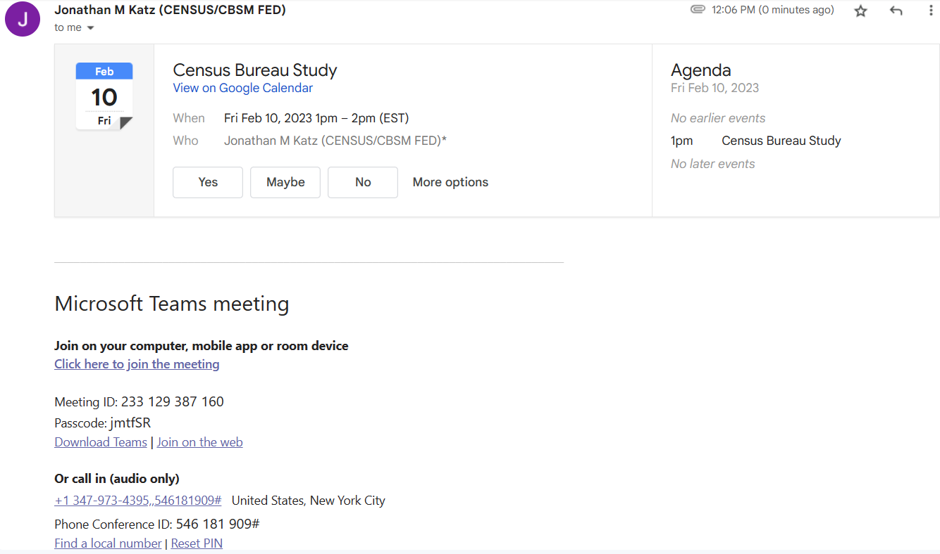

1. **If you already have Teams installed, feel free to use that. Otherwise select “continue on this browser.” Do NOT use Firefox:**

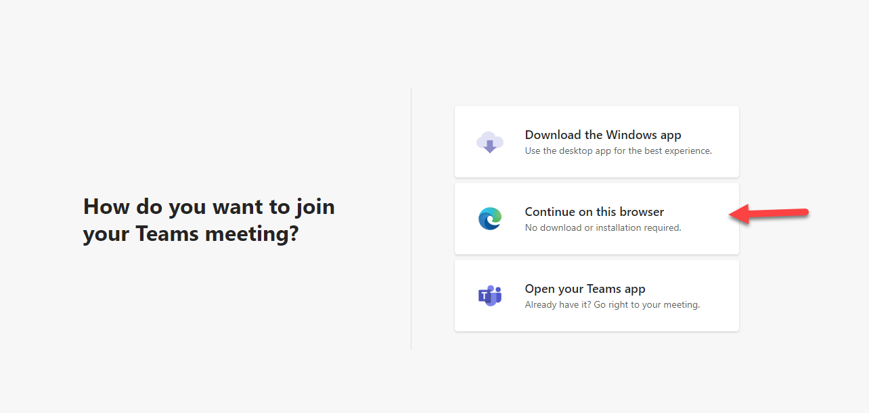

1. **Be sure to give permission to use your camera and microphone. Enter a name and click “join now”**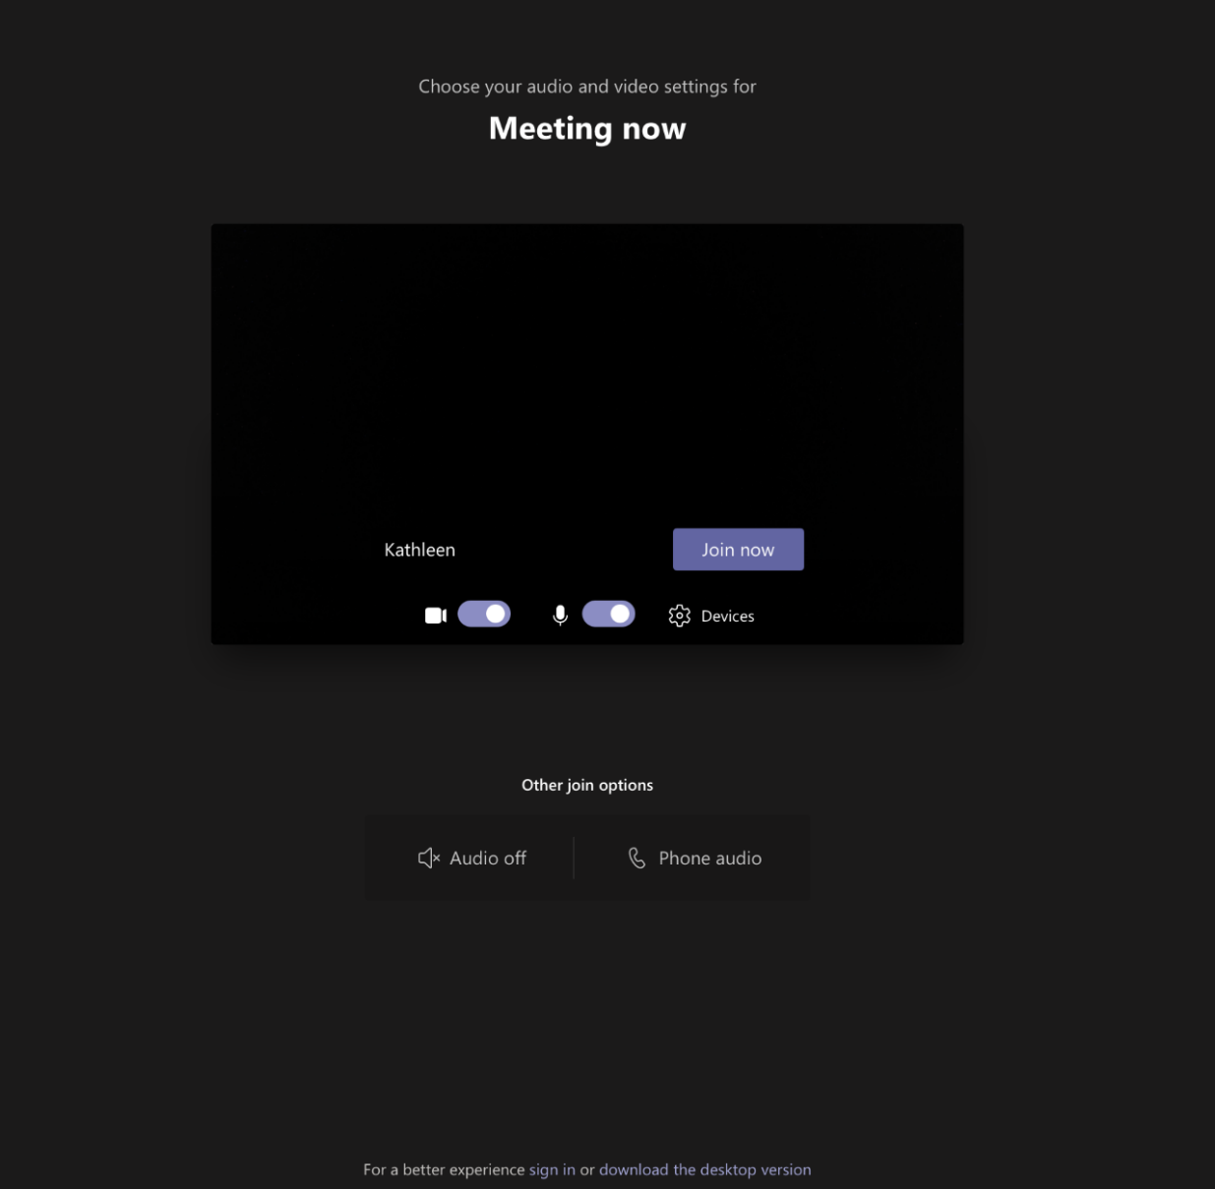
2. **This is how you share your screen**

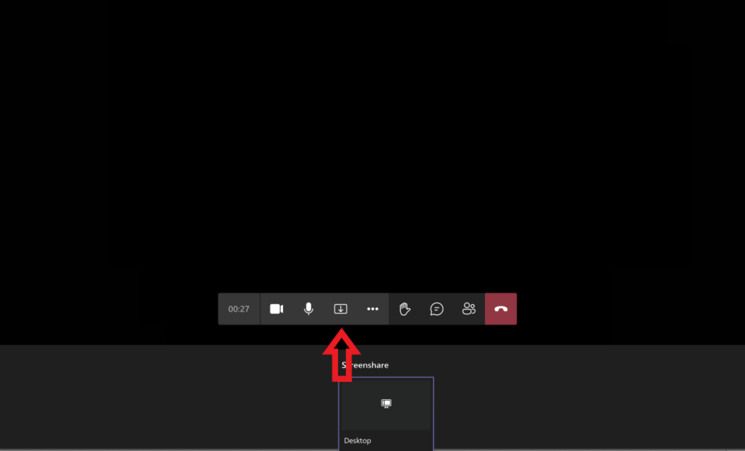

# Incentive Note (this will be a note embedded in the USPS Priority mail envelope)



Dear XXXXXX ,

Thank you again for your participation in research for the U.S. Census Bureau. You have given us valuable information to help improve the survey. As promised, enclosed is $40 cash.

We at the U.S. Census Bureau greatly value your time and input.

Sincerely

XXXXXX