**Wisconsin ABAWD Message Testing Protocol**

Participant ID: ______ Interviewer initials: _____

Interview Date: ___ / ___ / 2023 Start Time: ____________ End Time: ____________

Read or paraphrase the following intro text:

**Hello. My name is ________________, and I work for the Census Bureau. Thank you for agreeing to participate in our study.**

**Today we are talking to people about the information they receive from the FoodShare assistance program. The information should be clear and easy to understand, so people who are eligible receive their benefits and know about rules and requirements to continue participating in FoodShare. We have found that the best way to test letters and messages is to meet with people in person and get their feedback as they read the materials. You will be helping us test messages and communications that some FoodShare recipients have received in the past.**

[HAND PARTICIPANT CONSENT FORM]

**This is a consent form. It tells you a little bit about the study and gives me permission to audio record this interview. Our session today is completely confidential. Your participation in this study is completely voluntary. You may decline to answer any question and you may stop the interview at any time. We do not share information with anyone. Only the people on the project have access to the recording and we do not use any names in our reports. Take a look and let me know if you have any questions. Please sign it when you are finished, and then I will also sign it.**

[SIGN CONSENT FORM AFTER PARTICIPANT SIGNS]

Think Aloud: **As you read the materials today, I am interested in the thoughts and reactions that go through your mind as you process the messages. So I would like you to tell me everything that you are thinking and feeling as we go through these materials.**

Practice: **Lets practice before we start.** [SHOW PARTICIPANT PRACTICE PARAGRAPH]

**Please read this short paragraph and say what comes into your mind as you’re reading it.**

Practice probes: **In your own words, can you tell me what this paragraph is saying?**

**Did you find any part of it difficult to understand?**

**Thanks, that was great. So as we go through the FoodShare materials, I will ask you questions like these. I really want to hear your opinions and reactions, so don’t hesitate to speak up whenever something is unclear, or not easy to understand. We are going to look at five letters and I’m going to ask you to read each one first while you think aloud. And then I will ask you questions about each letter after you are done reading it. Do you have any questions before we begin?** [TURN ON RECORDER. CHECK BATTERY LEVEL.]

**Letter 1 – About Your Benefits**

**Here is a letter that someone might receive after applying for benefits. Please take a few minutes to read the letter and then we will talk about it.** If needed: **Please remember to say what comes to mind as you are reading.**

[SHOW RESPONDENT “About Your Benefits” LETTER. WHILE REVIEWING PAGE 1, NOTE IF R MENTIONS THE REFERENCE TO THE LATER SECTION “Your FoodShare Benefits” AND IF THEY APPEAR TO LOOK FOR THE REFERENCED SECTION.]

**In your own words, can you tell me what this letter is saying?**

**Did you find any part of it difficult to understand?**

If yes: **Which parts were difficult?**

**Was there anything you expected to see in this letter that was not here?**

**In your opinion, what is the most important information you saw in this letter, if any?**

**What would you expect to happen after receiving this letter?**

(if needed) **What does the recipient of the letter need to do, if anything?**

[POINT TO PAGE 1.] **Ok, let’s go back to the beginning of the letter. Please tell me in your own words what this first page is telling you.**

[IF NEEDED, POINT TO OR HIGHLIGHT THE “FoodShare” LINE IN THE TABLE.]

**Can you tell me in your own words what this section is saying?**

**In your opinion, was this section clear or unclear? Why do you say that?**

[POINT TO PAGE 2.] **Ok, how about this next page, what does this page mean to you?**

[POINT TO PAGE 3.] **And how about this page, were there any important pieces of information?**

[POINT TO OR HIGHLIGHT PARAGRAPH STARTING WITH, “Who will get FoodShare and how much?”] **What does this section mean to you?**

**In your opinion, is the information on this page clear or not clear? Why do you say that?**

[POINT TO OR HIGHLIGHT SECTION “More information.”] **What is this section telling you, in your own words?**

[NOTE WHETHER R MENTIONS 3 MONTHS, TIME LIMITED BENEFITS, WORK REQUIREMENTS, OR OTHER DETAILS FROM BOTTOM PARAGRAPH.]

[POINT TO PAGE 4.] **And how about this next page, can you say in your own words what this page is telling you?**

[NOTE WHETHER R REFERS TO PAGE 1 STATEMENT ABOUT LOSING BENEFITS.]

[POINT TO OR HIGHLIGHT SECTION “Who will not get FoodShare and why.”] **Can you say more about what this section telling you, in your own words?**

[IF NEEDED:] **This section says that Ted used all 3 months of his time limited benefits. Have you heard of “time limited benefits” before?**

**What does that mean to you when it says that Ted used all 3 months of his time limited benefits?**

[IF NEEDED:] **How about “FoodShare work requirement”, have you heard of that before?**

**What does it mean to you?**

**When you were reading this section, do you recall whether you were thinking about the message on page 1 about Ted losing his FoodShare benefits?**

**In your opinion, was it clear that the message on the first page was referring to this section on page 4?**

[POINT TO OR HIGHLIGHT SECOND SECTION WITH “How to get FoodShare benefits again” AT THE TOP] **How about this next section, what is this section telling you?**

[POINT TO OR HIGHLIGHT FIRST PARAGRAPH UNDER “What is the FoodShare work requirement?” **What does this first paragraph mean to you?**

**In your opinion, is this information clear or not clear? Why do you say that?**

**This section talks about certain adults between 18 and 49 with no minor children in the home. Have you heard of this before?**

**This section also says that these types of people can only get three months of benefits in a three year or 36 month period. Have you heard of this before?**

**In your opinion, is that clear or not clear? Why do you say that?**

[POINT TO OR HIGHLIGHT SECOND PARAGRAPH STARTING WITH “There are three ways…”] **How about this next section, what is this section telling you?**

**In your opinion, is this information clear or not clear? Why do you say that?**

**Have you ever heard of the FoodShare Employment and Training, Wisconsin Works, or Workforce Innovation and Opportunity Act programs before?**

[POINT TO OR HIGHLIGHT THIRD PARAGRAPH STARTING WITH “To learn more…”] **And** **this next section, what is this section telling you?**

[IF NEEDED:] **Please tell me more about what an exemption means to you.**

**Have you heard of exemptions related to work requirements before?**

[POINT TO OR HIGHLIGHT PARAGRAPH STARTING WITH, “How can I get FoodShare benefits again?”] **In your own words, can you tell me what this section is saying?**

**In your opinion, was this section clear or unclear? Why do you say that?**

[IF NEEDED, POINT TO 4TH BULLET] **What does this last bullet mean to you?**

**In your opinion, is it clear what that is referring to? Why do you say that?**

**While you were reviewing this page, do you recall seeing a link to a website?**

[IF NEEDED, POINT TO THE LINK IN THE 3RD PARAGRAPH.]

**If you received this letter in the mail, how likely would you be to use this link to visit the website?**

(if R is likely to use) **How would you use it?**

(if needed) **How likely would you be to copy the URL from this letter into your computer to visit the website?**

**Thank you for sharing your thoughts on this letter. Let’s take a look at another one.**

**Letter 2 – Time Limited**

**Here is a letter that someone receiving FoodShare benefits might receive. Please take a few minutes to read the letter and then we will talk about it.** If needed: **Please remember to say what comes to mind as you are reading.**

[SHOW RESPONDENT “Time-Limited” LETTER. NOTE WHAT INFO R PAYS ATTENTION TO.]

**In your own words, can you tell me what this letter is saying?**

**Did you find any part of it difficult to understand?**

If yes: **Which parts were difficult?**

**What would you expect to happen after receiving this letter?**

[POINT TO OR HIGHLIGHT FIRST PARAGRAPH] **Let’s take a look at this first paragraph.**

**Can you say more about what the first sentence is saying?**

**Can you tell me what “minor children** **who are in the same FoodShare household” means to you?**

**In your opinion, is this section clear or not clear? Why do you say that?**

[POINT TO OR HIGHLIGHT THE LAST SENTENCE “The current period began on…”] **What does this sentence mean to you?**

[POINT TO OR HIGHLIGHT PARAGRAPH STARTING WITH “Our records show…”] **How about this paragraph, can you say more about what this is telling you?**

(if needed) **Can you tell me in your own words what it means to “use one of your three time-limited benefit months”?**

[POINT TO OR HIGHLIGHT THIRD PARAGRAPH STARTING WITH “One way that you can meet…”] **What does this paragraph mean to you?**

[IF NEEDED POINT TO OR HIGHLIGHT BOLD PRINTED TEXT.] **What does this part in bold print mean to you?**

**In your opinion, is this information clear or not clear? Why do you say that?**

[POINT TO OR HIGHLIGHT the sentence that reads, “you must enroll and take part in activities by the start of your third time-limited FoodShare benefit month.”], **Can you say more about what that sentence means to you?**

[POINT TO OR HIGHLIGHT the sentence that starts with “Otherwise you will use up your three time-limited benefit months, and your FoodShare benefits will end….”] **Please tell me more about what this part means to you.**

[POINT TO OR HIGHLIGHT FOURTH PARAGRAPH STARTING WITH “To enroll…”] **And how about this last section at the bottom, what does that part mean to you?**

**This paragraph mentions an FSET service provider. Have you heard that term before? What does it mean to you?**

[OUTLINE OR HIGHLIGHT ENTIRE “How to Meet the Work Requirement”] **Now let’s look at the next page.**

[POINT OR HIGHLIGHT sentence that starts, “If your work hours drop below 80 hours a month…”] **In your own words, what is this sentence telling you?**

[POINT TO OR HIGHLIGHT “Who is exempt…”] **How about this next section, what does this section mean to you?**

[PROBE EVERY ITEM IN THE LIST. NOTE WHETHER R NOTICES THAT THE LIST CONTINUES ONTO THE FOLLOWING PAGE.]

(if needed) **Please go through the list and tell me what each of these means to you.**

[ON PAGE 3, POINT TO OR HIGHLIGHT THE SENTENCE STARTING WITH “If you meet one of the exemptions listed above…”] **Can you say more about what the exemptions mean to you?**

**Thank you for sharing your thoughts on that letter. Now let’s take a look at another one.**

**Letter 3 – Work Requirements Flyer**

[SHOW RESPONDENT “Flyer”]

**Please take a few minutes to read the flyer and then we will talk about it.** If needed: **Please remember to say what comes to mind as you are reading.**

**Have you ever received something like this flyer before?**

**In your own words, what is the point of this flyer?**

**Did you see any new information that you didn’t see in the previous letters?**

**In your opinion, what is the most important information you found in this flyer?**

**Did you find any part of it difficult to understand?**

(If yes:) **Which parts were difficult?**

[POINT TO OR HIGHLIGHT FIRST SECTION STARTING WITH “What is the work requirement…”] **What do you think is the point of this first paragraph?**

**In your opinion, is this section clear or not clear? Why do you say that?**

[POINT TO OR HIGHLIGHT THIRD SECTION STARTING WITH “If I am an adult who…”]. **What does this section mean to you?**

(If needed:) **What does “first full month” mean to you here?**

**In your opinion, is this section clear or not clear? Why do you say that?**

[POINT TO OR HIGHLIGHT FOURTH SECTION STARTING WITH “Which adults ages 18 through 49…”]. **Can you tell me who this section is describing?**

[IF NEEDED] **Please go through the list and tell me what each of these means to you.**

[IF NEEDED, POINT TO BULLET “You are enrolled in an institution…”] **This line mentions being enrolled at least half-time. What does that mean to you?**

[IF NEEDED, POINT TO BULLET “You are enrolled in W-2…” **This line refers to something called W-2. What does that mean to you?**

[POINT TO OR HIGHLIGHT FIFTH SECTION STARTING WITH, “What if I do not meet…”] **This section mentions a 36 month or three year period. What does that mean to you?**

**In your opinion, is this section clear or not clear? Why do you say that?**

**Thank you for sharing your thoughts about this flyer.**

**Letter 4 – FSET Initial Appointment**

[SHOW RESPONDENT “FSET Initial Appointment” LETTER]

**Please take a few minutes to read the letter and then we will talk about it.** If needed: **Please remember to say what comes to mind as you are reading.**

**Please tell me in your own words what you think the purpose of this letter is.**

**What would you expect to happen after receiving this letter?**

**Are there any parts of this letter that are confusing or unclear?**

If yes: **Which parts?**

[POINT TO OR HIGHLIGHT FIRST PARAGRAPH] **What do you think is the point of this first paragraph?**

(if needed) **This section mentions an appointment. Can you tell me in your own words what is the appointment for?**

**Have you ever participated in an FSET program or known anyone who has?**

[POINT TO OR HIGHLIGHT SECOND PARAGRAPH] **Please say more about what the work requirement means to you in this section?**

[POINT TO OR HIGHLIGHT SECTION STARTING WITH “Things you need to know”] **What does this section mean to you?**

(If needed)**: What stood out to you, if anything, in this section?**

[NOTE WHETHER R CORRECTLY UNDERSTANDS REASONS FOR CHANGING THE APPOINTMENT AND THE REQUIREMENT TO CALL THEIR CASEWORKER IF THEY CAN’T MAKE IT.]

(if needed) **What does this last bullet mean to you?**

(if needed) **What does “group setting” mean to you?**

**Thank you for sharing your thoughts about this document. We have just one more.**

**Letter 5 – FSET Appointment Final Notice**

**Please take a few minutes to read the letter and then we will talk about it.** If needed: **Please remember to say what comes to mind as you are reading.**

[SHOW RESPONDENT “FSET Appointment Final Notice” LETTER]

**In your own words, can you tell me what this letter is saying?**

**Did you find any part of it difficult to understand?**

If yes: **Which parts were difficult?**

**What would you expect to happen after receiving this letter?**

[POINT TO OR HIGHLIGHT FIRST PARAGRAPH, “You did not keep your first appointment...”] **Please tell me in your own words what this first paragraph is saying.**

[NOTE IF R MENTIONS LOSING THEIR BENEFITS BECAUSE OF NOT MEETING THE WORK REQUIREMENT]

[POINT TO OR HIGHLIGHT LAST SENTENCE STARTING WITH **“**If you do not keep this appointment…”. **Can you tell me more about what this sentence means to you?**

[NOTE IF R UNDERSTANDS THE REQUIREMENT TO CALL THEIR CASEWORKER IF THEY CAN’T MAKE IT]

**Thank you for sharing your thoughts about this document.**

**Debriefing Questions:**

**Thank you. Those are all the letters we have to look at today. I just have a few more questions before we are finished.**

**Is there any other information that you think would be helpful for people who must meet the work requirement?**

**Have you ever been notified that you were required to comply with the time limit?**

If yes: **How were you notified?**

**Tell me more about what the notice said.**

**In your opinion, was that notification clear and easy to understand?**

**Government agencies collect information when people fill out forms for programs. One example is the information given when someone fills out an application for food assistance benefits. Government agencies also collect data using surveys, like the survey that is taken every ten years about the population.**

**How would you feel if the information that agencies get from the application forms (such as the food assistance benefits) was shared with other government agencies (like the survey about the population) instead of asking the survey questions directly?**

[IF NEEDED:] **For example the SNAP application that you completed to get benefits asks a question about your date of birth.** **How would you feel if about your date of birth that you gave to SNAP was used by another agency that was conducting a survey, instead of the other agency asking you for your date of birth?**

**So the answer that you had given on your SNAP application would be used by the other agency. In your opinion, would that be okay or would that not be okay?**

**Tell me more about why you answered that way?**

**Is there anything else you would like to add that we didn’t get a chance to talk about today?**

**How did you learn about our study? Do you remember where you saw our flyer? Or did someone you know tell you about it?**

**Thanks for your time. Please remember that nothing that we discussed today will have any impact on any benefits you may receive, and if you have any questions based on anything we discussed, please contact your SNAP caseworker.**

[ASK PARTICIPANT TO FILL OUT VOUCHER FORM. GIVE PARTICIPANT INCENTIVE]

**Testing materials**

**Thinkaloud Practice Paragraph**

Our solar system was formed about 4.5 billion years ago. It consists of our sun and eight main planets: Mercury, Venus, Earth, Mars, Jupiter, Saturn, Uranus and Neptune. Mercury, Venus, Earth and Mars are mostly made of rock and metal and are called “terrestrial planets.” Jupiter, Saturn, Uranus and Neptune are called “gas giants” because they are mostly composed of gas.

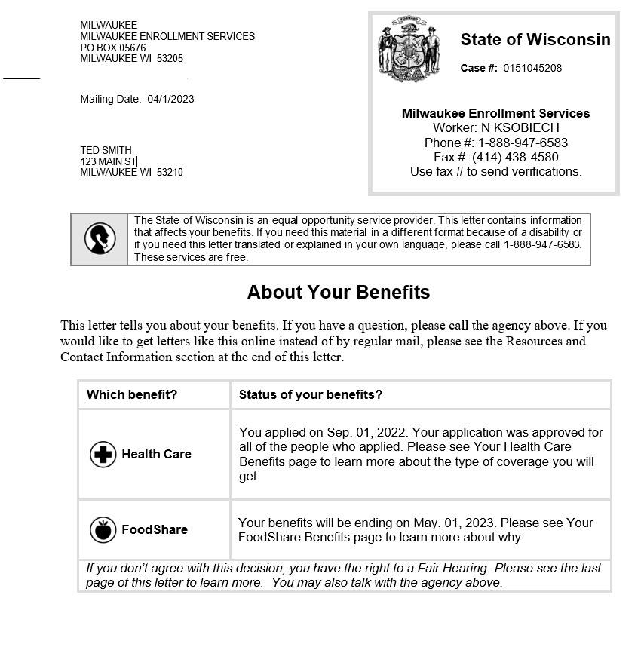**Letter 1 – About Your Benefits (4 pages)**

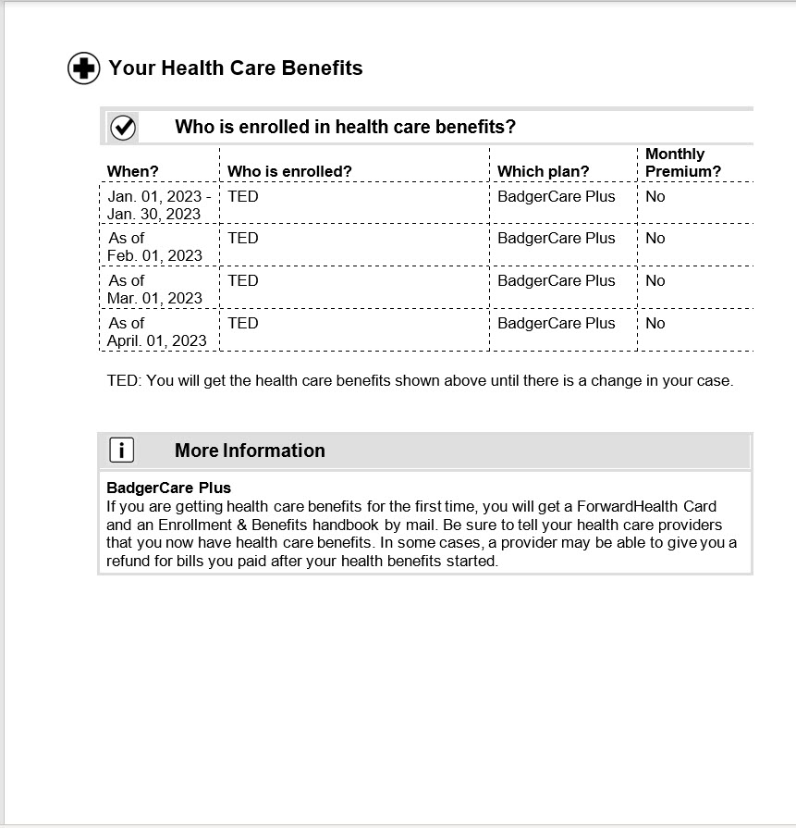

**Letter 2 – Time Limited (3 pages)**

**Letter 3 – Work Requirements Flyer (2 pages)**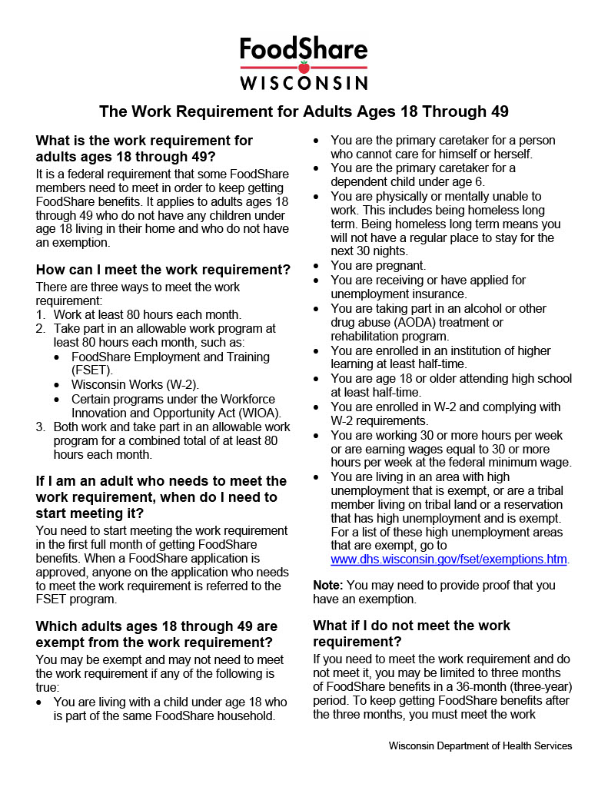

**Letter 4 – FSET Initial Appointment (2 pages)**

**Letter 5 – FSET Appointment Final Notice 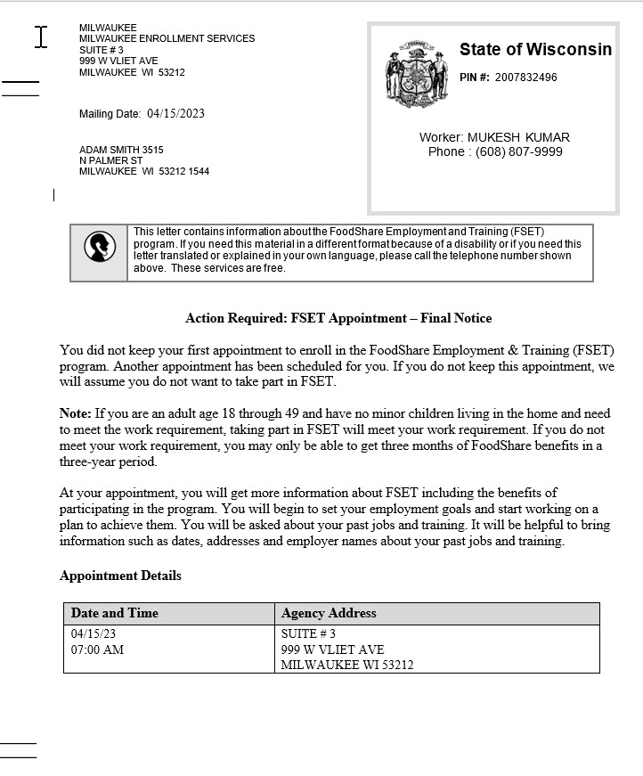(2 pages)**

