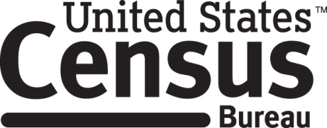

**Consent Form**

**SNAP Messaging Cognitive Interview**

The Census Bureau routinely tests the design and content of letters, surveys, and other communication materials in order to produce materials that are clear and easy for people to understand.

______________________ [NAME] consents to take part in a study to test forms and letters that are used to communicate with and gather information from people who receive food assistance benefits. In order to have a complete record of all comments, the interview session will be audio-recorded. The Census Bureau plans to use the recordings to improve the forms and letters. Staff directly involved in the project will have access to the recordings. Participation is voluntary and answers will remain strictly confidential.

This study is being conducted under the authority of Title 13 USC 8(b) and Title 29 USC 3141. The OMB control number for this study is 0607-0725; it expires 12/31/2022. Without this number, we could not collect your information. Federal law requires the protection of your privacy (Title 5 U.S. Code, Section 552a). Furnishing this information is voluntary; however, failure to do so will limit the Census Bureau’s ability to test the design and content of letters, surveys, and other communication materials in order to produce materials that are clear and easy for people to understand. Personally Identifiable Information collected includes name, telephone/cellular phone number, DOB or age, email address, race, or ethnicity. The information provided to us may be shared with other Census Bureau staff, contractors and those who have a need to know for work-related purposes and as identified in the Privacy Act System of Records Notice COMMERCE/Census-3 Special Censuses, Surveys, and Other Studies. If you have comments or questions about this study, please email adrm.pra@census.gov.

I have agreed to participate in this Census Bureau research study, and I give permission for my recording to be used for the purposes stated above.

____________________________ ___________________________

Participant's Signature Researcher's Signature

____________________________ __________________________

Printed Name Printed Name

___________________________ _______________________

Date Date