**Questions for Testing Race and Ethnicity for the 2023 ABS**

A.7 Number of Owners

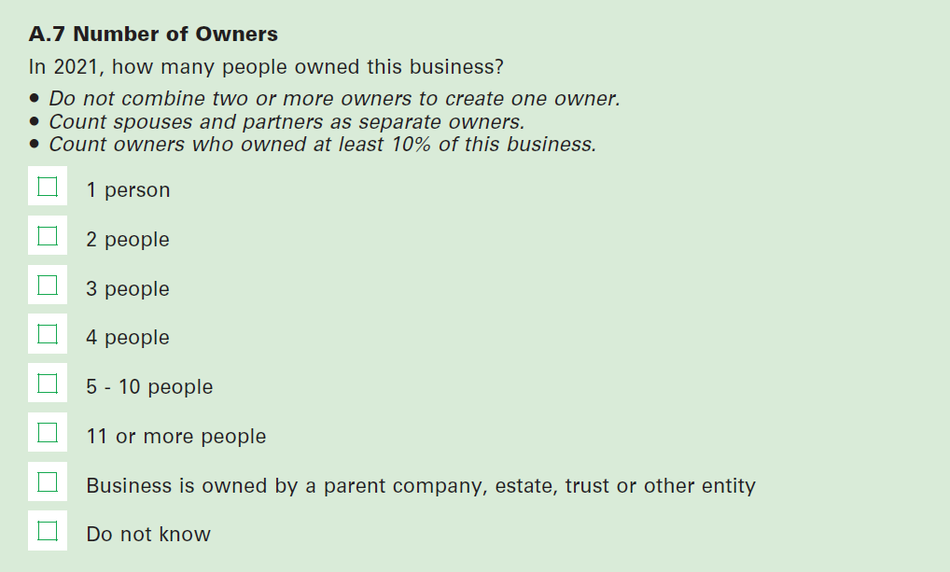

B.1.9 Prior Business Ownership

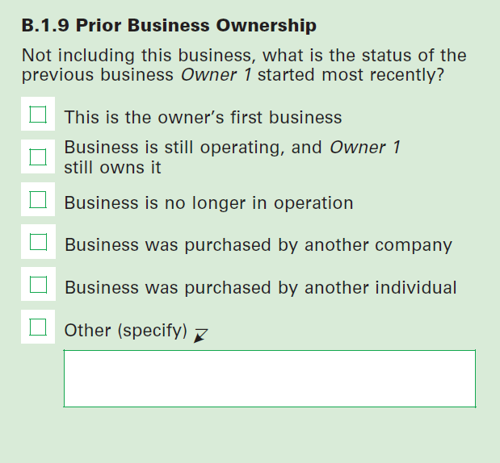

B.1.10 Education Prior to Owning the Business

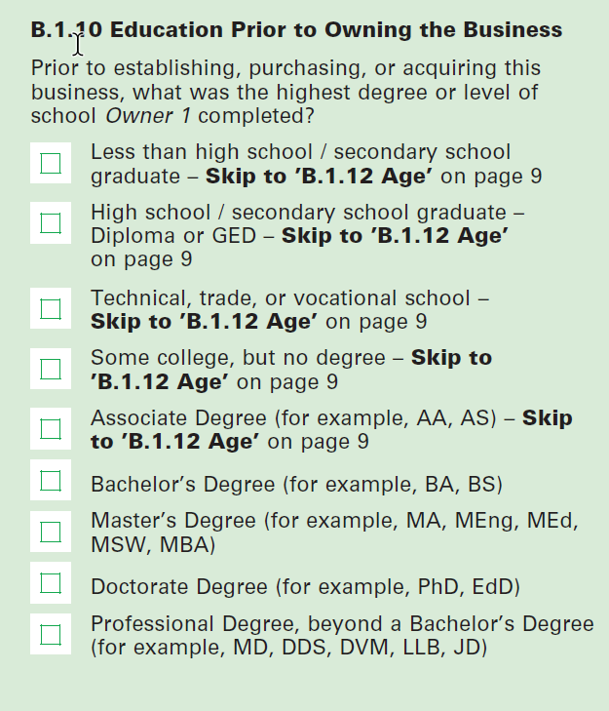

B.1.11 Field of Highest Degree Prior to Owning the Business

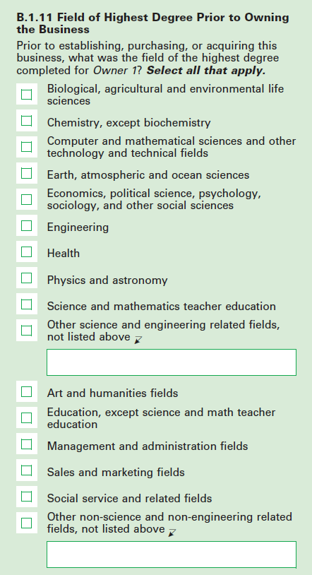

B.1.12 Age

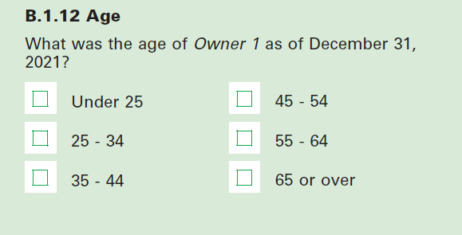

B.1.1 Sex

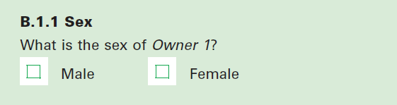

B.1.14 U.S. Citizenship

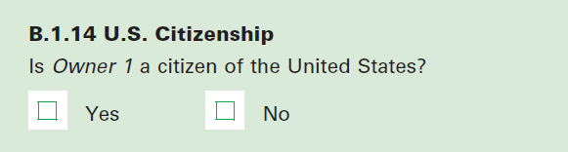

B.1.15 Owner Disability

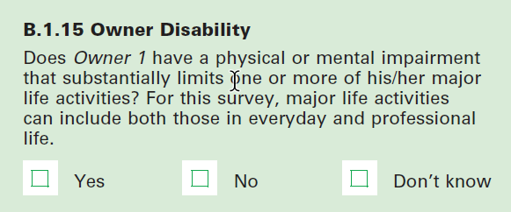

Race and Ethnicity (short version)

**Owner #1: What is Owner X’s race or ethnicity?** (Select [**X**] **ALL** that apply.)

* 1. White
  2. Hispanic or Latino
  3. Black or African American
  4. Asian
  5. American Indian or Alaska Native
  6. Middle Eastern or North African
  7. Native Hawaiian or Pacific Islander

Race and Ethnicity (long version)

