**Attachment A: Race And Ethnicity ITWG Testing Protocol**

**Protocol is to cover these OMB ITWG research topics:**

## 3a: What records do establishments have concerning the race/ethnicity of their [owners, staff, students, prisoners, clients, etc.]?

## 3b: What are the best approaches for collecting information on race/ethnicity from establishments? In other words, what question(s) and/or response options should be used?

**Note: [ ] are instructions for interviewer**

**Instructions to Respondent:**

Good [morning/afternoon],

My name is [INTERVIEWER] and I will be the facilitator for this interview. First, let me remind you that SAMHSA is collaborating with the Census Bureau in an effort to understand the implications of potential changes to the collection of race/ethnicity information in SAMSHA, Census Bureau, and other federal data collections.

* As part of this study, I have already shared with you a copy of the suggested changes via email, and we will go over some questions on how race and ethnicity is collected in your (facility/state).
* There are no right or wrong answers, so please feel free to share any thoughts you have on the different questions you will be asked.
* I estimate this will take us about 20 minutes.
* We plan to use your feedback to improve potentially how race and ethnicity data are collected by SAMSHA, the Census Bureau, and across the Federal Government. The Public Health Service Act (42 U.S.C. § 290aa(p)) authorizes this data collection.  The Census Bureau and SAMSHA are authorized to collaborate in this study under the Census Bureau’s joint project authority in 13 U.S.C. §8(b). Your privacy is protected by the Privacy Act, Title 5, U.S. Code. Your responses will be used to produce statistics. There are a limited number of uses of your data permitted under the Privacy Act.

Before we get started, for note-taking purposes, I would like to record this interview. This will facilitate the conversation without having to take additional time to write notes during the interview. If you agree to be recorded, please let me know. You also have the option to opt-out the recording, but I want to remind you that these recordings will not be shared with anyone who is not involved in this research project and the recordings will be destroyed once the project is over.

Do you agree to be recorded? [If the participant agrees to be recorded, turn on the recording capacity in Teams/Zoom, and ask the question again, so the consent is properly recorded; otherwise, if the participant does not agree to be recorded, then proceed with the interview. In case of the latter, remind the participant that you will follow up on a written consent via email]

OMB has proposed two different versions:

* I will show you one, then the other. These are the same ones that we sent via email ahead of time.
* They differ in length.
* They are geared towards a person answering it from him/herself, but you would be completing it for *all the people in your database*.
* [For respondents from Puerto Rico: These are translated into Spanish.]

**Proposed New Item: Short**

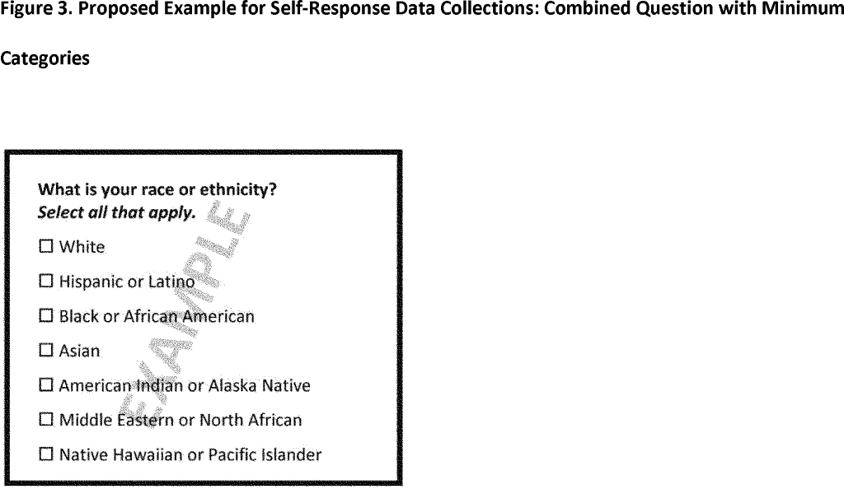

**Proposed New Item: Long**

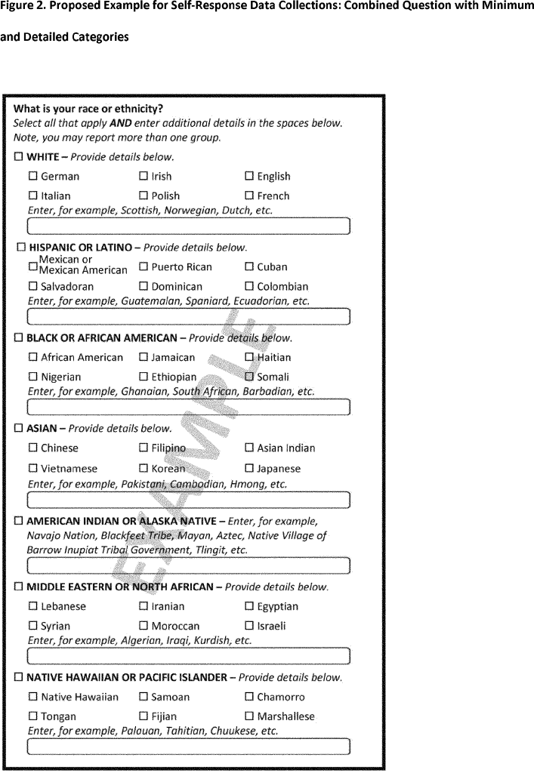

1. General record keeping /Response Analysis:
   1. How is race and ethnicity information of [clients/staff] collected in your organization?
   2. Would you need to look at records to provide this information?
   3. Where is that information stored? Who has access to it?
   4. When is that information collected? Is it ever updated? When? How often? Under what circumstances?
   5. Can you describe the process of summarizing and reporting the race/ethnicity information for the purpose of completing [for facility directors: the N-SUMHSS] [for state representatives: the TEDS/MH-CLD]?

f. For the current race and ethnicity information that you collect, did you ever receive any guidance on the categories to use? (Probe: how did you come up with these categories?)

1. Question text:
   1. Race and ethnicity have been proposed to be combined into one question, from the original two questions. There is discussion about changing the question from ‘race or ethnicity’ to ‘race and/or ethnicity.’ How would adding “and/or” (instead of “or”) change your interpretation of the question?
   2. How would report people with multiple races or ethnicities?
      1. Insert probe about the ‘select all that apply’ instruction.
   3. How is this information collected?
      1. Questionnaire or observation
      2. Self-report vs. proxy
      3. Mode of collection
2. Categories used:
   1. The categories you currently use - Are the categories set by local/state/Tribal standards? [Example, some states want information on specific tribes]
   2. What are the race and/or ethnicity categories that you have available in your records? What are the terms that you use in your system(s)?
      1. Do they match the categories that are offered in this question?
         1. **Please note that “Middle Eastern or North African” was proposed to be added.**
         2. **“Some other race” was proposed to be deleted.**
      2. Which categories match? Which categories do not match?
         1. How would you manage handling categories do not match?
         2. Would you be able to provide any information for the categories that do not match?
   3. Are there any race or ethnicity terms that you aren’t familiar with? Tell me more about those.
3. Aggregation: [This is the for the long version]
   1. Examples
      1. What do you think of the examples listed under the race, such as “German” or “Irish”?
      2. Would you report out a total for each example listed under race?
      3. Does this list seem exhaustive?
   2. Textbox
      1. What would you use the text box for under each race?
      2. How would you report if respondents used the textbox and you had to report it as a total?
   3. Is that information available for every [client, etc.], for most, for some, or for a few?
4. If you were required to use these proposed categories, how long will it take you to implement it on your records?
   1. Using this Chart I’m sharing on the screen now, how accessible would the *new* SHORT race and ethnicity items be?
   2. What about *new* LONG race and ethnicity items?
   3. What about the *current* items?

|  |  |  |
| --- | --- | --- |
| Color | Concept | Description |
| Green | Easily Accessible | The information is easily and readily available for each establishment. |
| Yellow | Accessible with minor effort | The information is available at a central location, but not in each establishment, which requires more effort. |
| Orange | Accessible with major effort | The information is available, but decentralized, which requires considerable effort to acquire. |
| Red | Inaccessible | The information is not available. |

1. Thanks, close out