2024 ABS - Draft Sexual Orientation and Gender Identity Questions in the Owner Characteristics Section

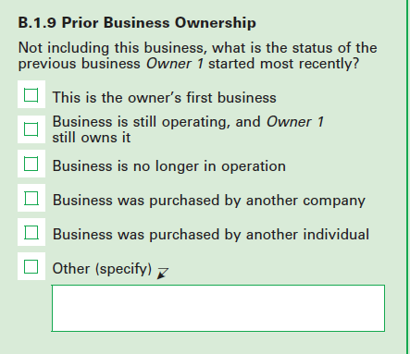

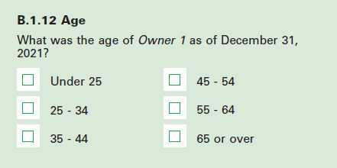

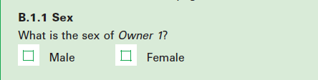

**OWNER GENDER IDENTITY**

What is Owner X’s gender? *Select all that apply.*

* Woman
* Man
* Transgender
* Nonbinary
* They use a different term: (specify) _____________________________________________________
* Don’t Know

**OWNER SEXUAL ORIENTATION**

Which of the following does Owner X consider themselves to be? *Select all that apply.*

* Straight or heterosexual
* Gay
* Lesbian
* Bisexual
* They use a different term: (specify) ____________________________________________________
* Don’t Know

