**2030 Census: Administrative Data Focus Group Protocol and Recruitment Email Templates**

**Steps to set up a Teams Meeting (to allow for observation by Census during the focus group):**

1. Create a “new meeting” on Teams (in Census VDI). Add a subject. Add your RTI email address, the moderator’s RTI email address, the notetaker’s RTI email address, the moderator’s Census email address, and the notetaker’s Census email address. Click SEND.
2. Update the setting for “Who can bypass the lobby” to “Only me and co-organizers.”

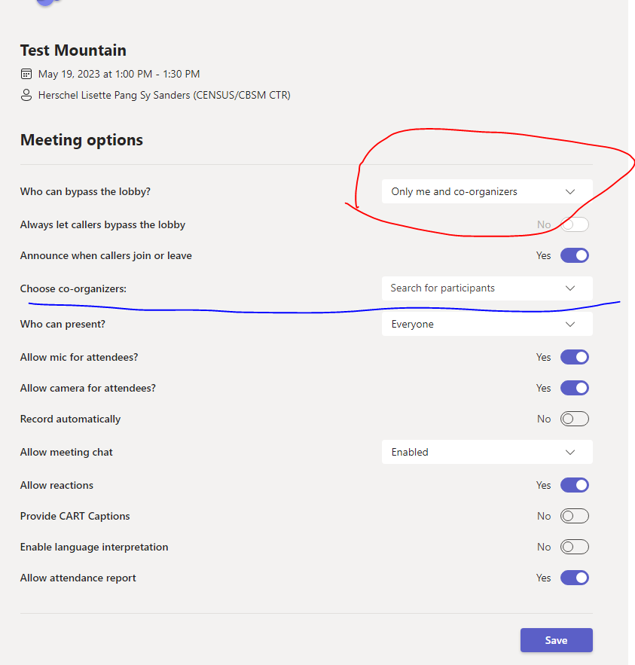

1. Open the invite from your calendar, click edit, go to Meeting Options, and add the moderator as a “co-organizer”, using their Census email address as they will join the meeting via the Census VDI. Click Save.

**CONTACTS TO PARTICIPANTS:**

* First contact/initial invite
* Confirmation email
* Week before email reminder
* Day before email reminder
* Day of text

**FIRST CONTACT/INVITE**

Subject: Availability for Census Bureau Focus Group on <DATE> and Receive $90 for Your Participation

Hello,

Thank you for your interest in participating in an upcoming focus group for the U.S. Census Bureau. **You are eligible to participate in the in-person focus group, which will take about 90 minutes. You will receive $90 for participating.** The focus group discussion will be conducted by RTI International, a nonprofit research organization, on behalf of the U.S. Census Bureau. The purpose of this discussion will be to hear your opinions and perspectives on topics related to the collection of information in the 2030 decennial census.

This in-person focus group will be held at <LOCATION> on <DATE> from <START TIME> to <END TIME>.

**At your earliest convenience, please reply to this email and let me know if you are available to participate in this focus group at this date, time, and location.** If you are available and if we still have space in the focus group, I will reach back out to confirm your participation and will provide additional information.

Please let me know if you have any questions or concerns about participating. You may also reach me by phone at 919-541-6040.

Sincerely,

[RECRUITER NAME]

**CONFIRMATION EMAIL**

Subject: Confirmed for In-Person Focus Group on <DATE>, Receive $90 for Your Participation

Hello,

Thank you for agreeing to participate in an upcoming, in-person focus group for the U.S. Census Bureau. Your focus group is scheduled for <DATE> from <START TIME> to <END TIME> at <LOCATION>. **At your earliest convenience, please reply to this email and let me know if you are still available to participate in this focus group at this date, time, and location.**

As previously communicated, this focus group discussion will be conducted by RTI International, a nonprofit research organization, on behalf of the U.S. Census Bureau. The purpose of this discussion will be to hear your opinions and perspectives on topics related to the collection of information in the 2030 decennial census. You will receive $90 for your participation.

|  |
| --- |
| Your focus group will be held at:  <LOCATION>  **Please arrive 15 minutes before the start time**.  If you are running late, please text Tim Flanigan of RTI International at 919-306-1638, and we will come meet you in the lobby. |

Please find attached a copy of the consent form. This document covers your rights as a participant and what to expect during the group discussion. Please review this document before the focus group. The moderator will go over this form prior to the discussion and you will be asked to sign this consent form at the start of the focus group.

If you have any additional questions, or need to reach me before the group discussion, please reply to this email or call 919-541-6040.

Thank you for your participation!

Sincerely,

[RECRUITER NAME]

**REMINDER EMAIL – SENT 1 WEEK BEFORE FOCUS GROUP**

Subject: Reminder for In-Person Focus Group on <DATE>, Receive $90 for Your Participation

Dear [**PARTICIPANT’S NAME**]:

This is a reminder that you are scheduled to participate in an in-person focus group on <DATE> from <START TIME> to <END TIME> at <LOCATION>. **If you are no longer available to participate on this day and time or at this location, please reply to this email and let us know as soon as possible**.

As previously communicated, this focus group discussion will be conducted by RTI International, a nonprofit research organization, on behalf of the U.S. Census Bureau. The purpose of this discussion will be to hear your opinions and perspectives on topics related to the collection of information in the 2030 decennial census. You will receive $90 for your participation.

|  |
| --- |
| Your focus group will be held at:  <LOCATION>  **Please arrive 15 minutes before the start time**.  If you are running late, please text Tim Flanigan of RTI International at 919-306-1638, and we will come meet you in the lobby. |

Please find attached a copy of the consent form. This document covers your rights as a participant and what to expect during the group discussion. Please review this document before the focus group. The moderator will go over this form prior to the discussion and you will be asked to sign this consent form at the start of the focus group.

If you have any additional questions, or need to reach me before the group discussion, please reply to this email or call 919-541-6040.

Sincerely,

[RECRUITER NAME]

**REMINDER EMAIL – SENT 1 DAY BEFORE FOCUS GROUP**

Subject: Reminder for In-Person Focus Group Tomorrow, 6/25, Receive $90 for Your Participation

Hello,

This is a reminder that you are scheduled to participate in an in-person focus group tomorrow, <DATE> from <START TIME> to <END TIME> at <LOCATION>. **If you are no longer available to participate on this day and time or at this location, please reply to this email and let us know as soon as possible**.

|  |
| --- |
| Your focus group will be held at:  <LOCATION>  **Please arrive 15 minutes before the start time**.  If you are running late, please text Tim Flanigan of RTI International at 919-306-1638, and we will come meet you in the lobby. |

Please find attached a copy of the consent form. This document covers your rights as a participant and what to expect during the group discussion. Please review this document before the focus group. The moderator will go over this form prior to the discussion and you will be asked to sign this consent form at the start of the focus group.

If you have any additional questions, or need to reach me before the group discussion, please reply to this email or call 919-541-6040.

Sincerely,

[RECRUITER NAME]