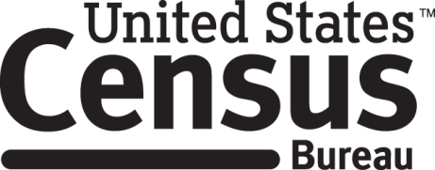

**Consent Form**

**2030 Census: Administrative Data – [Focus Group/Interview]**

The Census Bureau routinely conducts research and collects information from people across the United States.

____________ consents to take part in [a focus group/an interview] regarding your opinions on topics related to the collection of information in the 2030 decennial census. In order to have a complete record of all comments, the [focus group discussion/interview] will be audio-recorded. The Census Bureau plans to use the recordings to assist in the analysis of the information gathered during the [group discussions/interviews]. Staff directly involved in the project will have access to the recordings. Participation is voluntary and answers will remain strictly confidential. You may withdraw from the discussion at any time. Your participation and any comments you make will be kept confidential. Comments from all participants will be combined in a summary report that will not identify any individual. The [focus group discussion is expected to take about 90 minutes/ interview is expected to take 60 minutes]. You will receive [$90/$40] as a token of appreciation for your participation.

This voluntary study is being conducted under the authority of Title 13 USC Sections 6 and 182. The OMB control number for this study is 0607-0725; it expires 12/31/2025. Without this number, we could not collect your information. Federal law requires that your answers are kept confidential (Title 13, U.S. Code, Section 9), and protects your privacy under the Privacy Act (Title 5 U.S. Code, Section 552a). Furnishing this information is voluntary; however, failure to do so will limit the Census Bureau’s ability to gather information used in the development of survey instruments, and other communication materials in order to produce materials that are clear and easy for people to understand. Personally Identifiable Information collected includes name, telephone/cellular phone number, DOB or age, email address, race, or ethnicity. The information provided to us may be shared with other Census Bureau staff, contractors and those who have a need to know for work-related purposes and as identified in the Privacy Act System of Records Notice “COMMERCE/CENSUS-5, Decennial Census Programs.” If you have comments or questions about this study, please email adrm.pra@census.gov.

I have agreed to participate in this Census Bureau research study, and I give permission for my recording to be used for the purposes stated above.

____________________________ ___________________________ ____

[IF FG:] Participant's Signature Researcher's Signature P ID

____________________________ __________________________

[IF FG:]Participant’s Printed Name Researcher’s Printed Name

________________ _________________

[IF FG:]Date Date