# Satisfaction questions: asked after user completes the survey

*Please Note: The questionnaire will be electronic with word labels on either end of 7 radio buttons. See image below for an idea of what the final format will look like.*

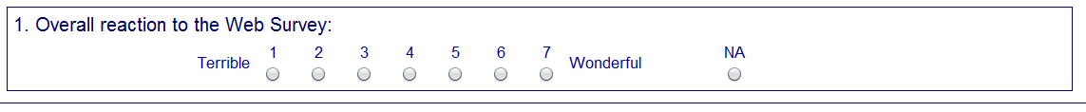

|  |
| --- |
| 1. Overall experience with the survey   Unpleasant to Pleasant |
| 1. The survey screens are visually pleasing   Never to Always |
| 1. The survey screens look professional   Never to Always |
| 1. Characters (words/text) on the screen   Barely legible to Very legible |
| 1. The survey questions follow a logical sequence   Never to Always |
| 1. Words used in the survey questions and answers   Hard to understand to Easy to understand |
| 1. Coming up with answers to the questions   Never bothered me to Always bothered me |
| 1. Instructions for correcting errors   Confusing to Clear |
| 1. Entering your answers into the survey   Difficult to Easy |
| 1. You knew what to do if you needed help answering the question   Never to Always |
| 11. Additional Comments__________________________________________________________________ |