Screenshots from the AIES Interactive Question Preview Tool

<https://www.census.gov/aies/questionspreview/>

**Item 1: Landing page for the AIES Question Preview Tool**

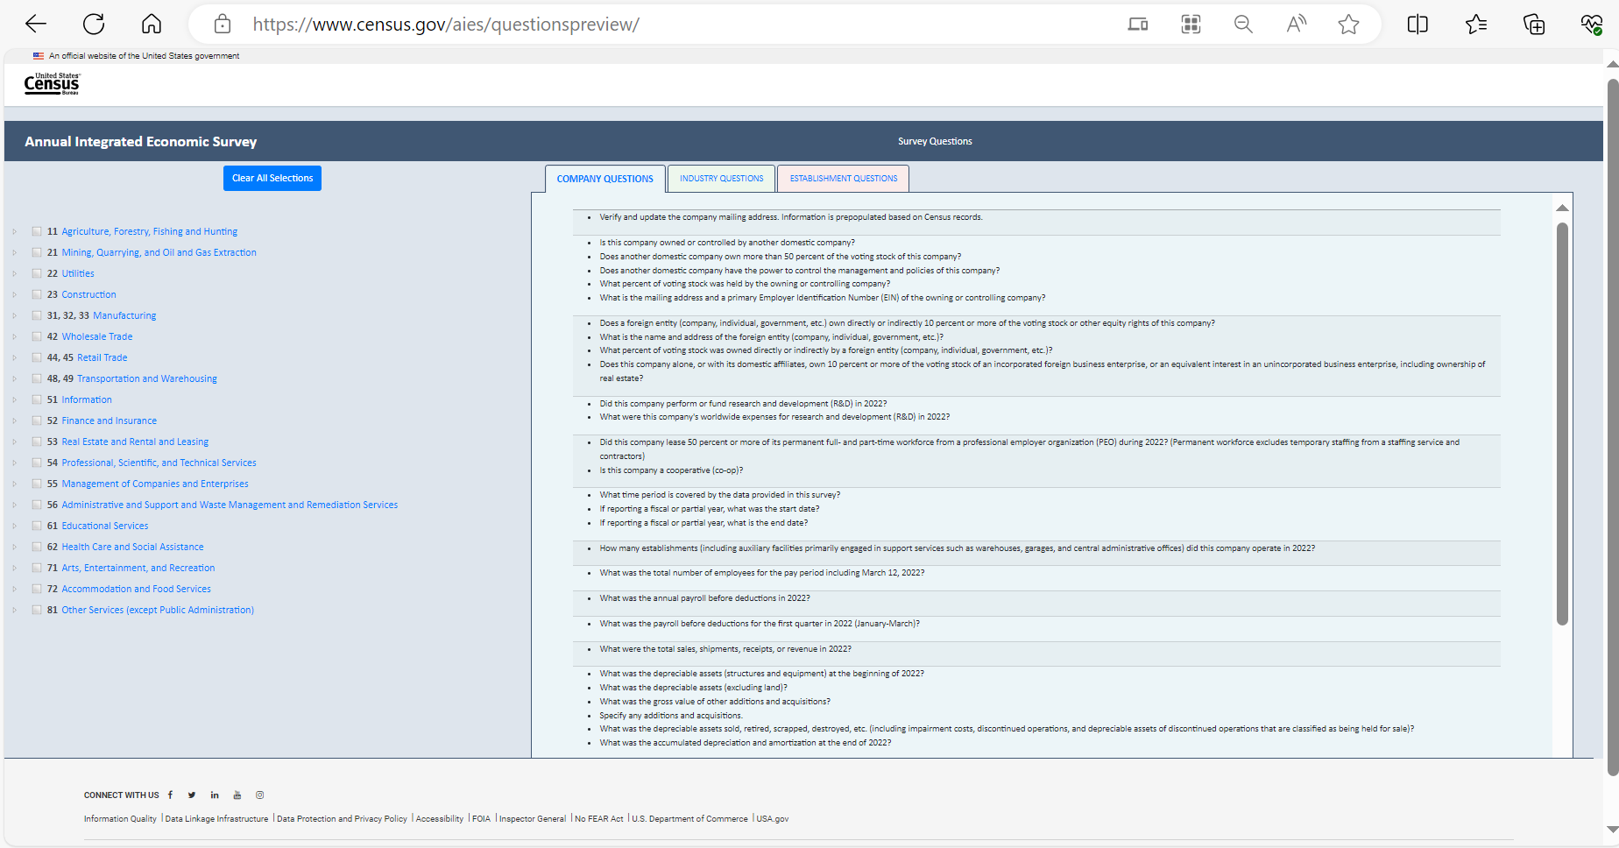

**Item 2:**



**Item 3: Company Questions tab (no selections entered)**



**Item 4: Industry Questions tab (no selections entered)**

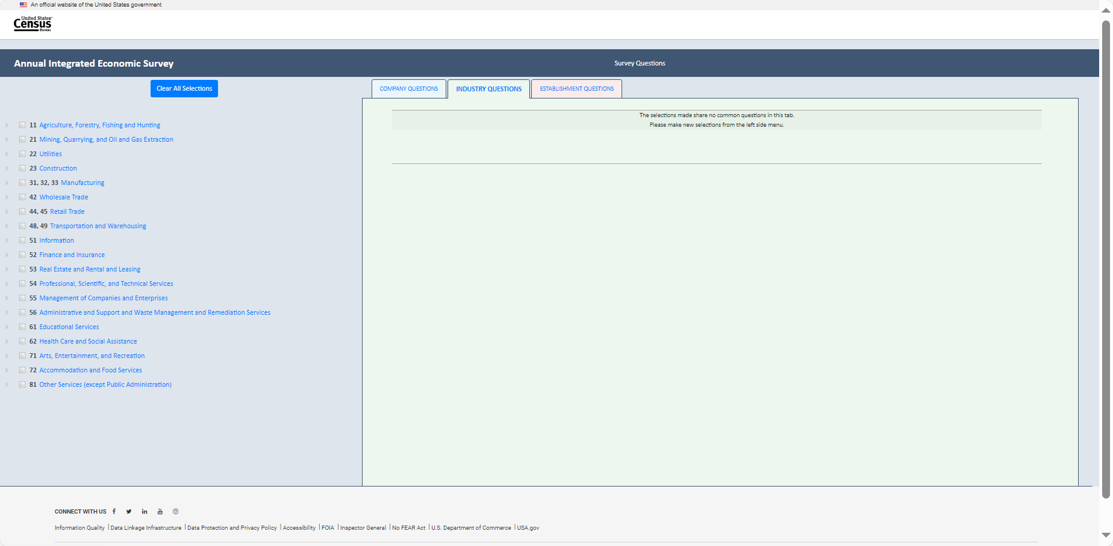

**Item 5: Establishment Questions tab (no selections entered)**

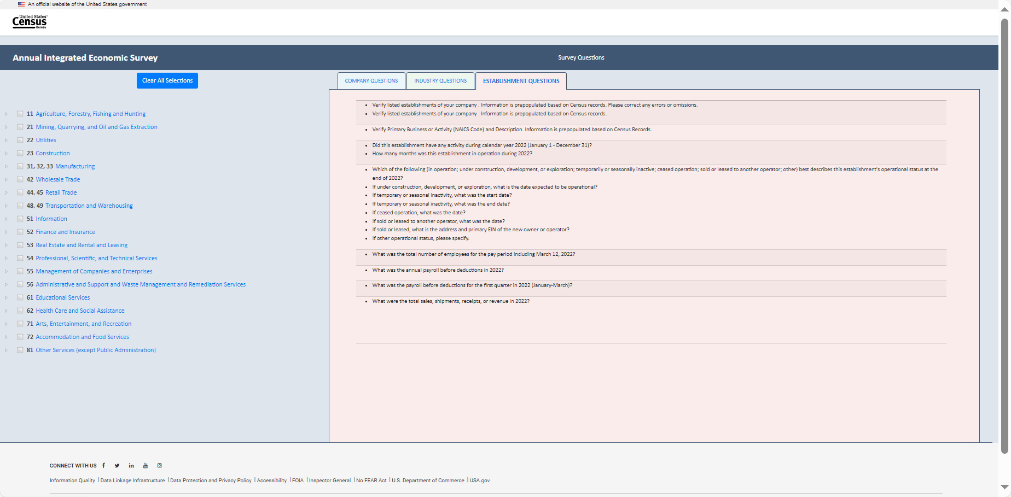

**Item 6: Example of the Census Cat Company** (Note: During the usability testing sessions, respondents will be making selections based on their respective businesses. The Census Cat Company example is for illustrative purposes only.)

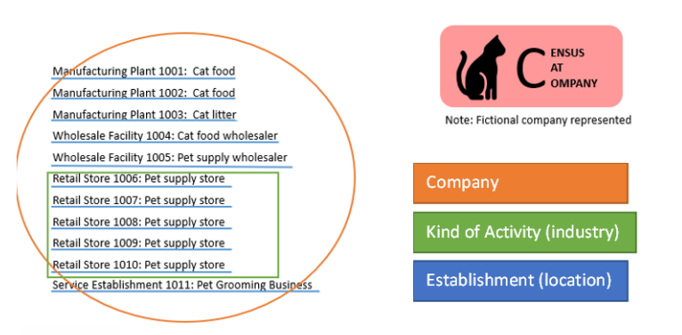 **Item 7: Answer key for Example of Census Cat Company**

|  |  |
| --- | --- |
| NAICS | Industry |
| 311111 | Dog and Cat Food Manufacturing |
| 311111 | Dog and Cat Food Manufacturing |
| 325998 | All Other Miscellaneous Chemical Product and Preparation Manufacturing |
| 424490 | Other Grocery and Related Products Merchant Wholesalers |
| 424990 | Other Miscellaneous Nondurable Goods Merchant Wholesalers |
| 453910 | Pet and Pet Supplies Stores |
| 453910 | Pet and Pet Supplies Stores |
| 453910 | Pet and Pet Supplies Stores |
| 453910 | Pet and Pet Supplies Stores |
| 453910 | Pet and Pet Supplies Stores |
| 812910 | Pet Care (except Veterinary) Services |
| 812910 | Pet Care (except Veterinary) Services |

**Making Selections for the Census Cat Company** (Note: During the usability testing sessions, respondents will be making selections based on their respective businesses. The Census Cat Company example is for illustrative purposes only.)

**Item 8.1: Making Selections for the Census Cat Company’s Cat Food Manufacturing (NAICS 311111)**

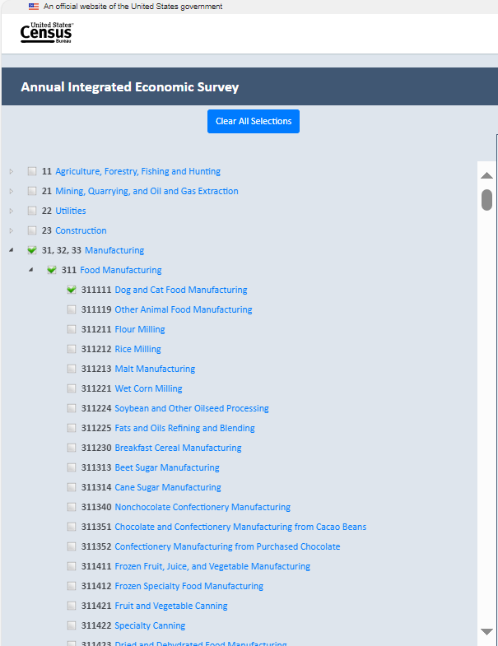

**Item 8.2: Making Selections for the Census Cat Company’s Cat Litter Manufacturing (NAICS 325998)**

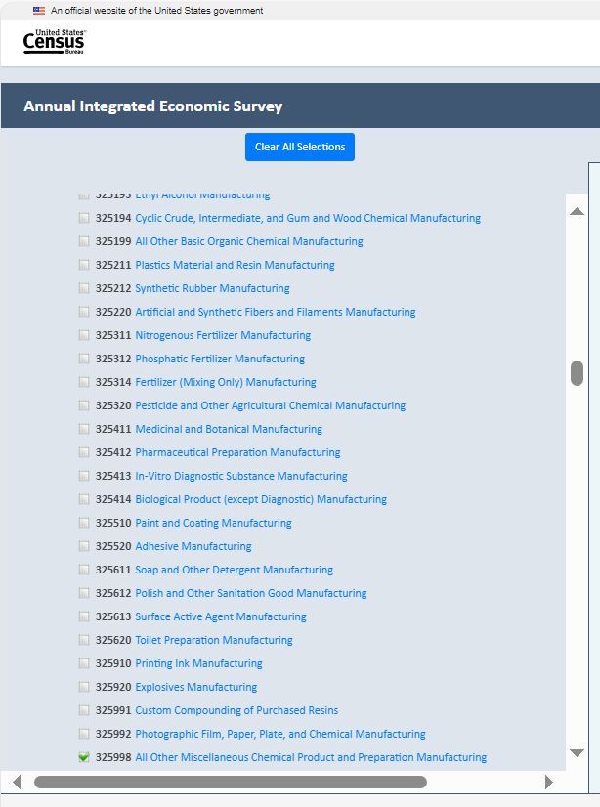

**Item 8.3.1: Making Selections for the Census Cat Company’s Cat Food and Pet Supply Wholesaler (NAICS 424990)**

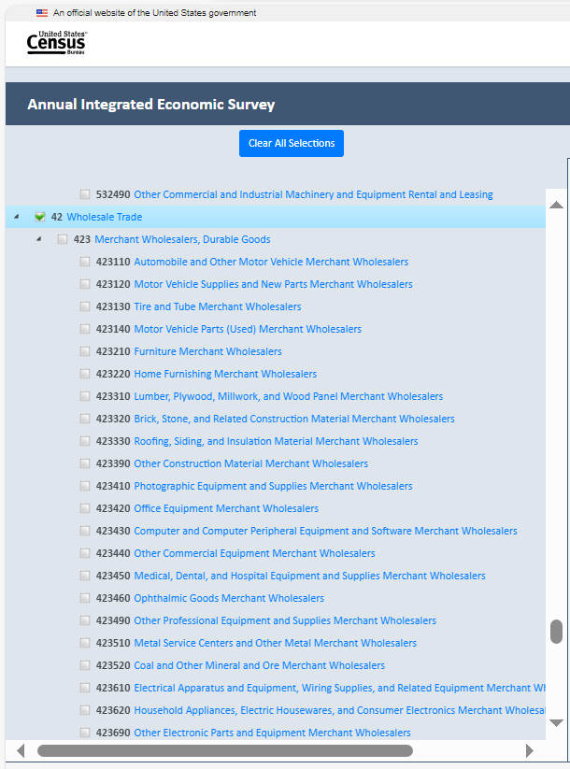

**Item 8.3.2: Making Selections for the Census Cat Company’s Cat Food and Pet Supply Wholesaler (NAICS 424990)**

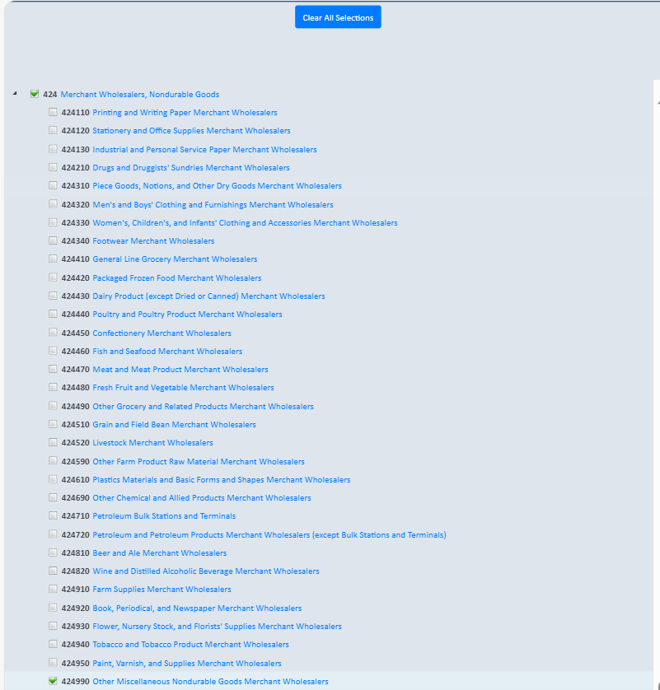

**Item 8.4: Making Selections for the Census Cat Company’s Pet Supply Stores (NAICS 453910)**

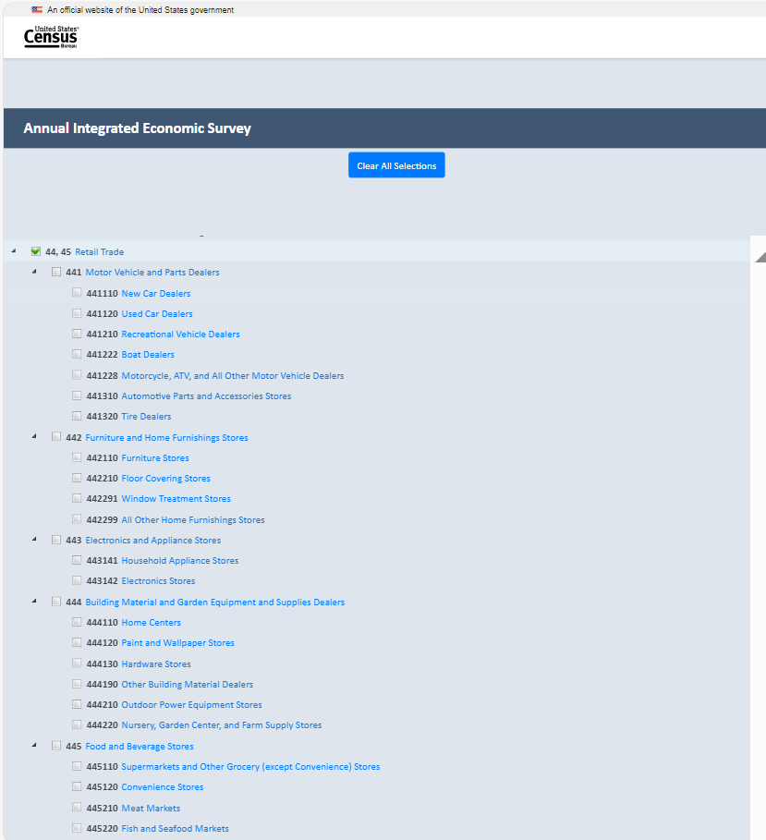

**Item 8.4.1: Making Selections for the Census Cat Company’s Pet Supply Stores (NAICS 453910)**

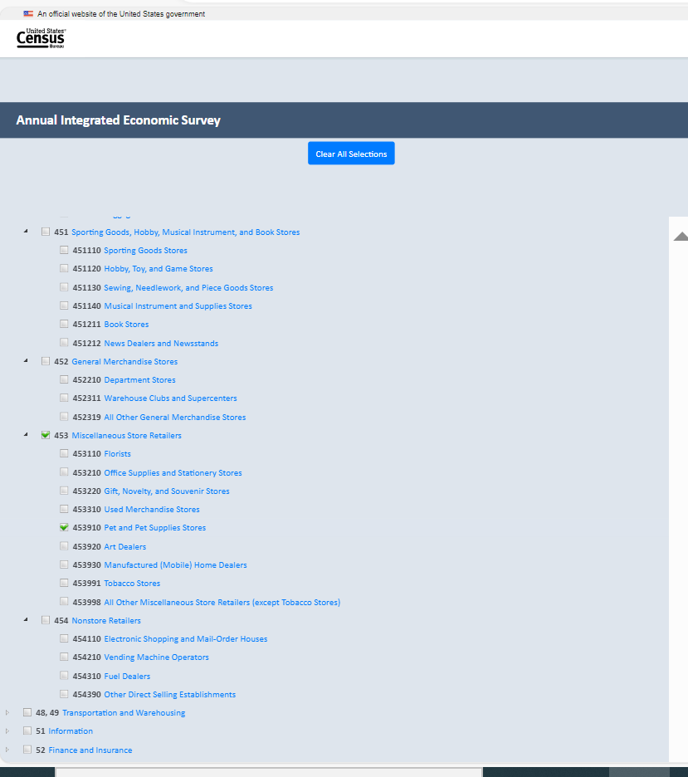

**Item 8.5: Making Selections for the Census Cat Company’s Pet Grooming Business (NAICS 812910)**

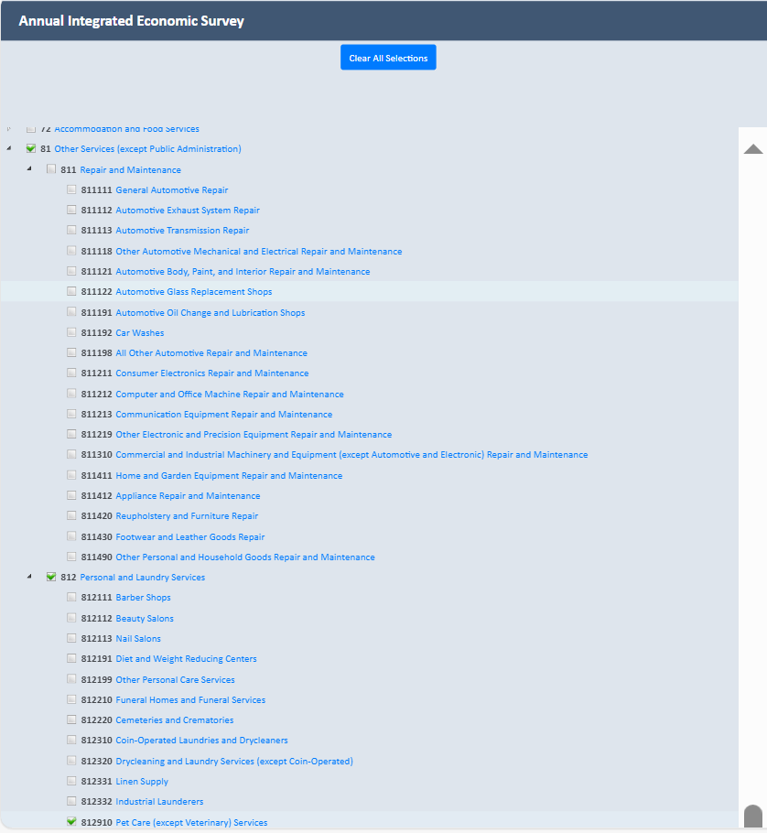

**Item 9: View of Company tab after all selections have been made for the Census Cat Company**

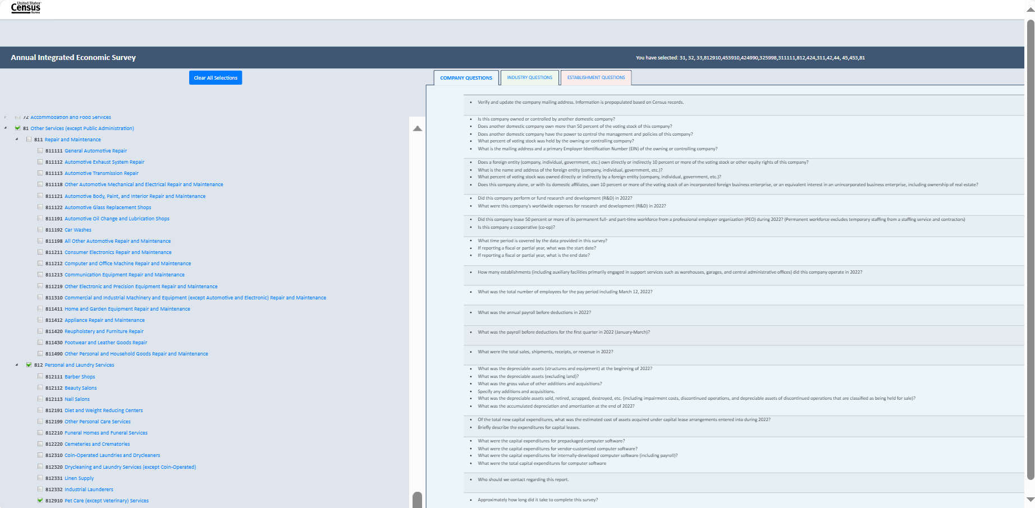

**Item 10: View of Industry tab after all selections have been made for the Census Cat Company**

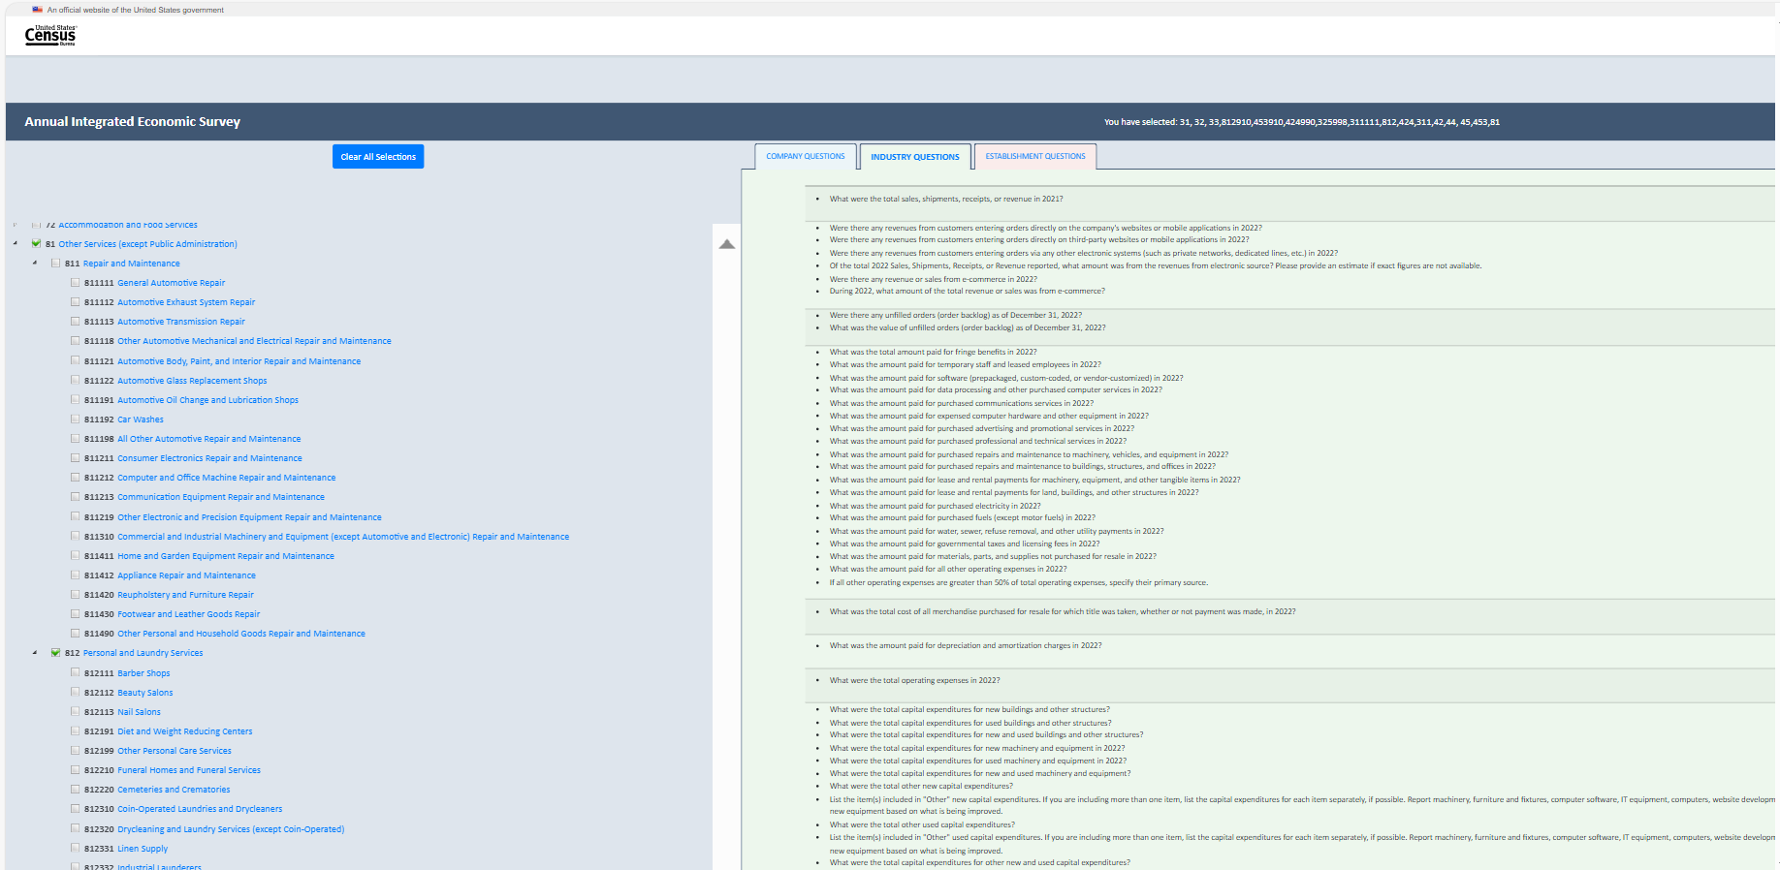

**Item 11: View of Establishment tab after all selections have been made for the Census Cat Company**

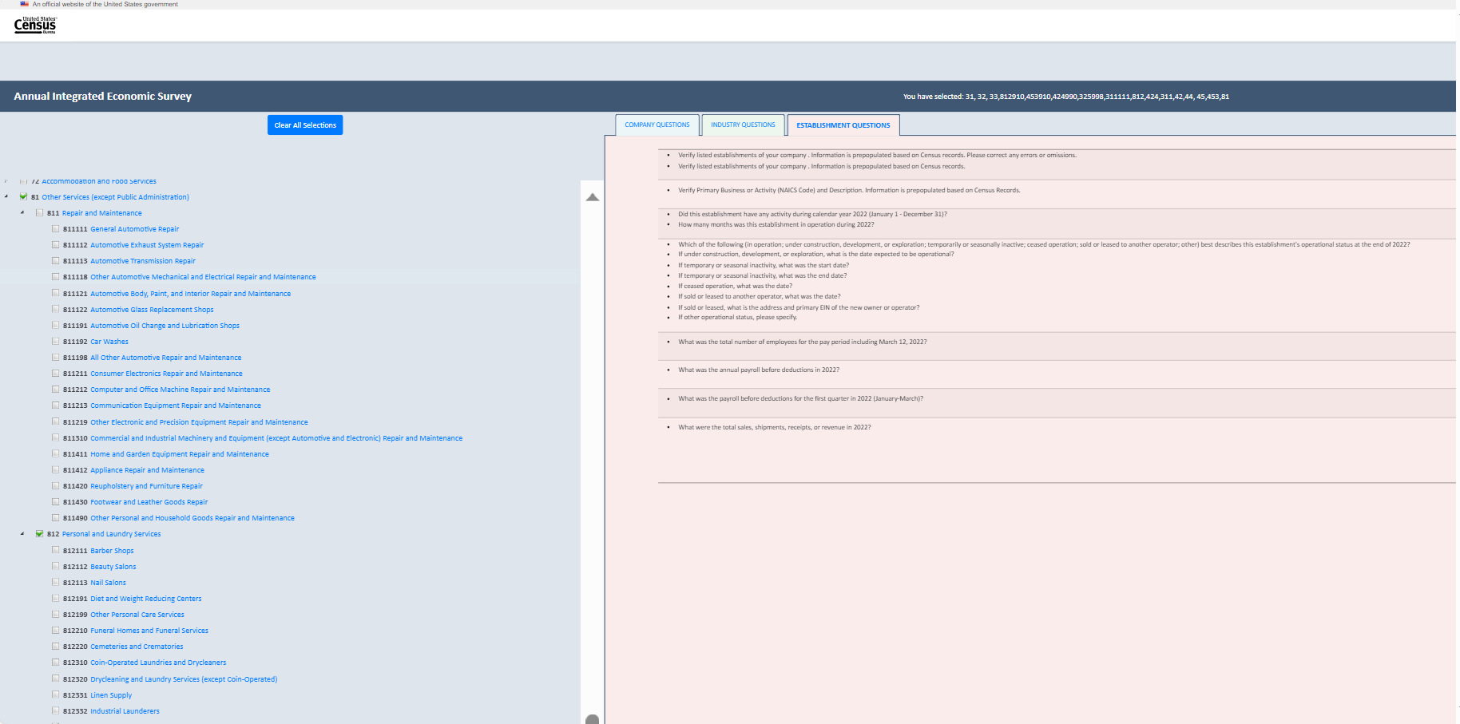

**Item 12: Export Feature** (Note: There is no screenshot as this feature is currently in development)

**Item 12: Exported Question Preview File for the Census Cat Company** (Note: There is no screenshot as this feature is currently in development)