*Attachment I: Communication Materials, Screener, and Consent Forms*

*National Health Interview Survey for Teens*

*(NHIS-TEEN)*

*Cognitive Interviews*

*OMB# 0607-0725*

November 2023

# NHIS-Teen Cognitive Interview Recruitment Advertisements

**Recruitment advertisement text for teens.**

Teens Needed for Testing a National Health Survey

The Census Bureau is looking for teens ages 12-17 to help test question wording on a national survey about health-related topics. Interviews will be one hour and will take place by computer and phone, through Microsoft Teams. Teens under age 18 must have a parent’s permission to participate. **We will provide $50 to each teen who participates in the study.**

We need teens ages 12-17 who meet **any** of the following criteria:

* Teens who participate in recreational physical activity or organized sports
* Teens with learning disabilities
* Teens who live in rural, suburban, or urban areas

**To see if your child is eligible for the study, please complete a short questionnaire at**

[**www.XXXXXXXX.com**](http://www.xxxxxxxx.com/)**, or contact Kevin at (301) 763-4979 or** [**csm.participate@census.gov**](mailto:csm.participate@census.gov) **for further information. Please mention the code TEEN when you call or email.**

# NHIS-Teen Cognitive Interview Recruitment Protocol and Eligibility Screener

RECRUITER-ADMINISTERED SCREENING QUESTIONNAIRE FOR NHIS TEEN

[Note to interviewer: If a teen under 18 calls to answer the screener questions for themselves, tell them that we have to briefly talk with their parents to get permission to screen them. If the parent is a monolingual Spanish speaker, let them know that we have staff who can call and ask for permission in Spanish.]

Introduction: **Hello, I'm _____________________ from the Census Bureau.**

**IF OUTBOUND CALL**: **I’m calling about [an email you sent/a voicemail you left] about testing a survey for teens ages 12-17. Any teen who participates will receive $50 to thank them for their time.**

**IF INBOUND CALL: Thanks for calling us about the test of a survey for teens.**

**I just need to get a little bit of background information to find out if your child is eligible to participate.**

**1.** **What is your name?** ___________________________________________

**2.** (ASK IF YOU DON’T HAVE THIS INFORMATION) **What is your daytime phone number?** (___)_____-________

**3.** **How many children between the ages of 12 and 17 live in your household?** _______

**IF NO CHILDREN 12-18** ***I'm sorry. Right now we are only testing the survey with teens ages 12-17. Thank you for your time.***

**IF MORE THAN ONE CHILD:** ***Let’s start with the oldest child first****.*

|  |  |  |  |  |
| --- | --- | --- | --- | --- |
|  | Child 1 | Child 2 | Child 3 | Child 4 |
| **4. How old is that child?** (Verify child is 12 -17) |  |  |  |  |
| **5. What is that child’s name?** |  |  |  |  |
| **6. Is _____ male or female?** |  |  |  |  |
| **7. What grade is _____ in?** |  |  |  |  |
| **8. Is _____ of Hispanic, Latino, or Spanish origin?** |  |  |  |  |
| **9. Please choose one or more races that _____considers him/herself to be.**  White  Black or African American  Asian  American Indian or Alaska Native  Native Hawaiian or other Pacific Islander |  |  |  |  |
| **10. Does _____ speak English fluently?** |  |  |  |  |
| **11. What city and state does _____ live in?** |  |  |  |  |
| **12a. Does ___ participate in recreational physical activity or organized sports?** |  |  |  |  |
| **12b. [If yes] Which physical activities or sport(s) do they do?** |  |  |  |  |
| **13a. Has ___ been diagnosed with a learning disability?** |  |  |  |  |
| **13b. [If yes] The interview will involve reading and responding to survey questions. Is ____ able to attempt to respond to the survey without assistance?** |  |  |  |  |
| **14. Do you think ____ would be interested in participating in the study if they are selected?** |  |  |  |  |

**IF MORE THAN ONE CHILD:** ***Now let’s talk about the [second/third/fourth] oldest child.***

**15. Do you have access to a laptop or desktop computer that the child could use for the interview if they are selected?**

**16. Do you have high speed internet access?**

**17. If necessary, would you be able to download a free software called Microsoft Teams to facilitate testing that you could remove immediately after the session?**

**18. What is the email address we should use to contact you, should your child qualify for a study? (write in) ____________**

**19. Which of the following best describes the place where you now live…a large city, a suburb near a large city, a small city or town, or a rural area?**

* **A large city**
* **A suburb near a large city**
* **A small city or town**
* **A rural area**

**20. In order to make sure that we recruit teens from a variety of backgrounds, my last question is about your household’s annual income. Is your household's annual income....**

**a. above $15,000?**

1 [ ] Yes 2 [ ] No - *skip to conclusion*

**b. above $25,000?**

1 [ ] Yes 2 [ ] No - *skip to conclusion*

**Is it above $50,000?**

1 [ ] Yes 2 [ ] No - *skip to conclusion*

**c. Is it above $100,000?**

1 [ ] Yes 2 [ ] No

Conclusion:

**IF THEY HAVE AN EMAIL ADDRESS:**

**Thanks for taking some time to answer my questions today. Whether or not you are selected I am going to email you some more information about how we protect the privacy of your data and your rights. [SKIP TO WRAP UP TEXT FOR ALL BELOW]**

**IF THEY DO NOT HAVE AN EMAIL ADDRESS:**

**Thanks for taking some time to answer my questions today. If you qualify, someone will be back in touch with you soon to schedule an interview.**

**The U.S. Census Bureau is required by law to protect your information. We are conducting this voluntary survey​ on behalf of the National Center for Health Statistics under the authority of 13 U.S.C. Section(s) 8(b). The purpose of collecting this information is to improve and inform future surveys.**

**Strict federal law protects your privacy and keeps your answers confidential under Section 308(d) of the Public Health Service Act (42 U.S.C. 242m(d)), the Privacy Act of 1974 (5 U.S.C. § 552a) and the Confidential Information Protection and Statistical Efficiency Act (CIPSEA, Title 5 of Public Law 107-347). Under the Federal Cybersecurity Enhancement Act of 2015, your data are protected from cybersecurity risks through screening of the systems that transmit your data, but not the responses you provided. The Census Bureau can only protect information once it is in the Census Bureau system and therefore cannot promise protection related to information shared when using a personal device.**

**WRAP-UP TEXT FOR ALL:**

**Over the next few weeks, we will be selecting the teens to test the survey. If your child is selected, we will be calling you to set up a time for the interview. Do you have any questions for me?**  **IF NO QUESTIONS: Thank you for your time!**

**[END SCREENING PHONE CALL]**

SELF ADMINISTERED SCREENING QUESTIONNAIRE FOR NHIS TEEN

Available at [**www.XXXXXXXX.com**](http://www.XXXXXXXX.com)

The U.S. Census Bureau is conducting research to improve questions in a national survey about health-related topics. The purpose of this research is to get feedback on how easy or difficult the survey questions are to answer. Selected participants will be asked for their thoughts and opinions about some survey questions. If your child is eligible, we will invite them to a 60-minute interview which will be conducted via a secure video conferencing app. Your child will receive $50 for participating in the interview.

To determine if they are eligible for the interview, we must ask you a few screening questions about their background. Your participation in the eligibility screening is completely voluntary. You may stop at any time or skip questions that you do not want to answer.

The U.S. Census Bureau is required by law to protect your information. We are conducting this voluntary survey​ on behalf of the National Center for Health Statistics under the authority of 13 U.S.C. Section(s) 8(b). The purpose of collecting this information is to improve and inform future surveys.

Strict federal law protects your privacy and keeps your answers confidential under Section 308(d) of the Public Health Service Act (42 U.S.C. 242m(d)), the Privacy Act of 1974 (5 U.S.C. § 552a) and the Confidential Information Protection and Statistical Efficiency Act (CIPSEA, Title 5 of Public Law 107-347). Under the Federal Cybersecurity Enhancement Act of 2015, your data are protected from cybersecurity risks through screening of the systems that transmit your data, but not the responses you provided. The Census Bureau can only protect information once it is in the Census Bureau system and therefore cannot promise protection related to information shared when using a personal device.

We estimated that completing the screening questions will take 10 minutes on average. This information collection has been approved by the Office of Management and Budget (OMB). You can validate that this survey is a legitimate federally-approved information collection using the Office of Management and Budget's approval number 0607-0725, which expires December 31, 2025. We are required to tell you this number to conduct this survey. Send comments regarding this estimate or any other aspect of this survey, including suggestions for reducing the time it takes to complete this survey to adrm.pra@census.gov.

If you have questions, please contact Betsarí Otero Class, U.S. Census Bureau, Center for Behavioral Science Methods, 301-763-2235. If you would like the contact NCHS directly, please call the office of the Ethics Review Board at the National Center for Health Statistics, toll-free at 1-800-223-8118.  Please leave a brief message with your name and phone number.  Say that you are calling about Project ID #2019-09. Your call will be returned as soon as possible.

If you are eligible for the study, we will call or email you to schedule a time for the interview.

**1.** **What is your name?** ___________________________________________

**2.** **What is your daytime phone number?** (___)_____-________

**3.** **How many children between the ages of 12 and 17 live in your household?** _______

**IF NO CHILDREN 12-17, SKIP OUT OF QUESTIONNAIRE:** **Thank you for taking the time to answer our questions today. We will get back to you soon if you are eligible for an interview.**

**IF MORE THAN ONE CHILD:** ***Please start with the oldest child first****.*

|  |
| --- |
|  |
| **4. How old is that child?** (Only allow responses between 12 -17): ____ |
| **5. What is that child’s name? ___________** |
| **6. Is _____ male or female?** Male / Female |
| **7. What grade is _____ in?** 5th/6th/7th/8th/9th/10th/11th/12th/Other  **Other** **Specify** _______ |
| **8. Is _____ of Hispanic, Latino, or Spanish origin?** Yes/No |
| **9. Please choose one or more races that _____considers him/herself to be.** *Mark all that apply.*  White  Black or African American  Asian  American Indian or Alaska Native  Native Hawaiian or other Pacific Islander |
| **10. Does _____ speak English fluently?** Yes / No |
| **11. What city and state does _____ live in? __________** |
| **12a. Does ___ participate in recreational physical activity or organized sports?** |
| **12b. [If yes] Which physical activities or sport(s) do they do?** |
| **13a. Has ___ been diagnosed with a learning disability?** |
| **13b. [If yes] The interview will involve reading and responding to survey questions. Is ____ able to attempt to respond to the survey without assistance?** |
| **14. Do you think ____ would be interested in participating in the study if they are selected?**  Yes / No |

**IF MORE THAN ONE CHILD:** ***Please answer the questions about the [second/third/fourth] oldest child. [PAGE WILL REPEAT 4-16 FOR AS MANY CHILDREN AS WERE INDICATED IN Q3]***

**15. Do you have access to a laptop or desktop computer that the child could use for the interview if they are selected? Yes / No**

**16. Do you have high speed internet access? Yes / No**

**17. If necessary, would you be able to download a free software called Microsoft Teams to facilitate testing that you could remove immediately after the session? Yes / No**

**18. What is the email address we should use to contact you, should your child qualify for a study? _____________**

**19. Which of the following best describes the place where you now live…**

* **a large city?**
* **a suburb near a large city?**
* **a small city or town?**
* **a rural area?**

**20. In order to make sure that we recruit teens from a variety of backgrounds, my last question is about your household’s annual income. Is your household's annual income....**

**a. above $15,000?**

1 [ ] Yes 2 [ ] No - *skip to conclusion*

**b. above $25,000?**

1 [ ] Yes 2 [ ] No - *skip to conclusion*

**Is it above $50,000?**

1 [ ] Yes 2 [ ] No - *skip to conclusion*

**c. Is it above $100,000?**

1 [ ] Yes 2 [ ] No

**Thank you for taking the time to answer our questions today. We will get back to you soon if you are eligible for an interview.**

**[END OF SELF-ADMINISTERED SCREENER]**

If they are selected for interview they will receive a follow-up phone call. This will be read to them when scheduling:

**The session will be conducted using an application called Microsoft Teams. Your child will use a mobile phone or computer at home. If joining from a computer, Microsoft Teams will open in a browser window. If joining from, you will be prompted to download the Microsoft Teams application. A researcher will send you an email with a link to download the Microsoft Teams app if your child will be joining from a mobile phone, a form explaining your child’s rights as a participant, and a place for you to indicate the address you would like to receive the payment at. Then they will set up a time to test the software with you before the session if you would like. Is this okay?**

# Privacy Protection Email

(All participants who call in for recruiting will be sent this email.)

Dear [PARENT/GUARDIAN NAME]:

Thanks for taking some time to answer my questions today. If your child qualifies, someone will be back in touch with you soon to schedule an interview for your child.

The U.S. Census Bureau is required by law to protect your information. We are conducting this voluntary survey​ on behalf of the National Center for Health Statistics under the authority of 13 U.S.C. Section(s) 8(b). The purpose of collecting this information is to improve and inform future surveys.

Strict federal law protects your privacy and keeps your answers confidential under Section 308(d) of the Public Health Service Act (42 U.S.C. 242m(d)), the Privacy Act of 1974 (5 U.S.C. § 552a) and the Confidential Information Protection and Statistical Efficiency Act (CIPSEA, Title 5 of Public Law 107-347). Under the Federal Cybersecurity Enhancement Act of 2015, your data are protected from cybersecurity risks through screening of the systems that transmit your data, but not the responses you provided. The Census Bureau can only protect information once it is in the Census Bureau system and therefore cannot promise protection related to information shared when using a personal device.

We estimated that completing the screening questions will take 10 minutes on average. If your child participates in the interview, that will take about an hour on average. This information collection has been approved by the Office of Management and Budget (OMB). You can validate that this survey is a legitimate federally-approved information collection using the Office of Management and Budget's approval number 0607-0725, which expires December 31, 2025. We are required to tell you this number to conduct this survey. Send comments regarding this estimate or any other aspect of this survey, including suggestions for reducing the time it takes to complete this survey to adrm.pra@census.gov.

Thank you for your time and your assistance,

[NAME]

# Consent Email (after scheduling interview)

Greetings [PARENT/GUARDIAN’S NAME],

We are looking forward to working with [CHILD’S NAME] on [DATE, TIME] for the upcoming teen study. The day before the interview, we will send you a link for the Microsoft Teams meeting you will join.

Below you will find a link to a webpage where you can give your signature to consent to participate in this research. We are also including instructions to download Microsoft Teams if your child plans to join the interview using a mobile phone; please do so before our scheduled time. Please sign the consent form and download the software before the time of your interview.

[CONSENT FORM LINK]

[MEETING LINK]

If you have any questions or need assistance installing Microsoft Teams, please contact me.

[EMAIL] or [PHONE NUMBER]

Thank you,

[NAME]

[MICROSOFT TEAMS ATTACHMENT]

[FAQ IF REQUESTED]

# Reminder email (sent one business day before interview)

Greetings [PARENT/GUARDIAN’S NAME],

Thank you again for agreeing to allow [CHILD’S NAME] to participate in our school study on [DATE, TIME]. We are planning to join the meeting using Microsoft Teams. We hope you have had a chance to install the Microsoft Teams app and sign the consent form. For your convenience we are attaching the consent form link and the software instructions again. We are also including the link for the Microsoft Teams meeting you will join in this email.

If anything has come up and you need to reschedule please contact me. If you have any trouble installing the software, please let me know. I would be happy to find a time to assist you before the interview.

[EMAIL] or [PHONE NUMBER]

Thank you,

[NAME]

[CONSENT FORM LINK]

[MICROSOFT TEAMS MEETING LINK]

[MICROSOFT TEAMS ATTACHMENT]

# Microsoft Teams Attachment

**Downloading Microsoft Teams Prior to the Study**

1. **First go to the app store on your phone. Below is an image of what it looks like on iOS**

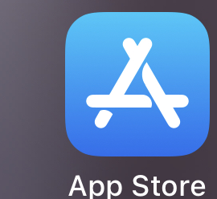

1. **Download “Microsoft Teams”**

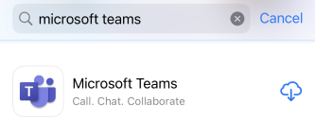

**Joining Study from Desktop/Laptop**

1. **You will receive an invitation that looks like this. Click the link to join at the time of your meeting:**

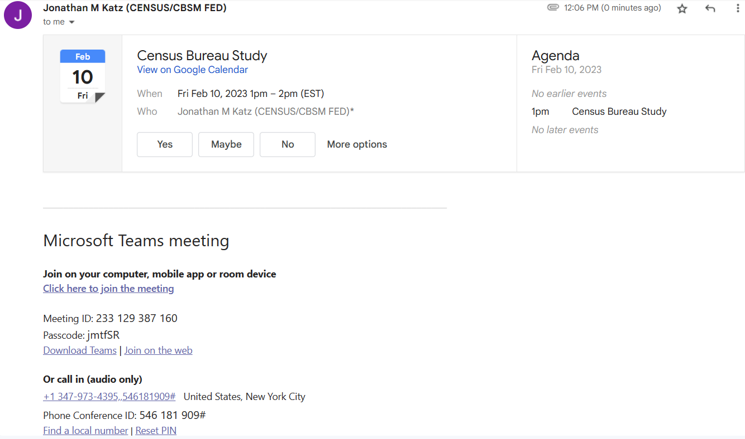

1. **If you already have Teams installed, feel free to use that. Otherwise select “continue on this browser.” Do NOT use Firefox:**

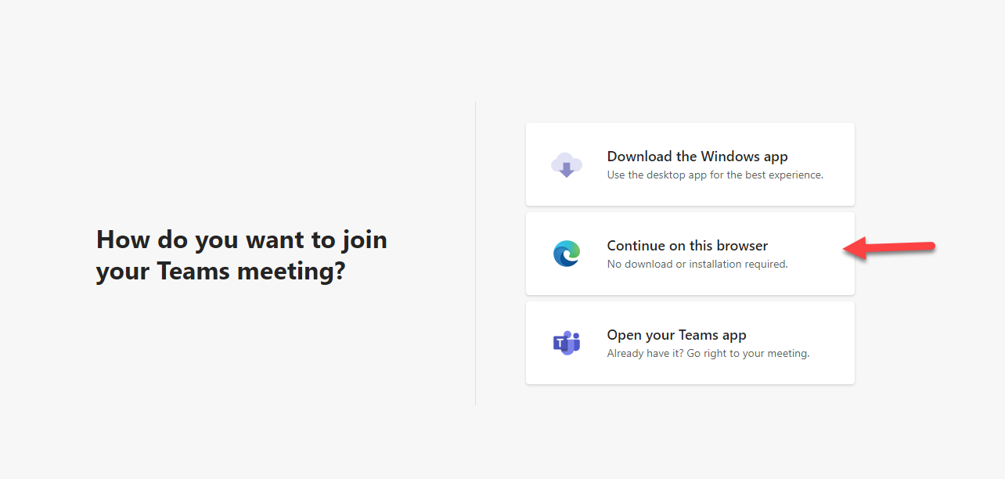

1. **Be sure to give permission to use your camera and microphone. Enter a name and click “join now**”

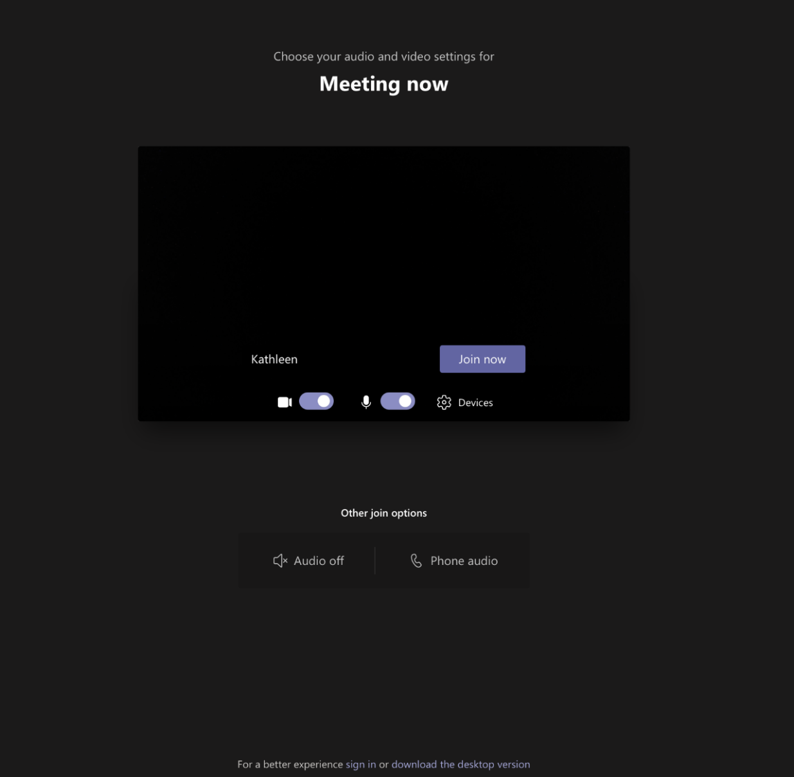

1. **This is how you share your screen**

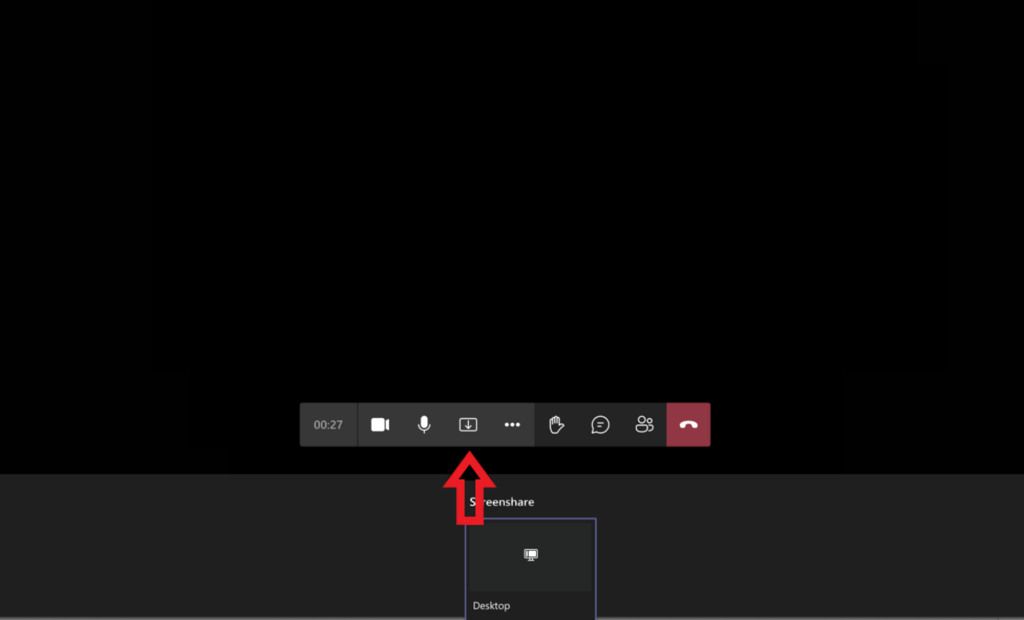

**Joining Microsoft Teams During the Study**

1. **You will receive an invitation that looks like this. Click the “Click here to join the meeting” when it’s time during the study.**

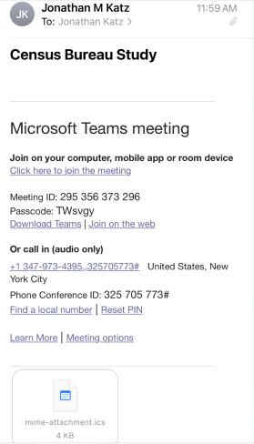

1. **Click “Join as a guest”**

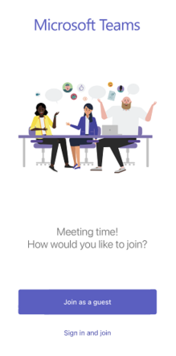

1. **Click “OK” to allow microphone**

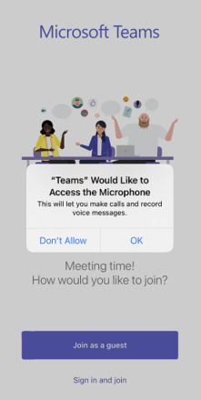

**4. Type your name and then click “Join Meeting”**

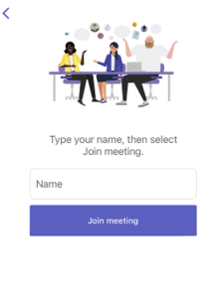

**5. This is what it will look like once you have joined the session**

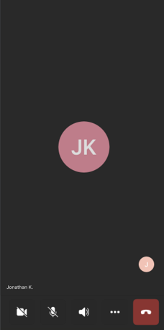

**6. Click the three dots at the bottom**

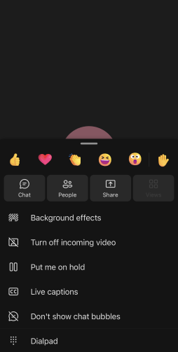

**7. Click the “Share” button. Then click “Share screen” and make sure “Audio” is toggled on.**

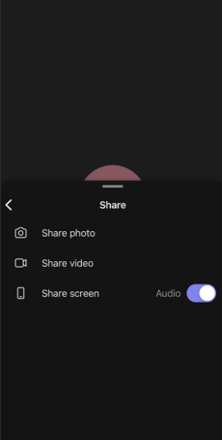

**8. Click “Start Broadcast”**

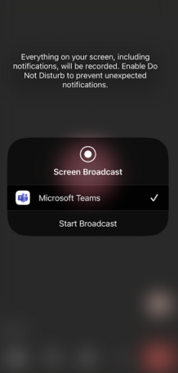

**8. Below is an example of what screen should look like when not presenting**

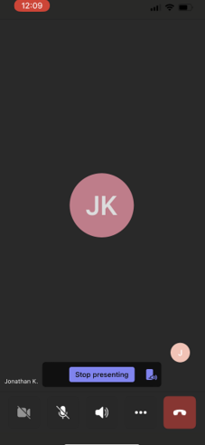



# Consent Forms

**National Health Interview Survey for Teens**

**Parental Consent to Participate in Research**

**[for teens younger than 18-years-old]**

**Purpose.** The National Health Interview Survey for Teens (NHIS-Teen) is conducted by the National Center for Health Statistics (NCHS). We are conducting this study under the authority of 13 U.S.C. Section 8(b). Federal law keeps your answers confidential (Section 308(d) of the Public Health Service Act (42 U.S.C. 242m(d)), the Privacy Act of 1974 (5 U.S.C. § 552a) and the Confidential Information Protection and Statistical Efficiency Act (CIPSEA, Title 5 of Public Law 107-347). The U.S. Census Bureau is under contract with NCHS to develop the questionnaires. The purpose of this study is to evaluate the NHIS-Teen questionnaire items.

**Procedures.** If you agree to allow your child to participate, the U.S. Census Bureau will ask your child to complete select questionnaire items from the NHIS-Teen. The U.S. Census Bureau also will ask a series of debriefing questions that will help us revise the current questionnaire. The interview should take about 60 minutes.

**Confidentiality.** Your child’s participation is voluntary and all of the information he/she provides may be used only for statistical purposes and may not be disclosed, or used, in identifiable form for any other purpose except as required by law (Section 308(d) of the Public Health Service Act (42 U.S.C. 242m(d)), the Privacy Act of 1974 (5 U.S.C. § 552a) and the Confidential Information Protection and Statistical Efficiency Act (CIPSEA, Title 5 of Public Law 107-347)). Your child’s name will not be attached to the answers they provide.

**Possible Risks and Discomforts.** We do not anticipate any risks or discomforts for respondents. However, should your child feel uncomfortable with any question asked, your child may skip the question or stop the interview at any time.

**Voluntary Participation.** Your child’s participation is completely voluntary. A decision to not participate will not be held against your child. If you agree to allow your child to participate, your child will receive $50 as a thank you for their time and input in the study.

**Further Questions.**

If you have questions, please contact Betsarí Otero Class, U.S. Census Bureau, Center for Behavioral Science Methods, 301-763-2235. If you would like the contact NCHS directly, please call the office of the Ethics Review Board at the National Center for Health Statistics, toll-free at 1-800-223-8118.  Please leave a brief message with your name and phone number.  Say that you are calling about Project ID #2019-09. Your call will be returned as soon as possible. Your information will be kept in our database for up to 10 years, and you can contact us at betsari.otero.class@census.gov or csm.participate@census.gov any time to remove it before the 10 years have elapsed.

With your permission, we would like to record this interview. The interview will be recorded for the survey portion to make sure we don’t miss anything that your child says and to help us write a report summarizing the results of the interviews. Direct quotes may be used in reports or in research presentations, but your child’s name will never be used in any reports or presentations. If you do not wish to allow your child to be recorded, your child may still participate in the interview and will still receive $50 for their participation.

By signing below, you agree that your child, _______________________________, may participate in this study.

Your signature below will indicate that your questions have been answered satisfactorily, and that you have read and understood the information provided above.

___________________________________ ___________________________

Parent’s signature Date

___________________________________

Parent’s printed name

________________________________

Researcher's signature

OMB Control Number: 0607-0725. Approval expires 12/31/2025.

**National Health Interview Survey for Teens**

**Consent to Participate in Research**

**[for teens younger than 18-years-old]**

**Purpose.** The National Health Interview Survey for Teens (NHIS-Teen) is conducted by the National Center for Health Statistics (NCHS). We are conducting this study under the authority of 13 U.S.C. Section 8(b). Federal law keeps your answers confidential (Section 308(d) of the Public Health Service Act (42 U.S.C. 242m(d)), the Privacy Act of 1974 (5 U.S.C. § 552a) and the Confidential Information Protection and Statistical Efficiency Act (CIPSEA, Title 5 of Public Law 107-347).. The U.S. Census Bureau is under contract with NCHS to develop the questionnaires. The purpose of this study is to evaluate the NHIS-Teen questionnaire items.

**Procedures.** If you agree to participate, the U.S. Census Bureau will ask you to complete select questionnaire items from the NHIS-Teen. The U.S. Census Bureau also will ask a series of debriefing questions that will help us revise the current questionnaire. The interview should take about 60 minutes.

**Confidentiality.** Your participation is voluntary and all of the information you provide may be used only for statistical purposes and may not be disclosed, or used, in identifiable form for any other purpose except as required by law (Section 308(d) of the Public Health Service Act (42 U.S.C. 242m(d)), the Privacy Act of 1974 (5 U.S.C. § 552a) and the Confidential Information Protection and Statistical Efficiency Act (CIPSEA, Title 5 of Public Law 107-347).. Your name will not be attached to the answers you provide.

**Possible Risks and Discomforts.** We do not anticipate any risks or discomforts for respondents. However, should you feel uncomfortable with any question asked, you may skip the question or stop the interview at any time.

**Voluntary Participation.** You participation is completely voluntary. A decision to not participate will not be held against you. If you agree to participate, you child will receive $50 as a thank you for your time and input in the study.

**Further Questions.**

If you have questions, please contact Betsarí Otero Class, U.S. Census Bureau, Center for Behavioral Science Methods, 301-763-2235. If you would like the contact NCHS directly, please call the office of the Ethics Review Board at the National Center for Health Statistics, toll-free at 1-800-223-8118.  Please leave a brief message with your name and phone number.  Say that you are calling about Project ID #2019-09. Your call will be returned as soon as possible. Your information will be kept in our database for up to 10 years, and you can contact us at betsari.otero.class@census.gov or csm.participate@census.gov any time to remove it before the 10 years have elapsed.

With your permission, we would like to record this interview. The interview will be recorded for the survey portion to make sure we don’t miss anything that you say and to help us write a report summarizing the results of the interviews. Direct quotes may be used in reports or in research presentations, but your name will never be used in any reports or presentations. If you do not wish to be recorded, you may still participate in the interview and will still receive $50 for your participation.

By signing below, you agree that you, _______________________________, will participate in this study.

Your signature below will indicate that your questions have been answered satisfactorily, and that you have read and understood the information provided above.

___________________________________ ___________________________

Signature Date

___________________________________

Printed name

________________________________

Researcher's signature

OMB Control Number: 0607-0725. Approval expires 12/31/2025.

# Payment Voucher

**STUDY PARTICIPANT RECEIVING $50**

**PUBLIC VOUCHER FOR PURCHASES AND SERVICES OTHER THAN PERSONAL**

The information that you provide in the spaces below will be used to release any incentive payments (cash or non-cash) to you. Census Bureau personnel will mail your incentive via USPS Priority Mail no later than five business days after completion of your interview. You will receive your incentive within about two weeks of completing your interview, depending on mail service.

In the box below, please enter your name and the address where you want your incentive to be sent.

Name

Street Address

City

State

ZIP

We will be sending the incentive payment using USPS Priority Mail. You will receive a USPS tracking number via email once the incentive has been sent.

Finally please sign below and enter today's date.

Signature:

Type today's date below:

# Resources for Participants

|  |
| --- |
| **Useful Information** |
| **Health Resources for Teens**  [Bright Futures Resources for Children and Teens (aap.org)](https://www.aap.org/en/practice-management/bright-futures/bright-futures-family-centered-care/bright-futures-resources-for-children-and-teens/)  **NAMI Teen & Young Adult HelpLine**  https://www.[nami.org/talktous](https://nami.org/talktous)  **YouthLine – a youth crisis helpline**  <https://www.theyouthline.org/>  **CyberBully Hotline**  <https://www.cyberbullyhotline.com/> |