**Appendix A: Instructions for Installing Microsoft Teams**

**Instructions for Installing Microsoft Teams and Sharing Smartphone Screen**

1. On your smartphone, go to the App store (on iPhones) or Google Play store (for Androids).
2. Search “*Microsoft Teams*”
3. Download the free Microsoft Teams app
4. On your smartphone, open the email from the researchers that contains the invitation to the Microsoft Teams meeting
5. Tap “*Click here to join the meeting*”. The Microsoft Teams app will open automatically.

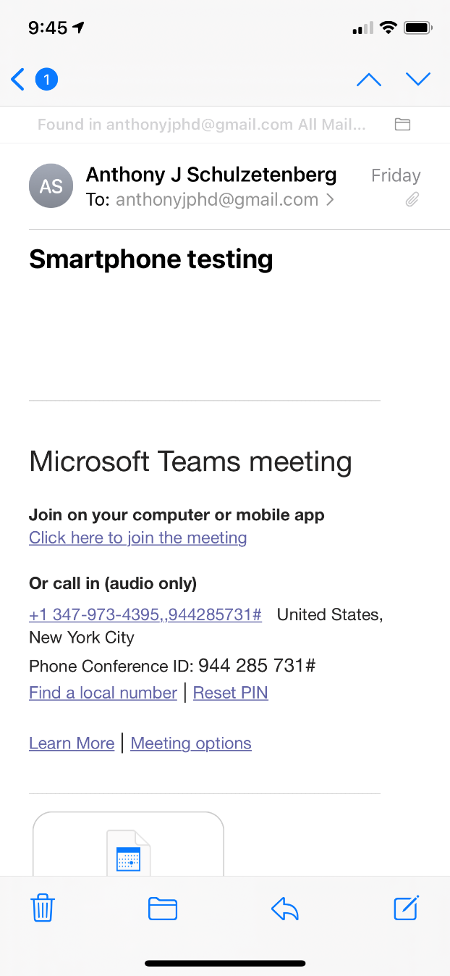

1. Tap “*Join as a guest*” then enter your name and tap “*Join meeting*”

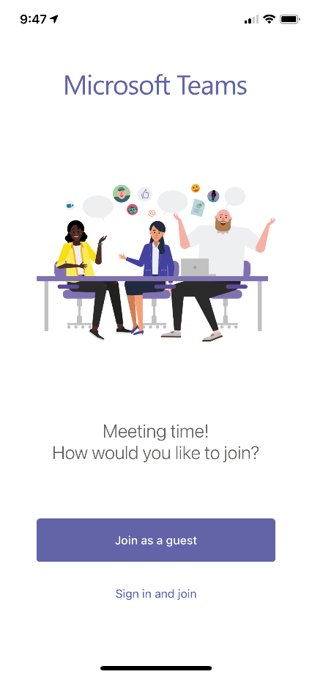 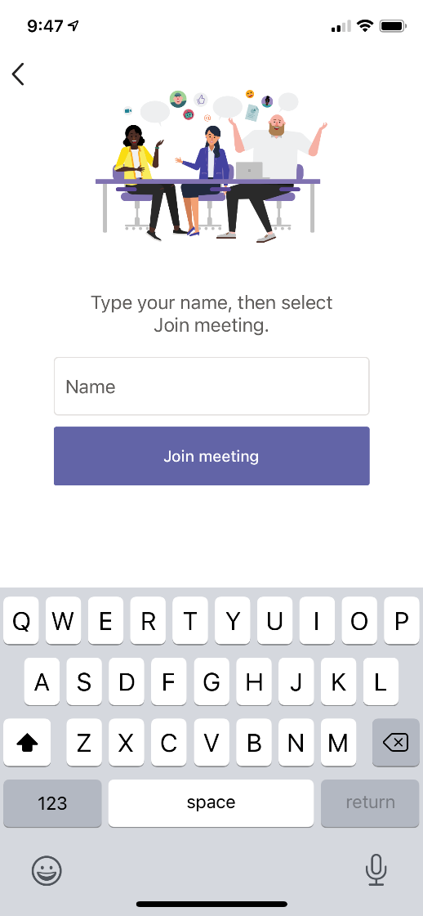

1. After you are admitted into the meeting, to share your screen, tap the three dots at the bottom of the screen.

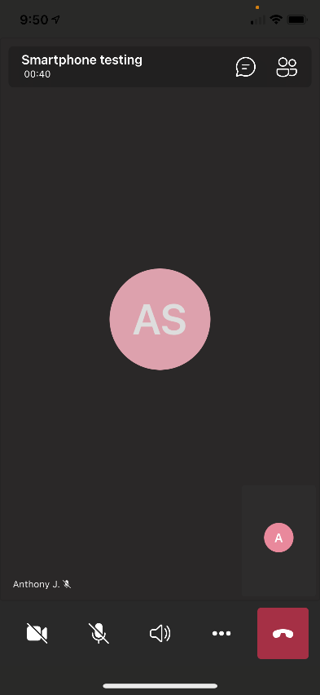

1. Tap “*Share*” then tap “*Share screen*”

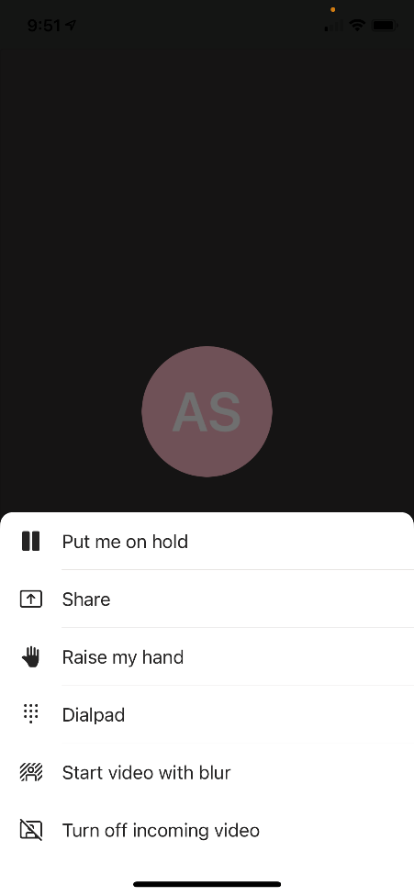 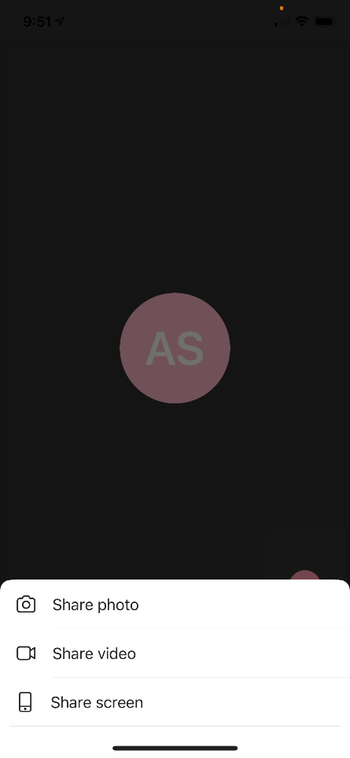

1. Tap “*Start Broadcast*”. Broadcast will begin with message. You are now sharing your smartphone screen. For iPhones, there will be a red oval around the time in the upper left to indicate your screen is being shared.

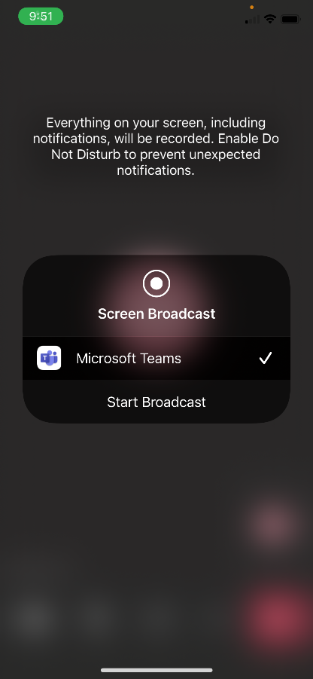 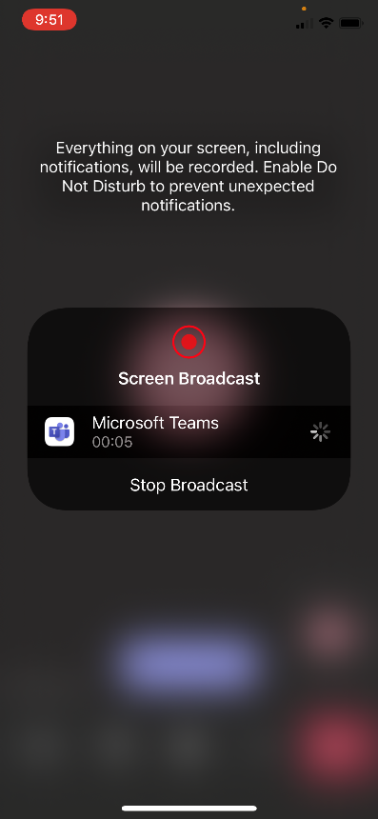

1. Exit the Teams app and open the FoodLogger app.
2. **After the research session,** return to the Teams app and tap “*Stop presenting*” and exit the meeting by tapping the red square on the bottom right of the screen.

