**Appendix P: Quiz for Training Assessment**

Quiz for Training Assessment

*Note: For evaluator use*

*Video #1: Q1-10*

*Video #2: Q11-14*

*Video #3: Q15-17*

*Video #4: Q18-24*

*Video #5: Q25-26*

*Video#6: Q27-29*

**Video #1**

(1) What tasks will you do in the next seven days using the FoodLogger?

* Report foods and drinks received in the next seven days
* Complete the profile questionnaire
* Complete the income questionnaire
* All of the above

(2) You should log all foods and drinks you purchase or get for free, including those acquired before the start of the study.

* True
* False

(3) The primary respondents can report food and drinks for

* Themselves
* Household members at least 11 years old
* Household members under 11 years old
* All of the above

(4) I need to report the following types of foods that are acquired during the 7-day study period. (Check all that apply)

* Groceries bought at a supermarket
* Takeout from a restaurant
* Food delivered to your home
* A meal received from a soup kitchen
* Food at a friend’s house
* Free food from a food pantry
* Coffee from a breakroom at work

(5) During the seven days of the study, everyone in the household should report foods and drinks every day.

* True
* False

(6) You went to a friend’s house. Two of you shared a pizza she ordered. Should you log this event?

* Yes
* No

(7) Food you buy for other people should be reported in the FoodLogger.

* True
* False

(8) Can I switch to a different smartphone to report your food and drinks during the study?

* Yes
* No

(9) What will happen when GPS location services is turned off in the FoodLogger app?

* The FoodLogger app will not track your location.
* Your Stops screen will not have a list of places.
* You will have to enter each place where you got food one place at a time.
* All of the above.

(10) If FoodLogger does not capture a stop where I get food, I won’t be able to add that stop.

* True
* False

**Video #2**

(11) A food event is

* An event when you get food and drink for free
* An event when you get food and drink for purchase
* An event when you get food and drink for purchase or for free
* None of the above

(12) When you report a food event, you will provide information including…

* where you got the food and/or drink.
* how the food and/or drink was consumed.
* Who paid for the food and/or drink.
* all of the above.

(13) Which is an image of a PLU code?

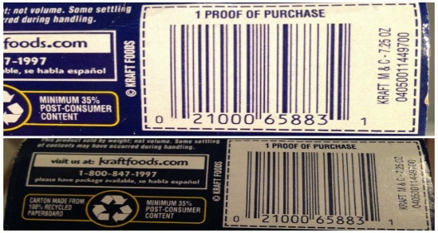

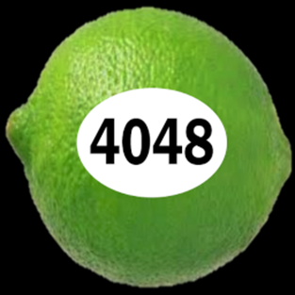

(14) What can be reported as a combo meal?

* Individual items that I pay for separately
* The entire meal I paid for
* Food and drinks sold together for a single price

**Video #3**

(15) I need to report foods and drinks I got for…

* Myself
* Other members of my household
* People outside of my household

(16) Which is the best way to add foods to the Foodlogger to reduce the number of detailed questions?

* Type in the name
* Scan its UPC barcode or type in its PLU code
* Take a picture of the item

(17) You can upload a paper receipt within the FoodLogger.

* Yes
* No

**Video #4**

(18) If you bought a coffee for $3 and got one for free during a 2 for 1 promotion, how should you enter it?

* Enter 1 coffee for $3
* Enter 2 coffees, one for $3 and the other for $0
* Enter 2 coffees and $3 for each

(19) Each item in a combo meal has a price.

* True
* False

(20) In the image below, there is a red exclamation point next to the item “6 piece chicken nugget happy meal.”

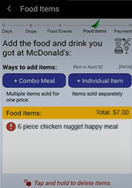

What should you do if you see a red exclamation point next to the name of an item?

* Ignore it
* Tap the name to go back to the questions
* Restart Foodlogger
* None of the above

(21) I bought a Happy Meal at McDonald’s with a 10% discount. According to the training video, I am supposed to report the regular price before discount.

* True
* False

(22) I grabbed 2 packs of ketchup after buying a Happy Meal at McDonald’s. Because the ketchup is not part of the Happy Meal, I don’t need to report it in FoodLogger.

* True
* False

(23) If you order food for delivery, do you need to add a food/drink stop?

* Yes
* No

(24) You ordered a combo at a restaurant, but you dropped the drink before being able to drink any of it. Should you still report it?

* Yes
* No

**Video #5**

(25) Each person in your household should complete the profile questionnaire and the income questionnaire.

* True
* False

(26) The primary respondent should complete the profile questionnaire and the income questionnaire on behalf of children under 11 years old.

* True
* False

**Video #6**

(27) The Day Overview should be completed …

* On the day of the Day Overview
* On the day after the Day Overview
* Any day during the 7-day study period
* The last day during the 7-day study period

(28) I can add missed food items during the Day Overview.

* True
* False

(29) Because I didn’t get any food or drink yesterday, I don’t need to complete the Day Overview for that day.

* True
* False