Attachment D:

2023 AIES Letters for Testing

**AIES-L1**

**Initial Letter**

**A Message from the Director, U.S. Census Bureau:**

Your firm has been selected to participate in the **2023 Annual Integrated Economic Survey.** Online reporting is *now open*. Please use the following information to access your survey:

1. **Register** OR **sign in** at https://portal.census.gov
2. **Enter** your authentication code.
3. **Report** by clicking on “REPORT NOW.” You can return to your account over multiple sessions to complete the survey.

**YOUR RESPONSE IS REQUIRED BY LAW** and will be kept strictly **CONFIDENTIAL.** Information about the authority, confidentiality, and burden of this data collection can be found on the back of this letter.

For more information or assistance with completing this survey, please visit census.gov/aies/information or call our customer helpline at 1-800-681-3012, Monday through Friday, 8:00 a.m. to 8:00 p.m. Eastern time. For a preview of the questions in this survey, visit census.gov/aies/questionspreview/.

**Thank you** in advance for your time and participation, and for helping the U.S. Census Bureau measure America’s people and economy.

Sincerely,

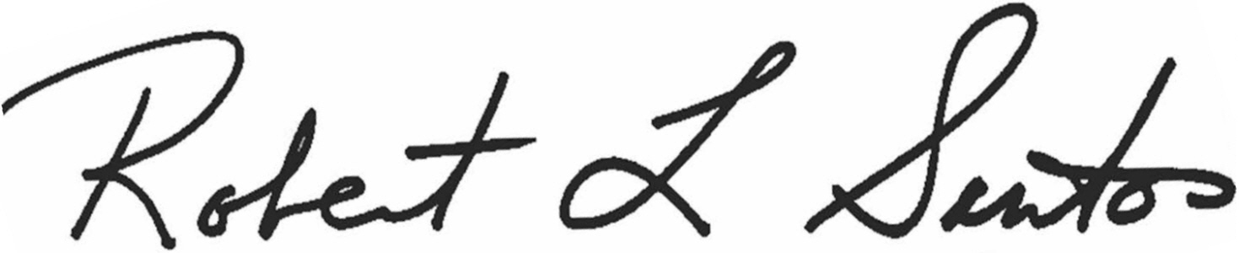

Robert L. Santos Director

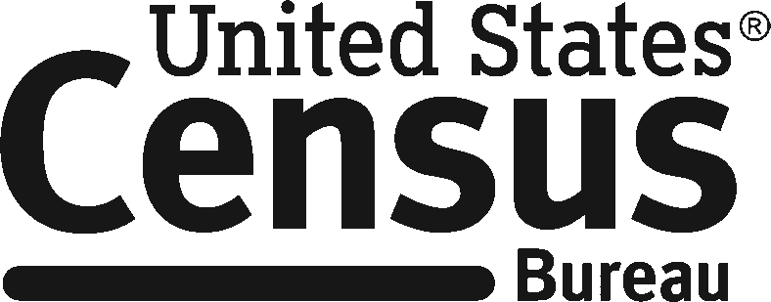

# AIES-L1

(02-06-2024)

**What is the Annual Integrated Economic Survey?**

The **Annual Integrated Economic Survey (AIES)** is a newly redesigned survey that combines multiple mandatory annual surveys into one comprehensive data collection. The new format simplifies reporting by consolidating all necessary questions into one convenient platform, requiring you to answer only industry-specific content that directly relates to your company’s activities.

With key data items standardized across all sectors, the AIES will offer a holistic annual picture of the U.S. economy. Your valuable data serve as a critical input in calculating the Gross Domestic Product (GDP), empowering policymakers and businesses, including your own, to make well-informed and precise decisions.

**How do I know this is a legitimate government survey?**

This survey has been approved by the Office of Management and Budget (OMB). The eight- digit OMB approval number is 0607-1024 and appears in the lower left corner of each reporting screen. Without this approval, we could not conduct this survey. We are conducting this survey under the authority of Title 13, United States Code, Sections 131 and 182.

**How long will it take to complete the survey?**

We estimate the Annual Integrated Economic Survey will take an average of 3.38 hours to complete. Factors such as company size, complexity, and activity will affect your actual time to complete the survey. This estimate includes the time to review instructions, search existing data sources, gather and maintain the data needed, and complete and review the survey.

**Will my response be confidential?**

Yes. The U.S. Census Bureau is required by law to keep your response confidential (Title 13, U.S. Code, Section 9). The Census Bureau is not permitted to publicly release your responses in a way that could identify your business, organization, or institution. Per the Federal Cybersecurity Enhancement Act of 2015, your data are protected from cybersecurity risks through screening of the systems that transmit data.

**Am I required to fill out the survey?**

Yes. Your business is required by law (Title 13, U.S. Code, Sections 224 and 225) to respond to this survey.

**How will the Census Bureau use the information I provide?**

By law, the Census Bureau can only use your business data to produce statistics.

**AIES-L2**

**Past Due Notice Letter**

**PAST DUE NOTICE**

Our records indicate that we have not received your **2023 Annual Integrated Economic Survey.** This survey is mandatory and requires your immediate attention.

**Authentication Code:**

**Due Date:**

1. **Register** OR **sign in** at https://portal.census.gov
2. **Add** your authentication code OR **locate** this report under “My Surveys”
3. **Report** by clicking on “REPORT NOW.” You can return to your account over multiple sessions to complete the survey.

**If you recently reported,** you can verify your filing status by clicking on “Options” and then “Filing Status.” Look for an entry under the “Date Received” column.

**YOUR RESPONSE IS REQUIRED BY LAW** and will be kept strictly **CONFIDENTIAL.** The U.S. Census Bureau is authorized to collect this information under Title 13, United States Code (Sections 131 and 182). The same law requires that you respond (Sections 224 and 225) and assures the confidentiality of the information you provide (Section 9). The Census Bureau is not permitted to publicly release your responses in a way that could identify your business, organization, or institution, and use your responses only to produce statistics.

For assistance with completing this survey or for a list of the surveys that are covered under this new collection, please visit census.gov/aies/information or call our customer helpline at 1-800-681-3012, Monday through Friday, 8:00 a.m. to 8:00 p.m. Eastern time. For a preview of the questions in this survey, visit census.gov/aies/questionspreview/.

**Thank you** in advance for your time and participation, and for helping the U.S. Census Bureau measure America’s people and economy.

Sincerely,

Lisa E. Donaldson

Chief, Economy Wide Statistics Division

U.S. Census Bureau

The Office of Management and Budget

(OMB) approval number for the Annual

Integrated Economic Survey is 0607-1024.

**AIES-L4L**

**Office of General Council (OCG) “Light” Letter**

**NOTICE OF FAILURE TO PROVIDE MANDATORY RESPONSE**

Our records indicate that we have not received your **2023 Annual Integrated Economic Survey** response. If you have submitted your survey within the past few weeks, **thank** **you** for your participation. You may verify your filing status by logging into your account at https://portal.census.gov.

If you have not yet reported, we remind you that your response is **REQUIRED BY LAW.** Title 13, United States Code, Sections 131 and 182, authorizes this collection. Sections 224 and 225 require your response. Section 9 requires that we keep your answers **STRICTLY CONFIDENTIAL**.

Although Title 13 (Section 224) and the Sentencing Reform Act of 1984 (18, U.S.C. 3559 and 3571) allow for possible prosecution of responsible officials and penalties up to $5,000 (and still require response), **the U.S. Census Bureau prefers to work cooperatively with businesses like yours to ensure we gather and distribute reliable statistics about the U.S. economy**. We ask for your help in meeting that goal, recognizing that we are relying on your valuable time and effort to comply with this request.

Online reporting is easy, with a secure account setup necessary to begin the reporting process. For assistance with completing this survey or for a list of the surveys that are covered under this new collection, please visit census.gov/aies/information or call our customer helpline at 1-800-681-3012, Monday through Friday, 8:00 a.m. to 8:00 p.m. Eastern time. For a preview of the questions in this survey, visit census.gov/aies/questionspreview/.

**Authentication Code:**

**Due Date:**

Your timely response will save tax dollars by reducing the need for additional mailings and telephone calls. Please report within 10 days, following these steps:

1. **Register** OR **sign in** at https://portal.census.gov
2. **Add** your authentication code OR **locate** this report under “My Surveys”
3. **Report** by clicking on “REPORT NOW”

After reporting, we invite you to review the useful data and analysis tools available to aid and inform businesses such as yours by visiting the Census Bureau’s website at https://www.census.gov/aies/information.

**Thank you** in advance for your time and participation.

Sincerely,

Nick Orsini

Associate Director for Economic Programs

U.S. Census Bureau

The Office of Management and Budget (OMB) approval number for the Annual Integrated Economic Survey is 0607-1024.

**AIES-ECSL1**

**Experimental “Dear CEO” Letter**

**PAST DUE NOTICE**

Our records indicate that we have not received your company’s 2023 Annual Integrated Economic Survey. This survey is mandatory and requires your immediate attention.

This survey includes questions about your company and all the locations for your company. Most questions can be answered using your general ledger, but some are about payroll and human resources. Please designate a person at your company to be responsible for answering this survey and complete the survey as soon as possible. This designated person will use the information below to access the survey.

**Authentication Code: XXXXXX**

DRAFT –

FOR RESEARCH ONLY

1. **Register** OR **sign in** at https://portal.census.gov
2. **Add** your authentication code OR **locate** this report under “My Surveys”
3. **Report** by clicking on “REPORT NOW.” You can return to your account over multiple sessions to complete the survey.

**YOUR RESPONSE IS REQUIRED BY LAW** and will be kept strictly **CONFIDENTIAL.** The U.S. Census Bureau is authorized to collect this information under Title 13, United States Code (Sections 131 and 182). The same law requires that you respond (Sections 224 and 225) and assures the confidentiality of the information you provide (Section 9). The Census Bureau is not permitted to publicly release your responses in a way that could identify your business, organization, or institution, and use your responses only to produce statistics.

For assistance with completing this survey or for a list of the surveys that are covered under this new collection, please visit census.gov/aies/information or call our customer helpline at 1-800-681-3012, Monday through Friday, 8:00 a.m. to 8:00 p.m. Eastern time. For a preview of the questions in this survey, visit census.gov/aies/questionspreview/.

**Thank you** in advance for your time and participation, and for helping the U.S. Census Bureau measure America’s people and economy.

Sincerely,

Lisa E. Donaldson

Chief, Economy Wide Statistics Division

U.S. Census Bureau

The Office of Management and Budget

(OMB) approval number for the Annual

Integrated Economic Survey is 0607-1024.