Attachment E:

2023 AIES Emails for Testing

**AIES Postcard**

## Introducing the Census Bureau’s new Annual Integrated Economic Survey

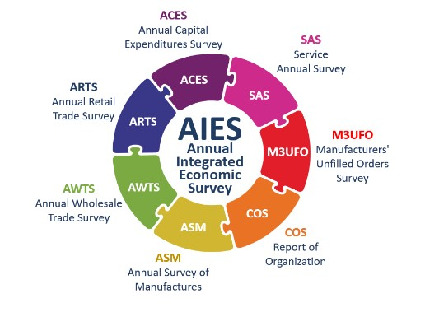

The U.S. Census Bureau is excited to announce the launch of the Annual Integrated Economic Survey (AIES). This new program will replace one or more surveys in which your company previously participated, streamlining your reporting by consolidating all necessary questions into one convenient survey. If selected to participate in the AIES, your business will receive a survey invitation in March of 2024.

Thank you for your participation in these important annual surveys. The Census Bureau is ready to support your company during this transition. For more information on the Annual Integrated Economic Survey, please visit census.gov/aies.

**AIES Advance Email**

**Subject:** IMPORTANT NOTICE: Annual Integrated Economic Survey

**ANNUAL INTEGRATED ECONOMIC SURVEY**

**Important Notice Regarding Upcoming Census Surveys**

*Check our email address – it’s official if it ends in @census.gov*

ATTN

COMPANY

We are writing to inform you that in a few weeks, we will be sending you the **2023 Annual Integrated Economic Survey.**

At this time, we encourage you to visit [census.gov/aies/information](https://census.gov/aies/information) for a list of surveys that are covered under the new collection and to start preparations for reporting. For a preview of the questions in this survey, visit [census.gov/aies/questionspreview/](https://census.gov/aies/questionspreview/).

**What is the Annual Integrated Economic Survey?**

The Annual Integrated Economic Survey (AIES) is a newly redesigned survey that combines multiple mandatory annual surveys into one comprehensive data collection. The new format simplifies reporting by consolidating all necessary questions into one convenient platform, requiring you to answer only industry-specific content that directly relates to your company’s activities.

With key data items standardized across all sectors, the AIES will offer a holistic annual picture of the U.S. economy. Your valuable data serve as a critical input in calculating the Gross Domestic Product (GDP), empowering policymakers and businesses, including your own, to make well-informed and precise decisions.

**Please do not reply directly to this automated email.**

Join us on March 13, 2024, at 11:00 a.m. Eastern Time for an informative webinar introducing the AIES, “Navigating the Annual Integrated Economic Survey (AIES): Integrating Economic Data Collection for Facilitating Response”. The webinar will walk through the survey's purpose and how it benefits your business, provide an overview of key dates to keep in mind, and highlight tools and resources that will simplify the survey response process. Limited seating is available, so register [here](https://uscensus.webex.com/weblink/register/r9cf560f490fcc5650138096f95b76c92) to ensure your place for this exclusive event.

**Thank you** in advance for your time and participation, and for helping the U.S. Census Bureau measure America’s people and economy.

Sincerely,

Lisa E. Donaldson

Chief, Economy Wide Statistics Division

U.S. Census Bureau

Office of Management and Budget Number: 0607-1024

Expires: 06/30/2026

**AIES Due Date Reminder Email**

**Subject:** DUE DATE REMINDER: Annual Integrated Economic Survey

**ANNUAL INTEGRATED ECONOMIC SURVEY**

**Due Date Reminder**

*Check our email address – it’s official if it ends in @census.gov*

ATTN

COMPANY

The U.S. Census Bureau recently requested your response to the **2023 Annual Integrated Economic Survey**. This is a reminder that the due date is fast approaching.

_____________________________________________________________________________________________________________________________________

**Due Date:** XXXXX XX, 20XX

1. Register or signin at <https://portal.census.gov>
2. Add your authentication code: **XXXX-XXXX-XXXX**

*Case-sensitive; if you copy and paste, ensure no blank spaces are captured.*

1. Report by clicking on “REPORT NOW”

_____________________________________________________________________________________________________________________________________

**What is the Annual Integrated Economic Survey?**

The **Annual Integrated Economic Survey (AIES)** is a newly redesigned survey that combines multiple mandatory annual surveys into one comprehensive data collection on business revenues, expenses, and assets. The new format simplifies reporting by consolidating all necessary questions into one convenient platform, requiring you to answer only industry-specific content that directly relate to your company’s participation.

With key data items standardized across all sectors, the AIES will offer a holistic annual picture of the U.S. economy. Your valuable data serve as a critical input in calculating the Gross Domestic Product (GDP), empowering policymakers and businesses, including your own, to make well-informed and precise decisions.

**Please do not reply directly to this automated email.** For assistance with completing this survey or for a list of the surveys that are covered under this new collection, please visit <https://census.gov/aies/information> or call our customer helpline at 1-800-681-3012, Monday through Friday, 8:00 a.m. to 8:00 p.m. Eastern time

**Thank you** in advance for your time and participation, and for helping the U.S. Census Bureau measure America’s people and economy.

Sincerely,

Lisa E. Donaldson

Chief, Economy Wide Statistics Division  
U.S. Census Bureau

Office of Management and Budget (OMB) Number: 0607-1024

Expires: 06/30/2026

ID: XXXXXXXXXXX