Attachment F:

2023 AIES Websites for Testing

**Interactive Content Selection Tool**

**https://www.census.gov/aies/questionspreview/**

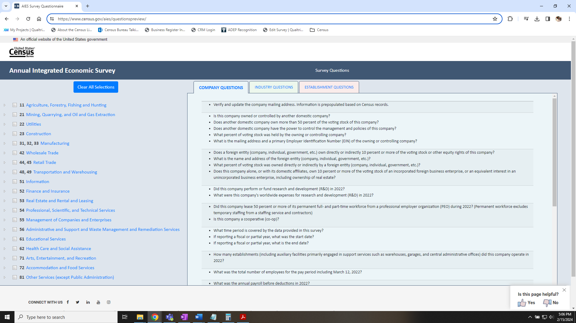

**AIES Landing Page**

**https://www.census.gov/programs-surveys/aies.html**

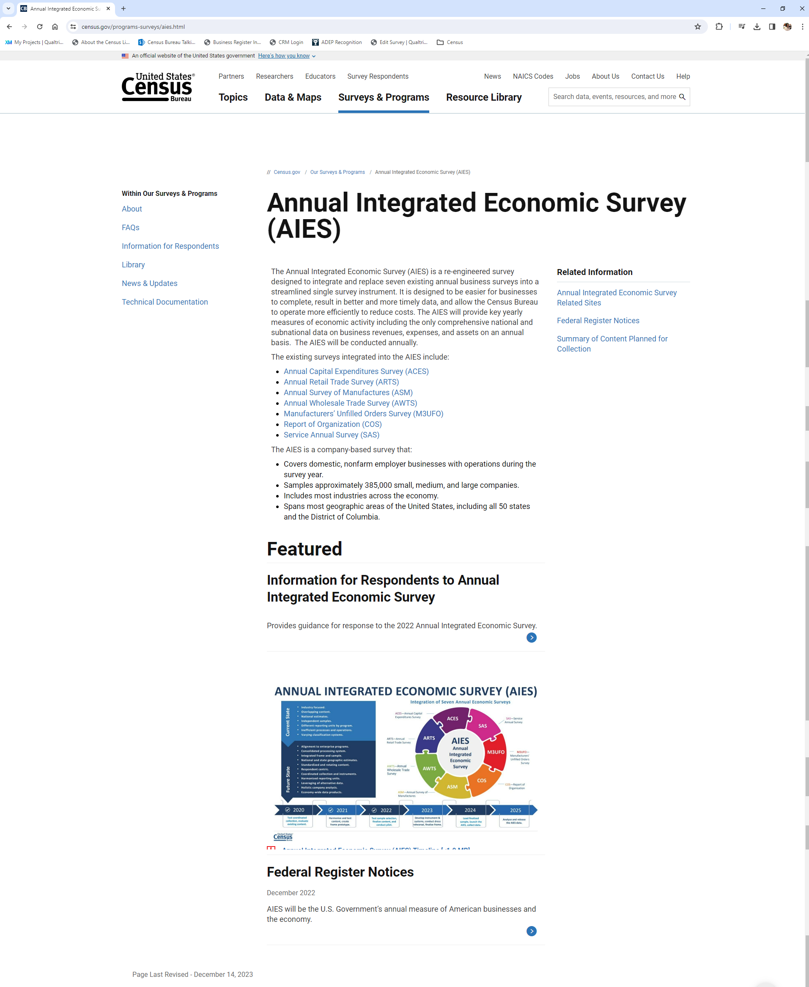

**AIES FAQ Page**

**https://www.census.gov/programs-surveys/aies/faq.html**

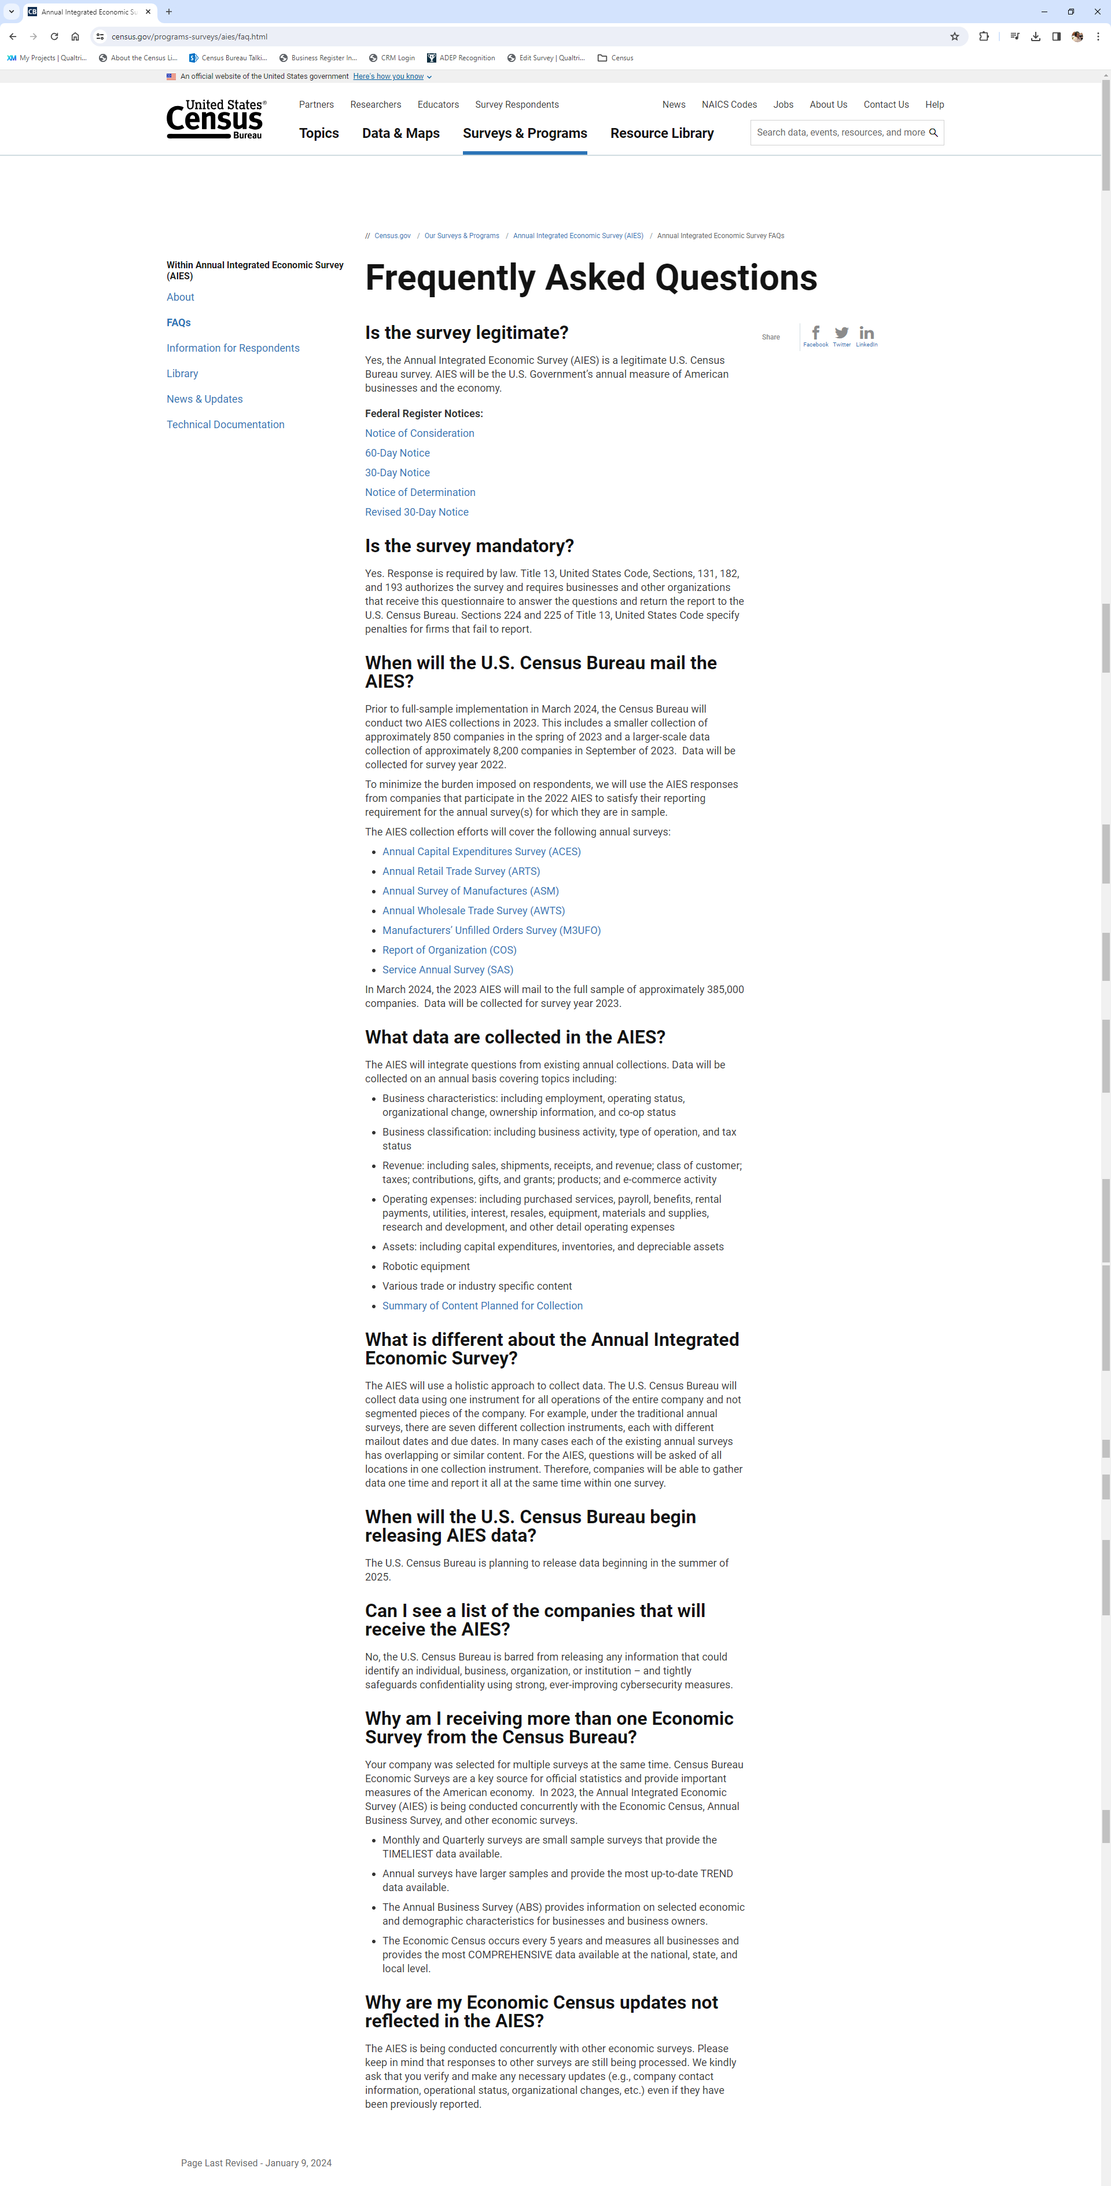

**AIES Information for Respondents Page**

**https://www.census.gov/programs-surveys/aies/information.html**

