Attachment G:

AIES Instrument Screenshots for Testing

Screenshot 1: Step 2, Reporting Period
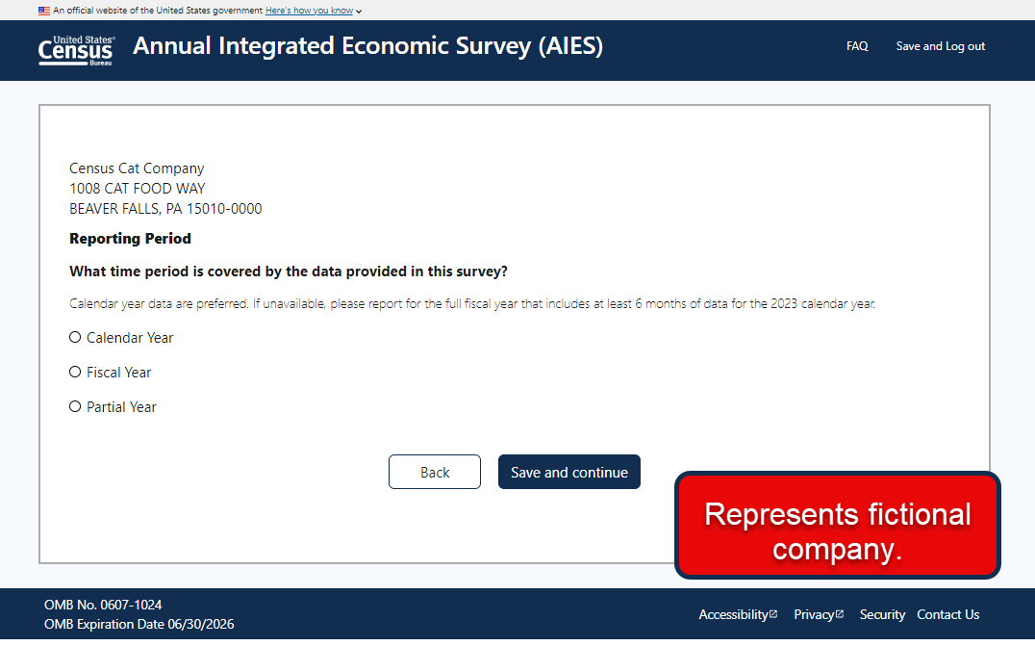

Screenshot 2: Step 2, Fiscal Year Selected
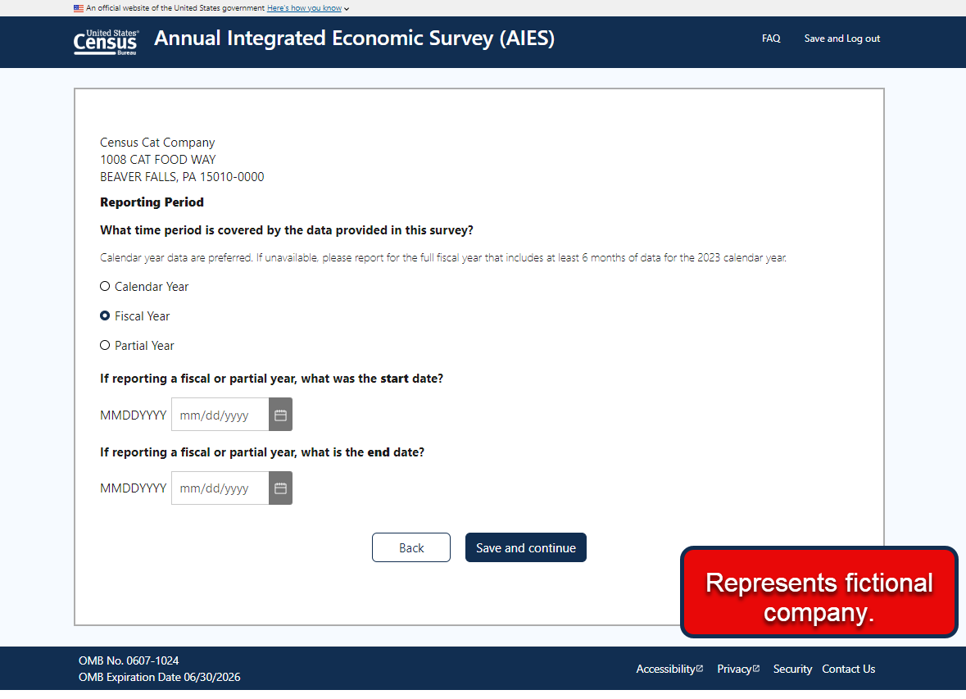

Screenshot 3: Step 1 FAQ Modal Window
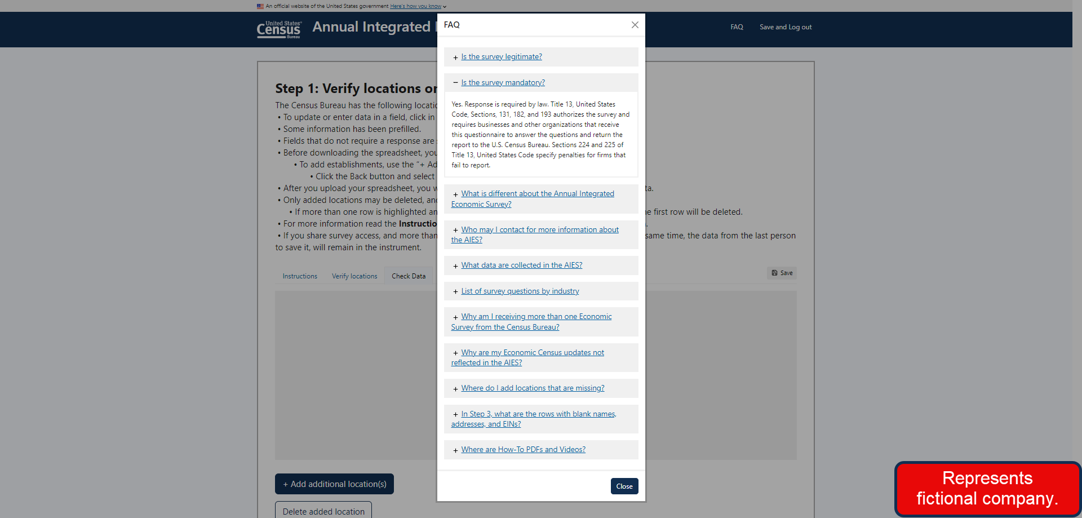

Screenshot 4: Step 2 Grid Format

