Screenshots
Main Menu

Mailing Address

Section E: Research Activities at Nonprofit Organizations

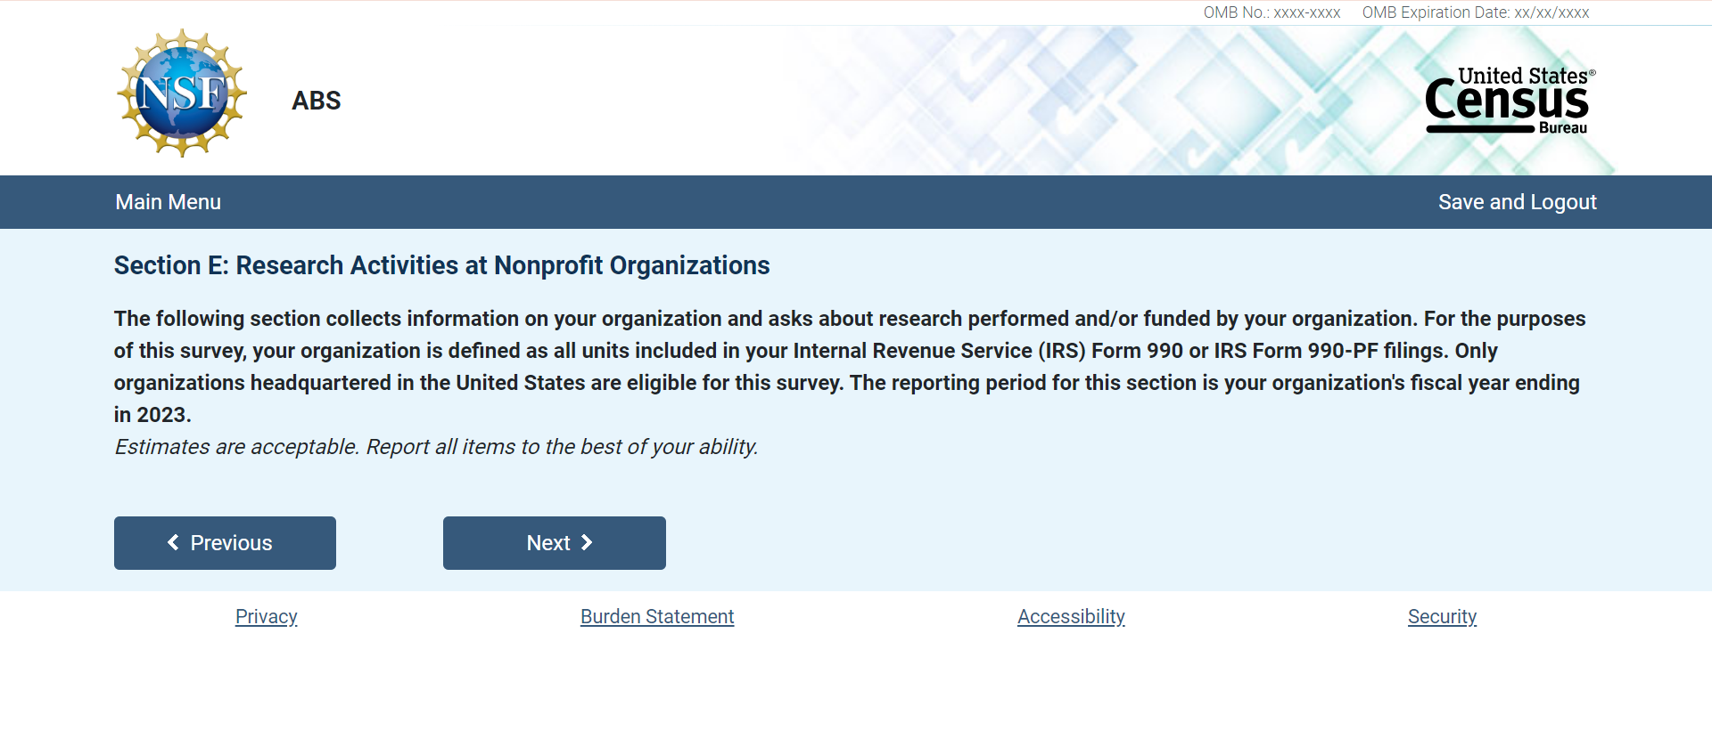

E.1 Nonprofit Organizations: Organization Affiliation

E.2 Nonprofit Organizations: Total Expenses

E.3 Nonprofit Organizations: Number of Employees

E.4 Nonprofit Organizations: Fiscal Year End

Nonprofit Organizations: Research Performed

E.5 Nonprofit Organizations: Research Performed

E.6 Nonprofit Organizations: Research by Others

E.7 Nonprofit Organizations: Funding for Research

E.8 Nonprofit Organizations: Research Funding Sources
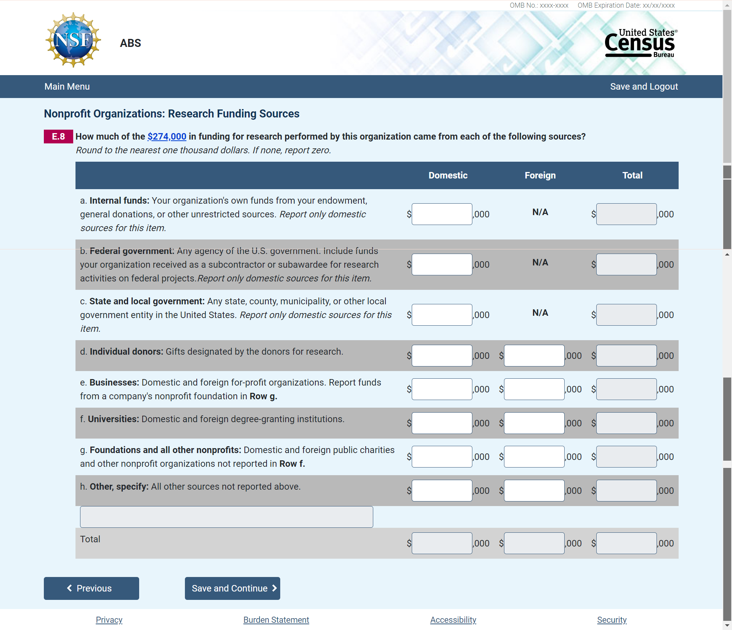

E.9 Nonprofit Organizations: Research Performance by Field
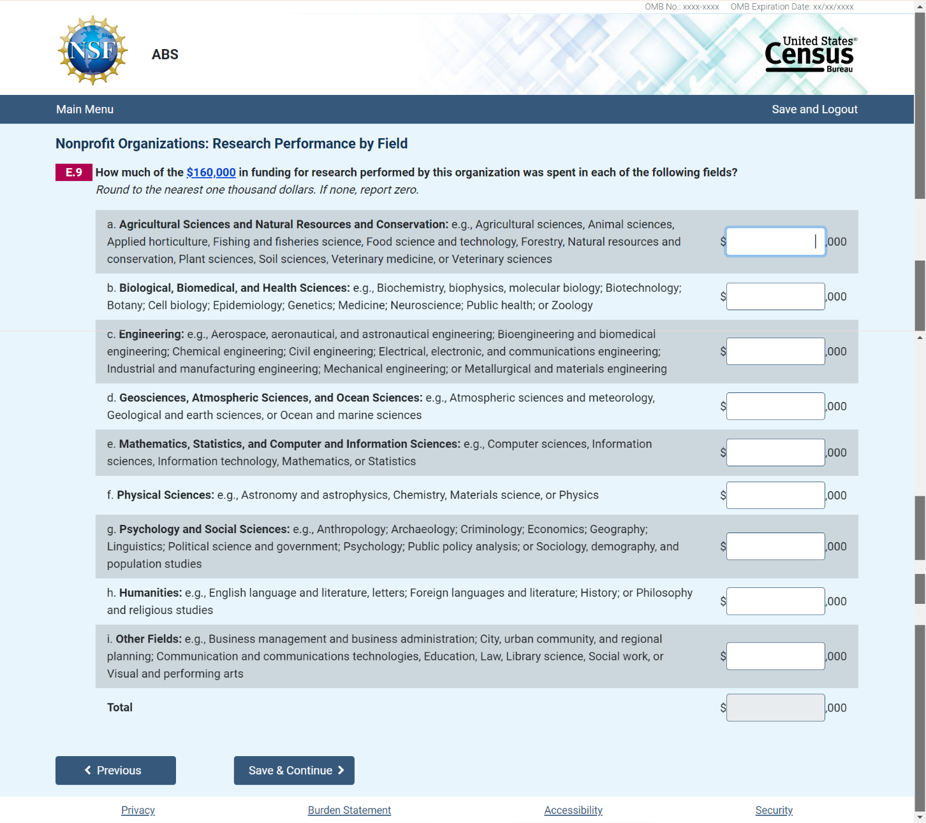

E.10 Nonprofit Organizations: Clinical Trials

E.11 Nonprofit Organizations: Type of Research

E.12 Nonprofit Organizations: Research by Type of Cost
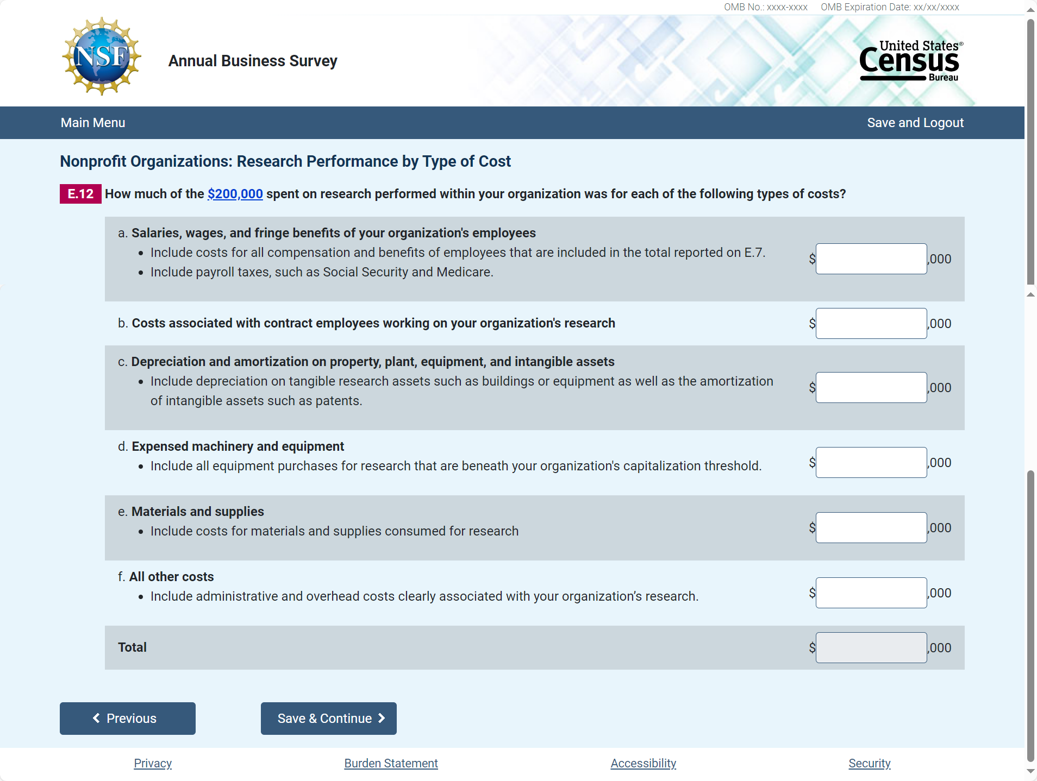

E.13 Nonprofit Organizations: Research Employee Type
E.14 Nonprofit Organizations: Full-time Equivalents

E.15 Nonprofit Organizations: Contract Employees

E.16 Nonprofit Organizations: Volunteers

E.17 Nonprofit Organizations: Research by Other Organizations

E.18 Nonprofit Organizations: Total Capital Expenditures
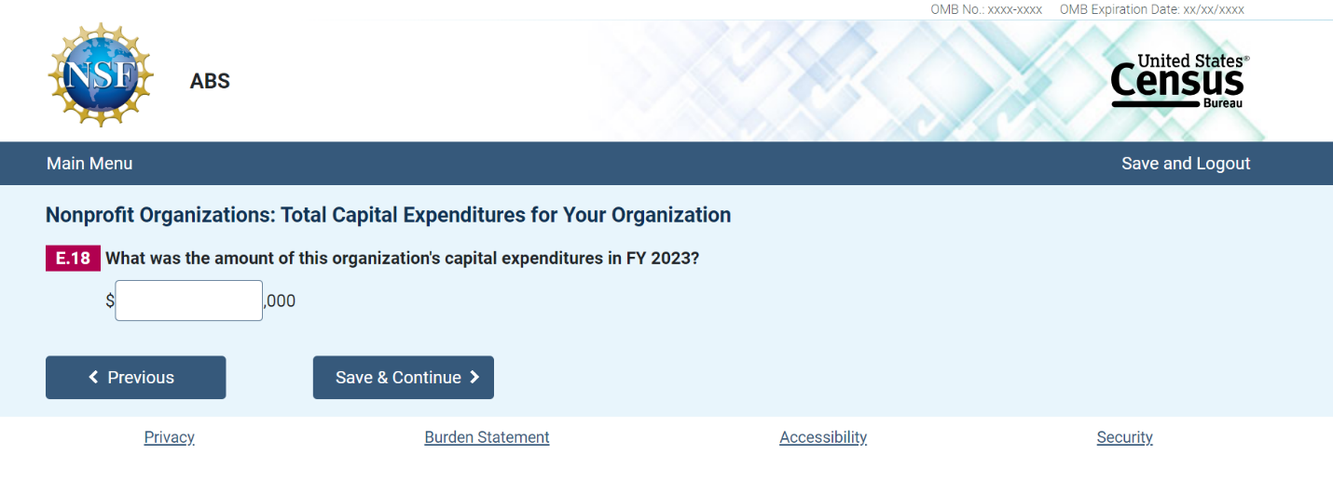

E.19 Nonprofit Organizations: Total Capital Expenditures

E.20 Nonprofit Organizations: Capital Expenditure by Type of Cost

