Satisfaction questions: asked after user completes their online questionnaire
Please Note: The questionnaire will be electronic with word labels on either end of 7 radio buttons. See image below for an idea of what the final format will look like.
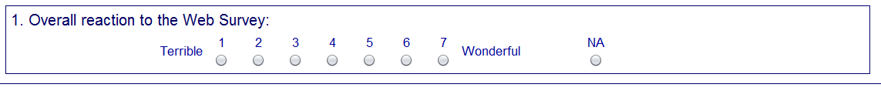

- Overall experience with the survey

Unpleasant to Pleasant

- The survey screens are visually pleasing

Never to Always

- The survey screens look professional

Never to Always

- Characters (words/text) on the screen

Barely legible to Very legible

- The survey questions follow a logical sequence

Never to Always

- Words used in the survey questions and answers

Hard to understand to Easy to understand

- Coming up with answers to the questions

Never bothered me to Always bothered me

- Instructions for correcting errors

Confusing to Clear

- Entering your answers into the survey

Difficult to Easy

- You knew what to do if you needed help answering the question

Never to Always

11. Additional Comments__________________________________________________________________

