**Annual Integrated Economic Survey** Production Screenshots

2024

Contents

Welcome Screen 2

Overview 3

Step One: Choice 4

Step One: Online Path 5

Run Checks 6

Add a Location 7

STEP ONE: Download Path 8

STEP ONE B. 9

STEP TWO 10

Company Mailing Address 11

Reporting Period 12

STEP THREE: Choice 13

STEP THREE: Online Path 14

STEP THREE: Download Path 15

SUBMIT 16

# Welcome Screen



# Overview

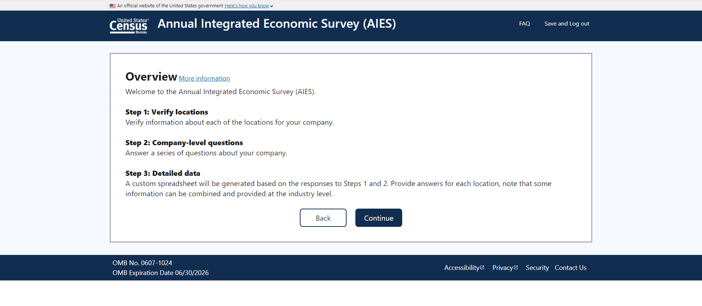

# Step One: Choice

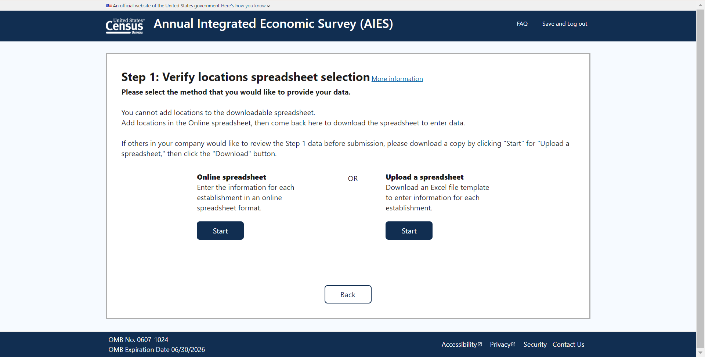

# Step One: Online Path

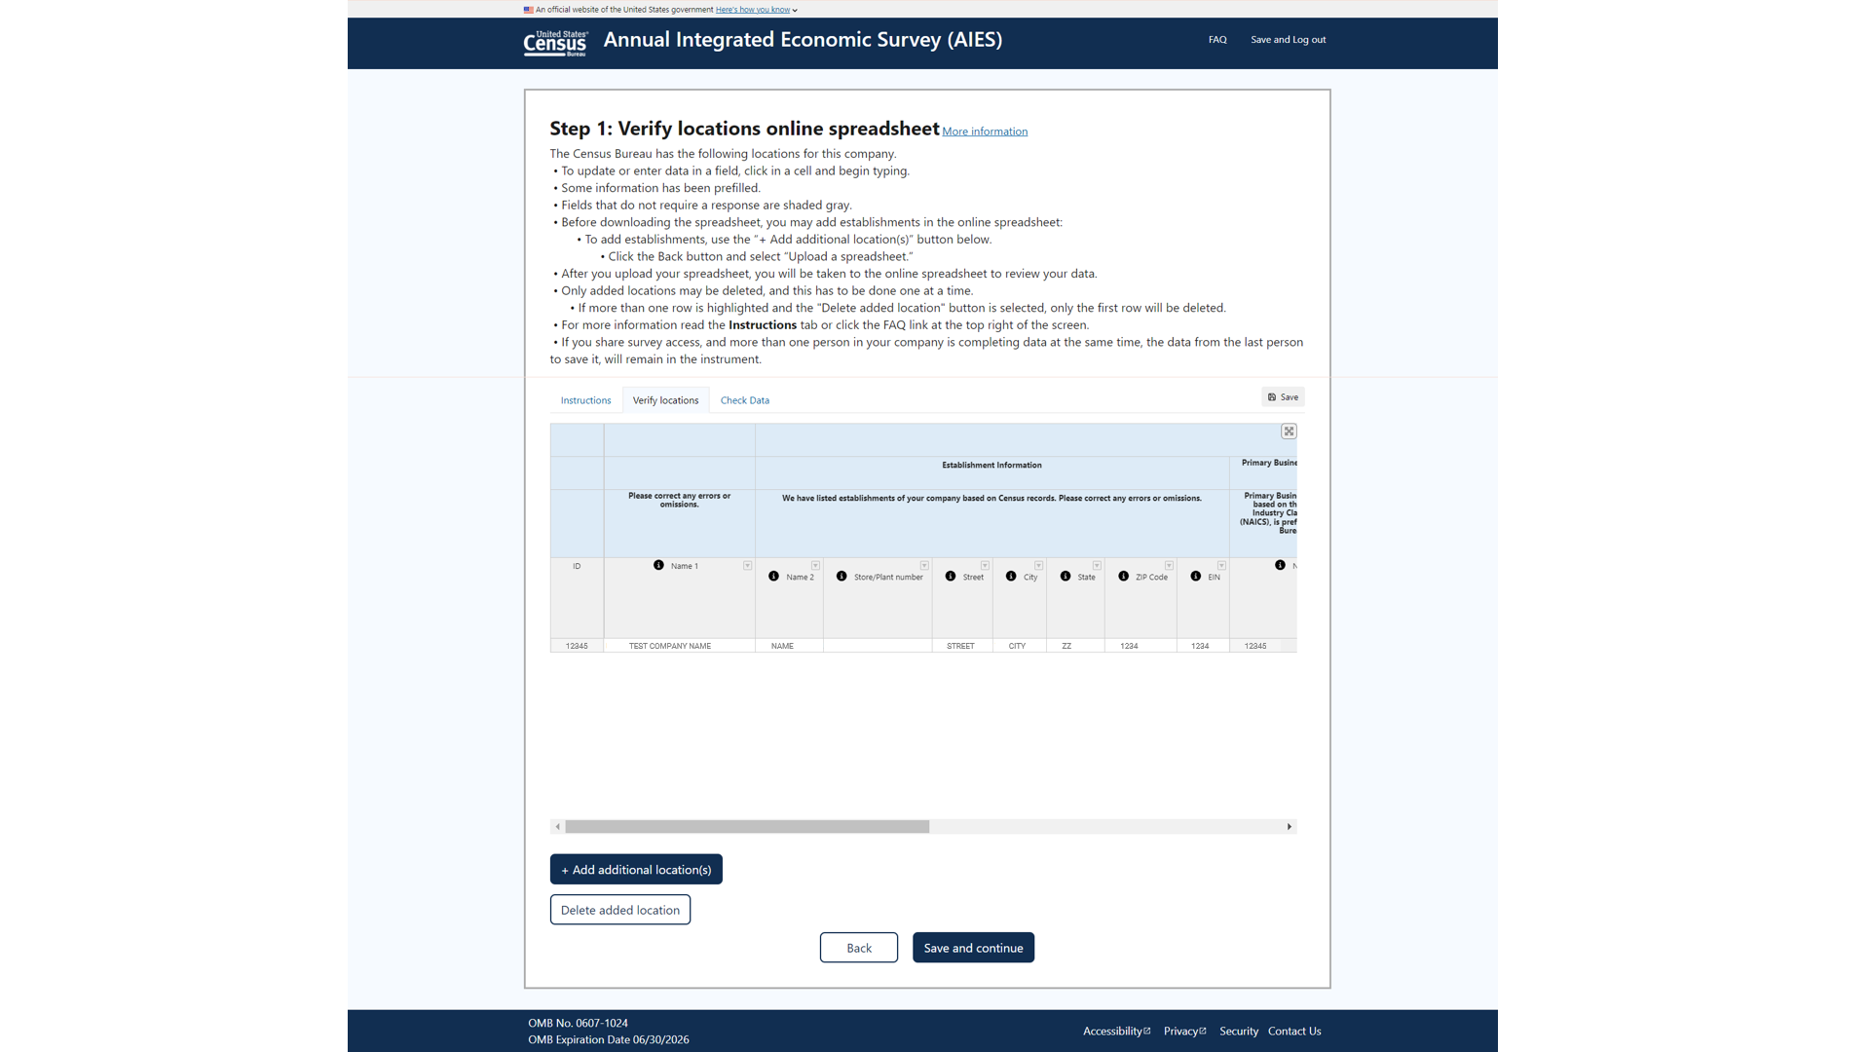

## Run Checks

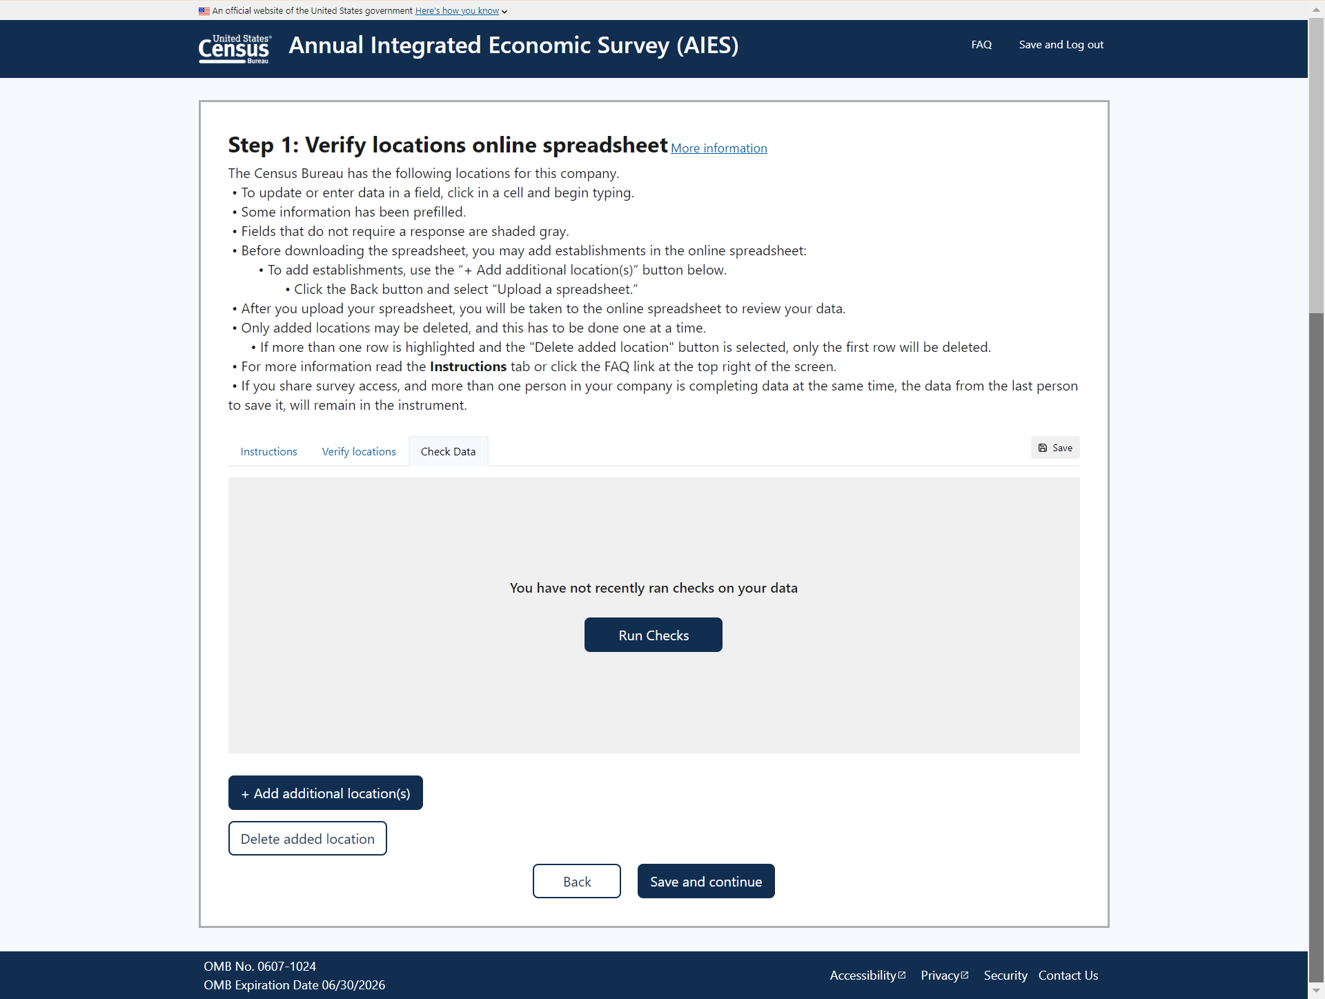

## Add a Location

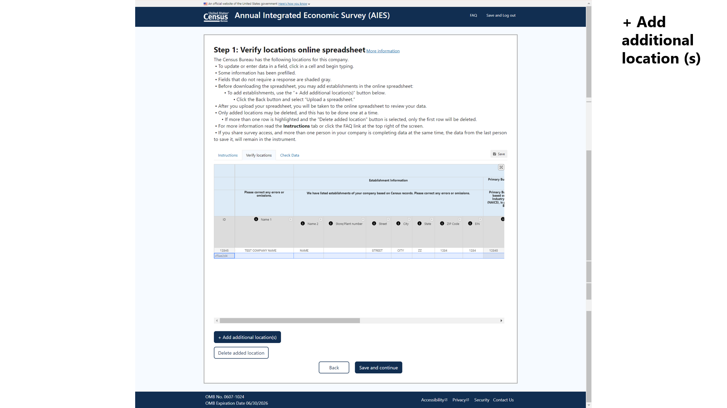

# STEP ONE: Download Path

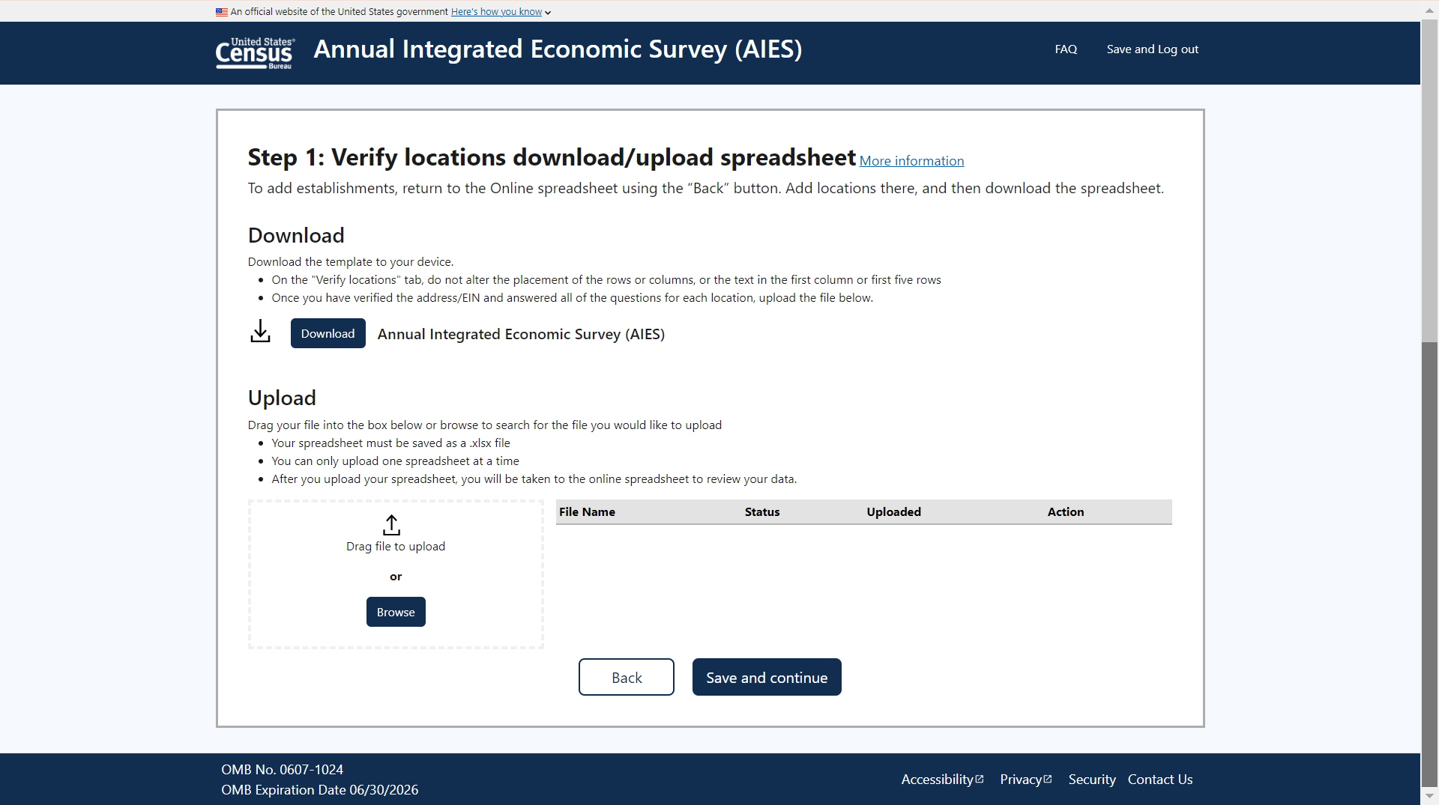

## STEP ONE B.

*If location added*

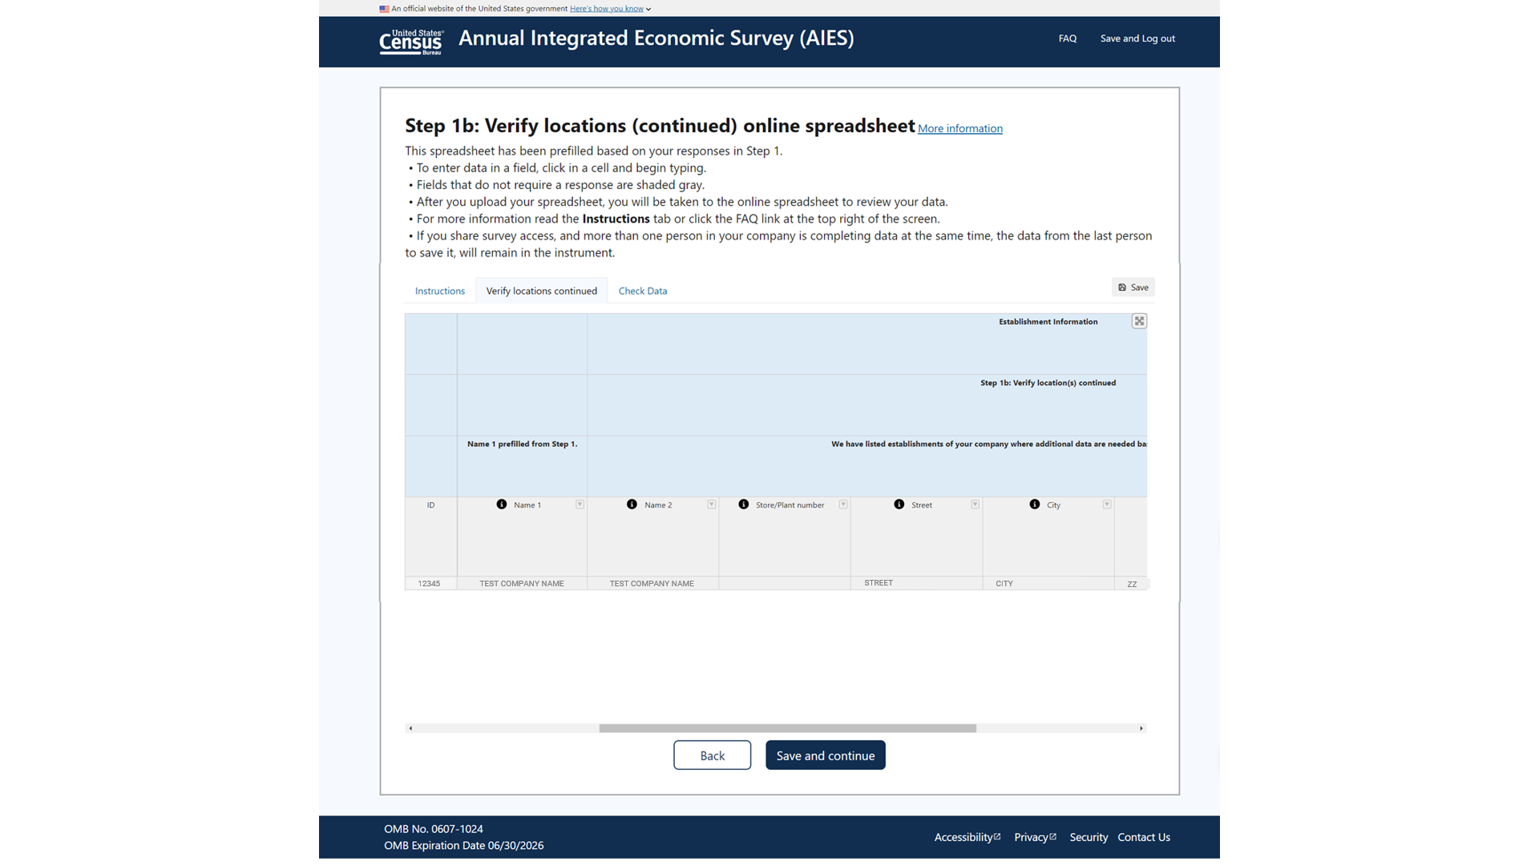

# STEP TWO

*[Not all Step 2 screens displayed]*

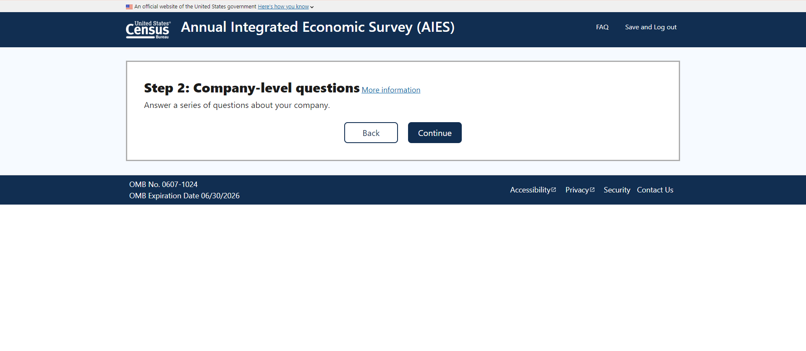

STEP TWO

## Company Mailing Address

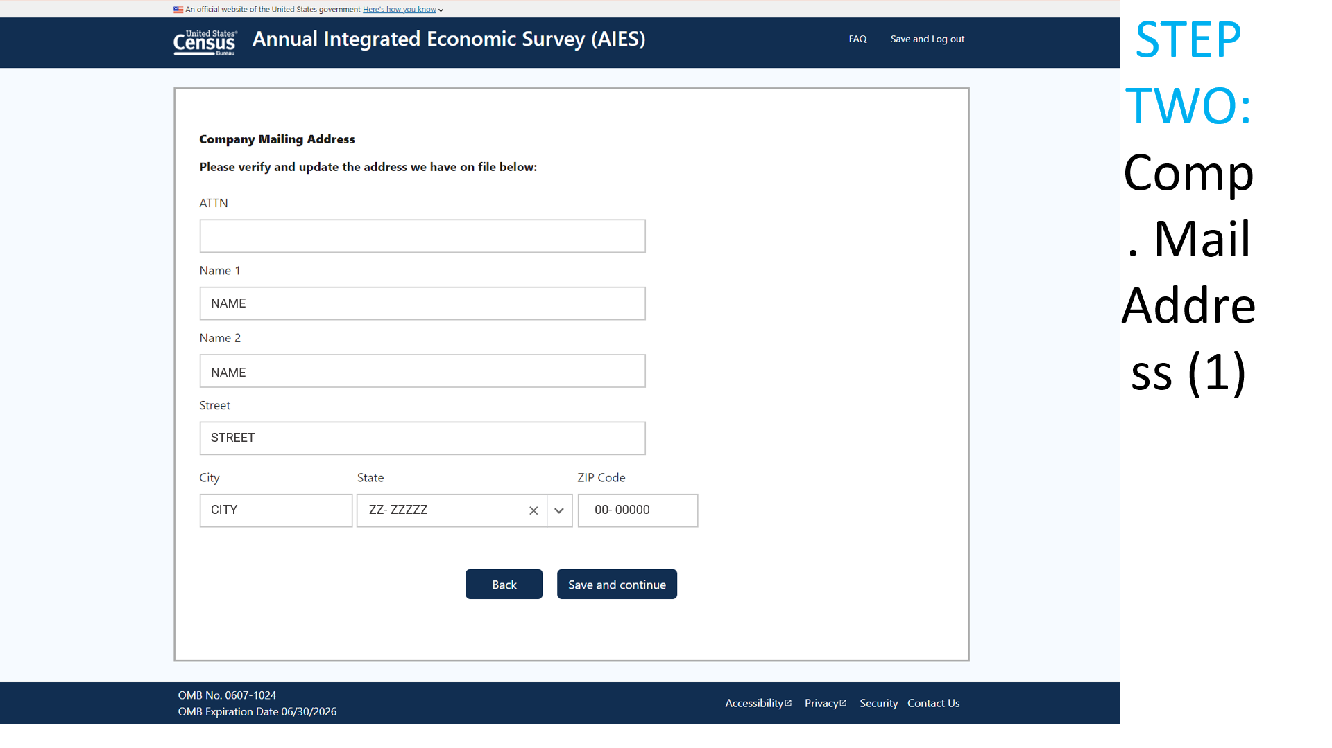

STEP TWO

## Reporting Period

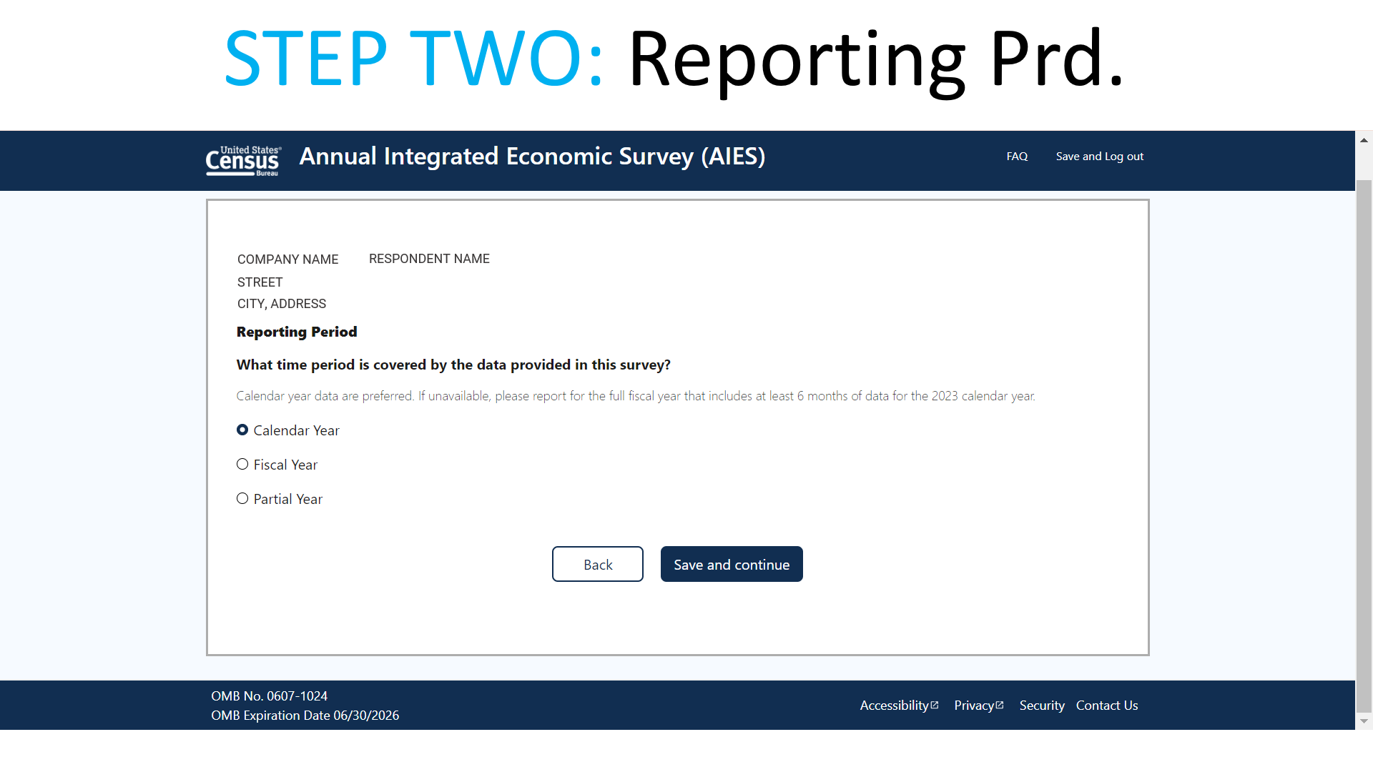

# STEP THREE: Choice

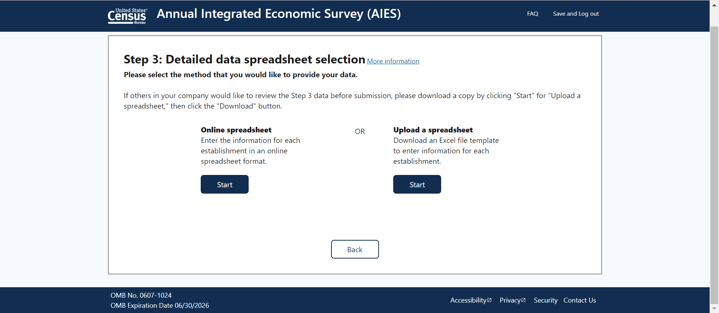

# STEP THREE: Online Path

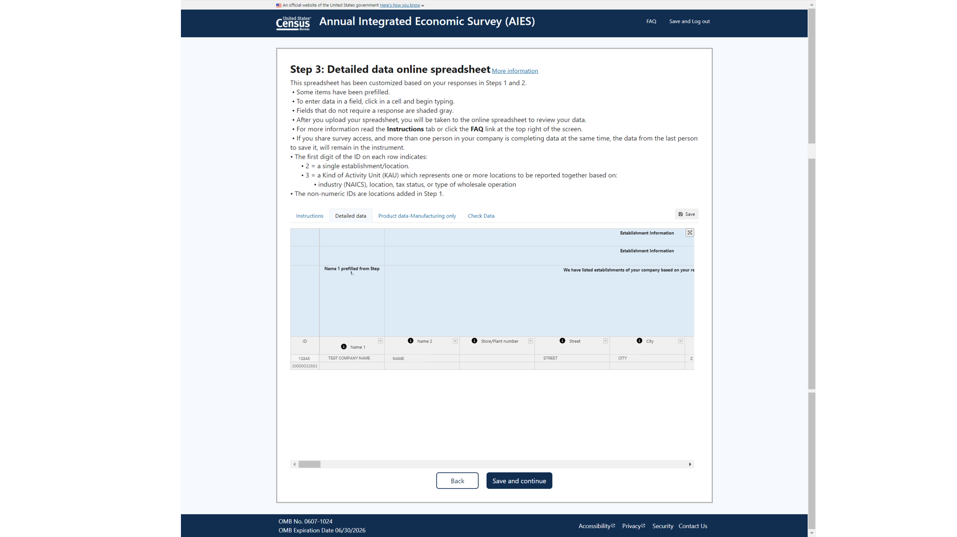

# STEP THREE: Download Path

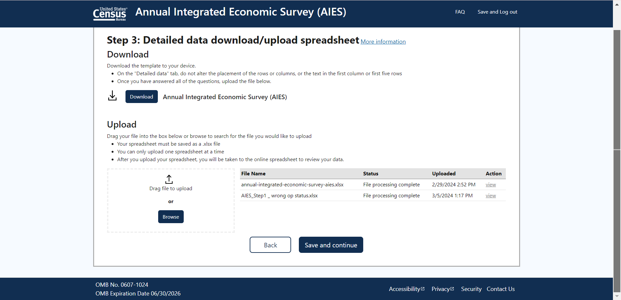

# SUBMIT

