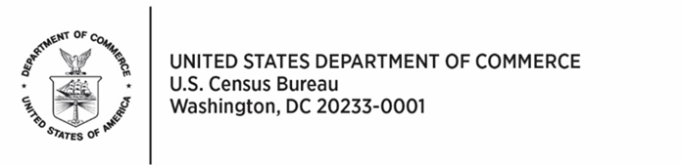

**CONSENT FORM**

The U.S. Census Bureau routinely conducts research on how we, and our partners, collect information in order to produce the best statistics possible. You have volunteered to take part in a study of data collection procedures.

We plan to use your feedback to improve the design and layout of the form for future data collections. Only staff involved in this product design research will have access to any responses you provide. This collection has been approved by the Office of Management and Budget (OMB). This eight-digit OMB approval number, 0607-0725, confirms this approval and expires on 12/31/2025. Without this approval, we could not conduct this study.

In order to have a complete record of your comments, your interview will be recorded (e.g., audio and screen). We plan to use your feedback to improve the design and layout of survey forms for future data collections. Only staff involved in this product design research will have access to the recording.

**AUTHORITY AND CONFIDENTIALITY**

This collection is authorized under Title 13 U.S. Code, Sections 131 and 182. The U.S. Census Bureau is required by Section 9 of the same law to keep your information confidential and can use your responses only to produce statistics. Your privacy is protected by the Privacy Act, Title 5 U.S. Code, Section 552a. The uses of these data are limited to those identified in the Privacy Act System of Record Notice titled “COMMERCE/CENSUS-4, Economic Survey Collection.” The Census Bureau is not permitted to publicly release your responses in a way that could identify you, your business, organization, or institution. Per the Federal Cybersecurity Enhancement Act of 2015, your data are protected from cybersecurity risks through screening of the systems that transmit your data.

**BURDEN ESTIMATE**

We estimate that completing this interview will take 45 minutes on average, including the time for reviewing instructions, searching existing data sources (if necessary), gathering and maintaining the data needed (if necessary), and completing and reviewing the collection of information. You may send comments regarding this estimate or any other aspect of this survey, including suggestions for reducing the time it takes to complete this survey to [econ.btos@census.gov](mailto:econ.btos@census.gov)

Click here to participate in this research.

* I agree to participate in this research

Enter your information below:

First Name: __________________________________________________

Last Name: __________________________________________________