# Commodity Flow Survey Screenshots

**Production 2022**

Contents

Commodity Flow Survey Screenshots 1

Login Screen 2

Pre Screener Reporting Choice 3

Main Menu 4

Item A: Company Information 5

Item A: Shipping Location Information 6

Item B: Total Annual Value of Shipments 7

Item C: Operating Status 7

Item D: Total Number and Value of Outbound Shipments 8

Item E: HAZMAT 8

Item F1: Shipment Reporting Options 8

Upload Shipments: *Spreadsheet Path* 9

Item F1: Shipment Reporting Options 9

Item F3: Shipment Characteristics 10

Item F: Enter Shipments 11

Item G1: Shipment Validation 11

Item G1: Shipment Validation, *Overlay* 12

Item G2: Product Code Validation 12

Shipment Validation: ML Overlay 13

Review Responses 14

Item I: Time to complete 14

Item J: Remarks 14

Submit Responses 15

## Login Screen

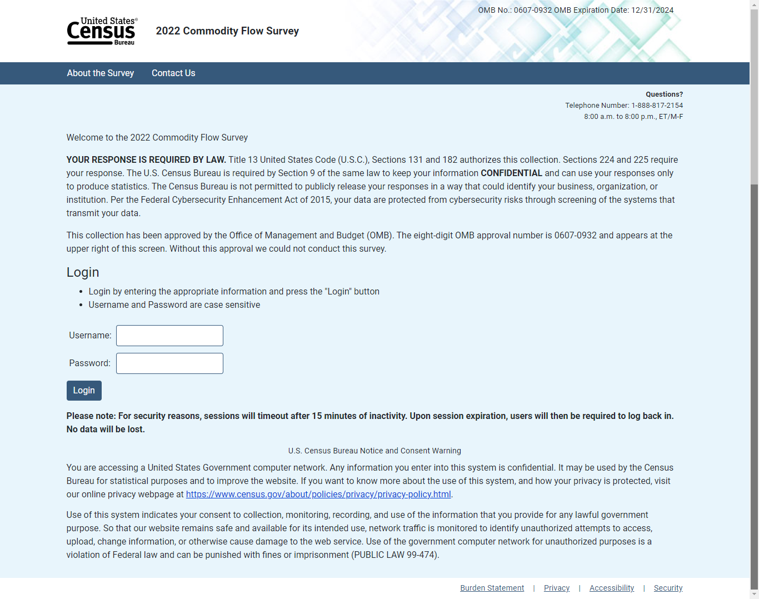

## Pre Screener Reporting Choice

(Select MU’s only)

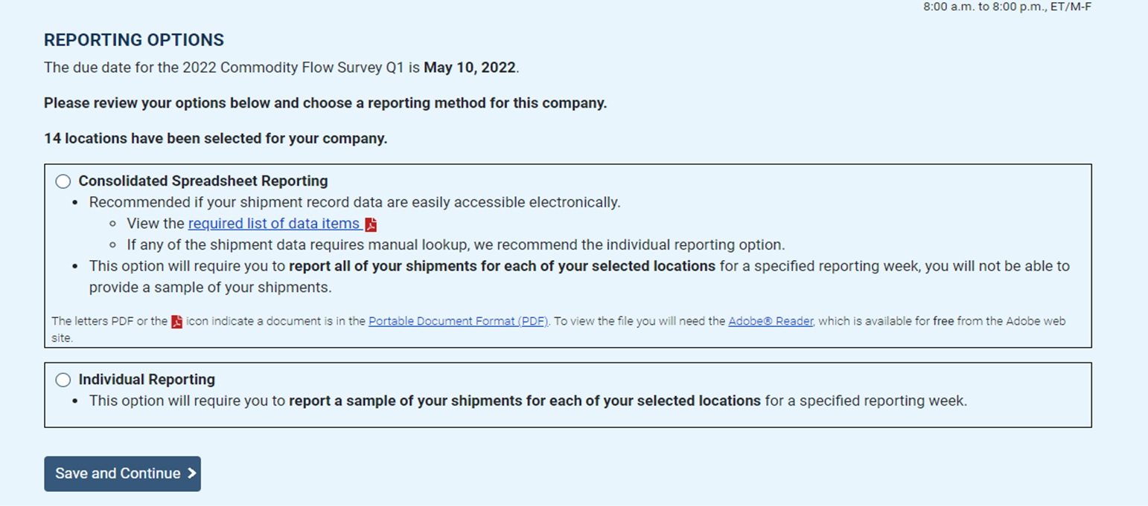

## Main Menu

## Item A: Company Information

## Item A: Shipping Location Information

## Item B: Total Annual Value of Shipments

## Item C: Operating Status

Originating Shipments Statement

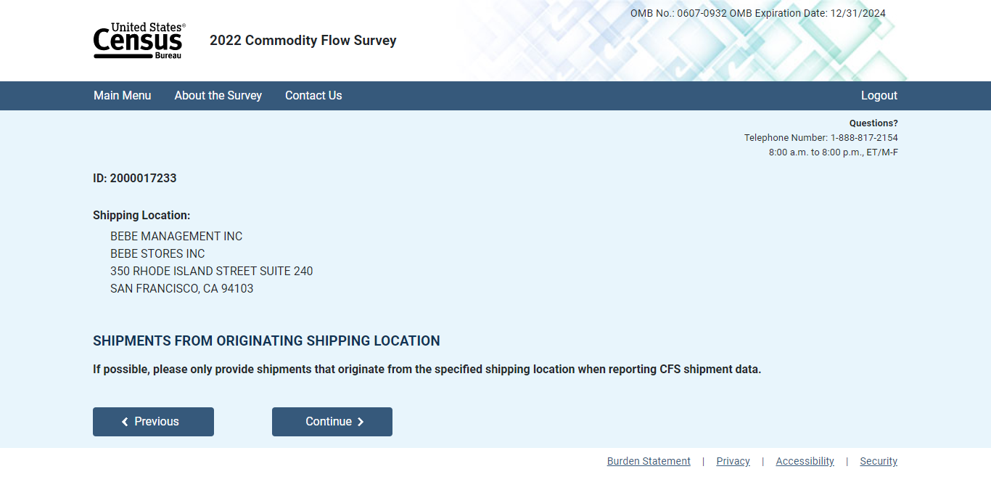

## Item D: Total Number and Value of Outbound Shipments

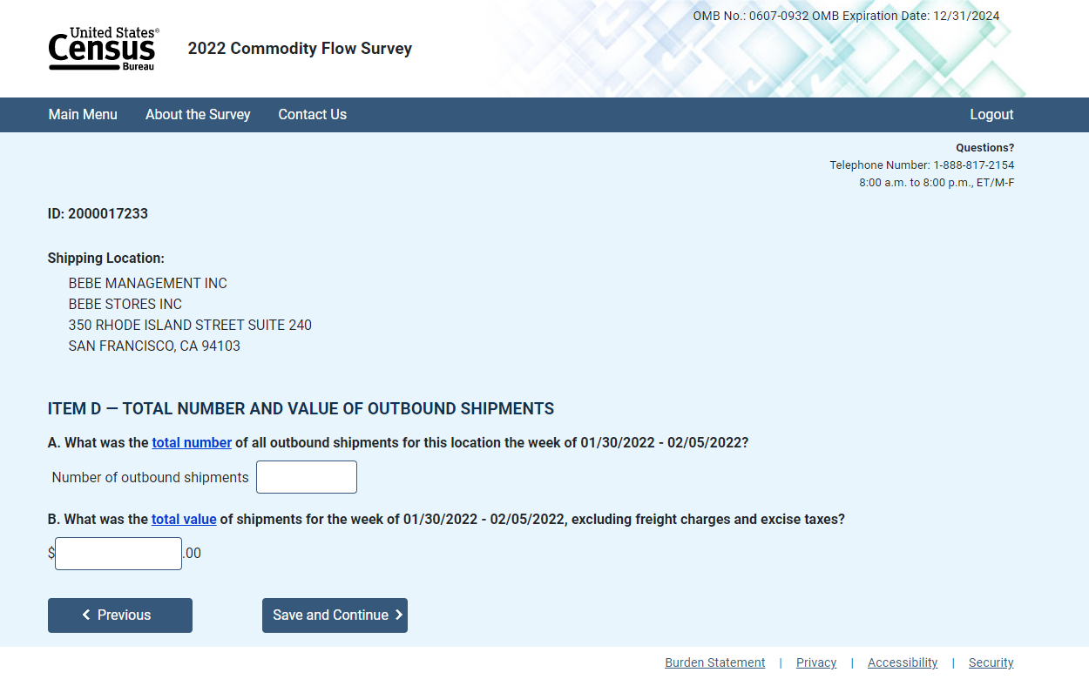

## Item E: HAZMAT

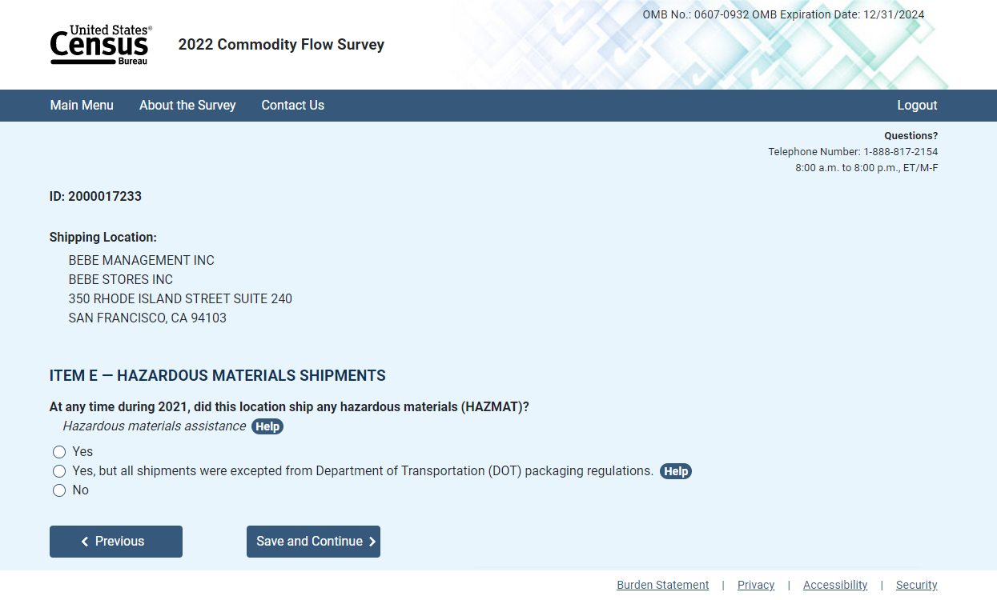

## Item F1: Shipment Reporting Options

Path A: Below 50 Shipments or ConsolidatedReporter

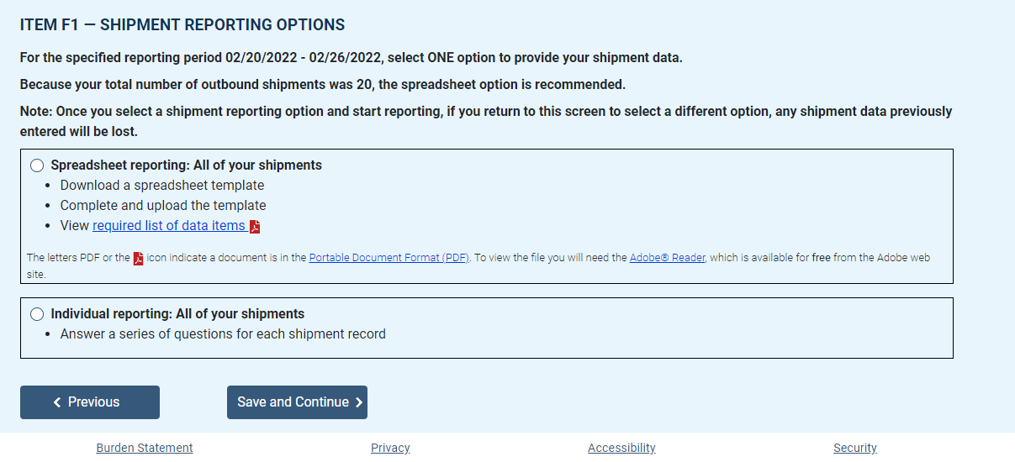

## Upload Shipments: *Spreadsheet Path*

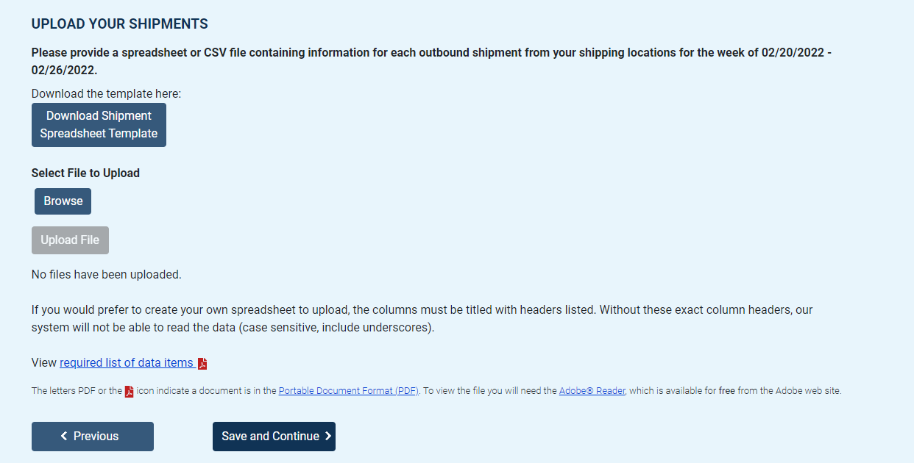

## Item F1: Shipment Reporting Options

Path B: Above 50 Shipments or IndividualReporter

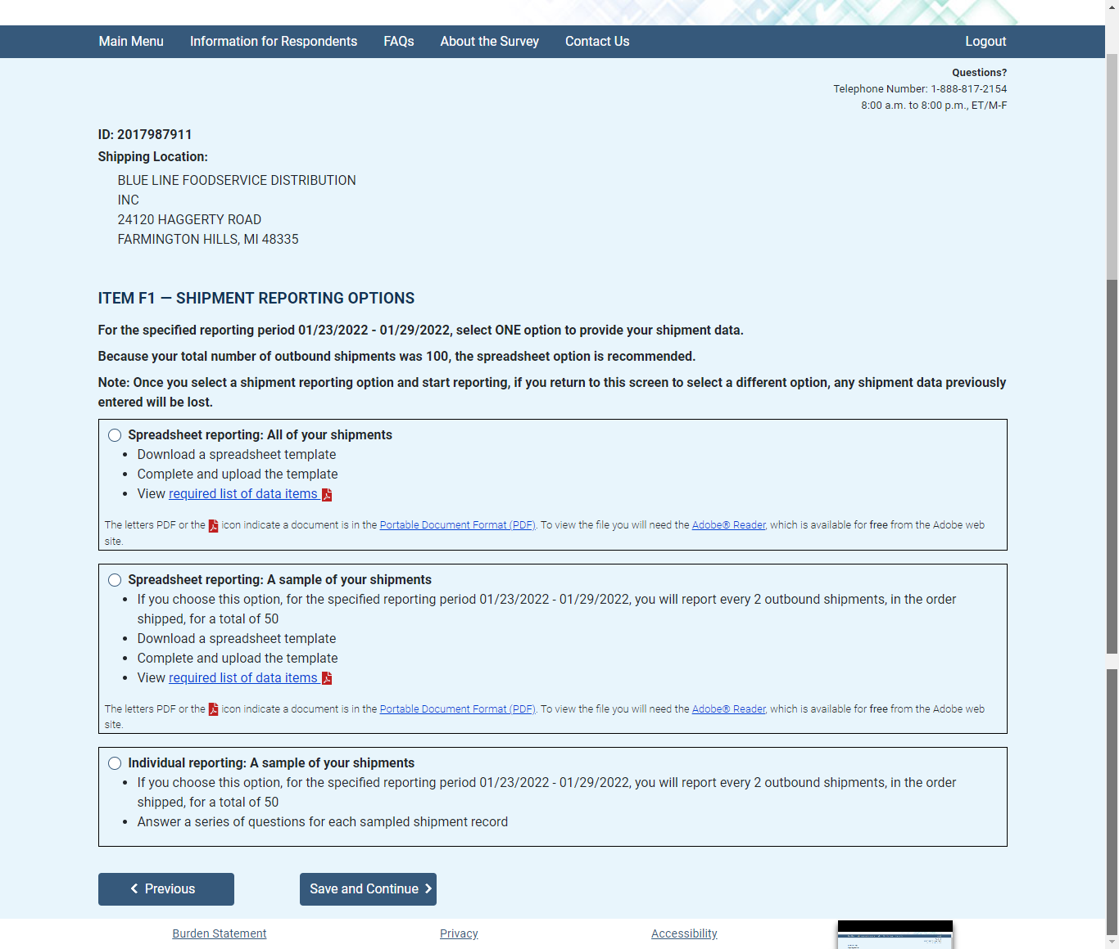

## Item F3: Shipment Characteristics

*Individual shipment reporting*

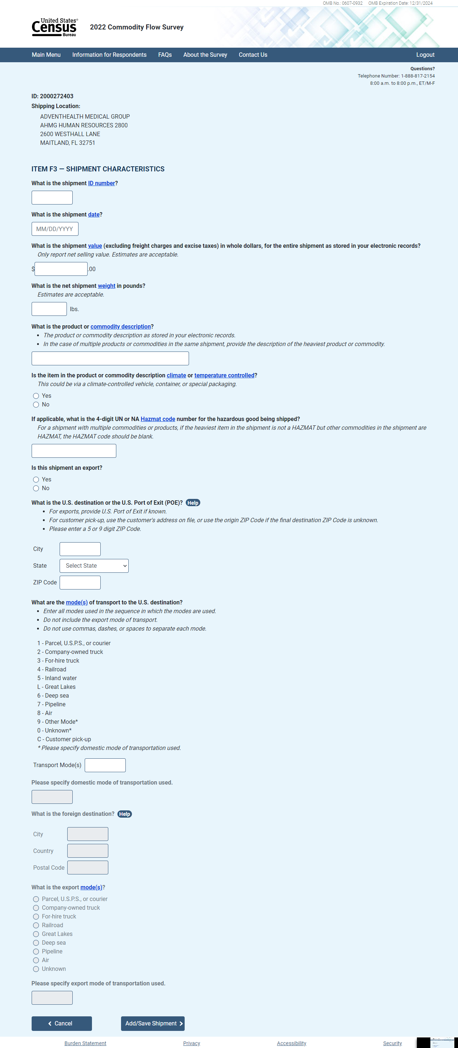

## Item F: Enter Shipments

*Individual shipment reporting*

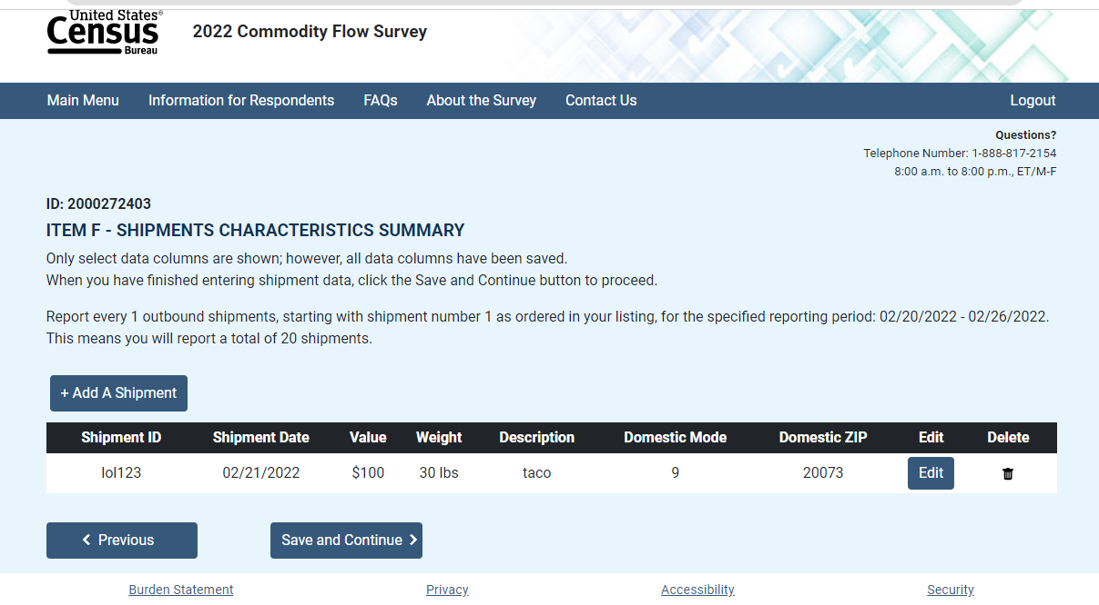

## Item G1: Shipment Validation

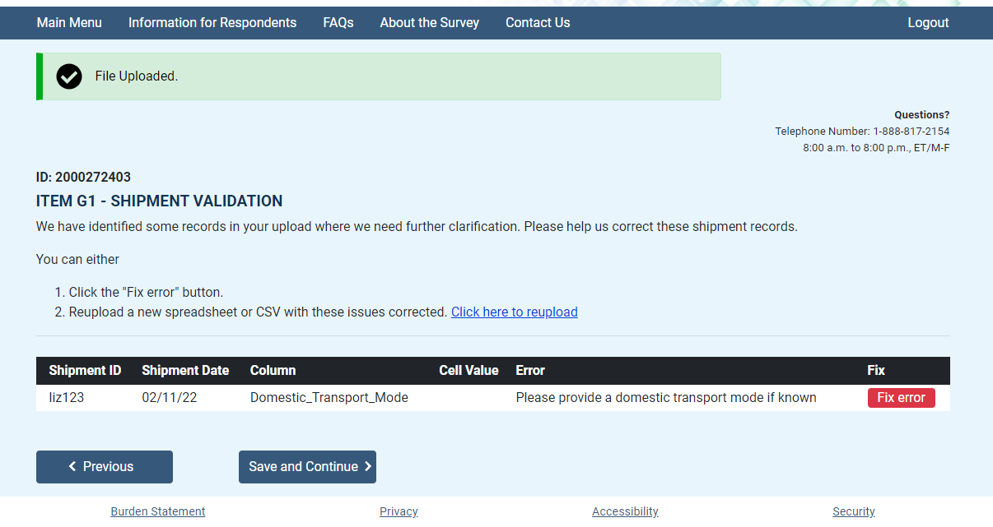

## Item G1: Shipment Validation, *Overlay*

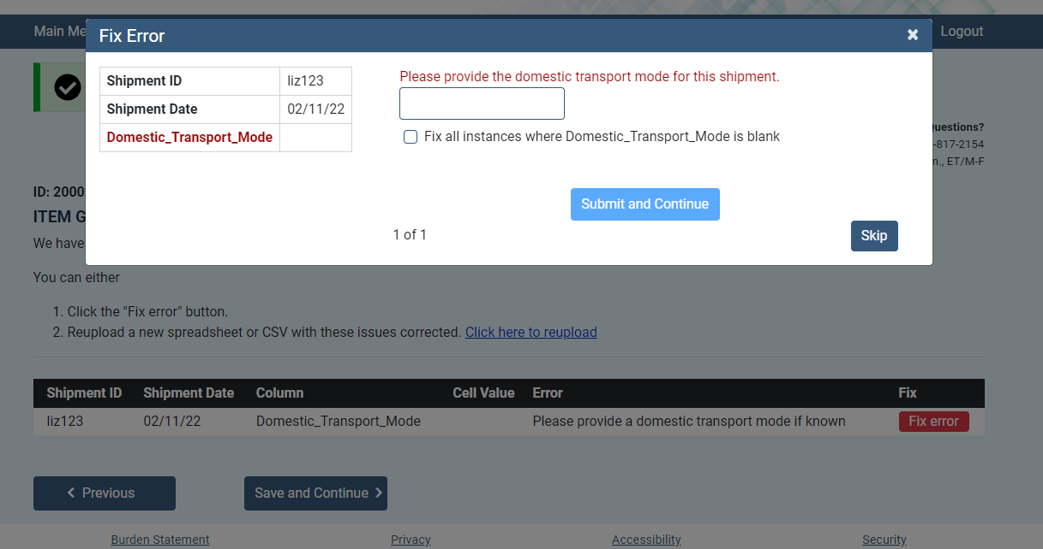

## Item G2: Product Code Validation

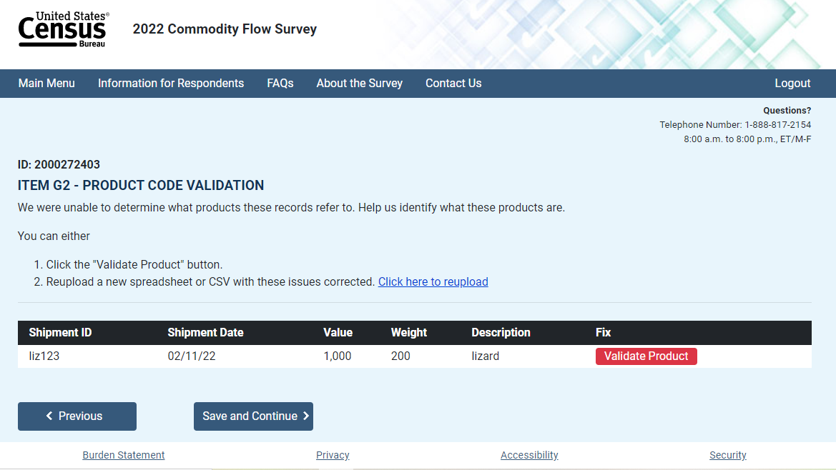

Shipment Validation: ML Overlay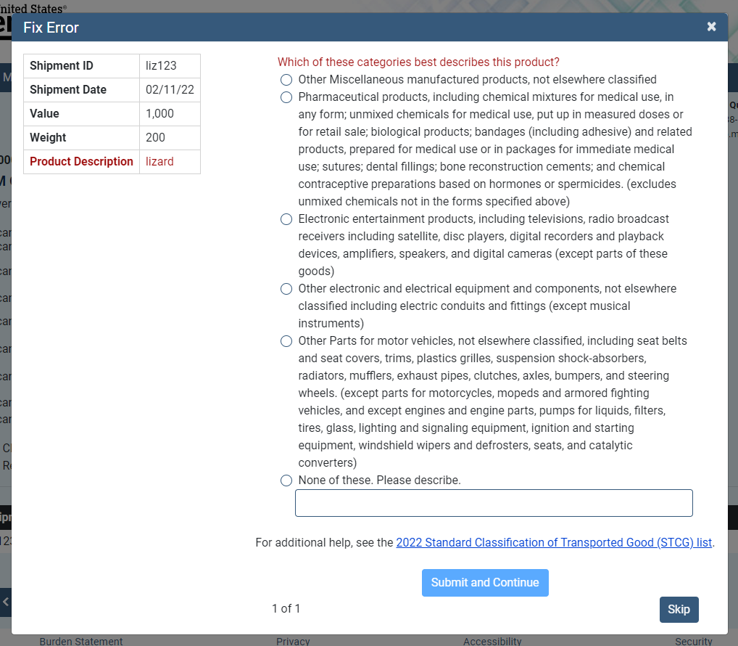

Note: HAZMAT Section begins here if respodent selected ‘Yes’ for *Item E*

Review Responses

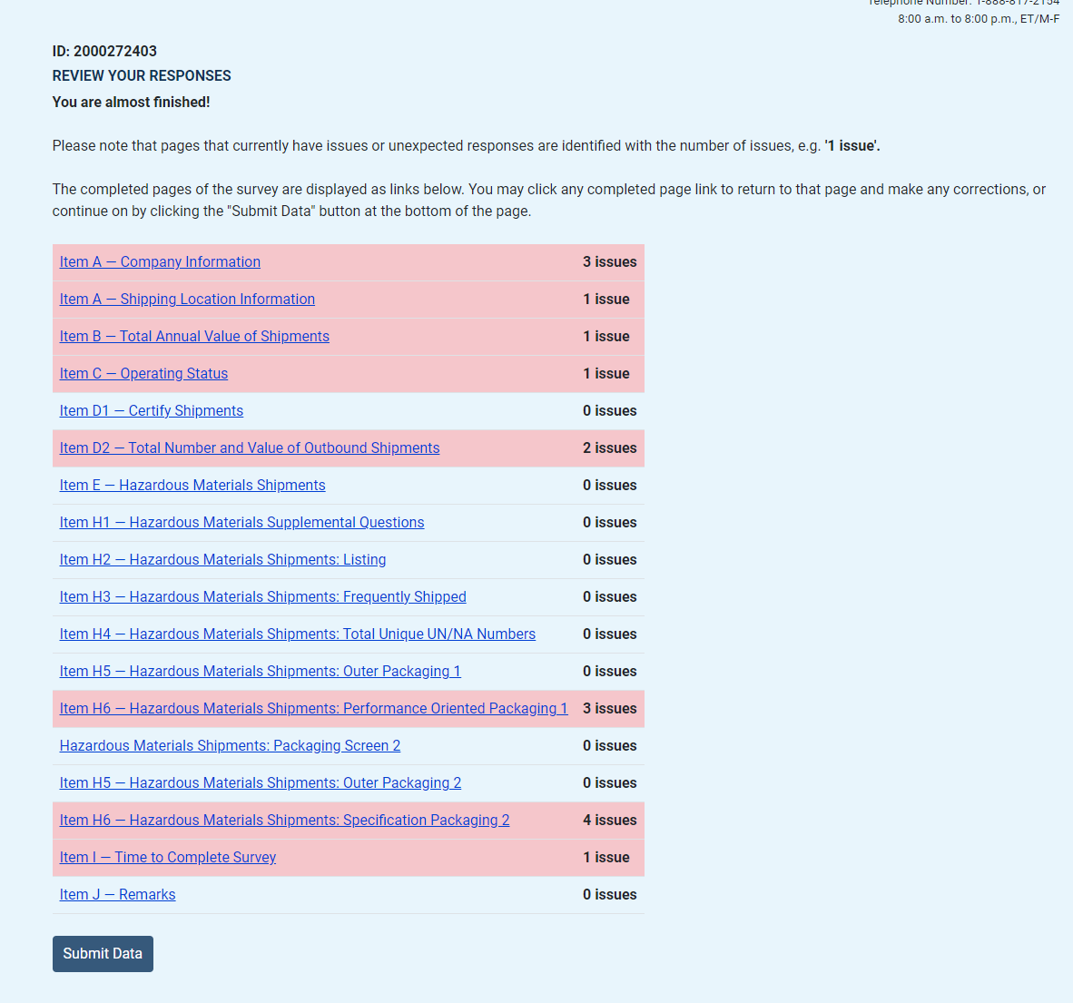

## Item I: Time to complete

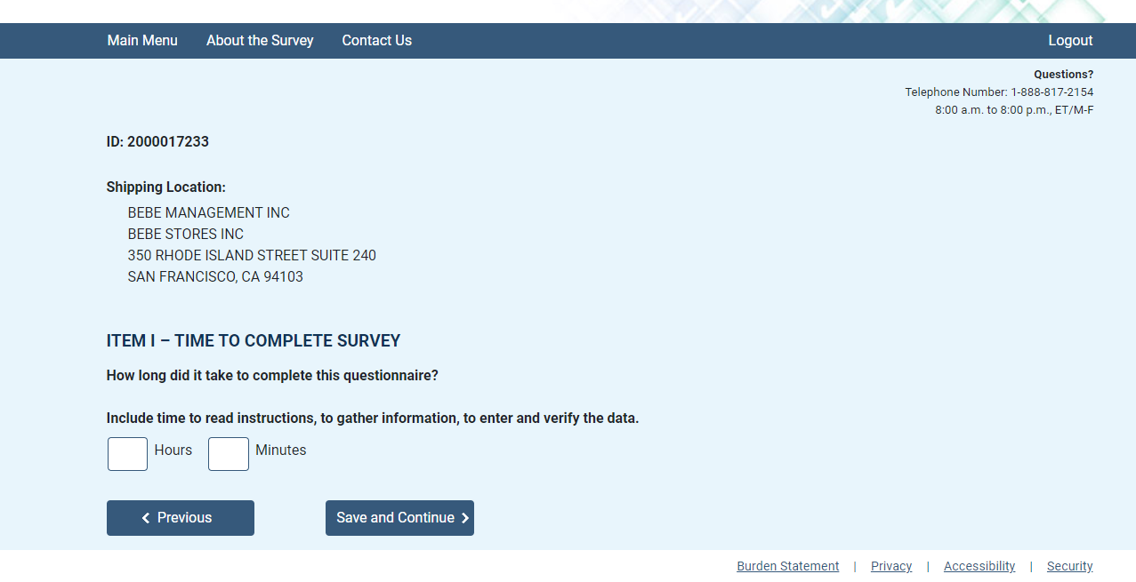

## Item J: Remarks

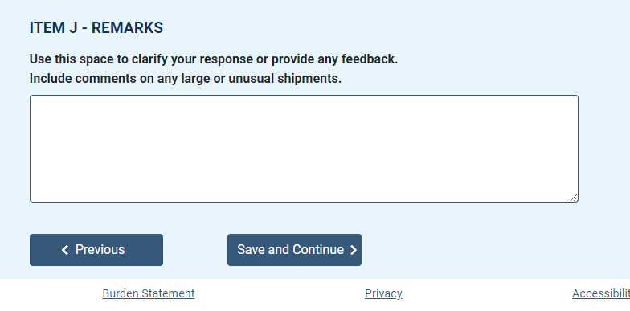

## Submit Responses

