*Attachment I: Communication Materials, Screener, and Consent Forms*

*National Health Interview Survey*

*(NHIS)*

*Cognitive Interviews*

*OMB# 0607-0725*

April 2025

# Cognitive Interview Recruitment Advertisements

Adults Needed for Testing a National Health Survey

The Census Bureau is looking for adults to help test question wording on a national survey about health. Interviews will be one hour and will take place by computer and phone, through Microsoft Teams. **We will provide $40 to each person who participates in the study.**

We are looking for adults 18 years or older to participate. We are especially interested in participants who meet **any** of the following criteria:

* Are aged 65 and over
* Live in a household with extended family or unrelated roommates
* Received food stamps or government assistance for rent payments
* Live in a household where an individual is on Medicaid

**To see if you are eligible for the study, please answer a few questions at**

[**www.XXXXXXXX.com**](http://www.xxxxxxxx.com/)**, or contact Kevin at (301) 763-4979 or** [**csm.participate@census.gov**](mailto:csm.participate@census.gov) **for further information. Please mention the code HEALTH when you call or email.**

# Cognitive Interview Recruitment Protocol and Eligibility Screener

RECRUITER-ADMINISTERED SCREENING QUESTIONNAIRE FOR NHIS

Hello, I’m _____________ from the Census Bureau. Thank you for contacting us about participating in one of our studies. I just need to get a little bit of background information to start.

The U.S. Census Bureau is conducting a study on behalf of the National Center for Health Statistics to improve questions in a national survey about health-related topics. The purpose of collecting this information is to improve and inform future surveys. Selected participants will be asked for their thoughts and opinions about some survey questions. If you are eligible, we will invite you to a 60-minute interview which will be conducted via a secure video conferencing app. Your will receive $40 to thank you for their time.

To determine if you are eligible for the interview, we must ask you a few screening questions. Your participation in the eligibility screening is completely voluntary. You may stop at any time or skip questions that you do not want to answer.

1. What is your name?

First name:_____________________

Last name:_____________________

1. What is your email address?
2. What is the best number to reach you during the day?

Mobile ([ ]) [ ] – [ ]

Home (if not mobile) ([ ]) [ ] – [ ]

Work (if any) ([ ]) [ ] – [ ] EXT.[ ]

4a. IF PROVIDED MOBILE NUMBER: If you qualify to participate in a study, we may send you a text message to remind you of your appointment. Do we have permission to send you text message reminders?

* Yes, you have my permission to send me text message reminders
* No, I prefer not to receive them

1. In what city, state, and ZIP code do you currently live?

City:_____________________

State:_____________________

Zip code:__________________

1. [if interviewer administered] Is your household’s annual income … (Read until interrupted.)

* Less than $15,000?
* $15,000 to $25,000?
* $25,000 to $50,000?
* $50,000 to $100,000?
* More than $100,000?

1. [if self administered] Is your household’s annual income …

* Less than $15,000?
* $15,000 to $24,999?
* $25,000 to $49,999?
* $50,000 to $100,000?
* More than $100,000?

1. [ASK IF HOUSEHOLD HAS > 1 PERSON] Who lives or stays with you?

*Select all that apply.*

[ ] Parent(s)

[ ] Grandparent(s)

[ ] Husband/wife/spouse

[ ] Unmarried partner

[ ] Children

[ ] Grandchildren

[ ] Other relative(s)

[ ] Roommates

[ ] Friends

[ ] Renter

[ ] Landlord or home Owner

[ ] Other – please specify ______________

1. ASK IF “Children” OR “Grandchildren” IS SELECTED: What is your relationship to the children/grandchildren in your household?

*Select all that apply.*

[ ] Biological or adoptive (grand)parent

[ ] Step (grand)parent

[ ] (Grand)parent-in-law

[ ] Aunt or uncle

[ ] Foster (grand)parent

[ ] Unrelated/No relation

[ ] Other – please specify: ______________

1. Have you ever used any of the following products?

*Select all that apply.*

* 1. Tobacco products
  2. E-cigarettes
  3. None of the above

1. Which of the following best describes the place where you now live…urban, suburban, or rural?

[ ] Urban

[ ] Suburban

[ ] Rural

**IF THEY HAVE AN EMAIL ADDRESS:**

**Thanks for taking some time to answer my questions today. Whether or not you are selected I am going to email you some more information about how we protect the privacy of your data and your rights. [SKIP TO WRAP UP TEXT FOR ALL BELOW]**

**IF THEY DO NOT HAVE AN EMAIL ADDRESS:**

**Thanks for taking some time to answer my questions today. If you qualify, someone will be back in touch with you soon to schedule an interview.**

**The U.S. Census Bureau is conducting this voluntary survey​ on behalf of the National Center for Health Statistics. We are required by law to protect your information. The purpose of collecting this information is to improve and inform future surveys.**

**Strict federal laws protects your privacy and keep your answers confidential under Section 308(d) of the Public Health Service Act (42 U.S.C. 242m(d)) and the Confidential Information Protection and Statistical Efficiency Act or CIPSEA (44 U.S.C. 3561-3583). Under the Federal Cybersecurity Enhancement Act of 2015, your data are protected from cybersecurity risks through screening of the systems that transmit your data, but not the security of your personal device. The Census Bureau can only protect information once it is in the Census Bureau system and therefore cannot promise protection related to information shared when using a personal device.**

**WRAP-UP TEXT FOR ALL:**

**Over the next few weeks, we will be selecting individuals to test the survey. If you are selected, we will be calling you to set up a time for the interview. Do you have any questions for me? IF NO QUESTIONS: Thank you for your time!**

**[END SCREENING PHONE CALL]**

SELF ADMINISTERED SCREENING QUESTIONNAIRE FOR NHIS

Available at [**www.XXXXXXXX.com**](http://www.XXXXXXXX.com)

The U.S. Census Bureau is conducting research on behalf of the National Center for health Statistics to improve questions in a national survey about health-related topics. The purpose of this research is to get feedback on how easy or difficult the survey questions are to answer. Selected participants will be asked for their thoughts and opinions about some survey questions. If you are eligible, we will invite you to a 60-minute interview which will be conducted via a secure video conferencing app. You will receive $40 for participating in the interview.

To determine if you are eligible for the interview, we must ask you a few screening questions about your background. Your participation in the eligibility screening is completely voluntary. You may stop at any time or skip questions that you do not want to answer.

The U.S. Census Bureau is required by law to protect your information.

Strict federal law protects your privacy (the Privacy Act of 1974, 5 U.S.C. § 552a) and keeps your answers confidential under Section 308(d) of the Public Health Service Act (42 U.S.C. 242m(d)) and the Confidential Information Protection and Statistical Efficiency Act or CIPSEA (44 U.S.C. 3561-3583). Under the Federal Cybersecurity Enhancement Act of 2015 (6 U.S.C. § 151 and 151 note), your data are protected from cybersecurity risks through screening of the systems that transmit your data, but not the security of your personal device. The Census Bureau can only protect information once it is in the Census Bureau system and therefore cannot promise protection related to information shared when using a personal device.

We estimated that completing the screening questions will take 10 minutes on average. This information collection has been approved by the Office of Management and Budget (OMB). You can validate that this survey is a legitimate federally-approved information collection using the Office of Management and Budget's approval number 0607-0725, which expires December 31, 2025. We are required to tell you this number to conduct this survey. Send comments regarding this estimate or any other aspect of this survey, including suggestions for reducing the time it takes to complete this survey to adrm.pra@census.gov.

If you have questions, please contact the Center for Behavioral Science Methods at the U.S. Census Bureau, 301-763-4979. If you would like the contact NCHS directly, please call the office of the Ethics Review Board at the National Center for Health Statistics, toll-free at 1-800-223-8118.  Please leave a brief message with your name and phone number.  Say that you are calling about Project ID #2024-02. Your call will be returned as soon as possible.

If you are eligible for the study, we will call or email you to schedule a time for the interview.

1. What is your name?

First name:_____________________

Last name:_____________________

1. What is your email address?
2. What is the best number to reach you during the day?

Mobile ([ ]) [ ] – [ ]

Home (if not mobile) ([ ]) [ ] – [ ]

Work (if any) ([ ]) [ ] – [ ] EXT.[ ]

4a. IF PROVIDED MOBILE NUMBER: If you qualify to participate in a study, we may send you a text message to remind you of your appointment. Do we have permission to send you text message reminders?

* Yes, you have my permission to send me text message reminders
* No, I prefer not to receive them

1. In what city, state, and ZIP code do you currently live?

City:_____________________

State:_____________________

Zip code:__________________

[if self administered] Is your household’s annual income …

* Less than $15,000?
* $15,000 to $24,999?
* $25,000 to $49,999?
* $50,000 to $100,000?
* More than $100,000?

1. [ASK IF HOUSEHOLD HAS > 1 PERSON] Who lives or stays with you?

*Select all that apply.*

[ ] Parent(s)

[ ] Grandparent(s)

[ ] Husband/wife/spouse

[ ] Unmarried partner

[ ] Children

[ ] Grandchildren

[ ] Other relative(s)

[ ] Roommates

[ ] Friends

[ ] Renter

[ ] Landlord or home Owner

[ ] Other – please specify ______________

1. ASK IF “Children” OR “Grandchildren” IS SELECTED: What is your relationship to the children/grandchildren in your household?

*Select all that apply.*

[ ] Biological or adoptive (grand)parent

[ ] Step (grand)parent

[ ] (Grand)parent-in-law

[ ] Aunt or uncle

[ ] Foster (grand)parent

[ ] Unrelated/No relation

[ ] Other – please specify: ______________

1. Have you ever used any of the following products?

*Select all that apply.*

* 1. Tobacco products
  2. E-cigarettes
  3. None of the above

1. Which of the following best describes the place where you now live?

[ ] Urban

[ ] Suburban

[ ] Rural

**Thank you for taking the time to answer our questions today. We will get back to you soon if you are eligible for an interview.**

**[END OF SELF-ADMINISTERED SCREENER]**

If they are selected for interview they will receive a follow-up phone call. This will be read to them when scheduling:

**The session will be conducted using an application called Microsoft Teams. You will use a computer or phone at home. When joining by computer, Microsoft Teams will open in a browser window. When joining by phone, you will open Microsoft Teams through an app. A researcher will send you an email with a calendar invite to the meeting and a form explaining your rights as a participant. Is this okay?**

# Privacy Protection Email

(All participants who call in for recruiting will be sent this email.)

Dear [NAME]:

Thanks for taking some time to answer my questions today. If you qualify, someone will be back in touch with you soon to schedule an interview.

The U.S. Census Bureau is required by law to protect your information. We are conducting this voluntary survey​ on behalf of the National Center for Health Statistics. The purpose of collecting this information is to improve and inform future surveys.

Strict federal law protects your privacy (the Privacy Act of 1974, 5 U.S.C. § 552a) and keeps your answers confidential under Section 308(d) of the Public Health Service Act (42 U.S.C. 242m(d)) and the Confidential Information Protection and Statistical Efficiency Act or CIPSEA (44 U.S.C. 3561-3583). Under the Federal Cybersecurity Enhancement Act of 2015 (6 U.S.C. § 151 and 151 note), your data are protected from cybersecurity risks through screening of the systems that transmit your data, but not the security of your personal device. The Census Bureau can only protect information once it is in the Census Bureau system and therefore cannot promise protection related to information shared when using a personal device.

We estimated that completing the screening questions will take 10 minutes on average. If you participate in the interview, that will take about an hour on average. This information collection has been approved by the Office of Management and Budget (OMB). You can validate that this survey is a legitimate federally-approved information collection using the Office of Management and Budget's approval number 0607-0725, which expires December 31, 2025. We are required to tell you this number to conduct this survey. Send comments regarding this estimate or any other aspect of this survey, including suggestions for reducing the time it takes to complete this survey to adrm.pra@census.gov.

Thank you for your time and your assistance,

[NAME]

# Email to schedule participant

Hi xxx,

We would like to schedule you for an interview. The study is virtual, 60 minutes, and you will receive $40 in compensation after finishing the study. We have the following times available (all times are in EST):

Monday, [month day]

* + - * + x:xx-x:xx am/pm

Tuesday, [month day]

* + - * + x:xx-x:xx am/pm

Wednesday, [month day]

* + - * + x:xx-x:xx am/pm

Thursday, [month day]

* + - * + x:xx-x:xx am/pm

Please respond to this email and indicate what days and times are best for you. If none of these dates and times work for you, please let us know.

If you have any questions or concerns, please reach out to me via email or call me at [insert phone number].

Thank you!

[Insert name]

# Consent Email (after scheduling interview)

Greetings [participant name],

We are looking forward to working with you on [Date, Time] for our upcoming conversation. At the above time please log into the Microsoft Teams calendar invite below. If you have any issues, please call [interviewer name] at [Interviewer phone number].

Below you will find a link to a webpage where you must read and sign a consent form before the time of your appointment to participate in this research.

[Consent form link]

Log in to Teams at the below link on [Date Time] **from a computer or smartphone.**

[Teams meeting link]

We are also including instructions on how to access Microsoft Teams.

If you have any questions, please contact me at [sender email] or [sender phone number].

Thank you,

[sender name]

[Teams attachment]

[FAQ IF REQUESTED]

# Reminder email no consent (sent 1 business day before interview)

Greetings ,

We are looking forward to working with you tomorrow [Date, Time] for our upcoming conversation. At the above time, please log into the Microsoft Teams meeting link found at the bottom of this email. If you have any issues, please call [interviewer name] at [Interviewer phone number].

We noticed you have not yet signed the consent form, you must do so before the time of your appointment. Below you will find a link to a webpage where you can give your signature to consent to participate in this research.

[Consent form link]

Log in to Teams at the below link on [Date Time] **from a computer or smartphone**.

[Teams Link]

We are also including instructions on how to access Microsoft Teams.

If you have any questions, please contact [sender name] at [sender email] or [sender phone number].

[sender name]

[Teams attachment]

[FAQ IF REQUESTED]

# Reminder email consent (sent one business day before interview)

Greetings,

We are looking forward to working with you tomorrow [Date, Time] for our upcoming conversation. Thank you for signing the consent form. At the above time, please log in to the Microsoft Teams at the below link on [Date Time] **from a computer or smartphone**. If you have any issues, please call [interviewer name] at [interviewer phone number].

[Teams Link]

We are including instructions on how to access Microsoft Teams.

If you have any questions, please contact [sender name] at [sender email] or [sender phone number].

Thank you,

[sender name]

[Teams attachment]

[FAQ IF REQUESTED]

# Microsoft Teams Attachment

**Downloading Microsoft Teams Prior to the Study**

1. **First go to the app store on your phone. Below is an image of what it looks like on iOS**

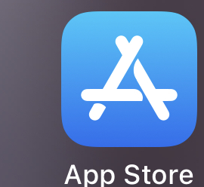

1. **Download “Microsoft Teams”**

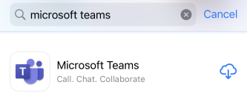

**Joining Study from Desktop/Laptop**

1. **You will receive an invitation that looks like this. Click the link to join at the time of your meeting:**

1. **If you already have Teams installed, feel free to use that. Otherwise select “continue on this browser.” Do NOT use Firefox:**

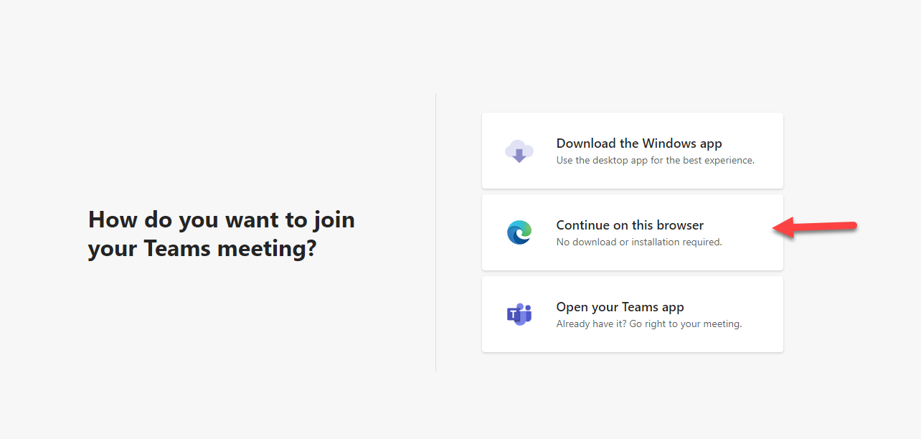

1. **Be sure to give permission to use your camera and microphone. Enter a name and click “join now**”

1. **This is how you share your screen**

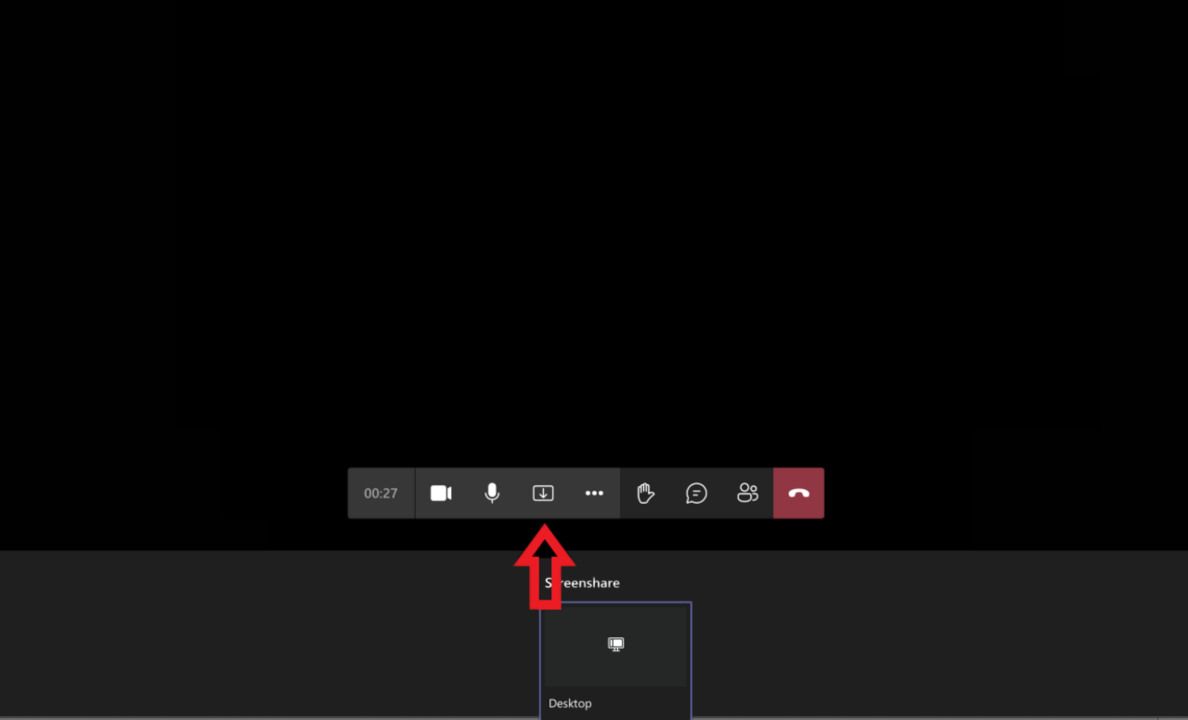

**Joining Study from Phone**

1. **You will receive an invitation that looks like this. Click the “Click here to join the meeting” when it’s time during the study.**

1. **Click “Join as a guest”**

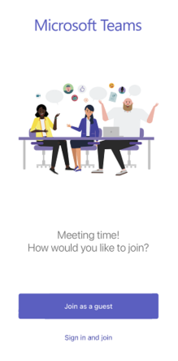

1. **Click “OK” to allow microphone**

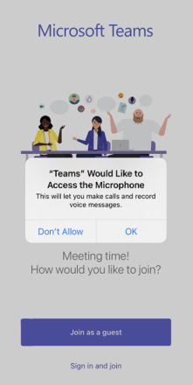

**4. Type your name and then click “Join Meeting”**

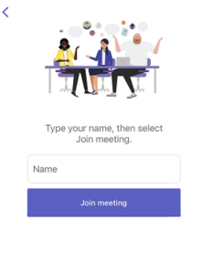

**5. This is what it will look like once you have joined the session**

**6. Click the three dots at the bottom**

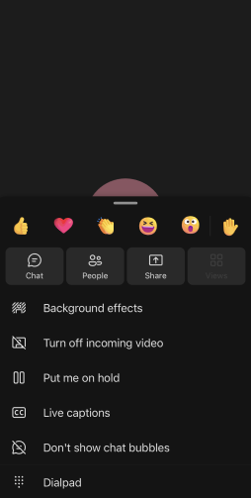

**7. Click the “Share” button. Then click “Share screen” and make sure “Audio” is toggled on.**

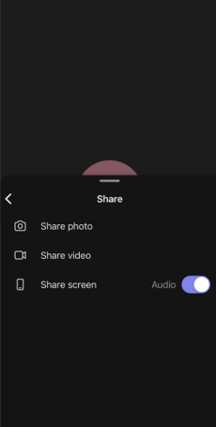

**8. Click “Start Broadcast”**

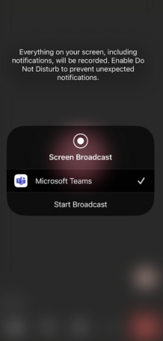

**8. Below is an example of what screen should look like when presenting**

# Consent Forms

**National Health Interview Survey**

**Consent to Participate in Research**

**Purpose.** The National Health Interview Survey (NHIS) is conducted by the National Center for Health Statistics (NCHS). We are conducting this study under the authority of 13 U.S.C. Section 8(b). Federal law protects your privacy (the Privacy Act of 1974, 5 U.S.C. § 552a) and keeps your answers confidential (Section 308(d) of the Public Health Service Act (42 U.S.C. 242m(d)) and the Confidential Information Protection and Statistical Efficiency Act (CIPSEA, Title 5 of Public Law 107-347). The U.S. Census Bureau is under contract with NCHS to develop the questionnaires. The purpose of this study is to evaluate the NHIS questionnaire items.

**Procedures.** If you agree to participate, the U.S. Census Bureau will ask you to complete select questionnaire items from the NHIS. The U.S. Census Bureau also will ask a series of debriefing questions that will help us revise the current questionnaire. The interview should take about 60 minutes. You should not be driving at any point during the interview, or we will have to end the interview and reschedule to a later date. This is for both your safety and the safety of those around you.

**Confidentiality.** Your participation is voluntary and all of the information you provide may be used only for statistical purposes and may not be disclosed, or used, in identifiable form for any other purpose except as required by law (Section 308(d) of the Public Health Service Act (42 U.S.C. 242m(d))and the Confidential Information Protection and Statistical Efficiency Act (CIPSEA, Title 5 of Public Law 107-347)). Your name will not be attached to the answers you provide.

**Possible Risks and Discomforts.** We do not anticipate any risks or discomforts for respondents. However, should you feel uncomfortable with any question asked, you may skip the question or stop the interview at any time.

**Voluntary Participation.** Your participation is completely voluntary. A decision to not participate will not be held against you. If you agree to participate, you will receive $40 via a digital gift card as a thank you for your time and input in the study.

**Further Questions.**

If you have questions, please contact the Center for Behavioral Science Methods at the U.S. Census Bureau, 301-763-8891. If you would like the contact NCHS directly, please call the office of the Ethics Review Board at the National Center for Health Statistics, toll-free at 1-800-223-8118.  Please leave a brief message with your name and phone number.  Say that you are calling about Project ID #2024-02. Your call will be returned as soon as possible. Your information will be kept in our database for up to 10 years, and you can contact us at csm.participate@census.gov any time to remove it before the 10 years have elapsed.

With your permission, we would like to record this interview. The interview will be recorded for the survey portion to make sure we don’t miss anything that you say and to help us write a report summarizing the results of the interviews. Direct quotes may be used in reports or in research presentations, but your name will never be used in any reports or presentations. If you do not wish to be recorded, you may still participate in the interview and will still receive $40 via a digital gift card for your participation.

By signing below, you agree that you, _______________________________, will participate in this study.

Your signature below will indicate that your questions have been answered satisfactorily, and that you have read and understood the information provided above.

**Use your mouse or finger to sign your name in the box below.**

___________________________________

Signature

Type today’s date below.

_________________________________

Fill in the following information below:

Your First Name:

Your Last Name:

OMB Control Number: 0607-0725. Approval expires 12/31/2025.

# Payment Voucher

**PUBLIC VOUCHER FOR PURCHASES AND SERVICES OTHER THAN PERSONAL**

The information that you provide in the spaces below will be used to release any incentive payments (cash or non-cash) to you. Census Bureau personnel will send you a link to receive the incentive no later than five business days after completion of your interview.

In the box below, please enter your name, email, and address where you would like to receive the digital incentive.

Name

Email Address

Street Address

City

State

ZIP

Please sign your name below. By signing your name, you acknowledge that the information for the voucher receipt is correct.

**Use your mouse or finger to sign your name in the below.**

Signature:

Type today's date below:

# Frequently Asked Questions

**Frequently Asked Questions**

**What are you going to be asking me?**

This study will include a short roster of members in your household, questions about marital status, insurance coverage, and a range of health topics. You can skip any questions you don’t want to answer.

**How long will you keep my recordings?**

All data collected from this study, including video recordings, will be kept for two years at which point it will be destroyed.

**Do I need to agree to a video recording?**

No, there are alternative ways to participate. If preferred, there is an option to do an audio only recording. If no recording is preferred, it is possible for interviewers to simply take notes to make sure your feedback on the survey is captured.

**Can I complete the study over a Smartphone?**   
Yes, the interview can be conducted over any Internet connected device, but it is necessary to download Microsoft Teams on whatever device is used.

**Will my answers be kept private?**

Yes, by law your answers cannot and will not be shared with anyone without your permission. Strict federal law protects your privacy (the Privacy Act of 1974, 5 U.S.C. § 552a) and keeps your answers confidential under Section 308(d) of the Public Health Service Act (42 U.S.C. 242m(d)) and the Confidential Information Protection and Statistical Efficiency Act or CIPSEA (44 U.S.C. 3561-3583).

**What compensation will I get from participating in this study?**

You will receive $40 via a digital gift card for participating.

**How long after participating will I be compensated for my time?**  
You will receive a link to redeem your $40 digital gift card within a week from the day of your interview.

**Who do I contact if I have additional questions about the study?**

Please contact the U.S. Census Bureau, Center for Behavioral Science Methods, 301-763-8891 or by e-mail at [kathleen.m.kephart@census.gov](mailto:kathleen.m.kephart@census.gov).

**How do I contact the sponsor of this study?**

If you want to contact the National Center for Health Statistics directly, please call the office of the NCHS Ethics Review Board, toll-free at 1-800-223-8118.  Please leave a brief message with your name and phone number.  Say that you are calling about Project ID #2024-02. Your call will be returned as soon as possible.