Subject: Final Notice: Annual Integrated Economic Survey

ANNUAL INTEGRATED ECONOMIC SURVEY

Final Notice

Check our email address – it’s official if it ends in census.gov

ATTN: Alex Doe

COMPANY: Best Widgets, Inc.

Collection for the 2024 Annual Integrated Economic Survey ends on September 30, 2025. Your response is required, and this is your final chance to respond. Your response is important, as the AIES is the most comprehensive survey that provides key measures of economic activity across the United States. For assistance with reporting, please view our FAQs as well as our how-to videos.
______________________________________________________________________________________________________________________________________________________

- Access your Census Bureau account at https://portal.census.gov and locate your survey under “My Surveys.”
- Click on “REPORT NOW” to begin or resume reporting.
- Submit your responses once you reach the end of the reporting instrument.
______________________________________________________________________________________________________________________________________________________

If you recently reported, you can verify your filing status by clicking on “Options” and then “Filing Status.” Look for an entry under the “Date Received” column.

YOUR RESPONSE IS REQUIRED BY LAW and will be kept strictly CONFIDENTIAL. The U.S. Census Bureau is authorized to collect this information under Title 13, United States Code (Sections 131 and 182). The same law requires that you respond (Sections 224 and 225) and assures the confidentiality of the information you provide (Section 9). The Census Bureau is not permitted to publicly release your responses in a way that could identify your business, organization, or institution, and uses your responses only to produce statistics.

Although Title 13 (Section 224) and the Sentencing Reform Act of 1984 (18, U.S.C. 3559 and 3571) allow for possible prosecution of responsible officials and penalties up to $5,000 (and still require response), the U.S. Census Bureau prefers to work cooperatively with businesses like yours to ensure we gather and distribute reliable statistics about the U.S. economy. We ask for your help in meeting that goal, recognizing that we are relying on your valuable time and effort to comply with this request.

Please do not reply directly to this automated email. For assistance completing this survey, please visit https://census.gov/aies/information or call our customer helpline at 1-800-681-3012, Monday through Friday, 8:00 a.m. to 8:00 p.m. Eastern time. For a preview of the questions in this survey, visit https://census.gov/aies/questionspreview/.

Thank you in advance for your time and participation, and for helping the U.S. Census Bureau measure America’s economy.
Sincerely,

Lisa E. Donaldson
Chief, Economy-Wide Statistics Division
U.S. Census Bureau

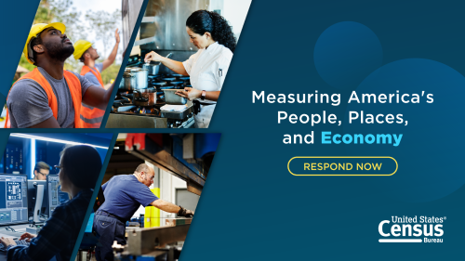

Office of Management and Budget Number (OMB): 0607-1024
Expires: 01/31/2028

ID: 344626789

