**This instrument is covered by the Paperwork Reduction Act of 1995**

**OMB Control No. 0651-0088 (exp. 09/30/2028)**

**Estimated time to complete: 4 minutes**

**Your participation is voluntary and there are no effects for choosing not to participate.**

**Do not include any personal information on this survey including name, email address, phone number, etc.**

[System of Records Notices - COMMERCE-PAT-TM-20 | U.S. Department of Commerce](https://www.commerce.gov/node/5012)

**A Federal agency may not conduct or sponsor, and a person is not required to respond to, nor shall a person be subject to a penalty for failure to comply with an information collection subject to the requirements of the Paperwork Reduction Act of 1995, unless the information collection has a currently valid OMB Control Number. Response to this information collection is voluntary; however, it allows the USPTO to analyze the overall effectiveness of the program. Send comments regarding this burden estimate or any other aspect of this information collection, including suggestions for reducing this burden to the Chief Administrative Officer, United States Patent and Trademark Office, P.O. Box 1450, Alexandria, VA 22313-1450 or email InformationCollection@uspto.gov.**

**Patents Contact Centers Survey**

**Thank you for contacting USPTO. Please take a few minutes to share your feedback, which will help us provide the best experience possible.**

**Please rate your level of agreement with the statement: Based on my experience with the contact center, I trust USPTO to grant patents in accordance with U.S. laws and regulations.**

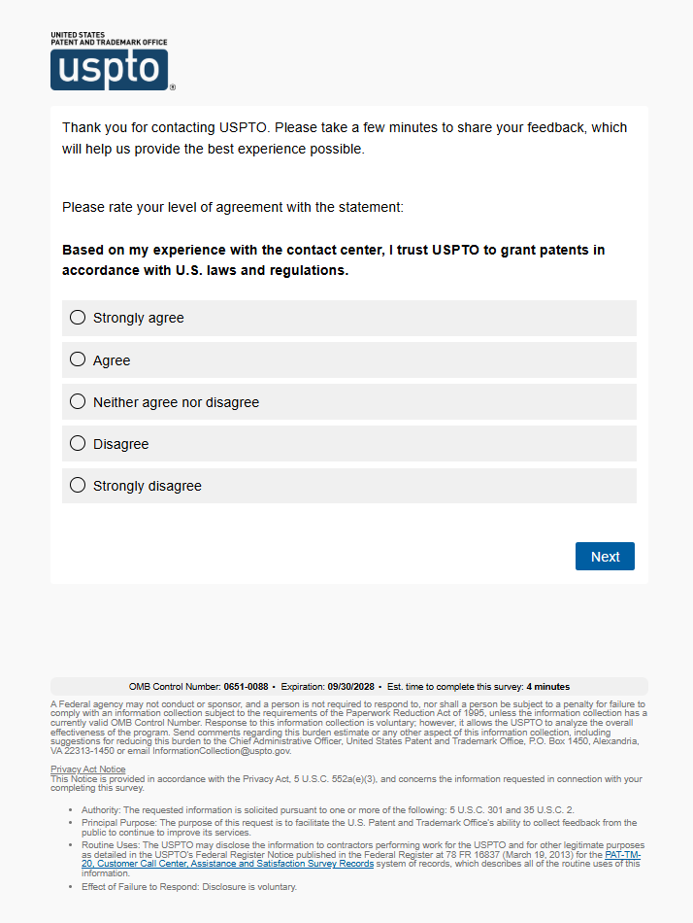

**Overall, how satisfied are you with the service you received from USPTO?**

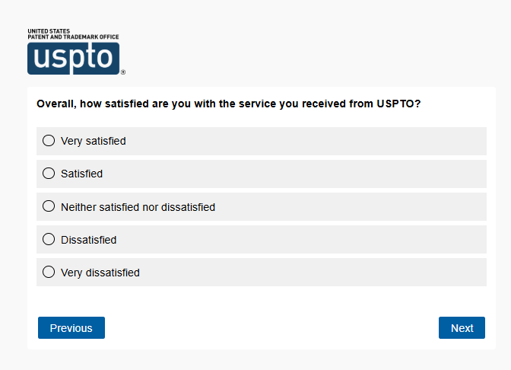

**Please rate your level of agreement with the statement: It was easy to complete what I needed to.**

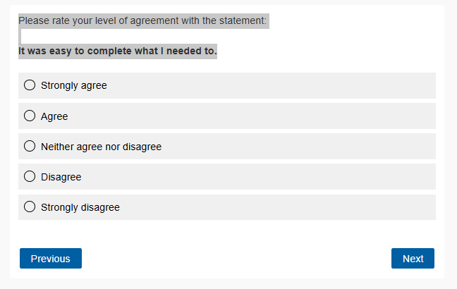

**Please rate your level of agreement with the statement: After being connected to a representative, the amount of time I was on the phone was reasonable.**

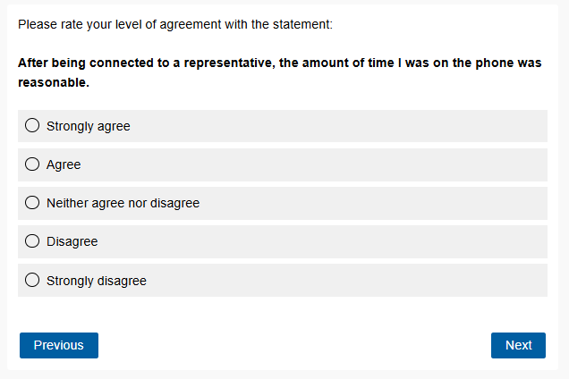

**Please rate the customer service representative who assisted you in the contact center for:**

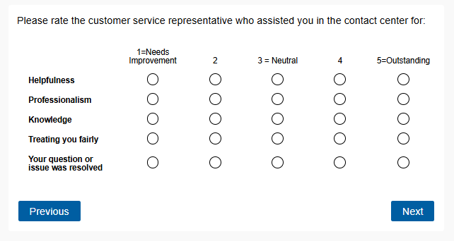

**Based on your interaction with the USPTO, please share any suggestions for improvements that the customer service representative or contact center could make to improve the customer service experience.**

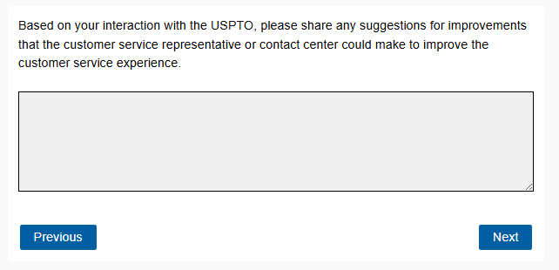

**What was your purpose for contacting AAU? Please select all that apply.**

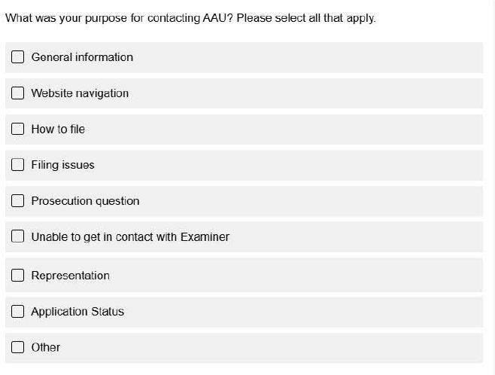

**What was your purpose for contacting EBC? Please select all that apply.**

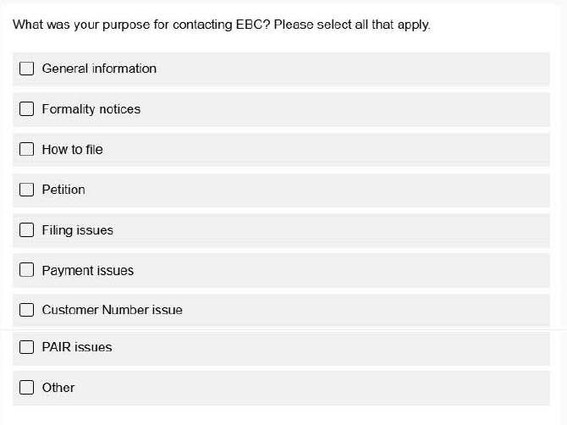

**What was your purpose for contacting IAC? Please select all that apply.**

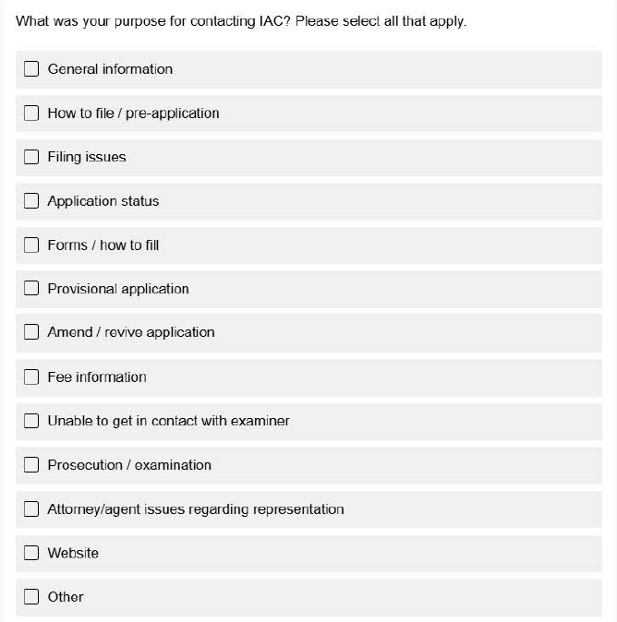

**What was your purpose for contacting OMB? Please select all that apply.**

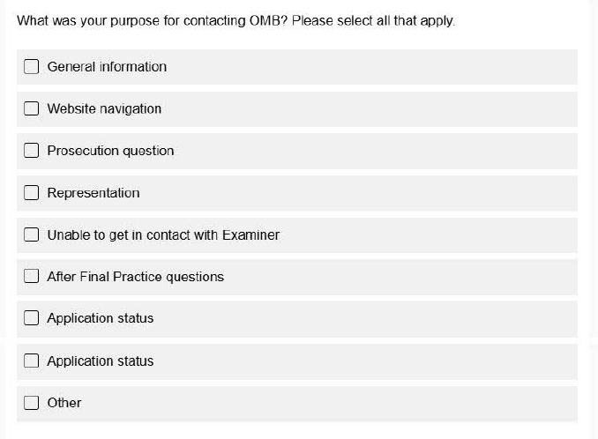

**What was your purpose for contacting the Pro Se contact center? Please select all that**

**apply.**

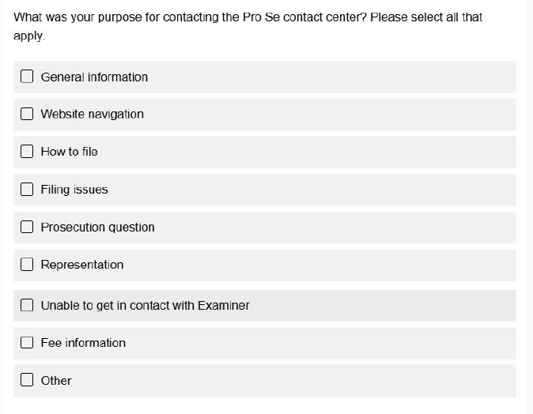

**What was your purpose for contacting OPET? Please select all that apply.**

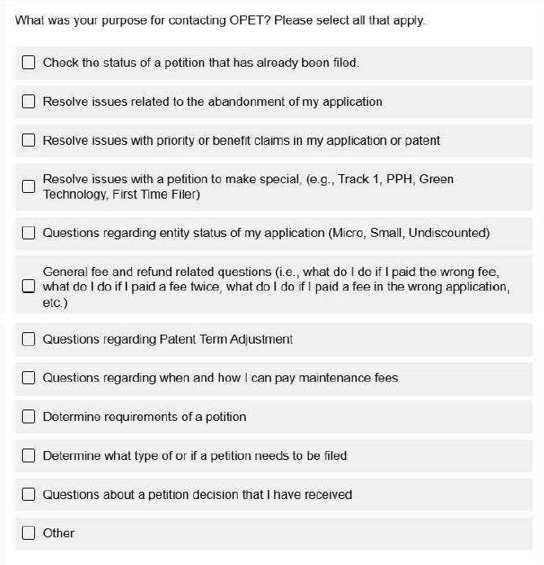

**What was your purpose for contacting PCT? Please select all that apply.**

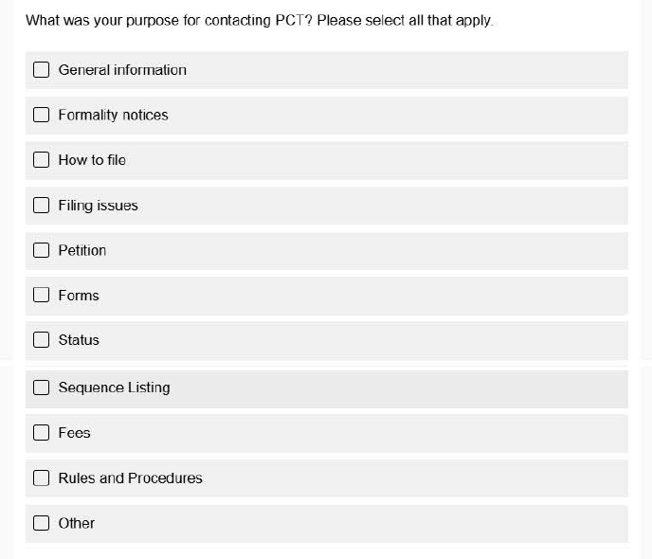

**What was your purpose for contacting UCC? Please select all that apply.**

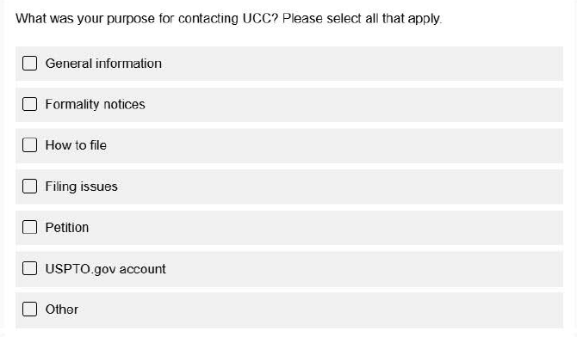

**Which of the following did you do before contacting us? Select all that apply.**

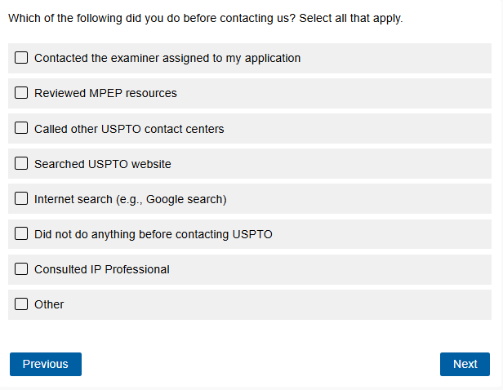

**Which of the following best describes your role?**

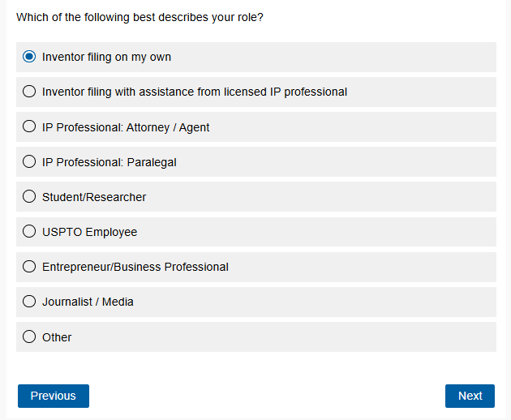

**Where are you currently in the application process?**

