**This instrument is covered by the Paperwork Reduction Act of 1995**

**OMB Control No. 0651-0088 (exp. 09/30/2028)**

**Estimated time to complete: 4 minutes**

**Your participation is voluntary and there are no effects for choosing not to participate.**

**Do not include any personal information on this survey including name, email address, phone number, etc.**

[System of Records Notices - COMMERCE-PAT-TM-20 | U.S. Department of Commerce](https://www.commerce.gov/node/5012)

**A Federal agency may not conduct or sponsor, and a person is not required to respond to, nor shall a person be subject to a penalty for failure to comply with an information collection subject to the requirements of the Paperwork Reduction Act of 1995, unless the information collection has a currently valid OMB Control Number. Response to this information collection is voluntary; however, it allows the USPTO to analyze the overall effectiveness of the program. Send comments regarding this burden estimate or any other aspect of this information collection, including suggestions for reducing this burden to the Chief Administrative Officer, United States Patent and Trademark Office, P.O. Box 1450, Alexandria, VA 22313-1450 or email InformationCollection@uspto.gov.**

**Patent Public Search (PPUBS) Survey**

To help us better understand and support your needs, please let us know about your experience using the Patent Public Search (PPUBS). This survey should take less than 5 minutes to complete.

**Based on my experience with PPUBS, I trust USPTO to grant patents in accordance with U.S. laws and regulations.**

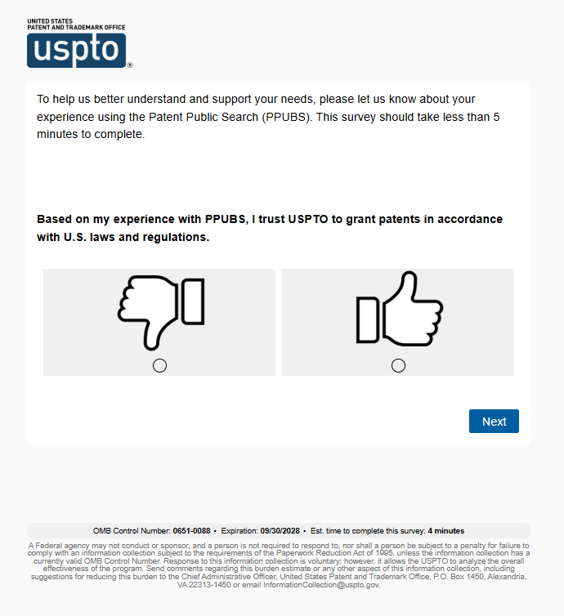

**Tell us about your experience.**

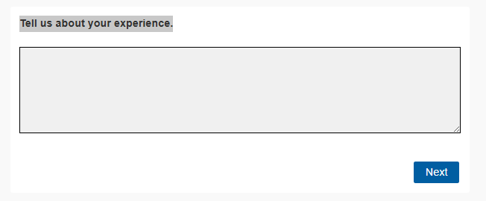

**Overall, how satisfied are you with your experience using PPUBS?**

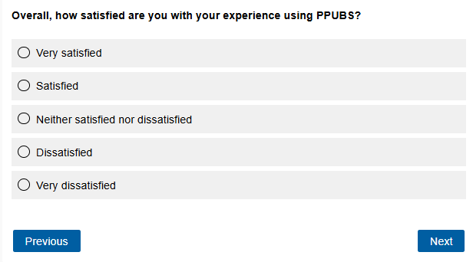

What was your intended task in PPUBS? Please select all that apply.

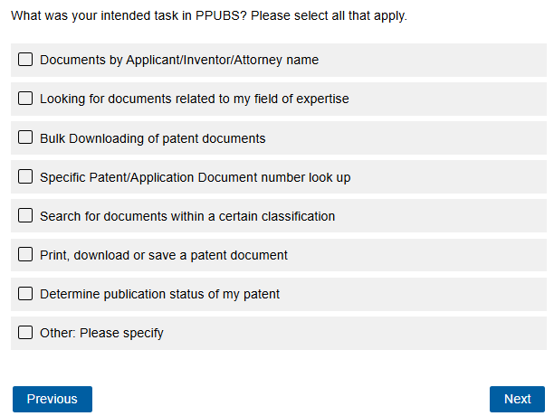

Which PPUBS search interface did you use?

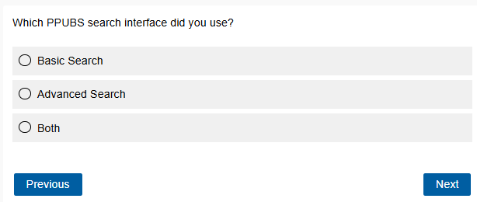

If “Basic Search” selected:

Why did you not use Advanced Search? Please select up to four.

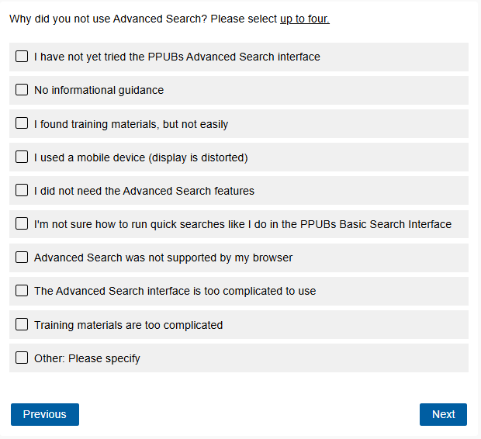

If “Advanced Search” or “Both” is selected:

In Advanced Search, what new features would be useful for you? Please select up to four.

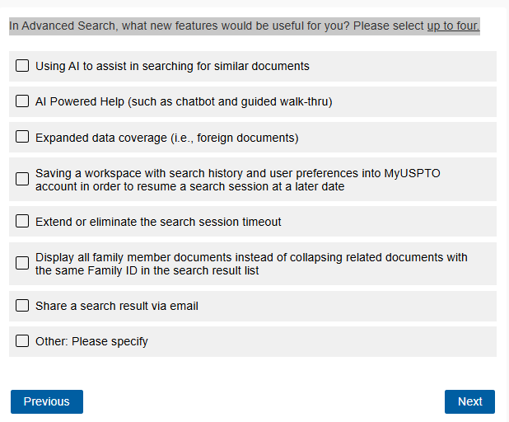

Which of the following digital search tools do you have search experience with? Select all that apply.

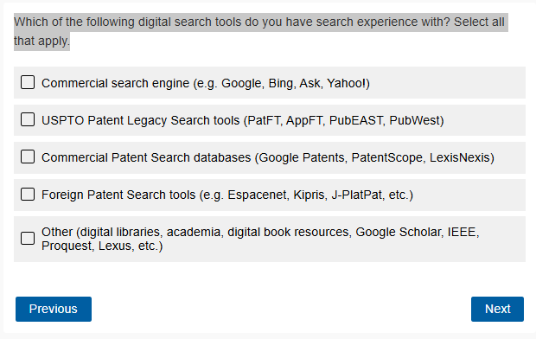

How often do you conduct searches using PPUBS?

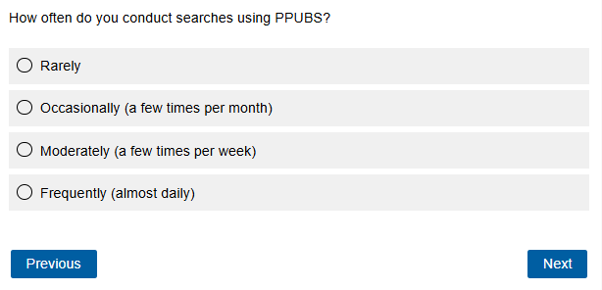

Which training materials did you find most useful?

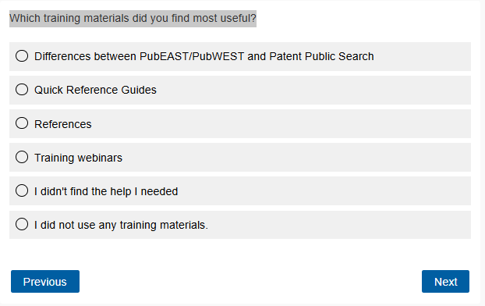

Which of these training methods/materials would best improve your searching? Please select up to four.

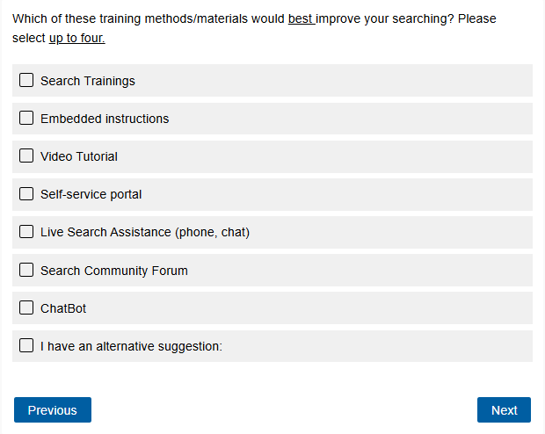

Which of the following best describes your role?

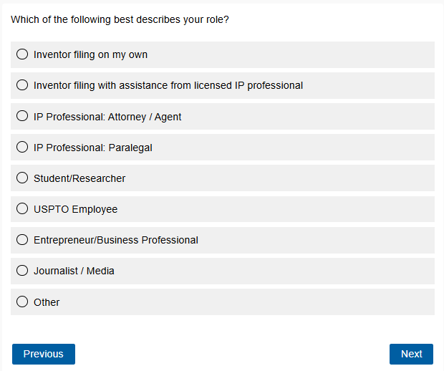

Where are you currently in the application process?

