This instrument is covered by the Paperwork Reduction Act of 1995
OMB Control No. 0651-0088 (exp. 09/30/2028)
Estimated time to complete: 4 minutes
Your participation is voluntary and there are no effects for choosing not to participate.
Do not include any personal information on this survey including name, email address, phone number, etc.
System of Records Notices - COMMERCE-PAT-TM-20 | U.S. Department of Commerce

A Federal agency may not conduct or sponsor, and a person is not required to respond to, nor shall a person be subject to a penalty for failure to comply with an information collection subject to the requirements of the Paperwork Reduction Act of 1995, unless the information collection has a currently valid OMB Control Number. Response to this information collection is voluntary; however, it allows the USPTO to analyze the overall effectiveness of the program. Send comments regarding this burden estimate or any other aspect of this information collection, including suggestions for reducing this burden to the Chief Administrative Officer, United States Patent and Trademark Office, P.O. Box 1450, Alexandria, VA 22313-1450 or email InformationCollection@uspto.gov.

Patent Center Survey

To help us better understand and support your needs, please let us know about your experience using the Patent Center. This survey should take less than 5 minutes to complete.
Based on my experience with Patent Center, I trust USPTO to grant patents in accordance with U.S. laws and regulations.

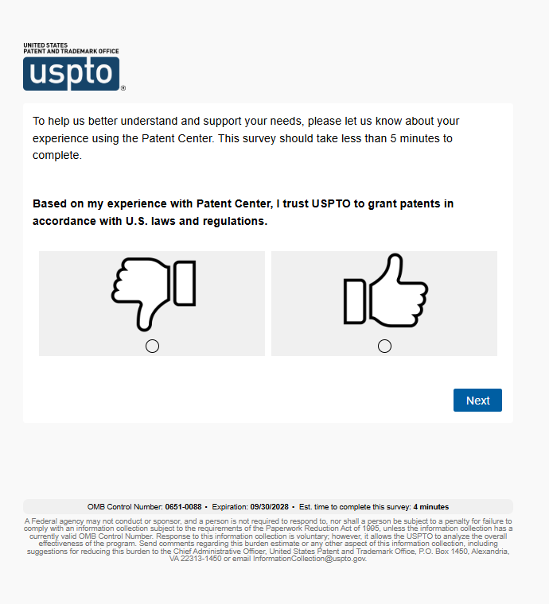

Tell us about your experience.
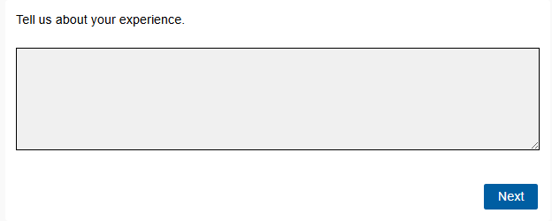

Overall, how satisfied are you with your experience with Patent Center?
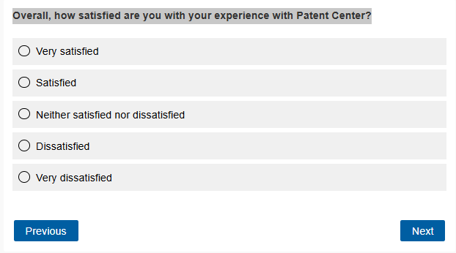

What was your intended task in Patent Center? Please select all that apply.

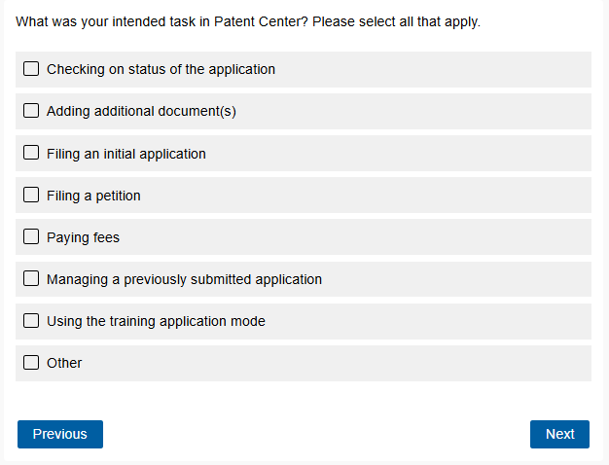

Which of the following resources did you use to file in Patent Center? Please select all that apply.

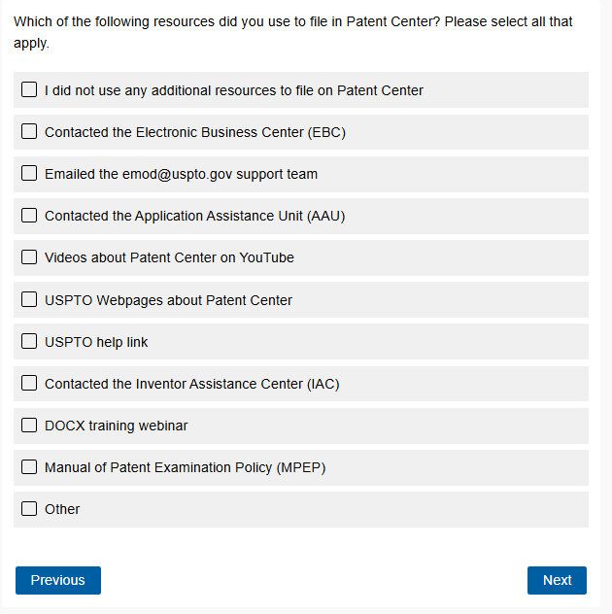

When submitting documents, which of the following apply to you? Please select all that apply.

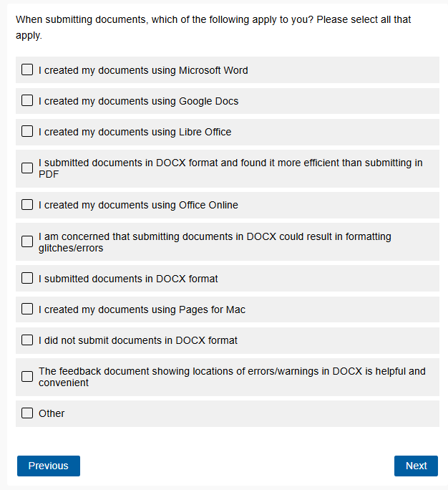

Which feature(s) within Patent Center do you find most useful? Please select up to four.

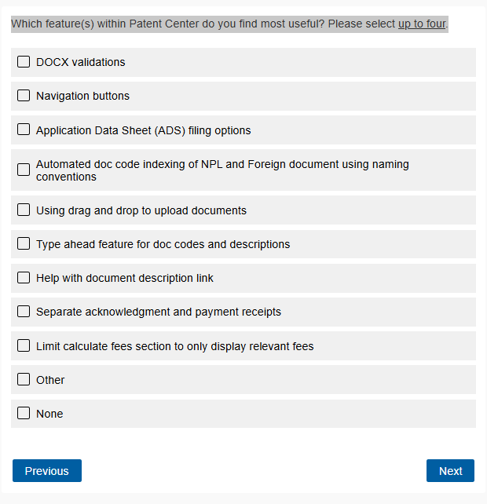

What new features or functionality would make Patent Center more useful to you? Please select up to four.

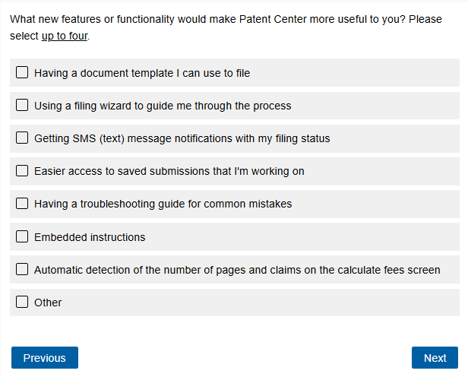

Did you experience any problems when using Patent Center? Please select all that apply.

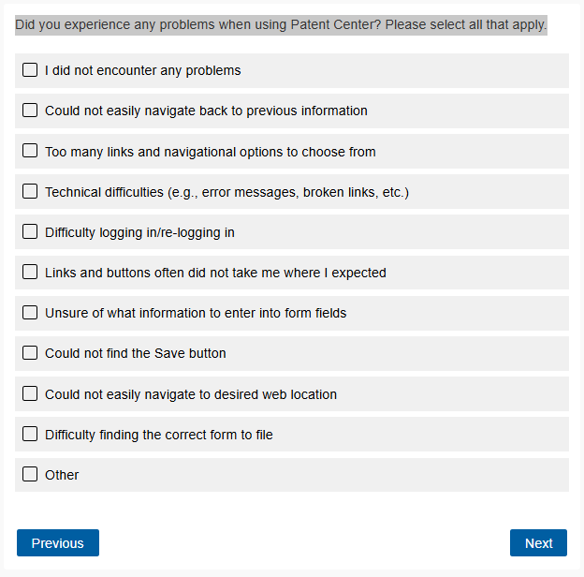

How many patent applications have you submitted to the USPTO?

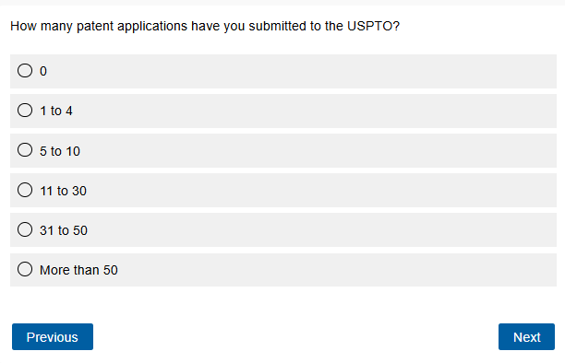

Which of the following best describes your role?

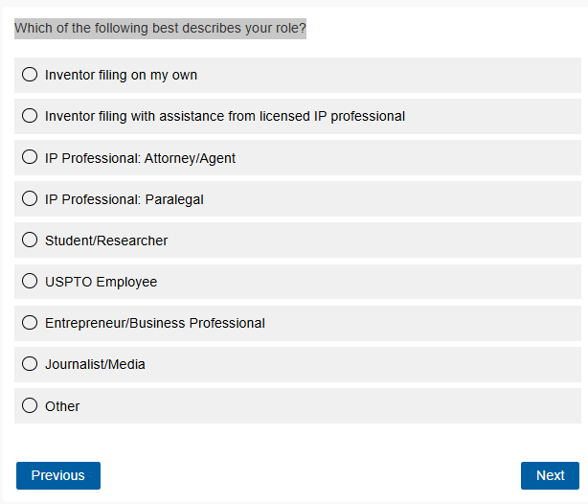

Where are you currently in the application process?

