USPS Mail Campaign
Draft of Notification Postcard (USPS touchpoint 1) MC&FP to send final copy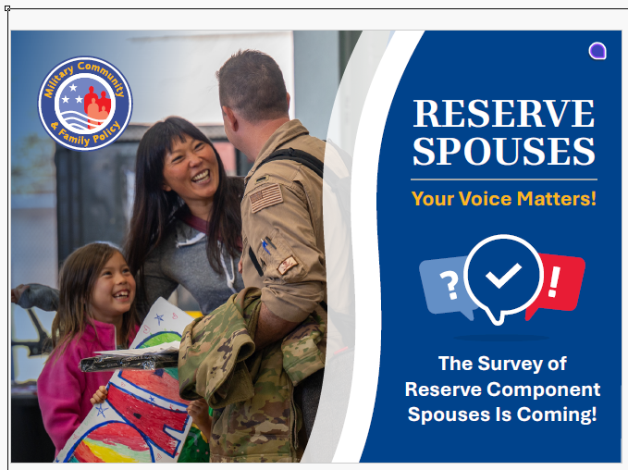
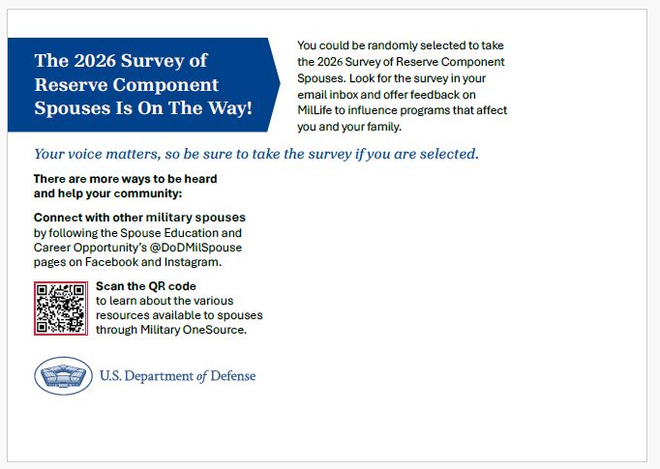

Invitation (USPS Touchpoint 2)
Dear Name,
I want to personally thank you for your service and all you do to support your Reserve component family. You are an essential member of the Total Force and that is why I hope you will share your experiences and opinions via the Reserve Component Spouse Survey (RCSS). Military families play a vital role in our nation’s military readiness and by participating, you ensure that the DoD truly understands the issues that military families are facing today.
Please scan the QR code to start your confidential survey.
You can also visit https://www.dodsurveys.mil and enter your Ticket Number XXXXXXX.
QR CODE
xxxxxxxxxxxxxxxxxxxx

What you have to say matters a great deal. The results of this official DoD survey are reported to leadership, policymakers, and the public and are used to effect change. Since the 2023 RCSS, congress extended 12 weeks of parental leave to all Service members, expanded reimbursements for travel over 50 miles to attend training/muster duty, and expanded dual basic allowance to Members without dependents.
Your voice is powerful. DoD selects a random, representative sample of spouses to participate in this survey every other year. As a spouse selected to complete the survey, you represent the spouse community. By participating in this confidential DoD survey, you can ensure that Reserve component spouses have a voice and a seat at the table when it comes to finding ways to help DoD better support military families.
We understand your time is precious. Your responses are saved so you can return any time before the closing date to submit your responses. The survey will take up to 30 minutes. Your participation is voluntary. Your insight is invaluable. Thank you for taking the time to complete this survey. YOUR input will make a difference!
Sincerely,
Name
Title

Reminder 1 (USPS Touchpoint 3 PAPER SURVEY ENCLOSED)

Dear Name,
As a military spouse, you know the sacrifices families make in support of Service to our country and I thank you. Military families play a vital role in our nation’s military readiness. That is why I am asking you to share your experiences via the biennial Reserve Component Spouse Survey. By participating in this confidential DoD survey, you can ensure that Reserve component spouses have a voice and a seat at the table when it comes to finding ways to help DoD better support military families.
If you have already completed the survey, thank you for taking the time to do so. If you have not submitted your responses, please take a few minutes to visit the survey and press submit to record your responses.
There are three ways you can access the survey:
- Scan the QR code below to start your confidential web survey
- Visit https://www.dodsurveys.mil and enter your Ticket Number XXXXXXX to access the web survey
- Complete the enclosed paper survey and return it in the postage paid envelope
QR CODE
xxxxxxxxxxxxxxxxxxxx

What you have to say matters a great deal and your voice is powerful. The results of this official DoD survey are reported to leadership, policymakers, and the public and are used to effect change.
Your responses are saved. Return before the closing date to submit your responses to ensure that policymakers and leaders hear directly from spouses like you on the issues that matter most to military families.
The survey takes up to 30 minutes, depending on your situation and how much you’d like to share. Your participation is voluntary. Your insight is invaluable. Let your voice be heard. Help DoD better support your family.

Thank you,
Signature
Title

Reminder 2 (USPS Touchpoint 4)

Dear Name,
If you have just completed the Reserve Component Spouse Survey, I want to thank you for your time and input. If you have not had a chance to complete the survey, or you haven’t submitted your answers, please complete the survey and press submit.
This is the official DoD Reserve Component Spouse Survey and it is only available to a sample of spouses every other year. That’s why it is so important that every spouse invited in 2026 has their say—to ensure DoD truly understands the issues that military families are facing today.
There are three ways you can access the survey:
- Use your phone to scan the QR code below.
- Visit https://www.dodsurveys.mil and enter your Ticket Number XXXXXXX
- Complete the enclosed paper survey and return it in the postage paid envelope.
QR CODE
xxxxxxxxxxxxxxxxxxxx

What you have to say matters. The results of this official DoD survey are reported to leadership, policymakers, and the public and are used to effect change. Since the 2023 RCSS, congress extended parental leave to all Service members, expanded reimbursements for travel, and expanded dual basic allowance.
Your responses are saved so that you may return to complete your survey before the closing date. The survey takes up to 30 minutes, depending on your situation and how much you’d like to share. Your participation is voluntary.
Thank you for your participation in this confidential survey and for all you give to our country every day.

Thank you,
Signature
Title

Reminder 3 (USPS Touchpoint 5)

Dear Name,
The 2026 DoD Reserve Component Spouse Survey is going to close soon and we still need to hear from more spouses like you to ensure policies that support military families reflect the issues that military families are facing today.
It’s easy to participate. Answer questions that pertain to you on the web and submit your answers. Data collected is confidential. We know your time is precious, but your insight is invaluable to the larger Reserve spouse community. Please submit your answers as soon as possible, before this window to have your say closes.
There are three ways you can access the survey:
- Use your phone to scan the QR code below.
- Visit https://www.dodsurveys.mil and enter your Ticket Number XXXXXXX
- Complete the enclosed paper survey and return it in the postage paid envelope.
QR CODE
xxxxxxxxxxxxxxxxxxxx

Let your voice be heard. Help us serve your family before this survey closes on …..

Thank you,
Signature
Title

2025 EMAIL Campaign

EMAIL Announcement (Electronic touchpoint 1)

Dear NAME,

I’m writing to you with an invitation to participate in the 2026 Reserve Component Spouse Survey. This is the official, biennial survey of Reserve component spouses and What you have to say matters a great deal. DoD selects a random sample of spouses to participate in this survey every other year, so you represent the Reserve component spouse community. Ensure that policymakers and leaders hear directly from spouses on the issues that matter most by starting the survey today.

Please go to DoDsurveys.mil on any computer, tablet, or smartphone and enter your Ticket Number. You may also scan the QR code in the official invitation sent to you via USPS.

This is an opportunity for Reserve component spouses to BE HEARD and help shape the programs that support you, your family, and the military community overall. For example, this year’s survey will ask you about your family’s experiences with:
- Activations and deployments
- Financial well-being
- Unemployment/Underemployment
- Child care
- Health

I know your time is precious. It will take up to 30 minutes to complete the survey, depending on your unique circumstances (deployments, employment status, children, etc.) and you only answer questions that pertain to you and your family. Your responses are saved, so you won’t have to start over if you have to step away and return to finish your survey later. Your participation is voluntary and your responses are confidential.

Start your survey today to ensure spouses have a voice and a seat at the table when it comes to supporting military families. YOUR input will make a difference!

Sincerely,
Carol Newell
Director
Center for Retention & Readiness
Office of People Analytics

This survey is “Official Business” and members of the military or federal government employees can complete the survey at their work stations, using government equipment. The results are private to the extent permissible by law. If you choose, you can also complete the survey at home or elsewhere.

If you have any questions or concerns, please contact our Survey Processing Center by replying to this e-mail, e-mailing RCS-Survey@mail.mil, calling toll-free 1-800-881-5307, or sending a fax to 1-763-268-3002. If you do not wish to participate or receive additional reminders about this survey, you may remove yourself from the mailing list by replying to this message. Be sure to include your ticket number and the words, "Please remove me from this survey's mailing list." If you wish to withdraw your answers after starting this survey, notify the Survey Processing Center prior to August 15, 2023. You will be required to provide your ticket number.

For your convenience, OPA has set up a telephone line for anyone who wishes to verify the survey’s legitimacy. Call 1- 571-372-1034 for a list of current data collections by licensed OPA surveys. Alternatively, call 372-1034 from any

DoD or other government telephone with DSN. This prerecorded list does not include surveys being conducted by other DoD offices.

OMB Control Number 0704-0653/Expiration Date 03/31/2026

EMAIL Reminder 1 (Electronic touchpoint 2)

Dear NAME,

Dear Ms. Pat Sample:
I recently contacted you about an opportunity to share your experiences via the 2026 Reserve Component Spouse Survey. Thank you for completing this Department of Defense survey if you have already done so. If you missed it, or perhaps you haven’t submitted your answers yet, please do so as soon as possible!
Spouses just like you have shared their thoughts on quality of life topics that our military community really cares about, financial condition and the impact of military life on your children, but we still need more spouses to participate to ensure these survey results reflect the experiences of the milspouse community.
Please go to DoDsurveys.mil on any computer, tablet, or smartphone and enter your Ticket Number #####
We know your time is at a premium and even 10 minutes is a lot to ask, but please know that the data from this survey is the information policy makers use to guide resources to programs that impact military spouses and their families.
Your participation is voluntary. If you have partially completed the survey, but have not clicked the “Submit” button, please go back, log onto the website, complete as many items as you can and submit the survey today. If you prefer, you may fill out a paper version of the survey sent to you by mail.
Thank you in advance for sharing your experiences through the Reserve Component Spouse Survey.
Sincerely,
Carol Newell
Director
Center for Retention & Readiness
Office of People Analytics

This survey is “Official Business” and members of the military or federal government employees can complete the survey at their work stations, using government equipment. The results are private to the extent permissible by law. If you choose, you can also complete the survey at home or elsewhere.

If you have any questions or concerns, please contact our Survey Processing Center by replying to this e-mail, e-mailing RCS-Survey@mail.mil, calling toll-free 1-800-881-5307, or sending a fax to 1-763-268-3002. If you do not wish to participate or receive additional reminders about this survey, you may remove yourself from the mailing list by replying to this message. Be sure to include your ticket number and the words, "Please remove me from this survey's mailing list." If you wish to withdraw your answers after starting this survey, notify the Survey Processing Center prior to August 15, 2023. You will be required to provide your ticket number.

For your convenience, OPA has set up a telephone line for anyone who wishes to verify the survey’s legitimacy. Call 1- 571-372-1034 for a list of current data collections by licensed OPA surveys. Alternatively, call 372-1034 from any

DoD or other government telephone with DSN. This prerecorded list does not include surveys being conducted by other DoD offices.

OMB Control Number 0704-0653/Expiration Date 03/31/2026

Email Reminder 2 (Electronic touchpoint 3)

Dear
Your Ticket Number: ######

If you have already completed the 2026 Reserve Component Spouse Survey—THANK YOU! We appreciate your time and invaluable insight.

If you haven’t had a chance to complete this important survey conducted by the Department of Defense (DoD), it’s not too late.

This official DoD survey and is only available to a representative sample of spouses every other year. That’s why it is so important that every spouse invited in 2026 has their say—to ensure DoD truly understands the issues that military families are facing today. The results of this survey are shared with the Services, DoD leadership, policymakers, and the public. Visit the website below to return your confidential responses before this opportunity closes.

Website URL: DoDsurveys.mil
Ticket Number: REMIND3

The survey takes between up to 30 minutes, depending on your situation. Your participation is voluntary.

Thank you in advance for sharing your experiences.

Sincerely,
Carol Newell
Director, Center for Retention and Readiness
Office of People Analytics (OPA)

This survey is “Official Business” and members of the military or federal government employees can complete the survey at their work stations, using government equipment. The results are private to the extent permissible by law. If you choose, you can also complete the survey at home or elsewhere.

If you have any questions or concerns, please contact our Survey Processing Center by replying to this e-mail, e-mailing RCS-Survey@mail.mil, calling toll-free 1-800-881-5307, or sending a fax to 1-763-268-3002. If you do not wish to participate or receive additional reminders about this survey, you may remove yourself from the mailing list by replying to this message. Be sure to include your ticket number and the words, "Please remove me from this survey's mailing list." If you wish to withdraw your answers after starting this survey, notify the Survey Processing Center prior to August 15, 2023. You will be required to provide your ticket number.

For your convenience, OPA has set up a telephone line for anyone who wishes to verify the survey’s legitimacy. Call 1- 571-372-1034 for a list of current data collections by licensed OPA surveys. Alternatively, call 372-1034 from any

DoD or other government telephone with DSN. This prerecorded list does not include surveys being conducted by other DoD offices.

OMB Control Number 0704-0653/Expiration Date 03/31/2026
Email Reminder 3 (Electronic touchpoint 4)
Dear
Your Ticket Number: ######

If you have already completed the 2026 Reserve Component Spouse Survey—THANK YOU! We appreciate your time and invaluable insight.

If you haven’t had a chance to complete this important survey conducted by the Department of Defense (DoD), it’s not too late. Visit the website below to start or return to your survey before this survey closes.

Website URL: DoDsurveys.mil
Ticket Number: REMIND3

This is the official DoD Reserve Component Spouse Survey and it is only available to a representative sample of spouses every other year. That’s why it is so important that every spouse invited in 2026 has their say—to ensure DoD truly understands the issues that military families are facing today. The results of this survey are shared with the Services, DoD leadership, policymakers, and the public.

The survey takes up to 30 minutes, depending on your situation and how much you’d like to share. Your participation is voluntary.

Let your voice be heard. Help DoD better support military families by sharing your story.

Sincerely,
Carol Newell
Director, Center for Retention and Readiness
Office of People Analytics (OPA)

This survey is “Official Business” and members of the military or federal government employees can complete the survey at their work stations, using government equipment. The results are private to the extent permissible by law. If you choose, you can also complete the survey at home or elsewhere.

If you have any questions or concerns, please contact our Survey Processing Center by replying to this e-mail, e-mailing RCS-Survey@mail.mil, calling toll-free 1-800-881-5307, or sending a fax to 1-763-268-3002. If you do not wish to participate or receive additional reminders about this survey, you may remove yourself from the mailing list by replying to this message. Be sure to include your ticket number and the words, "Please remove me from this survey's mailing list." If you wish to withdraw your answers after starting this survey, notify the Survey Processing Center prior to August 15, 2023. You will be required to provide your ticket number.

For your convenience, OPA has set up a telephone line for anyone who wishes to verify the survey’s legitimacy. Call 1- 571-372-1034 for a list of current data collections by licensed OPA surveys. Alternatively, call 372-1034 from any

DoD or other government telephone with DSN. This prerecorded list does not include surveys being conducted by other DoD offices.

OMB Control Number 0704-0653/Expiration Date 03/31/2026
Email Reminder 4 (Electronic touchpoint 5)

Dear
Your Ticket Number: ######

The end of the survey period has nearly arrived, but you still have an opportunity to share your story with Department of Defense leaders.

If you have already completed the Reserve Component Spouse Survey, we thank you. And if you have not had the time, please take a few minutes today if you can – your voice is powerful and we need to hear from you! Please press submit if you’ve started but haven’t completed your survey.

Website URL: DoDsurveys.mil
Ticket Number: REMIND4
By participating in this confidential DoD survey, you can ensure that Reserve component spouses have a voice and a seat at the table when it comes to finding ways to help DoD better support military families.

Sincerely,
Carol Newell
Director, Center for Retention and Readiness
Office of People Analytics (OPA)

This survey is “Official Business” and members of the military or federal government employees can complete the survey at their work stations, using government equipment. The results are private to the extent permissible by law. If you choose, you can also complete the survey at home or elsewhere.

If you have any questions or concerns, please contact our Survey Processing Center by replying to this e-mail, e-mailing RCS-Survey@mail.mil, calling toll-free 1-800-881-5307, or sending a fax to 1-763-268-3002. If you do not wish to participate or receive additional reminders about this survey, you may remove yourself from the mailing list by replying to this message. Be sure to include your ticket number and the words, "Please remove me from this survey's mailing list." If you wish to withdraw your answers after starting this survey, notify the Survey Processing Center prior to August 15, 2023. You will be required to provide your ticket number.

For your convenience, OPA has set up a telephone line for anyone who wishes to verify the survey’s legitimacy. Call 1- 571-372-1034 for a list of current data collections by licensed OPA surveys. Alternatively, call 372-1034 from any

DoD or other government telephone with DSN. This prerecorded list does not include surveys being conducted by other DoD offices.

OMB Control Number 0704-0653/Expiration Date 03/31/2026

OPTIONAL: Email Reminder 5 (Electronic touchpoint 6)

Dear
Your Ticket Number:

The Reserve Component Spouse Survey will close in xx days. Please take a few minutes to participate today. Participating in this confidential DoD survey ensures that Reserve component spouses have a voice and a seat at the table when it comes to finding ways to help DoD better support military families.

If you have already completed the Reserve Component Spouse Survey, we thank you. Please share your story– your voice is powerful and we need to hear from you!

If you have started but have not completed the survey, please click submit to submit your responses.

Website URL: DoDsurveys.mil
Ticket Number: REMIND5

Sincerely,
Carol Newell
Director, Center for Retention and Readiness
Office of People Analytics (OPA)

This survey is “Official Business” and members of the military or federal government employees can complete the survey at their work stations, using government equipment. The results are private to the extent permissible by law. If you choose, you can also complete the survey at home or elsewhere.

If you have any questions or concerns, please contact our Survey Processing Center by replying to this e-mail, e-mailing RCS-Survey@mail.mil, calling toll-free 1-800-881-5307, or sending a fax to 1-763-268-3002. If you do not wish to participate or receive additional reminders about this survey, you may remove yourself from the mailing list by replying to this message. Be sure to include your ticket number and the words, "Please remove me from this survey's mailing list." If you wish to withdraw your answers after starting this survey, notify the Survey Processing Center prior to August 15, 2023. You will be required to provide your ticket number.

For your convenience, OPA has set up a telephone line for anyone who wishes to verify the survey’s legitimacy. Call 1- 571-372-1034 for a list of current data collections by licensed OPA surveys. Alternatively, call 372-1034 from any

DoD or other government telephone with DSN. This prerecorded list does not include surveys being conducted by other DoD offices.

OMB Control Number 0704-0653/Expiration Date 03/31/2026

OPTIONAL: Email Reminder 6 (Electronic touchpoint 7)

Dear
Your Ticket Number:

The Reserve Component Spouse Survey is closing tomorrow. Time is running out, so if you have not completed the survey, please take a few minutes to submit your answers on this official DoD survey today. Your input influences programs that affect you, your family, and the overall Reserve component community.

Website URL: DoDsurveys.mil
Ticket Number: REMIND6

Participating in this confidential DoD survey ensures that Reserve component spouses have a voice and a seat at the table when it comes to finding ways to help DoD better support military families.

Sincerely,
Carol Newell
Director, Center for Retention and Readiness
Office of People Analytics (OPA)

This survey is “Official Business” and members of the military or federal government employees can complete the survey at their work stations, using government equipment. The results are private to the extent permissible by law. If you choose, you can also complete the survey at home or elsewhere.

If you have any questions or concerns, please contact our Survey Processing Center by replying to this e-mail, e-mailing RCS-Survey@mail.mil, calling toll-free 1-800-881-5307, or sending a fax to 1-763-268-3002. If you do not wish to participate or receive additional reminders about this survey, you may remove yourself from the mailing list by replying to this message. Be sure to include your ticket number and the words, "Please remove me from this survey's mailing list." If you wish to withdraw your answers after starting this survey, notify the Survey Processing Center prior to August 15, 2023. You will be required to provide your ticket number.

For your convenience, OPA has set up a telephone line for anyone who wishes to verify the survey’s legitimacy. Call 1- 571-372-1034 for a list of current data collections by licensed OPA surveys. Alternatively, call 372-1034 from any

DoD or other government telephone with DSN. This prerecorded list does not include surveys being conducted by other DoD offices.

OMB Control Number 0704-0653/Expiration Date 03/31/202

