**In Service Verification Form (Screenshots)**

***Participant Verification***

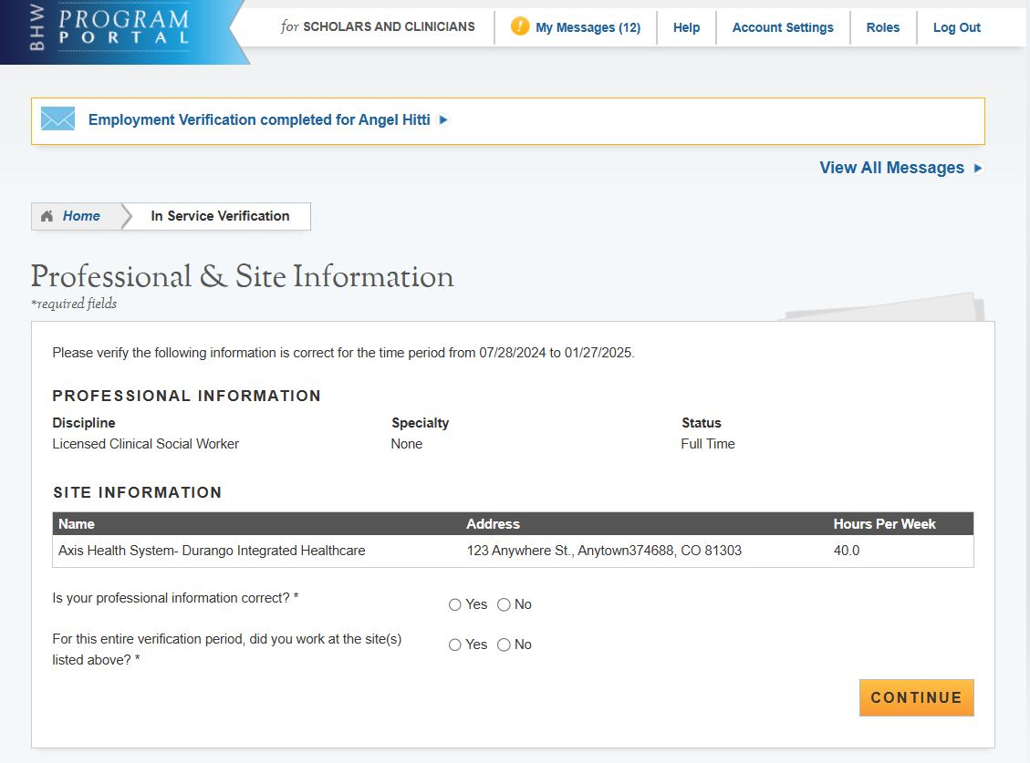

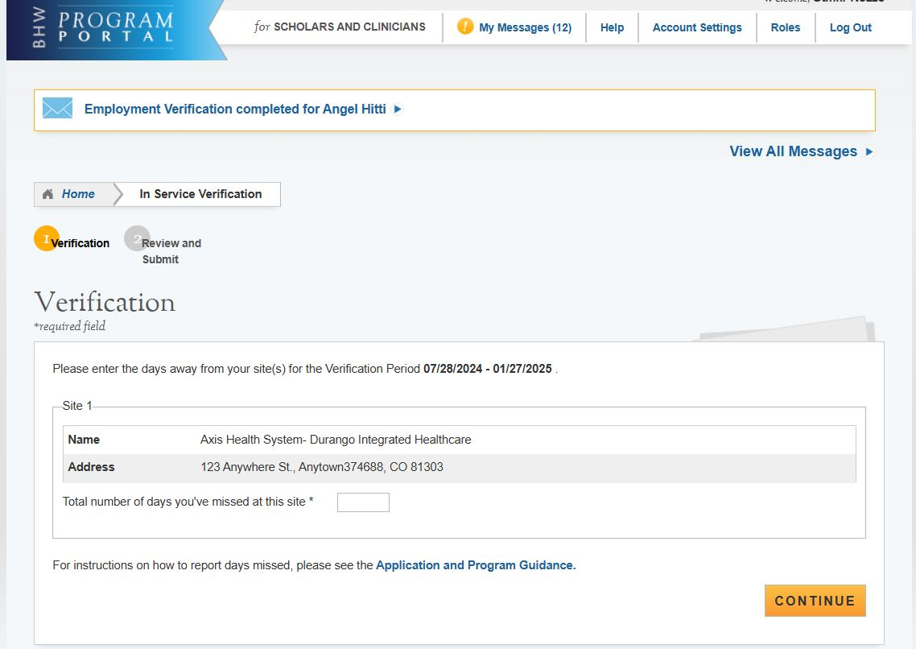

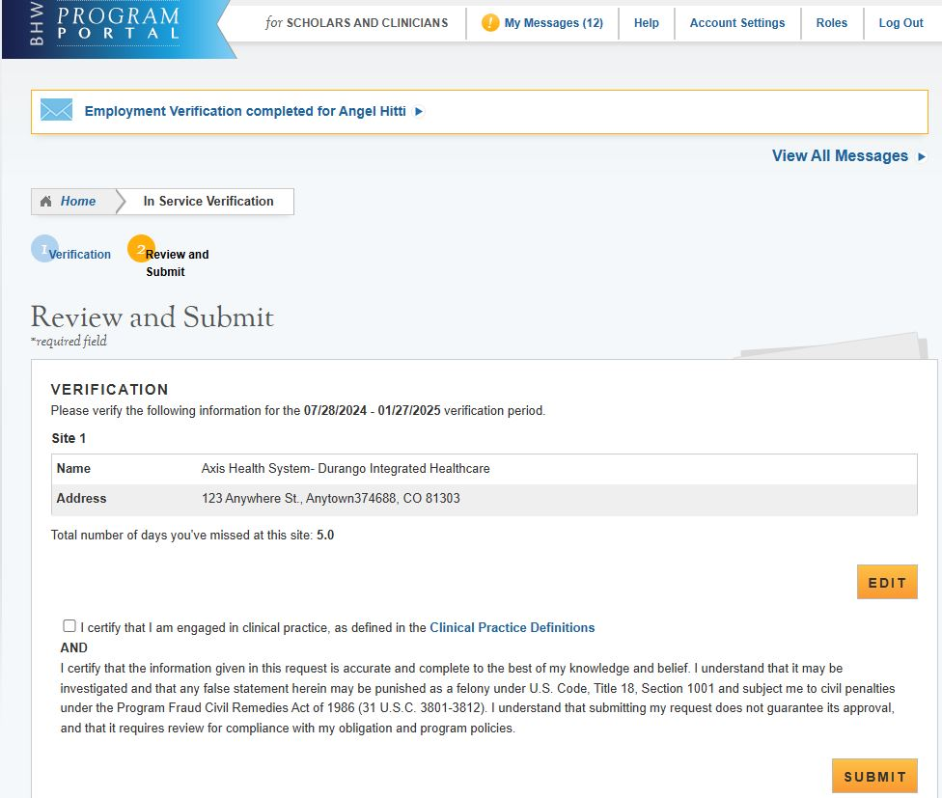

***Site POC Verification***

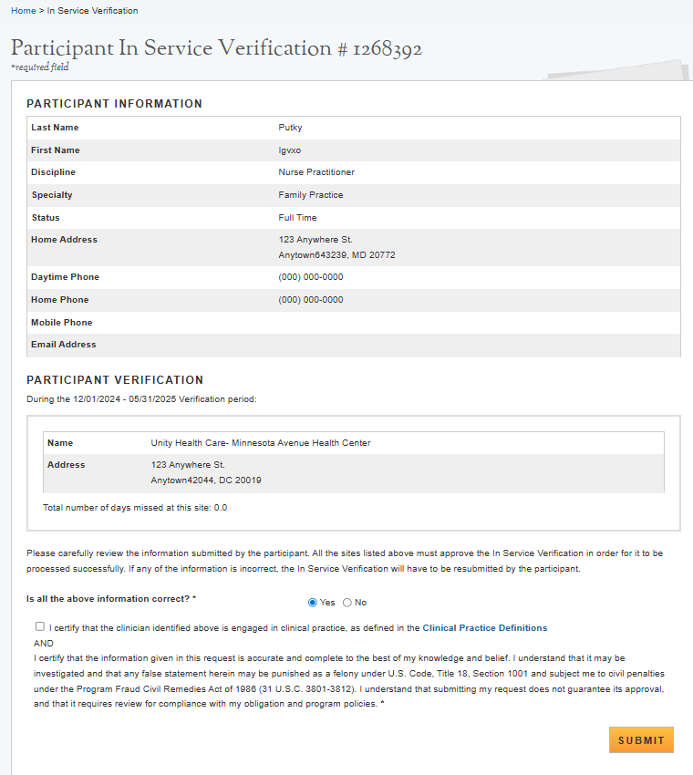

OMB No. 0915‐0140 Expiration Date: xx/xx/xxxx

**Public Burden Statement:** The purpose of this information collection is to obtain information through the Nurse Corps Loan Repayment Program that is used to assess a Loan Repayment Program applicant’s eligibility and qualifications for the Loan Repayment Program and to monitor a participant’s compliance with the program’s service requirements. Applicants interested in participating in the Nurse Corps Loan Repayment Program must submit an application to the Nurse Corps. An agency may not conduct or sponsor, and a person is not required to respond to, a collection of information unless it displays a currently valid OMB control number. The OMB control number for this information collection is 0915-0140 and it is valid until xx/xx/xxxx. This information collection is required to obtain or retain a benefit (Section 846 of the Public Health Service Act, as amended [42 U.S.C. 297n]). The information is protected by the Privacy Act, but it may be disclosed outside the U.S. Department of Health and Human Services, as permitted by the Privacy Act and Freedom of Information Act, to Congress, the National Archives, and the Government Accountability Office, and pursuant to court order and various routine uses as described in the System of Record Notice 09-15-0037.Public reporting burden for this collection of information is estimated to average xx hours per response, including the time for reviewing instructions, searching existing data sources, and completing and reviewing the collection of information. Send comments regarding this burden estimate or any other aspect of this collection of information, including suggestions for reducing this burden, to HRSA Reports Clearance Officer, 5600 Fishers Lane, Room 14NWH04, Rockville, Maryland, 20857.