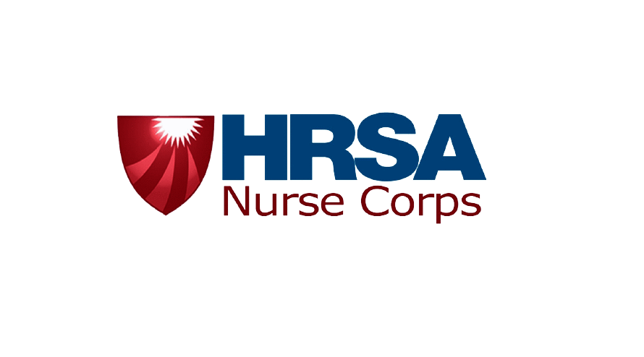
Form Approved OMB No. 0915-0301
Expires xx/xx/xxxx
BUREAU OF HEALTH WORKFORCE

NURSE CORPS SCHOLARSHIP PROGRAM
AUTHORIZATION TO RELEASE INFORMATION

I, , hereby authorize: (Print Name - First, Middle Initial, Last)

- The school where I am accepted for enrollment/am enrolled/was enrolled while applying for and participating in the Nurse Corps Scholarship Program to disclose information pertaining to my school enrollment to the Department of Health and Human Services (DHHS), and/or its contractors. Information pertaining to my school enrollment includes, but is not limited to, my transcripts and grades, academic standing, enrollment and degree status, curriculum and examination requirements for graduation, tuition and fees, leave-of-absence, withdrawal, or dismissal from school. This information will be used by DHHS to determine my eligibility to continue to receive scholarship benefits and the amount of those benefits.

- The entity/entities where I am/was approved to provide service in satisfaction of my Nurse Corps Scholarship Program obligation to disclose to DHHS, and/or its contractors, information pertaining to my compliance with the Nursing Scholarship service requirements. Such information includes, but is not limited to, my practice location(s), practice responsibilities, work schedule or other documentation indicating the hours that I worked and the hours I was away from the site, records relating to my work performance and (if applicable) the circumstances relating to the termination of my employment at the service location.

- The DHHS, and/or its contractors, to release my name, address(es) and social security number to see if I appear on the Excluded Parties List System.

This authorization takes effect on the date that I sign this release form. If I do not become a participant, this authorization shall remain in effect one year from the date that the authorization is signed and dated, or until this authorization is revoked by me in writing. If I become a participant, the above authorizations shall remain in effect until the date my Nursing Scholarship commitment has been fulfilled.

(Signature of Individual) (Date)

Please upload to the Nurse Corps SP Portal: https://programportal.hrsa.gov/


Public Burden Statement: The purpose of the Nurse Corps Scholarship Program (Nurse Corps SP) is to provide scholarships to nursing students in exchange for a minimum two-year full-time service commitment (or part-time equivalent), at an eligible health care facility with a critical shortage of nurses. The information that applicants supply is used to evaluate their eligibility, qualifications and to assess their continued compliance with the applicable standards for participation in the Nurse Corps SP. The OMB control number for this information collection is 0915-0301 and it is valid until xx/xx/xx. This information collection is required to obtain a benefit (Section 846(d) of the Public Health Service Act (42 United States Code 297n (d)), as amended). Data will be private to the extent permitted by the law. Public reporting burden for this collection of information is estimated to average approximately 36 minutes per response, including the time for reviewing instructions, searching existing data sources, and completing and reviewing the collection of information. Send comments regarding this burden estimate or any other aspect of this collection of information, including suggestions for reducing this burden, to HRSA Reports Clearance Officer, 5600 Fishers Lane, Room 14NWH04, Rockville, Maryland, 20857.

