Form Approved
OMB Control Number: 0920-1282
Expiration Date: 06/30/2026

Centers for Disease Control and Prevention
DP23-0020: A Strategic Approach to Advancing Health Equity for Priority Populations with or at Risk for
Diabetes (2320)



Component A
Performance Measure Data Collection Platform
March 2024

Public reporting burden of this collection of information is estimated to average 8 hours per response per year, including the time for reviewing instructions, searching existing data sources, gathering and maintaining the data needed, and completing and reviewing the collection of information. An agency may not conduct or sponsor, and a person is not required to respond to a collection of information unless it displays a currently valid OMB control number. Send comments regarding this burden estimate or any other aspect of this collection of information, including suggestions for reducing this burden to CDC/ATSDR Reports Clearance Officer; 1600 Clifton Road NE, MS D-74, Atlanta, Georgia 30333; Attn: OMB-PRA (0920-1282).
Table of Contents
Performance Measure Reporting Cadence 4
Guidance for Reviewing Performance Measure Screenshots 4
DP23-0020 Home Screen – Component A 5
DP23-0020- Performance Measure Template Key-Component A 5
DP23-0020 Measure 1.1 – Component A 6
DP23-0020 Measure 1.2 – Component A 8
DP23-0020 Measure 1.3 – Component A 10
DP23-0020 Measure 1.a – Component A 12
DP23-0020 Measure 1.b – Component A 14
DP23-0020 Measure 2.2 – Component A 16
DP23-0020 Measure 2.a – Component A 18
DP23-0020 Measure 3.1 – Component A 20
DP23-0020 Measure 3.a – Component A 22
DP23-0020 Measure 4.1 – Component A 24
DP23-0020 Measure 4.a – Component A 26
DP23-0020 Measure 5.1 – Component A 28
DP23-0020 Measure 5.a – Component A 30
DP23-0020 Measure 6.2 – Component A 32
DP23-0020 Measure 6.a – Component A 34
DP23-0020 Measure 7.1 – Component A 36
DP23-0020 Measure 7.a – Component A 38
DP23-0020 Measure 8.a – Component A 40
DP23-0020 Measure 8.b – Component A 42
DP23-0020 Measure 9.1 – Component A 44
DP23-0020 Measure 9.2 – Component A 46
DP23-0020 Measure 9.a – Component A 48
DP23-0020 Measure 9.b – Component A 50
DP23-0020 Measure 9.c – Component A 52
DP23-0020 Measure 9.d – Component A 54
DP23-0020 Measure 10.2 – Component A 56
DP23-0020 Measure 10.a – Component A 58
DP23-0020 Measure 10.b – Component A 60
DP23-0020 Measure 10.c – Component A 62
DP23-0020 Measure 11.1 – Component A 64
DP23-0020 Measure 12.1 – Component A 66
DP23-0020 Measure 13.1 – Component A 68
DP23-0020 Measure 14 – Component A 70
DP23-0020 Measure 15 – Component A 72

Performance Measure Reporting Cadence
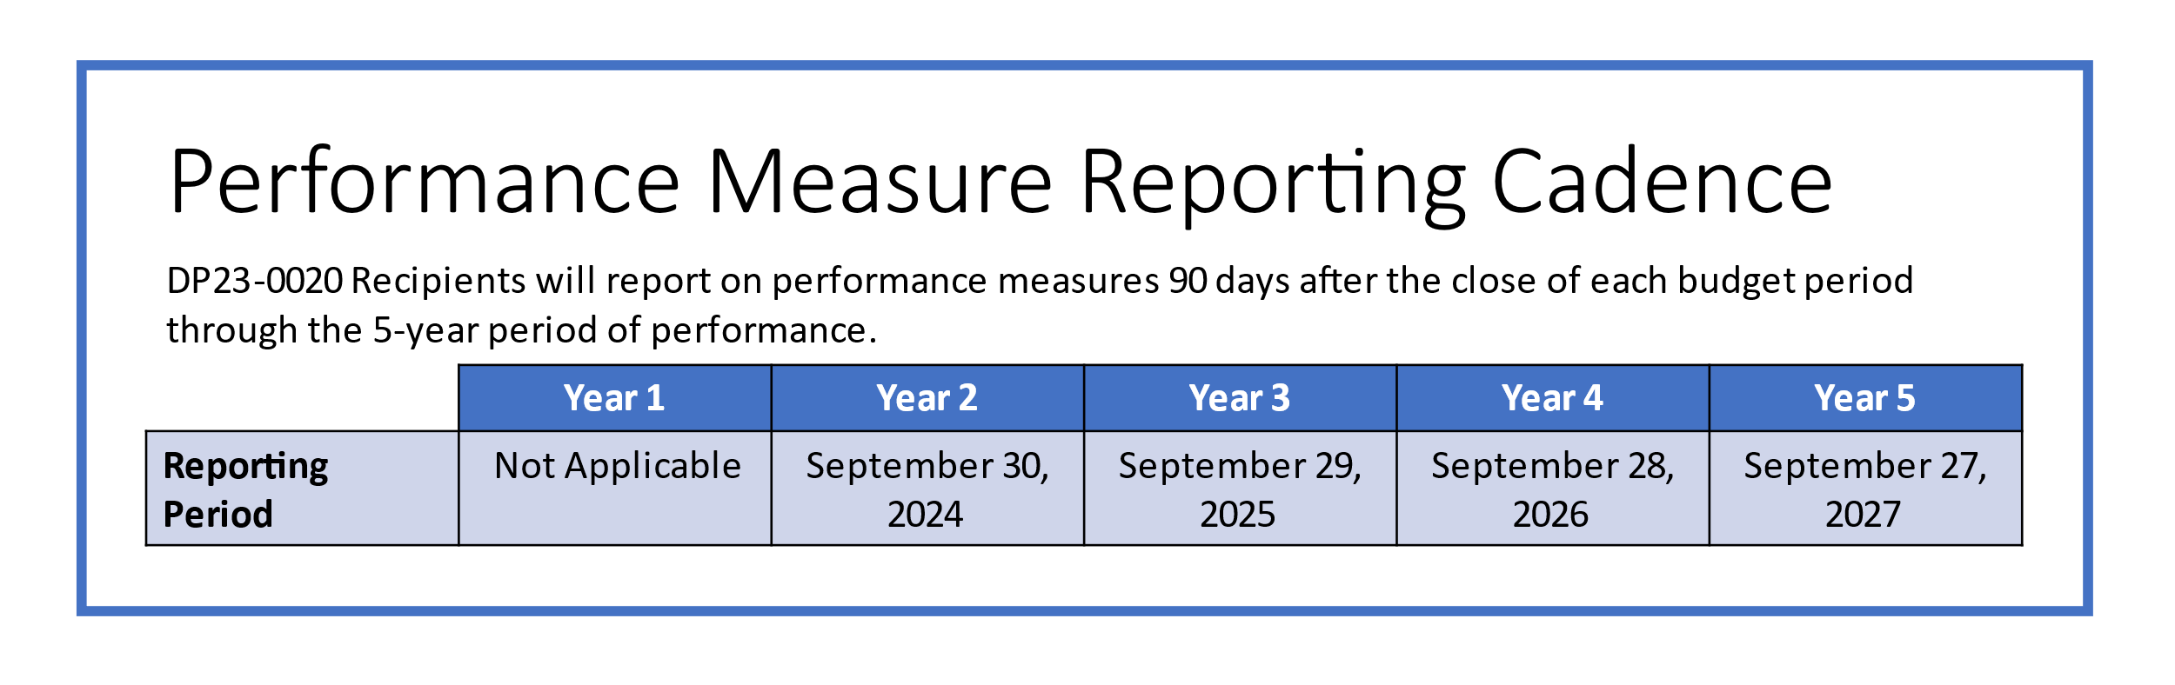

Guidance for Reviewing Performance Measure Screenshots
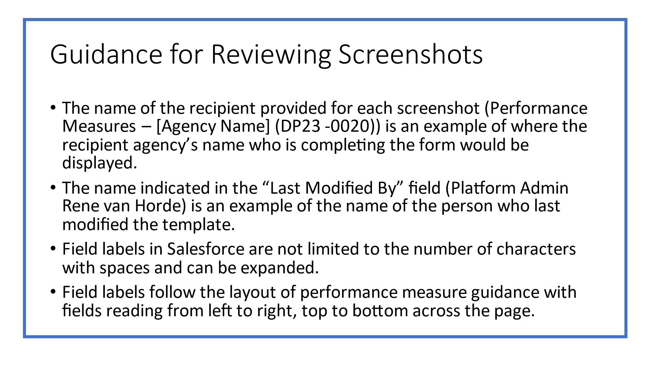

DP23-0020 Home Screen – Component A
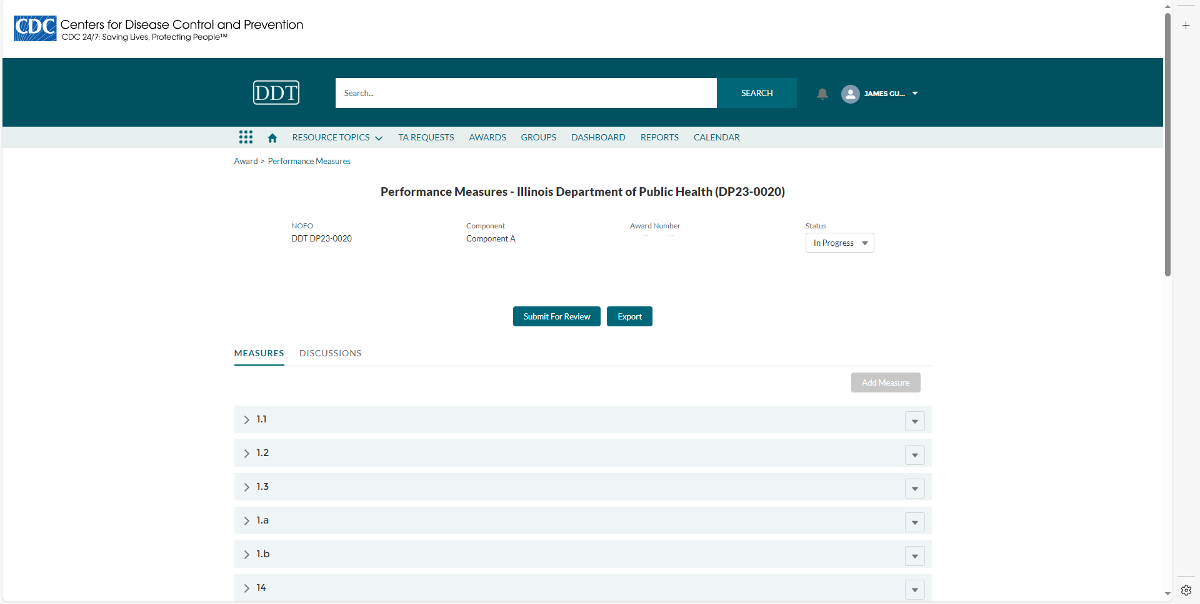

DP23-0020- Performance Measure Template Key-Component A
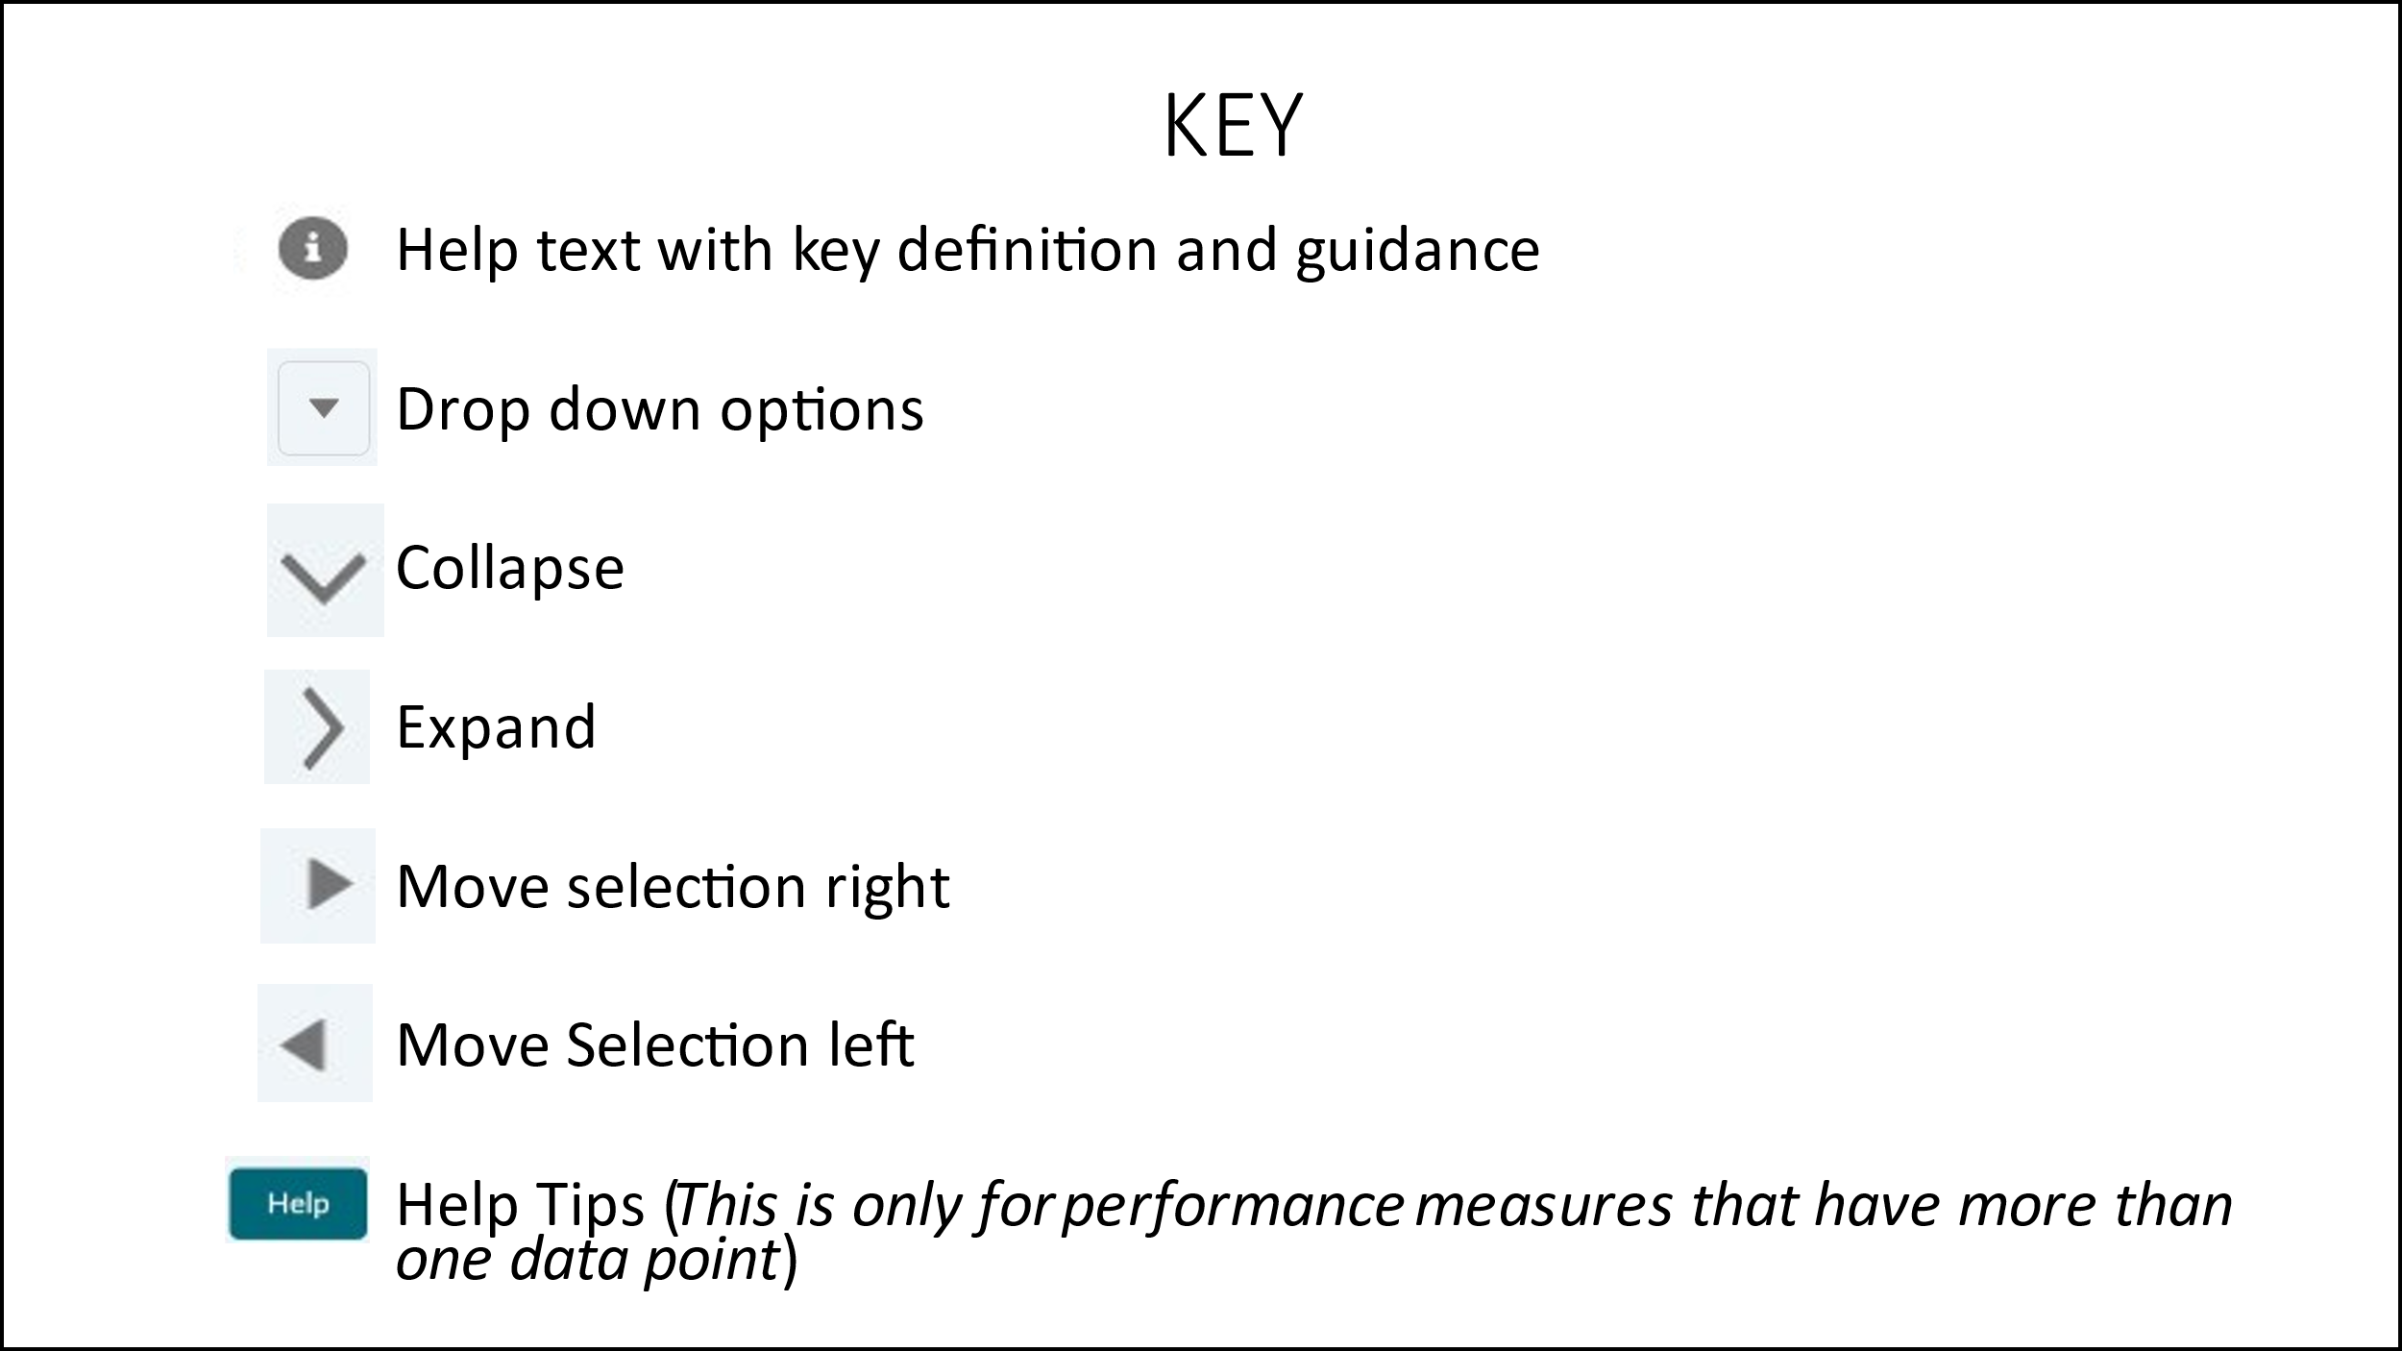

DP23-0020 Measure 1.1 – Component A
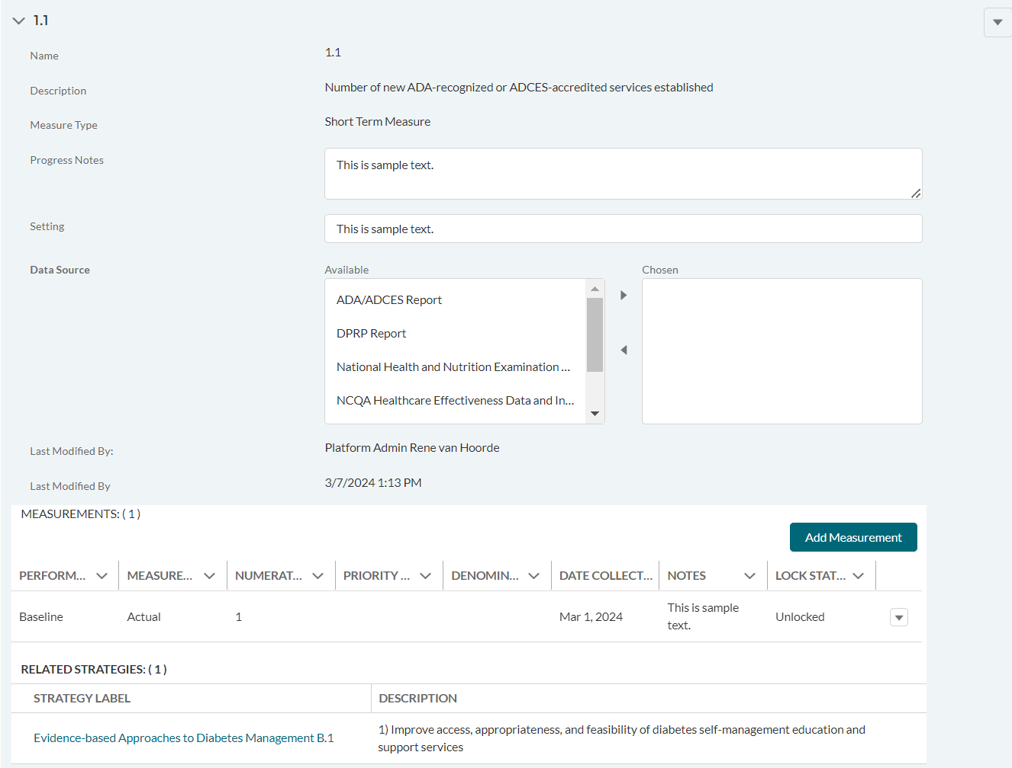

DP23-0020 Measure 1.1 _Add Measurement Option – Component A
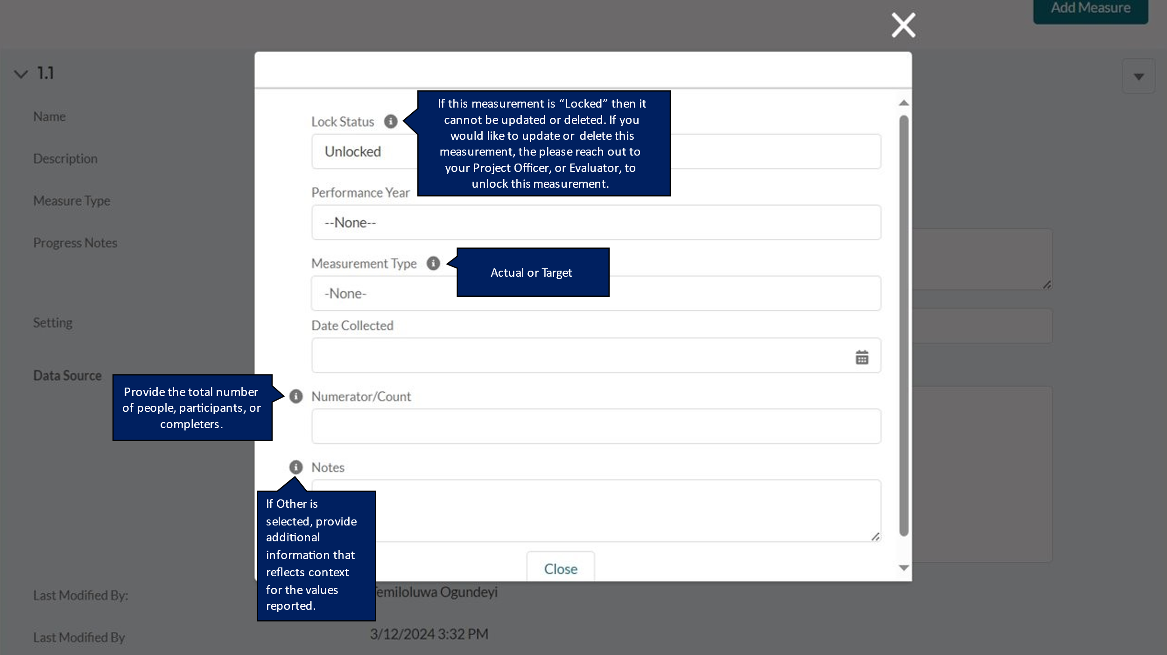

DP23-0020 Measure 1.2 – Component A
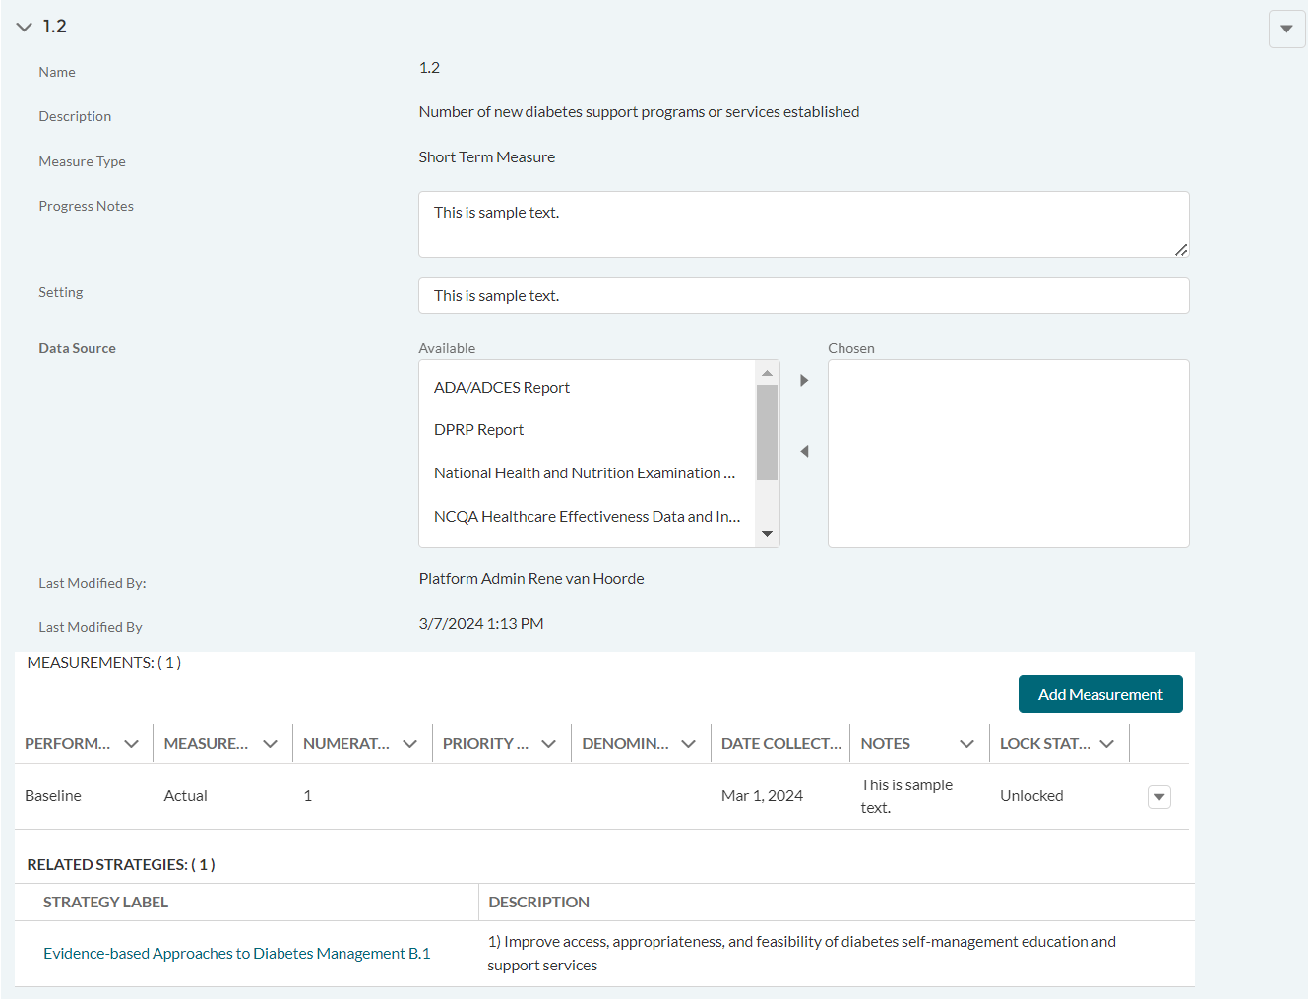

DP23-0020 Measure 1.2 _Add Measurement Option – Component A
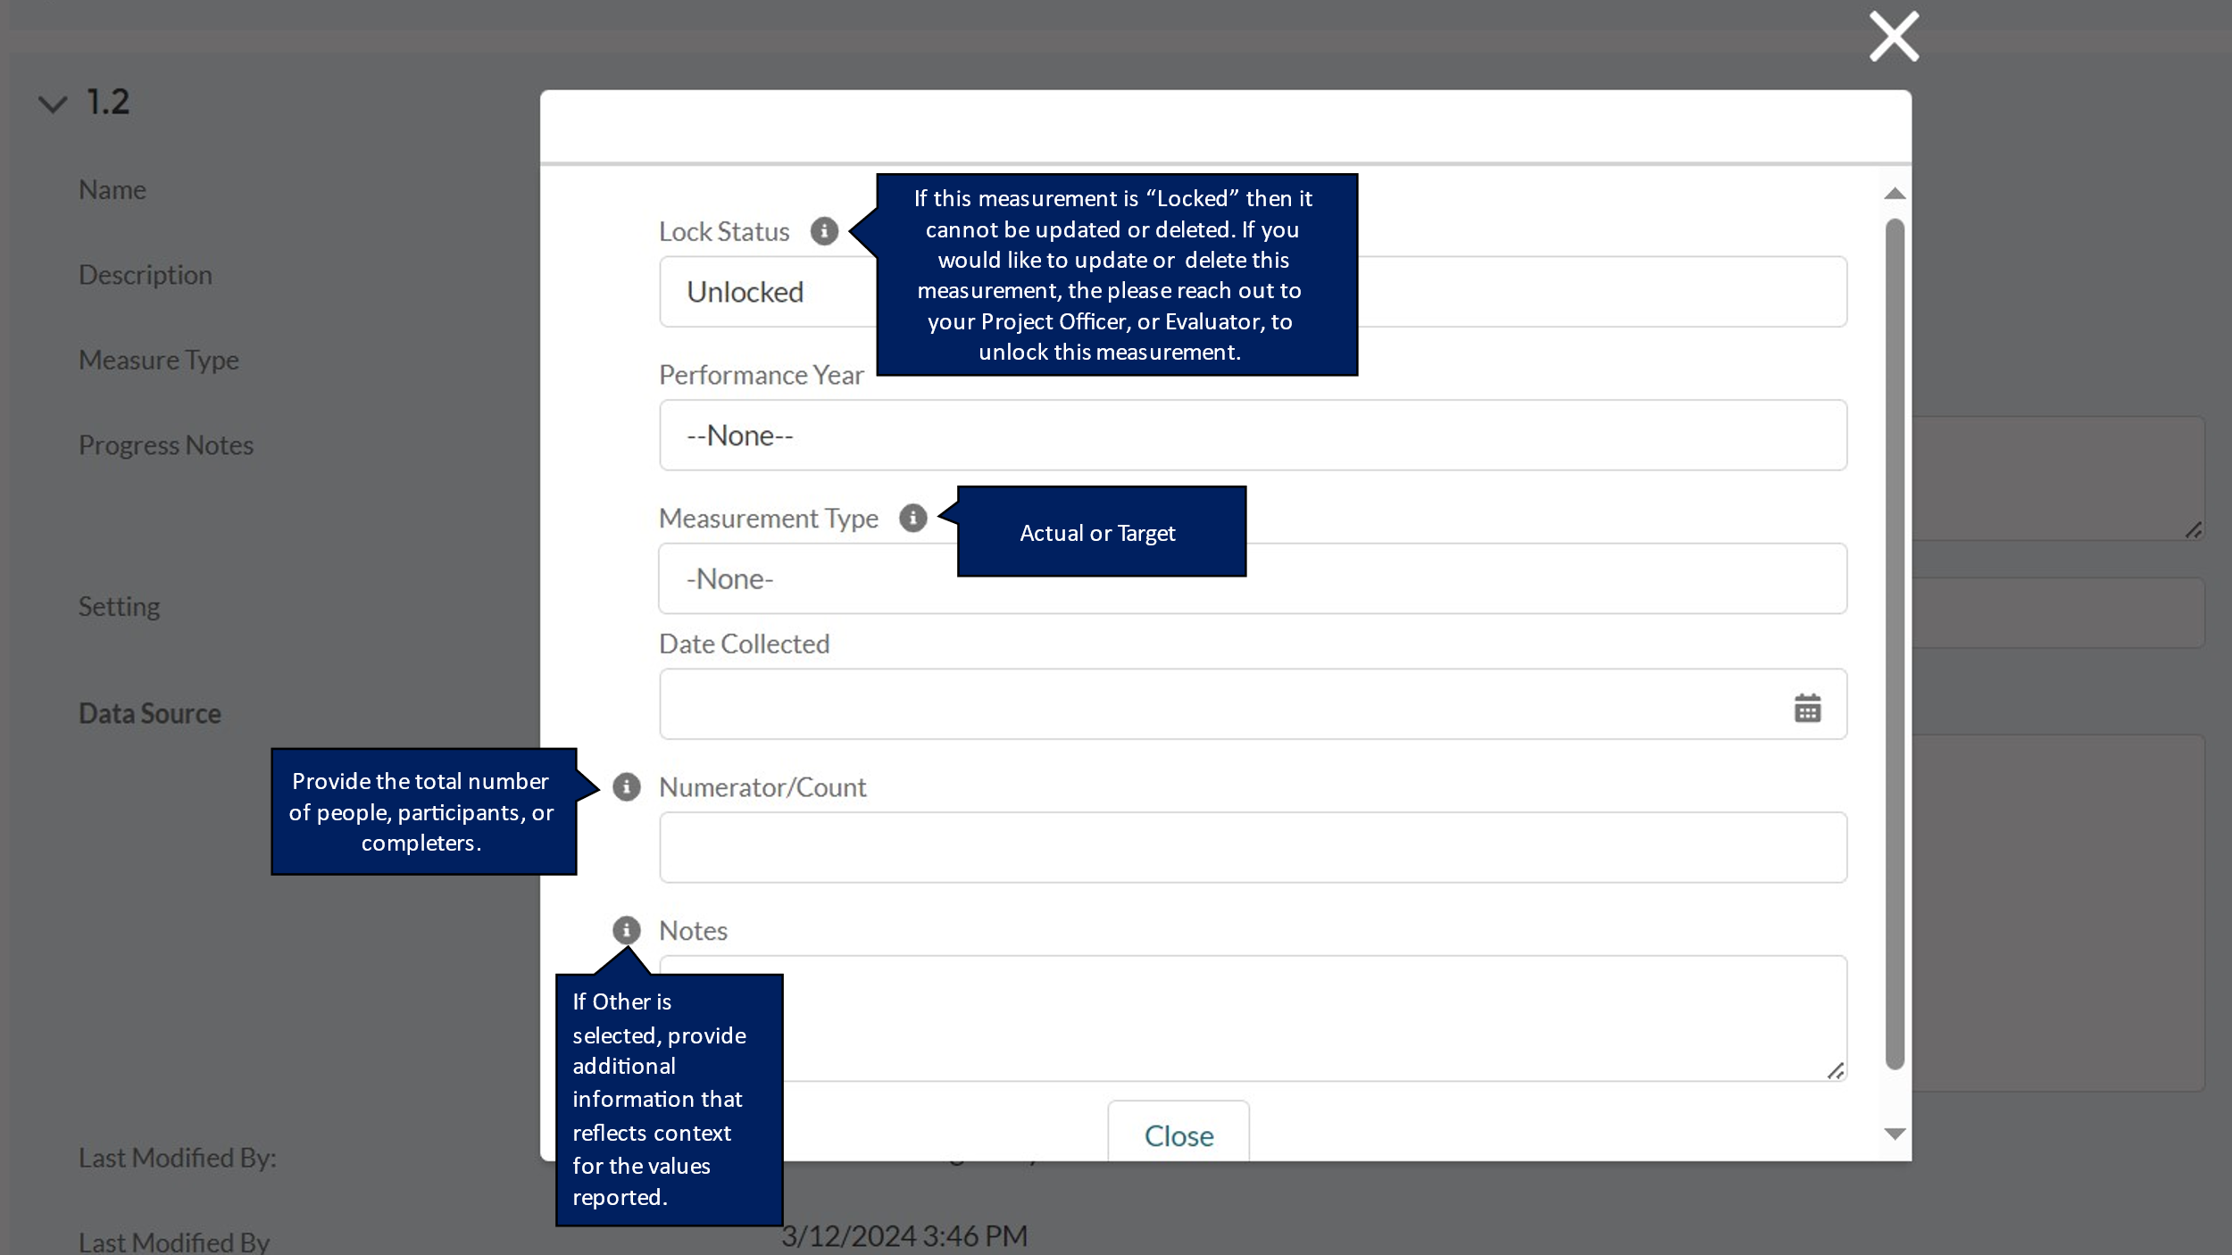

DP23-0020 Measure 1.3 – Component A
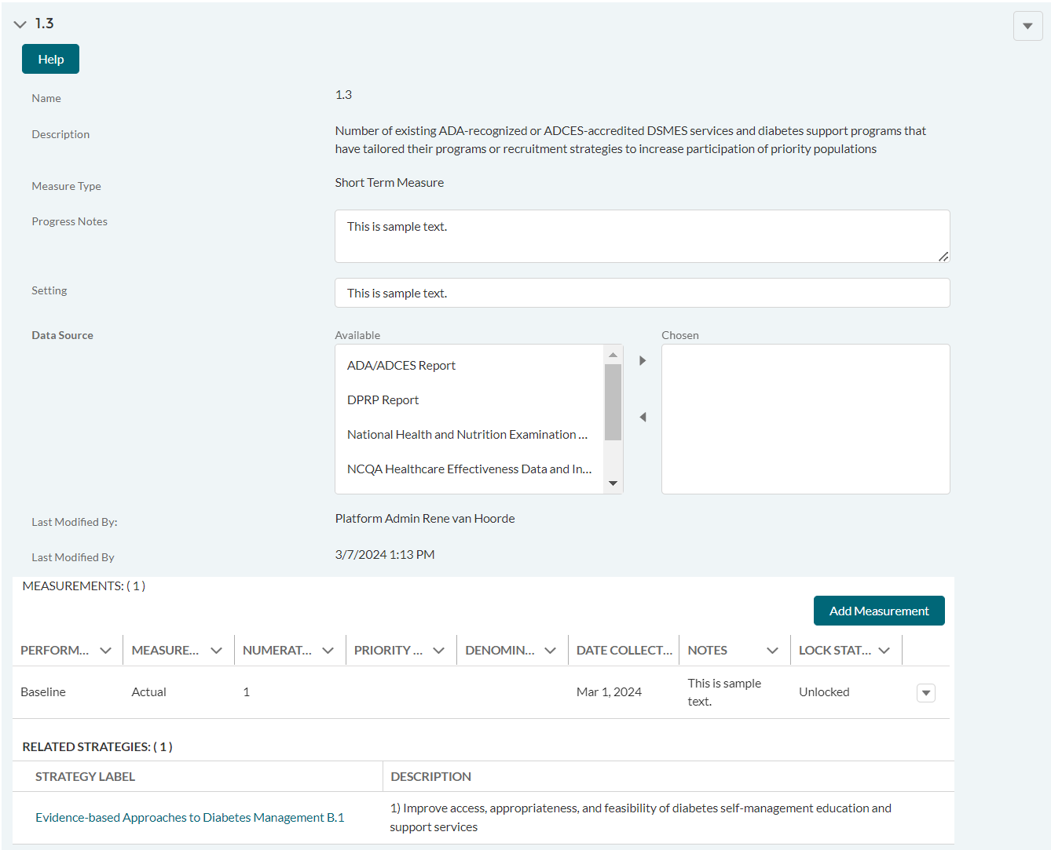

DP23-0020 Measure 1.3 _Add Measurement Option – Component A
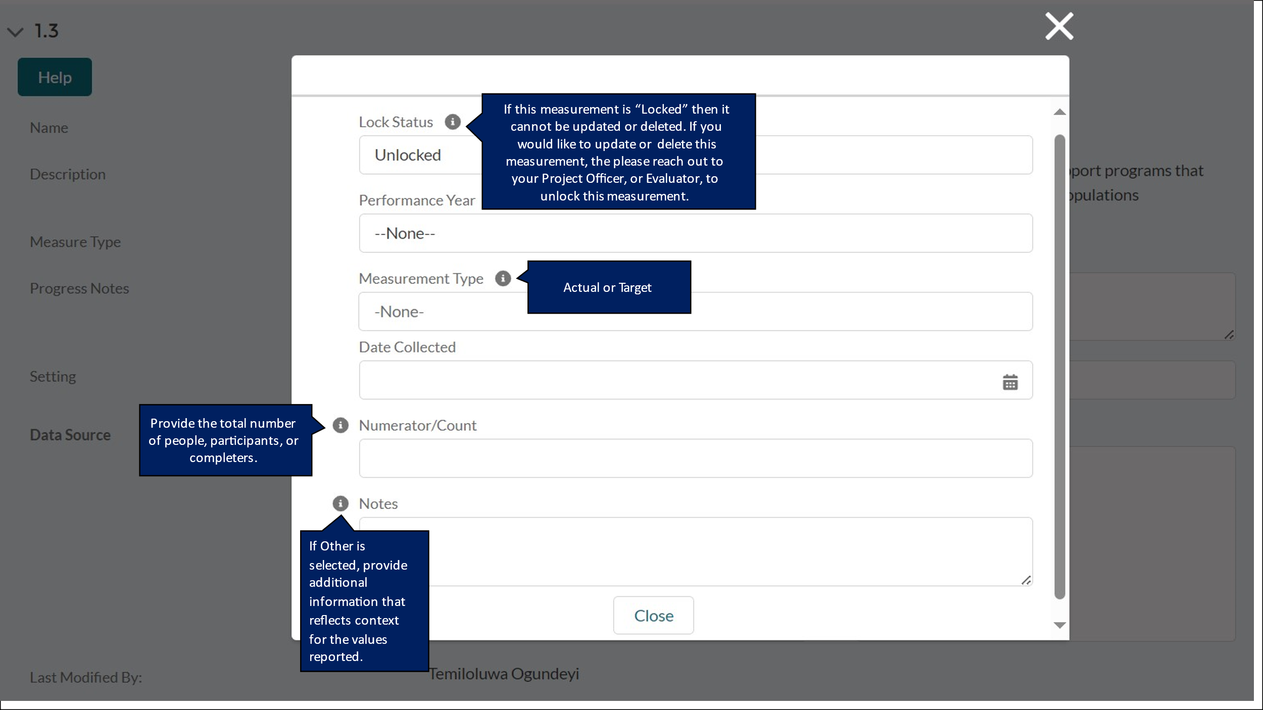

DP23-0020 Measure 1.a – Component A
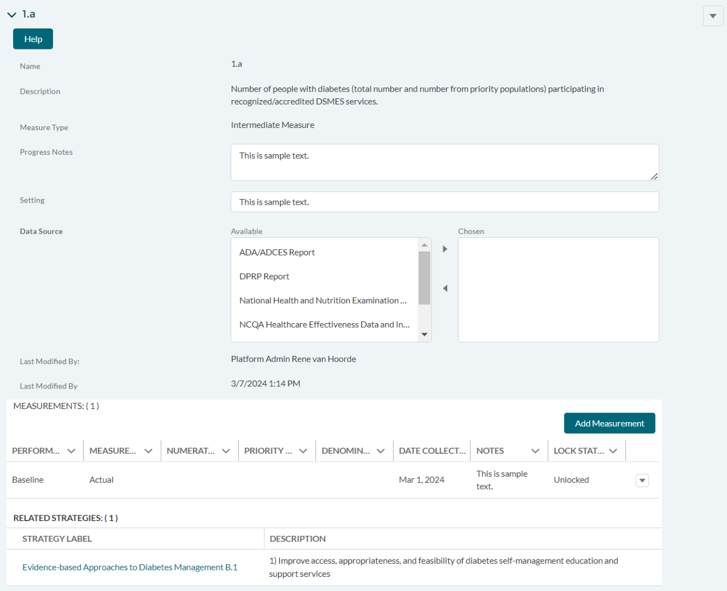

DP23-0020 Measure 1.a _Add Measurement Option – Component A
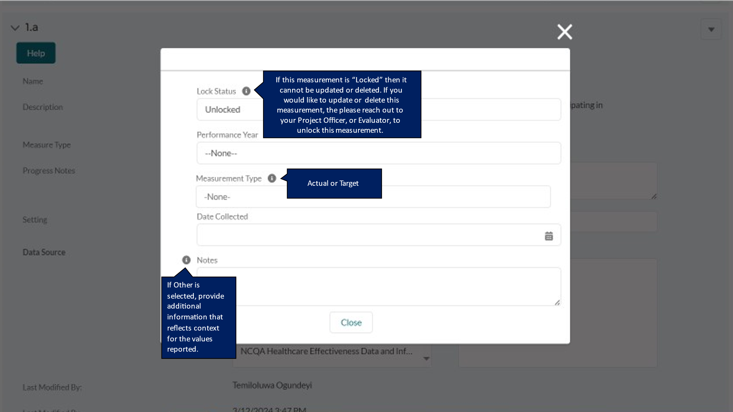

DP23-0020 Measure 1.b – Component A
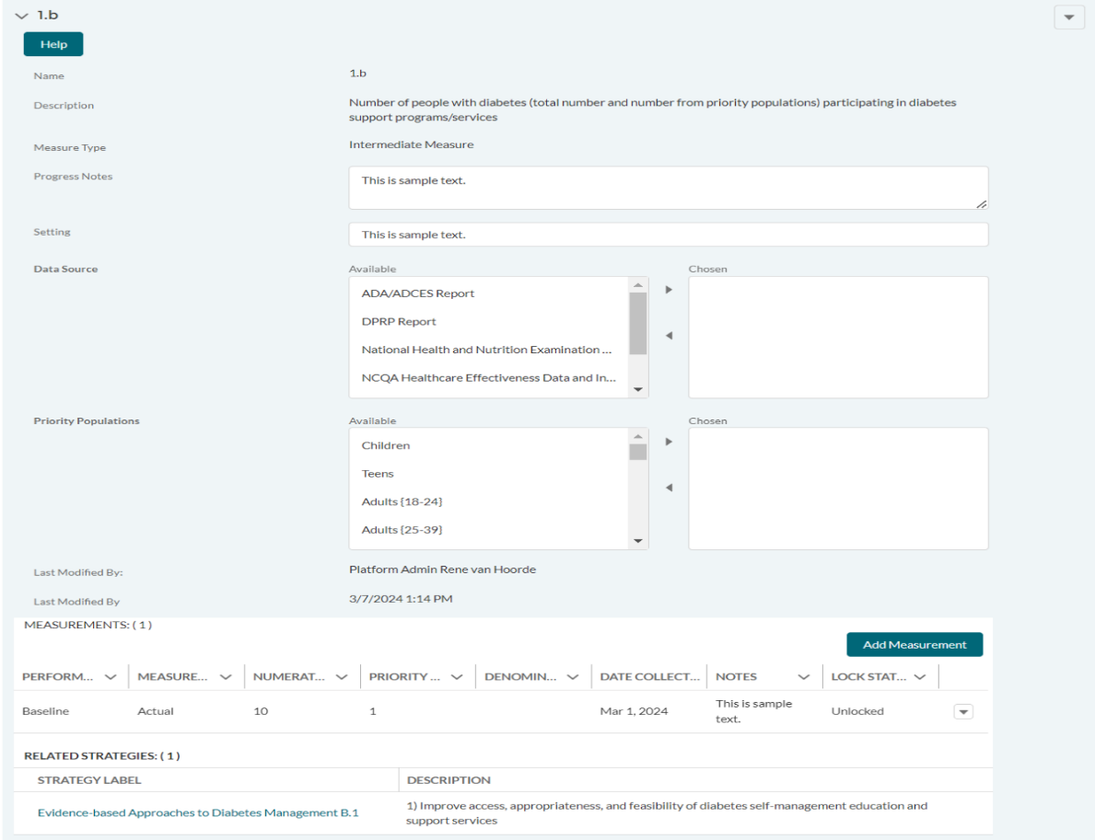

DP23-0020 Measure 1.b _Add Measurement Option – Component A
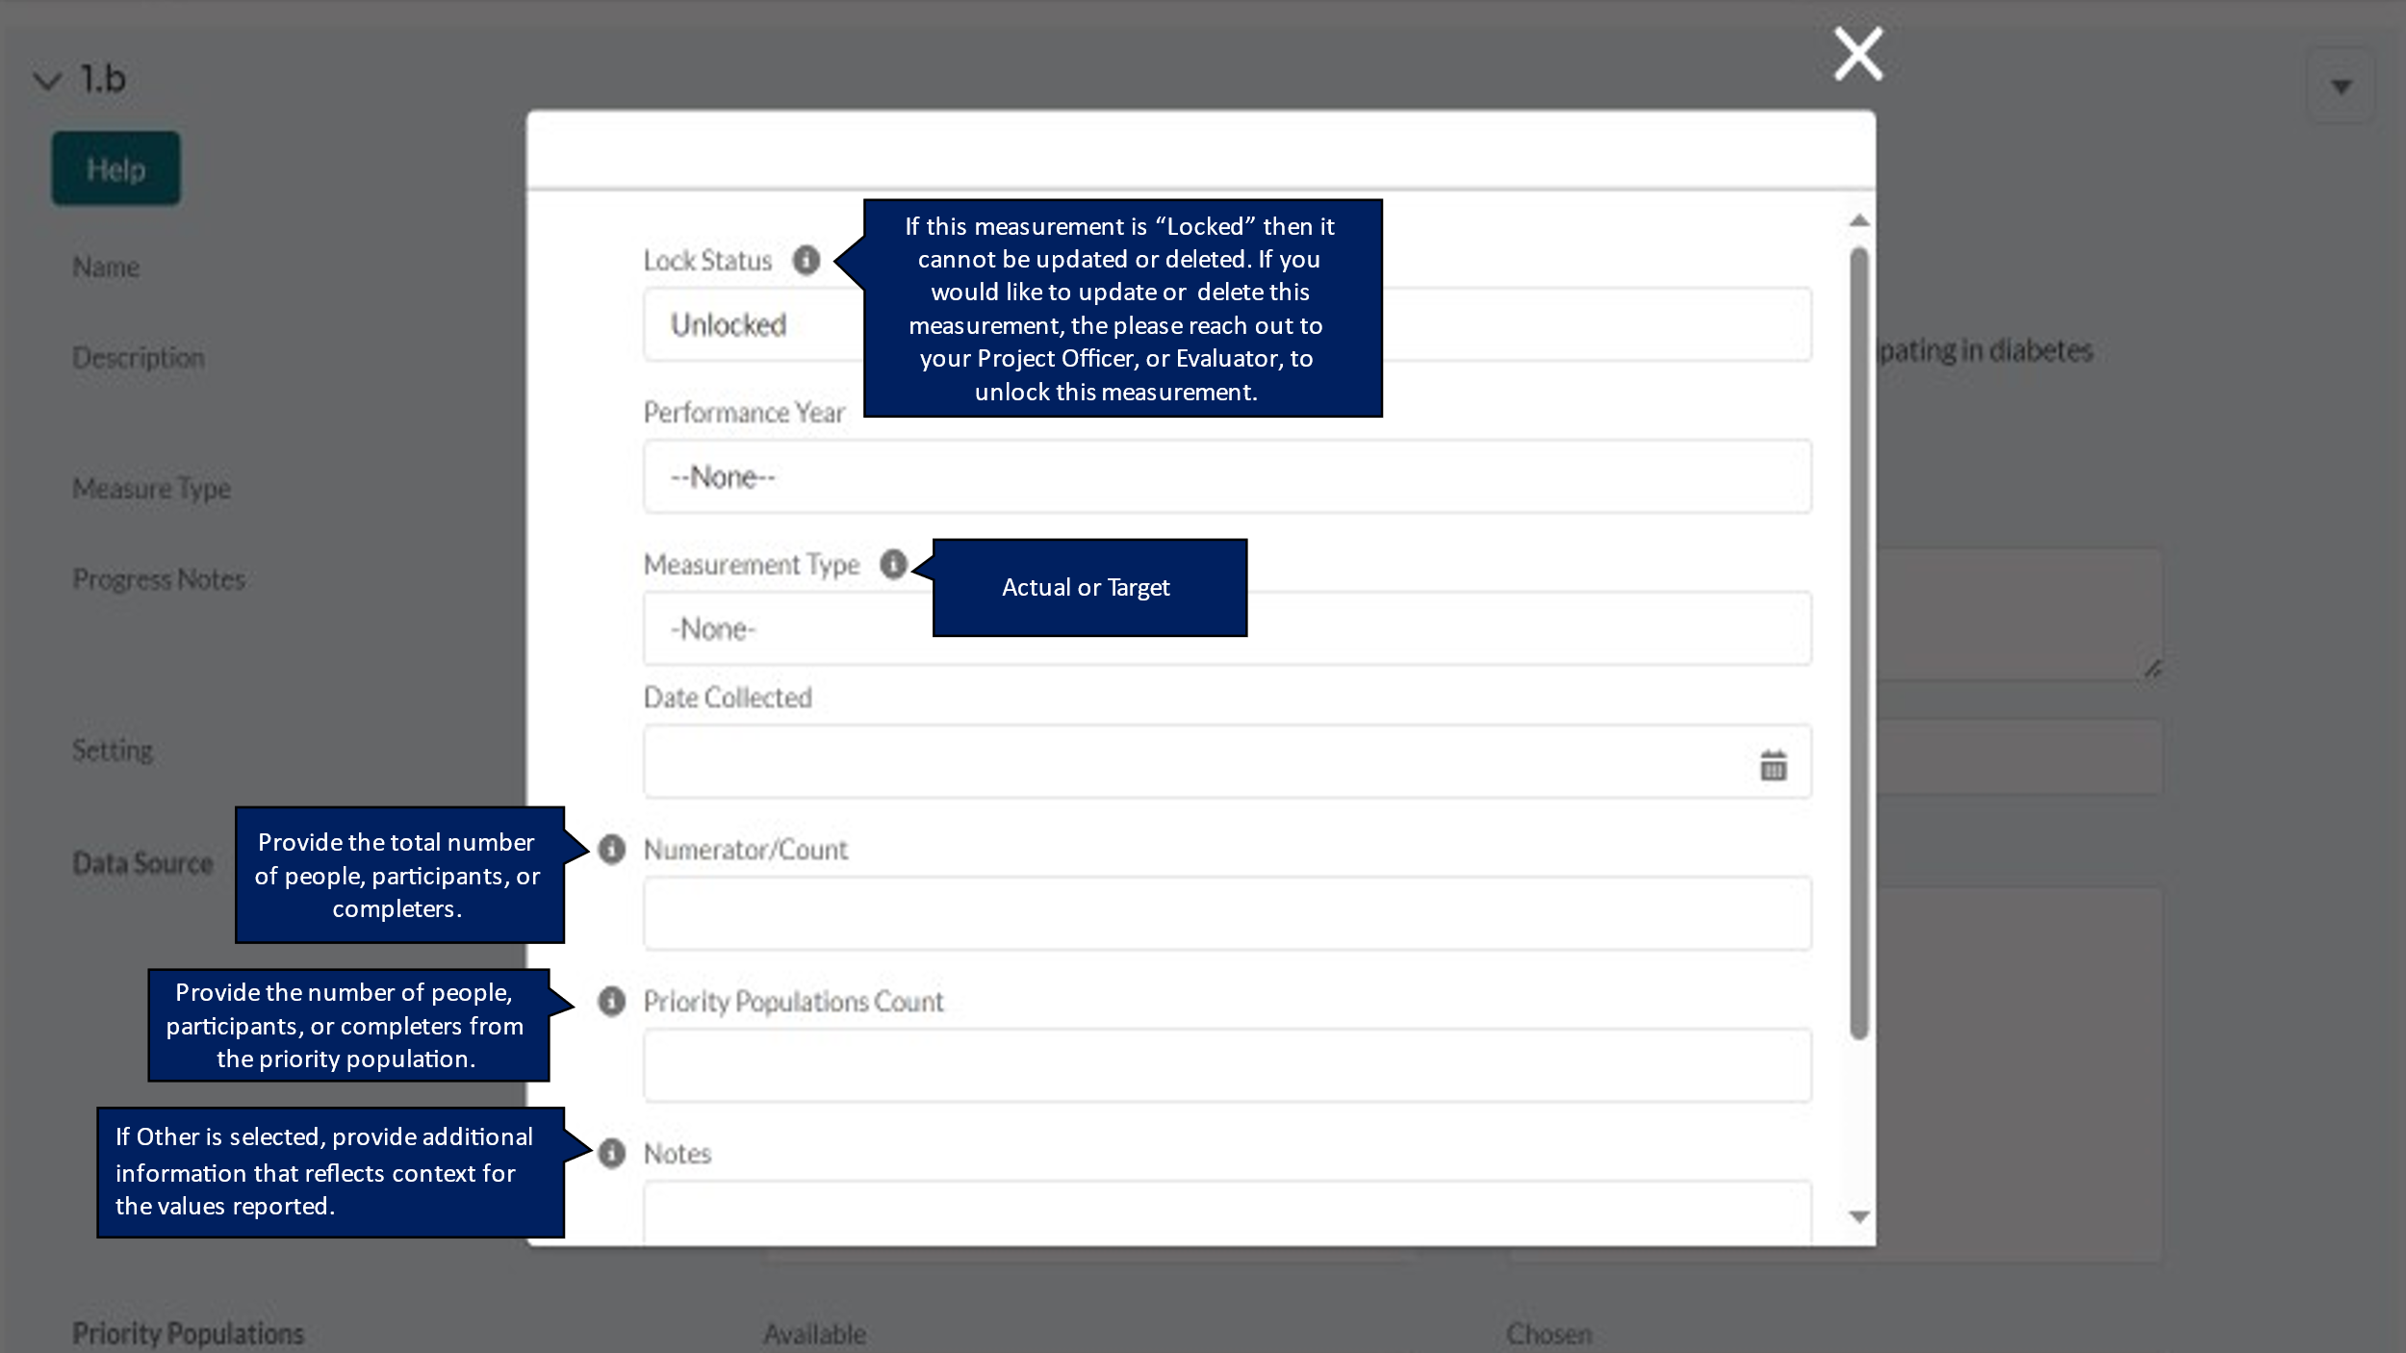

DP23-0020 Measure 2.2 – Component A
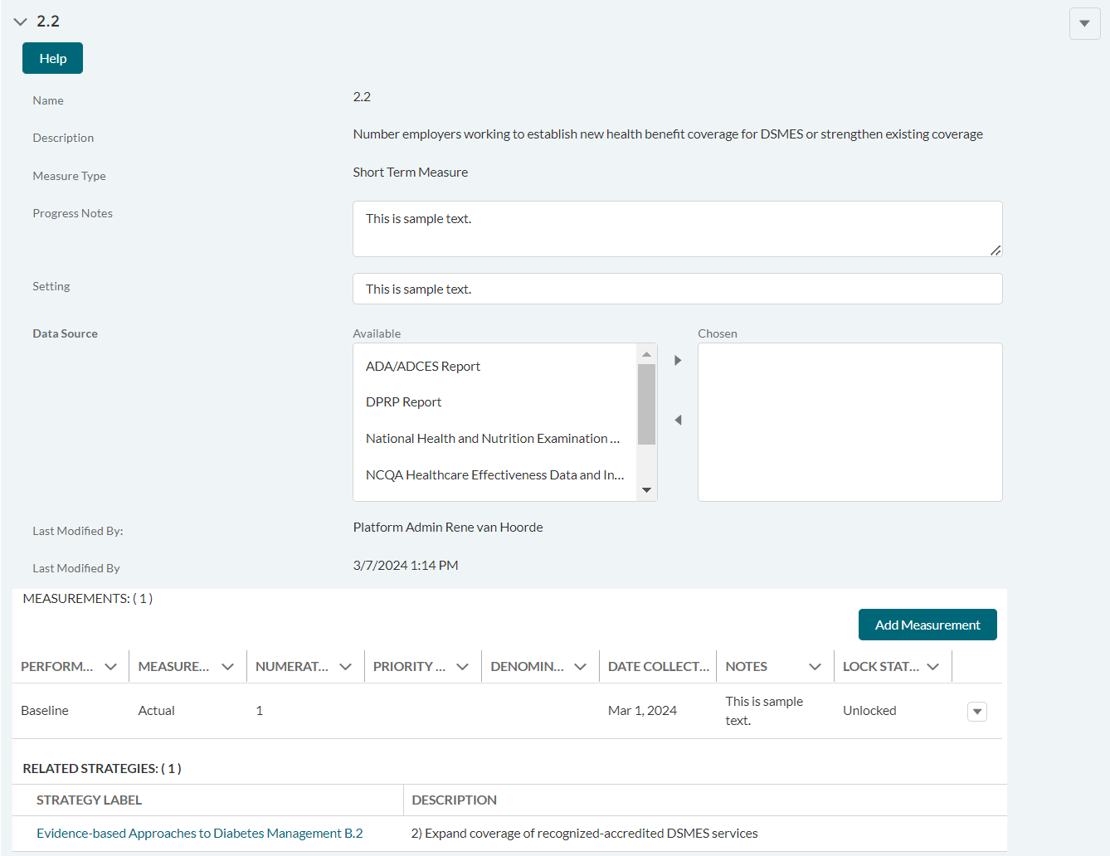

DP23-0020 Measure 2.2 _Add Measurement Option – Component A
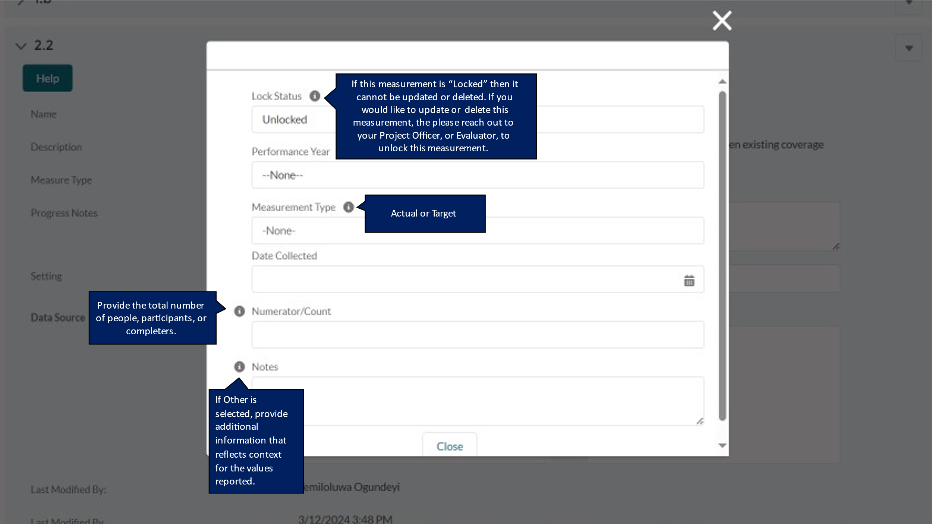

DP23-0020 Measure 2.a – Component A
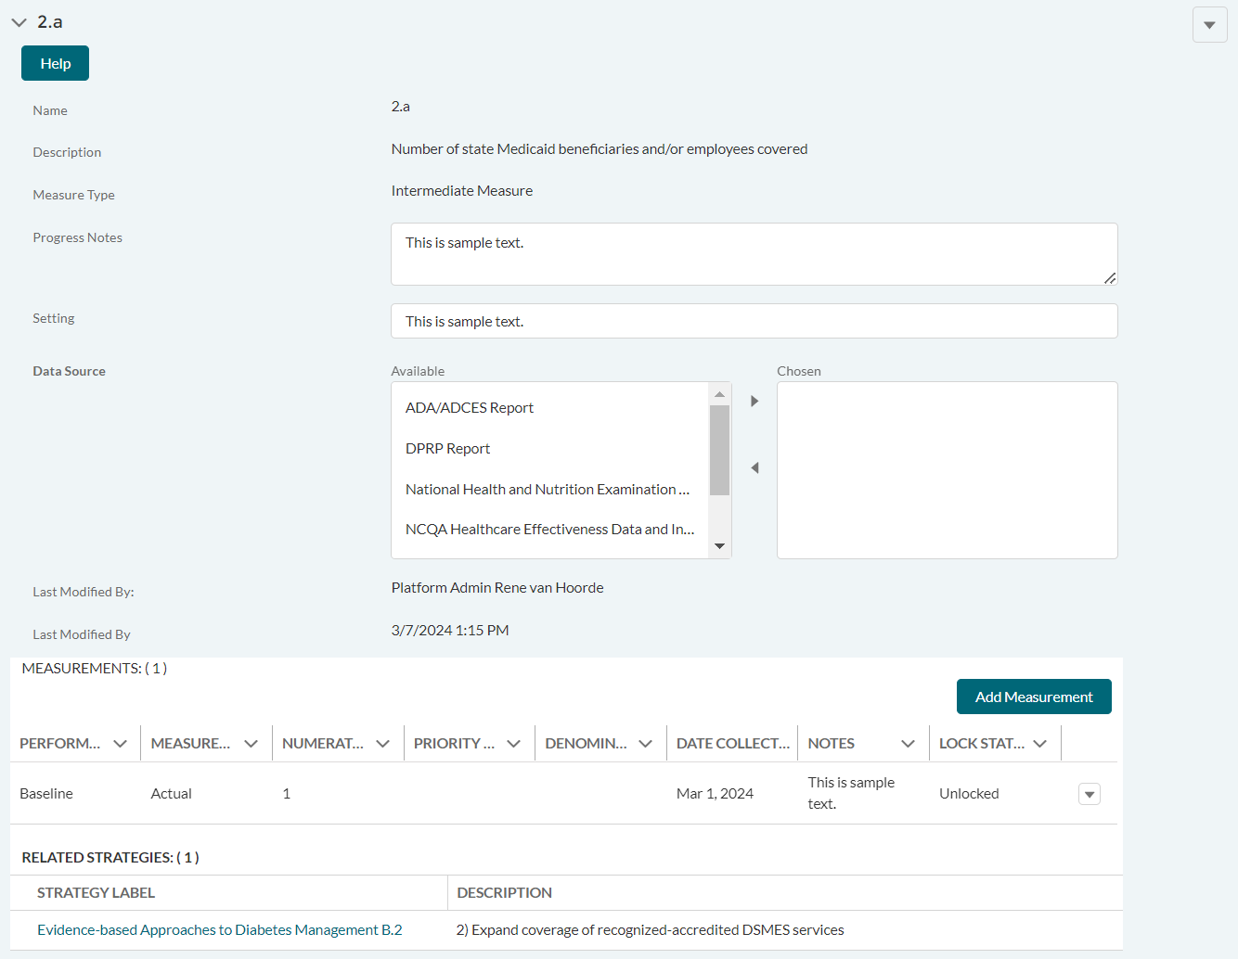

DP23-0020 Measure 2.a _Add Measurement Option – Component A
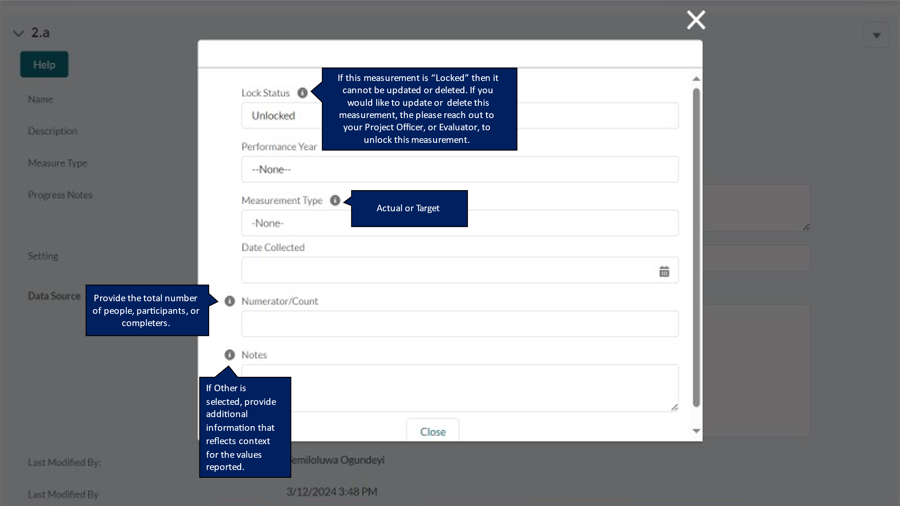

DP23-0020 Measure 3.1 – Component A
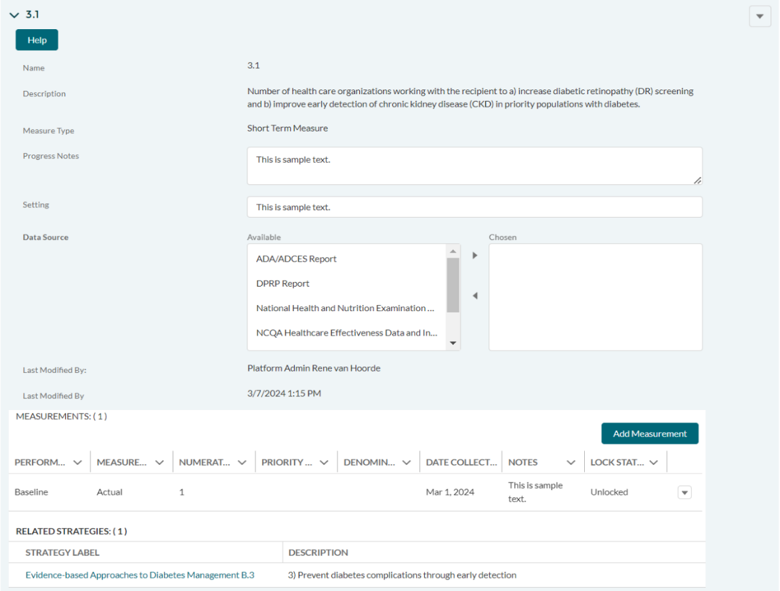

DP23-0020 Measure 3.1_Add Measurement Option – Component A
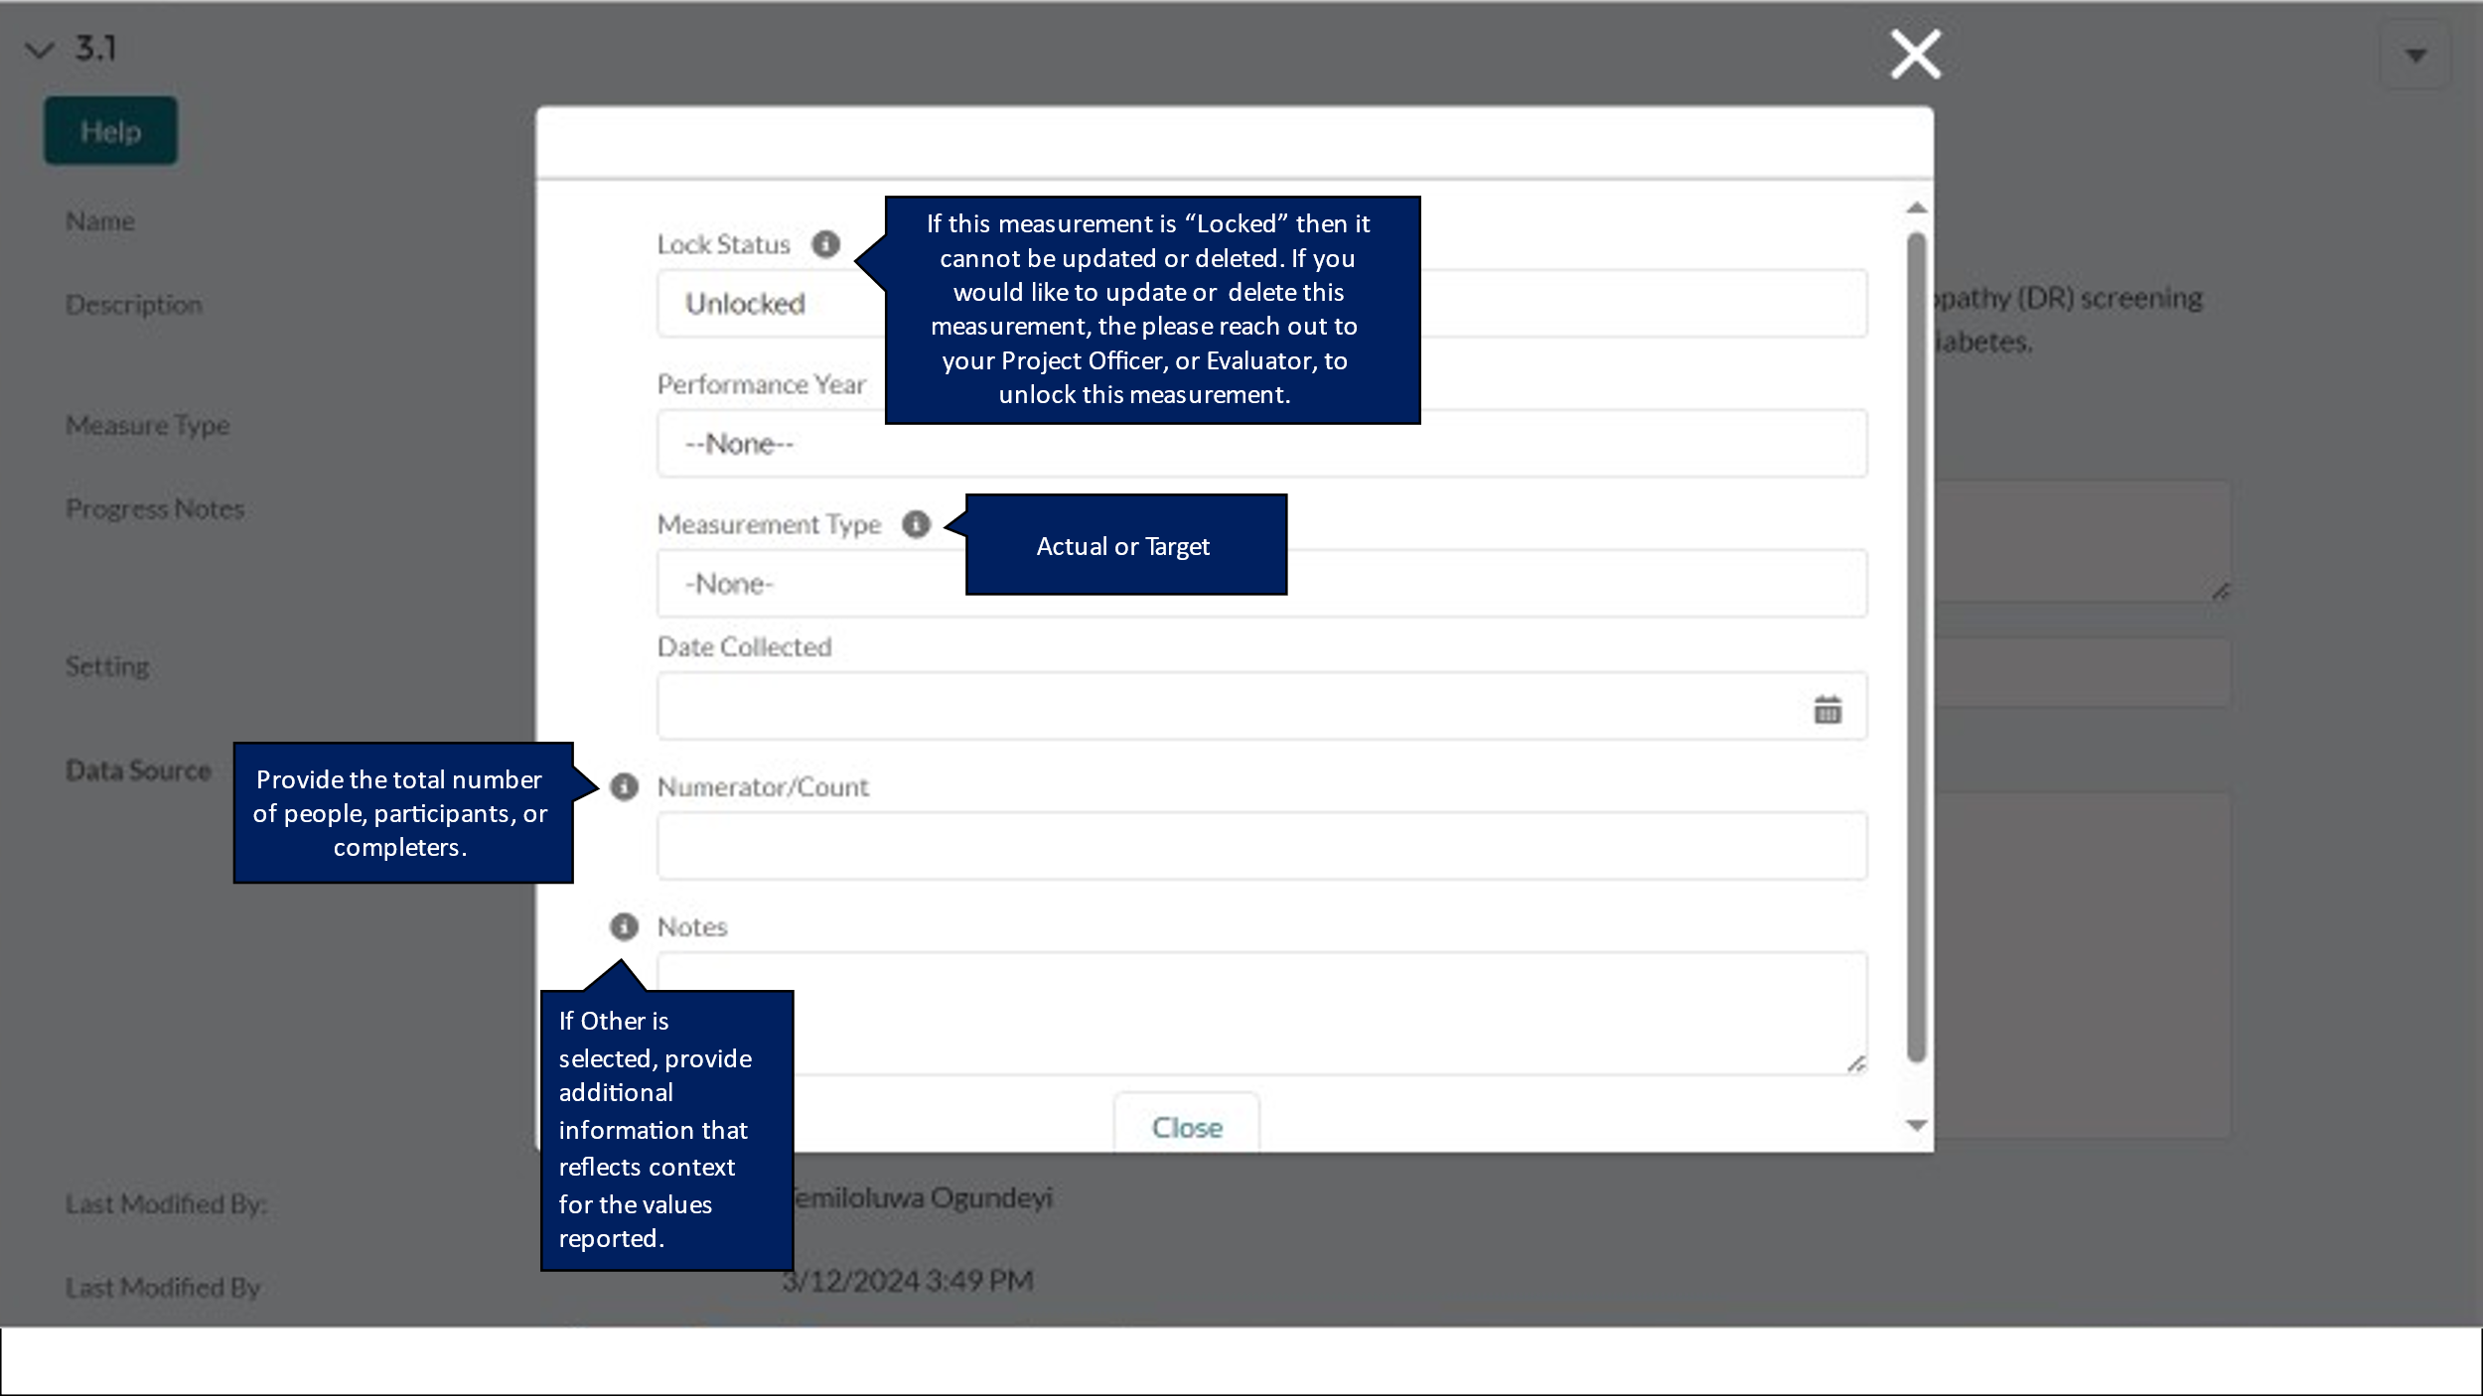

DP23-0020 Measure 3.a – Component A
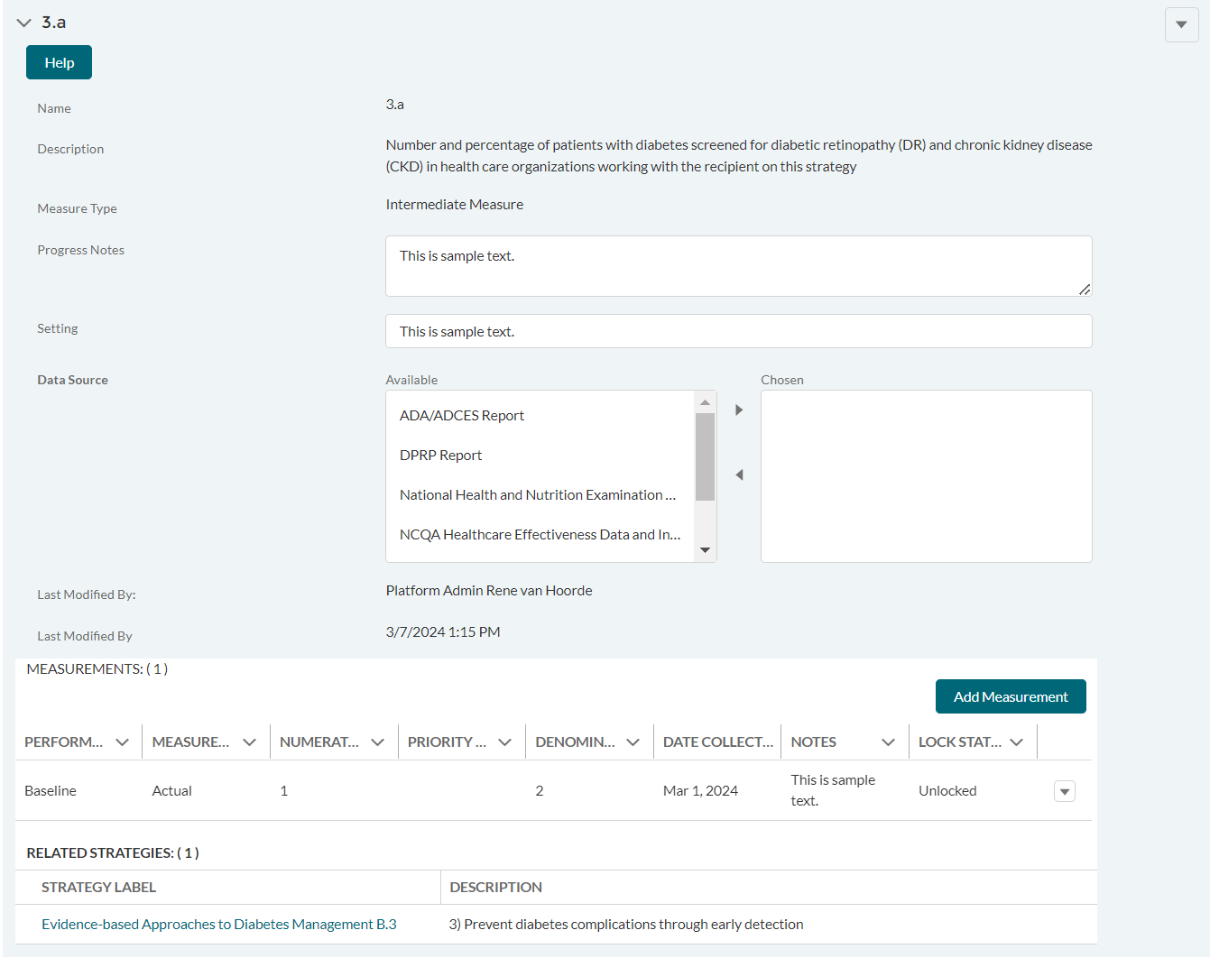

DP23-0020 Measure 3.a_Add Measurement Option – Component A
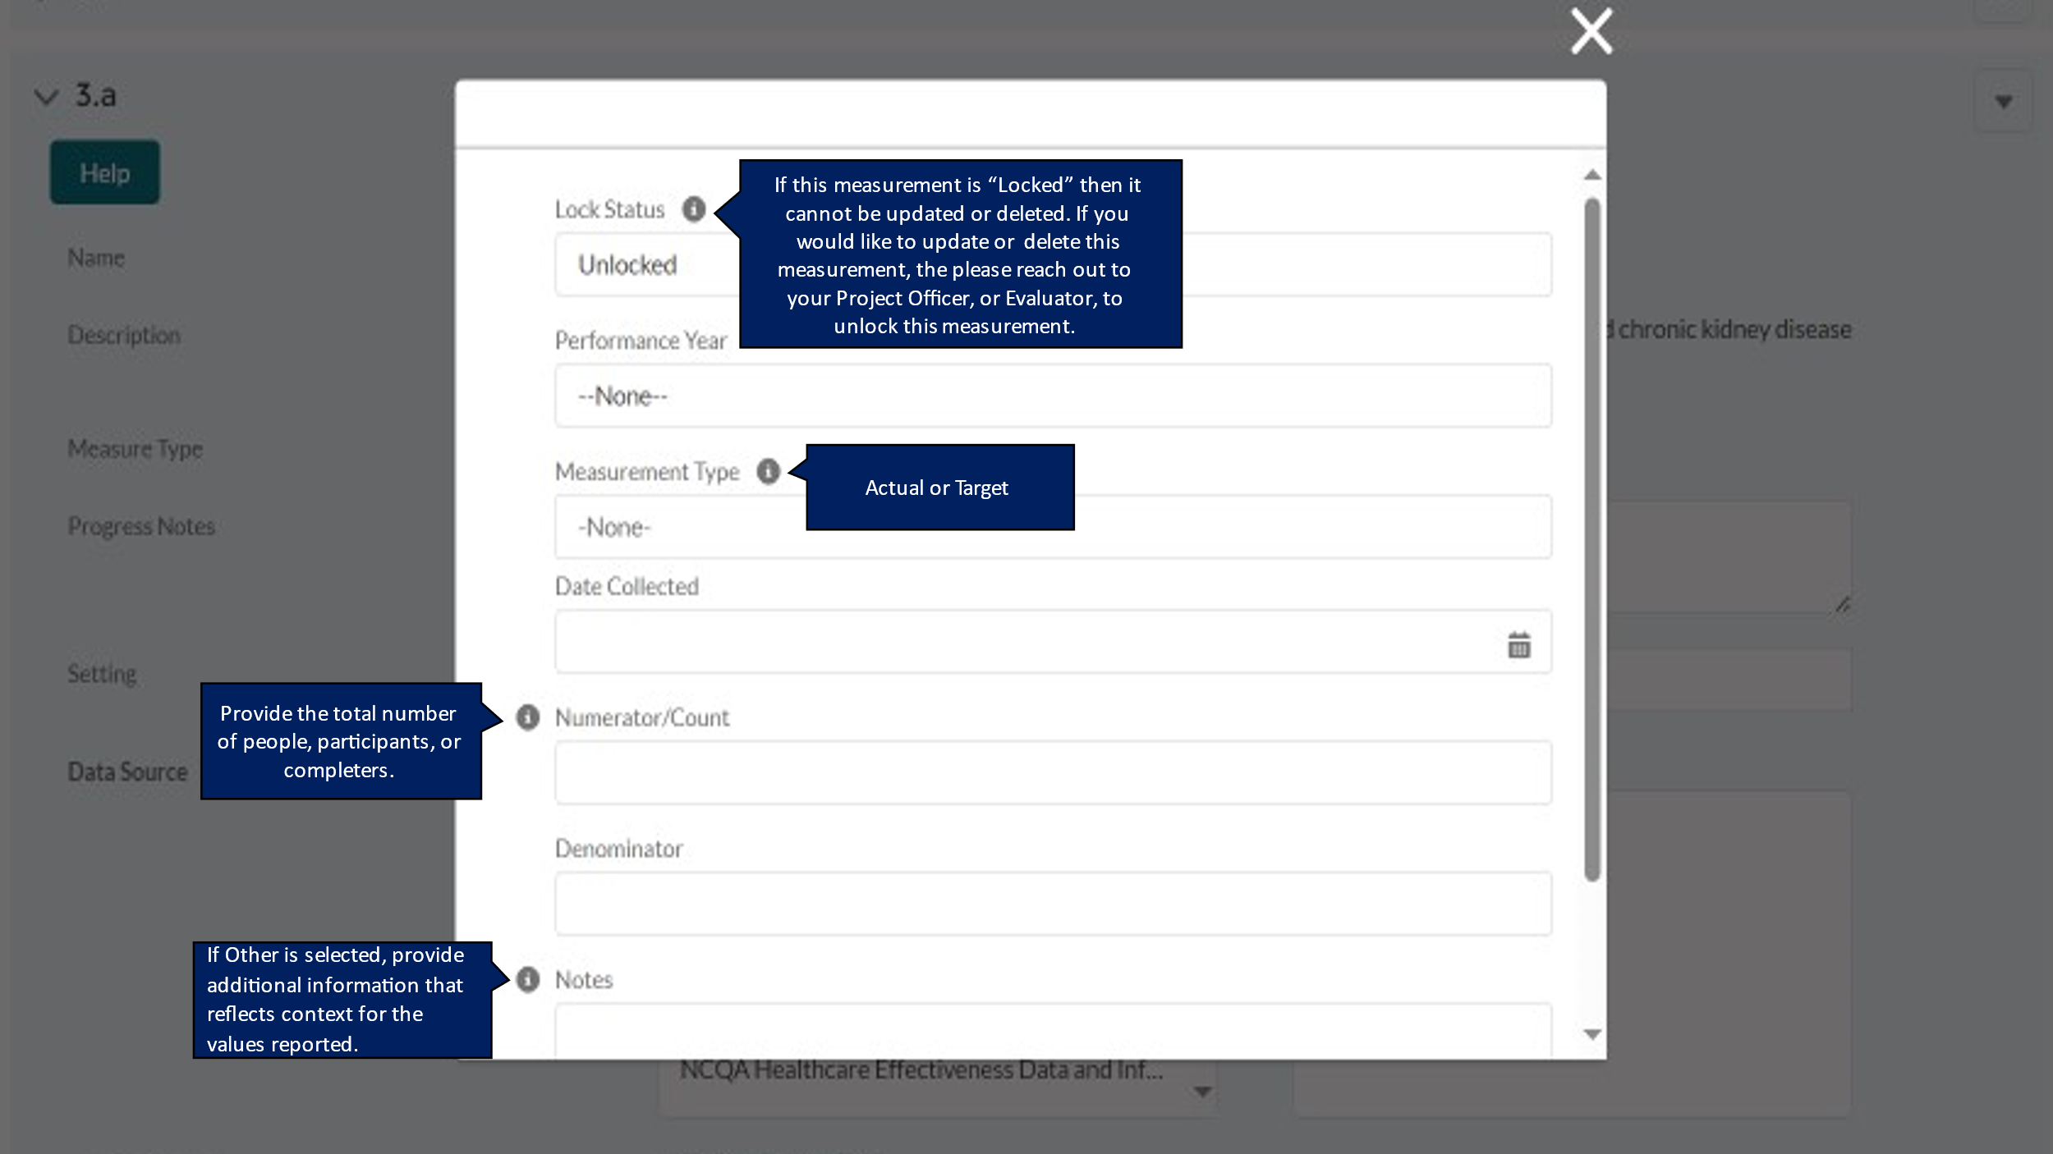

DP23-0020 Measure 4.1 – Component A
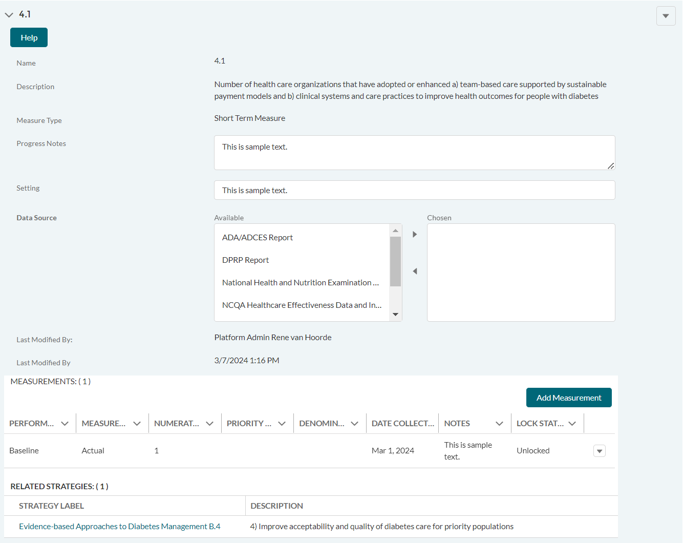

DP23-0020 Measure 4.1_Add Measurement Option – Component A
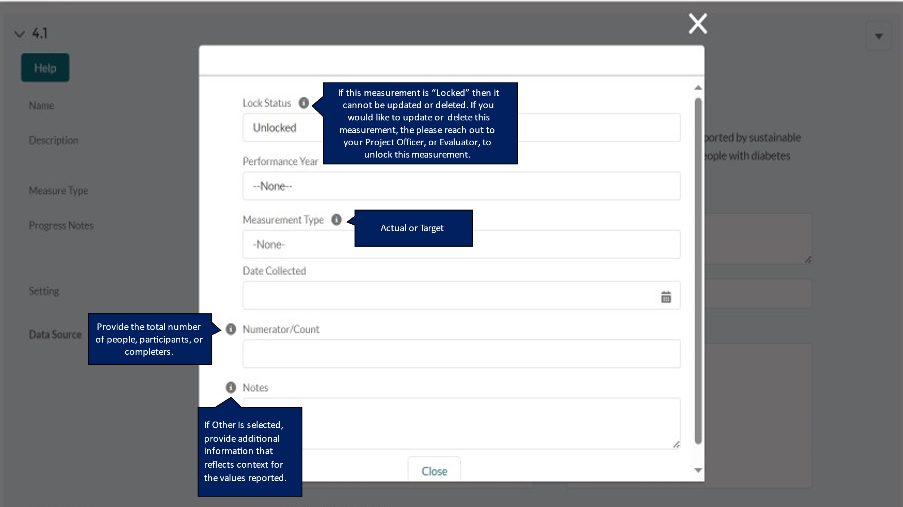

DP23-0020 Measure 4.a – Component A
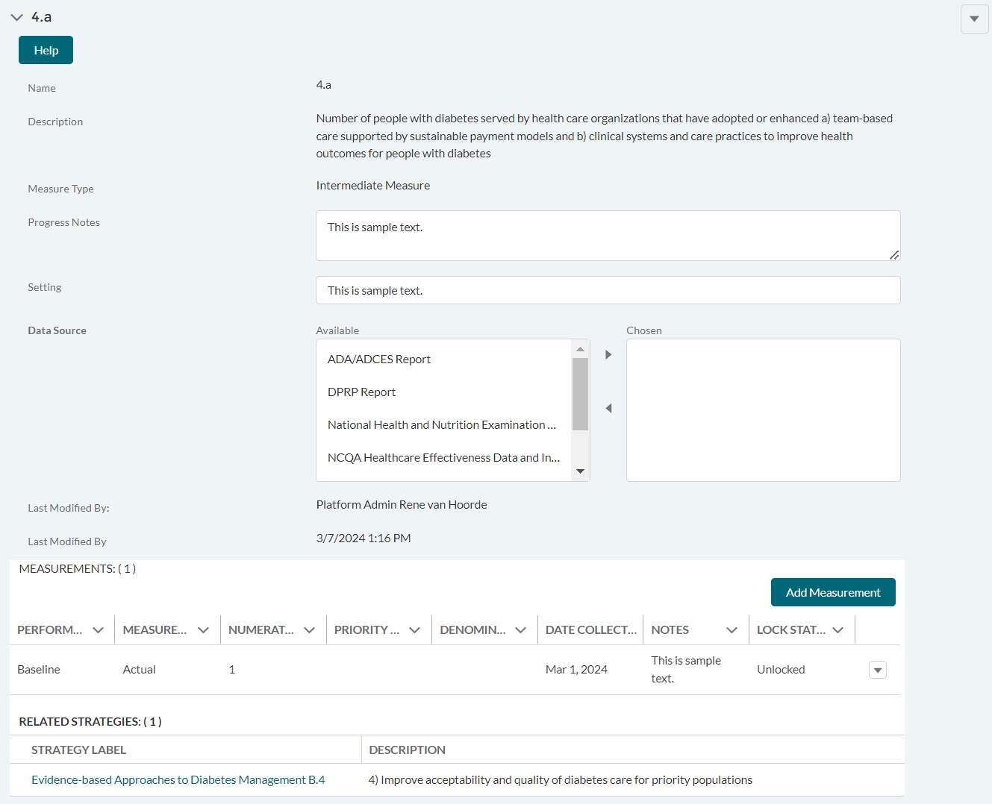

DP23-0020 Measure 4.a_Add Measurement Option – Component A
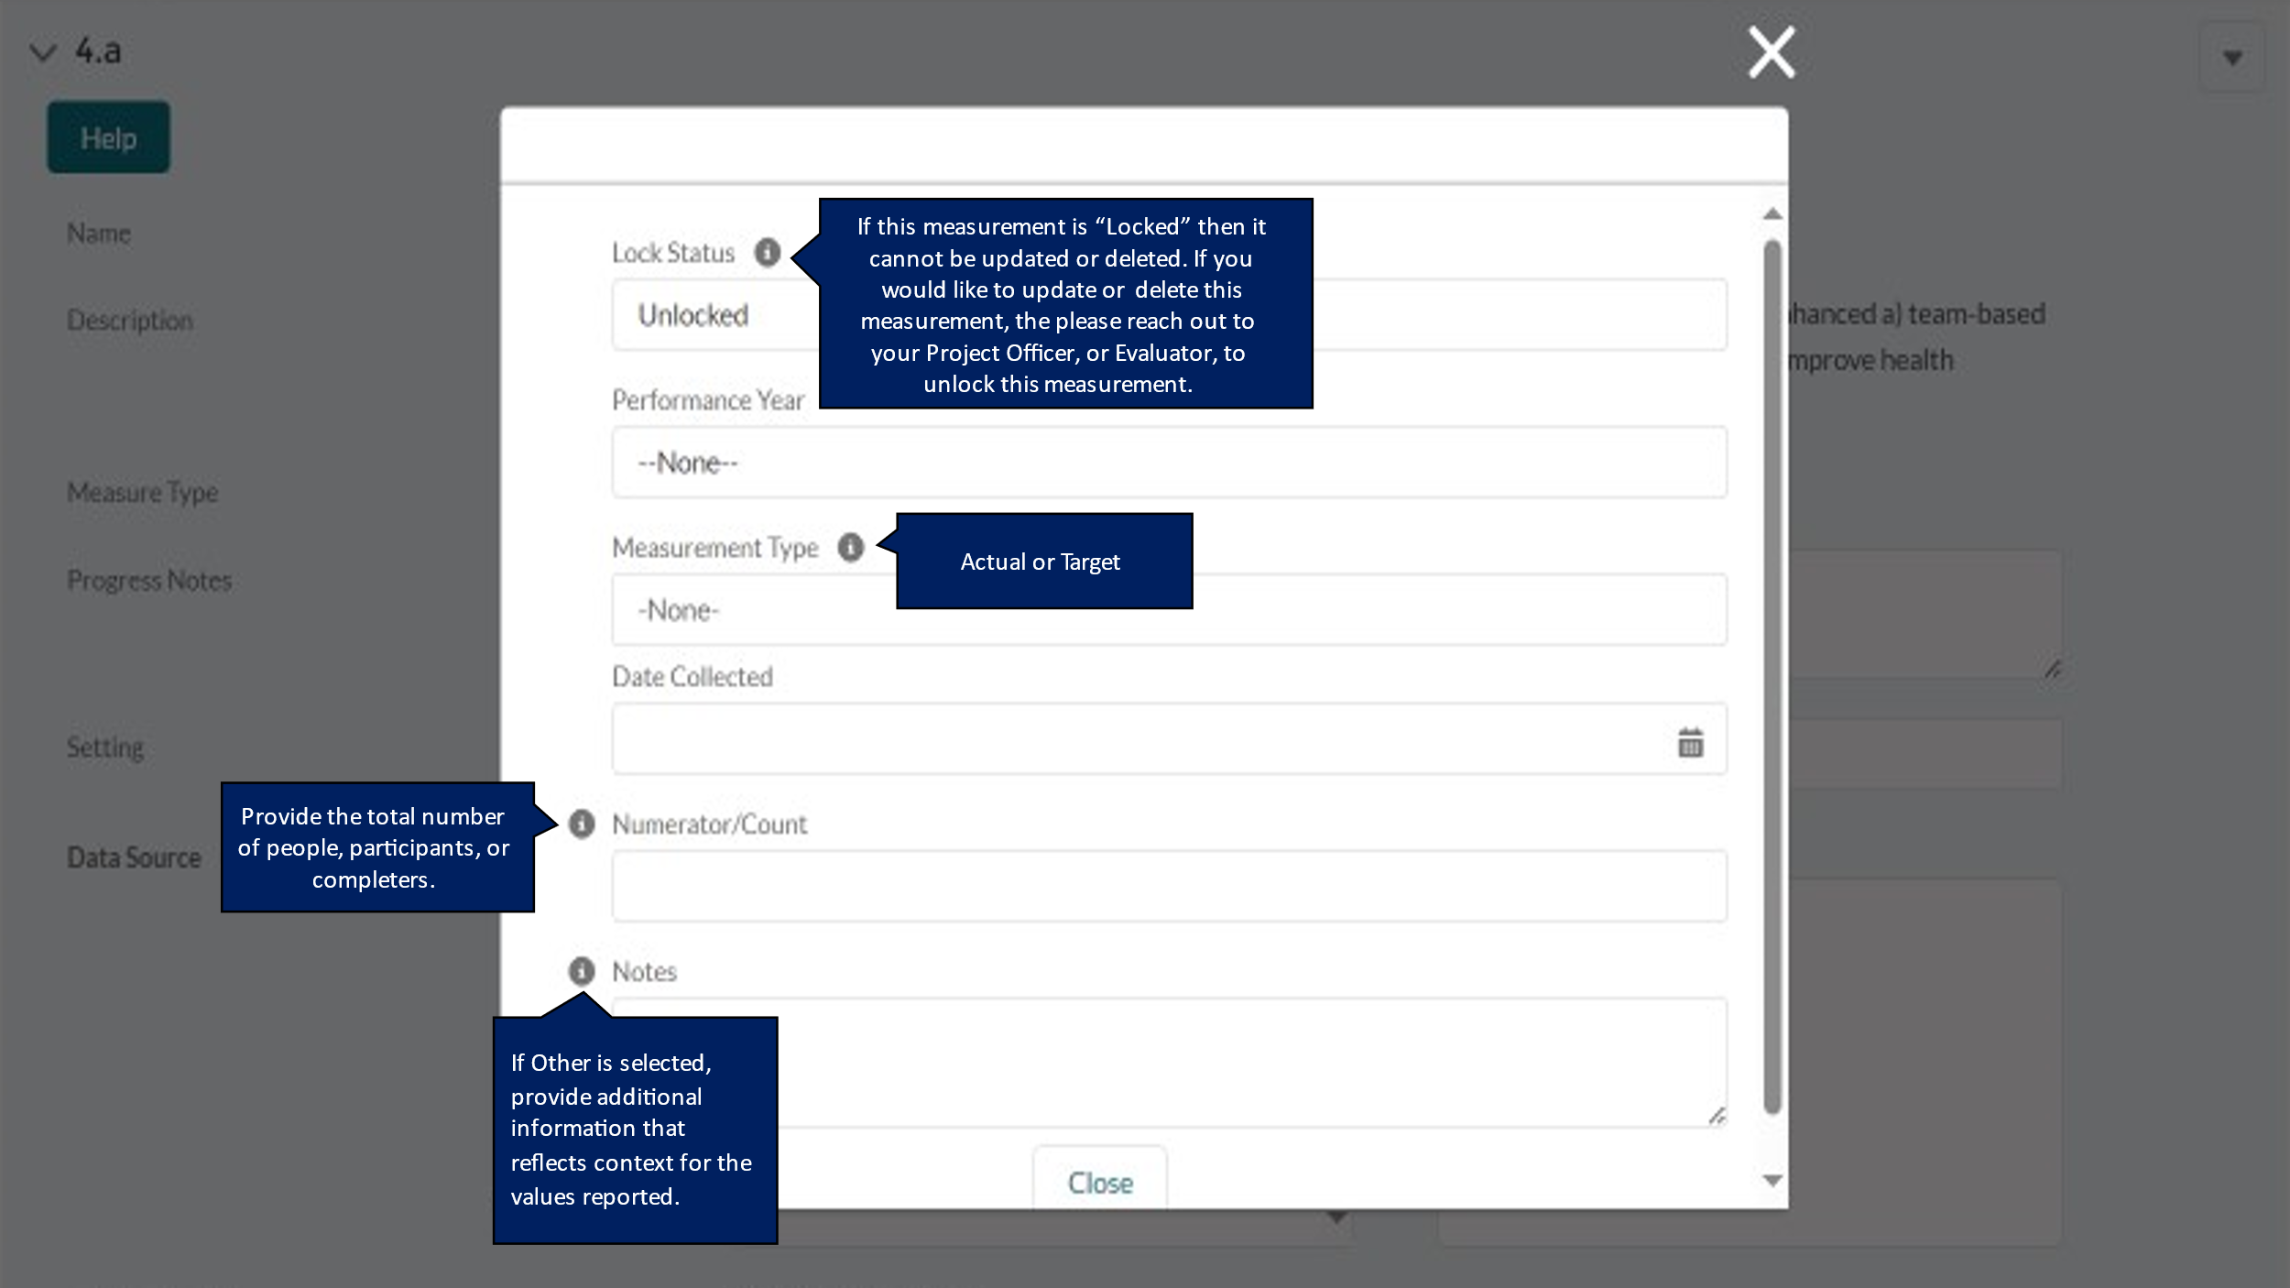

DP23-0020 Measure 5.1 – Component A
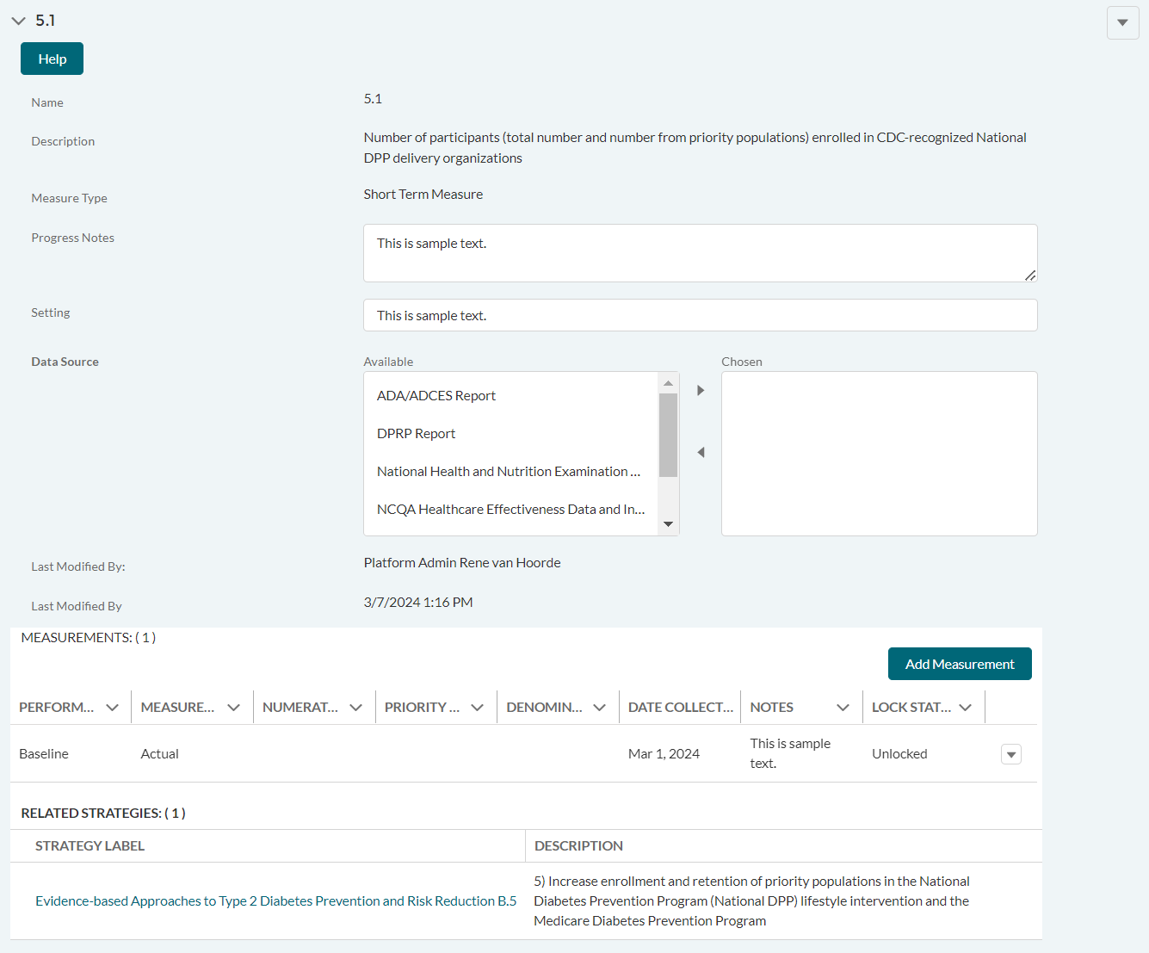

DP23-0020 Measure 5.1_Add Measurement Option – Component A
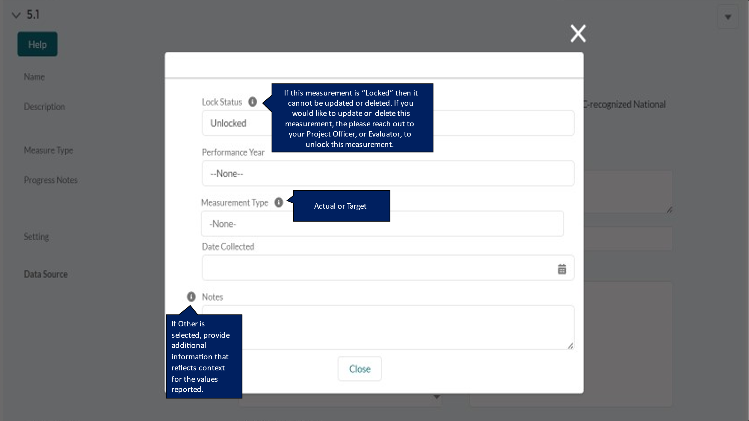

DP23-0020 Measure 5.a – Component A
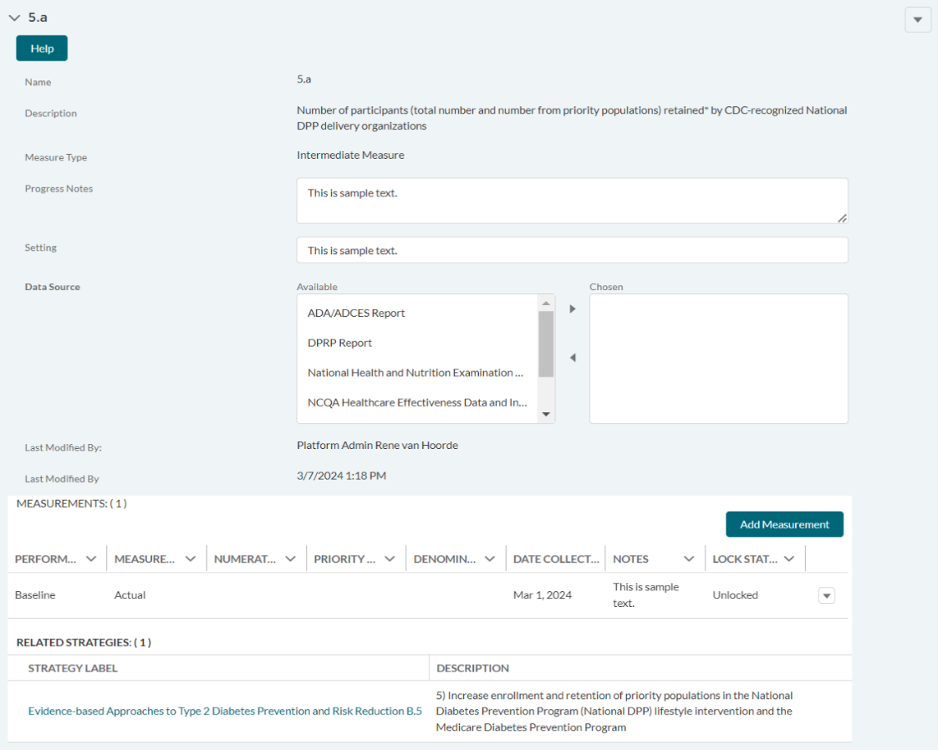

DP23-0020 Measure 5.a_Add Measurement Option – Component A
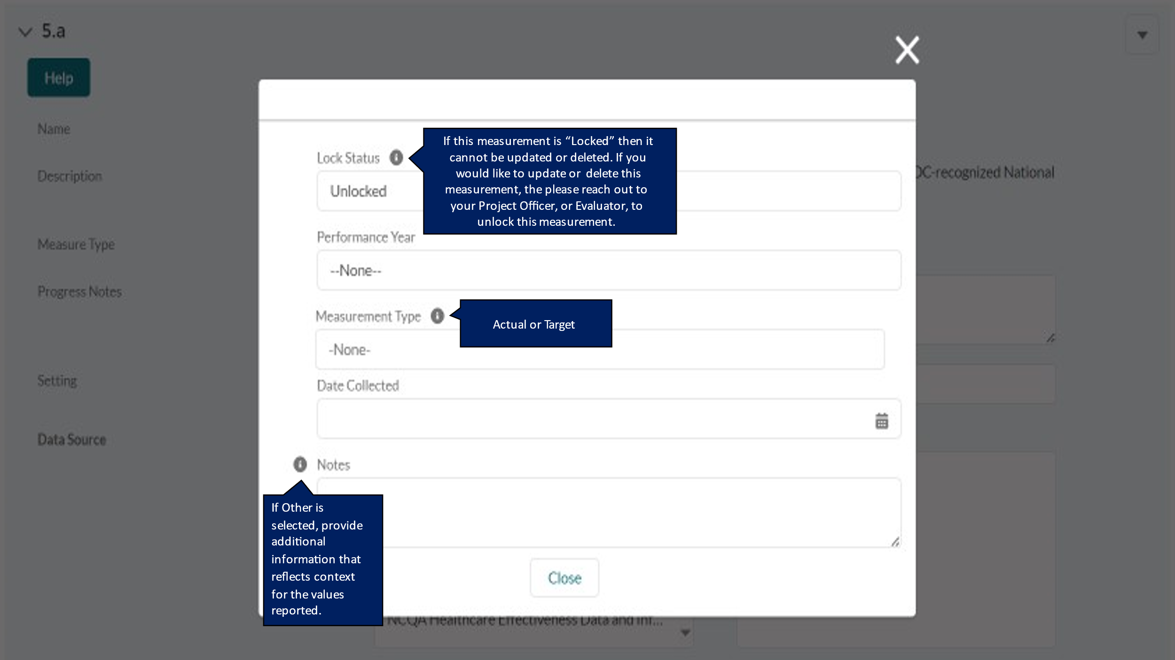

DP23-0020 Measure 6.2 – Component A
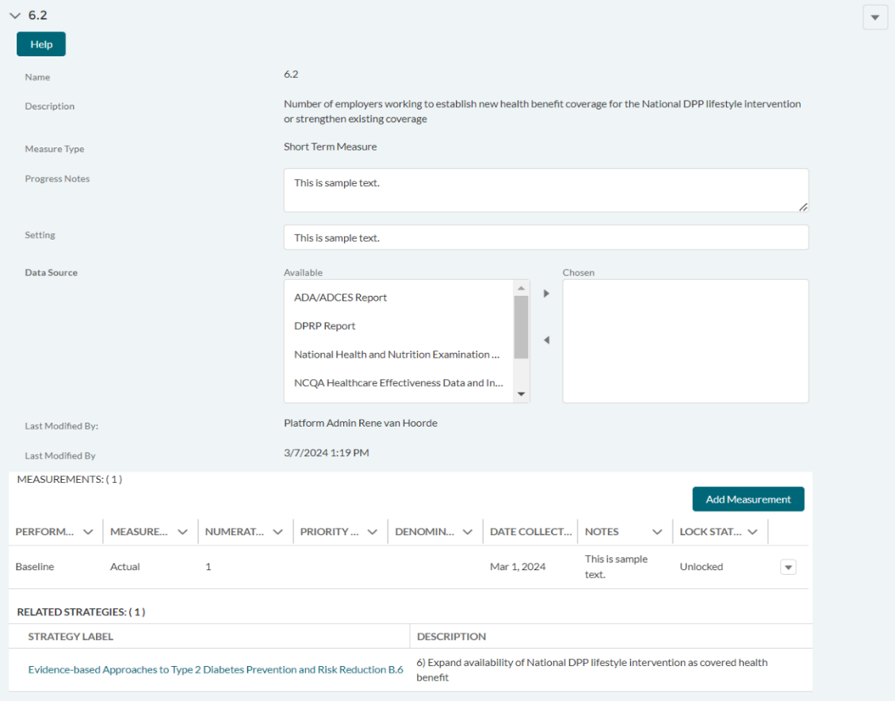

DP23-0020 Measure 6.2_Add Measurement Option – Component A
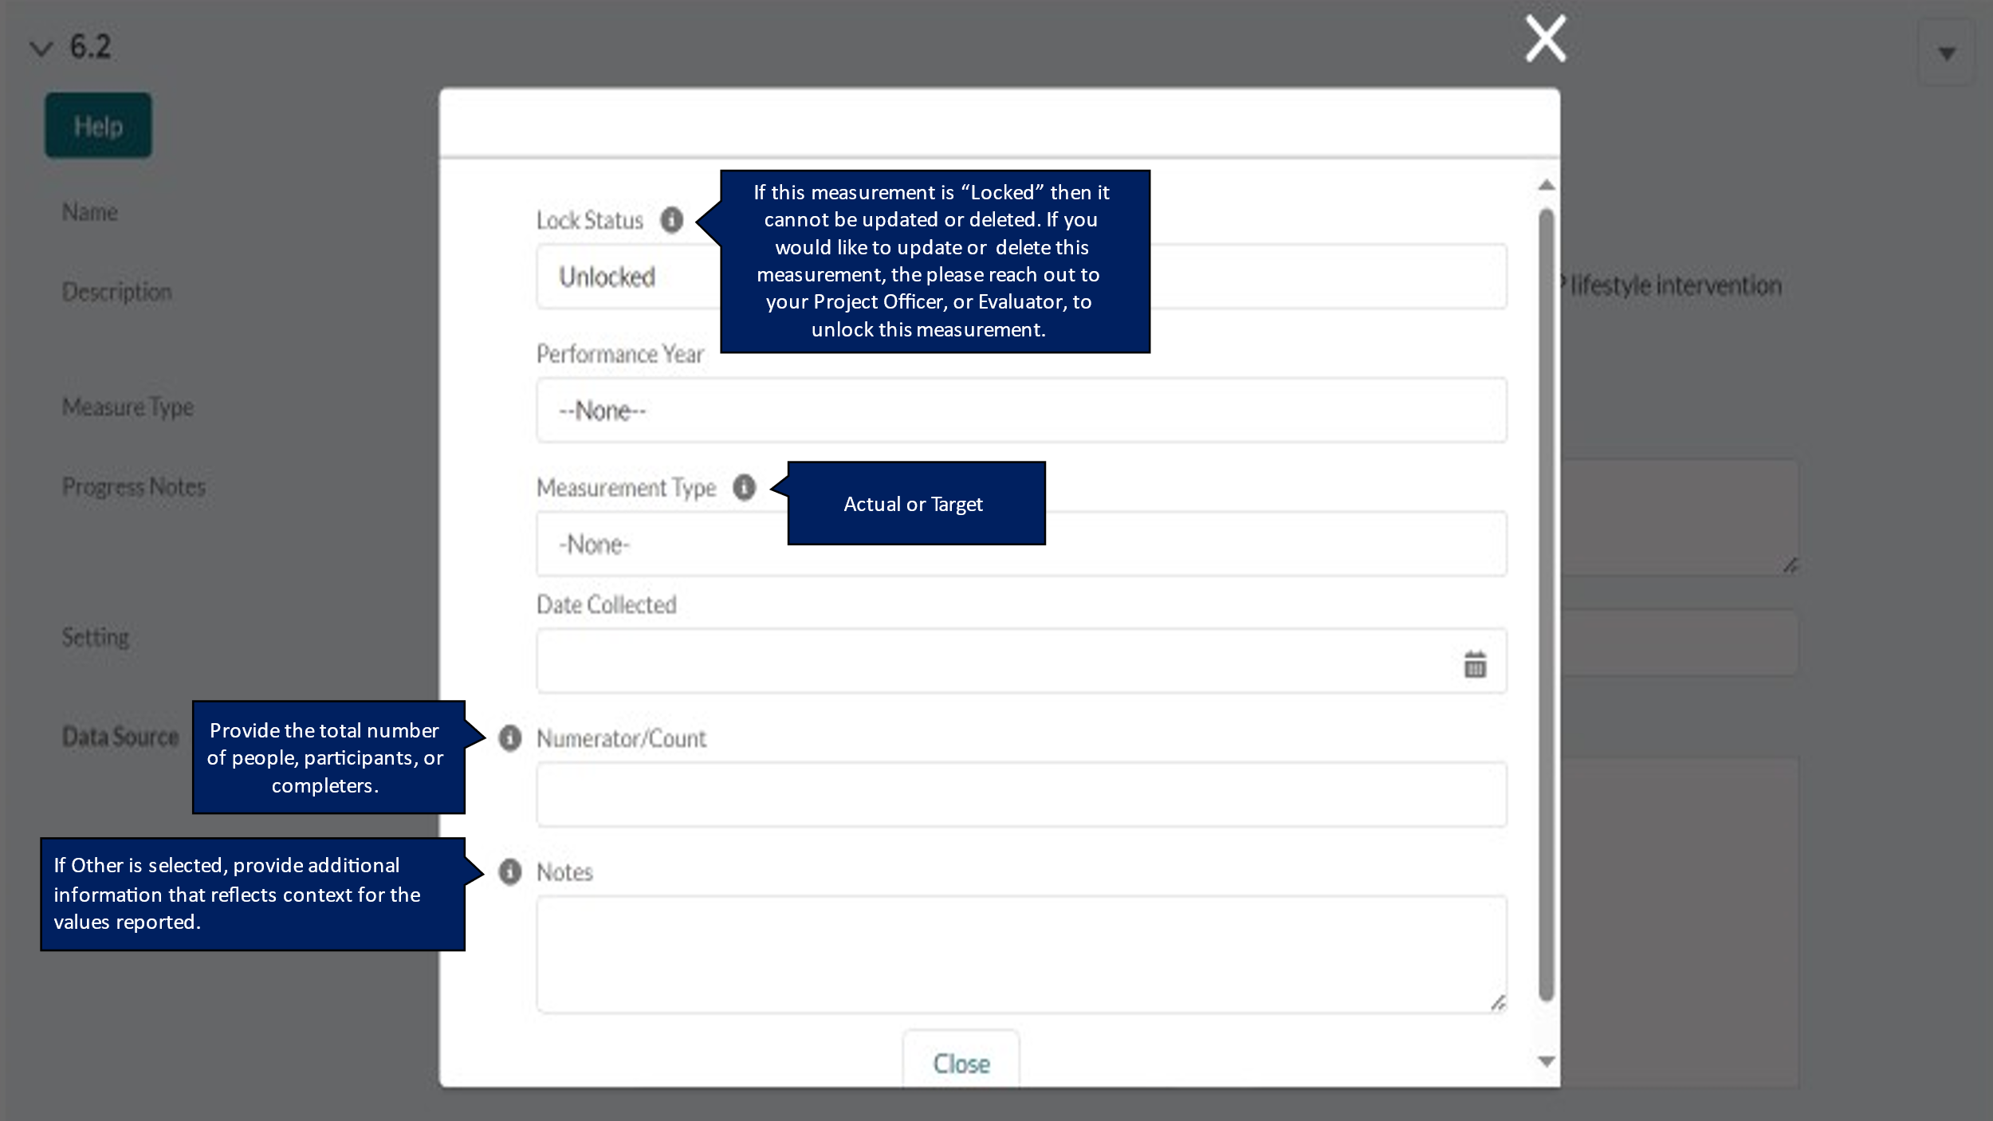

DP23-0020 Measure 6.a – Component A
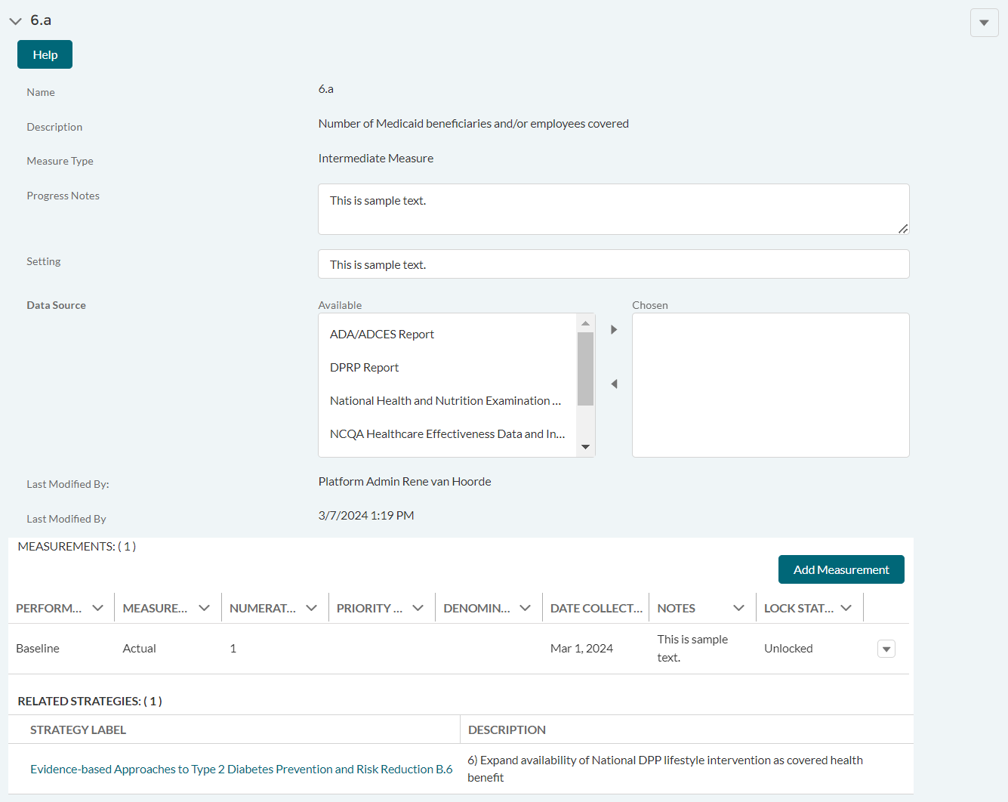

DP23-0020 Measure 6.a_Add Measurement Option – Component A
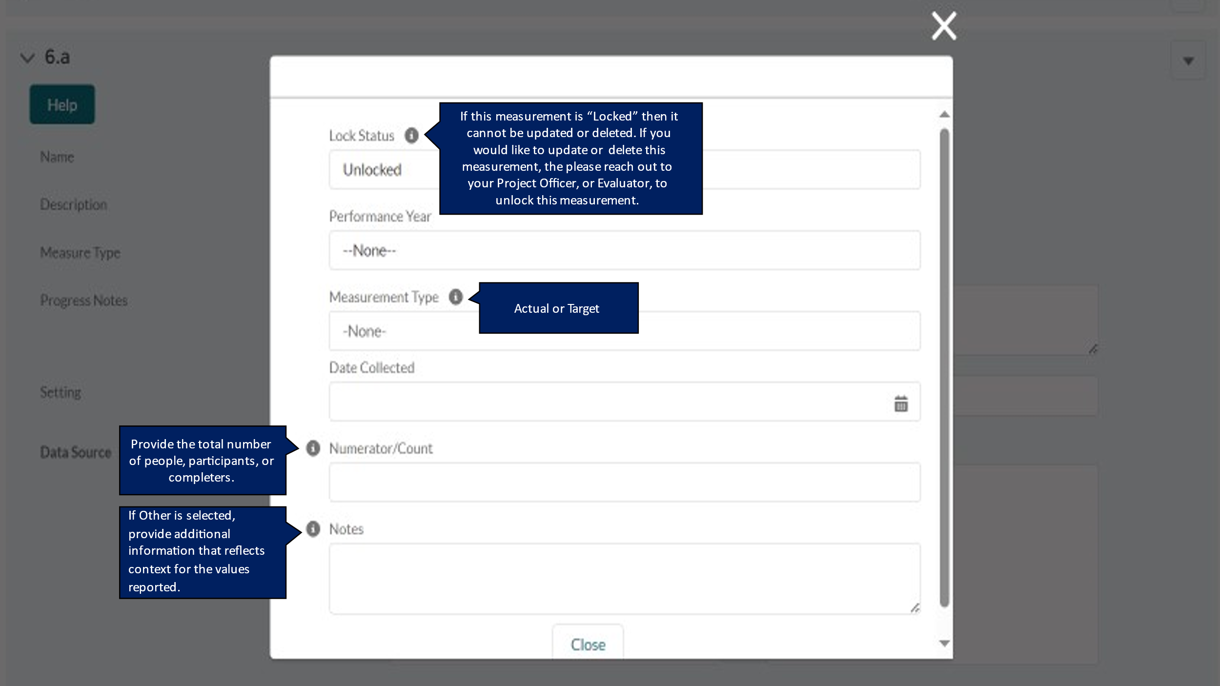

DP23-0020 Measure 7.1 – Component A
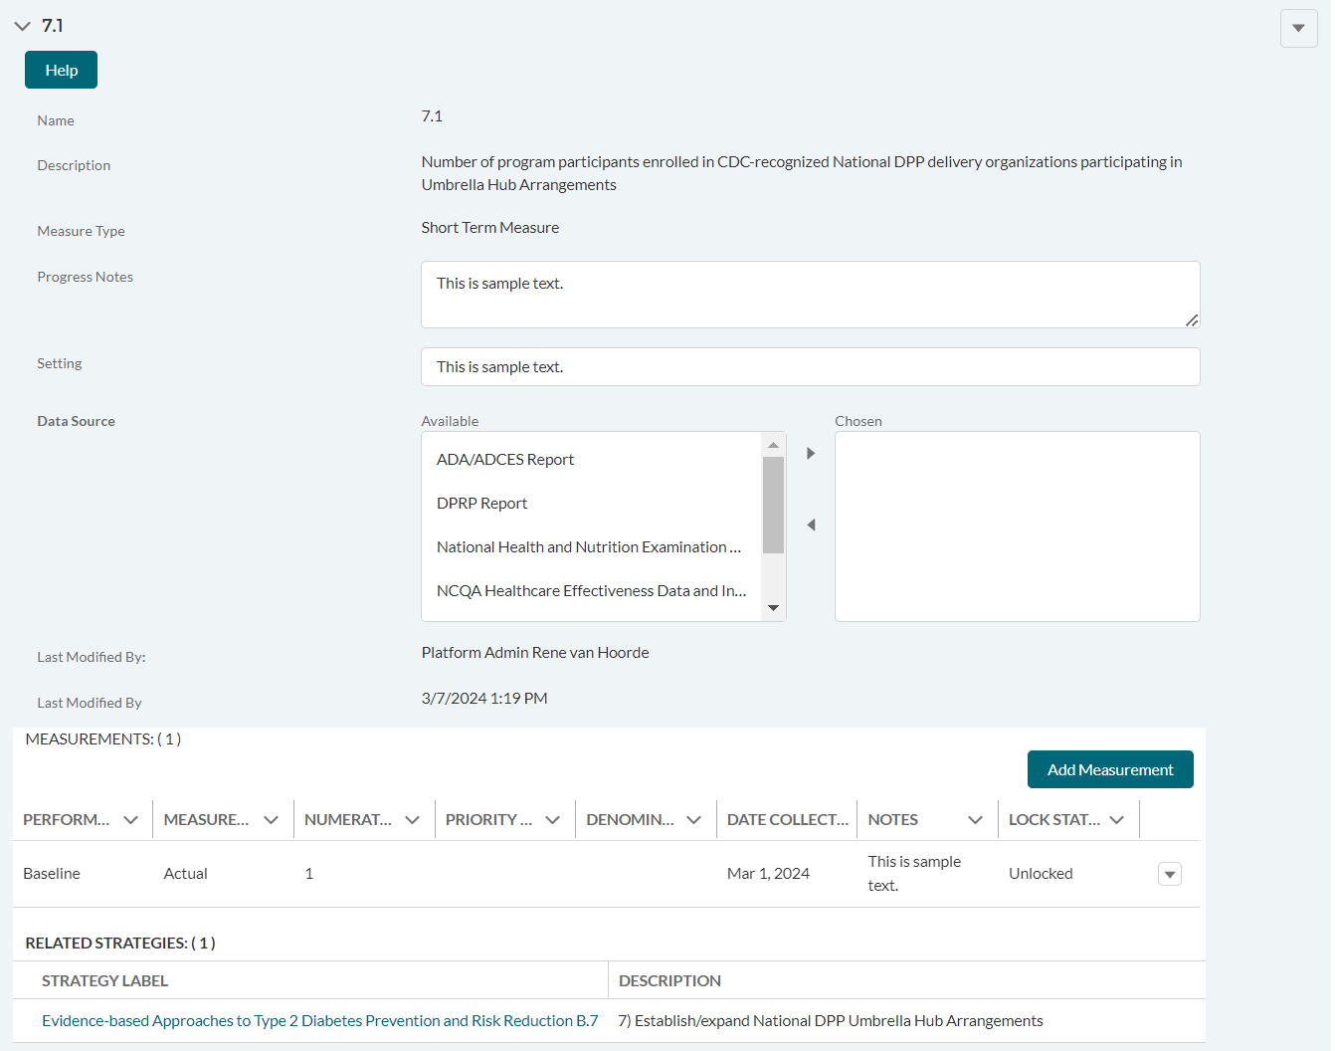

DP23-0020 Measure 7.1_Add Measurement Option – Component A
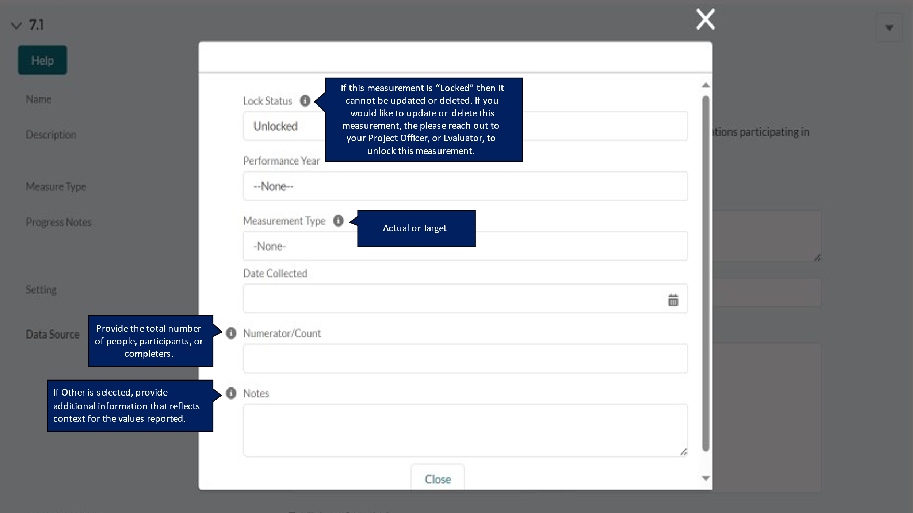

DP23-0020 Measure 7.a – Component A
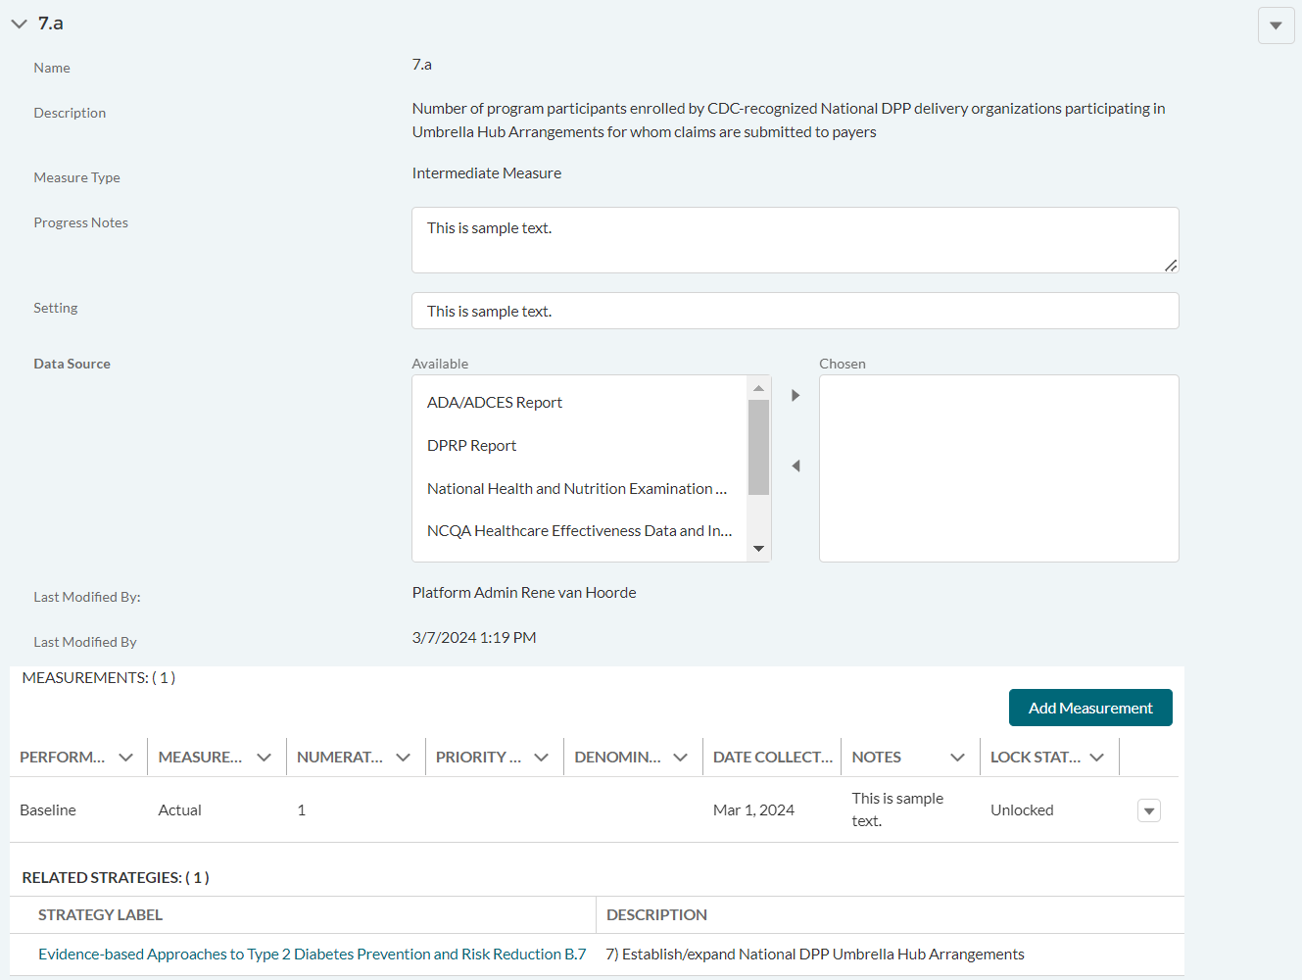

DP23-0020 Measure 7.a_Add Measurement Option – Component A
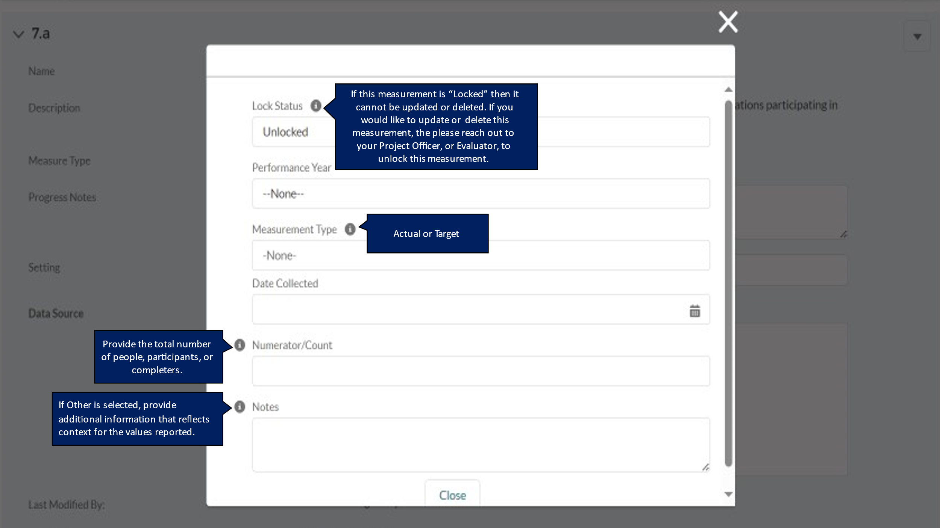

DP23-0020 Measure 8.a – Component A
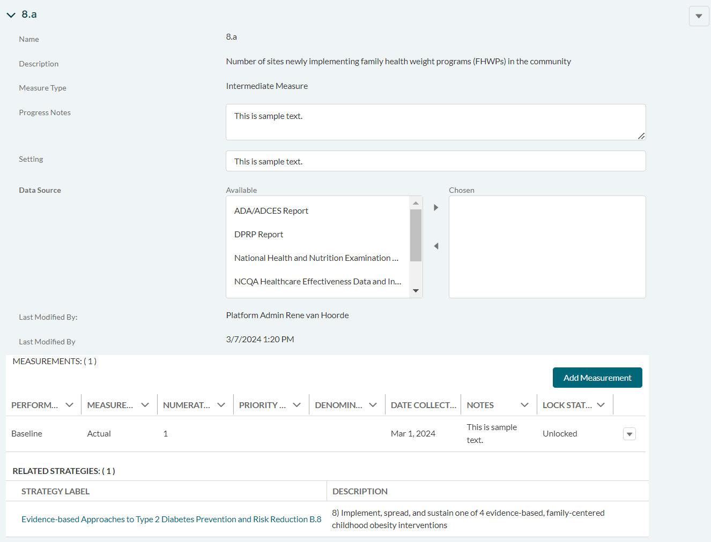

DP23-0020 Measure 8.a_Add Measurement Option – Component A
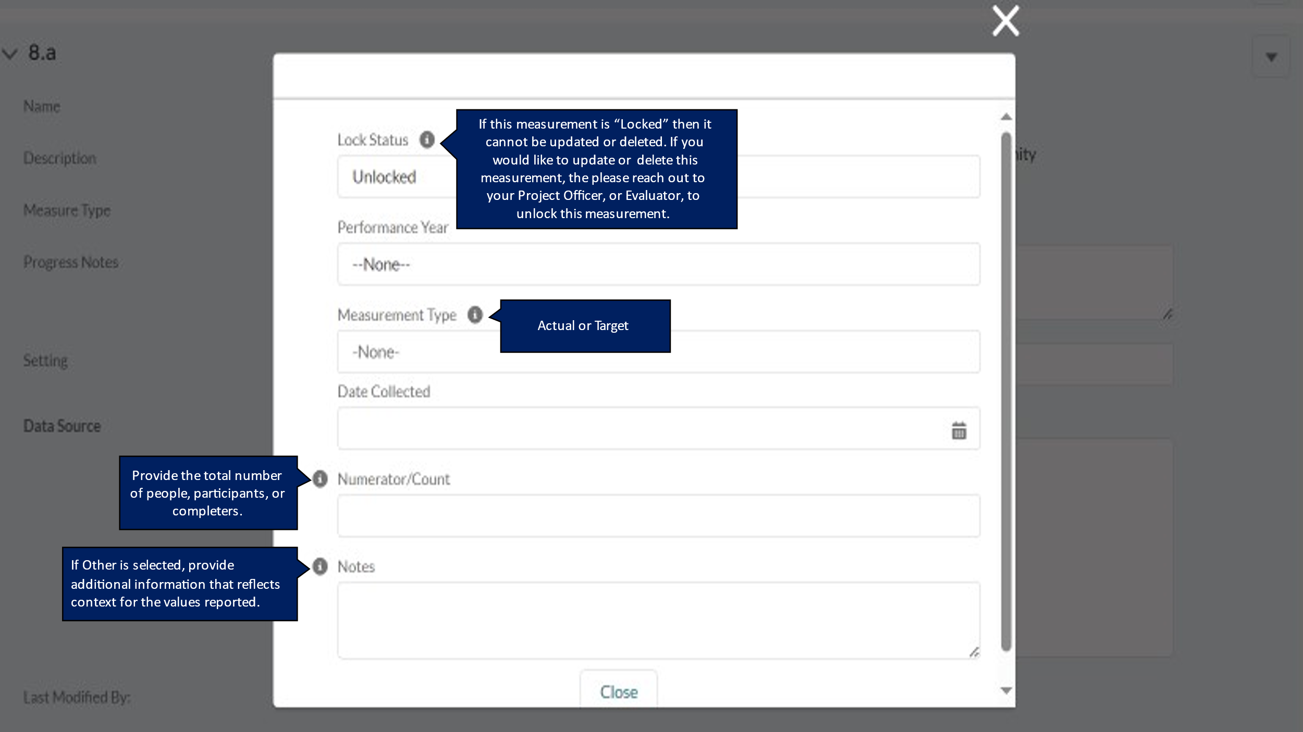

DP23-0020 Measure 8.b – Component A
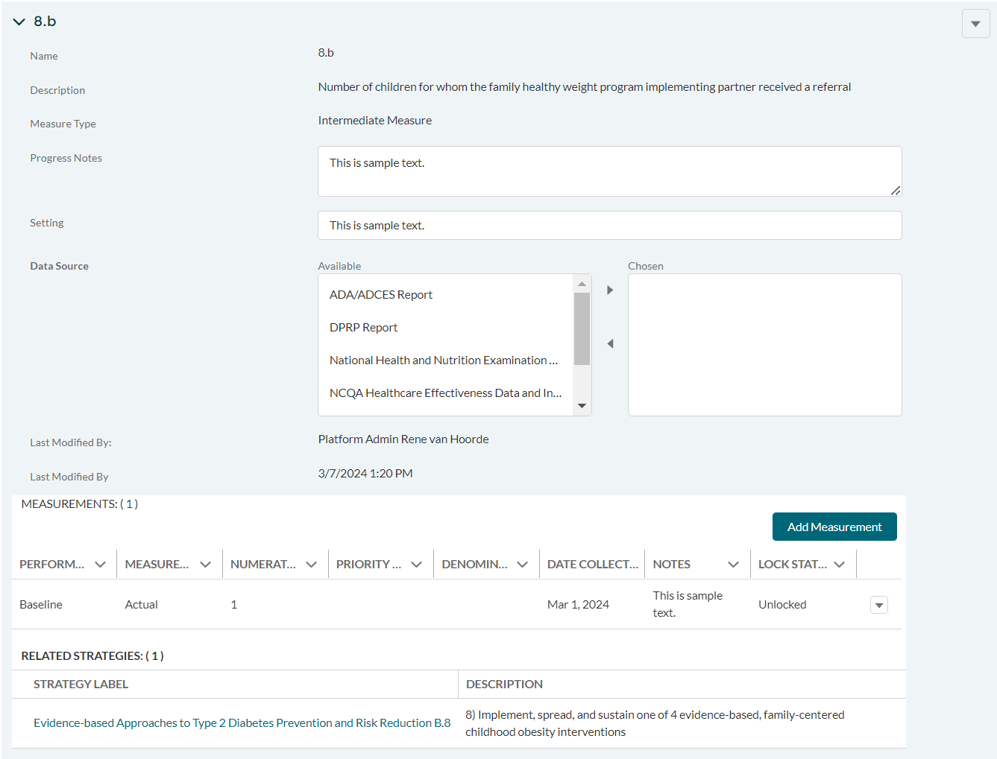

DP23-0020 Measure 8.b_Add Measurement Option – Component A
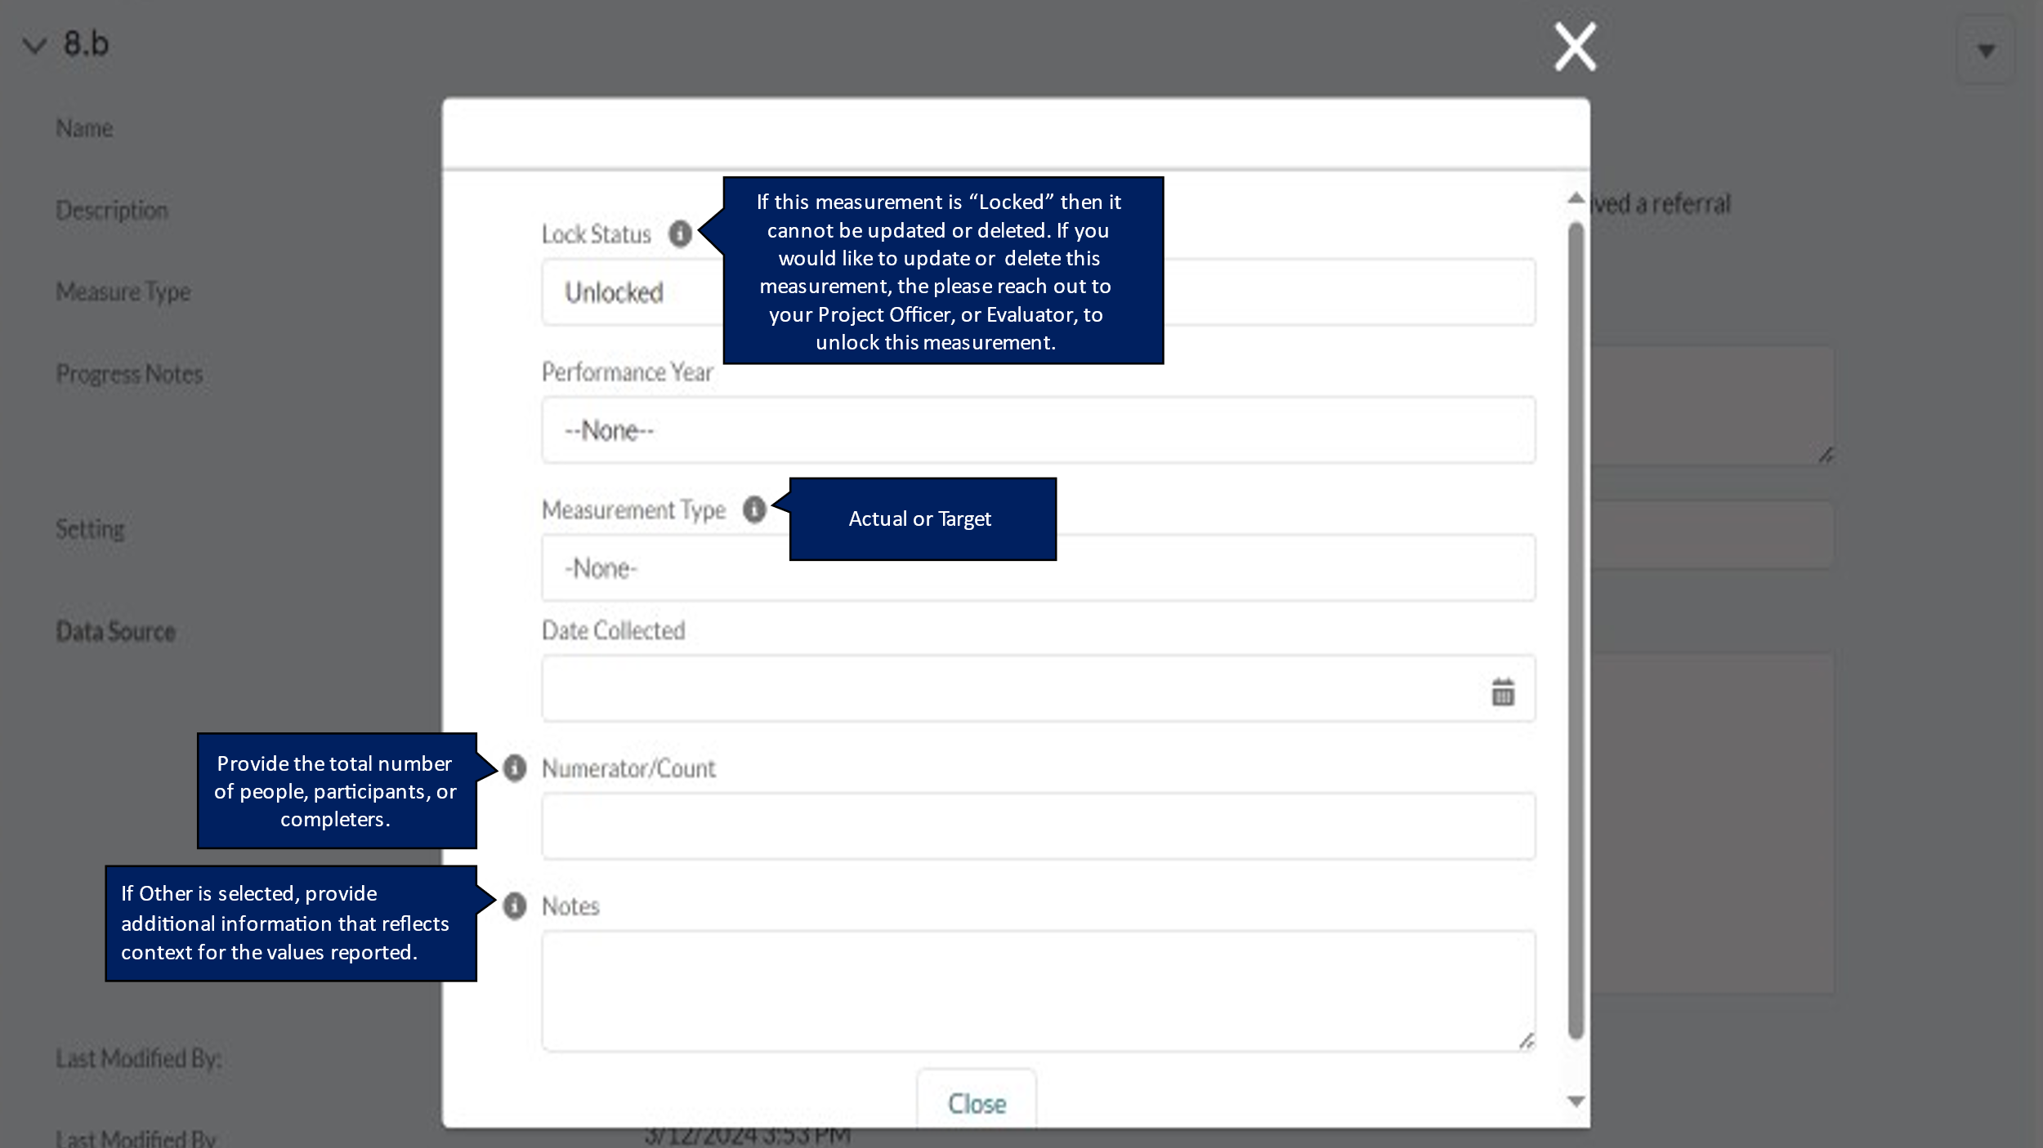

DP23-0020 Measure 9.1 – Component A
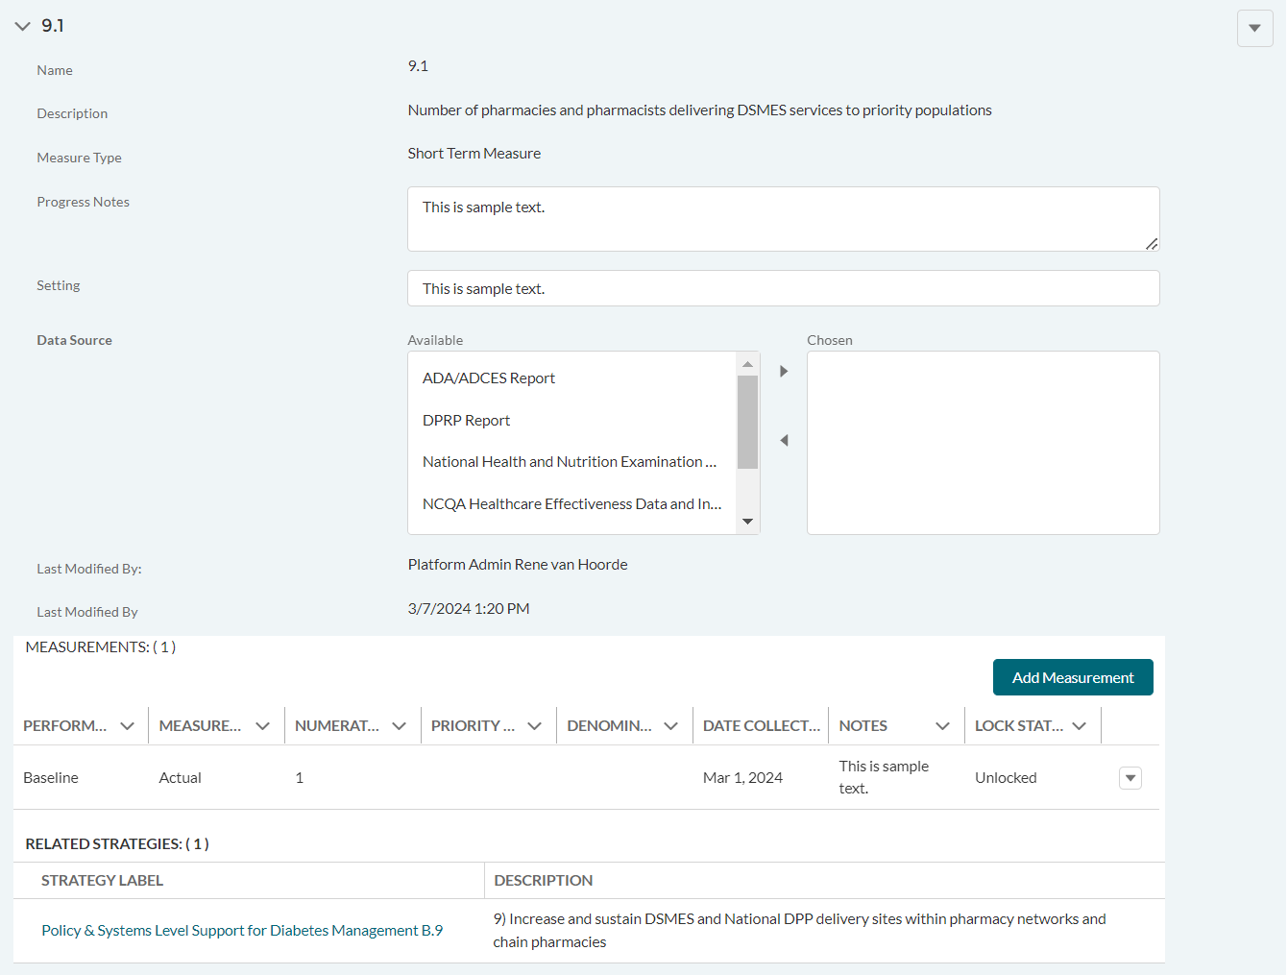

DP23-0020 Measure 9.1_Add Measurement Option – Component A
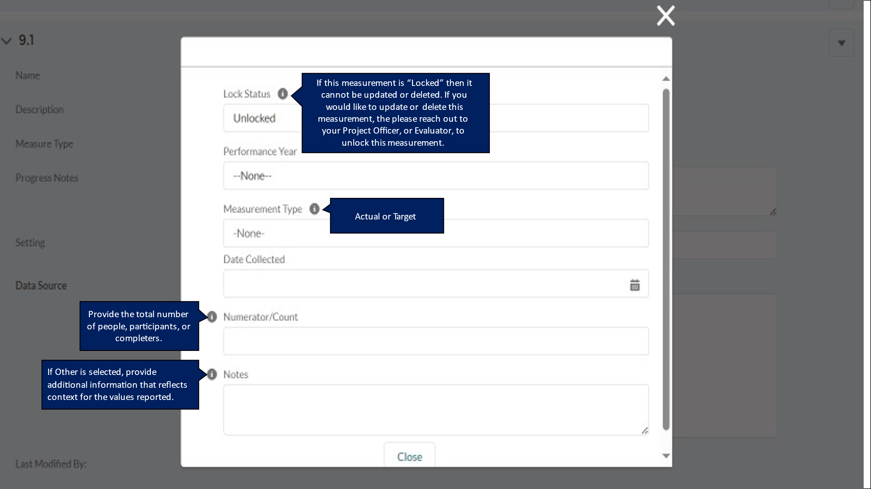

DP23-0020 Measure 9.2 – Component A
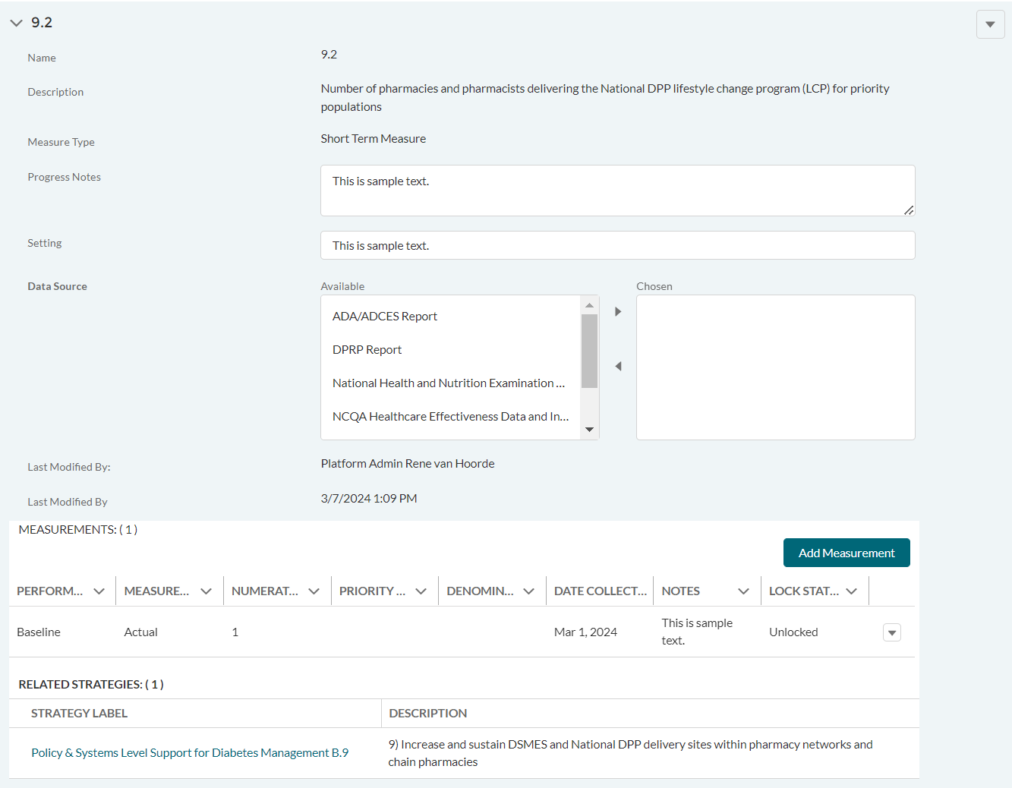

DP23-0020 Measure 9.2_Add Measurement Option – Component A
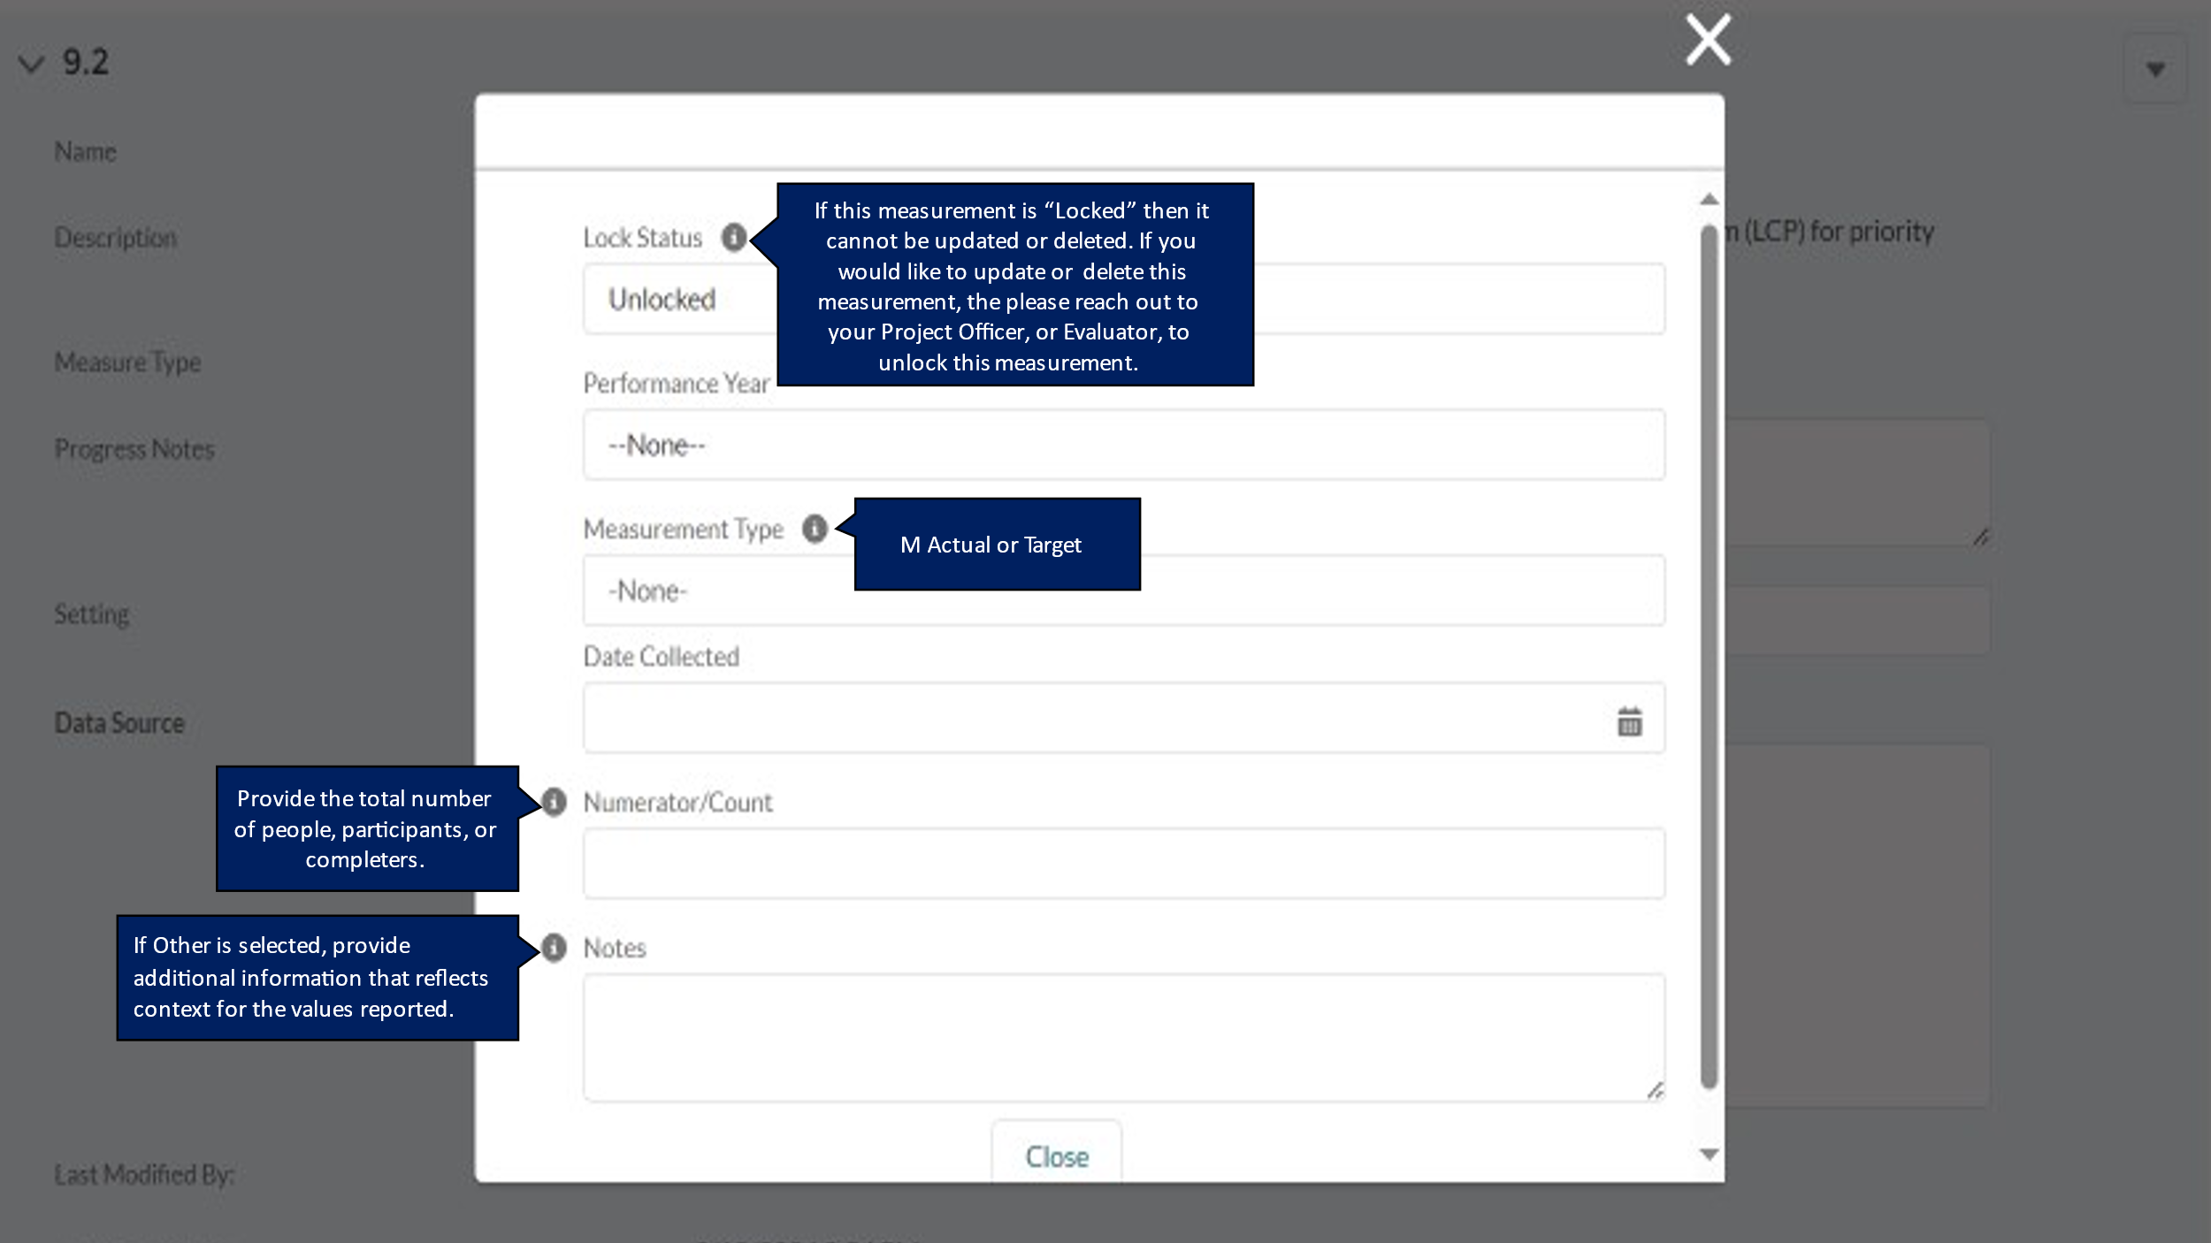

DP23-0020 Measure 9.a – Component A
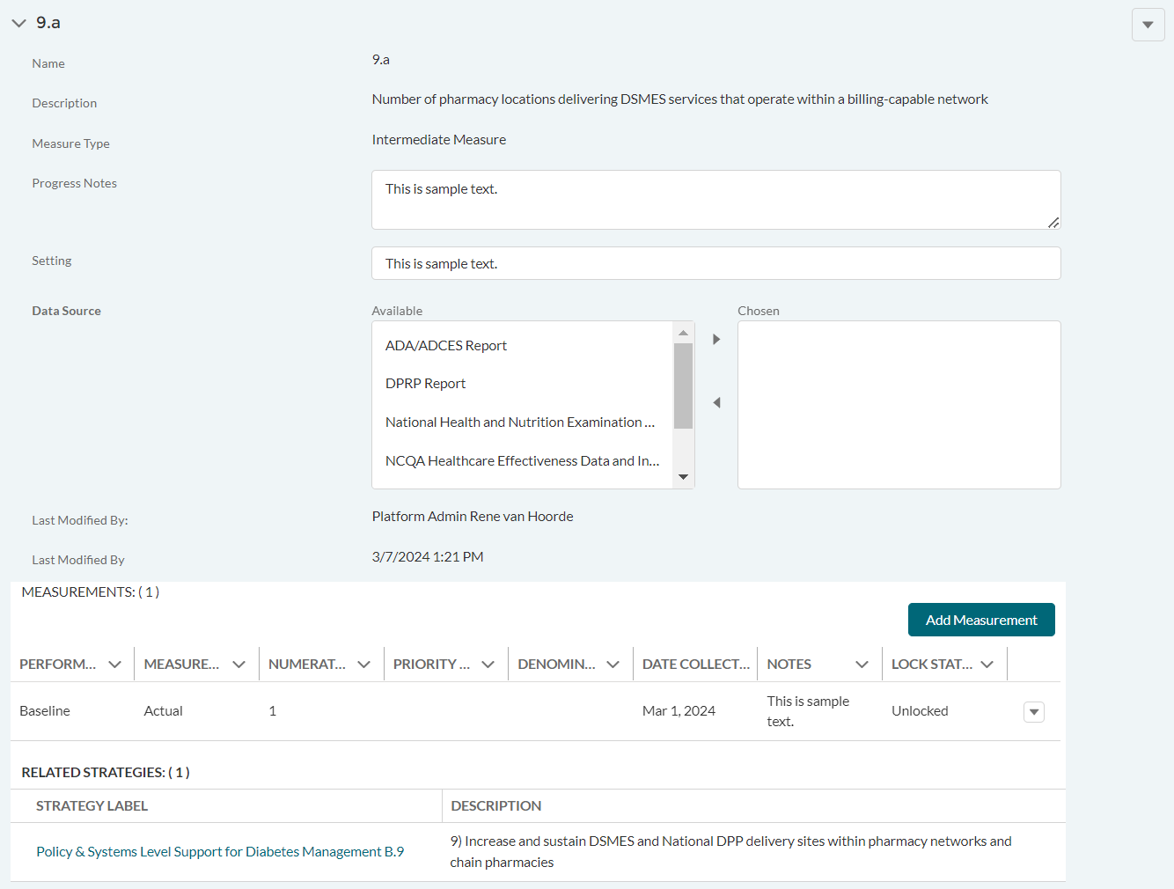

DP23-0020 Measure 9.a_Add Measurement Option – Component A
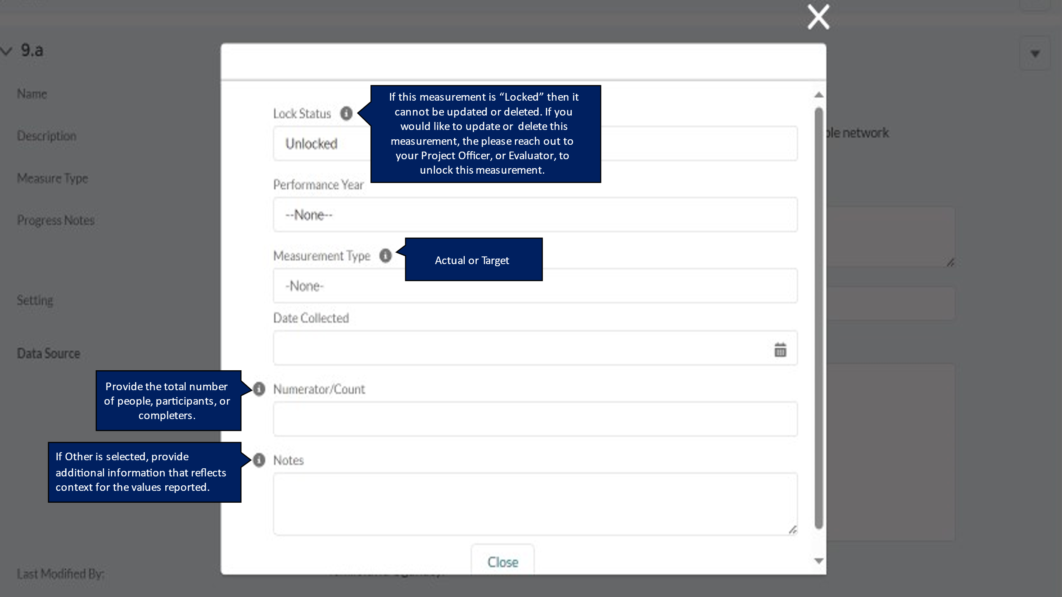

DP23-0020 Measure 9.b – Component A
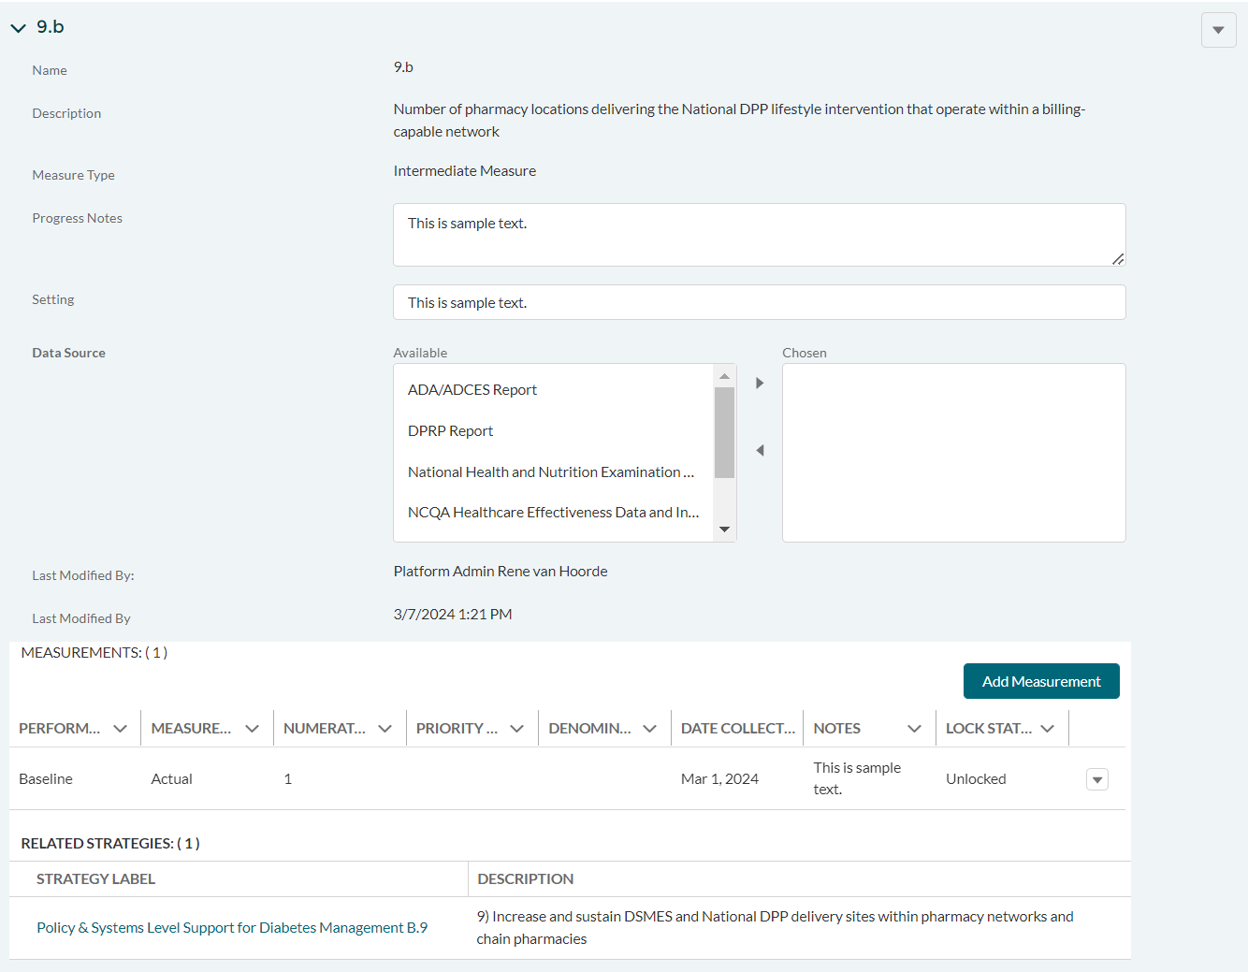

DP23-0020 Measure 9.b_Add Measurement Option – Component A
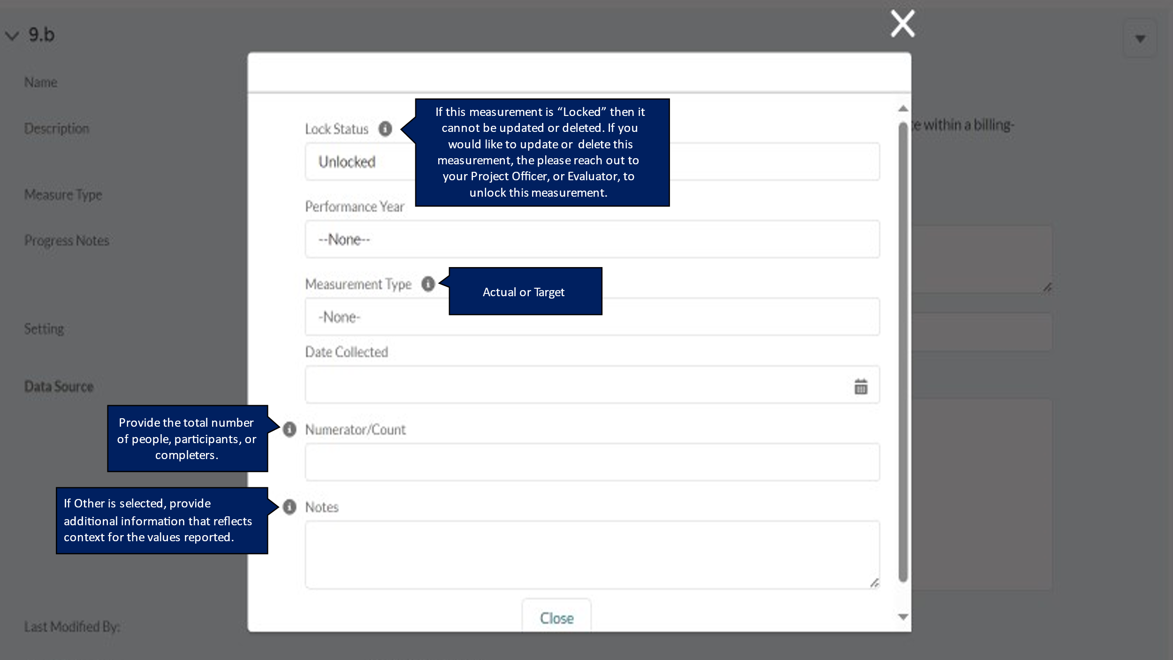

DP23-0020 Measure 9.c – Component A
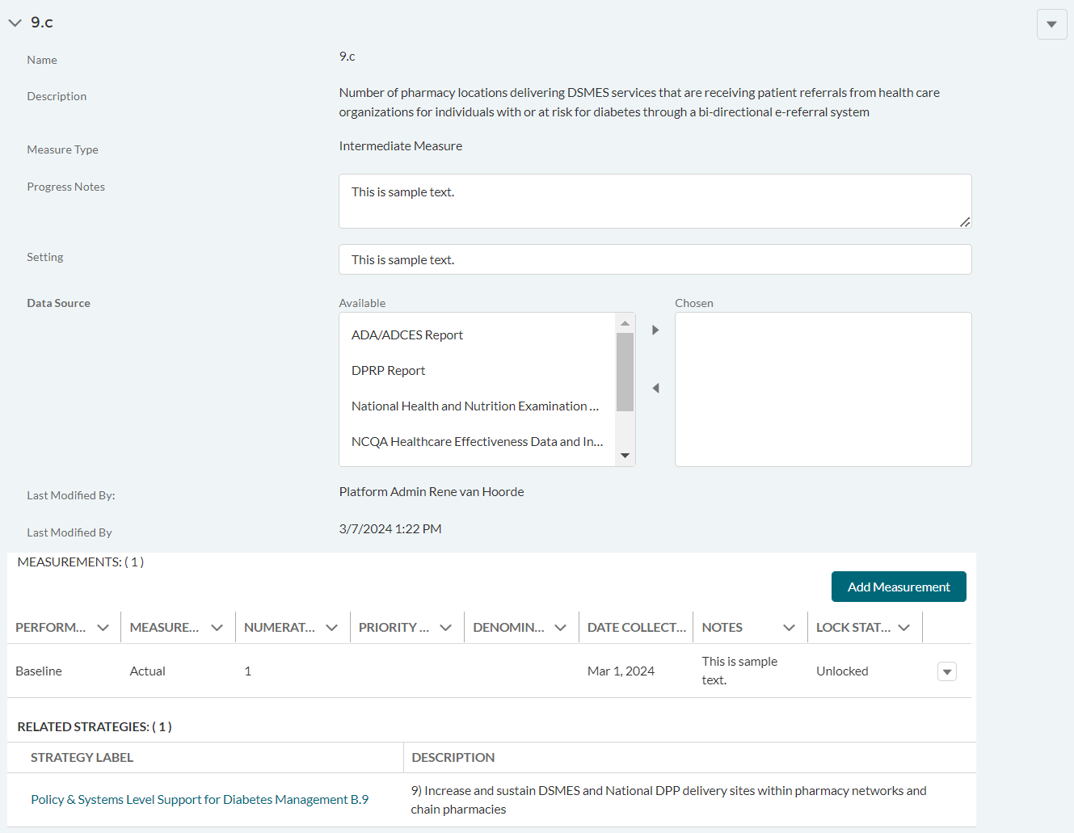

DP23-0020 Measure 9.c_Add Measurement Option – Component A
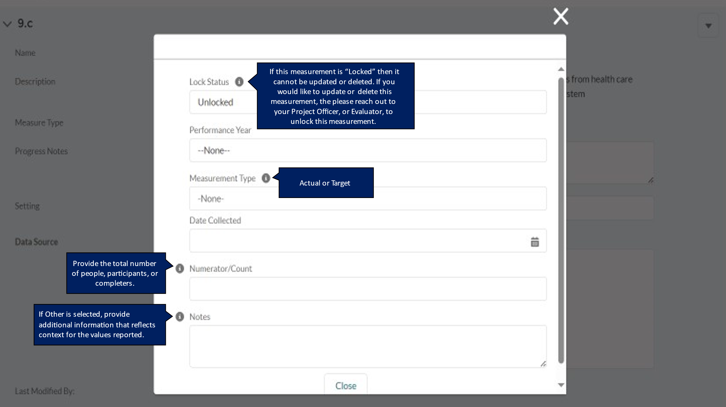

DP23-0020 Measure 9.d – Component A
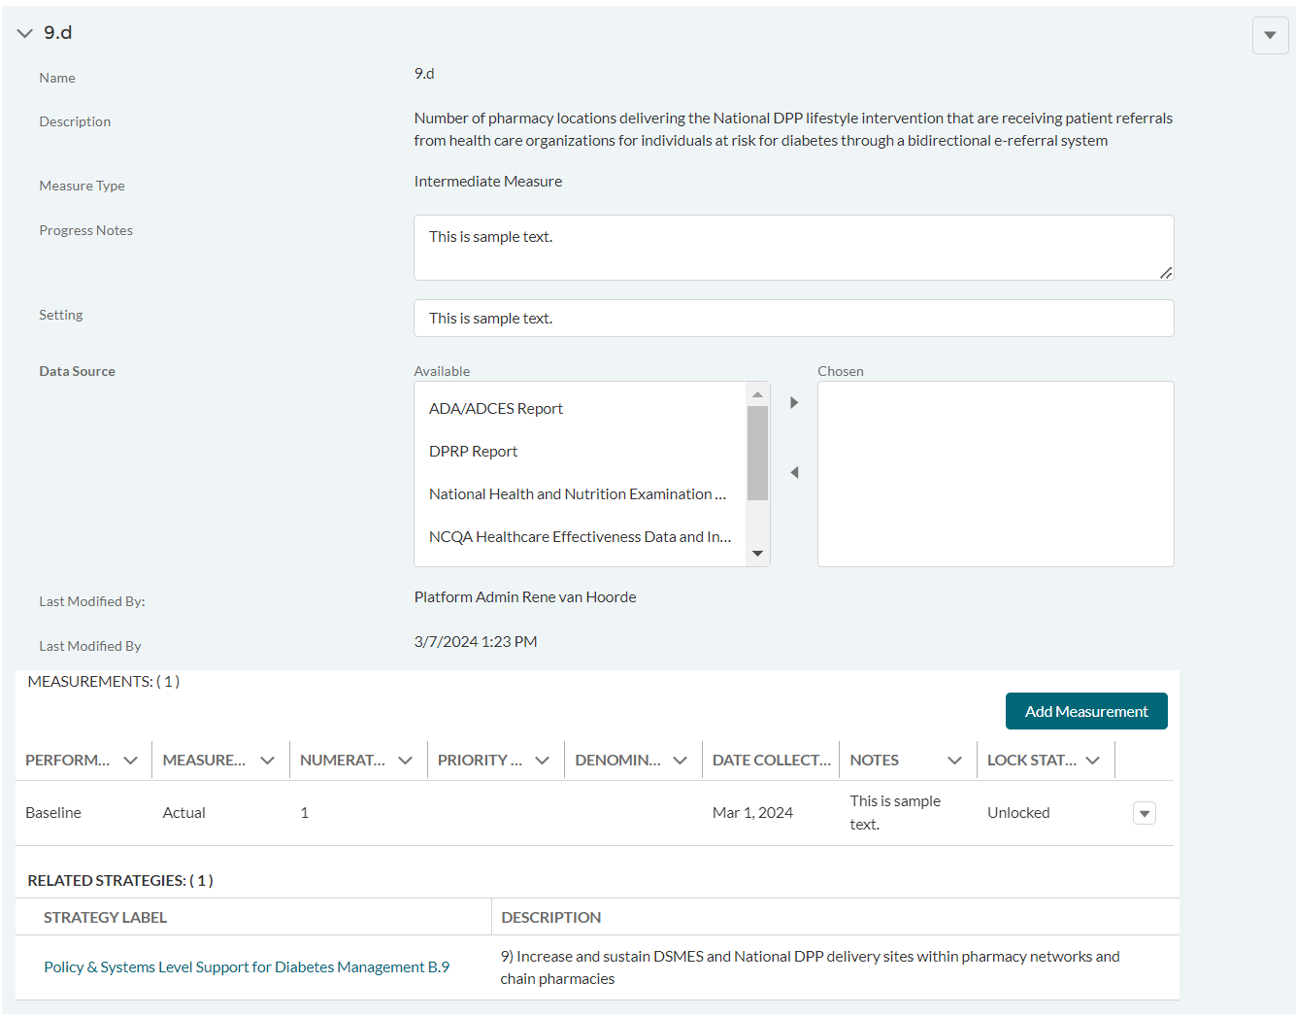

DP23-0020 Measure 9.d_Add Measurement Option – Component A
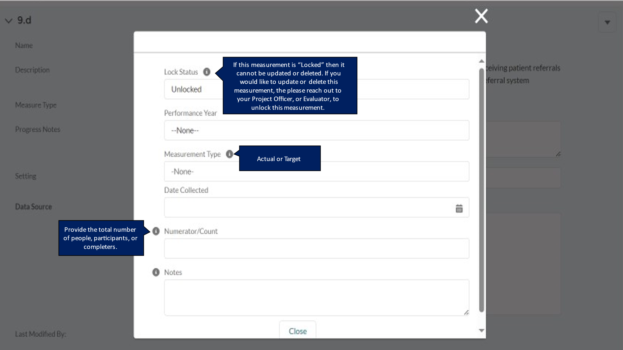

DP23-0020 Measure 10.2 – Component A
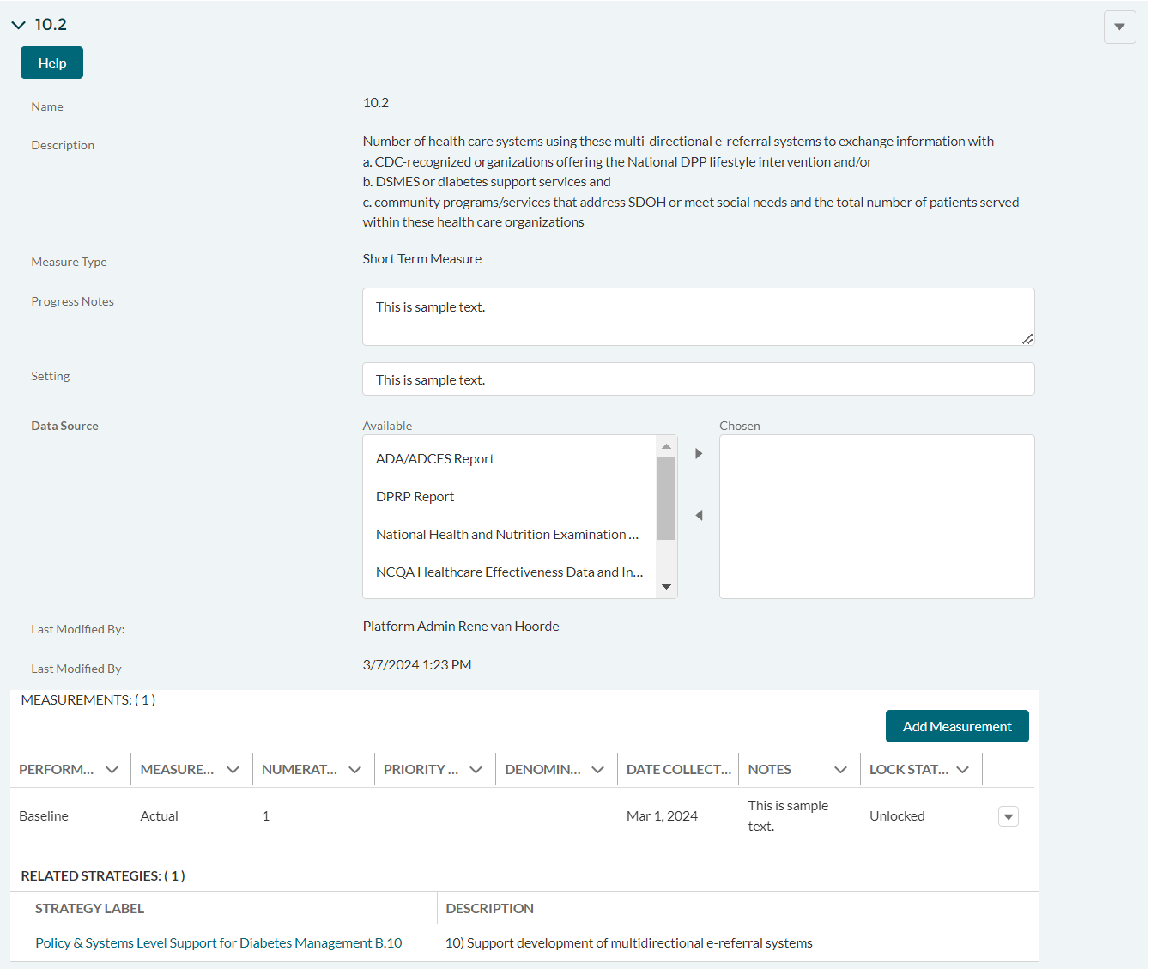

DP23-0020 Measure 10.2_Add Measurement Option – Component A
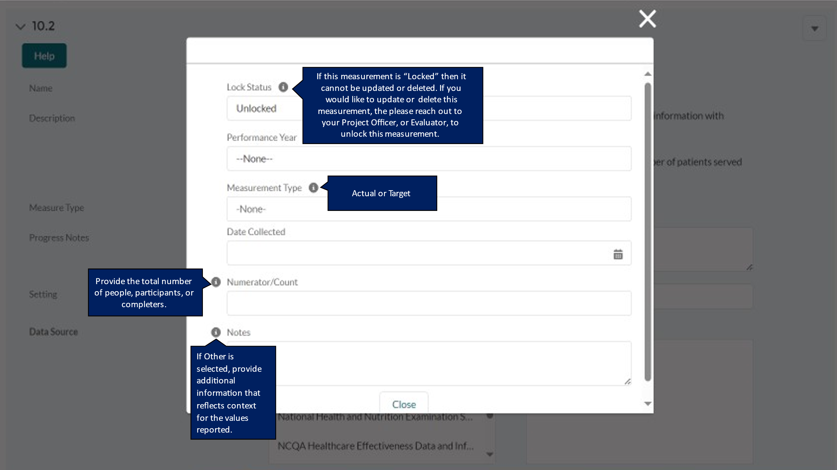

DP23-0020 Measure 10.a – Component A
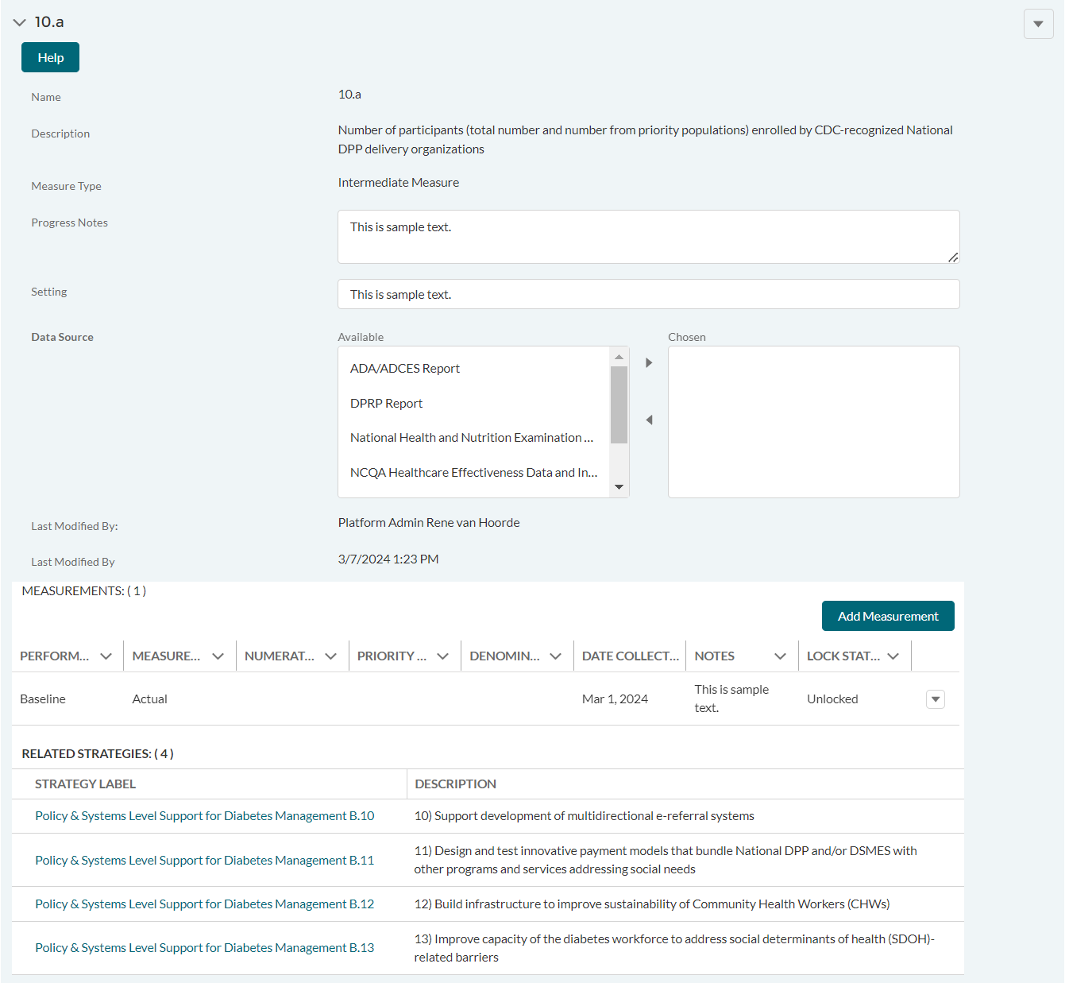

DP23-0020 Measure 10.a_Add Measurement Option – Component A
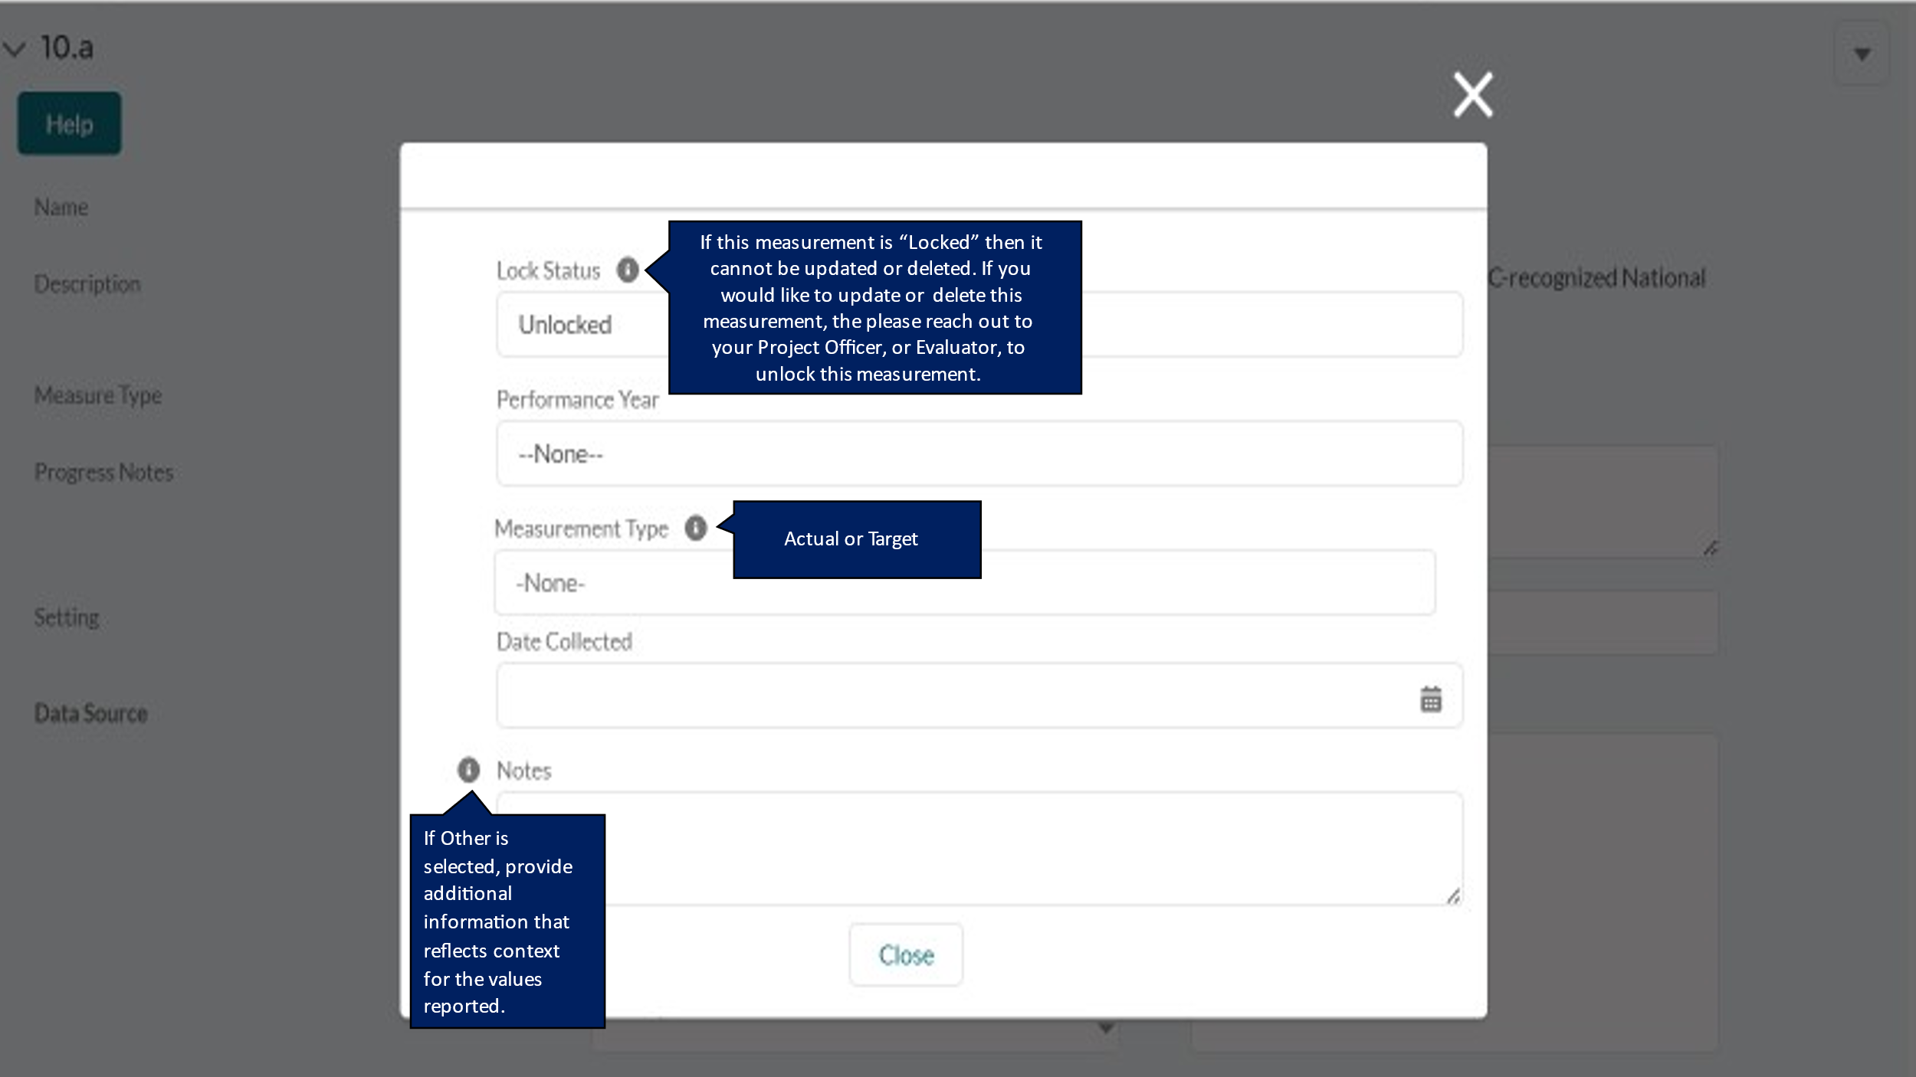

DP23-0020 Measure 10.b – Component A
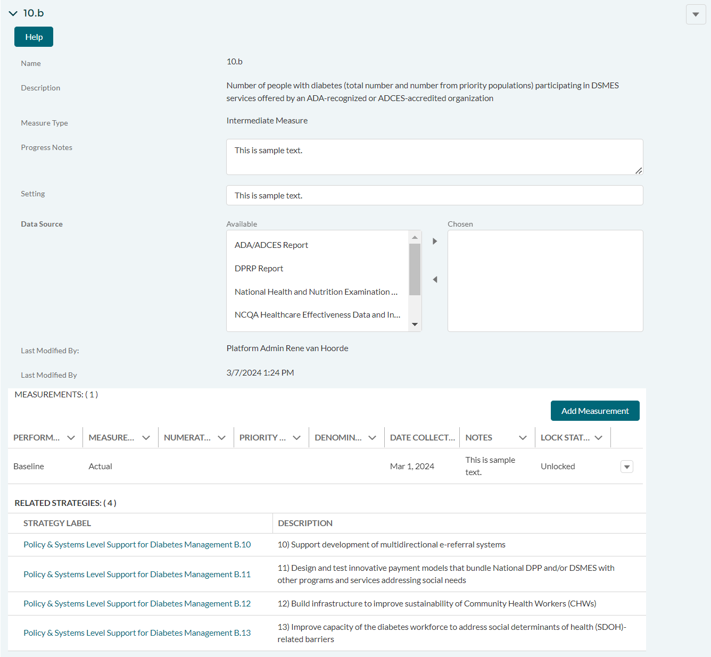

DP23-0020 Measure 10.b_Add Measurement Option – Component A
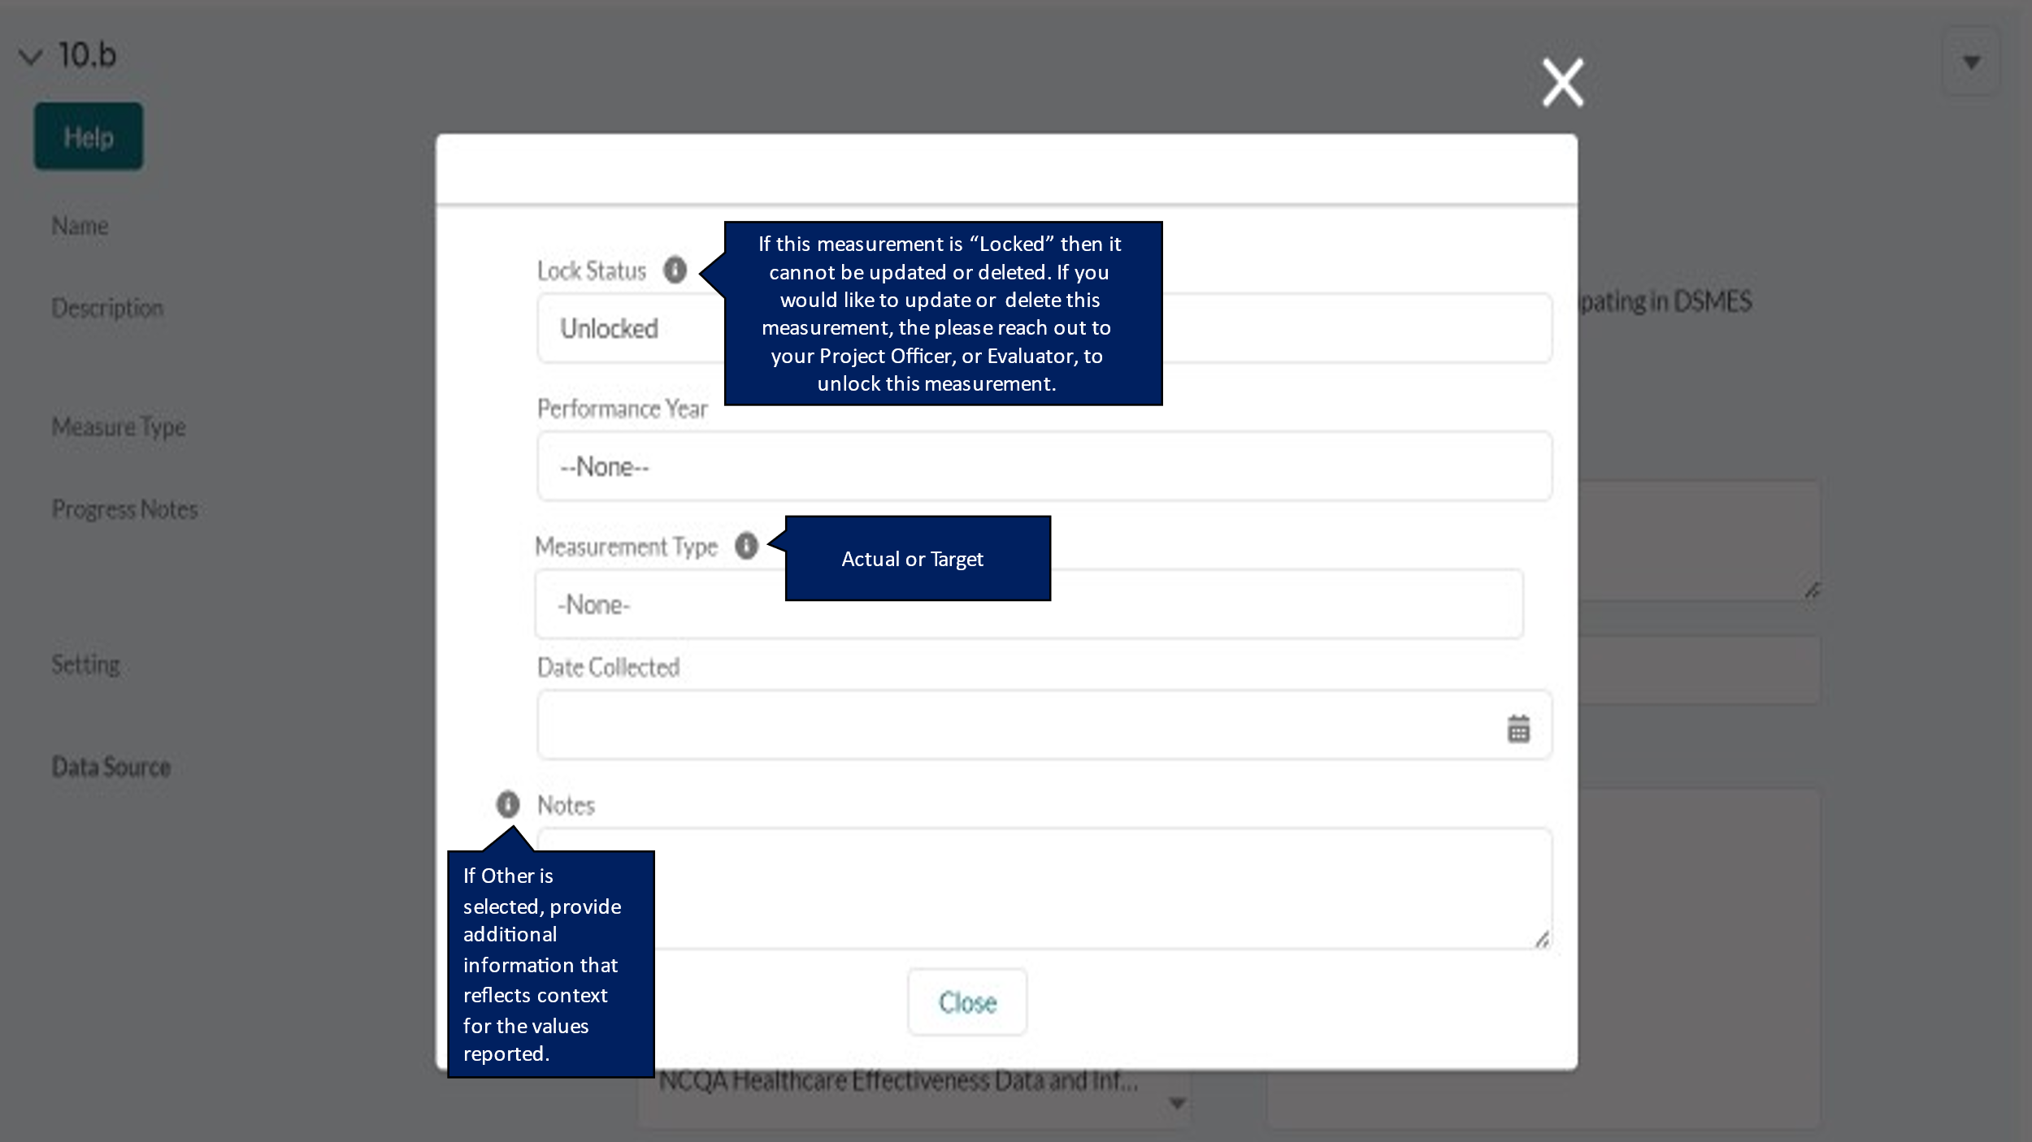

DP23-0020 Measure 10.c – Component A
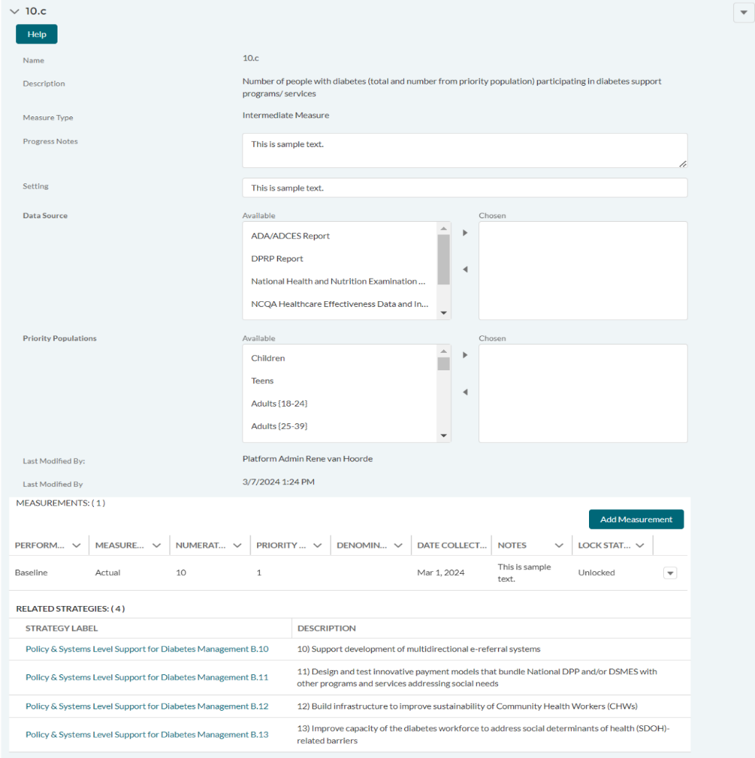

DP23-0020 Measure 10.c_Add Measurement Option – Component A
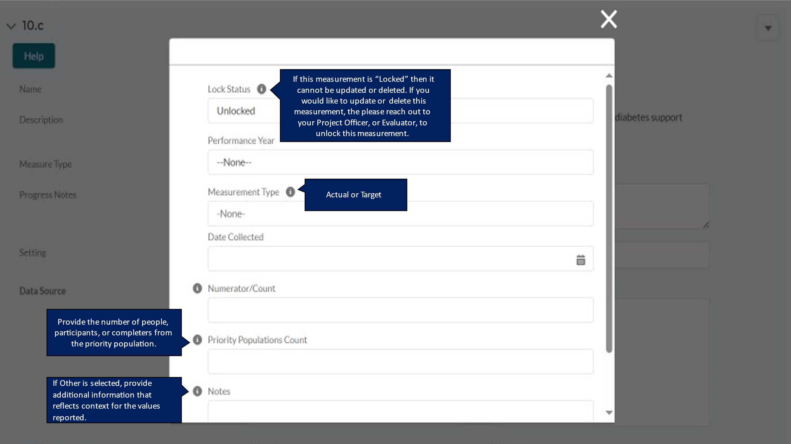

DP23-0020 Measure 11.1 – Component A
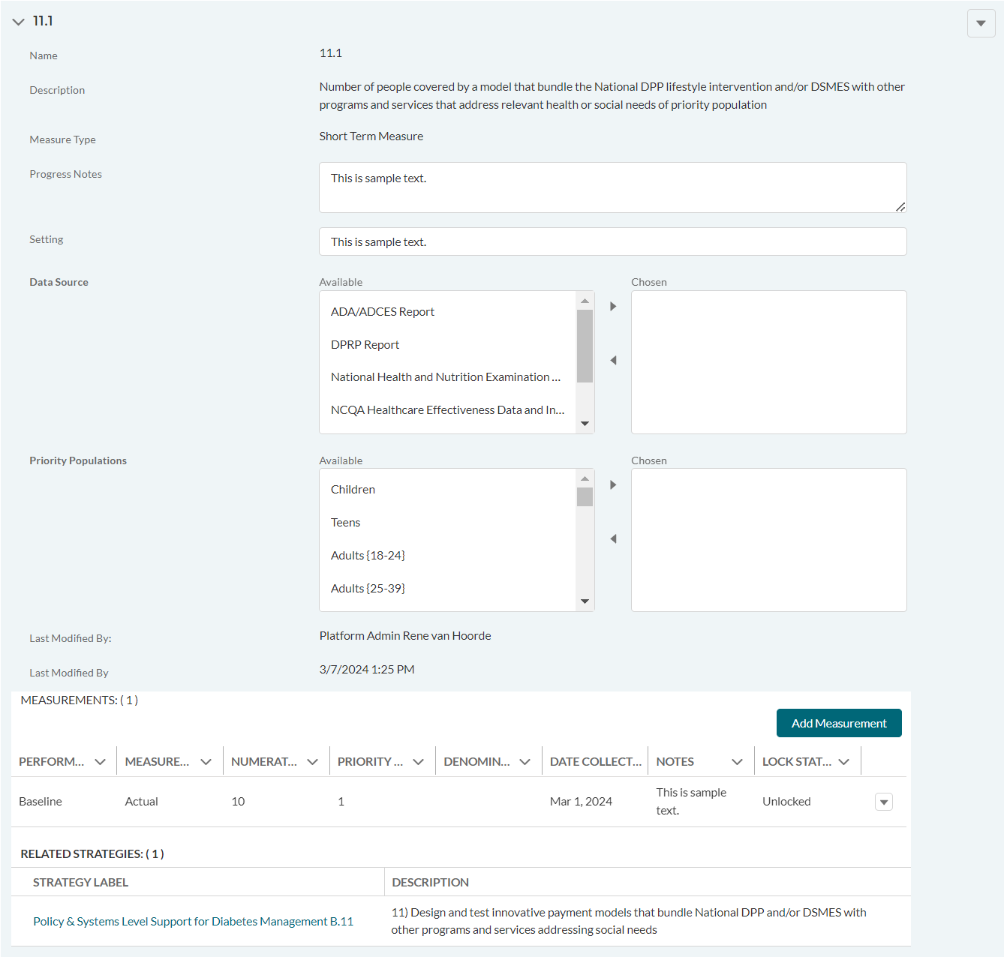

DP23-0020 Measure 11.1_Add Measurement Option – Component A
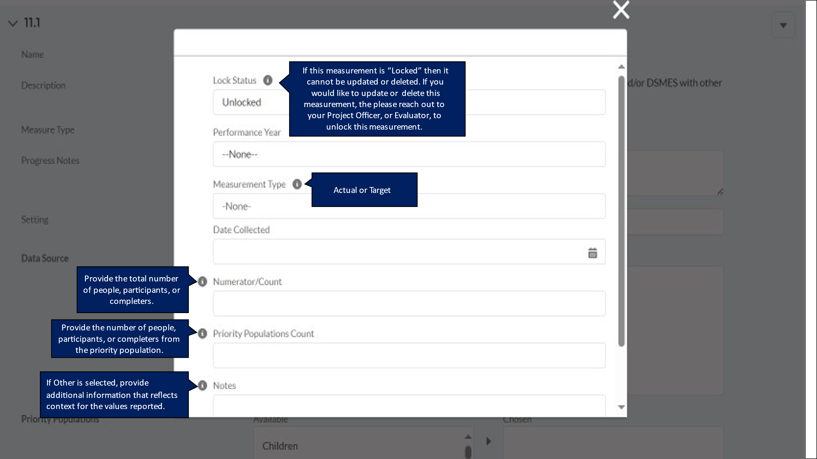

DP23-0020 Measure 12.1 – Component A
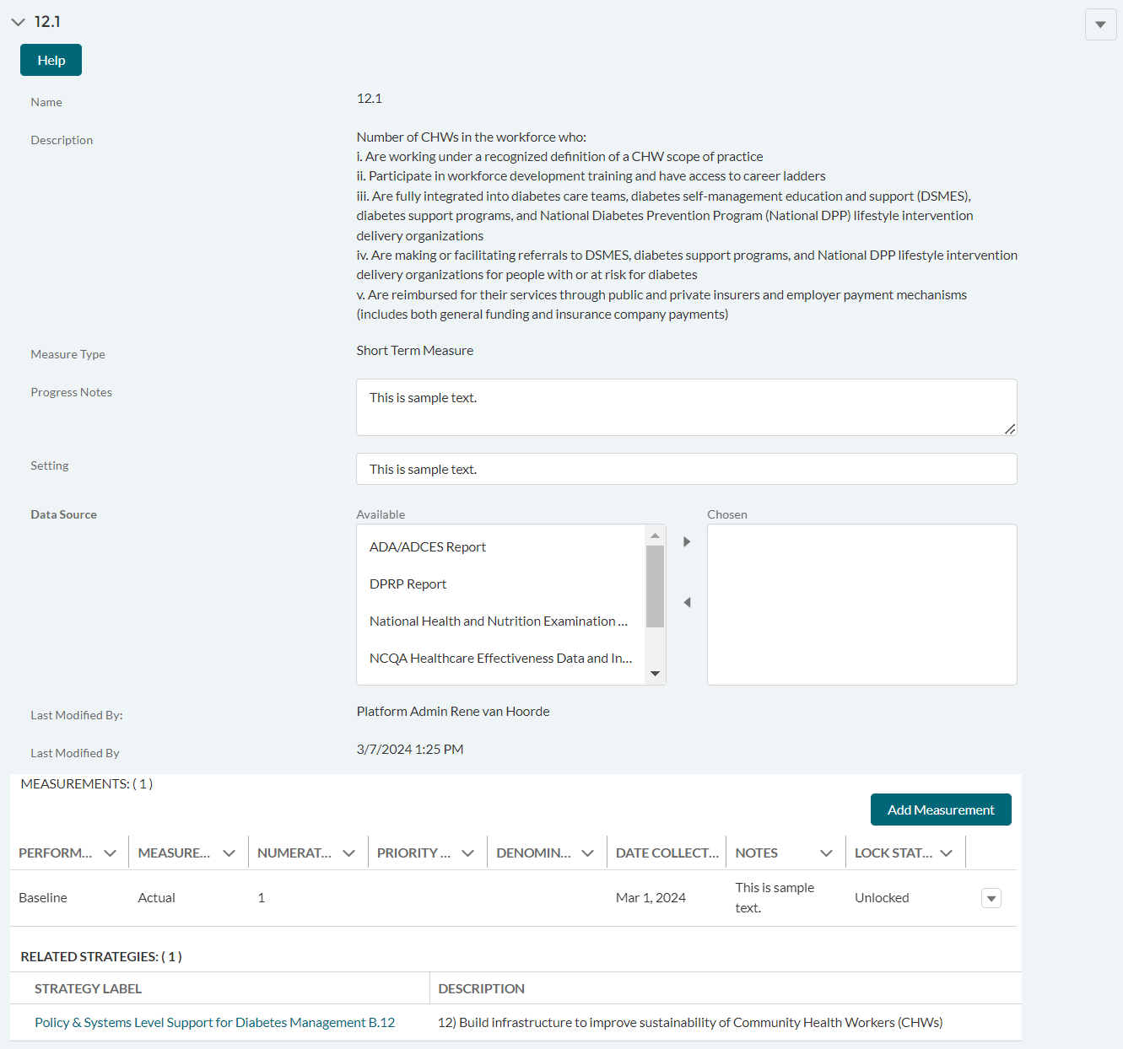

DP23-0020 Measure 12.1_Add Measurement Option – Component A
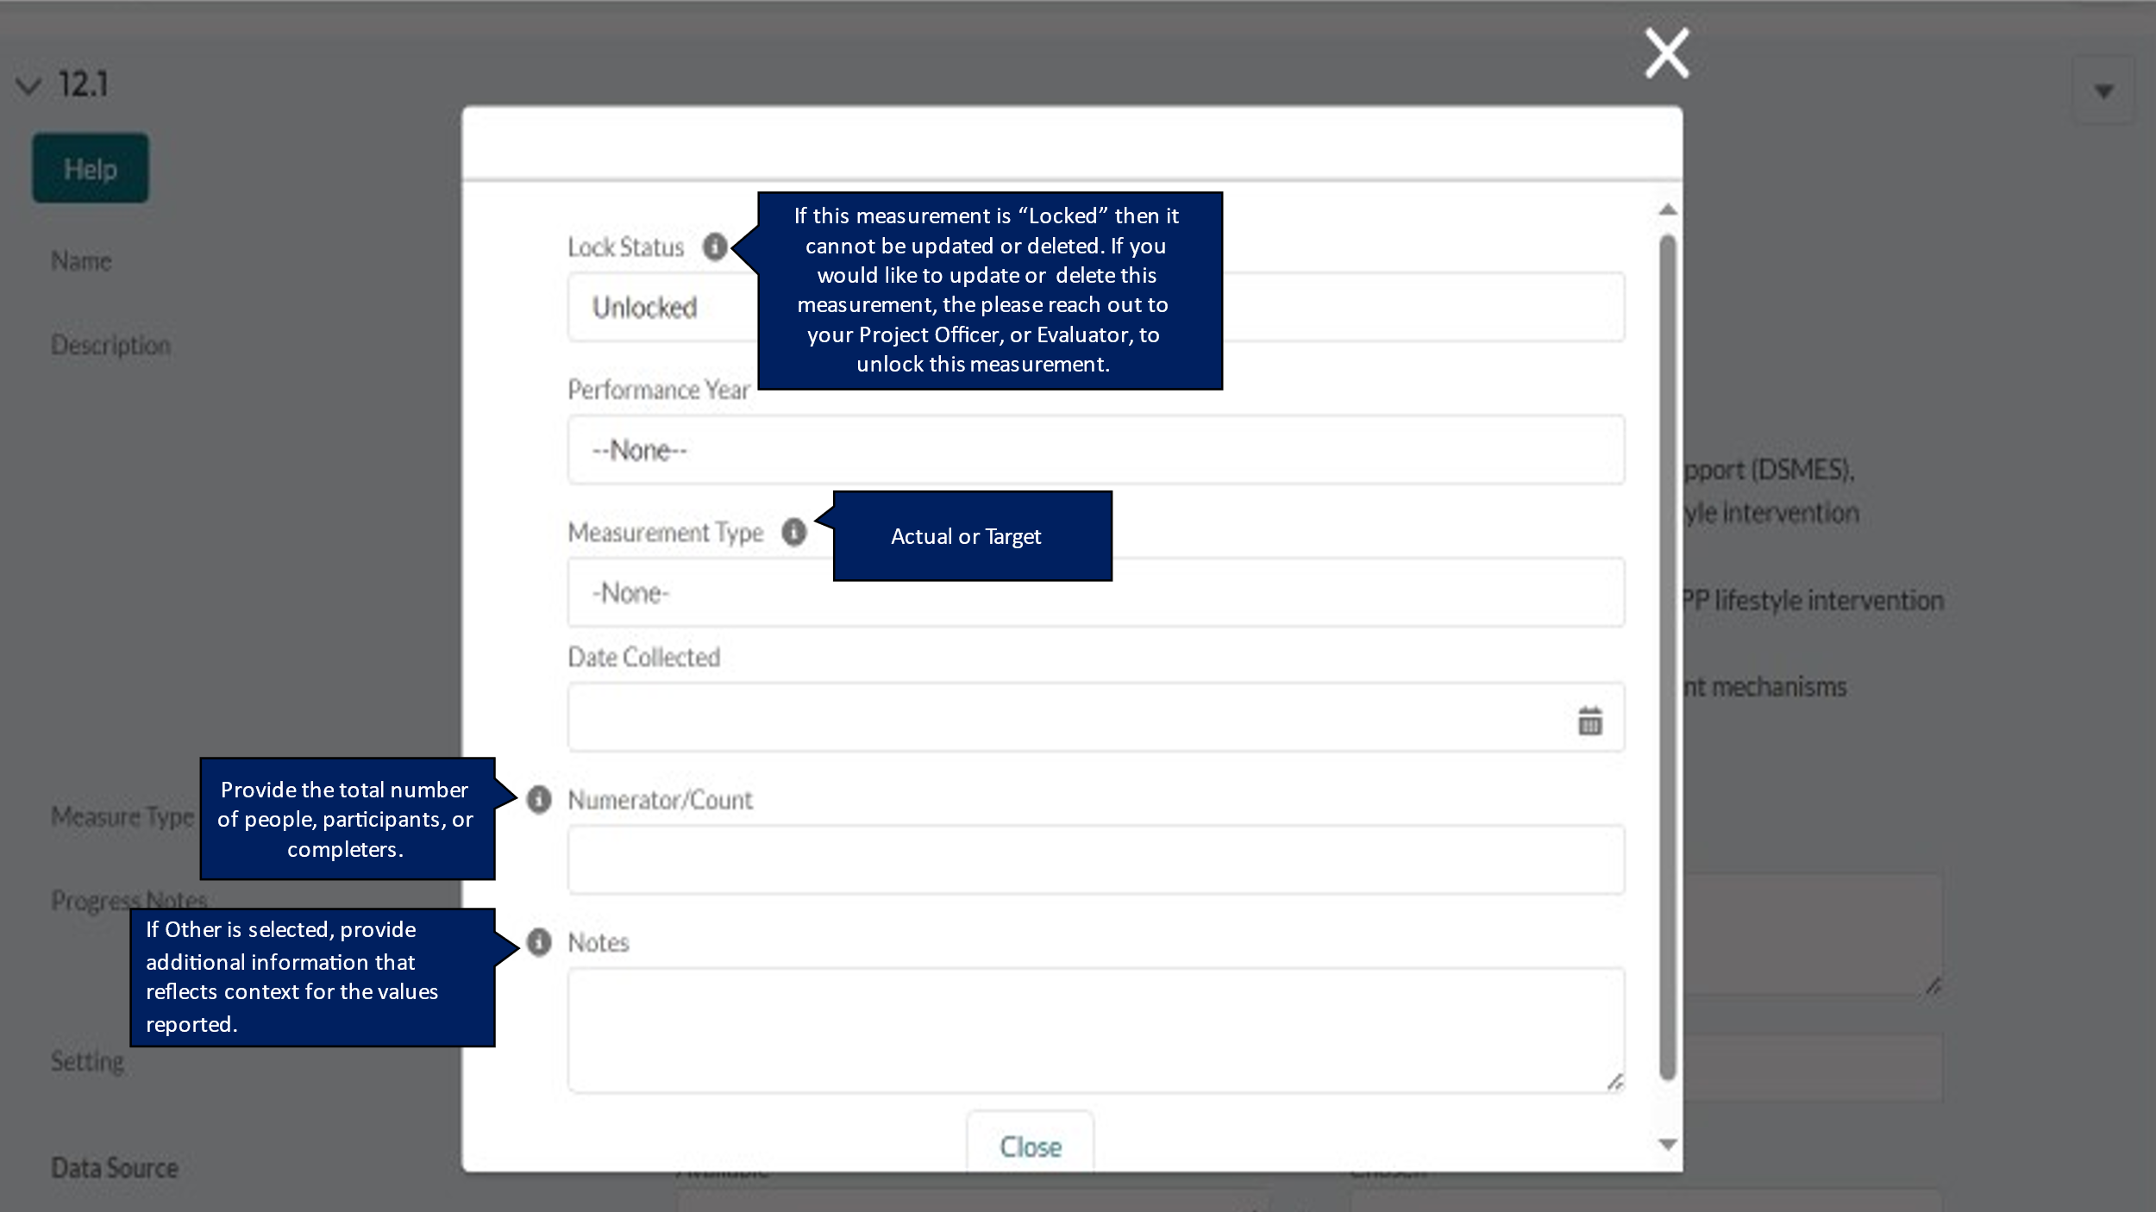

DP23-0020 Measure 13.1 – Component A
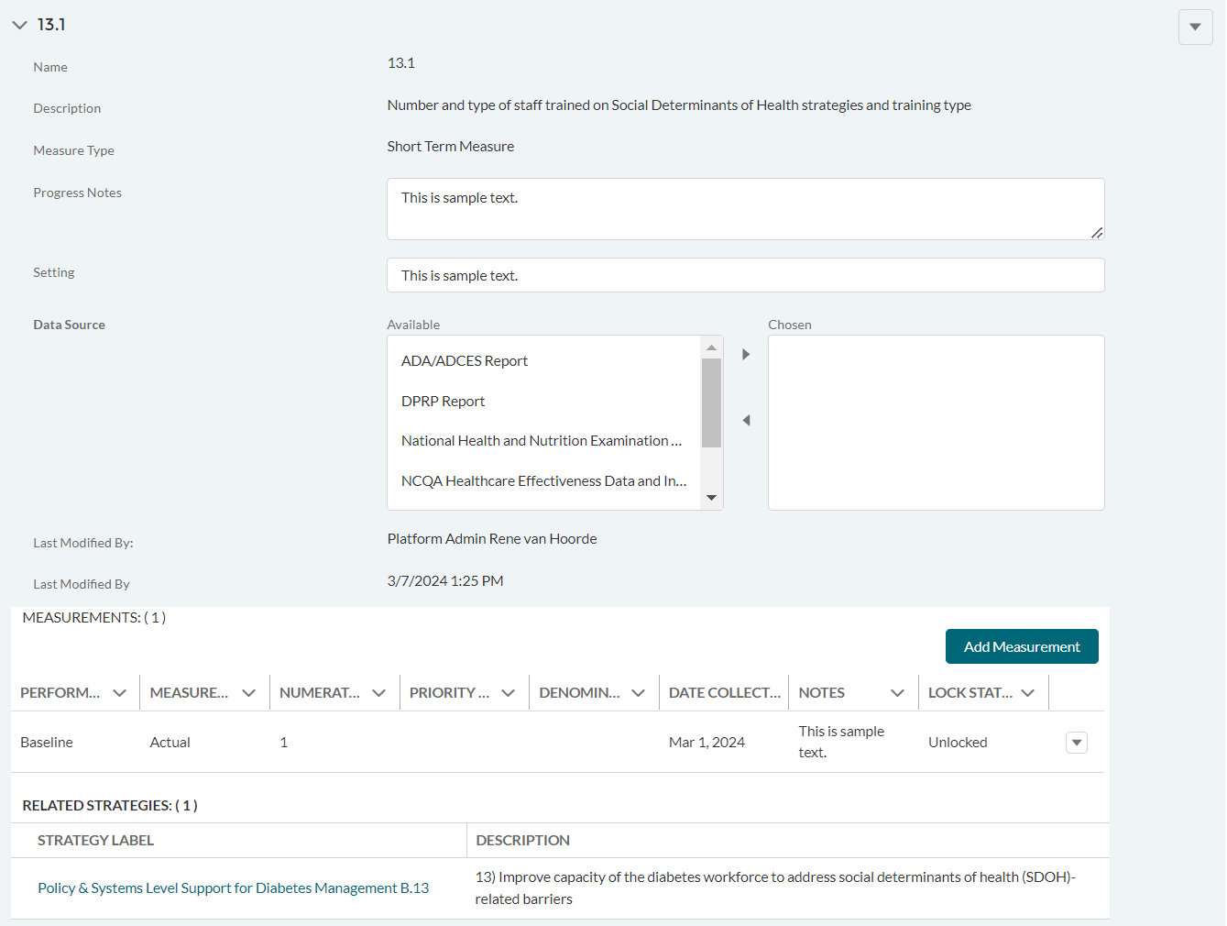

DP23-0020 Measure 13.1_Add Measurement Option – Component A
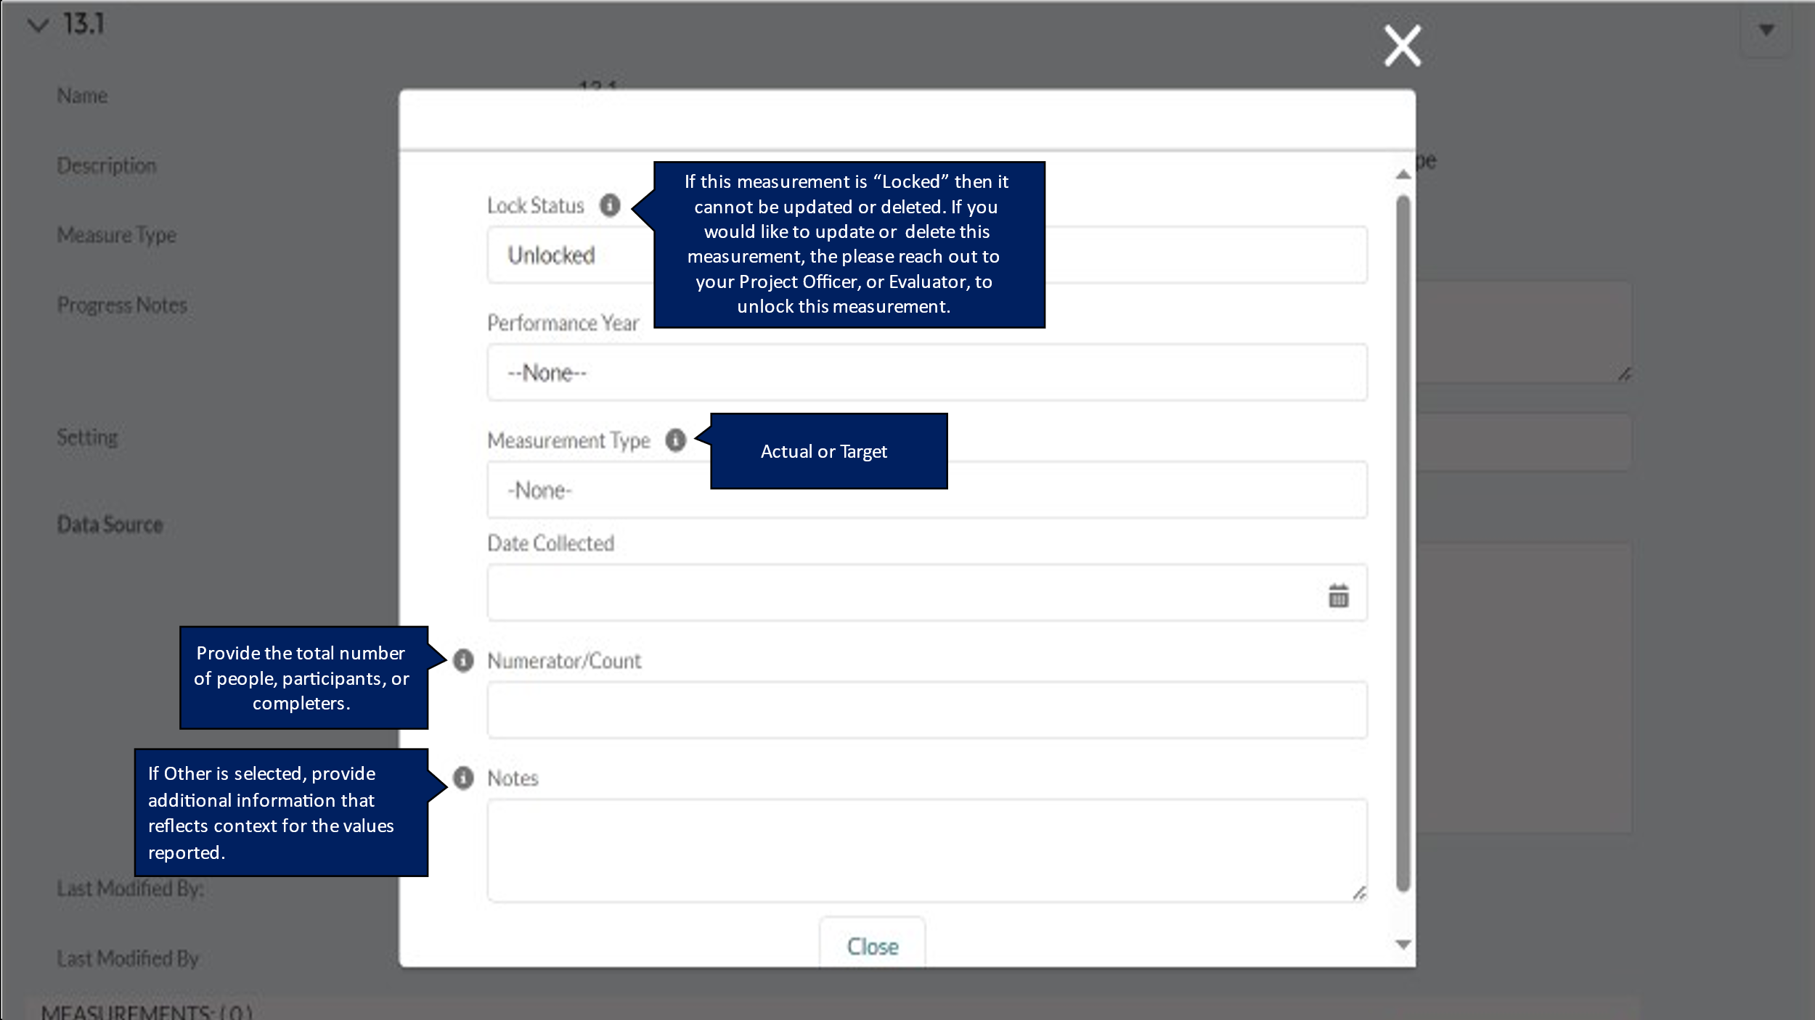

DP23-0020 Measure 14 – Component A
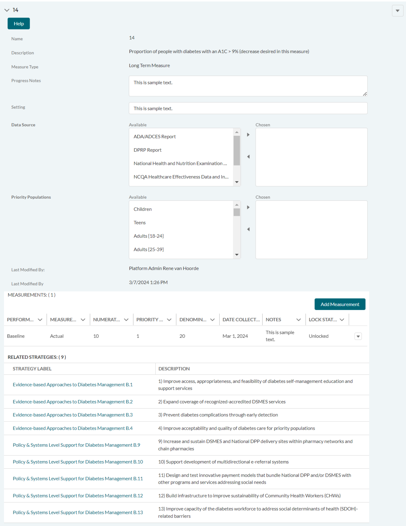

DP23-0020 Measure 14_Add Measurement Option – Component A
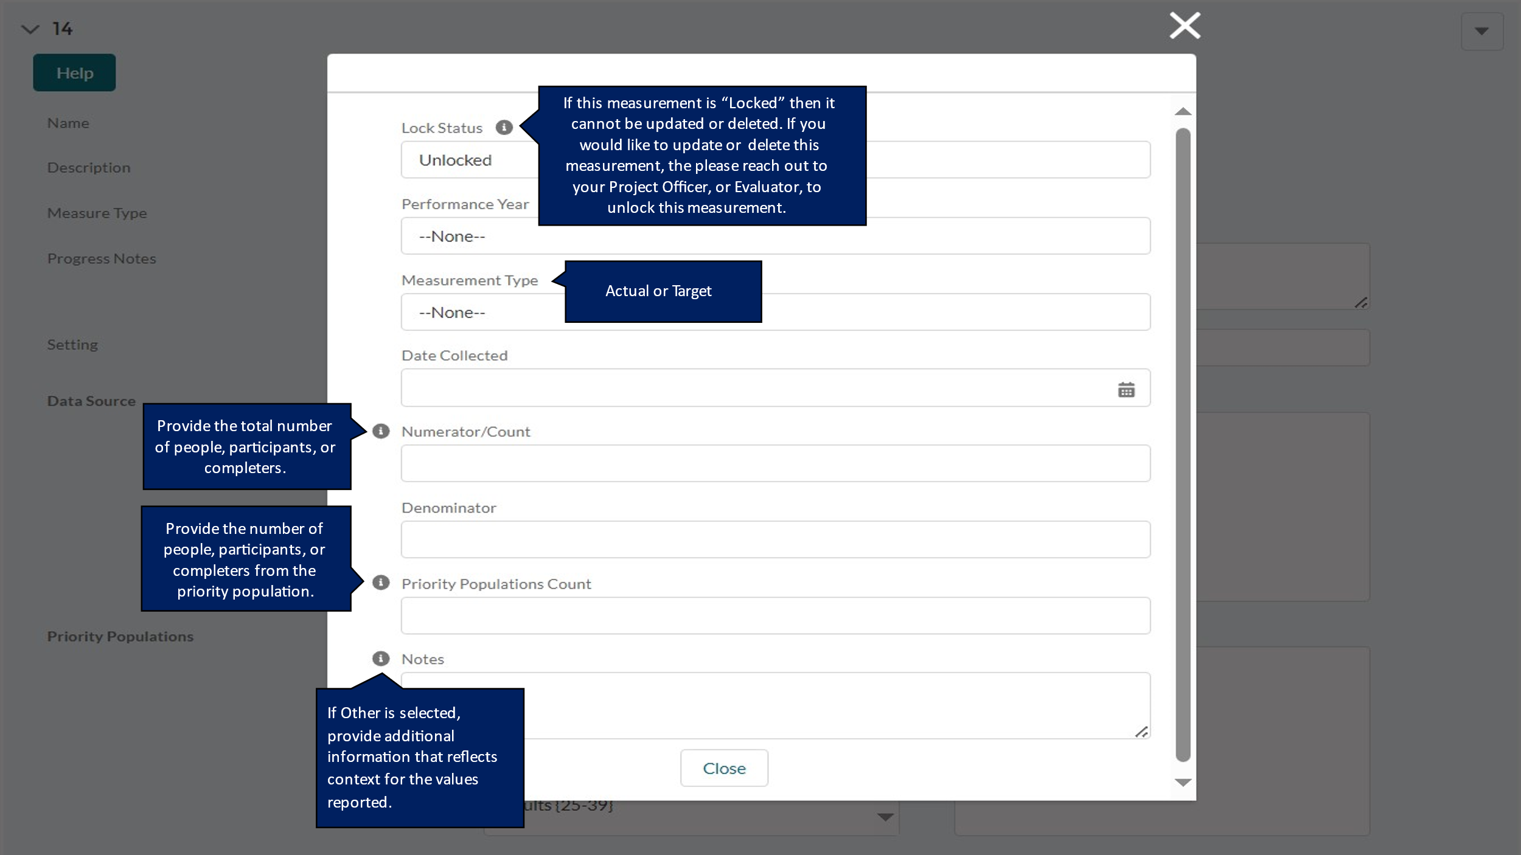

DP23-0020 Measure 15 – Component A
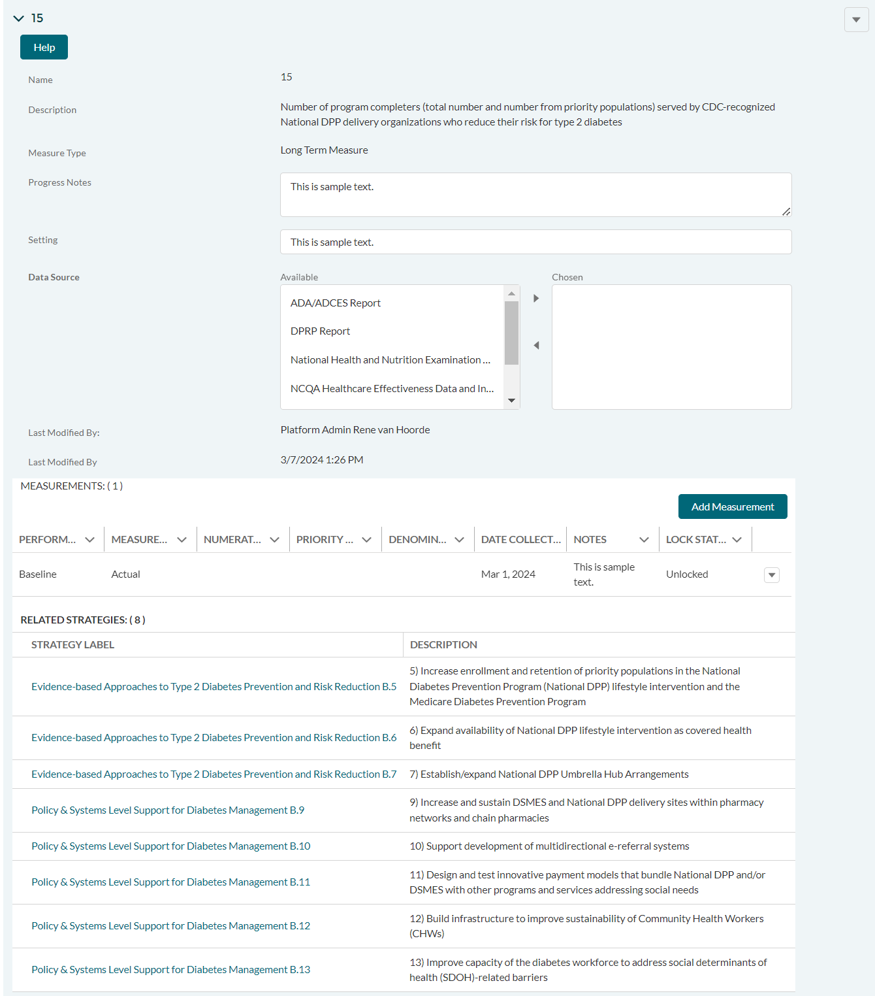

DP23-0020 Measure 15_Add Measurement Option – Component A
