

Performance Measures

Reporting Reference Guide

Program Development and Evaluation Branch
Evaluation Team

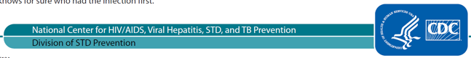
TABLE OF CONTENTS

INTRODUCTION 3
STD PCHD PERFORMANCE MEASURES: AT-A-GLANCE 5
SURVEILLANCE 7
Summary of Measures 7
Pregnancy Ascertainment for Syphilis Surveillance 7
CONGENITAL SYPHILIS 10
Summary of Measures 10
Potential Congenital Syphilis Cases Averted 10
OUTBREAK RESPONSE 13
Summary of Measures 13
Active or Initiated STD Outbreak Response Plan(s) 13
Staff Deployments to Assist Other Outbreaks…………………………………………………………..15
DISEASE INVESTIGATION AND INTERVENTION 18
Summary of Measures 18
Disease Intervention for Early Syphilis 19
Doxycycline Post-Exposure Prophylaxis (DoxyPEP) for Bacterial STI Prevention 23
STD-RELATED HIV PREVENTION IN DISEASE INVESTIGATION 25
Summary of Measures 25
STD-Related HIV Prevention 27
TREATMENT FOR SYPHILIS AND GONORRHEA 32
Summary of Measures 32
Gonorrhea Treatment 32
Recommended Treatment for Syphilis 34
DYNAMIC DASHBOARD 36
Dashboard Data Limitations 36
Dashboard Instructions 37
How to Obtain Visuals for Your Reports 39
FEEDBACK 42

INTRODUCTION
The Centers for Disease Control and Prevention (CDC) funds 59 health departments to conduct STD surveillance, prevention, and control through cooperative agreement PS19-1901 STD Prevention and Control for Health Departments (STD PCHD). The Performance Measures Reporting Reference Guide provides a snapshot of performance measures, calculation methods, and rationale for collecting the information. This document should be reviewed before completing the Data Collection Template.
The purpose of the performance measures outlined in this document is to assess recipients’ individual and collective progress towards the larger aims of the cooperative agreement, direct technical assistance to recipients, and obtain information needed to help assess the cooperative agreement’s public health impact.
The Evaluation Team has upgraded the STD PCHD Data Collection template to enhance our data management capabilities. This revised template now has:
• Visual cues for missing and auto-calculated data.
• Built-in data validation for improved data integrity.
• Automated calculations to expedite data processing.
• Automatic error messages to reduce user input errors.
• An improved user interface (UI) and user experience (UX) design, simplifying interactions.
• A dynamic intra-Excel dashboard that displays real-time data, enabling users to easily integrate this information into presentations and reports. For a more detailed description of its uses and how to use it, see this section.
The data will be used by CDC to generate reports that characterize recipients’ progress individually. Findings will be disseminated to all STD PCHD recipients and key DSTDP staff to stimulate discussion of program success, barriers, and provide technical assistance as needed.
If you have any questions about the measures or how to calculate and complete the Data Collection Tool, please email std_pchd@cdc.gov.

Note: Two data fields appear at least once in each worksheet. Here are their definitions; they are not repeated in each section below.
Indicate the quality of the data above by selecting an answer from the dropdown menu. | Select “yes” if you feel that for any reason, the data for the performance measure (numerator or denominator) are of poor quality, incomplete, or of uncertain validity. This does not refer to the quality of the data in your surveillance information system; rather, we are referring to the quality of the data provided for the performance measure (although they may be related.) Please tell us if you have serious doubts about whether this measure should be interpreted as accurate for your project area, for this reporting period. If you select “yes,” please explain why in the next field.
Any data limitations, including reasons unable to report (text response). | Use this space to describe why you were unable to report on this measure at this time or describe why you indicated that the data were of low or poor quality. If there are important caveats or other limitations to the data reported, please describe that here. Leave this field blank if you were able to provide the data, indicated that the data were not poor or low quality, or did not have important caveats to note.

STD PCHD PERFORMANCE MEASURES: AT-A-GLANCE

Strategy Area I: Surveillance
Chlamydia, Gonorrhea (GC), Syphilis, and Congenital Syphilis Surveillance
(Note: the Performance Measure related to Enhanced Gonorrhea Surveillance is no longer required to be reported to CDC and has been deleted)
The following are in addition to national case counts and rates, as well as routine measurement of case surveillance data quality/ completeness:
- Among all female syphilis cases (all stages), % with pregnancy status documented as “Yes, pregnant” or “No, not pregnant” within 14 days of specimen collection (a_17)
Congenital Syphilis Outcomes
- Among all potential congenital syphilis cases, number/% averted (b_6)
Strategy Area II: Disease Investigation and Intervention
Outbreak Response
- Total number of times that the outbreak plan was active or initiated for an STD (c_5)
- Among all STD program staff deployed, % STD staff deployed for a non-STD outbreak (c_8a)

Disease Intervention and Investigation for Syphilis
- Total number of partners brought to treatment (d_16)( Calculated separately for pregnant women, other women of reproductive age, MSW, and MSM/MSMW)
- (New) Percentage of Priority Medical Providers (STD clinic/Non-STD Clinic) identified in jurisdiction that provide DoxyPEP to patients (d_22)

Strategy Area III: Promotion of CDC-Recommended SCRN/DX/TX
Syphilis Treatment
- Among early syphilis cases, % treated with BPG within 14 days of specimen collection (f_19)
- Among early syphilis cases, % treated with Doxycycline within 14 days of specimen collection (f_19a)
Strategy Area IV: Promotion of Prevention and Policy
No common metrics; rely on work plan and progress reports only.

Strategy Area V: Data Use for Program Improvement
No common metrics; rely on work plan and progress reports only.
Cross-Cutting: HIV Prevention
Syphilis disease investigation and intervention
Calculated separately for pregnant women, other women of reproductive age, MSW, and MSM/MSMW
- Among interviewed syphilis or GC cases (and not known to be HIV+), % newly-diagnosed with HIV within 30 days after syphilis (or GC) diagnosis (e_7)
- Among interviewed and newly diagnosed with HIV, % linked to HIV care within 30 days after new HIV diagnosis (e_11)
- Among interviewed (and not known to be HIV+), % referred for PrEP after syphilis (or GC) diagnosis (e_15)

Disease investigation for MSM/MSMW with GC (for areas that investigate GC among MSM/MSMW)
- Among interviewed syphilis or GC cases (and not known to be HIV+), % newly-diagnosed with HIV within 30 days after syphilis (or GC) diagnosis (e_7)
- Among interviewed and newly diagnosed with HIV, % linked to HIV care within 30 days after new HIV diagnosis (e_11)
- Among interviewed (and not known to be HIV+), % referred for PrEP after syphilis (or GC) diagnosis (e_15)

Cross-Cutting: Partnerships
No common metrics; rely on work plan and progress reports only.

SURVEILLANCE
The performance measures described below are those that are new data requests from STD PCHD recipients for this strategy area. For surveillance, there are additional performance measures that DSTDP will calculate using surveillance data that are already sent to DSTDP as part of case reporting (e.g. completeness of data on certain key variables).

Summary of Measures

Line No. | Performance Measure | Rationale
a_17 | Among all female syphilis cases (all stages), % with pregnancy status documented as “Yes, pregnant” or “No, not pregnant” within 14 days of specimen collection | This process measure is intended to reflect a project area’s ability to put surveillance data into timely action for addressing syphilis in pregnant women and preventing potential cases of congenital syphilis. This relates directly to Strategy 3b.

Pregnancy Ascertainment for Syphilis Surveillance

Line No. | Data Field | Notes / Tips
a_10 | Total number of female syphilis cases (all stages) reported in the project area in the reporting period | This value is auto-calculated based on the values you enter in a_11, a_12, and a_13. This includes cases of all stages: primary, secondary, early non-primary non-secondary, unknown or late syphilis. This is the denominator for the performance measure.
a_11 | Total number of female syphilis cases (all stages) with pregnancy status documented as "Yes, pregnant" | Please enter a whole number for this question. Pregnancy status may have been obtained from DIS interviews with cases, follow-up with providers, a lab result, or other sources. “Documented” means that the information was contained in the surveillance and/or case management system.
a_12 | Total number of female syphilis cases (all stages) with pregnancy status documented as "No, not pregnant" | See above
a_13 | Total number of female syphilis cases (all stages) with pregnancy status documented as "Unknown" or “Missing” | Please enter a whole number for this question. This includes all cases where pregnancy status has not been obtained and/or is not documented in the surveillance and/or case management system as “Yes, pregnant” or “No, not pregnant.”
a_14 | Percent of female syphilis cases (all stages) that had pregnancy status documented as "Yes, pregnant" or "No, not pregnant" | This value is auto-calculated. If there are 0 cases in denominator, field may remain as 'Enter Denominator'. This reflects the percent of all cases that have documentation of pregnancy status, at the time of performance measure reporting. It does not take into account when that information was obtained by the program. In this measure, information on pregnancy status obtained 4 months after a case is first reported to the STD program is treated the same as information obtained 1 week after a case is reported. Auto calculated from other fields.
a_15 | Is your surveillance and/or case management system able to document when pregnancy status was obtained? | Select “Yes” or “No” from the dropdown menu. Not all systems currently time stamp the date when particular data fields are completed or have a data field to document when information was entered into the surveillance system. Use this space to indicate whether your project area can provide that information, which is needed to calculate the performance measure.  If no, leave the next field blank and skip to data quality fields.
a_16 | If yes (a_15): Total number of female syphilis cases (all stages) with pregnancy status documented as "Yes, pregnant" or "No, not pregnant" within 14 days of specimen collection | Please enter a whole number for this question that is less than or equal to the sum of a_11 and a_12. This refers to when information on pregnancy status was documented into the surveillance system, and whether it was documented within 14 days of specimen collection (i.e., in time for rapid follow-up and maximum time for intervention.). This will be a subset of all the cases for which pregnancy status was documented as “Yes” or “No”. The specimen collection refers to that for syphilis testing, not for pregnancy testing. This is the numerator for the performance measure.
a_17 | Among all female syphilis cases (all stages), % with pregnancy status documented as “Yes, pregnant” or “No, not pregnant” within 14 days of specimen collection | This value is auto-calculated. If there are 0 cases in denominator, field may remain as 'Enter Denominator'. This is a main performance measure.

CONGENITAL SYPHILIS
All project areas, regardless of congenital syphilis or female syphilis morbidity, should report the following. What follows is a subset of what was requested in the final years of STD AAPPS. This relates to multiple STD PCHD Strategies including 4, 7, and 12.

Summary of Measures

Performance Measures | Rationale
Among all potential congenital syphilis cases, % averted | Focusing disease prevention and control efforts on reducing congenital syphilis morbidity is a priority and includes recognizing how many congenital syphilis cases are potentially averted. While likely an overestimate of actual cases averted, this performance measure helps reflects the scale of public health intervention to prevent congenital syphilis in a project area.

Potential Congenital Syphilis Cases Averted

Line No. |  | Data Field | Notes / Tips
b_1 |  | Total number of females with syphilis (all stages) reported in the project area in the reporting period | This value is pre-populated from your response to a_10 on tab A. To update it, return to a_10 on tab A and change your response. This includes cases of all stages: primary, secondary, early non-primary non-secondary, unknown or late syphilis. This should match the number provided in the analogous field under Surveillance/Pregnancy Ascertainment.
b_2 |  | Total number of pregnant females with syphilis (all stages) | This value is pre-populated from your response to a_11 on tab A. To update it, return to a_11 on tab A and change your response. This is the denominator for the performance measure. It includes all stages, regardless of age. This number is likely similar, if not equal to, the number of females with syphilis with pregnancy status documented as “yes, pregnant,” provided in the analogous field under Surveillance/Pregnancy Ascertainment.
b_3 |  | % of total female syphilis cases that were pregnant | This value is auto-calculated. If there are 0 cases in denominator, field may remain as 'Enter Denominator'.
b_4 |  | Total number of reported congenital syphilis cases and stillbirths | Please enter a whole number for this question. This is the total number of CS cases and CS-related stillbirths reported in the reporting period. This may vary from your area’s official CS case count that appears in the annual CDC STD surveillance report.
b_5 |  | Total number of potential congenital syphilis cases averted | This value is a whole number auto-calculated as the sum of b_2 minus b_4. This is the numerator for the performance measure. It is calculated by subtracting the number of congenital syphilis cases from the number of pregnant females with syphilis.  Note that the pregnant females with syphilis and the congenital syphilis cases do not need to be formally linked to calculate this performance measure.
b_6 |  | Among all potential congenital syphilis cases, % averted | This value is auto-calculated. If there are 0 cases in denominator, field may remain as 'Enter Denominator.' If your % is greater than 100%, please explain why in the data quality comments below. Performance measure is calculated by: (pregnant women with syphilis - congenital syphilis cases)/(pregnant women with syphilis)  This performance measure reflects an estimate of the proportion of potential congenital syphilis cases averted, where a “congenital syphilis case” is defined according to the current surveillance definition. Because currently available tests cannot reliably diagnose all true congenital syphilis infections, the current surveillance case definition includes any infant born to an infected mother who did not receive adequate treatment prior to delivery.  Because the transmission rate from an inadequately treated mother to her infant is not 100%, this performance measure is not an accurate estimate of the number of actual infections that were prevented. Estimating the number of babies that would have been born with true congenital syphilis infection involves a different set of estimates and assumptions related to syphilis transmission rates, stage of syphilis of the mother, and the efficacy of clinical interventions, among others. This performance measure does not incorporate those.

OUTBREAK RESPONSE
DSTDP requests information on the STD and other outbreak investigations/responses each project area initiated and participated in during the reporting period. This information will be used to help describe STD programs’ role in outbreaks (including pandemics) and the extent of STD programs’ work on outbreak response over time. These measures relate to STD PCHD Strategy Area II, Strategies 6a and 6b, but are not direct corollaries of them. These are not truly measures of program “performance.” Rather, this is information about program activities not otherwise captured in a standardized way.

Summary of Measures

Performance Measures | Rationale
Total number of times that the outbreak plan was active or initiated for an STD | This provides a sense of how common outbreaks occur and reach the point of formal activation among recipients. This will help describe the extent of outbreak work among recipients.
Total number of STD staff deployed for non-STD outbreaks | This provides a sense of how much STD program staff are tapped for their outbreak expertise.

Active or Initiated STD Outbreak Response Plan(s)

Line No. | Data Field | Notes / Tips
c_1 | Does your project area have an STD outbreak plan in place? | Select from dropdown. If no, please skip to the section “Staff assignments to assist other outbreaks” (c_6). Answer “Yes” if your STD program has an outbreak plan in place and “No” if it does not. If a project area does not have an STD outbreak plan in place, then it would not be able to report on this measure. We realize it is possible for project areas to respond to outbreaks without a formal outbreak plan in place, but this measure tracks the formal activation of an outbreak plan.  If the answer is “No,” please skip to the next measure, “Staff deployed for non-STD outbreaks.”
c_2 | Total number of times that the outbreak plan was active or initiated for syphilis by the project area in the reporting period | Please enter a whole number for this question. The “initiation” or “activation” of an outbreak response plan should be determined by each project area, per their own plan’s criteria. Regardless, “initiation” or “activation” should reflect a clear decision to take initial steps to respond to a potential outbreak, per your project area’s protocol. This measure could include activation for congenital syphilis as well as adult syphilis.  This includes new outbreak plan initiations as well as outbreak plan initiations that may have started in a prior reporting period and continued into the current reporting period. If none, enter “0.”  Close monitoring of a potential outbreak, short of an outright initiation of an outbreak plan, should not be included here. DSTDP realizes that this measure underestimates the effort dedicated to outbreak response, but the use of “formal initiation of an outbreak response plan” provided a more standardized, objective definition for project areas to use.
c_3 | Total number of times that the outbreak plan was active or initiated for GC in the reporting period | Please enter a whole number for this question. See above. If none, enter “0.”
c_4 | Total number of times that the outbreak plan was active or initiated for another STD in the reporting period | Please enter a whole number for this question. See above. This might include activations for LGV or other conditions. This should not include activations related to HIV only. If none, enter “0.”
c_5 | Total number of times that the outbreak plan was active or initiated in the reporting period for an STD | This value is a whole number auto-calculated as the sum of c_2 plus c_3 plus c_4.

Staff Deployments to Assist Other Outbreaks

Line No. | Data Field | Notes/Tips
c_6 | Total number of STD program staff deployed on temporary, formal assignments to assist with HIV, Hepatitis, or TB outbreaks during the reporting period | Please enter a whole number for this question. This refers to formal reassignment to assist with an outbreak response for HIV, viral hepatitis, and/or TB. This could include field deployment, as well as temporary, part-time, or full-time reassignment. Regardless, to be counted, the staff person’s assistance should have been formalized and reflect duties that were not a part of the routine duties of the staff involved. Staff that assisted in ad hoc or informal ways should not be counted. STD program staff include only those directly employed by the recipient. STD program staff who are in-kind or subcontractors should be counted as STD program staff. STD program staff that contribute to outbreak response activities on a part-time basis should be counted in the total. For the purposes of these measures, we are not interested in the amount of time spent assisting with outbreak response for each staff person. Please do not count staff contributing to outbreak response only in overtime status. Federal field staff should not be included in this number.  The temporary, formal assignment may have started in a prior reporting period but must have continued into the current reporting period, to be included.  If none, enter “0.” If a staff person participated in 2+ outbreaks, still count that person as 1 here.  Staff who are funded by HIV, TB, Hepatitis, or other funding sources and who work routinely on outbreaks related to those other pathogens should not be included in these measures. The intent of these measures is to reflect instances when STD program staff are diverted from their usual duties.
c_7 | Total number of STD program staff deployed on temporary, formal assignments to assist with non-STD (e.g. foodborne, etc.) outbreaks during the reporting period. | Please enter a whole number for this question. See above. This may relate to foodborne outbreaks, Zika, Ebola, measles, or other conditions. Pandemics (e.g., COVID-19) should be included here. If none, enter “0.”
c_8 | Total number of STD staff deployed for all outbreaks of all types (STD and non-STD) | This value is a whole number auto-calculated as the sum of c_6 plus c_7. Note that staff who assisted with HIV, Hepatitis, or TB outbreaks may have also assisted with outbreaks related to other conditions, or the same person may have been deployed multiple times. DSTDP realizes that the summed auto-calculation would double count these staff members.  If there are any staff members who were double counted, please note this in the data limitations section and include the number of double-counted staff members.
c_8a | Among all STD program staff deployed, % STD staff deployed for a non-STD outbreak | This value is auto-calculated. If there are 0 cases in denominator, field may remain as 'Enter Denominator'
c_9 | Total number of outbreak responses (HIV, Hepatitis, TB, or other conditions) for which those staff were formally assigned to assist during the period. | Please enter a whole number for this question. This refers to the two fields above and reflects how many separate outbreak responses those staff assisted with. This helps contextualize the formal staff assistance. If none, enter “0.”

DISEASE INVESTIGATION AND INTERVENTION
Disease Investigation and Intervention (DII) activities are critical to successful STD/HIV prevention and control. The following process and outcome measures are collected for key sub-populations, so STD programs can assess successes and challenges and use the data for program improvement. The following relate to implementation of STD PCHD Strategies 7 and 9.

Summary of Measures

Line No. | Performance Measures | Rationale
d_16 | Total number of partners brought to treatment | Assessing the number of partners brought to treatment, including only those found to be infected through program intervention (Dispo C), allows programs to assess one aspect of the effectiveness of partner services for syphilis that is more directly attributable to the program. Disease intervention rate will also be calculated with what is submitted, providing an alternative perspective on partner services’ effectiveness.
Definitions of key populations used for syphilis reporting
Pregnant females under age 45 |  | This is a priority population for all DII activities due to efforts to prevent congenital syphilis. The age of 45 is selected as the upper limit of females of reproductive age for the purpose of this performance measure. It is understood that there are females who become pregnant beyond the age of 45.
Other females under age 45 |  | Females under the age of 45 who are not pregnant at the time of diagnosis, regardless of sex of sex partners.
Males with only female partners (MSW) |  | This population includes males of any age, regardless of their sex at birth. This includes males that report only female partners during the interview period for partner services, for the syphilis infection being investigated in the reporting period (not lifetime sex partners).
Males with male partners (MSM and MSMW) |  | MSM and MSMW of any age should be included in this category if they had male partners during the interview period, even if they also have or named female sex partners during the interview period. Including MSMW with MSM combines two important subpopulations, but not to an extent that should significantly affect broader conclusions and comparisons for performance measurement purposes.

Disease Intervention for Early Syphilis

Line No. | Data Field | Notes / Tips
d_1 | Total number of early syphilis cases by the project area in the reporting period | Please enter a whole number for this question. This is the denominator for many key measures below. Early syphilis is defined as primary, secondary, and early non-P&S. It is recognized that there will be some early syphilis cases that are not included here because sex, age, pregnancy status, or sex of sex partner remained unknown. The total across these cells may vary substantially from the total number of early syphilis cases reported in the project area.
d_2 | Total number of cases initiated | Please enter a whole number that is less than or equal to the value you entered in d_1. Initiated = assigned to DIS for case management, including partner services, follow-up. This is the denominator for the interview rate.
d_3 | Total number of cases interviewed | Please enter a whole number that is less than or equal to the value you entered in d_2. Interview = partner services offered to client and a partial or complete interview was conducted. Clients who refused to be interviewed should not be included. Clients who were interviewed and did not name any partners should be included. This is the numerator for the Interview rate.
d_4 | Interview rate | This value is auto-calculated. If there are 0 cases in denominator, field may remain as 'Enter Denominator'. The denominator is d_2. May not be > than 1.0.
d_5 | Total number of contacts (partners) initiated for partner services | Please enter a whole number for this question. This is your numerator for the contact index. Contact refers to sex, needle-sharing, or both. Contacts initiated = assigned to DIS for case management follow-up. For MSMW, include both male and female partners.
d_6 | Contact Index | This value is auto-calculated. If there are 0 cases in denominator, field may remain as 'Enter Denominator'. The calculation is the total number of contacts initiated divided by the total number cases reported. May be > than 1.0.
d_7 | Total number of contacts examined (tested) within 30 days before or after the index patient’s initial specimen collection. (Dispo A, B, C, D, E, F, Z) | Please enter a whole number less than or equal to the value you entered in d_5.  The contact has a serological test for syphilis within 30 days before or after the index patient’s initial specimen collection. This would include Disposition codes A, B, C, D, E, F, and Z as long as it’s within the timeframe. This is the numerator for the new exam rate.  This includes all contacts examined, regardless of program involvement. This is consistent with the definition used under STD AAPPS for analogous performance measures.
d_8 | Exam Rate | This value is auto-calculated. If there are 0 cases in denominator, field may remain as 'Enter Denominator'. The calculation is the number of contacts examined (tested) divided by the number of contacts initiated. May not be > than 1.0.
d_9 | Total number of contacts previously treated (Dispo E) within 30 days before or after the index patient's initial specimen collection | Please enter a whole number that is less than or equal to the value you entered in d_7. Double check that the total of the values entered in d_9 through d_12 do not exceed d_7. Infected, but treated without program involvement. This is part of the numerator, along with Dispos A, Z, and C, for the Tx index.
d_10 | Total number of contacts preventively treated (Dispo A) within 30 days before or after the index patient's initial specimen collection | Please enter a whole number that is less than or equal to the value you entered in d_7. Double check that the total of the values entered in d_9 through d_12 do not exceed d_7. Not infected, but preventively treated with program involvement. This is part of the numerator, along with Dispos E, Z, and C, for the Tx index.
d_11 | Total number of contacts preventively treated (Dispo Z) within 30 days before or after the index patient's initial specimen collection | Please enter a whole number that is less than or equal to the value you entered in d_7. Double check that the total of the values entered in d_9 through d_12 do not exceed d_7. Not infected, but preventively treated without program involvement. This is part of the numerator, along with Dispos E, A, and C, for the Tx index.
d_12 | Total number of contacts brought to Tx for new syphilis infection (Dispo C) within 30 days after the index patient's initial specimen collection | Please enter a whole number that is less than or equal to the value you entered in d_7. Double check that the total of the values entered in d_9 through d_12 do not exceed d_7. Infected, treated with program involvement. This is part of the numerator, along with Dispos E, A, and Z, for the Tx index.
d_13 | Treatment index (Tx index) | This value is auto-calculated. If there are 0 cases in denominator, field may remain as 'Enter Denominator'. The calculation is the cumulative sum of d_9 through d_12 divided by d_1. May be > 1.0.
d_14 | Total number of cases w/at least 1 contact (partner) treated for syphilis (Dispo A, C, E, Z) within 30 days before or after the index patient’s initial specimen collection | Please enter a whole number that is less than or equal to the value you entered in d_3. This is the numerator for the disease intervention rate. It reflects the number of cases with at least one contact (partner) treated within 30 days before or after the index patient’s initial specimen collection. This includes contacts who were infected and treated, and those who were preventively treated.
d_15 | Disease Intervention Rate (DIR) | This value is auto-calculated. If there are 0 cases in denominator, field may remain as 'Enter Denominator'. This percentage should be different from the treatment index (which is a ratio). It is possible the number of cases for DIR and the number of people calculated for Tx index could match, but unlikely. May not be > than 1.0.
d_16 | Total number of partners brought to treatment | This value is pre-populated from your response to d_12. To update it, return to d_12 and change your response. This is a performance measure that equals Disposition Code C (d_12).
d_17 | Total number of new cases of syphilis found through partner services | This value is a whole number auto-calculated as the sum of d_9 plus d_12, Disposition Codes E and C, respectively, reflecting intervention more directly attributable to STD program partner services.

Doxycycline Post-Exposure Prophylaxis (DoxyPEP) for Bacterial STI Prevention (New Performance Measure for the 2024 Reporting Period)
Line No. | Data Field | Notes / Tips
d_20 | Total number of Priority Medical Practices (STD clinic/Non-STD Clinic) identified in jurisdiction | Please enter a whole number for this question.  Each recipient should identify a set of priority medical practices with which it is strategically important to collaborate for scale-up of high-impact STI interventions such as doxy-PEP. Recipients may consider factors such as high number of cases diagnosed of syphilis and gonorrhea by medical practice, patient volume, and current level of adoption and degree of independence in scaling up high-impact STI interventions. Population(s) served may also be an important consideration, e.g. doxy PEP is currently recommended for certain populations. Identify Priority Medical Practices for collaboration. Confirm that Priority Medical Practices provide clinical services for patients at increased risk of acquiring syphilis and gonorrhea and eligible for doxy PEP (e.g. males with male partners). Priority Medical Practices may be STD clinics or non-STD clinics. This is the denominator for d_22.
d_21 | Total number of Priority Medical Practices (STD clinic/Non-STD Clinic) identified in jurisdiction that provide DoxyPEP to patients | Please enter a whole number that is less than or equal to the value you entered in d_20.  This is the number of Priority Medical Practices in d_20 that dispense or prescribe DoxyPEP to their patients. This is the numerator for d_22.
d_22 | Percentage of Priority Medical Practices (STD clinic/Non-STD Clinic) identified in jurisdiction that provide DoxyPEP to patients | This value is auto-calculated as d_21 divided by d_20. If there are 0 cases in denominator, field may remain as 'Enter Denominator'. The higher the percentage of Priority Medical Practices dispensing or prescribing DoxyPEP, the greater the likelihood of preventing syphilis and gonorrhea in the community.
d_23 | Briefly describe what criteria were used to select Priority Medical Practices. (text response) | Please limit your response to 500 words (2500 characters) or less. Describe what consideration(s) you used to determine priority medical practices throughout your jurisdiction? How did you determine which practices in those counties to include as Priority Medical practices? How did you determine the risk level of the practice’s patient population?
d_24 | Briefly describe successes cited by Priority Medical Practices related to DoxyPEP implementation. (text response) | Please limit your response to 500 words (2500 characters) or less. Successes may include Leadership/staff buy-in/commitment, policy/protocol development and implementation, patient awareness and education.
d_25 | Briefly describe challenges cited by Priority Medical Practices related to DoxyPEP implementation. (text response) | Please limit your response to 500 words (2500 characters) or less. Challenges may include lack of Leadership/staff buy-in/commitment, policy/protocol development and implementation, patient awareness, education, and uptake.

STD-RELATED HIV PREVENTION IN DISEASE INVESTIGATION
The identification of new HIV cases, linkage to and retention in HIV care for those who are HIV positive, and referral for PrEP for those who are HIV negative but at-risk, are pillars of effective HIV prevention and control. STD programs play a significant role in all these HIV prevention activities, and it is important to measure these contributions. The following performance measures are collected for key sub-populations, so STD programs can assess successes and challenges and use the data for program improvement.
While STD programs address HIV prevention in many aspects of their work, the following measures focus on HIV prevention conducted in the course of index case follow-up of syphilis cases, using the same subpopulations as those used for the syphilis disease intervention measures. For areas that follow up with GC index cases who are MSM/MSMW, there are also data fields to report on relevant HIV prevention measures for that population. Notably, the following measures do not relate to the partners of index syphilis and GC cases; these are focused on disease investigation, not intervention.
The definitions provided below for the key outcomes (PrEP referral, new HIV diagnosis, and linkage to care) are meant to match those provided by CDC’s Division of HIV/AIDS Prevention (DHAP). In case of inconsistency, project areas should use DHAP’s definitions and what they use to report similar concepts to DHAP.

Summary of Measures

Performance Measures |  | Rationale
Among interviewed syphilis or GC cases (and not already known to be HIV+), % newly diagnosed with HIV within 30 days after the syphilis/GC diagnosis |  | HIV testing of persons with STDs is an important standard of care. STD staff are in a unique position to offer high risk individuals (partners) HIV testing to identify new HIV cases and begin the HIV care continuum.
Among interviewed and newly diagnosed with HIV, % linked to HIV care within 30 days after the new HIV diagnosis |  | Once HIV is newly diagnosed, STD staff are in a unique position to help link clients to HIV care in a timely manner as part of comprehensive case management.
Among interviewed (and not known to be HIV+), % referred for PrEP |  | STD staff engaging with STD patients who test negative for HIV are in a unique position to ensure those individuals have an opportunity to prevent HIV infection via the use of PrEP.
Definitions of key populations used for DII activities
(see Syphilis Disease Investigation and Intervention section above)
Pregnant females under age 45 | This is a priority population for all DII activities due to efforts to prevent congenital syphilis. The age of 45 is selected as the upper limit of females of reproductive age for the purpose of this performance measure. It is understood that there are females who become pregnant beyond the age of 45.
Other females under age 45 | Females under the age of 45 who are not pregnant at the time of diagnosis, regardless of sex of sex partners.
Males with only female partners (MSW) | This population includes males of any age, regardless of their sex at birth. This includes males that report only female partners during the interview period for partner services, for the infection being investigated in the reporting period (not lifetime sex partners).
Males with male partners (MSM and MSMW) | MSM and MSMW of any age should be included in this category if they had male partners during the interview period, even if they also have or named female sex partners during the interview period. Including MSMW with MSM combines two important subpopulations, but not to an extent that should significantly affect broader conclusions and comparisons for performance measurement purposes.
GC cases among MSM/MSMW investigated for partner services | Not all areas investigate GC cases for disease investigation. For those that do for HIV prevention purposes, please report only for MSM/MSMW cases identified.

STD-Related HIV Prevention

Line No. | Data Field | Notes/Tips
e_1 | Total number of cases in the project area in the reporting period | For MSM/MSMW with GC, please enter a whole number for this question. The data for the other key populations are pre-populated from your response to d_1 on tab D. To update these, return to d_1 on tab D and change your response.  Early syphilis is defined as primary, secondary, early non-P&S. These numbers will be pulled from the syphilis DII worksheet, so they match.  For the purposes of these PM, patients with a dual diagnosis of syphilis and GC should only be counted in the syphilis data, not the GC data. We do not want double counting.  Please leave blank for the investigated GC cases.
e_2 | Total number of cases initiated | For MSM/MSMW with GC, please enter a whole number that is less than or equal to the value you entered in e_1. The data for the other key populations are pre-populated from your response to d_2 on tab D. To update these, return to d_2 on tab D and change your response.  Initiated = assigned to DIS for case management follow-up, including partner services. For the syphilis cases, this will be pulled from the syphilis DII worksheet, so they match.  For GC MSM/MSMW cases, please enter total cases initiated. It is understood that an area may need to interview or follow up on cases in order to know if they are MSM/MSMW and therefore for this measure, that may be 100% by definition.
e_3 | Total number of cases interviewed | For MSM/MSMW with GC, please enter a whole number that is less than or equal to the value you entered in e_2. The data for the other key populations are pre-populated from your response to d_3 on tab D. To update these, return to d_3 on tab D and change your response.  Interview = partner services offered to client and a partial or complete interview was conducted. Clients who refused to be interviewed should not be included. Clients who were interviewed and did not name any partners should be included. For syphilis cases, this will be pulled from the syphilis DII worksheet, so they match.  For GC MSM/MSMW cases, please enter total cases interviewed or followed-up successfully. This interview does NOT necessarily need to include offering of partner services. The focus of the follow-up of index cases is on HIV prevention of index cases (who are MSM and diagnosed with GC). As above, it is understood that an area may need to interview or follow-up on cases in order to know if they are MSM/MSMW and therefore for this measure, that may be 100% by definition.
e_4 | Of interviewed, number known to be living with HIV at the time of syphilis (or GC) diagnosis | For all key populations, please enter a whole number that is less than or equal to the value you entered in e_3.  Living with HIV = Previously reported in the HIV surveillance system (i.e., e-HARS) or the client self-reports a previous positive HIV test or evidence of a previous positive test is found on review of other data sources.
e_5 | Of interviewed, number newly-diagnosed with HIV within 30 days after the syphilis (or GC) diagnosis | For all key populations, please enter a whole number that is less than or equal to e_3 minus e_4.  Newly diagnosed = The HIV surveillance system was checked and no prior report was found and there is no indication of a previous diagnosis by either client self-report or review of other data sources.  Within 30 days after the syphilis/GC diagnosis (i.e., date of specimen collection) = Includes the day of the syphilis/GC diagnosis and the 30th day.
e_6 | Among interviewed, overall HIV coinfection rate | For all key populations, this value is auto-calculated. If there are 0 cases in denominator, field may remain as 'Enter Denominator'. This includes those identified as HIV infected before the syphilis/GC diagnosis and those identified as HIV infected within 30 days after diagnosis.
e_7 | Among interviewed syphilis or GC cases (and not known to be HIV+), % newly-diagnosed with HIV within 30 days after syphilis (or GC) diagnosis | For all key populations, this value is auto-calculated. If there are 0 cases in denominator, field may remain as 'Enter Denominator'.
e_10 | Of syphilis (or GC) cases newly diagnosed with HIV (e_5), number linked to HIV care within 30 days after new HIV diagnosis | For all key populations, please enter a whole number that is less than or equal to the value you entered in e_5.  Linkage to care = Laboratory evidence (CD4, viral load results) of at least 1 HIV care visit within 30 days of the date of diagnosis. Within 30 days after the new HIV diagnosis = includes the day of the HIV diagnosis (i.e., date of specimen collection) and the 30th day.
e_11 | Among interviewed and newly diagnosed with HIV, % linked to HIV care within 30 days after new HIV diagnosis | For all key populations, this value is auto-calculated. If there are 0 cases in denominator, field may remain as 'Enter Denominator'.
e_14 | Of interviewed (and not known to be HIV+), number referred for PrEP after syphilis (or GC) diagnosis | For all key populations, please enter a whole number that is less than or equal to the sum of e_3 minus e_4 minus e_5.  This is intended to only capture referrals for PrEP. These measures do not address PrEP eligibility, successful linkage to a PrEP provider, or other aspects of the PrEP “cascade” here. If your system currently does not capture/ document PrEP referrals, please leave this field blank and note in “data limitations” text box provided.  HIV negative = A person has a negative test result based on the most recent HIV test conducted, self-reported or lab verified.  Referral = Directing clients to a service in person or through telephone, written, or other form of communication. Generally, a one-time event. Referral may be made formally from one clinical provider to another, within a case management system by professional case managers, informally through support staff, or as part of an outreach service program.
e_15 | Among interviewed (and not known to be HIV+), % referred for PrEP after syphilis (or GC) diagnosis | For all key populations, this value is auto-calculated. If there are 0 cases in denominator, field may remain as 'Enter Denominator'.  DSTDP realizes that patients already on PrEP will be counted in the denominator for referrals. In an effort to keep this measure simple, we have only accounted for HIV status, not accounted for PrEP status, PrEP eligibility, or other parts of the PrEP cascade. DSTDP is as interested in the number of patients referred for PrEP as the percent referred; the number (numerator) provided will still be of great value to measure, even if it is clear that the % referred is somewhat crude. We will continue to assess this measure’s value over time.

TREATMENT FOR SYPHILIS AND GONORRHEA
The timely treatment of gonorrhea and syphilis with recommended therapy is critical to interrupting disease transmission and preventing adverse outcomes and dangerous sequelae. The following measures and contextual variables will allow monitoring of such treatment and the identification of opportunities for improvement. These relate to STD PCHD Strategies 11a and 11b.

Summary of Measures

Performance Measures | Rationale
Among GC cases, % treated with recommended medication within 14 days of specimen collection | The timely treatment of GC using first line medication is critical to interrupting transmission; preventing concerning sequelae, such as infertility and increased risk of HIV; and stemming GC resistance to antibiotic treatments. In 2021, the recommended treatment was to treat with a single 500 mg injection of ceftriaxone.
Among early syphilis cases, % treated with recommended medication within 14 days of specimen collection | The timely treatment of syphilis is critical to interrupting transmission and preventing dangerous sequelae, such as congenital syphilis. Recent shortages of recommended medication for syphilis have raised concerns about syphilis treatment and prompted additional monitoring. In 2021, the recommended treatment was BPG (Benzathine penicillin G).

Gonorrhea Treatment

Line No. | Data Field | Notes/Tips
f_1 | For this measure, is the project area reporting on all cases or a sample of cases, based on enhanced GC surveillance? If neither, explain below in Data Notes | Select from dropdown. Project areas may report on all GC cases, or they may report on a sample of GC cases based on enhanced GC surveillance conducted through SSuN or through STD PCHD Strategy 2b. Please indicate which is used for the reporting that follows. If neither, please explain in the data limitations section.
f_2 | Total number of GC cases reported in the reporting period (overall or among a sample) | Please enter a whole number for this question. This is the denominator for the performance measure. This may differ slightly from final STD surveillance reports for the same time period.
f_7 | Total number of GC cases with recommended medication documented (among all or among a sample) | Please enter a whole number that is less than or equal to f_2. This includes information on medication type only, and it usually only indicates whether a particular medication was dispensed or prescribed. It does not speak to dosage, whether treatment was taken/received by the patient, or whether GC was successfully treated.
f_8 | Total number of GC cases with recommended medication documented as having been prescribed/received within 14 days of date of specimen collection (among all or among a sample) | Please enter a whole number that is less than or equal to the value you entered in f_7. To be counted, treatment should be dispensed ≤ 14 days of the date of specimen collection for GC.
f_9 | Among all GC cases, % with recommended medication documented, per CDC guidance (among all or among a sample) | This value is auto-calculated. If there are 0 cases in denominator, field may remain as 'Enter Denominator.’ This mirrors the performance measure collected under STD AAPPS and will allow for tracking trends documented from the STD AAPPS time period.
f_10 | Among all GC cases, % with recommended medication documented within 14 days of the date of specimen collection, per CDC guidance (among all or among a sample) | This value is auto-calculated. If there are 0 cases in denominator, field may remain as 'Enter Denominator.’ This adds the timeliness element to this performance measure.

Recommended Treatment for Syphilis

Line No. | Data Field | Notes / Tips
f_13 | Total number of early syphilis (ES) cases reported in the project area in the reporting period | Please enter a whole number for this question. This is the denominator for the timely Tx proportion. Early syphilis is defined as primary, secondary, early non-P&S. This may differ slightly from final STD surveillance reports for the same time period.  This should be similar, if not equal, to the sum of early syphilis cases reported for other performance measures (disease investigation and intervention section); however, it may differ, as it does not require known sex or age.
f_18 | Total number of early syphilis cases documented as having been prescribed/received BPG within 14 days of date of specimen collection | Please enter a whole number that is less than or equal to the value you entered in f_13. This is the numerator for the timely treatment proportion for variable f_19This is. BPG is Benzathine Penicillin G (LA). To be counted, treatment should be dispensed ≤ 14 days of the date of specimen collection for syphilis. The measure does not include dosage. People who receive recommended alternative medication due to penicillin allergy or BPG shortages should not be counted here.
f_18a | (New Variable) Total number of early syphilis cases documented as having been prescribed/received treatment with Doxycycline within 14 days of specimen collection | Please enter a whole number that is less than or equal to the value you entered in f_13. (This is a new variable for the 2024 reporting period).  This is the numerator for the timely treatment proportion for variable f_19a. To be counted, treatment should be dispensed or prescribed ≤ 14 days of the date of specimen collection for syphilis. The measure does not include dosage. However, you should ensure treatment is adequate for syphilis infection according to current CDC STI treatment guidelines and that it is not simply for bacterial STI prevention (doxy PEP).
f_19 | Among early syphilis cases, % treated with BPG within 14 days of specimen collection | This value is auto-calculated. If there are 0 cases in denominator, field may remain as 'Enter Denominator.'
f_19a | (New Performance Measure) Among early syphilis cases, % treated with Doxycycline within 14 days of specimen collection | This value is auto-calculated. If there are 0 cases in denominator, field may remain as 'Enter Denominator.'

DYNAMIC DASHBOARD
The final section of this data collection template is a dynamic intra-Excel dashboard that displays real-time data. The purpose of this dynamic dashboard is to provide you a sense of your jurisdiction's performance live while updating this template and to provide you an instant visual ready to use in your own reporting, documentation, and presentations.

Dashboard Data Limitations
Before beginning to use this dashboard, please note the following caveats:
- This dashboard provides real-time jurisdiction-level data based on the data entered in Excel for the given reporting period.
- This dashboard does not compare performance measures between reporting periods.
- This dashboard does not compare performance measures between jurisdictions.
- This dashboard does not provide cumulative data among all jurisdictions for a given reporting period.
- This dashboard does not provide cumulative data among all reporting periods for a given jurisdiction.

Dashboard Instructions
Using the example image below, see the following features to improve ease of use:
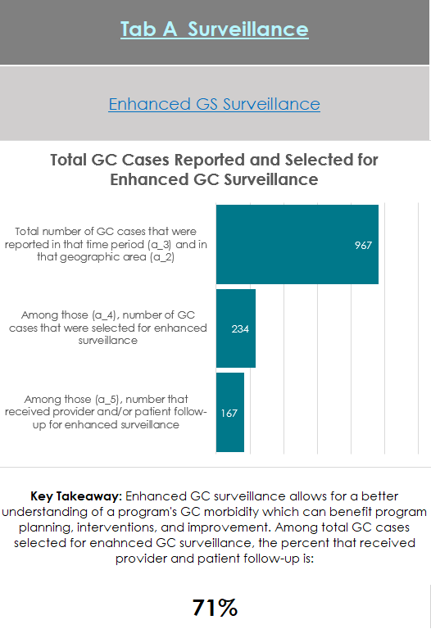
Intra-Excel Link: If you want to refer to the exact part of the template from which the data for a particular visual originated, click the link(s) above it for the tab and section, respectively.
Key Takeaway: This is the interpretation of the graphic so you know exactly what the values in the visual mean.
Visual: This is the graphic you will copy and paste directly into your own documentation.

Note: Please keep in mind that the dashboard is organized vertically, meaning that its best and easiest use is when you scroll down for the graphics corresponding to each tab. The visuals to the right or left of another are related to another tab, so don’t focus on these or scroll horizontally until you are ready to take a deeper dive into the next tab (see below).


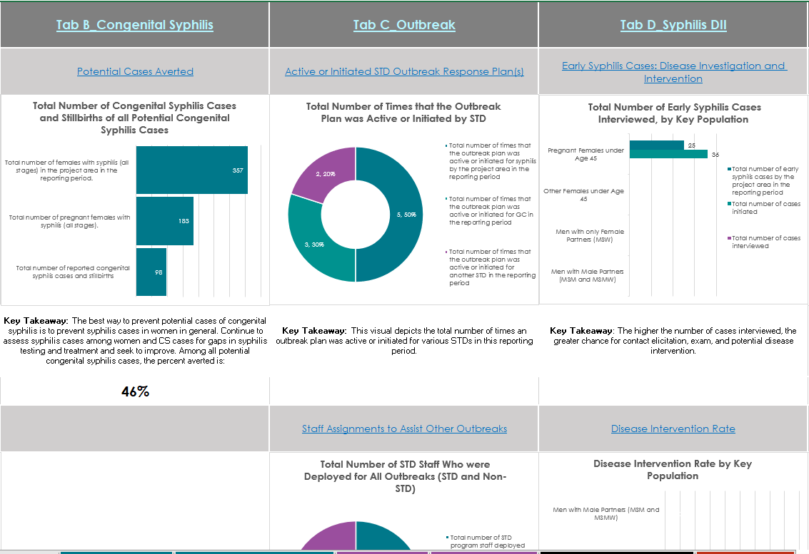

How to Obtain Visuals for Your Reports
Step 1: Copy the visual by either by right-clicking on the visual and clicking “Copy” (see picture below) or clicking the visual and using the ctrl + c keyboard shortcut.
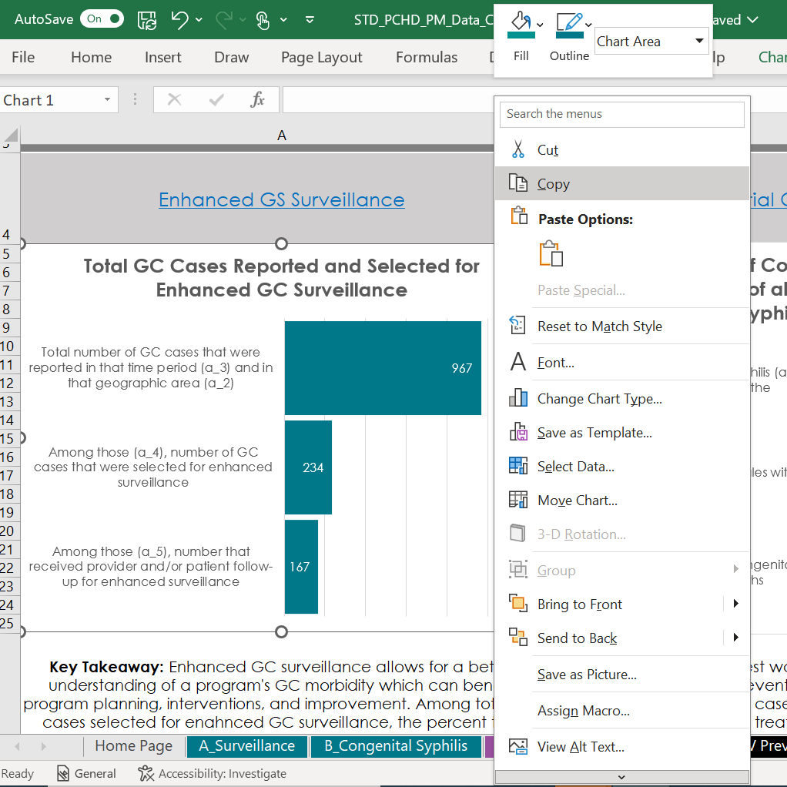
Step 2: Open another file, such as a Microsoft Word document or Microsoft PowerPoint presentation.

Step 3: Paste the visual either by right-clicking anywhere in that file and clicking "Paste" (see below) or use the ctrl + v keyboard shortcut.
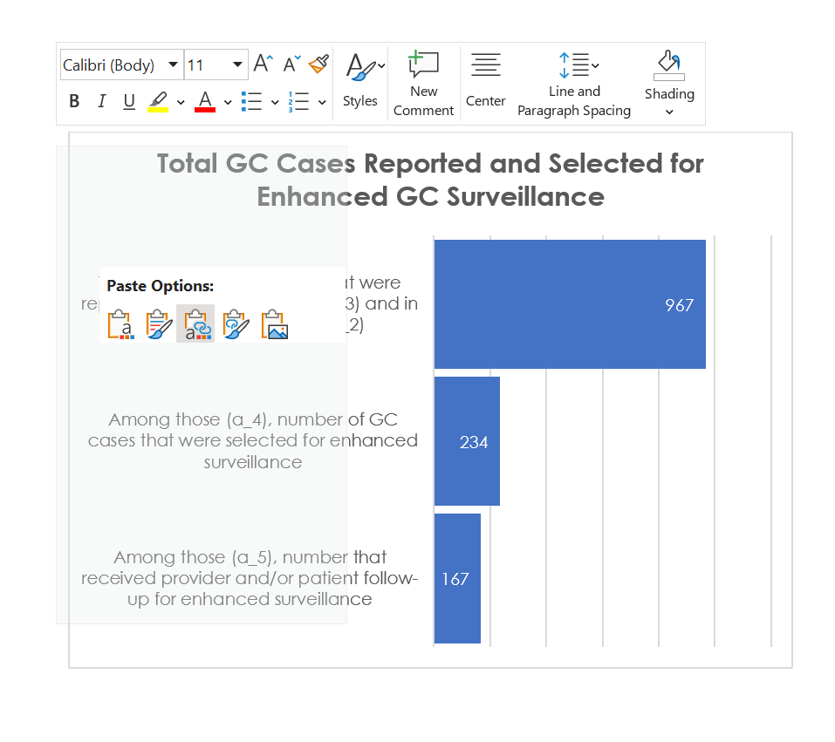

Step 4: Once pasted, choose the format and type of object (e.g. Microsoft Office Graphic Object vs .JPEG picture, etc.) of the visual as you would like it pasted into your document or presentation (see Step 3 above). If you used the ctrl + v keyboard shortcut, click the dropdown next to the clipboard icon labeled "Ctrl" (see below). Alternatively, use the ctrl + alt + v keyboard shortcut in Step 3 and these options will be shown automatically in list form (see below).
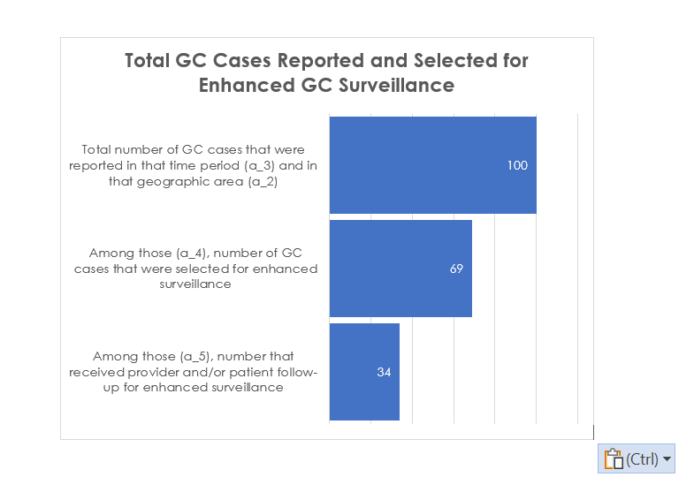
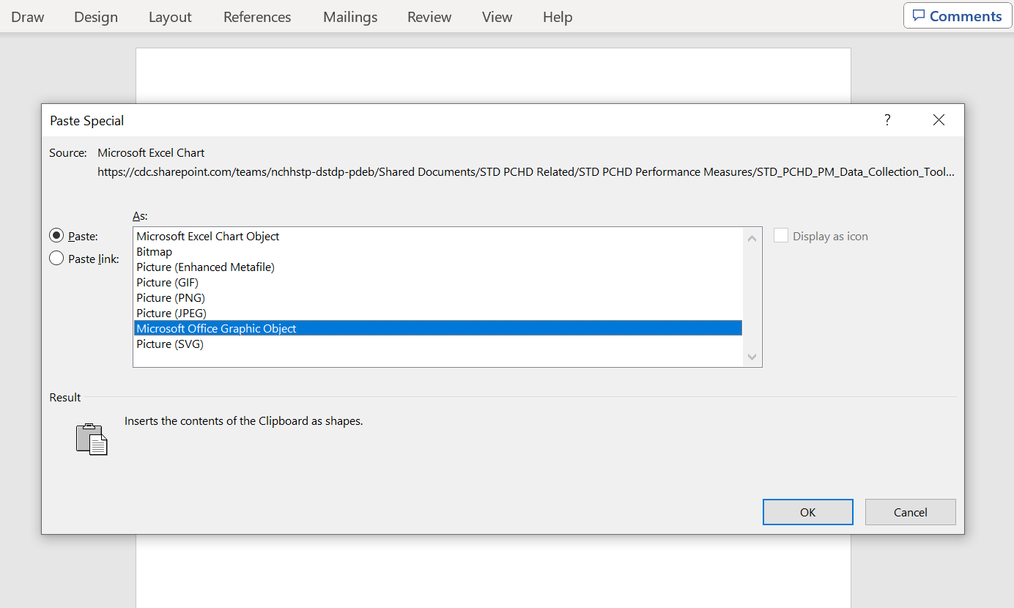

FEEDBACK
This section is optional for completion, but the STD PCHD Team would highly appreciate your comments regarding the updates to the PM Data Collection Template, especially regarding the new UI improvements, data validation measures, and Dashboard tab. Thank you in advance! 😊

