I. OTHER CIRCUMSTANCES OF INCIDENT - ANSWER RELEVANT SECTIONS
I1. SUDDEN AND UNEXPECTED DEATH IN THE YOUNG (SDY) This section displays online based on your state's settings.
Section I1: OMB No. 0920-1092, Exp. Date: 9/30/2025
Public reporting burden of this collection of information is estimated to average 10 minutes per response, including the time for reviewing instructions, searching existing data sources, gathering and maintaining the data needed, and completing and reviewing the collection of information. An agency may not conduct or sponsor, and a person is not required to respond to a collection of information unless it displays a currently valid OMB control number. Send comments regarding this burden estimate or any other aspect of this collection of information, including suggestions for reducing this burden to: CDC/ATSDR Reports Clearance Officer; 1600 Clifton Road NE, MS D-74, Atlanta, Georgia 30333; ATTN: PRA (0920-1092)
a. Was this death:A homicide?
A suicide?
An overdose?If any of these apply, go to Section I2,
A result of an external cause that was the obvious and only reason for the fatal injury?THIS IS NOT AN SDY CASE.
Expected within 6 months due to terminal illness?
None of the above, go to I1b THIS IS AN SDY CASE
U/K, go to I1b
b. Did the child have a history of any of the following acute conditions | c. At any time more than 72 hours preceding death did the child have a personal
or symptoms within 72 hours prior to death? | history of any of the following chronic conditions or symptoms?
Symptom Present w/in 72 hours of death | Symptom Present more than 72 hours of death
Cardiac Yes No U/K | Cardiac | Yes No U/K
Chest pain | Chest pain
Dizziness/lightheadedness | Dizziness/lightheadedness
Fainting | Fainting
Palpitations | Palpitations
Neurologic | Neurologic
Concussion | Concussion
Confusion | Confusion
Convulsions/seizure | Convulsions/seizure
Headache | Head injury
Head injury | Respiratory
Respiratory | Difficulty breathing
Asthma | Other
Pneumonia  Difficulty breathing  Other Acute Symptoms | Other, specify:
Pneumonia  Difficulty breathing  Other Acute Symptoms | d. Did the child have any prior serious injuries (e.g. near drowning, car
Fever | accident, brain injury)?
Muscle aches/cramping | No U/K  Yes
Vomiting  Other, specify: | If yes, describe:
e. Had the child in the past ever been diagnosed by a medical professional for the following?
Condition Diagnosed Condition Diagnosed Condition Diagnosed

Blood disease Y N UNeurologic (continued) Y N U
Cardiac (continued)
Y
N

U

High cholesterol
Hypertension
Myocarditis (heart infection)
Pulmonary hypertension
Sudden cardiac arrest
Neurologic
Y
N

U
Anoxic brain Injury
Traumatic brain injury/
head injury/concussion
Br
ain tumor
Brain hemorrhage
Developmental brain disorder
Epilepsy/seizure disorder
Febrile seizure
Sickle cell disease Neurodegenerative disease
Sickle cell traitStroke/mini stroke/
Thrombophilia (clotting disorder) TIA-Transient Ischemic
Cardiac Y N UAttack
Abnormal electrocardiogram Central nervous system
(EKG or ECG)infection (meningitis
Aneurysm or aortic dilatation or encephalitis)
Arrhythmia/arrhythmia syndrome Respiratory Y N U
Cardiomyopathy Apnea
Congenital heart disease Asthma
Coronary artery abnormalityPulmonary embolism
EndocarditisPulmonary hemorrhage
Heart failureRespiratory arrest
Heart murmur
Page 15 of 24

Diabetes
Condition (continued)
Diagnosed
Diagnosed
Diagnosed
Other
Y

N

U
Y

N
U

Y

N

U
Connective tissue disease
Kidney disease
Oncologic disease treated by
Mental illness/psychiatric disease
chemotherapy or radiation
Endocrine disorder, other:
Metabolic disease
Prematurity
thyroid, adrenal, pituitary
Muscle disorder or muscular
Congenital disorder/
Hearing problems or deafness
dystrophy
genetic syndrome
Other, specify:
If a more specific diagnosis is known, provide any additional information:
If any cardiac conditions above are selected, what cardiac treatments did the child have? Check all that apply:
None
Cardiac ablation
Heart surgery
Heart transplant
Cardiac device placement
Interventional cardiac
Other, specify:
(implanted cardioverter defibrillator (ICD)
catheterization
U/K
or pacemaker or Ventricular Assist Device (VAD))
f. Did the child have any blood relatives (brothers, sisters, parents, aunts, uncles, cousins, grandparents or other more distant |  |  | g. Has any blood relative (siblings,
relatives) with the following diseases, conditions or symptoms? |  |  | parents, aunts, uncles, cousins,
Y N U Deaths |  |  | grandparents) had genetic
Sudden unexpected death before age 50 |  |  | testing?
If yes, the type of event, which relative, and relative’s age at death (for example, brother at age 30 who died |  |  | Yes No U/K
in an unexplained motor vehicle accident (driver of car)):  Heart Disease Y N U Symptoms |  |  | If yes, describe the test/gene
Heart condition/heart attack or stroke before age 50 Febrile seizures |  |  | tested, reason for testing, family
If yes, describe: Unexplained fainting |  |  | member tested, and results:
Aortic aneurysm or aortic rupture Other Diagnoses  Arrhythmia (fast or irregular heart rhythm) Congenital deafness  Cardiomyopathy Connective tissue disease  Congenital heart diseaseMitochondrial disease  Neurologic DiseaseMuscle disorder or muscular dystrophy |  |  | Was a gene mutation found?
Epilepsy or convulsions/seizureThrombophilia (clotting disorder)  Other neurologic diseaseOther diseases that are genetic or  run in families, specify: |  |  | Yes No U/K
h. In the 72 hours prior to death was the child taking any prescribed |  | k. Was the child taking any of the following substance(s) within 24 hours of death?
medication(s)? Yes No U/K |  | Check all that apply:
If yes, describe: |  | Over-the-counter medicineAlcohol  Energy drinksIllegal drugs
i. Within 2 weeks prior to death had the child: | N/A Yes No U/K
Taken extra doses of prescribed medications |  | Caffeine Legalized marijuana
Missed doses of prescribed medications |  | Performance enhancers Other, specify:
Changed prescribed medications, describe: |  | Supplements  Tobacco U/K
j. Was the child compliant with their prescribed medications?
N/A Yes No U/K  If not compliant, describe why and how often: |  | If yes to any items above, describe:
l. Did the child experience any of the following stimuli at time of incident or within 24 hours of the incident? At incident Within 24 hrs of incident
Stimuli Yes No U/K Yes No U/K
Physical activityIf yes to physical activity, describe type of activity:
Sleep deprivationAt incident Within 24 hours of incident
Driving
Visual/video game stimuli
Emotional stimuli
Auditory stimuli/startle
Physical traumaOther specify:
Other, specify:At incident Within 24 hours of incident
m. Was the child an athlete? N/A Yes No U/K
If yes, type of sport: Competitive Recreational U/K
If competitive, did the child participate in the 6 months prior to death? Yes No U/K
n. Did the child ever have any of the following uncharacteristic symptoms |  |  |  | o. For child age 12 or older, did the child receive a pre-participation exam
during or within 24 hours after physical activity? Check all that apply: |  |  |  | for a sport? N/A Yes U/K  No
Chest pain Palpitations |  |  |  | If yes:
Convulsions/seizure Shortness of breath/difficulty breathing |  |  |  | Was it done within a year prior to death? Yes No U/K
Dizziness/lightheadedness Other, specify: |  |  |  | Did the exam lead to restrictions for sports or otherwise?
Fainting U/K |  |  |  | Yes No U/K
If yes to any item, describe type of physical activity and extent of symptoms: |  |  |  | If yes, specify restrictions:
Questions p through v: Answer if "Epilepsy/Seizure Disorder" is answered Yes in question e above (Diagnosed for a medical condition)
p. How old was the child when diagnosed with epilepsy/seizure disorder?  Age 0 (infant) through 20 years:  U/K |  | r. What type(s) of seizures did the child have? Check all that apply:  Non-convulsive  Convulsive (grand mal seizure or generalized tonic-clonic seizure)  Occur when exposure to strobe lights, video game, or flickering light (reflex seizure)  U/K |  |  |  | t. How many seizures did the child have in the year preceding death?  0/never 2More than 3  13U/K
q. What were the underlying cause(s) of the child’s seizures? Check all that apply:  Brain injury/trauma, Other acute illness or  specify: injury other than  Brain tumor epilepsy  CerebrovascularOther, specify:  Central nervous system  infection U/K  Developmental brain disorder  Genetic/chromosomal  Idiopathic or cryptogenic |  |  |  |  |  | u. Did treatment for seizures includ anti-epileptic drugs?  U/K  Yes  No  If yes, how many different types of antiepileptic drugs did the child  14 25  36 | e  take?  More than 6  U/K
 |  | s. Describe the child's epilepsy/seizures (not including the seizure at time of death). Check all that apply:  Last less than 30 minutes  Last more than 30 minutes (status epilepticus)  Occur in the presence of fever (febrile seizure)  Occur in the absence of fever  Occur when exposed to strobe lights, video game, or flickering light (reflex seizure) |  |  |  |  | e  take?  More than 6  U/K
v. Was night surveillance used?
Yes No U/K
I2. ANSWER THIS ONLY IF CHILD IS UNDER AGE FIVE:
Yes, go to I2a No, go to I2tU/K, go to I2a WAS DEATH RELATED TO SLEEPING OR THE SLEEP ENVIRONMENT⁺?
a. Incident sleep place:
Adult bedRocking-inclinedIf adult bed, what type? If car seat, was car seat
If crib, type:WaterbedsleeperTwin secured in seat of car?
Crib
Not portable Futon Stroller Full Yes No U/K
PortableCouchSwingQueen
Unknown crib typeChairBouncy chairKing
BassinetFloorOther, specify:Other, specify:
Bed side sleeperCar seatU/KU/K
Baby box
b. Child put to sleep: On back  On stomach  On side  U/K | c. Child found:  On back  On stomach  On side  U/K |  | e. Usual sleep position: On back  On stomach  On side  U/K |  | f. Was there any type of crib, portable crib or bassinet in home for child?  Yes No U/K
d. Usual sleep place:
Adult bedRocking-inclinedIf adult bed, what type?
If crib, type:WaterbedsleeperTwinKing
Not portableFutonStrollerFullOther, specify:
PortableCouchSwingQueenU/K
Unknown crib typeChairBouncy chair
BassinetFloorOther, specify:
Bed side sleeperCar seatU/K
Crib
Baby box
g. Child in a new or different environment than usual?  Yes No U/K  If yes, describe why: |  | h. Child last placed to sleep with a pacifier?  Yes No U/K |  |  | i. Child wrapped or swaddled in blanket when last placed?  Yes No U/K  If yes, describe:
Page 17 of 24

j. Child overheated? Yes No U/K |  |  |  | k. Child exposed to second hand smoke?
Check all that apply: Room too hot, temp ____ degrees F |  |  |  | Yes No U/K
Too much bedding |  |  |  | If yes, how often: Frequently U/K
Too much clothing |  |  |  | Occasionally
l. Child's face when found:  Down  Up  To left or right side  U/K | m. Child's neck when found:  Hyperextended (head back)  Hypoextended (chin to chest)  Neutral  Turned  U/K | n. Child's airway when found (includesIf fully or partially obstructed, what was obstructed? nose, mouth, neck and/or chest):NoseChest compressed  Unobstructed by person or objectMouthU/K  Fully obstructed by person or objectNeck compressed  Partially obstructed by person orIf fully or partially obstructed, describe obstruction in objectdetail:  U/K
o. Objects in child's sleep environment and relation to airway obstruction:
If present, describe position of object: If present, did object
Objects: Present? On top Under Next Tangled obstruct airway?
Yes No U/K of child child to child around child U/K Yes No UK
Adult(s)If adult(s) obstructed
Other child(ren)airway, describe relation-
Animal(s)ship of adult to child (for
Mattressexample, childbearing
Comforter, quilt, or otherparent):
Fitted sheet
Thin blanket/flat sheet
Pillow(s)
Cushion
Nursing or U shaped pillow
Sleep positioner (wedge)
Bumper pads
Clothing
Bottle
Wearable monitor
Crib railing/side
Wall
Toy(s)
Other(s), specify:
__________________ __________________
p. Was there a reliable, non-conflicting witness account of how the child was found? Yes No U/K
q. Caregiver/supervisor fell asleep while feeding child?  Yes No U/K  If yes, type of feeding: Bottle Breast U/K |  |  | r. Child sleeping in the same room as caregiver/supervisor at time of death?  Yes No U/K
s. Child sleeping on same If yes, reasons stated for sleeping on If yes, check all that apply: surface with person(s) or same surface, check all that apply:With adult(s): # _______
# U/K
Yes
No
# U/K
# U/K
animal(s)?To feedAdult obese: U/K
Yes No U/K To soothe With other children: # _____ Children's ages: _________
Usual sleep patternWith animal(s): # _______ Type(s) of animal: ________
No infant bed availableU/K
Home/living space overcrowded Other, specify:
U/K
t. Is there a scene re-creation photo available for upload? Yes No If yes, upload here. Only one photo allowed.
Select photo that demonstrates position and location of child’s body and airway (nose, mouth, neck, and chest). Size must be less than 6 mb and in .jpg or .gif format.
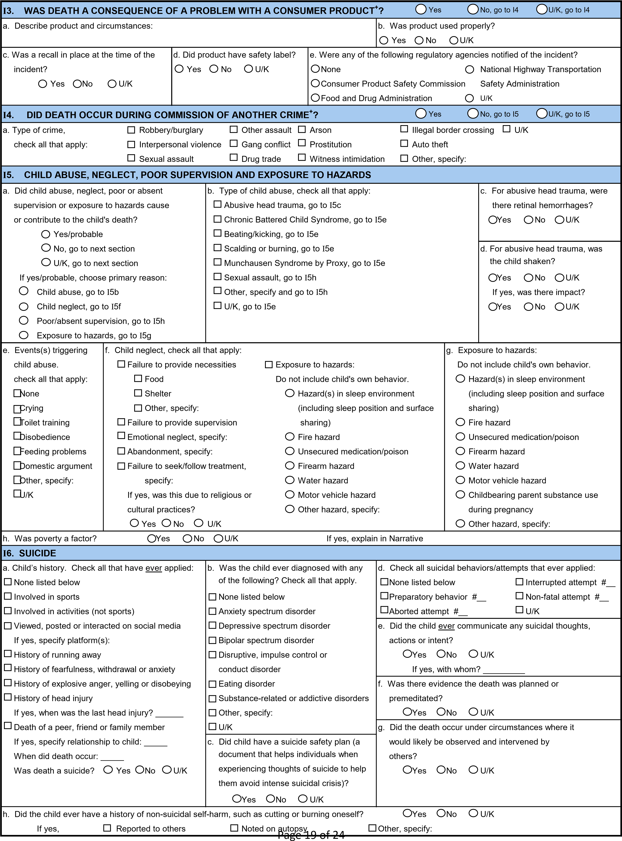
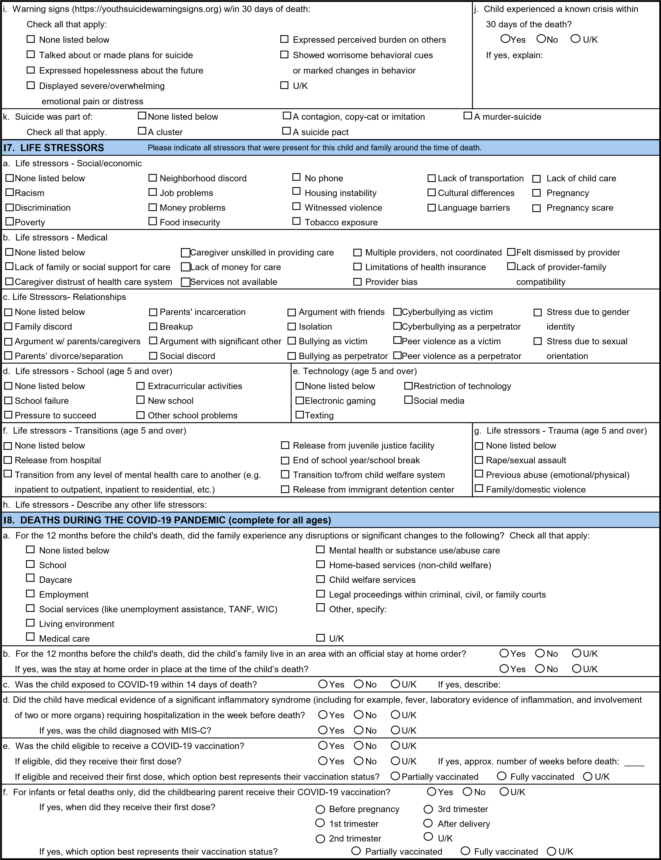
g. Select the one option that best describes the impact of COVID-19 on this child’s death: |  |  |  |  |  | h. Did COVID-19 impact the team’s ability to conduct this fatality review?
COVID-19 was the immediate or underlying cause of death |  |  |  |  |  | Yes No U/K
COVID-19 was diagnosed at autopsy or child was suspected to have COVID-19 |  |  |  |  |  | If yes, check all that apply:
COVID-19 indirectly contributed to the death but was not the immediate or |  |  |  |  |  | Unable to obtain records
underlying cause of death |  |  |  |  |  | Team members unable to attend review
The childbearing parent contracted COVID-19, specify: |  |  |  |  |  | Remote reviews negatively impacted review process
Before pregnancy3rd trimester  1st trimesterAfter delivery  2nd trimesterU/K  Other, specify:  COVID-19 had no impact on this child's death  U/K |  |  |  |  |  | Team leaders redirected to COVID-19 response
J. PERSON RESPONSIBLE (OTHER THAN DECEDENT) This section is skipped for fetal deaths⁺
1. Did a person or persons other than the |  | 2. What act(s)? Enter information for the first person under "One" and if |  |  |  |  |  |  | 3. Did the team have information
child do something or fail to do |  | there is a second person, use column "Two." Describe acts in narrative. |  |  |  |  |  |  | about the person(s)?
something that caused or contributed |  | One Two One Two |  |  |  |  |  |  | One Two
to the death? |  | Child abuse Exposure to hazards |  |  |  |  |  |  |  | Yes
Yes/probable |  | Child neglect Assault, not child abuse |  |  |  |  |  |  |  | No, go to K
No, go to K |  | Poor/absent Other, specify:
U/K, go to K |  | supervision U/K
4. Is person listed in a previous section? |  |  | 5. Primary person(s) responsible for action(s): Select one for each person respo |  |  |  |  |  |  | nsible.
One Two |  |  | One Two |  | One Two |  |  |  | One | Two
Yes, childbearing parent, go to J17 |  |  | Adoptive parent |  | Sibling |  |  |  |  | Medical provider
Yes, non-childbearing biological |  |  | Stepparent |  | Other relative |  |  |  |  | Institutional staff
parent, go to J17 |  |  | Foster parent |  | Friend |  |  |  |  | Babysitter
Yes, caregiver one, go to J17 |  |  | Parent's partner |  | Acquaintance |  |  |  |  | Licensed child care
Yes, caregiver two, go to J17 |  |  | Grandparent |  | Child's boyfriend or |  |  |  |  | worker
Yes, supervisor, go to J19 |  |  |  |  | girlfriend |  |  |  |  | Other, specify:
No |  |  |  |  | Stranger |  |  |  |  | U/K
6. Person's age in years: | 7. Person's sex: |  |  | 8. Person speaks and understands English? |  |  |  | 9. Person on active military duty?
One Two | One Two |  |  | One Two |  |  |  | One Two
 | Male |  |  | Yes |  |  |  | Yes
# Years | Female |  |  | No |  |  |  | No
U/K | U/K |  |  | U/K |  |  |  | U/K
 |  |  |  | If no, language spoken: |  |  |  | If yes, specify branch:
10. Person(s) have history of | 11. Person(s) have history of child |  |  | 12. Person(s) have history of child |  |  |  | 13. Person(s) have disability or chronic
substance abuse? | maltreatment as victim? |  |  | maltreatment as a perpetrator? |  |  |  | illness?
One Two | One Two |  |  | One Two |  |  |  | One Two
Yes | Yes |  |  | Yes |  |  |  | Yes
No | No |  |  | No |  |  |  | No
U/K | U/K |  |  | U/K |  |  |  | U/K
14. Person(s) have prior | 15. Person(s) have history of intimate partner violence? |  |  |  |  |  | 16. Person(s) have delinquent/criminal history?
child deaths? | One Two |  |  |  |  |  | One Two
One Two | Yes, as victim |  |  |  |  |  | Yes
Yes | Yes, as perpetrator |  |  |  |  |  | No
No | No |  |  |  |  |  | U/K
U/K | U/K
17. At the time of the incident, was the person asleep? One Two
One Two If yes, select the most appropriate Night time sleep
Yes description of the person's sleeping Day time nap, describe:
No period at incident:Day time sleep (for example, person is night shift worker), describe:
U/KOther, describe:
Page 21 of 24

