Justification for No material or Non-substantive Change to Currently Approved Collection

AGENCY: Employee Benefits Security Administration (EBSA)
TITLE: Benefits Advisor Intake Form “Request Assistance from a Benefits Advisor”
STATUS: OMB Control Number: 1210-0146 Exp. Date: 04/30/2027

The Department of Labor is submitting a request for a no material/non-substantive change to the web form used to seek assistance from an Employee Benefits Security Administration Benefits Advisor. These enhancements aim to streamline the form and reduce the amount of data required from the public.
The proposed changes will make the form clearer and more efficient by eliminating the need for four separate tabs of information currently in use. It will perform a search to prevent duplicate entries, allow users to update their submissions, and facilitate requests for new issues. Furthermore, several response options provide immediate on-screen assistance. The form is designed to automatically route and respond based on selected input, enabling opportunities for prompt resolutions.
Key features of the updated form include:
- Simplified Navigation: A single, consolidated form replaces multiple tabs, enhancing user experience.
- Duplicate Request Prevention: Searches will ensure no duplicate records are created, from submissions made from call received on the toll-free line and submitted through the web form.
- Update Capability: Submitters can easily update their existing open submission(s).
- Immediate Assistance: Certain response options will deliver instant on-screen help.
Users can choose one of six options to summarize their issue, which initiates an internal system scan for any existing inquiries. If relevant, the system will prompt details on an existing inquiry and/or open a new ticket, providing on-screen confirmation:
- COBRA Continuation Health Coverage: Inquiry option for questions about COBRA benefits.
- Health Plan Assistance: For help with health plan-related queries.
- Retirement Plan Help: Addresses assistance needs concerning retirement plans.
- Other Employee Benefit Plans: Covers inquiries not mentioned above.
For those who receive a Social Security notice about potential retirement benefits and need more information, the form presents a yes/no option:
- Plan Number: Users are asked if they have the plan number from the notice.
  - If No: They can add details about their question and submit their request for a benefits advisor to contact them within three business days.
  - If Yes: They will be prompted to enter the plan number, initiating a search.
    - Plan Found: Instant on-screen information will be provided, along with an email copy and an option to print a screen-friendly version.
    - Plan Not Found: Their request will be submitted for a benefits advisor to contact them within three business days.
- Additionally, users who wish to opt out of the Lost & Found Retirement Savings database (RSLFDB) can select this option to ensure their information is removed. If they decide to opt back in, they can do so by logging into the RSLFDB.
This revised format minimizes the effort required to input data and efficiently manages responses based on the information provided.
By introducing these improvements, the Department of Labor aims to enhance the user experience and ensure timely assistance for all inquiries regarding benefits advisement.

Current Form
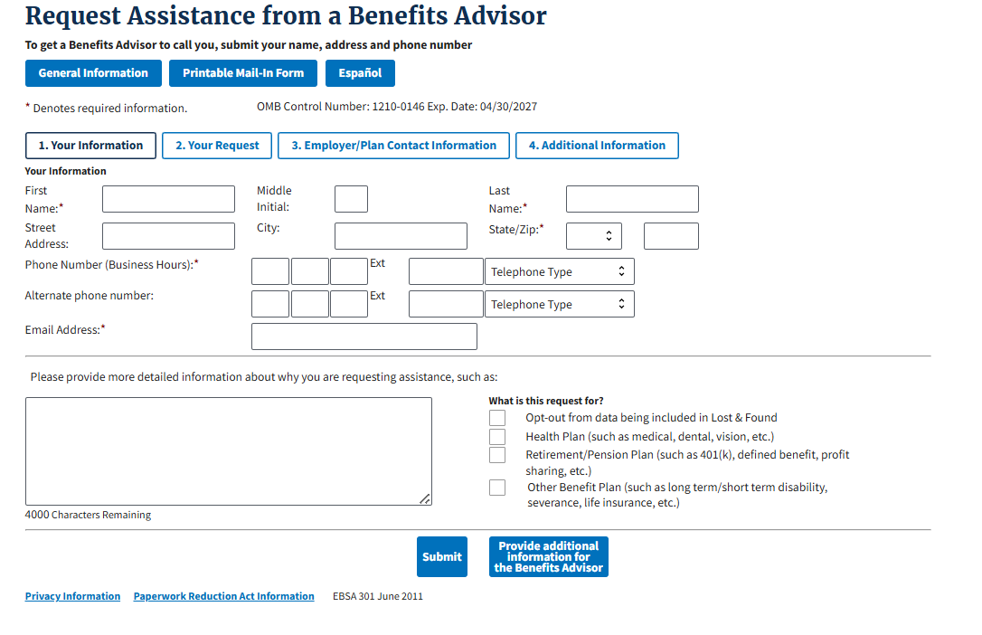
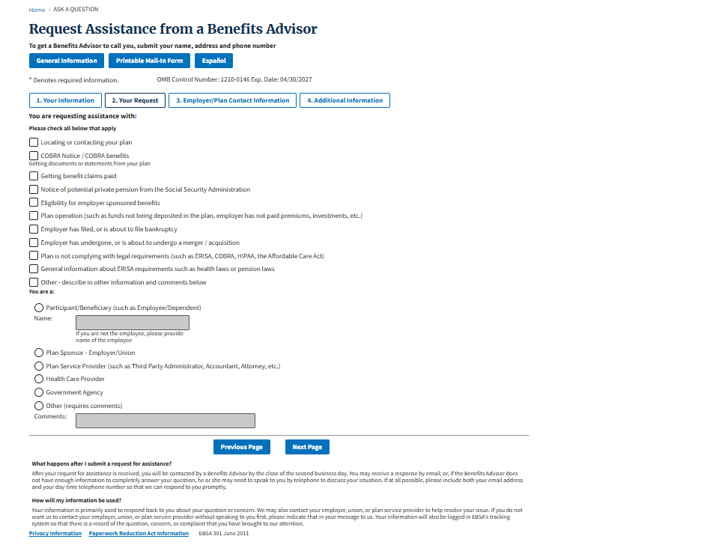
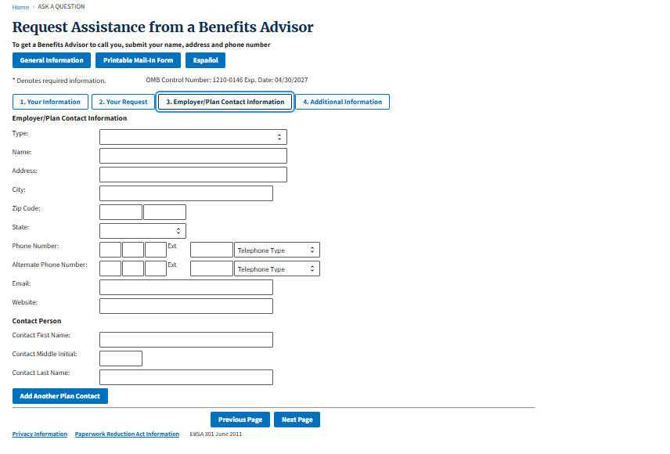
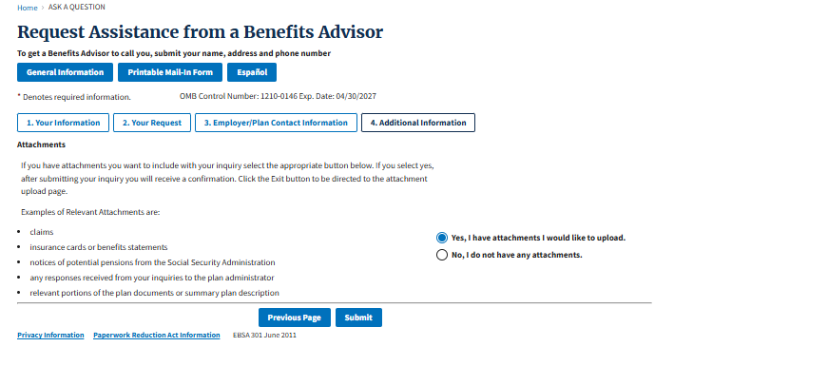

New Enhanced Form
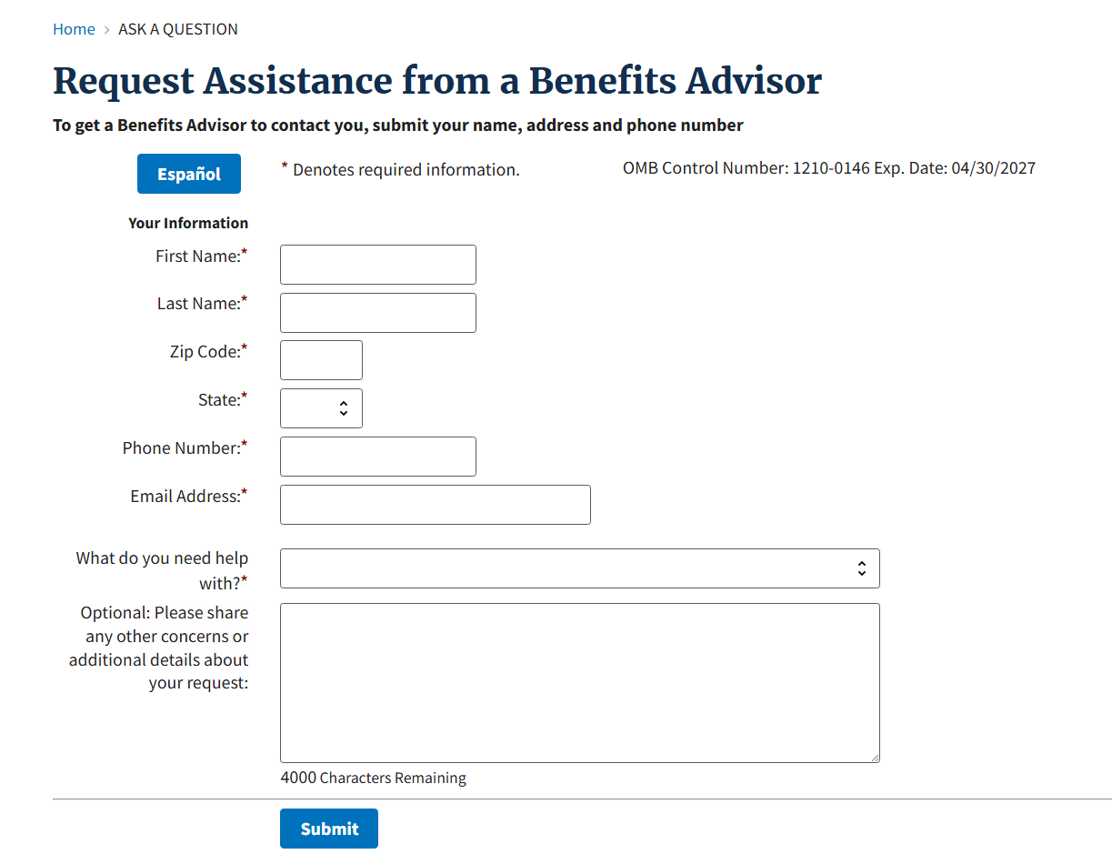
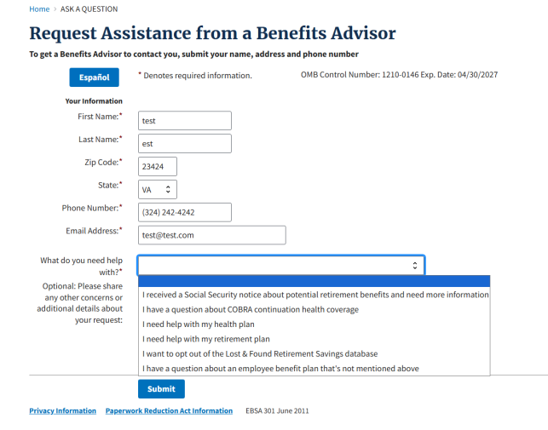

For all selected options (except the opt out) if submitter has an open inquiry – they will receive this screen.
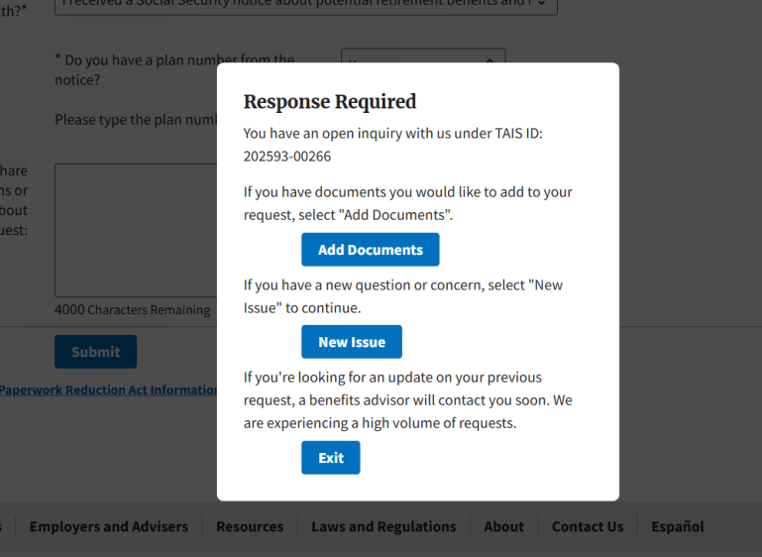
If there is no open inquiry and they select any option but (the opt out, or the SSA notice), they will receive this confirmation screen.
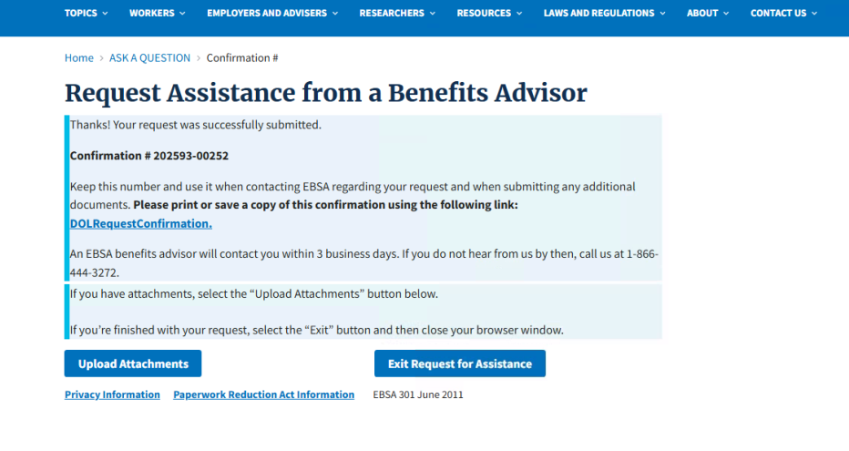Exit confirmation - after they selected Exit Request for Assistance.
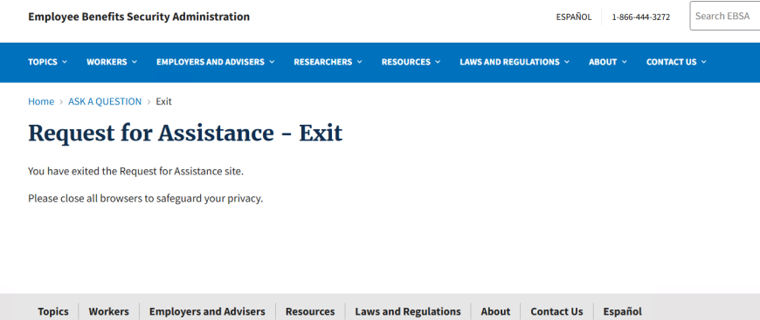
If submitter selected the SSA notice, they would get these screens:
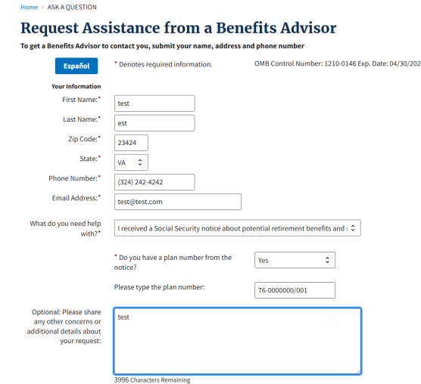
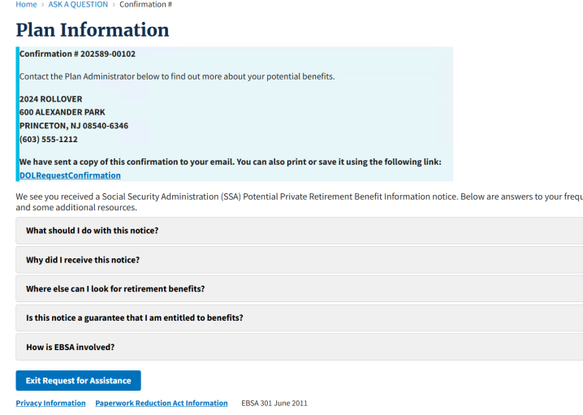
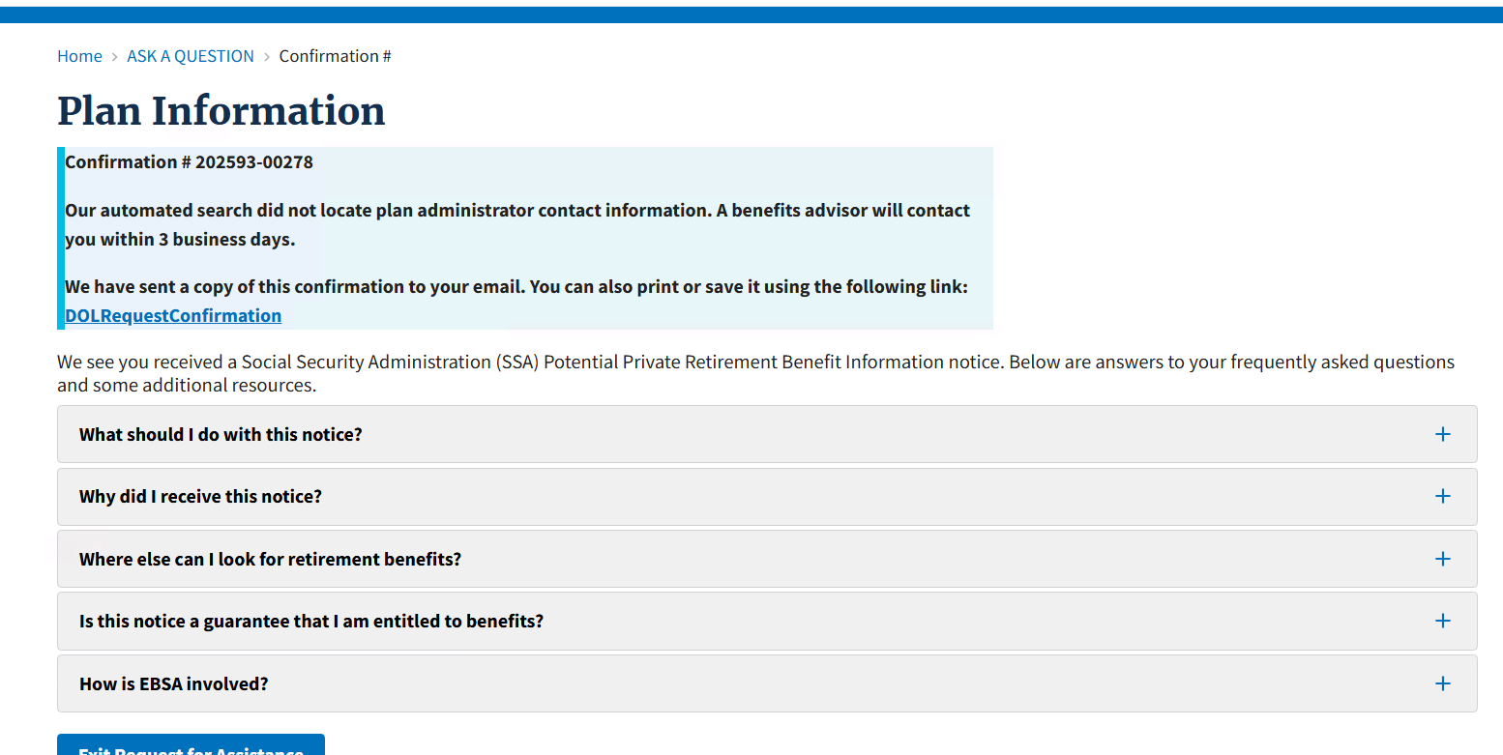
If opt out was selected – these screens will appear. Important note: This is how the form operates now for this selection.
