**Data items collected by the eGov Gasoline Tax Exemption request but not collected by the DS-99 Form;**

1. **Date of Birth**
2. **Personal Address**

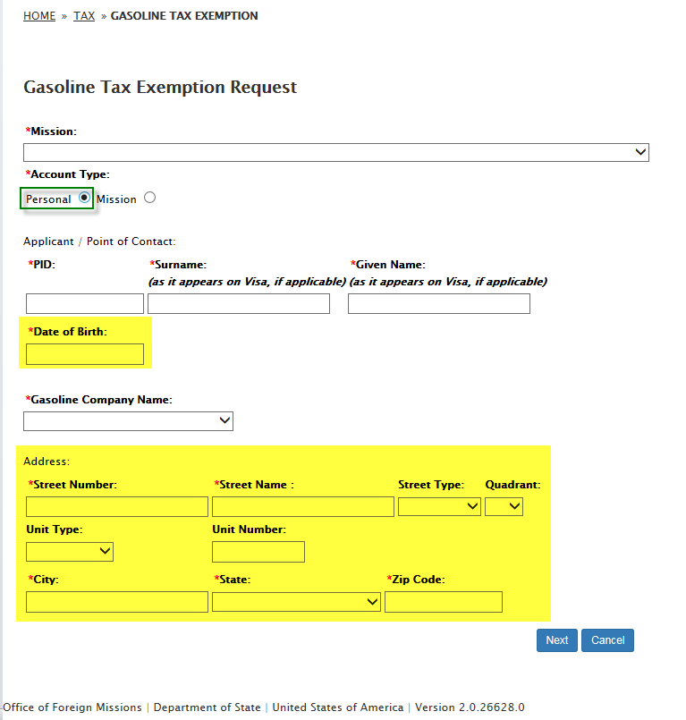

1. **Mission Property Address**

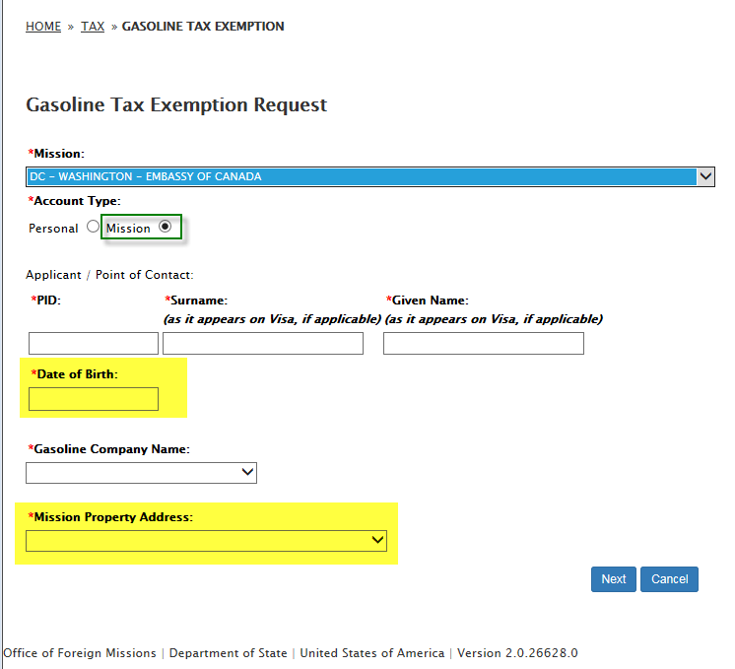

1. **Gasoline company business or fleet credit card application document**

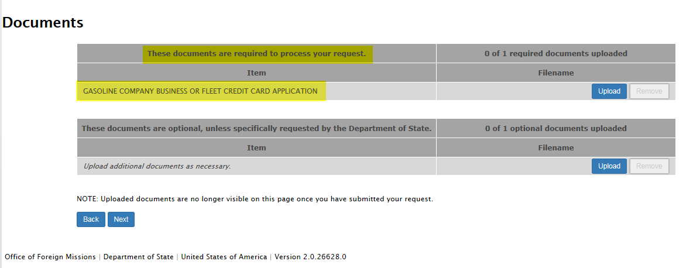

1. **Remarks**

