Data items collected by the eGov White House Tours (Chief of Mission Tour) request but not collected by the DS-4284 Form;

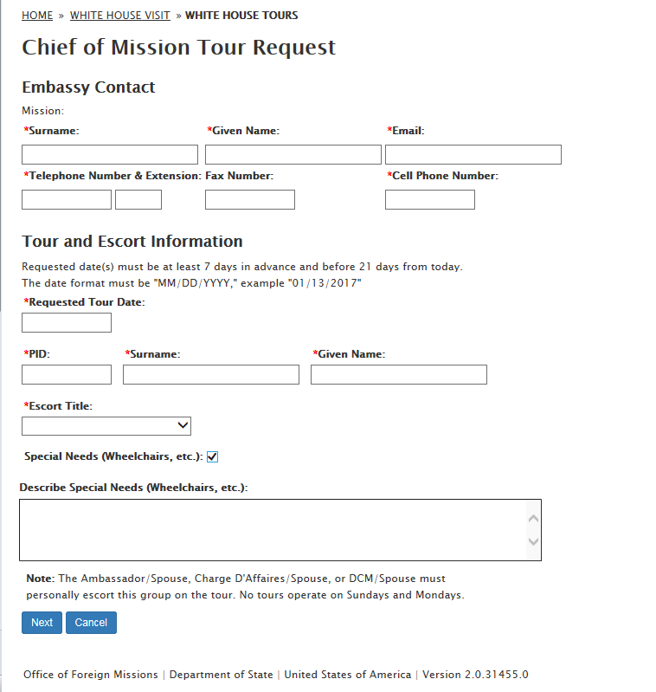

Tour Information section / Visitor List page
DS-4284 | eGov page
Number of People (1-6) | Please add up to five visitors

Add Visitor dialog box input field label text:
Input Field | DS-4284 Text | eGov page Text
Visitor location, City | City you're staying in the U.S. (example: Atlanta) | City living in United States:
Visitor location, State | State you're staying in the U.S. (example: Georgia) | State living in United States:

- Add Visitor:
  - Citizenship Status: Foreign National
    - Country of Origin
    - Passport Number
  - Citizenship Status: Legal Resident & United States Citizen
    - Social Security Number
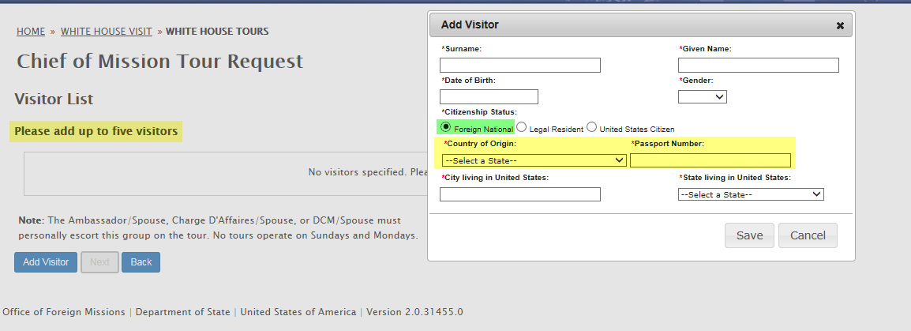
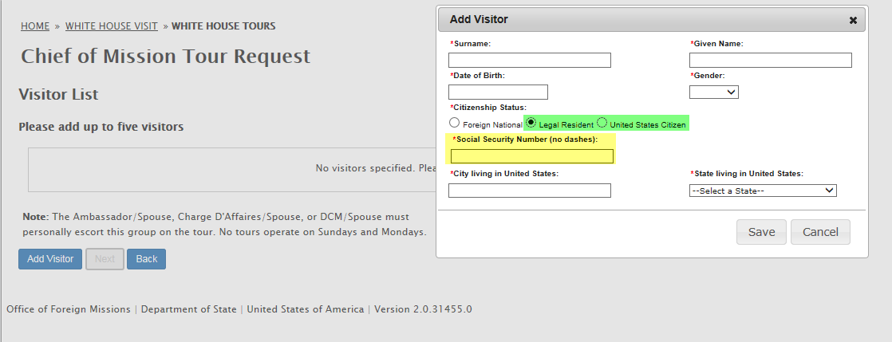
- Remark
- Agree with Disclaimer
