August 11, 2025

Non-substantive Change Justification Statement for
OMB Control Number 1513–0017, Drawback on Beer Exported

Under the Internal Revenue Code of 1986 (IRC) at 26 U.S.C. 5051, all beer produced in or imported into the United States is subject to a Federal excise tax, but, under 26 U.S.C. 5053(a), beer exported from the United States is not subject to that tax. As such, under the IRC at 26 U.S.C. 5055, brewers may receive drawback (refund) of the excise tax paid on domestically produced beer when it is subsequently exported or delivered for use as supplies on certain vessels or aircraft if the brewer provides proof of such action as the Secretary of the Treasury requires by regulation.
Among other things, the Alcohol and Tobacco Tax and Trade Bureau (TTB) administers chapter 51 (distilled spirits, wine, and beer) of the IRC pursuant to section 1111(d) of the Homeland Security Act of 2002, as codified at 6 U.S.C. 531(d). Under the authority of 26 U.S.C. 5055, the TTB regulations in 27 CFR Part 28, Exportation of Alcohol, allow a brewer or a brewer’s agent to file a claim for drawback of the excise taxes paid on beer that is subsequently exported. Under those regulations, “export” includes exportation to a foreign country or to U.S. armed forces stationed overseas, for use as supplies on certain vessels or aircraft, and transfers to a foreign trade zone for subsequent exportation.
Specific to this information collection, approved under OMB control number 1513–0017, the TTB regulations at 27 CFR 28.221, 28.222, 28.225, 28.226, and 28.227 require brewers or their agents to make such claims on form TTB F 5130.6, Drawback on Beer Exported. This form identifies the claimant, documents the beer exported and the amount of tax claimed for drawback, and certifies the beer’s exportation, receipt by the U.S. armed forces for export, or lading as supplies on a vessel or aircraft.
On March 25, 2025, the President issued an Executive Order, “Modernizing Payments To and From America’s Bank Account,” which was published in the Federal Register as E.O. 14247 on March 28, 2025, at 90 FR 14001. As a cost-saving and theft-prevention measure, the Executive Order requires, in general, that the Secretary of the Treasury cease issuing paper checks for all Federal disbursements, benefit payments, vendor payments, and tax refunds, and to make such payments via direct deposit or other electronic methods, effective September 30, 2025.
In response to E.O. 14247, TTB is revising form TTB F 5130.6 to add Items 14c, 14d, and 14e, which will allow the respondent to select payment of the claimed excise tax drawback either by direct deposit to a checking or savings account or as a credit to be taken on their alcohol excise tax return, and, if the respondent selects the direct deposit option, supply their direct deposit routing number and bank account number.
TTB believes that these changes to TTB F 56130.6 made in response to E.O. 14247 do not affect this information collection’s per-respondent or total annual burden. The addition of new Items 14c, 14d, and 14e merely require information that is already known by and immediately available to the respondent. These changes do not introduce new concepts and entail no burden other than that necessary to identify the respondent’s selection of direct deposit or credit of tax drawback payments, and the necessary routing and account numbers to allow for direct deposit of a drawback payment if the respondent selects that option. As such, TTB believes that these changes are non-substantive in nature, and we request OMB approval of the described changes to this information collection on that basis.

The figure below shows the insertion of new Items 14c, 14d, and 14e in Section II–Claim, on the revised form TTB F 5620.7 (07/2025 version). Items 1 to 14b and 15 to 38, and the form’s instructions remain the same as displayed on the previous edition of the form (01/2019 version). TTB has reduced the type size of the footnotes located at the bottom of page 1 of the form to accommodate the addition of the new items on that page of the form.

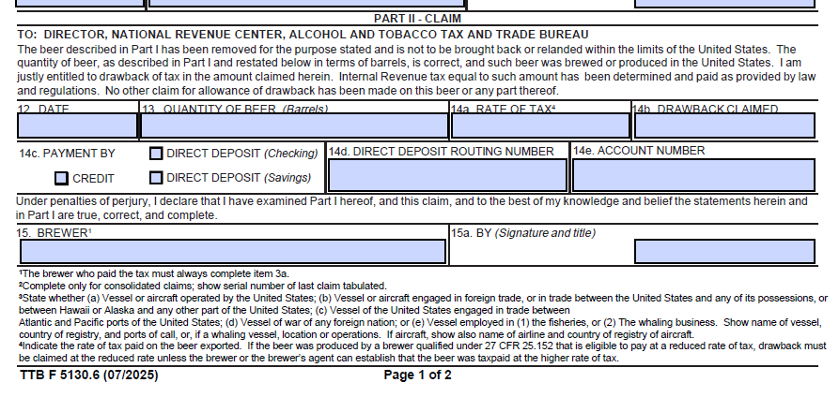

[END]

