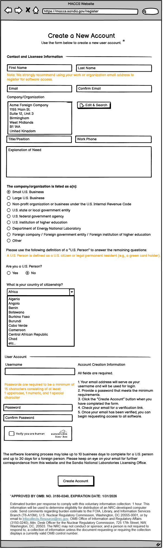

Revised Non-Disclosure Agreement (NDA) terms:

GENERIC NON-DISCLOSURE AGREEMENT FOR A
COMPUTER SAFETY CODE OF THE U.S. NUCLEAR REGULATORY COMMISSION
I understand that the conditions for receiving the MACCS Code Suite are as follows:
1. I understand that the above stated code is the result of work sponsored by an agency of the United States Government and recognizes that neither the United States Government nor any agency thereof, nor any of their employees makes any warranty, expressed or implied, or assumes any legal liability or responsibility for any third party’s use, or the results of such use, or of any information, product, or process included in or calculated by this code, or represents that the use would not infringe privately owned rights.
2. All NRC codes distributed under this Non-Disclosure Agreement are to be considered privileged information unless otherwise noted, are protected by NRC and myself respectively, and shall be treated likewise by the Parties. They are, in particular, subject to all the provisions of this Non-Disclosure Agreement prior to dissemination. The codes are subject to this protection in both object and source forms and as recorded in any media.
3. I shall not release this code to any third party, including international offices or affiliates of my organization, without obtaining prior written permission from the NRC, and the third party must also obtain in advance written permission from the NRC. Third party includes any office or affiliate of my organization that is located in a country different from the mailing address of the signing official for this Non-Disclosure Agreement.
4. Prohibited uses of the code by foreign entities include commercial use in the development of a new reactor design and commercial use in the United States unless performed by its U.S. subsidiary, or undisclosed uses in furtherance of its military.
5. I shall notify the NRC of any public safety problem as soon as possible which may be uncovered through the use of this code.
6. I shall communicate any code errors to the NRC.
7. I shall provide the NRC with any nonproprietary improvements or modifications made to this code.
8. I shall provide the NRC with a nonproprietary summary of any proprietary modifications made to this code, including a summary of the impact on representative code calculations.
9. I shall identify a modified version of the NRC code with a somewhat different name, in any report or presentation that mentions calculations made with the modified version of the NRC code.
10. I am solely responsible for obtaining any assistance needed to implement or use this code.
12. For foreign entities, NRC codes and other related analytical techniques covered under this agreement, and any improvements, modifications or updates to such codes or techniques, are for the purpose of risk assessment; materials, reactor, and plant systems safety research; radiation protection & dose assessment (RAMP); and licensing. The use of codes and techniques for other purposes require the prior consent of NRC.
13. I shall not share or loan a copy of the software to others that are not authorized to use it.
14. In no event shall the U.S. Government, nor any agency thereof, nor any representative thereof, nor my organization, nor any representative thereof, be liable for consequential, indirect, incidental, or special damages.
Notice to Federal employees only (and in accordance with the Whistleblower Protection Enhancement Act of 2012):
These provisions are consistent with and do not supersede, conflict with, or otherwise alter the employee obligations, rights, or liabilities created by existing statute or Executive order relating to (1) classified information, (2) communications to Congress, (3) the reporting to an Inspector General or the Office of Special Counsel of a violation of any law, rule, or regulation, or mismanagement, a gross waste of funds, an abuse of authority, or a substantial and specific danger to public health or safety, or (4) any other whistleblower protection. The definitions, requirements, obligations, rights, sanctions, and liabilities created by controlling Executive orders and statutory provisions are incorporated into this agreement and are controlling.

Click to Accept

