**Seeking Input on the 2025-2026 Baldrige Excellence Framework**

February 13, 2024

Share

[Facebook](https://www.facebook.com/share.php?u=https://www.nist.gov/news-events/news/2024/02/seeking-input-2025-2026-baldrige-excellence-framework)

[Linkedin](https://www.linkedin.com/shareArticle?mini=true&url=https://www.nist.gov/news-events/news/2024/02/seeking-input-2025-2026-baldrige-excellence-framework&source=https://www.nist.gov/news-events/news/2024/02/seeking-input-2025-2026-baldrige-excellence-framework)

[X.com](https://x.com/intent/tweet?url=https://www.nist.gov/news-events/news/2024/02/seeking-input-2025-2026-baldrige-excellence-framework&status=https://www.nist.gov/news-events/news/2024/02/seeking-input-2025-2026-baldrige-excellence-framework)

[Email](mailto:?subject=NIST.gov&body=Check%20out%20this%20site%20https://www.nist.gov/news-events/news/2024/02/seeking-input-2025-2026-baldrige-excellence-framework)

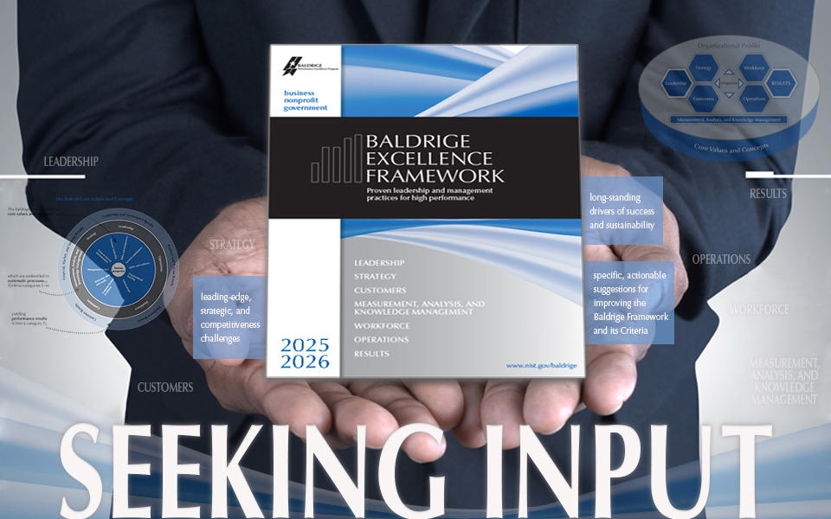

*Credit: Horoscope/Shutterstock*

The Baldrige Performance Excellence Program (BPEP) is seeking wide input for updates and other revisions to the [Baldrige Excellence Framework®](https://www.nist.gov/baldrige/publications/baldrige-excellence-framework), our core, comprehensive resource that is updated every two years.

As with past revisions, the 2025‒2026 version will codify the leading edge of validated leadership, management, and operational practices; foster core values/concepts of role-model organizations; and support organizational excellence and resilient long-term success.

BPEP invites anyone with expertise and insights on best practices for high-performing businesses and other organizations to submit input related to the questions below or to offer other specific, actionable suggestions for improving the Baldrige framework by email to [iday@nist.gov](mailto:iday@nist.gov) by May 24, 2024.

* What are the leading-edge, strategic, and competitiveness challenges that you are facing in your organization/industry (or seeing in the organizations with whom you work)?
* What changes have there been to the drivers of organizational resilience and long-term success?
* What are your suggestions for reorganizing and/or simplifying the Baldrige Excellence Framework® to enhance ease-of-use?

BPEP continually gathers insights from role-model organizations, from thought leaders, and from studies of organizations and their CEOs to inform the evolution of the framework. In addition, some of the most important insights BPEP has received for past revisions have come directly from members of the Baldrige community and the general public who are interested in helping organizations be successful in the long term.

Note, in 2024, for the first time, the [Criteria for Performance Excellence®](https://www.nist.gov/baldrige/baldrige-criteria-commentary) that are found in the framework are not identical to the [Baldrige Award Criteria](https://www.nist.gov/baldrige/baldrige-award/award-criteria). However, the award criteria are derived from the concepts in and content of the framework. At this time, we are interested in your input on the framework overall.

**OMB Control # 0693-0033**  
**Expiration date: 09/30/2025**

A Federal agency may not conduct or sponsor, and a person is not required to respond to, nor shall a person be subject to a penalty for failure to comply with an information collection subject to the requirements of the Paperwork Reduction Act of 1995 unless the information collection has a currently valid OMB Control Number. The approved OMB Control Number for this information collection is 0693-0033. Without this approval, we could not conduct this information collection. Public reporting for this information collection is estimated to be approximately 15 minutes per response, including the time for reviewing instructions, searching existing data sources, gathering and maintaining the data needed, and completing and reviewing the information collection. All responses to this information collection are voluntary. Send comments regarding this burden estimate or any other aspect of this information collection, including suggestions for reducing this burden, to the National Institute of Standards and Technology, Attn: Robert Fangmeyer, Director Baldrige Program, [robert.fangmeyer@nist.gov](mailto:robert.fangmeyer@nist.gov).

This following tweet directs the responder to the tool above.

