**OMB Control No. # 0693-0033**

**NIST Generic Clearance for Program Evaluation Data Collections**

**Expiration date: September 30, 2025**

Evaluation of the NIST Foreign Guest Researcher Program:

The NIST Foreign Guest Researchers Survey Instrument

**Page 1**

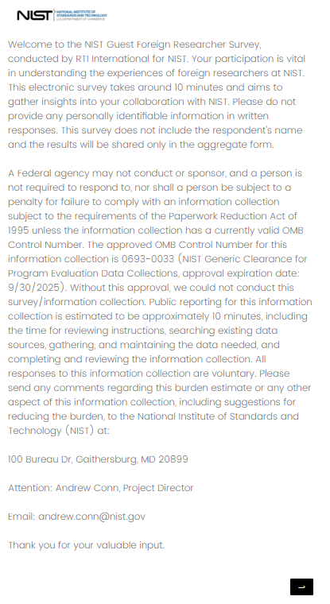

**Page 2**

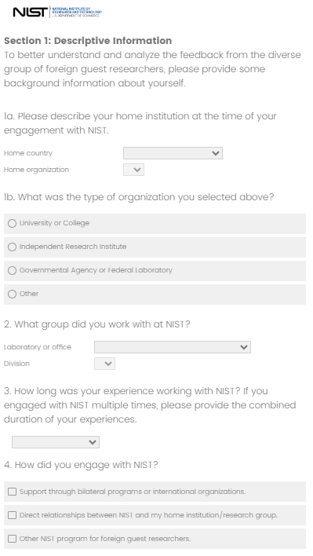

**Page 2 (continued)**

**Page 3**

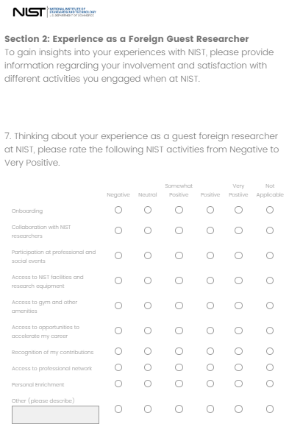

*IAAO has added two entries to this list - visa issuance process and badging in a timely manner (no modifications to the grading scale).

**Page 3 (continued)**

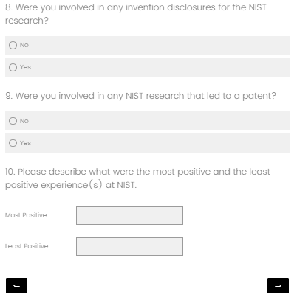

**Page 4**

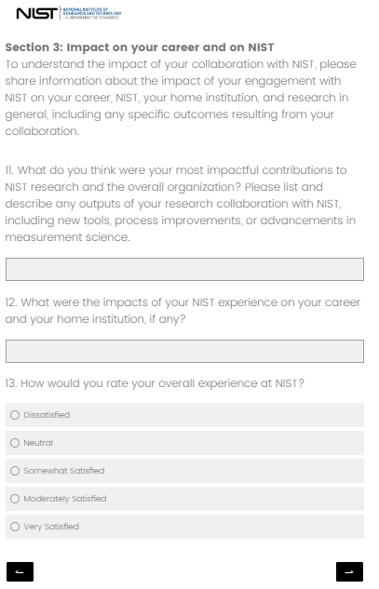

**Page 5**

