## **Exhibit O(2): HRSA 99-1(1) - Determination of Weighted and Unweighted Resident FTE Counts**

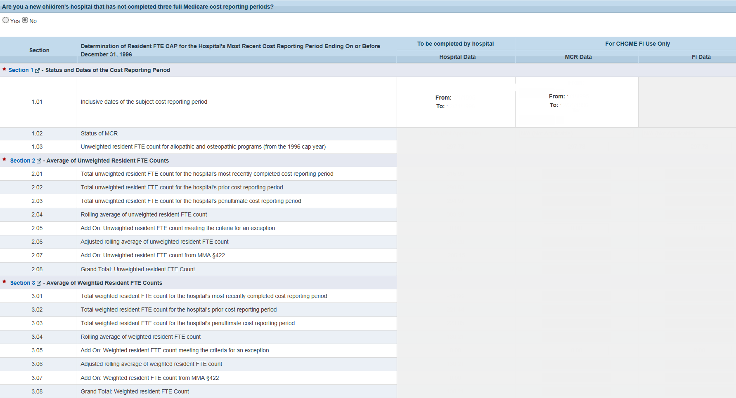

## **Exhibit O(2): HRSA 99-1(2) - Determination of Weighted and Unweighted Resident FTE Counts**

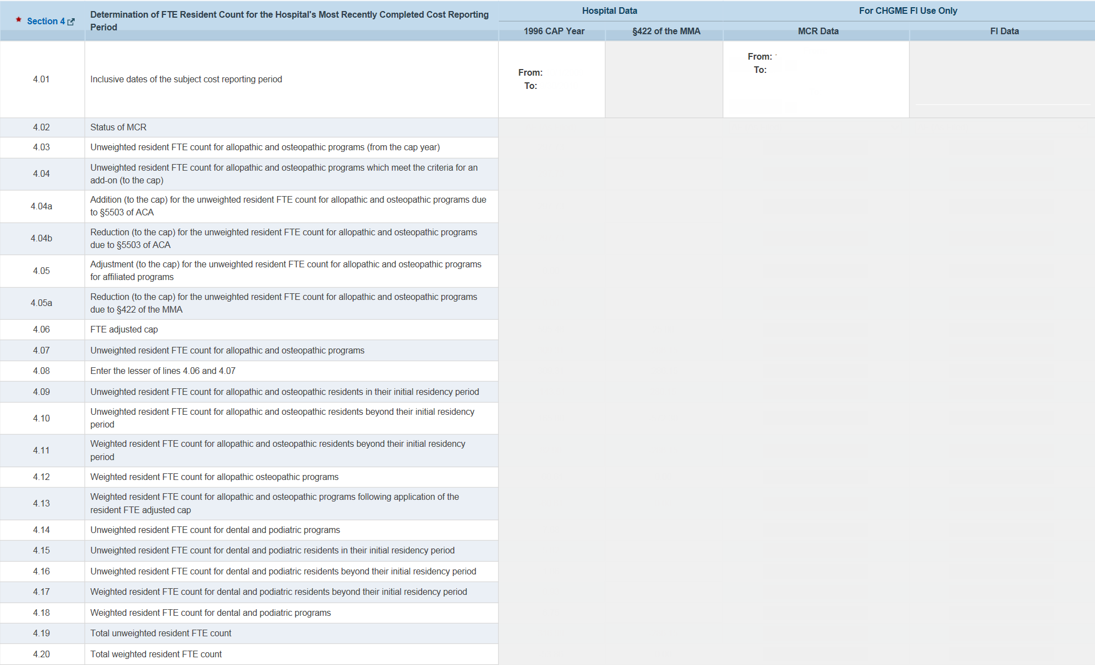

## **Exhibit O(2): HRSA 99-1(2A) - Determination of Weighted and Unweighted Resident FTE Counts**

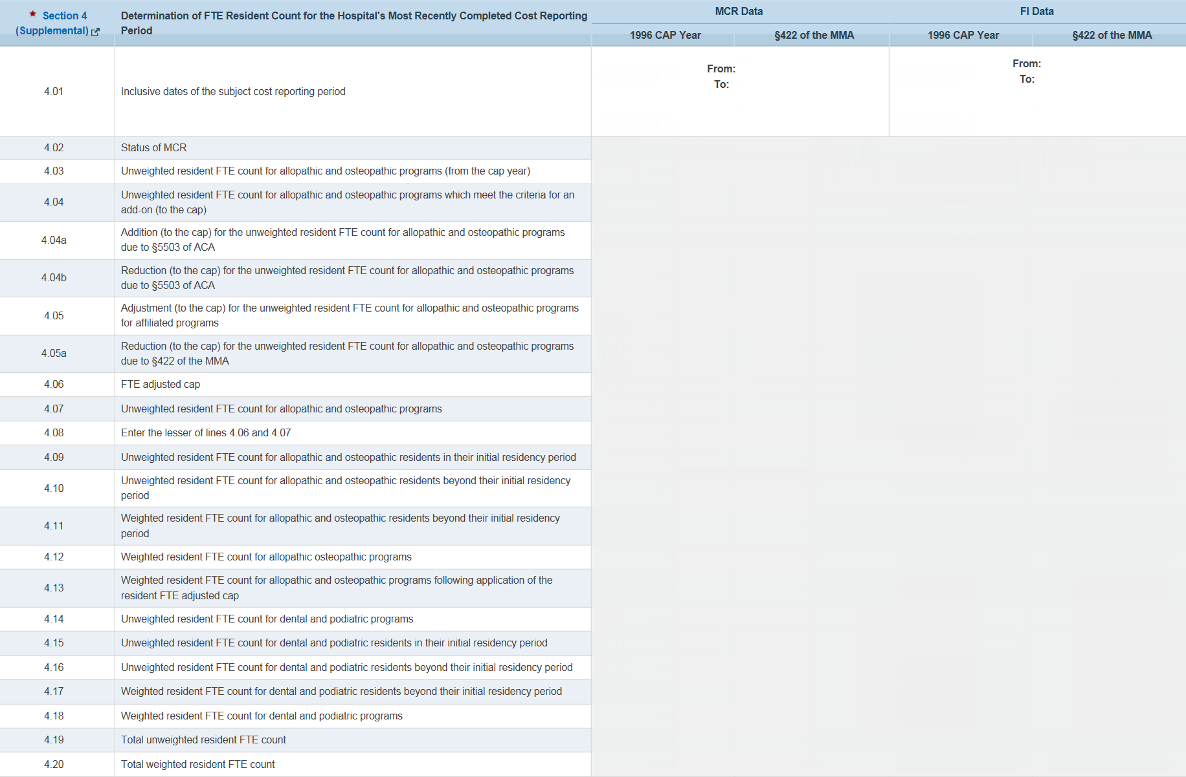

## **Exhibit O(2): HRSA 99-1(3) - Determination of Weighted and Unweighted Resident FTE Counts**

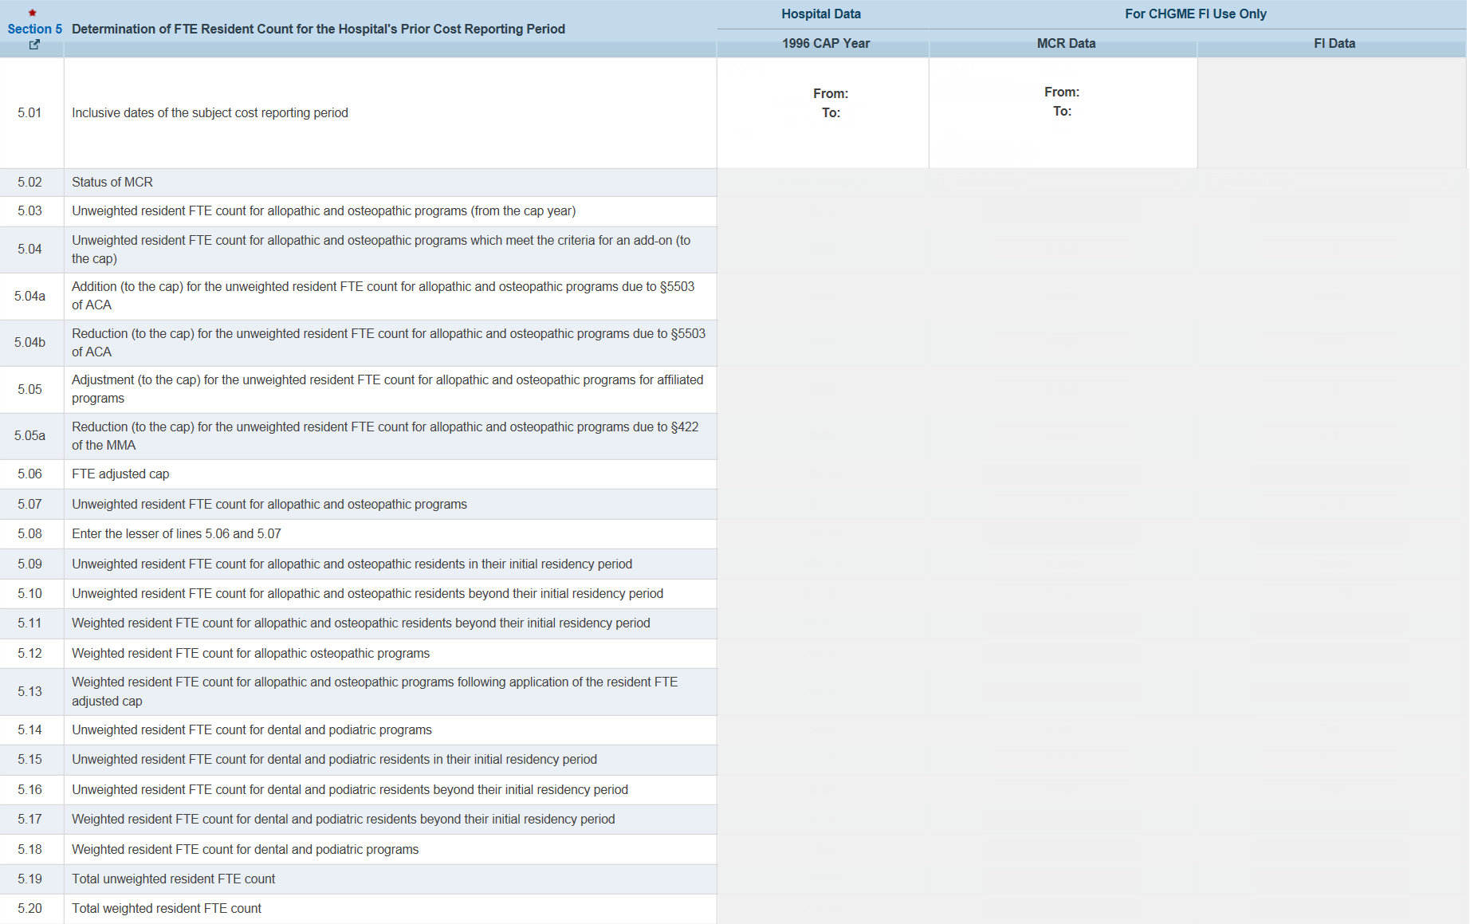

## **Exhibit O(2): HRSA 99-1(4) - Determination of Weighted and Unweighted Resident FTE Counts**

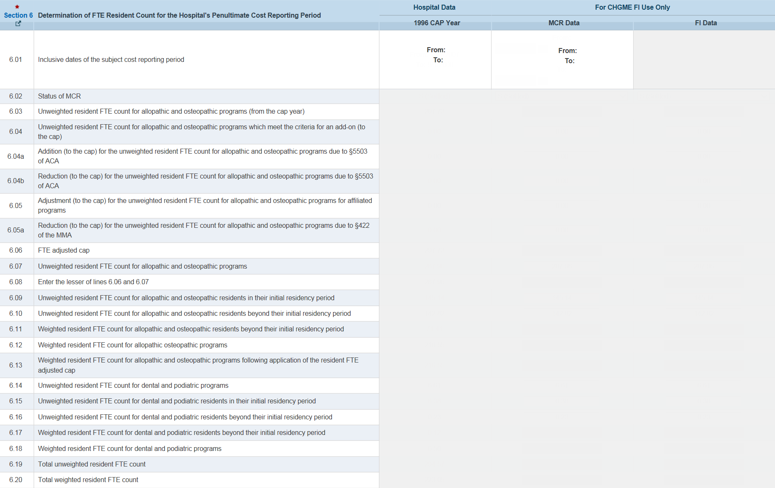

**Public Burden Statement**: The purpose of this information collection is to obtain performance data for the following: HRSA Grantees and cooperative agreement recipients, public health, and applications. In addition, these data will facilitate the ability to demonstrate alignment between BHW programs and CHGME Payment Program’s participating children’s hospitals. An agency may not conduct or sponsor, and a person is not required to respond to, a collection of information unless it displays a currently valid OMB control number. The OMB control number for this information collection is 0915-0247 and it is valid until 12/31/2025. Public reporting burden for this collection of information is estimated to average 3.7 hours per response, including the time for reviewing instructions, searching existing data sources, and completing and reviewing the collection of information. Send comments regarding this burden estimate or any other aspect of this collection of information, including suggestions for reducing this burden, to HRSA Information Collection Clearance Officer, 5600 Fishers Lane, Room 14NWH04, Rockville, Maryland, 20857.