Poster Abstracts – Email 1
Audience: internal BRAIN community and 2024 and 2026 conference registrants
Subject: Submit Your Poster Abstracts for the 2026 BRAIN Initiative Conference!
Date: Week of April 20 or TBD based on form approval

Body:
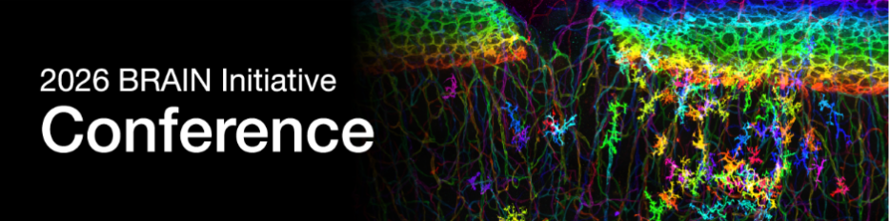

Are you interested in presenting your work at the 2026 BRAIN Initiative Conference?
Poster abstract submissions are open for this year’s conference, August 11–13, 2026, at the Bethesda North Marriott Hotel & Conference Center in Rockville, Maryland.
Poster sessions provide an opportunity to share your research with the BRAIN community and contribute to discussions on emerging scientific priorities and innovations in neuroscience. Poster space is limited. Assignments will be made in order of submission.
Researchers may also opt to be considered for a Scholar Spotlight Lightning Talk, which will take place prior to the morning plenary sessions. These talks provide selected presenters with the opportunity to briefly highlight their work for a broader conference audience. Interest in Scholar Spotlight can be indicated during the poster submission process.
Submit your poster today! Poster submission closes Friday, June 5, 2026, at 11:59 PM Eastern Time.
For more information about this year’s BRAIN Conference, please visit the 2026 BRAIN Initiative Conference website.
Questions about the event?
- Program inquiries: BRAINConference@ninds.nih.gov
- Logistics, registration, and submission inquiries: BRAINConference@rippleeffect.com
Best,
BRAIN Conference Team

