Photo and Video Contest Now Open – Email 4
Subject: 2026 BRAIN Initiative Photo and Video Contest is Open!
Audiences: Cvent to full listserv via BRAINConference@rippleeffect.com,
NIH internal listservs via BRAINConfernce@ninds.nih.gov or OBD
Date: Week of May 4

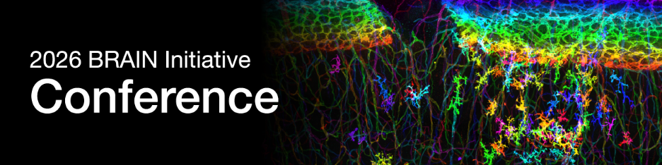
The BRAIN Initiative has been funding ground-breaking neuroscience research since 2014. Many innovative tools, resources, insights into neural circuit function, and first-in-human trials have been made possible by BRAIN Initiative researchers.
As we prepare to host the 2026 BRAIN Initiative Conference, we are excited to launch this year’s photo and video contest. This unique contest is an opportunity to showcase the colorful and inspiring images and videos captured by today's advances in neurotechnology. We’re excited to check out your creative fusions of art and science!
Submission Guidelines
- Criteria: This contest is open to all those engaged in the BRAIN Initiative, regardless of discipline, career stage, or funding source.
- Photos: Please submit your pictures in JPEG, GIF, or PNG formats at a minimum 300 dpi resolution, and a range of 1-10 MB in size.
- Videos: Videos should be no longer than 30 seconds and submitted as an .MP4 file under 20 MB
Submit your photos and videos by Sunday, June 7, 2026, at 11:59 PM Eastern Time.

The BRAIN Director will review anonymized entries and narrow the field to the top six photo and top six video entries that capture the creative spirit of this year’s BRAIN Conference theme, Inventing the Future. The finalists will be posted online for public voting. The top three photos and top three videos will be announced at the 2026 BRAIN Initiative Conference.
Share your artistry today!
Questions about the event?
- Program inquiries: BRAINConference@ninds.nih.gov
- Logistics, registration, and submission inquiries: BRAINConference@rippleeffect.com

Best,
BRAIN Conference Team

